Data Visualization Practical

Practical 1
Name: Line Plot
Aim: To track daily weather changes over one week.
Description: This visualization maps temperature data sequentially across a seven-day period. By connecting discrete daily data points with a continuous drawn line, it allows observers to quickly identify mid-week temperature drops, sudden weekend spikes, and overall climate trends over the course of the week.
Code:
import matplotlib.pyplot as plt
import seaborn as sns

x = [1, 2, 3, 4, 5, 6, 7]
y = [22, 24, 23, 26, 28, 27, 29]

sns.set_style("white")
with plt.xkcd():
plt.figure(figsize=(7, 5))
sns.lineplot(x=x, y=y, linestyle="solid")
plt.title("Daily Temperature Tracker")
plt.xlabel("Day of the Week")
plt.ylabel("Temperature (C)")
plt.tight_layout()
plt.show()
Output:

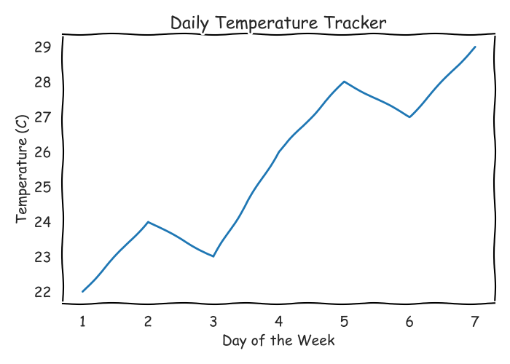

Practical 2
Name: Scatter Plot
Aim: To analyze study time versus exam performance.
Description: This chart plots individual student data points along two distinct axes representing hours spent preparing and final test scores. By displaying every student as an independent point on the grid, it visually demonstrates whether a direct positive correlation exists between preparation time and academic success.
Code:
import matplotlib.pyplot as plt
import seaborn as sns

x = [1, 2, 3, 4, 5, 6, 7, 8, 9, 10]
y = [45, 50, 58, 65, 68, 75, 82, 85, 93, 98]

sns.set_style("white")
with plt.xkcd():
plt.figure(figsize=(7, 5))
sns.scatterplot(x=x, y=y)
plt.title("Study Hours vs Test Score")
plt.xlabel("Hours Studied")
plt.ylabel("Exam Score (%)")
plt.tight_layout()
plt.show()

Output:
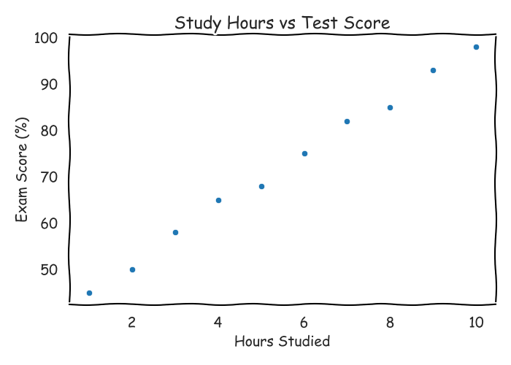

Practical 3
Name: Box Plot
Aim: To compare employee salary distributions across departments.
Description: This plot provides a concise summary of corporate payroll data by breaking down employee earnings into quartiles for each major company department. It displays the median income line, the middle fifty percent data spread, and potential statistical outliers to highlight systemic wage differences.
Code:
import matplotlib.pyplot as plt
import seaborn as sns

departments = ["HR", "HR", "HR", "IT", "IT", "IT", "Sales", "Sales", "Sales"]
salaries = [3200, 3500, 3100, 5400, 5800, 5200, 4100, 4600, 4300]

sns.set_style("white")
with plt.xkcd():
plt.figure(figsize=(7, 5))
sns.boxplot(x=departments, y=salaries)
plt.title("Employee Salaries by Department")
plt.xlabel("Department")
plt.ylabel("Monthly Salary ($)")
plt.tight_layout()
plt.show()

Output:
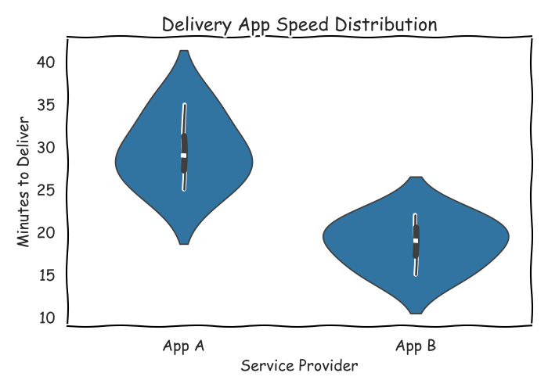

Practical 4
Name: Violin Plot
Aim: To display delivery wait times across food apps.
Description: This graphic combines traditional summary statistics with a continuous kernel density distribution to illustrate logistics performance. The resulting symmetric shape shows not just the average wait times for each delivery application, but also the exact probability frequencies where order arrivals peak or lag.
Code:
import matplotlib.pyplot as plt
import seaborn as sns

apps = ["App A", "App A", "App A", "App A", "App B", "App B", "App B", "App B"]
times = [25, 30, 28, 35, 15, 22, 18, 20]

sns.set_style("white")
with plt.xkcd():
plt.figure(figsize=(7, 5))
sns.violinplot(x=apps, y=times)
plt.title("Delivery App Speed Distribution")
plt.xlabel("Service Provider")
plt.ylabel("Minutes to Deliver")
plt.tight_layout()
plt.show()

Output:
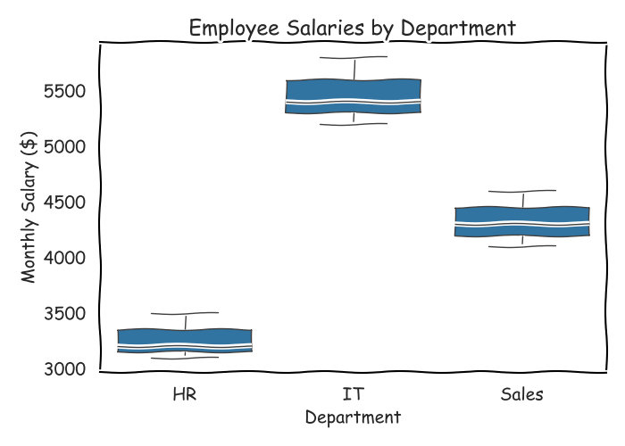

Practical 5

Name: Bar Chart
Aim: To track mobile phone sales across different months.
Description: This visualization utilizes distinct vertical bars aligned along a chronological timeline from January to December to represent total retail inventory moved. The varying heights of each individual column make it simple to track seasonal demand spikes during holiday periods or sales slumps in quieter months.
Code:
import matplotlib.pyplot as plt
import seaborn as sns

brands = ["Apple", "Samsung", "Google"]
sales = [150, 125, 85]

sns.set_style("white")
with plt.xkcd():
plt.figure(figsize=(7, 5))
sns.barplot(x=brands, y=sales, errorbar=None)
plt.title("Weekly Smartphone Sales")
plt.xlabel("Brand Name")
plt.ylabel("Units Sold")
plt.tight_layout()
plt.show()

Output:
