Performance of Concrete Incorporating Super-Absorbing Polymers

by

Gaurav Singh (2022UCE1243)
Khushi Kumawat (2022UCE1610)
Nigam Kumar (2022UCE1425)

Submitted
in partial fulfillment of the requirements of the degree of

Bachelor of Technology (Civil Engineering)

to the


Department of Civil Engineering
Malaviya National Institute of Technology Jaipur,
JAIPUR

May 2025
CERTIFICATE

This is to certify that the project report entitled "Performance of Concrete Incorporating Super-Absorbing Polymers" which is being submitted by Gaurav Singh (2022UCE1243), Khushi Kumawat (2022UCE1610), and Nigam Kumar (2022UCE1425), for the partial fulfillment of the requirements of the degree of B.Tech. (Civil Engineering) to the Department of Civil Engineering, Malaviya National Institute of Technology Jaipur, has been carried out under my supervision and guidance.

Dr. Sushree Sunayana
Supervisor
Dept. of Civil Engg.
MNIT Jaipur

DECLARATION
We, Gaurav Singh, Khushi Kumawat, and Nigam Kumar, declare that this minor project report titled "Performance of Concrete Incorporating Super-Absorbing Polymers" and the work presented in it are our own. We confirm that:

- This work was done wholly or mainly while in candidature for a bachelor degree at this university.
- Where any part of this report has previously been submitted for a degree or any other qualification at this university or any other institution, this has been clearly stated.
- Where we have consulted the published work of others, this is always clearly attributed.
- Where we have quoted from the work of others, the source is always given.
- With the exception of such quotations, this report is entirely our own work.
- We have acknowledged all main sources of help.

Gaurav Singh (2022UCE1243)
Khushi Kumawat (2022UCE1610)
Nigam Kumar (2022UCE1425)

Date: ____ / ____ / 2025
Jaipur

ACKNOWLEDGEMENTS
Any accomplishment requires blessings and efforts of numerous individuals and this work is no exception. We express our deepest sense of gratitude to Dr. Sushree Sunayana, Professor, Department of Civil Engineering, MNIT Jaipur, for her invaluable guidance, technical insights, and continuous encouragement throughout the development of this project titled "Performance of Concrete Incorporating Super-Absorbing Polymers."

We gratefully acknowledge the assistance of the Concrete Technology Laboratory staff at MNIT Jaipur for facilitating the experimental programme by providing essential equipment and ensuring smooth laboratory operations. Their technical support during casting, curing, and testing of concrete specimens was indispensable.

We also wish to acknowledge the foundational contributions of the RILEM Technical Committees and researchers including Viktor Mechtcherine, Jensen and Hansen, Zhou et al., and Wang et al., whose published work in the field of Super-Absorbent Polymers provided scientific direction and technical grounding for our study.

Finally, we wish to acknowledge the constant support of our friends and family, whose motivation, patience, and encouragement helped us stay focused and complete this project successfully. We are thankful to everyone who directly or indirectly contributed to the successful completion of this work.

Gaurav Singh (2022UCE1243)
Khushi Kumawat (2022UCE1610)
Nigam Kumar (2022UCE1425)
Date: May 2025, Jaipur
ABSTRACT
Performance of Concrete Incorporating Super-Absorbing Polymers
Internal curing has emerged as an effective technique to mitigate self-desiccation, autogenous shrinkage, and early-age cracking in low water-cement ratio concrete. Among the various materials used, Super-Absorbent Polymers (SAP) have gained significant attention due to their high water absorption capacity and controlled desorption behavior.

This study presents a detailed investigation of SAP’s absorption and desorption characteristics through experimental methods such as the tea-bag absorption test, open-air desorption analysis, and interaction with cement filtrate. Additionally, the impact of SAP on fresh and hardened concrete properties was evaluated. M30 grade concrete mixes were prepared with SAP dosages of 0.2%, 0.4%, and 0.6% (by weight of cement) and water-cement ratios ranging from 0.34 to 0.45.

Results indicate that SAP swelling behavior is highly dependent on the surrounding medium. Maximum absorption was observed in distilled water (380–420%), moderate in tap water (230–260%), and significantly reduced in cement filtrate (below 60%) due to ionic presence. Desorption studies revealed a gradual release of 7–13 g/day, confirming SAP’s role as an internal curing agent.

In concrete, pre-wetted SAP improved workability, with slump increasing at higher SAP dosages and water-cement ratios. Although early-age (7-day) compressive strength showed slight reductions, 28-day strength was comparable or improved, particularly at lower water-cement ratios. The optimum performance was achieved at 0.2% SAP dosage and a water-cement ratio of 0.38.

Furthermore, an XGBoost-based machine learning model was developed to predict compressive strength using key parameters.

Overall, the study establishes SAP as a promising internal curing material, with an optimal dosage of 0.2%–0.4% and a recommended water-cement ratio of 0.36–0.38 for balanced performance.

Keywords: Super-Absorbent Polymers (SAP), Internal Curing, Compressive Strength, Autogenous Shrinkage, Water-Cement Ratio, Workability, M30 Concrete, Machine Learning, XGBoost.

TABLE OF CONTENTS
Particulars | Page No.
Certificate | i
Declaration | ii
Acknowledgements | iii
Abstract | iv
Table of Contents | v
List of Tables | vi
List of Figures | vii
Abbreviations | viii
Chapter 1 – Introduction | 1
1.1 Background and Motivation | 1
1.2 Need for Internal Curing | 3
1.3 Role of SAP in Concrete | 4
1.4 Objectives of the Study | 6
1.5 Scope of the Study | 7
Chapter 2 – Literature Review | 8
2.1 Introduction to Superabsorbent Polymers | 8
2.2 Chemical Composition of SAP | 9
2.3 Absorption Mechanism and Kinetics | 10
2.4 Desorption Mechanism | 12
2.5 SAP-Cement Filtrate Interaction | 13
2.6 SAP in Fresh and Hardened Concrete | 14
2.7 SAP and Shrinkage Reduction | 16
2.8 SAP and Durability | 17
2.9 Comparison with Other Internal Curing Agents | 18
2.10 Summary of Literature Findings | 19
Chapter 3 – Materials, Methods & Experimental Setup | 20
3.1 Introduction | 20
3.2 Materials and Apparatus Used | 21
3.3 Preparation of Cement Filtrate | 22
3.4 SAP Absorption Testing (Tea-Bag Method) | 23
3.5 SAP Desorption Testing (Open-Air Method) | 24
3.6 Concrete Mix Design | 25
3.7 Fresh Concrete Testing | 28
3.8 Casting and Curing of Specimens | 29
3.9 Hardened Concrete Testing | 30
Chapter 4 – Experimental Results and Discussion | 31
4.1 SAP Absorption–Desorption Behaviour | 31
4.2 Fresh Concrete Properties - Slump Test Results | 34
4.3 Hardened Concrete Properties - Compressive Strength | 36
4.4 Comparison: With and Without SAP | 39
4.5 Comparison: Conventional vs. Internal Curing | 40
4.6 Machine Learning Predictive Analysis | 41
Chapter 5 – Conclusions and Future Scope | 44
5.1 Conclusions | 44
5.2 Future Scope | 46
References | 48

LIST OF TABLES

Table No. | Title | Page No.
3.1 | Materials Used in Experimental Study | 21
3.2 | Concrete Mix Proportion per 1 m³ (w/c = 0.45) | 26
3.3 | Concrete Mix Proportion per 1 m³ (w/c = 0.38) | 27
4.1 | SAP Absorption Capacity in Different Solutions | 31
4.2 | SAP Desorption Rate (Open-Air Method) | 33
4.3 | Fresh Concrete Slump Test Results - All Mix Compositions | 34
4.4 | 7-Day Compressive Strength Results | 36
4.5 | 28-Day Compressive Strength Results | 37
4.6 | Comparison: Concrete With and Without SAP | 39
4.7 | Comparison: Conventional vs. Internal Curing | 40
4.8 | ML Model Performance Comparison | 43
2.1 | Literature Review Summary | 19

LIST OF FIGURES
Table No. | Title | Page No.
3.1 | Materials Used in Experimental Study | 21
3.2 | Concrete Mix Proportion per 1 m³ (w/c = 0.45) | 26
3.3 | Concrete Mix Proportion per 1 m³ (w/c = 0.38) | 27
4.1 | SAP Absorption Capacity in Different Solutions | 31
4.2 | SAP Desorption Rate (Open-Air Method) | 33
4.3 | Fresh Concrete Slump Test Results – All Mix Compositions | 34
4.4 | 7-Day Compressive Strength Results | 36
4.5 | 28-Day Compressive Strength Results | 37
4.6 | Comparison: Concrete With and Without SAP | 39
4.7 | Comparison: Conventional vs. Internal Curing | 40
4.8 | ML Model Performance Comparison | 43
2.1 | Literature Review Summary | 19

ABBREVIATIONS
SAP | : | Super-Absorbent Polymer
IC | : | Internal Curing
w/c | : | Water-Cement Ratio
HPC | : | High-Performance Concrete
HSC | : | High-Strength Concrete
UHPC | : | Ultra-High Performance Concrete
OPC | : | Ordinary Portland Cement
RH | : | Relative Humidity
C-S-H | : | Calcium Silicate Hydrate
ITZ | : | Interfacial Transition Zone
APZ | : | Affected Paste Zone
LWA | : | Lightweight Aggregate
RILEM | : | International Union of Laboratories and Experts in Construction Materials
IS | : | Indian Standard
ACI | : | American Concrete Institute
CTM | : | Compression Testing Machine
SEM | : | Scanning Electron Microscopy
BSE | : | Backscattered Electron
EDA | : | Exploratory Data Analysis
ML | : | Machine Learning
XGBoost | : | Extreme Gradient Boosting
API | : | Application Programming Interface
FA | : | Fine Aggregate
CA | : | Coarse Aggregate
MPa | : | Megapascal
DI Water | : | Deionized / Distilled Water
RCPT | : | Rapid Chloride Penetration Test
RAC | : | Recycled Aggregate Concrete

CHAPTER 1

INTRODUCTION

1.1 Background and Motivation
Concrete is the most widely used construction material in the world, owing to its versatility, economic viability, structural performance, and ability to be cast into any desired shape. It forms the backbone of modern infrastructure, ranging from buildings and bridges to dams and industrial floors. However, the ever-increasing demand for durable, high-performance structures has pushed the boundaries of conventional concrete design, leading to mixes with very low water-cement ratios (w/c < 0.40).

While reducing the water-cement ratio significantly improves strength and reduces permeability, it introduces a critical challenge: insufficient internal moisture for complete hydration. In dense, low-permeability concrete, the limited water available during hydration leads to a cascade of detrimental effects:

- Rapid internal relative humidity (RH) reduction within the concrete matrix.
- Self-desiccation - the process where cement particles consume available water faster than it can be replenished.
- Autogenous shrinkage - volumetric reduction occurring without any moisture exchange with the environment.
- Early-age microcracking due to tensile stresses generated by differential shrinkage.
- Loss of long-term durability, reduced service life, and compromised structural integrity.

Traditional external curing techniques, such as water ponding, wet burlap, spraying, or applying curing compounds, fail to provide uniform moisture distribution throughout the concrete's depth. This is especially true for deep placements, slender sections, or regions with highly dense and low-permeability matrices where water cannot penetrate sufficiently from outside.

To overcome these fundamental limitations, researchers and engineers have developed the concept of Internal Curing (IC). Internal curing refers to the process of introducing additional water into the concrete mix itself - water that is not counted as part of the mix water, but is held in pre-wetted porous materials and released slowly as the internal relative humidity decreases during hydration. This water fills the capillary pores vacated during chemical shrinkage and supports continuous hydration throughout the concrete's cross-section.

Among various internal curing agents investigated, Super-Absorbent Polymers (SAP) stand out due to their remarkable capacity to absorb hundreds of times their own weight in water, and then release it gradually in response to humidity gradients within the concrete. Jensen and Hansen pioneered the application of SAP for internal curing in high-performance concrete, and since then, extensive research by RILEM Technical Committees (TC-225 and TC-260) and individual researchers worldwide has validated and refined the use of SAP across diverse concrete systems.

The context of this study is particularly relevant for semi-arid and hot-climate regions like Rajasthan, India, where external curing is challenging due to rapid surface evaporation and limited water availability. Internal curing using SAP presents a promising and practical solution for ensuring adequate hydration in such environments.
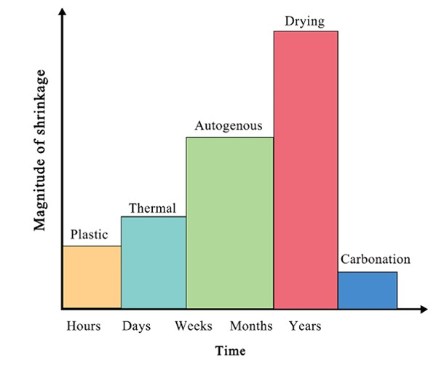

Fig. 1.1 Types of shrinkage, relative size and the tie sequence in which they occur.

1.2 Need for Internal Curing
Internal curing ensures the availability of additional water that is not originally part of the mixing water. This supplementary water compensates for chemical shrinkage - the volume reduction occurring when anhydrous cement reacts with water to form hydration products - and thereby reduces the risk of self-desiccation.
Internal curing is particularly essential for the following categories of concrete and structural conditions:
- Mass concrete placements where external curing cannot penetrate deep into the section.
- Restrained structural components where autogenous shrinkage leads to cracking under restraint.
- Structures in hot, arid climates where external water evaporates rapidly from the surface.
- Concrete bridge decks and pavements where early-age shrinkage cracking is a persistent problem.

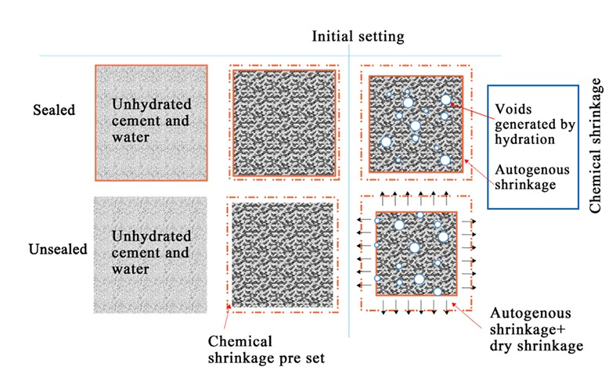
The American Concrete Institute (ACI 308) and RILEM both recognize internal curing as a critical strategy for improving hydration and reducing shrinkage in modern concrete. Studies have consistently shown that internal curing can reduce autogenous shrinkage by 35-70%, improve the degree of hydration, and enhance long-term mechanical and durability properties.

Fig. 1.2 Relationship between several important shrinkage quantities in both environments (without regard to thermal shrinkage and carbonation shrinkage).

1.3 Role of SAP in Concrete
Super-Absorbent Polymers are cross-linked hydrogels, three-dimensional polymer networks - capable of absorbing water up to several hundred times their own dry weight. Their functionality in concrete can be described through three distinct phases:

Absorption Phase
During the mixing stage, SAP particles absorb water from the mix, swelling into gel-like micro-reservoirs within the concrete matrix. If pre-wetted SAP is used, the particles arrive fully swollen and release water during hydration. If dry SAP is added, it competes with cement for the available mix water, reducing workability.

Reservoir Phase
Once swollen, SAP particles act as distributed internal water reservoirs throughout the concrete matrix. They maintain a local zone of higher moisture - known as the Affected Paste Zone (APZ) - around each SAP particle, where hydration proceeds more completely than in the surrounding paste.

Desorption Phase
As cement hydration progresses and internal relative humidity decreases below the swelling equilibrium of the SAP, the polymer begins to release water. This desorption is driven by the increasing capillary tension and humidity gradient within the concrete pores. The released water supports secondary hydration, densifies the microstructure, reduces pore connectivity, and mitigates autogenous shrinkage.

1.4 Objectives of the Study
Based on the background, literature gaps, and experimental design, the following specific objectives were formulated for this study:

To investigate the absorption and desorption kinetics of Super-absorbing polymer in cementitious solution.

To investigate the effects of SAP on fresh and hardened concrete properties.

To determine the optimised dosage of SAP with a suitable low water-cement ratio.

To perform predictive analysis using statistical and machine learning models based on experimental data.

1.5 Scope of the Study
The present study focuses on the following key aspects:
- SAP absorption and desorption kinetics in distilled water, tap water, and simulated cement pore solution (cement filtrate).
- Effect of SAP on fresh concrete workability (slump) at water-cement ratios of 0.34, 0.36, 0.38, 0.40, and 0.45.
- Effect of SAP on hardened M30 concrete compressive strength at 7, 28 and 90 days of curing.
- Determination of optimum SAP dosage for effective internal curing while maintaining adequate workability.
- Comparison between conventional water curing and internal curing using SAP.
- Comparison of compressive strength with and without SAP.
- Application of machine learning for predictive modelling of concrete strength.

All experiments were conducted in the Concrete Technology Laboratory, MNIT Jaipur.

CHAPTER 2

LITERATURE REVIEW
The following chapter presents a thorough review of the existing scientific literature on Super-Absorbent Polymers (SAP) in concrete, covering their chemistry, absorption-desorption behaviour, interactions with cement systems, effects on fresh and hardened concrete, shrinkage reduction, durability improvements, and recent advances.

2.1 Introduction to Superabsorbent Polymers (SAP)
Superabsorbent Polymers are cross-linked macromolecules that attract water and possess the remarkable capability to absorb and retain large amounts of water relative to their dry mass. Depending on their chemical composition and the ionic conditions of the surrounding solution, SAP can absorb between 100 to 1000 times their weight in pure water. Their use spans several industries including agriculture, personal hygiene products, and, more recently, construction materials.

The application of SAP in cement-based systems began with pioneering work by Jensen and Hansen (2001), who were the first to systematically propose and study the use of SAP for internal curing of high-performance concrete. In the context of concrete, SAP particles act as internal reservoirs: they capture water during the mixing phase and slowly discharge it as the internal moisture level drops during hydration. This controlled release of water helps mitigate self-desiccation, autogenous shrinkage, and early-age microcracking - problems that are especially significant in concrete with low water-cement ratios.

RILEM Technical Committee TC-225-SAP (2013) provided the first comprehensive set of guidelines on SAP use in concrete, covering testing methods, dosage recommendations, rheological effects, and durability. This was followed by TC-260-RSC (2017) which further refined recommendations and provided extensive experimental evidence from multiple research groups worldwide.

2.2 Chemical Composition of SAP
Most SAP used in concrete applications are derived from polyacrylate or polyacrylamide monomers that are cross-linked into a three-dimensional network. The type of polymer determines its swelling behaviour, stability in alkaline environments, and interaction with cement chemistry. The main chemical types include:

Ionic SAP (Anionic / Cationic)
Anionic SAP composed of acrylic acid, sodium acrylate, and potassium acrylate demonstrate significant swelling in distilled or low-ionic water. Their swelling is highly responsive to ionic strength, declining markedly in cement pore solution. Anionic SAP are the most widely studied type for concrete applications.

Non-Ionic SAP
Polyacrylamide-based SAP exhibits lower overall swelling capacity but demonstrates greater stability in ionic environments. This makes non-ionic SAP more predictable in cement systems, though their water absorption per unit mass is lower than ionic varieties.

Zwitterionic and Amphoteric SAP
These advanced types contain both positive and negative functional groups, offering balanced swelling behaviour and salt resistance.

The chemical composition of SAP fundamentally influences its absorption capacity, desorption rate, interaction with cement ions, and resulting effect on concrete properties. For this study, an anionic polyacrylate-based SAP was selected, which is the most commonly used type in concrete internal curing research and industry.

2.3 Absorption Mechanism and Kinetics

2.3.1 Fundamentals of Swelling
The absorption behaviour of SAP results from a combination of polymer-water interactions, osmotic pressure gradients, and ionic effects. According to Mechtcherine (2010), SAP swelling occurs due to an osmotic imbalance between the polymer network and the surrounding fluid. The process involves:

- Hydrophilic functional groups (carboxylate, amide, hydroxyl) attract water molecules through hydrogen bonding and electrostatic interactions.
- Polymer chains ionize in solution, creating electrostatic repulsion within the network that drives further expansion.
- Water diffuses inward, expanding the polymer network against the elastic restoring force of cross-links.
- Swelling equilibrium is reached when osmotic pressure equals the elastic retraction force of the cross-linked network.

2.3.2 Influence of Ionic Concentration
SAP swelling is highly sensitive to the ionic concentration of the surrounding solution. Cement pore solution contains significant concentrations of calcium (Ca²⁺), sodium (Na⁺), potassium (K⁺), and hydroxyl (OH⁻) ions at pH greater than 13. These ions suppress SAP swelling through several mechanisms:

- Charge Shielding: Ca²⁺ and other cations bind to carboxylate groups on the polymer chains, reducing electrostatic repulsion and preventing chain extension.
- Ion-Induced Collapse: Divalent ions such as Ca²⁺ can cross-link polymer chains, physically stiffening the network.
- Reduced Water Activity: High ionic strength in cement filtrate reduces the chemical potential of free water, lowering the osmotic driving force.

As a result, SAP absorption follows the universal trend: Distilled Water > Tap Water > Cement Filtrate. This hierarchy was confirmed in experimental studies by Zhao, Jensen, and Hasholt (2014) and was verified in our experiments as well.

2.3.3 Absorption Kinetics
Absorption kinetics typically follow a two-stage mechanism: an initial rapid uptake where surface swelling dominates and causes immediate slump reduction, followed by a slower internal swelling phase where water penetrates deep into the polymer network, forming long-term internal reservoirs for hydration.

2.4 Desorption Mechanism
Desorption is the controlled release of stored water from SAP particles. It is influenced by cement hydration progress, internal pore pressure, capillary tension, and relative humidity gradients within the concrete matrix.

The primary driving forces for desorption include the decrease in internal relative humidity as hydration progresses, capillary tension in pores (governed by the Kelvin–Laplace equation), heat evolution leading to increased moisture demand, and the consumption of free water in hydration reactions.

Slow, controlled desorption is essential for effective internal curing because cement hydration requires a continuous supply of water over days and weeks, not a sudden release. Studies have shown that SAP desorption rates of 7–15 g per day closely match the water demand of cement particles during hydration, making SAP an ideal internal curing agent.

Mechtcherine (2010) demonstrated that SAP in cement systems typically undergoes complete desorption within 7–14 days, corresponding well with the critical early hydration period. After complete desorption, SAP leaves behind spherical or irregular voids whose diameter depends on the original SAP particle size and swelling capacity.

2.5 SAP-Cement Filtrate Interaction
Wang et al. (2016) studied the interaction between SAP and cement paste in detail, characterizing the Affected Paste Zone (APZ) — the region of cement paste immediately surrounding each SAP particle. Key findings from this research include:

- Higher degree of hydration in the APZ (approximately 5% increase compared to surrounding paste), attributed to the local water supply from the SAP reservoir.
- Early-age increase in capillary porosity in the APZ, since swollen SAP temporarily creates larger voids.
- Later-age decrease in porosity as hydration products fill the voids after SAP desorption.
- Higher microhardness around SAP voids, indicating denser calcium-silicate-hydrate (C–S–H) formation in the affected zone.

These findings are highly significant because they demonstrate that SAP voids are not simply defects in the concrete matrix — they are functional microstructural zones that enhance hydration and improve long-term properties.

2.6 SAP in Fresh and Hardened Concrete

2.6.1 Fresh Concrete Behaviour
The addition of SAP significantly changes the rheological properties and workability of fresh concrete. The nature of the effect depends heavily on whether SAP is added in dry or pre-wetted form:

Dry SAP absorbs mixing water immediately upon contact, reducing the effective water-cement ratio and causing significant slump loss. According to RILEM TC-225 (2013), dry SAP can cause up to 60-70% slump loss unless additional water or superplasticizer is provided. Larger SAP particles absorb more water and cause greater workability reduction.

Pre-wetted SAP does not compete with cement for mixing water. When SAP is fully saturated before incorporation, it contributes to workability by providing additional free moisture at the surface of particles. This is why our experimental results show that pre-wetted SAP actually increases slump - the opposite of dry SAP behaviour.

2.6.2 Hardened Concrete Behaviour
SAP influences hardened concrete properties through two competing effects: void formation (reducing strength) and enhanced hydration from internal curing water (increasing strength). At early ages (7 days), the void formation effect typically dominates, leading to slightly lower compressive strength. At later ages (28 days), the enhanced hydration effect becomes dominant, often resulting in comparable or higher strength compared to control specimens.

Multiple studies confirm that the net effect of SAP on 28-day strength is neutral to positive when the dosage is correctly optimized (0.1–0.3% by weight of cement). Beyond 0.4%, the void formation effect becomes excessive and strength is significantly reduced.

2.7 SAP and Shrinkage Reduction
SAP is most widely recognized for its ability to reduce autogenous shrinkage in low water-cement ratio concrete. The mechanism operates through maintaining internal RH between 95–100%, thereby reducing the capillary tension that drives autogenous shrinkage.

Across the literature, consistent evidence shows 35–70% reduction in autogenous shrinkage with SAP dosages of 0.1–0.3% by weight of cement. RILEM TC-260 (Mechtcherine et al., 2017) reports up to 46% reduction in autogenous shrinkage compared to control specimens. This makes SAP significantly more effective than shrinkage-reducing admixtures (SRA) or lightweight aggregates (LWA) for the specific purpose of mitigating autogenous shrinkage.

The effect of SAP on drying shrinkage is more nuanced. While SAP significantly reduces autogenous shrinkage, its effect on drying shrinkage can be slightly negative due to the added voids. However, this effect is generally negligible when SAP dosage is kept at or below 0.2% and particles are small and well-dispersed.

2.8 SAP and Durability

2.8.1 Pore Structure Refinement
Early-age porosity increases due to swollen SAP particles, but later-age porosity decreases as hydration products fill the SAP voids. The APZ becomes denser and less permeable over time, contributing to better microcrack resistance and improved durability.

2.8.2 Freeze-Thaw Resistance
SAP improves freeze-thaw durability through the formation of controlled, closed voids that act as pressure relief chambers during freezing cycles, similar to deliberately entrained air voids. Multiple RILEM investigations confirm improved freeze-thaw resistance in SAP-modified concrete.

2.8.3 Chloride Ion Penetration
Research shows mixed outcomes on chloride penetration resistance. Minor increases can occur due to macrovoids, but are often compensated by pore refinement in the APZ. RILEM concludes that the net effect on chloride penetration is neutral to slightly beneficial when SAP dosage is optimized.

2.9 Comparison with Other Internal Curing Agents
Table 2.1 presents a comparison between SAP and Lightweight Aggregates (LWA) as internal curing agents:

Property | SAP | Lightweight Aggregate (LWA)
Water Retention | Very High (100–1000 g/g) | Moderate (15–30 g/g)
Release Control | Excellent (humidity-driven) | Limited (less controlled)
Particle Size | 100–2000 µm (tunable) | 2–8 mm (larger)
Effect on Workability | Higher if pre-wetted | Less pronounced
Void Distribution | Predictable and uniform | Irregular
Shrinkage Reduction | 35–70% | 20–40%
Dosage Required | 0.1–0.3% of cement | 5–20% of aggregate

Table 2.1: Comparison of SAP and Lightweight Aggregate as Internal Curing Agents

2.10 Summary of Literature Findings
The literature conclusively establishes the following:

- SAP significantly reduces autogenous shrinkage by maintaining internal relative humidity above 95%.
- Absorption is highest in distilled water, moderate in tap water, and strongly suppressed in cement filtrate.
- Desorption is slow and sustained (7–15 g/day), promoting continuous hydration.
- Early compressive strength typically decreases slightly, but is compensated at later ages.
- SAP improves microstructure, reduces cracking, and enhances durability properties.
- Optimum SAP dosage for internal curing is 0.1–0.3% by weight of cement.
- Pre-wetted SAP provides more predictable and controllable behaviour compared to dry SAP.
- SAP is now recognized globally as a highly effective internal curing material for modern low w/c concretes.

The following table summarizes the key literature studies referenced in this work:

Sr. | Title | Author(s) | Year | Key Findings
1 | Superabsorbent Polymers for Internal Curing Concrete | Zhou, Wang, Taylor, Gu et al. | 2015 | SAP chemistry and internal curing role; reduces self-desiccation, improves hydration, minimizes shrinkage, enhances durability
2 | Influence of SAP on the Surrounding Cement Paste | Wang, Yang, Hu, Li, Cheng et al. | 2016 | SAP increases early porosity but reduces it later; improves hydration ~5%; microhardness higher in APZ
3 | Application of SAP in Concrete – RILEM Update | Mechtcherine, Wyrzykowski et al. | 2017 | Shrinkage control, freeze–thaw resistance; challenges of SAP variability and dosage control
4 | Absorption & Release Mechanism of SAP | Viktor Mechtcherine | 2010 | Swelling and desorption based on osmotic pressure and humidity gradients; polymer structure governs performance
5 | Application of SAP in Concrete (RILEM TC 225) | RILEM TC 225-SAP | 2013 | Comprehensive guidelines; rheology, shrinkage reduction, durability, standardization needs
6 | Measuring Absorption in Cementitious Environments | Zhao, Jensen, Hasholt | 2014 | Tea-bag method; absorption depends on ionic concentration; accurate measurement techniques

Table 2.2: Summary of Key Literature References

CHAPTER 3

MATERIALS, METHODS & EXPERIMENTAL SETUP
This chapter describes in detail the materials, apparatus, test methods, and experimental procedures adopted to evaluate the performance of concrete incorporating Super-Absorbent Polymers (SAP).

3.1 Introduction
The experimental work in this study was organised into four major components: (i) characterisation of SAP absorption and desorption behaviour, (ii) study of SAP interaction with cement filtrate as a proxy for cement pore solution, (iii) preparation of M30 grade concrete mixes with varying SAP dosages and water-cement ratios, and (iv) evaluation of fresh and hardened concrete properties.
The consistency and repeatability of test results were ensured by performing each test in triplicate and reporting average values. Results were cross-referenced with established literature findings to validate experimental observations.

3.2 Materials and Apparatus Used

3.2.1 Materials

Sr. | Material | Specification | Purpose
1 | Ordinary Portland Cement (OPC) | Grade 43, IS 8112 | Binder material in concrete
2 | Coarse Aggregate | 12 mm – 20 mm, angular | Structural filler in concrete
3 | Fine Aggregate (Sand) | Zone II, IS 383 | Fine filler in concrete
4 | Super-Absorbent Polymer (SAP) | Anionic polyacrylate type | Internal curing agent
5 | Distilled Water | pH 7.2 | Pre-wetting SAP; absorption tests
6 | Tap Water | pH 8.4 | Concrete mixing water; absorption tests
Table 3.1: Materials Used in Experimental Study

3.2.2 Apparatus
The following equipment was used throughout the experimental programme: pH measuring probe and meter; measuring cylinders (100 mL, 500 mL, 1000 mL); precision weighing balance (0.01 g accuracy); magnetic stirrer with hot plate; Whatman Grade 1 filter paper; conical flasks and beakers; tea bags (permeable, for absorption tests); slump cone (300 mm height, IS 1199); tamping rod (600 mm, 16 mm diameter); 2000 kN Compression Testing Machine (CTM); 100 mm × 100 mm × 100 mm cube moulds; table vibrator for compaction; water curing tank.

3.3 Preparation of Cement Filtrate
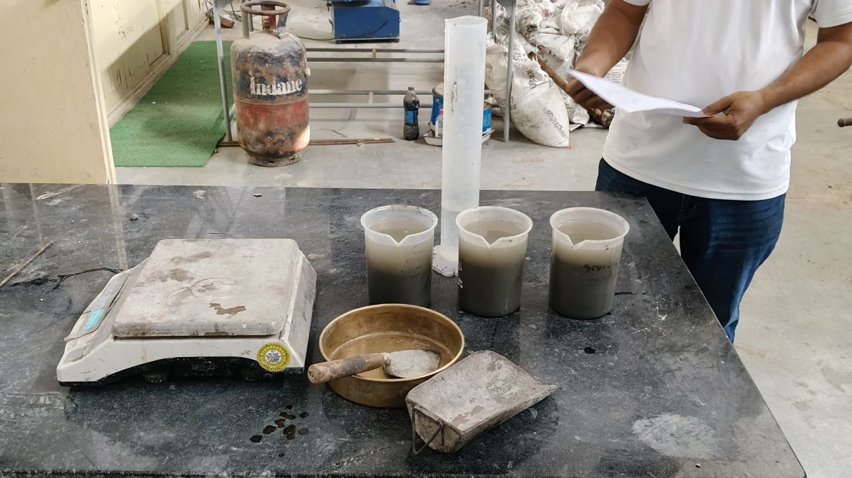
Cement filtrate was prepared to simulate the cement pore solution environment for SAP ionic absorption testing. This is critical because the ionic composition of cement pore solution differs significantly from that of plain water, and strongly affects SAP swelling behaviour.

Fig. 3.1 Preparation of cement filtrate

3.3.1 Procedure
- OPC cement and tap water were mixed in a 1:5 ratio (by mass) in a conical flask.
- The slurry was stirred continuously at 300 rpm for 24 hours using a magnetic stirrer.
- The slurry was filtered using Grade 1 Whatman filter paper to obtain the filtrate.
- The pH of the filtrate was measured using a calibrated pH meter. The measured pH was approximately 13, confirming highly alkaline conditions representative of cement pore solution.
The high pH and ionic content of the cement filtrate were critical for evaluating real-world SAP performance in concrete. The filtrate contained significant concentrations of calcium, sodium, potassium, and hydroxyl ions, creating the ionic environment that suppresses SAP swelling.
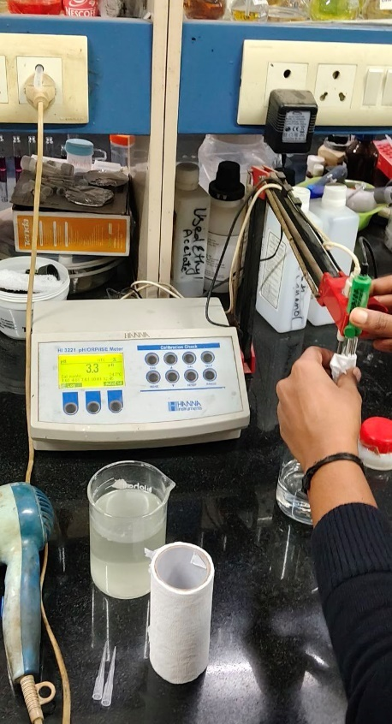
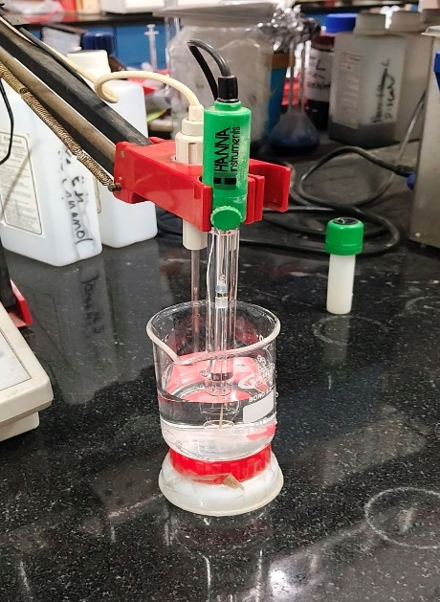

Fig. 3.2 and 3.3. Testing pH using a pH measuring probe.

3.4 SAP Absorption Testing (Tea-Bag Method)
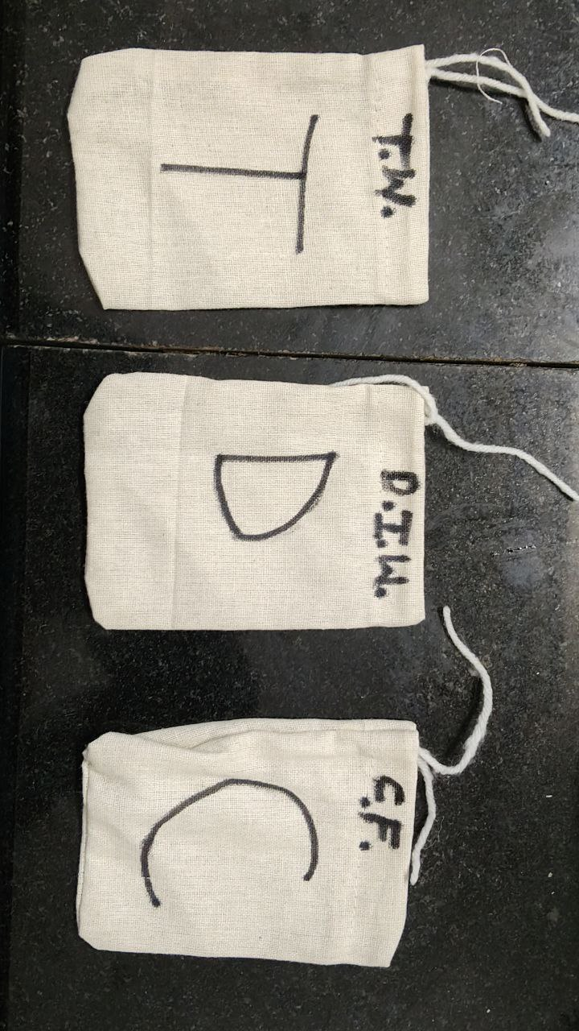
The tea-bag method is the standard procedure recommended by RILEM TC-260 for measuring SAP absorption capacity. It allows direct measurement of the mass of water absorbed by a known mass of SAP under controlled conditions.

Fig. 3.4 Tea bags for testing

3.4.1 Procedure
- SAP was accurately weighed (approximately 3 g per test, recorded as mSAP) and placed inside permeable tea bags.
- Tea bags were sealed to prevent SAP loss during testing.
- Separate tea bags were prepared for each test liquid: distilled water, tap water, and cement filtrate.
- Tea bags were immersed in 180 mL of each test liquid.
- At predetermined time intervals (1, 5, 10, 30, 60 minutes; 3 hours; and 24 hours after SAP-liquid contact), the tea bag with swollen SAP was carefully removed from the liquid.
- The tea bag was gently wiped with dry gauze to remove surface moisture and weighed (recorded as mTB3).

Absorption capacity (Q) was calculated using the formula: Q = (mTB3 - mTB1) / mSAP, where mTB1 is the initial mass of the empty wet tea bag. Three trials were performed for each liquid, and average values were reported.
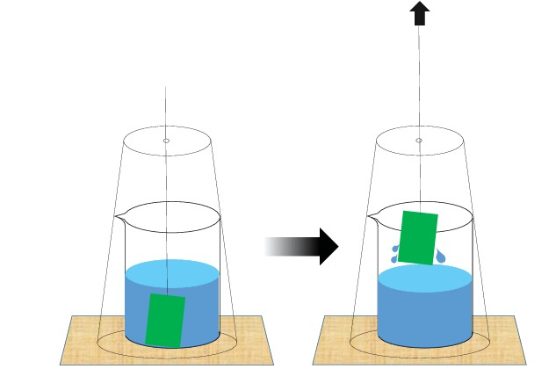

Fig. 3.5 Sketch of the set-up for the dipping method, a modification of the reference tea-bag method

3.5 SAP Desorption Testing (Open-Air Method)
The open-air desorption test was used to measure the rate of water release from fully saturated SAP under ambient conditions. This test simulates the internal curing water release that occurs inside concrete as humidity decreases during hydration.

3.5.1 Procedure
- SAP samples were fully saturated in distilled water and tap water, respectively, until equilibrium swelling was achieved (typically 24 hours).
- Excess surface water was removed from the swollen SAP by gentle blotting with dry gauze.
- Swollen SAP samples were placed on filter paper in open air at ambient temperature (25–30°C) and relative humidity (50–60%).
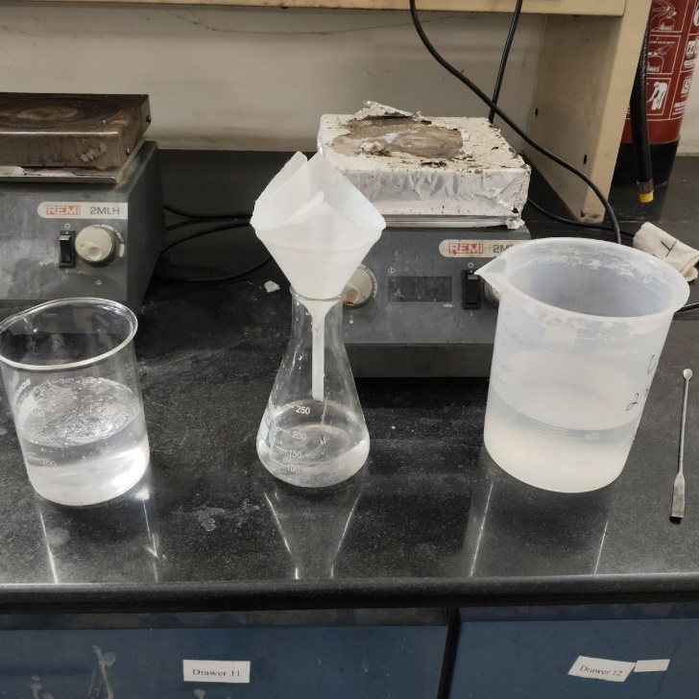
- Mass loss was recorded every 24 hours to track the rate of water release over time.

Fig 3.6 Open air drying

3.6 Concrete Mix Design
Concrete mixes were designed using IS 10262:2019 (Concrete Mix Proportioning – Guidelines) with modifications for SAP addition. The primary grade targeted was M30 (target mean compressive strength of 38.25 MPa).

3.6.1 Basic Design Parameters

1. Basic data:
- Grade of concrete: M30
- Target mean strength: fck = 30 + 1.65 × 5 = 38.25 MPa
- Maximum size of aggregate: 20 mm (angular)
- Exposure condition: Moderate (IS 456:2000)
- Workability target: 50–75 mm slump
- Grade of concrete: M30
- Target mean strength:
$$f_{ck}=30+1.65×5=38.25\text{ MPa}$$
- Exposure condition: Moderate
- Adopted water–cement ratio: 0.45
- Assumed air content: 1% (0.01 m³)

2. Selection of Water–Cement Ratio
As per IS 456, maximum w/c for moderate exposure = 0.50
Adopted w/c = 0.45

3. Selection of Water Content
Base water content for 20 mm aggregate: 186 kg/m³
Adjustment for target slump (+3%):
$$\text{Water}=186×1.03=191.58 kg/m^{3}$$

4. Cement Content
$$\text{Cement}=\frac{191.58}{0.45}=425.75 kg/m^{3}$$
This satisfies the minimum cement content requirement for RCC (≥ 320 kg/m³).
5. Aggregate Proportion (as per IS 10262)
For 20 mm aggregate and Zone–II sand:
Base volume of coarse aggregate (VCA): 0.62
Adjustment for w/c → +0.01
Final VCA = 0.6
Final VFA = 1 – 0.63 = 0.37
6. Volume Calculations of Ingredients
Cement:
$$V_{c}=\frac{425.75}{3150}=0.135 m^{3}$$
Water:
$$V_{w}=\frac{191.58}{1000}=0.192 m^{3}$$
Air Content:
$$V_{air}=0.01 m^{3}$$
Total Volume of Aggregates:
$$V_{agg}=1-(0.135+0.192+0.01)=0.668 m^{3}$$
7. Mass of Aggregates
Coarse Aggregate
$${\text{M}}_{CA}=0.63×0.668×2700=1153.10 kg/m^{3}$$
Fine Aggregate:
$${\text{M}}_{FA}=0.37×0.668×2650=642.62 kg/m^{3}$$

Material | Quantity per m³
Cement (OPC 43 Grade) | 425.75 kg
Water | 191.58 kg
Fine Aggregate | 642.62 kg
Coarse Aggregate | 1153.10 kg
SAP (0.2% of cement) | 850 g
Water–Cement Ratio | 0.45

Table 3.2: Concrete Mix Proportion per 1 m³ (w/c = 0.45)

3.6.2 Mix Proportions for 10 CUBES (100 mm)

(Including 15% Extra Material)

Volume of 10 cubes
$$10×0.001=0.01 m^{3}$$

Add 15% extra
$$0.01×1.15=0.0115 m^{3}$$
Multiplying each ingredient (per m³) by 0.0115:
Cement
$$425.75×0.0115=4.90 kg$$
Water
$$191.58×0.0115=2.21 kg$$
Fine Aggregate
$$642.62×0.0115=7.39 kg$$
Coarse Aggregate
$$1153.10×0.0115=13.26 kg$$
Coarse Aggregate Split
- 10–20 mm: 7.96 kg
- 4.75–10 mm: 5.30 kg

SAP (0.2%)
$$0.85×0.0115=$$
DI Water for SAP Pre-Wetting
$$9.8×55=539 g$$
FINAL MIX (Batching Format)
For 1 m³
- Cement: 425.75 kg
- Water: 191.58 kg
- Fine Aggregate: 642.62 kg
- Coarse Aggregate: 1153.10 kg
- SAP (0.2%): 850 g
- Water–Cement Ratio: 0.45

For 10 Cubes (with 15% extra)
- Cement: 4.90 kg
- Water: 2.21 kg
- Fine Aggregate: 7.39 kg
- Coarse Aggregate: 13.26 kg
    - 10–20 mm: 7.96 kg
    - 4.75–10 mm: 5.30 kg
- SAP: 9.8 g
- DI Water for SAP: 539 g

3.6.3 SAP Dosages Tested
Three SAP dosage levels were investigated: 0.2%, 0.4%, and 0.6% by weight of cement. These dosages are consistent with the range reported in the literature as potentially beneficial for internal curing. The water-cement ratios tested were: 0.34, 0.36, 0.38, 0.40, and 0.45, providing a comprehensive view of SAP performance across a wide range of mix designs.

Mixing Procedure
- Dry ingredients (cement, fine aggregate, coarse aggregate) were dry-mixed for 1 minute.
- 80% of the mixing water was added, and the mix was blended for 2 minutes.
- Remaining 20% of water, along with the superplasticizer, was added and mixed.
- Pre-wetted SAP (saturated in distilled water) was added, and the mix was blended for 3-4 minutes to ensure uniform SAP dispersion.
Note: Pre-wetted SAP was consistently used in this study to avoid unpredictable reductions in workability caused by dry SAP competing with cement for mix water. RILEM TC-260 recommends this approach for controlled internal curing.

3.7 Fresh Concrete Testing
The slump test was conducted immediately after mixing as per IS 1199 to evaluate the workability of fresh concrete. The slump cone (300 mm height) was filled in three layers with 25 tampings each. The slump was measured immediately after lifting the cone. Each mix composition was tested at least twice and the average value reported. 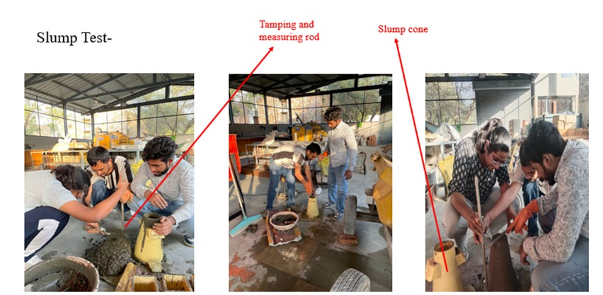
Fig. 3.7. Slump testing

3.8 Casting and Curing of Specimens
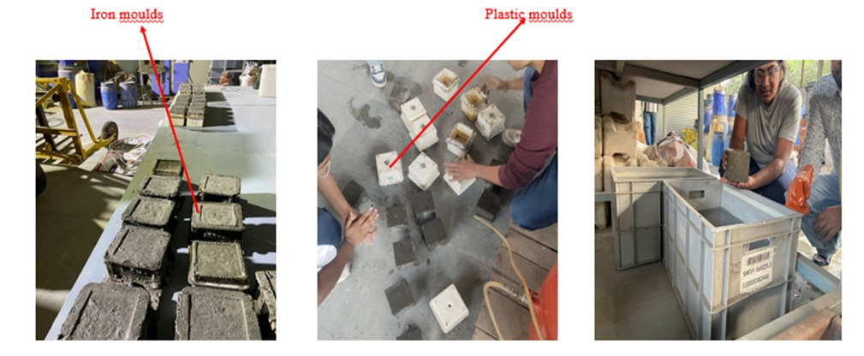
Cube specimens of 100 mm × 100 mm × 100 mm were cast for compressive strength testing. Freshly mixed concrete was placed in moulds and compacted using a table vibrator to eliminate entrapped air. Specimens were demoulded after 24 ± 2 hours and immediately transferred to a water curing tank. Curing was continued until the respective testing ages of 7, 28 and 90 days.

Fig. 3.8 Demoulding and Curing

3.9 Hardened Concrete Testing
Compressive strength tests were conducted at 7-day and 28-day ages using a 2000 kN Compression Testing Machine (CTM) as per IS 516. The loading rate was maintained at 140 kg/cm²/minute. Three specimens were tested for each mix composition at each age, and the average value was reported as the compressive strength of that mix.
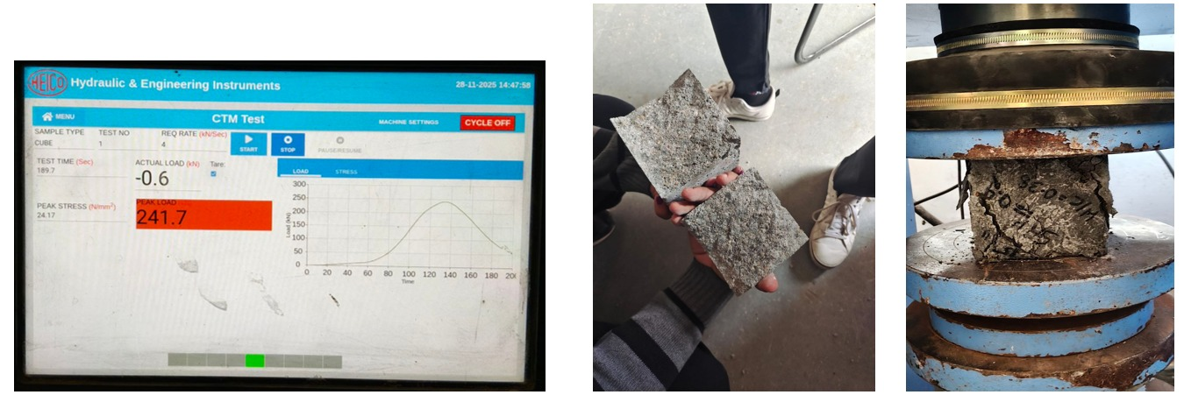

Fig. 3.9. Hardened concrete properties

CHAPTER 4

EXPERIMENTAL RESULTS AND DISCUSSION
This chapter presents a detailed analysis and discussion of all experimental results obtained during the study. The results are organized into five sections: (i) SAP absorption–desorption behaviour, (ii) fresh concrete slump test results, (iii) hardened concrete compressive strength, (iv) comparison between mixes with and without SAP, (v) comparison between conventional and internal curing, and (vi) machine learning predictive analysis. Each section discusses the experimental findings in the context of theoretical mechanisms and established literature.

4.1 SAP Absorption–Desorption Behaviour

4.1.1 Absorption Results – Tea-Bag Method
The tea-bag absorption tests clearly demonstrated the strong influence of ionic concentration on SAP swelling behaviour. The absorption results across three test solutions are summarized in Table 4.1:

Solution | Absorption Capacity (%) | Physical Interpretation
Distilled Water (pH 7.2) | 380 – 420% | Maximum swelling; minimal ionic suppression
Tap Water (pH 8.4) | 230 – 260% | Moderate swelling; partial ionic suppression
Cement Filtrate (pH 13) | < 60% | Strongly suppressed swelling; high ionic content

Table 4.1: SAP Absorption Capacity in Different Solutions

In distilled water, SAP particles showed the highest swelling of 380–420% of their dry weight, attributed to the complete absence of ionic species. The osmotic pressure difference between the polymer interior and the surrounding water was maximized, driving extensive water uptake. In tap water, SAP absorption was 230–260%, reflecting partial ionic suppression from dissolved mineral salts at moderate concentration. In cement filtrate (pH ≈ 13), absorption was drastically reduced to below 60%, due to the high concentrations of Ca²⁺, Na⁺, K⁺, and OH⁻ ions that shield the polymer charges and reduce the osmotic driving force.

These results confirm the universal ionic suppression trend documented in literature and validate the experimental procedure. The dramatic difference between distilled water absorption (≈400%) and cement filtrate absorption (<60%) underscores the critical importance of pre-wetting SAP before incorporation into concrete. If dry SAP is added directly to the concrete mix, it is exposed immediately to the cement pore solution environment and absorbs far less water than its theoretical capacity, leading to unpredictable internal curing performance.
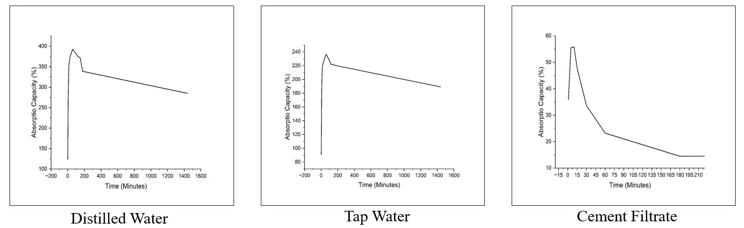

Fig.4.1.Curves showing absorption kinetics of SAP in (a) Distilled water, (b) Tap water, (c) Cement filtrate
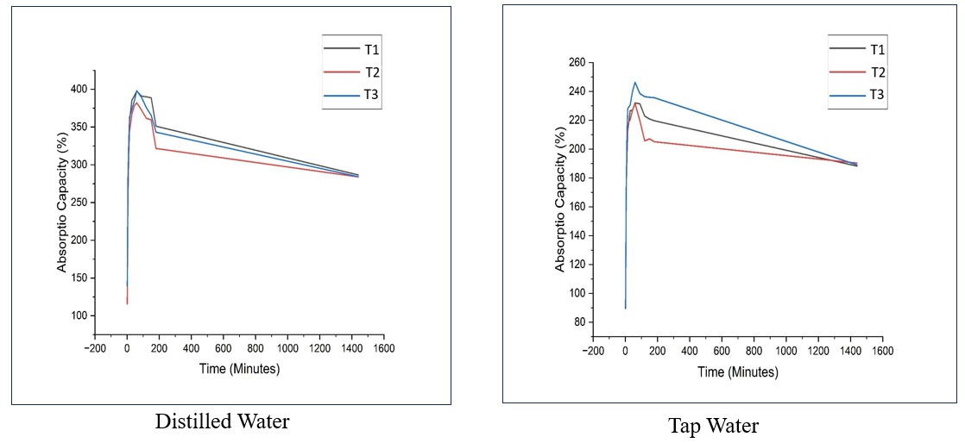
0The absorption curves showed that the majority of water uptake occurred within the first 60 minutes of immersion, with equilibrium reached by 3–24 hours depending on the solution. The rapid initial uptake is characteristic of surface swelling, followed by a slower phase of internal water diffusion through the polymer network.

Fig. 3.9. Curves showing absorption kinetics of SAP for 24 hours (a) Distilled water (b) Tap water

4.1.2 Desorption Results
The desorption measurements revealed important insights into the water release characteristics of SAP that are directly relevant to its function as an internal curing agent:

Day | Desorption Rate (g/day) – Distilled Water SAP | Desorption Rate (g/day) – Tap Water SAP | Trend
Day 1 | ~11 g/day | ~11 g/day | High initial release
Day 2–3 | ~13 g/day (peak) | ~10 g/day | Peak then moderate
Day 4–7 | ~9–10 g/day | ~7–8 g/day | Gradual decline
Day 8+ | ~7 g/day | ~7 g/day | Slow sustained release

Table 4.2: SAP Desorption Rate (Open-Air Method)

Both distilled water and tap water SAP samples exhibited sustained water release over 8–9 days. SAP swollen in distilled water showed a slightly higher initial desorption rate (peak ≈ 13 g/day) and slightly faster decline, while tap water SAP showed a more gradual and smoother release pattern (7–11 g/day). This difference is attributed to the higher initial swelling in distilled water creating a larger osmotic driving force for early release.
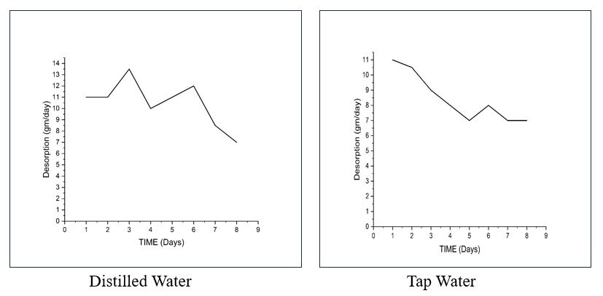
The desorption rate of 7–13 g/day aligns well with the daily water demand of cement hydration in low w/c concrete, confirming that SAP functions as an effective internal curing agent. The gradual release ensures that water is available throughout the critical early hydration period (Days 0–7) and continues into the later hydration stages (Days 7–14), supporting both primary and secondary hydration reactions.
Fig. 4.3. Curves showing desorption kinetics of SAP for 8 days (a) Distilled water (b) Tap water

4.2 Fresh Concrete Properties – Slump Test Results
Slump tests were conducted on all 15 concrete mix compositions incorporating pre-wetted SAP at water-cement ratios ranging from 0.34 to 0.45 and SAP dosages of 0.2%, 0.4%, and 0.6%. The complete results are presented in Table 4.3:

Mix No. | Water-Cement Ratio | SAP Dosage (% of cement wt.) | Slump Value (mm) | Remarks
1 | 0.40 | 0.2% | 70 | Low-medium
2 | 0.40 | 0.4% | 150 | Medium-high
3 | 0.40 | 0.6% | 200 | High
4 | 0.45 | 0.2% | 170 | Medium-high
5 | 0.45 | 0.4% | 230 | High
6 | 0.45 | 0.6% | 300 | Very high
7 | 0.38 | 0.2% | 70 | Satisfactory
8 | 0.38 | 0.4% | 100 | Satisfactory
9 | 0.38 | 0.6% | 190 | High
10 | 0.36 | 0.2% | 10 | Very low
11 | 0.36 | 0.4% | 40 | Low
12 | 0.36 | 0.6% | 70 | Acceptable
13 | 0.34 | 0.2% | - | Stiff mix
14 | 0.34 | 0.4% | 30 | Very low
15 | 0.34 | 0.6% | 60 | Low

Table 4.3: Fresh Concrete Slump Test Results - All Mix Compositions

4.2.1 Effect of SAP Dosage on Workability
A clear and consistent trend was observed: increasing SAP dosage led to higher slump values. For example, at w/c = 0.40, slump increased from 70 mm (0.2% SAP) to 150 mm (0.4% SAP) to 200 mm (0.6% SAP). This is contrary to the behaviour of dry SAP, which would absorb mix water and reduce slump. The increase in slump with pre-wetted SAP addition is explained by the additional free moisture contributed by the pre-saturated SAP particles to the fresh mix, effectively increasing the available lubricating water.

4.2.2 Effect of Water-Cement Ratio on Workability
Increasing the water-cement ratio from 0.34 to 0.45 significantly improved workability, as expected from the fundamental principle of concrete mix design. At lower w/c ratios (0.34–0.36), mixes were stiff and workability was borderline acceptable even with pre-wetted SAP. This demonstrates that SAP alone cannot fully compensate for insufficient base water content in extremely lean mixes.

At w/c = 0.38 with 0.2% SAP (Mix 7), the slump was 70 mm - within the target range of 50-75 mm - providing adequate workability for practical placement and compaction. This mix was identified as the most promising from a workability standpoint among the low w/c mixes. Higher SAP dosages at this w/c ratio provided higher slump but with potential strength concerns due to increased void formation.

4.3 Hardened Concrete Properties – Compressive Strength

4.3.1 7-Day Compressive Strength
Table 4.4 presents the 7-day compressive strength results for selected key mix compositions:

w/c Ratio | SAP Dosage (%) | 7-Day Strength (MPa) | Remarks
0.38 | 0.2 | 25.8 | Best at 7 days
0.38 | 0.4 | 22.4 | Good
0.38 | 0.6 | 18.1 | Reduced by voids
0.40 | 0.2 | 24.6 | Acceptable
0.45 | 0.2 | 20.1 | Lower due to high w/c

Table 4.4: 7-Day Compressive Strength Results

At 7 days, the best performance was observed at w/c = 0.38 with 0.2% SAP, yielding approximately 25.8 MPa. Increasing SAP dosage beyond 0.2% progressively reduced 7-day strength, primarily due to the increased void volume left after partial SAP desorption at early ages. Excess SAP (0.6%) caused the greatest strength reduction, confirming that void formation dominates at early ages when more SAP is used.

The general trend at 7 days showed no consistent pattern — performance depended on the specific combination of w/c ratio and SAP dosage, with the optimum lying between 0.2% and 0.4% SAP. Mixes with w/c = 0.38 consistently outperformed those with higher water-cement ratios at the same SAP dosage.

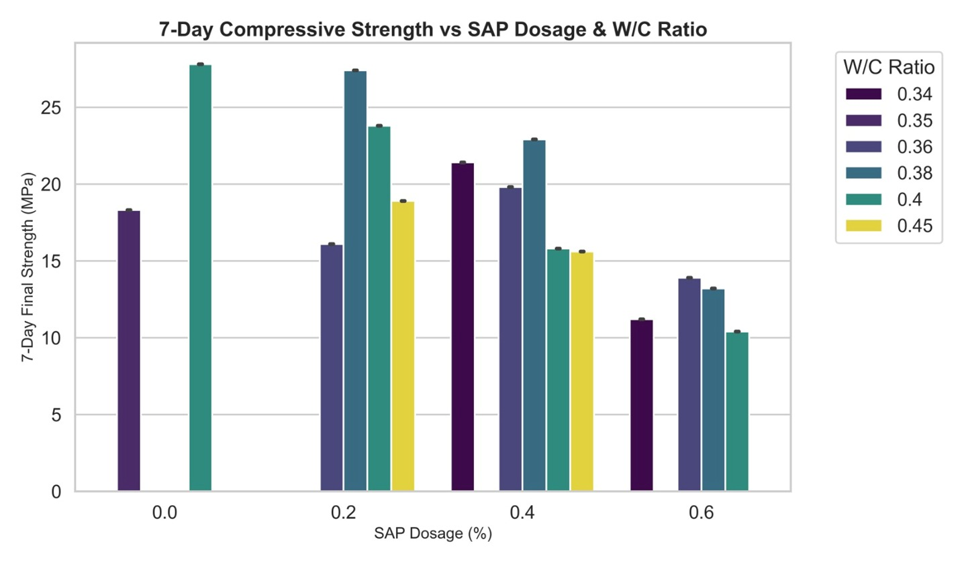
Fig. 4.4. Graph (7 -Day Compressive Strength vs SAP Dosage and Water-Cement ratio)

4.3.2 28-Day Compressive Strength

w/c Ratio | SAP Dosage (%) | 28-Day Strength (MPa) | Remarks
0.36 | 0.4 | 33.8 | Best overall
0.38 | 0.2 | 32.1 | Excellent balance
0.40 | 0.2 | 31.4 | Good
0.34 | 0.4–0.6 | 28–30 | Internal curing beneficial
0.38 | 0.6 | 25.2 | Excess SAP reduces strength

Table 4.5: 28-Day Compressive Strength Results

By 28 days, the SAP mixes showed significantly improved strength compared to their 7-day performance, reflecting the contribution of internal curing water to continued hydration. At w/c = 0.40, 0.2% SAP provided the highest 28-day strength among all 0.40 w/c mixes. At w/c = 0.36, 0.4% SAP performed best, suggesting that at lower water-cement ratios, slightly higher SAP dosage is needed to compensate for the greater water deficit.

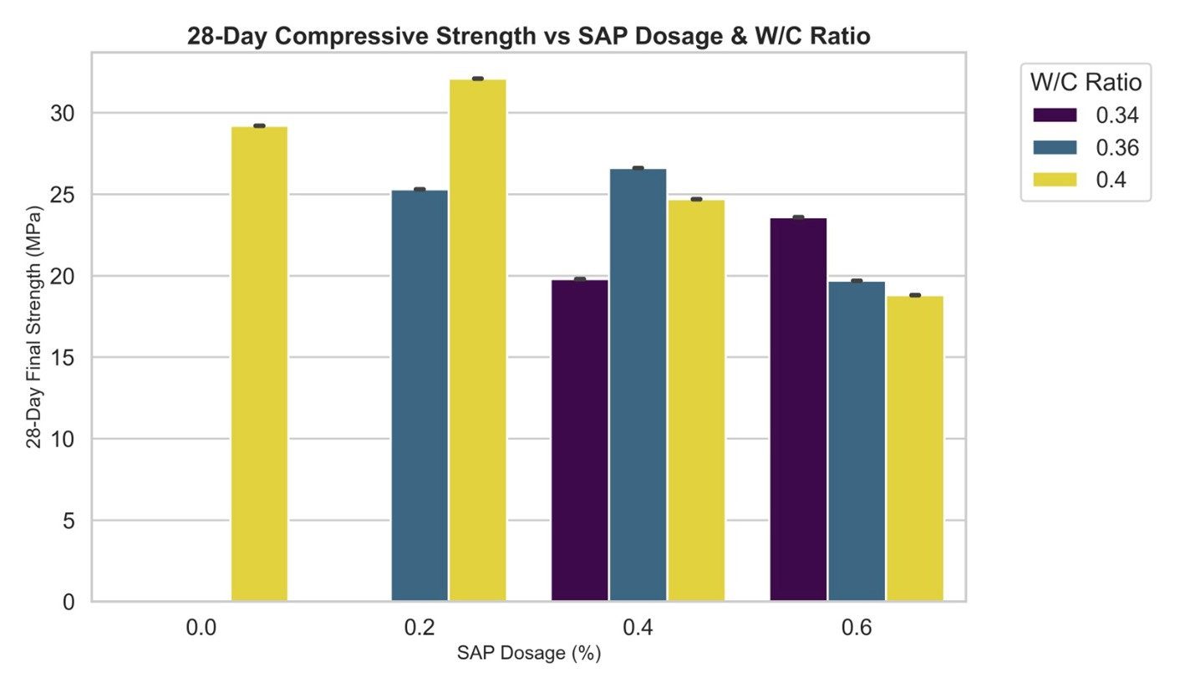
The key trend at 28 days was: the effect of SAP becomes increasingly beneficial as water-cement ratio decreases. At w/c = 0.34, which has very limited mixing water, higher SAP dosage (0.4%–0.6%) improved 28-day strength by ensuring adequate internal curing water for the hydration-starved cement particles. This aligns with the fundamental purpose of internal curing in low w/c concrete.
Fig. 4.5. Graph (28 -Day Compressive Strength vs SAP Dosage and Water-Cement ratio)

4.4 Comparison: With and Without SAP
A direct comparison between control concrete (without SAP) and SAP-modified concrete (0.2% SAP) at the same water-cement ratio provides the clearest evidence of SAP's effect on concrete performance:

Concrete Type | Average 7-Day Strength (MPa) | Average 28-Day Strength (MPa)
Control (Without SAP) | 27.8 | 29.2
With SAP (0.2%) | 23.8 | 32.1

Table 4.6: Comparison of Concrete With and Without SAP

These results clearly illustrate the characteristic behaviour of SAP in concrete. At 7 days, the control mix (without SAP) shows higher compressive strength (27.8 MPa) compared to the SAP mix (23.8 MPa). This early-age strength reduction (approximately 14%) is attributable to the presence of SAP voids in the microstructure before complete hydration has filled them with C-S-H products.

However, by 28 days, the trend reverses dramatically. The SAP mix achieves 32.1 MPa compared to 29.2 MPa for the control mix - a significant improvement of approximately 10%. This strength increase reflects the continued hydration supported by the internal curing water released from SAP particles over the first 7-14 days, leading to a denser microstructure, reduced porosity, and better utilization of cement's hydration potential.

This crossover pattern - early strength loss followed by later strength gain - is the hallmark of effective SAP-based internal curing and has been consistently reported in the literature. It confirms that the long-term benefits of internal curing outweigh the short-term void-related strength reduction.

4.5 Comparison: Conventional vs. Internal Curing

Curing Mechanism | Average 7-Day Strength (MPa) | Average 28-Day Strength (MPa)
Conventional + Internal Curing (SAP) | 19.8 | 26.6
Internal Curing Only (SAP, no external water) | 16.9 | 20.5

Table 4.7: Comparison of Conventional Curing and Internal Curing
The combination of conventional external curing and SAP-based internal curing consistently outperformed internal curing alone at both 7 and 28 days. Combined curing
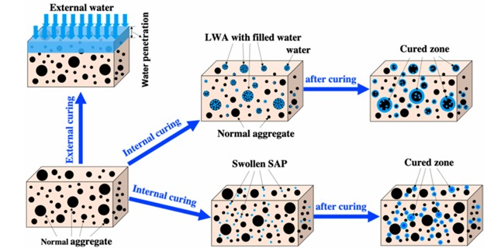

Fig. 4.6.Comparison of Conventional Curing and Internal Curing

provided 26.6 MPa at 28 days, compared to 20.5 MPa for SAP internal curing alone. This demonstrates that while SAP is highly effective as an internal curing agent, it works best as a supplement to - rather than a replacement for - conventional external water curing.
The higher performance of combined curing is explained by the dual water availability: external water prevents surface drying and provides moisture from outside, while SAP releases water from within the concrete, ensuring that both the surface regions and the interior remain well-hydrated throughout the curing period. This is particularly important for thicker structural sections where external curing water cannot penetrate deeply.

Machine Learning Predictive Analysis

Problem Statement and Motivation
Traditional compressive strength testing requires concrete specimens to be cast, cured for 7, 14, 28 and 90 days, and then physically crushed - a time-consuming and resource-intensive process. The ability to predict concrete strength accurately from mix design parameters using machine learning models would significantly accelerate the mix optimization process and reduce experimental effort.

In this study, the experimental dataset comprising water-cement ratio, SAP dosage percentage, and curing age was used to develop and validate a machine learning model capable of predicting compressive strength of SAP-modified concrete.

4.6.2 Dataset Description and EDA
The dataset consisted of experimental compressive strength measurements collected across all mix compositions and testing ages (7, 14, 28 and 90 days). Key input features were: SAP dosage (%), water-cement ratio, and curing age (days). The target variable was compressive strength (MPa). Exploratory Data Analysis (EDA) revealed that SAP dosage and curing age had the most significant influence on strength, with a non-linear relationship between SAP dosage and strength that confirmed the need for a non-linear modelling approach.
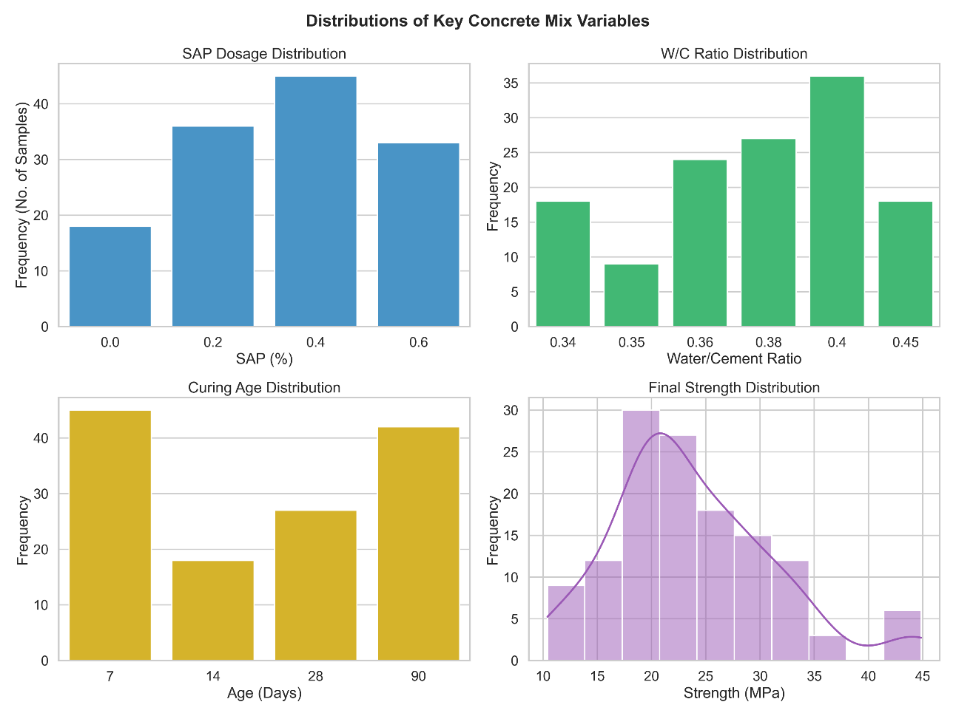
Fig. 4.7. Data Description

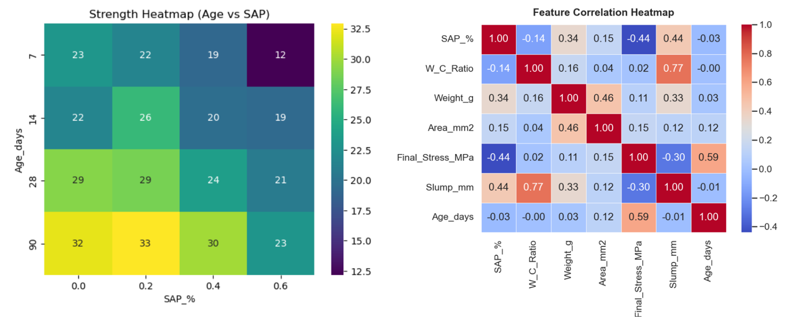
Fig. 4.8. Strength Heatmap Fig. 4.9. Feature Correlation Heatmap

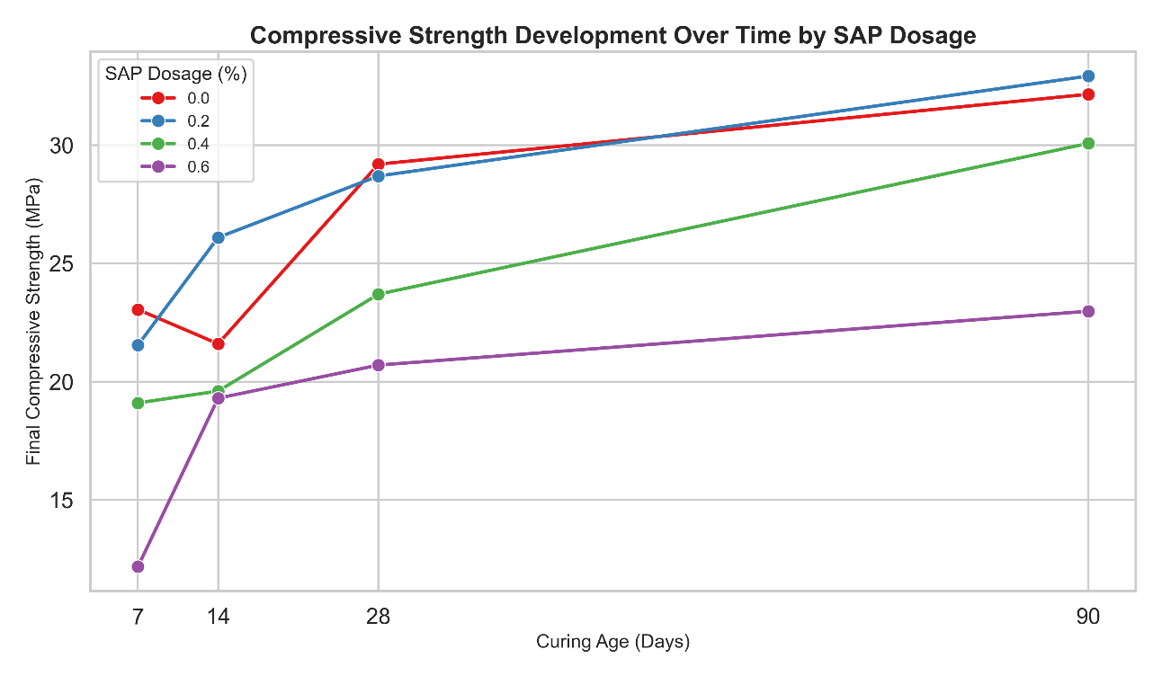
Fig. 4.10. Compressive Strength Development Over Time by SAP Dosage

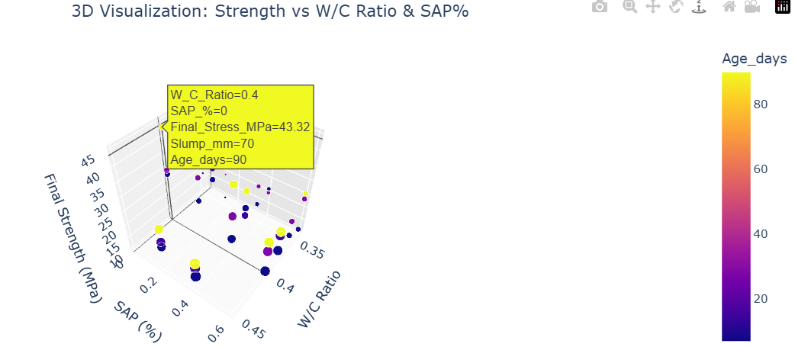
Fig. 4.11. 3D Visualization of all parameters

4.6.3 Model Selection - XGBoost Regressor
Several machine learning algorithms were evaluated, including Linear Regression, Random Forest, Gradient Boosting Regressor, and XGBoost Regressor. Gradient Boosting Regressor was selected as the final model for the following reasons:
• It handles non-linear relationships effectively without requiring explicit feature engineering.
• It uses a boosting approach (sequential learning) that progressively reduces prediction errors through model iterations.
• It provides better generalization to unseen data compared to other evaluated models.
• It achieved the highest R² score and the lowest RMSE and MAE values among all tested models.
• It improves prediction accuracy by combining multiple weak learners into a strong predictive model.
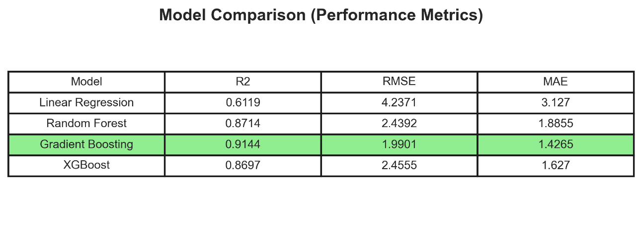
Table 4.8: ML Model Performance Comparison

Gradient Boosting Regressor achieved the highest R² score of 0.9144 and the lowest RMSE of 1.9901 among all models tested. It also obtained the lowest MAE value of 1.4265, indicating more accurate predictions with minimum error. The performance comparison showed that the model predicted compressive strength values more effectively than Linear Regression, Random Forest, and XGBoost models. The relatively low RMSE indicates that the prediction error remained close to approximately ±2 MPa, which is acceptable for practical concrete mix design applications.

4.6.4 Model Deployment
The trained Gradient Boosting model was deployed as a web application using a Flask backend API and Streamlit frontend interface. The deployed application allows users to input water-cement ratio, SAP dosage, and desired curing age, and receive a real-time compressive strength prediction along with interactive graphs and strength classification (below target, on target, above target). This tool has practical utility for rapid mix design optimization without requiring physical specimen testing.

CHAPTER 5

CONCLUSIONS AND FUTURE SCOPE

5.1 Conclusions
Based on the comprehensive experimental investigation and analysis of concrete incorporating Super-Absorbent Polymers, the following conclusions can be drawn:

SAP Absorption-Desorption Kinetics
- SAP exhibits strongly ionic-dependent swelling behaviour. Absorption capacity ranged from 380-420% in distilled water (maximum), 230-260% in tap water (moderate), to less than 60% in cement filtrate (strongly suppressed). This confirms that ionic species in cement pore solution significantly reduce SAP swelling potential.
- Desorption occurs gradually at 7-13 g/day over 8-9 days, closely matching the water demand of cement hydration. This confirms that SAP functions as an effective internal water reservoir, releasing moisture progressively during the critical early hydration period and supporting continuous hydration.
- SAP must be pre-wetted before incorporation into concrete to achieve its full absorption potential and predictable workability behaviour, since cement filtrate dramatically suppresses swelling when dry SAP is exposed to it during mixing.

5.1.2 Fresh Concrete Properties
- Pre-wetted SAP improves fresh concrete workability. Increasing SAP dosage from 0.2% to 0.6% consistently increased slump values at all water-cement ratios tested, due to additional free moisture contributed by saturated SAP particles.
- At w/c = 0.38 with 0.2% SAP, the slump of 70 mm is within the practical target range, providing adequate workability for placement and compaction while maintaining a low water-cement ratio beneficial for durability.

5.1.3 Hardened Concrete Properties
- SAP causes a temporary reduction in early-age (7-day) compressive strength due to void formation after partial desorption. This reduction is approximately 10-15% compared to control mixes at optimum dosage (0.2%).
- At 28 days, SAP mixes show comparable or improved compressive strength compared to control mixes. The SAP mix at 0.2% dosage achieved 32.1 MPa compared to 29.2 MPa for the control mix - a 10% improvement - demonstrating the long-term benefit of sustained internal curing.
- The beneficial effect of SAP on 28-day strength increases as water-cement ratio decreases. At very low w/c (0.34-0.36), higher SAP dosages (0.4%) are needed to compensate for the greater water deficit, whereas at moderate w/c (0.38–0.40), 0.2% SAP provides the optimal balance.
- Excess SAP (0.6%) reduces both 7-day and 28-day compressive strength due to excessive void formation, confirming that SAP dosage must be carefully controlled within 0.2%-0.4%.

5.1.4 Optimal Mix Recommendation
- The recommended mix for practical use is: water-cement ratio of 0.36-0.38 with 0.2%-0.4% pre-wetted SAP, along with appropriate superplasticizer dosage to achieve target workability. This combination provides satisfactory fresh concrete properties, adequate early strength, and superior long-term strength development.

5.1.5 Machine Learning Predictions
- The Gradient Boosting Regressor model achieved high predictive accuracy (R² = 0.9144, RMSE = 1.9901 MPa, and MAE = 1.4265 MPa) for predicting concrete compressive strength as a function of SAP dosage, water-cement ratio, and curing age. The deployed web application provides a practical tool for rapid mix design optimization and strength prediction.

In summary, SAP-based internal curing is a viable and effective approach for improving hydration continuity, workability, and long-term mechanical performance in low water-cement ratio concrete. This technology holds particular promise for hot, arid climates like Rajasthan, where external curing is challenging and early-age self-desiccation is a critical concern.

5.2 Future Scope of the Project
While this study has provided valuable experimental insights, several important aspects remain to be investigated in future research:

5.2.1 Testing with Lower Water-Cement Ratios
Future studies should evaluate mixes at progressively lower w/c ratios (0.40, 0.36, 0.32, 0.28) with SAP dosages of 0%, 0.1%, and 0.2%. Measurements should include fresh properties, compressive strength at 7, 14, and 28 days, and early-age autogenous shrinkage or internal relative humidity for the first 7-14 days. This would help identify the practical lower limit of w/c where SAP maintains acceptable workability and provides a net benefit in late-age strength and shrinkage control.

5.2.2 Microstructural Investigation
Detailed microstructural analysis using Scanning Electron Microscopy (SEM) and Backscattered Electron (BSE) imaging, combined with microhardness mapping on representative specimens (control, SAP 0.2%, and low w/c extreme) at 7 and 28 days, would provide direct evidence of SAP void morphology, C-S-H density around voids (APZ), pore size distribution, and ITZ quality. Correlating these microstructural indicators with measured strength and durability data would significantly strengthen the scientific understanding of SAP mechanisms.

5.2.3 SAP in Recycled Aggregate Concrete (RAC)
Preparing mixes with 0%, 25%, 50%, and 100% recycled coarse aggregate replacement, using the optimized w/c and 0.2% SAP, would assess whether SAP can improve the typically inferior ITZ and compensate for the higher porosity of recycled aggregates. This has significant implications for sustainable construction practices.

5.2.4 Curing Comparison Studies
A systematic comparison of compressive strength, internal relative humidity evolution, and autogenous shrinkage under continuous water curing versus sealed curing conditions - for both control and SAP mixes - would help isolate the specific contribution of internal curing from SAP, independent of external moisture availability. This would provide clearer design guidelines for the use of SAP in field conditions where continuous external curing is not always feasible.

5.2.5 Autogenous Shrinkage Measurement
Direct measurement of autogenous shrinkage using corrugated tube specimens or sealed prismatic specimens over the first 28 days would provide quantitative data on SAP's shrinkage reduction effectiveness in the specific concrete compositions studied here. This would strengthen the practical case for SAP adoption in restrained structures prone to early-age cracking.

5.2.6 Long-Term Durability Studies
Future work should include durability testing such as Rapid Chloride Penetration Test (RCPT), water sorptivity, carbonation depth, and freeze-thaw resistance on optimized SAP-modified concrete mixes. This would provide a comprehensive characterization of the long-term performance benefits of SAP-based internal curing beyond the mechanical properties covered in this study.

REFERENCES
[1] Jensen, O. M., and Hansen, P. F. (2001). Water-entrained cement-based materials: I. Principles and theoretical background. Cement and Concrete Research, 31(4), 647–654.

[2] Mechtcherine, V. (2010). Absorption and release mechanism of superabsorbent polymers. In V. Mechtcherine and H.W. Reinhardt (Eds.), Application of super absorbent polymers (SAP) in concrete construction. RILEM TC 225-SAP.

[3] RILEM Technical Committee TC 225-SAP, Mechtcherine, V. et al. (2013). Application of super absorbent polymers (SAP) in concrete construction – State-of-the-art report. Springer, Dordrecht.

[4] Zhao, H., Jensen, O.M., and Hasholt, M.T. (2014). Measuring absorption of SAP in cementitious environments. In Proceedings of the International RILEM Conference on SAP and Internal Curing. Ghent, Belgium.

[5] Zhou, C., Wang, Z., Taylor, P., Gu, X. et al. (2015). Superabsorbent polymers for internal curing concrete. ASTM International, West Conshohocken, PA.

[6] Wang, F., Yang, J., Hu, S., Li, X., and Cheng, H. (2016). Influence of superabsorbent polymers on the surrounding cement paste. Cement and Concrete Research, 81, 112–121.

[7] Mechtcherine, V., Wyrzykowski, M., Schröfl, C. et al. (2017). Application of superabsorbent polymers (SAP) in concrete construction – update of RILEM state-of-the-art report. Materials and Structures, 50(2), 195.

[8] ACI Committee 308. (2016). Guide to External and Internal Curing of Concrete (ACI 308R-16). American Concrete Institute, Farmington Hills, MI.

[9] Bureau of Indian Standards. IS 10262:2019. Concrete Mix Proportioning – Guidelines. BIS, New Delhi.

[10] Bureau of Indian Standards. IS 456:2000. Plain and Reinforced Concrete – Code of Practice (Fourth Revision). BIS, New Delhi.

[11] Bureau of Indian Standards. IS 1199:1959. Methods of Sampling and Analysis of Concrete. BIS, New Delhi.

[12] Bureau of Indian Standards. IS 516:1959. Methods of Tests for Strength of Concrete. BIS, New Delhi.

[13] Bureau of Indian Standards. IS 8112:2013. Specification for Ordinary Portland Cement, 43 Grade. BIS, New Delhi.

[14] Bureau of Indian Standards. IS 383:2016. Coarse and Fine Aggregate for Concrete – Specification (Third Revision). BIS, New Delhi.

