Objective: To implement and analyze GREEDY AND DYNAMIC approaches for solving Knapsack problem and compare their time and space complexities (through graph)
Write algorithms also for each version.
4a. Fractional knapsack Problem
4b. 0/1 Knapsack Problem.
CODE:
#include <stdio.h>

// Structure for an item
struct Item {
int value, weight;
};

// Function to get max of two integers
int max(int a, int b) { return (a > b) ? a : b; }

// Fractional Knapsack (Greedy)
void fractionalKnapsack(struct Item arr[], int n, int W) {
double ratio[n];
for (int i = 0; i < n; i++)
ratio[i] = (double)arr[i].value / arr[i].weight;

// Sort items by ratio (descending)
for (int i = 0; i < n - 1; i++) {
for (int j = 0; j < n - i - 1; j++) {
if (ratio[j] < ratio[j + 1]) {
double temp = ratio[j];
ratio[j] = ratio[j + 1];
ratio[j + 1] = temp;

struct Item tempItem = arr[j];
arr[j] = arr[j + 1];
arr[j + 1] = tempItem;
}
}
}

int curWeight = 0;
double finalValue = 0.0;

for (int i = 0; i < n; i++) {
if (curWeight + arr[i].weight <= W) {
curWeight += arr[i].weight;
finalValue += arr[i].value;
} else {
int remain = W - curWeight;
finalValue += arr[i].value * ((double)remain / arr[i].weight);
break;
}
}

printf("Maximum value in Fractional Knapsack = %.2f\n", finalValue);
}

// 0/1 Knapsack (Dynamic Programming)
int knapSack(int W, struct Item arr[], int n) {
int dp[n + 1][W + 1];
for (int i = 0; i <= n; i++) {
for (int w = 0; w <= W; w++) {
if (i == 0 || w == 0)
dp[i][w] = 0;
else if (arr[i - 1].weight <= w)
dp[i][w] = max(arr[i - 1].value + dp[i - 1][w - arr[i - 1].weight],
dp[i - 1][w]);
else
dp[i][w] = dp[i - 1][w];
}
}
return dp[n][W];
}

int main() {
struct Item arr[] = {{60, 10}, {100, 20}, {120, 30}};
int n = sizeof(arr) / sizeof(arr[0]);
int W = 50;

fractionalKnapsack(arr, n, W);

int maxVal = knapSack(W, arr, n);
printf("Maximum value in 0/1 Knapsack = %d\n", maxVal);

return 0;
}
OUTPUT:
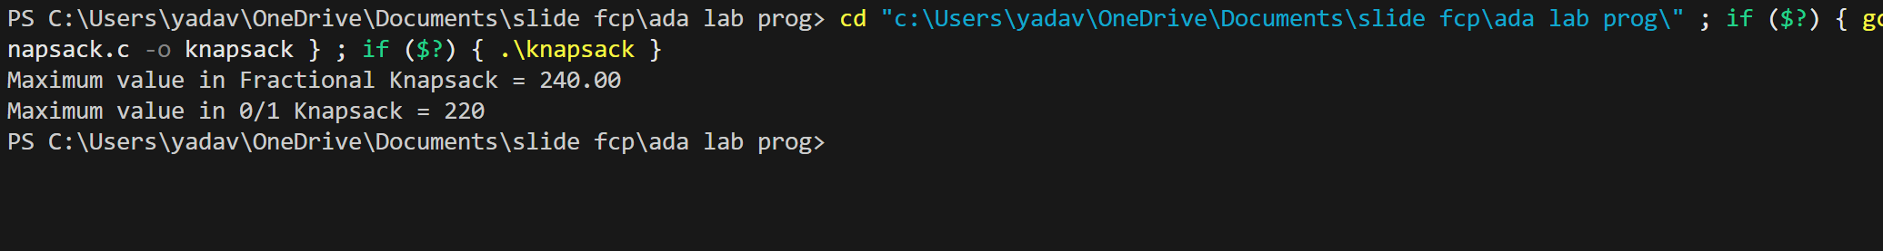
PYTHON CODE:
import matplotlib.pyplot as plt
import numpy as np

# Number of items
n = np.arange(1, 100, 5)
W = 50

# Fractional Knapsack: O(n log n)
time_greedy = n * np.log2(n)
space_greedy = n

# 0/1 Knapsack: O(nW)
time_dp = n * W
space_dp = n * W

plt.figure(figsize=(10, 6))
plt.plot(n, time_greedy, label='Greedy Time (O(n log n))', linestyle='-', marker='o')
plt.plot(n, time_dp, label='DP Time (O(nW))', linestyle='--', marker='s')
plt.title('Time Complexity Comparison: Greedy vs Dynamic Knapsack')
plt.xlabel('Number of Items (n)')
plt.ylabel('Operations (approx scale)')
plt.legend()
plt.grid(True)
plt.show()

plt.figure(figsize=(10, 6))
plt.plot(n, space_greedy, label='Greedy Space (O(n))', linestyle='-', marker='o')
plt.plot(n, space_dp, label='DP Space (O(nW))', linestyle='--', marker='s')
plt.title('Space Complexity Comparison: Greedy vs Dynamic Knapsack')
plt.xlabel('Number of Items (n)')
plt.ylabel('Space Usage (approx scale)')
plt.legend()
plt.grid(True)
plt.show()

GRAPH: 