**Name🡺 Gaurav Yadav**

**Section E , class Roll=57**

**Uni. Roll no=191500297**

**Session 2022-2023**

**Submitted to 🡺Akash Kumar Chodhary**

**Php Assignment-2**

Q1.Write a program to calculate Electricity bill in PHP

Description:

You need to write a PHP Script to calculate electricity bill using if-else conditions.

Conditions:

For first 50 units – Rs. 3.50/unit

For next 100 units – Rs. 4.00/unit

For next 100 units – Rs. 5.20/unit

For units above 250 – Rs. 6.50/unit

You can use conditional statements.

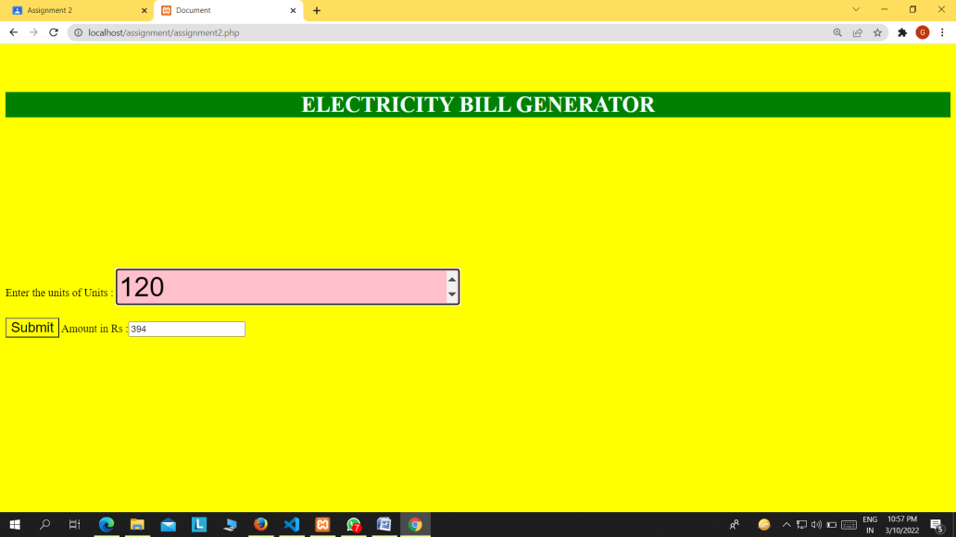

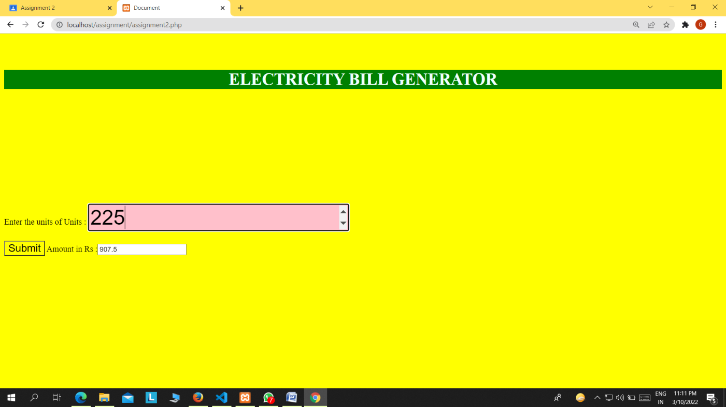

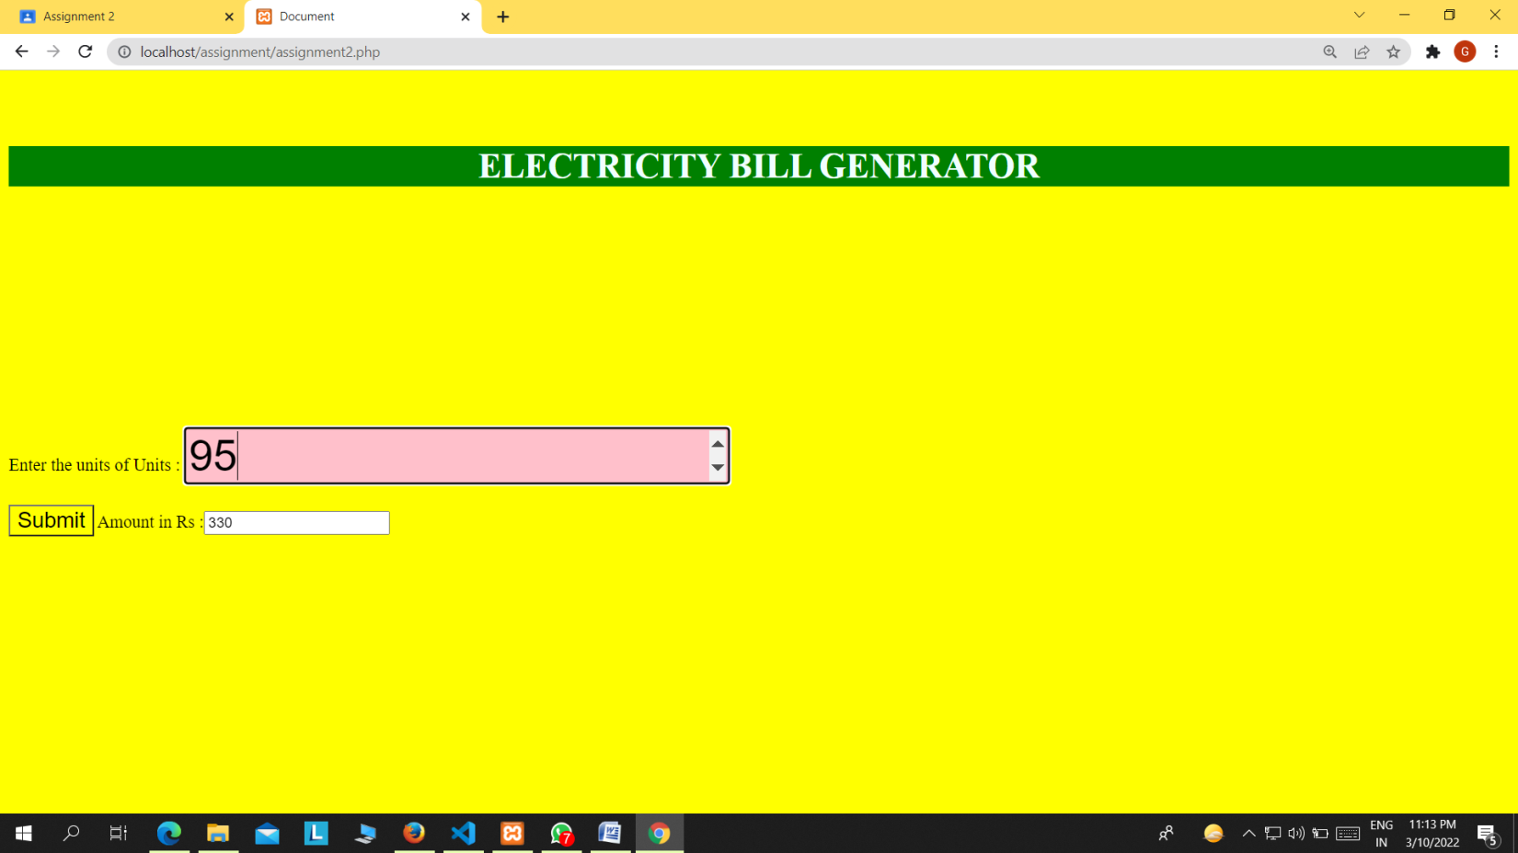

<!DOCTYPE html>

<html lang="en">

<head>

    <meta charset="UTF-8">

    <meta http-equiv="X-UA-Compatible" content="IE=edge">

    <meta name="viewport" content="width=device-width, initial-scale=1.0">

    <title>Document</title>

     <link rel="stylesheet" href="ass.css">

</head>

<style>

    body{

        background-color:yellow;

    }

</style>

<body>

    <h1> ELECTRICITY BILL GENERATOR</h1>

    <form action="" method="POST"  >

       Enter the units of Units : <input type="number" name="num1" style="background-color:pink;font-size:40px;margin-top:200px" placeholder="enter the units">

       <br>

       <br>

       <input type="submit" name="submit" style="background-color:yellow;font-size:20px;">

       <?php

$total='';

if(isset($_POST['submit']))

{

$units=$_POST['num1'];

$first=3.00;

$second=4.00;

$third=5.20;

$fourth=6.50;

if($units<=50)

{

    $total=$units*$first;

}

elseif($units>50 && $units<=100)

{

    $previous=50*$first;

    $rest=$units-50;

    $total=$previous+($rest*$second);

}

elseif($units>100 && $units<=200)

{

    $previous=50*$first+(100*$second);

    $rest=$units-150;

    $total=$previous+($rest*$third);

}

elseif($units>200 && $units<=250)

{

    $previous=(50*$first)+(100*$second)+(100*$third);

    $rest=$units-250;

    $total=$previous+($rest*$fourth);

}

} ?>

       Amount in Rs :<input type="text" name="result" value="<?php echo $total; ?>">

    </form>

</body>

</html>

Q2. Write a PHP program to check whether a number is positive, negative or zero

Description:

Write a PHP program to check whether a number is positive, negative or zero.

Instructions:

You can use if else conditions.

You should use appropriate PHP Operators.

Also check if it not a numeric value.

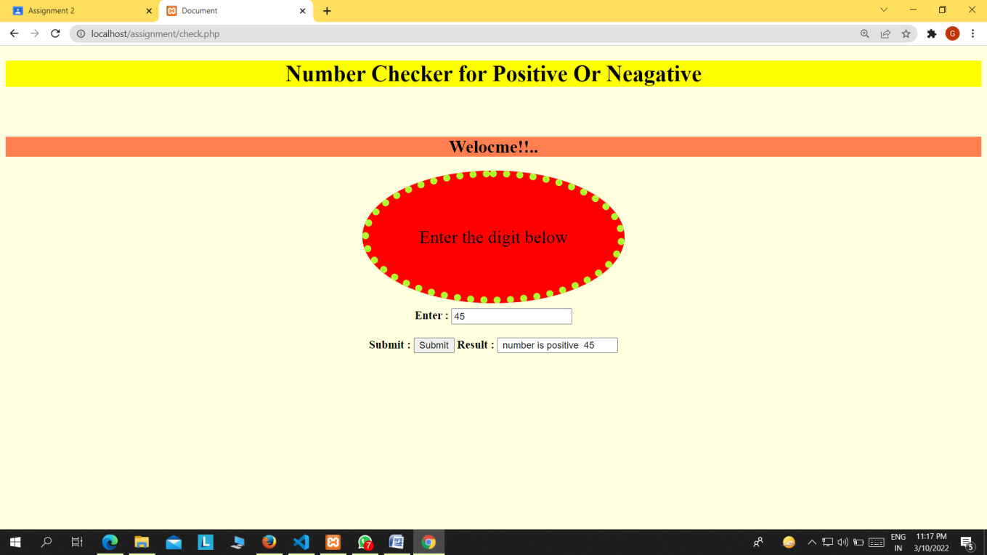

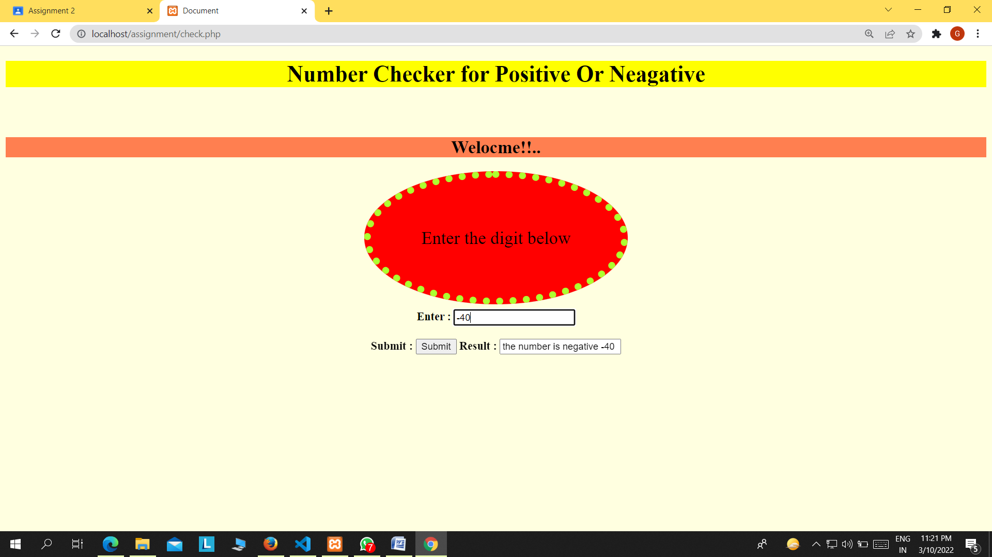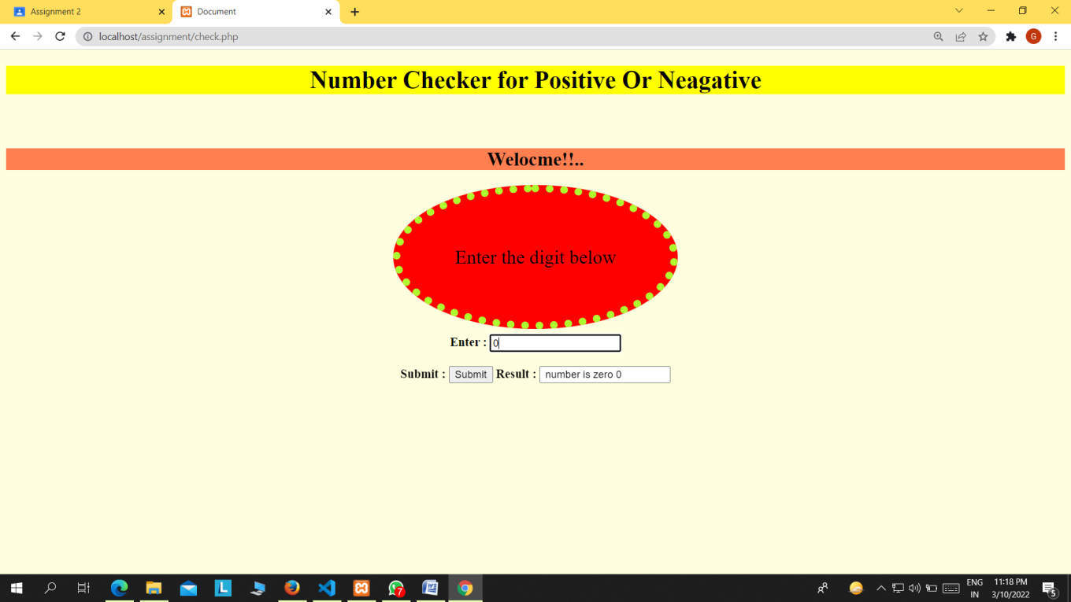

<!DOCTYPE html>

<html lang="en">

<head>

    <meta charset="UTF-8">

    <meta http-equiv="X-UA-Compatible" content="IE=edge">

    <meta name="viewport" content="width=device-width, initial-scale=1.0">

    <title>Document</title>

    <style>

        h1

        {

            font-size: xx-large;

            background-color: yellow;

            text-align: center;

        }

        .mycode h2{

            background-color: blue;

            text-align: center;

            font-size: 25px;

            margin-top: 70px;

            background-color: coral;

        }

       .my{

           font-size: 25px;

           background-color: red;

           text-align: center;

           border-radius:50%;

           padding-top: 70px;

           padding-bottom: 70px;

           padding-left: 70px;

           padding-right: 70px;

           border-style: dotted;

           border-color: greenyellow;

           border-width: 10px;

           }

        .new

        {

            margin-top: 100px;

            text-align: center;

        }

        .code{

            text-align: center;

            margin-top: 30px;

        }

        body{

            background-color:lightyellow;

        }

    </style>

</head>

<body>

    <h1>Number Checker for Positive Or Neagative</h1>

    <div class="mycode">

        <h2>Welocme!!..</h2>

    </div>

    <div class="new">

        <span class="my">Enter the digit below</span>

    </div>

    <br>

    <br>

    <br>

   <div class="code">

       <form action="" method="post">

          <b> Enter :</b> <input type="text" name="num1" placeholder="enter number">

           <br>

           <br>

        <b> Submit : </b> <input type="submit" name="submit">

        <?php

        $result='';

        if(isset($_POST['submit']))

       {

       $num_one=$_POST['num1'];

       if($num_one==0)

        {

            $result=" number is zero $num_one ";

        }

        else  if($num_one>0){

        $result=" number is positive  $num_one ";

        }

        else

        {

            $result="the number is negative $num_one ";

        }

      }

      ?>

        <b> Result : </b> <input type="text" name="result" value="<?php echo $result ; ?>">

       </form>

   </div>

</body>

</html>

Q3. Write a program to convert the given string into an array.

Suppose the string is -

$a = 'Burch Jr, Philip H., The American establishment, Research in political economy 6(1983), 83-156';

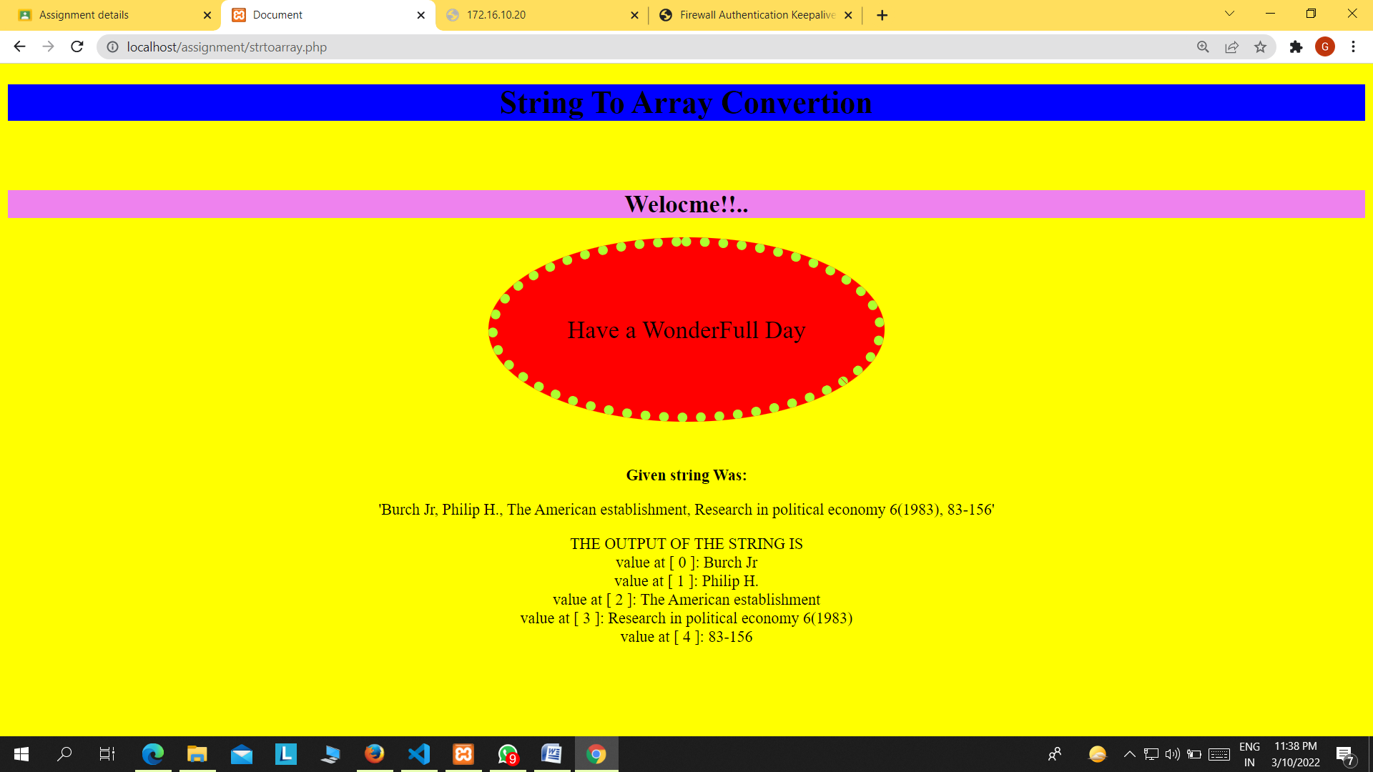

<!DOCTYPE html>

<html lang="en">

<head>

    <meta charset="UTF-8">

    <meta http-equiv="X-UA-Compatible" content="IE=edge">

    <meta name="viewport" content="width=device-width, initial-scale=1.0">

    <title>Document</title>

    <style>

        h1

        {

            font-size: xx-large;

            background-color: blue;

            text-align: center;

        }

        .mycode h2{

            background-color: blue;

            text-align: center;

            font-size: 25px;

            margin-top: 70px;

            background-color: violet;

        }

       .my{

           font-size: 25px;

           background-color: red;

           text-align: center;

           border-radius:50%;

           padding-top: 70px;

           padding-bottom: 70px;

           padding-left: 70px;

           padding-right: 70px;

           border-style: dotted;

           border-color: greenyellow;

           border-width: 10px;

           }

        .new

        {

            margin-top: 100px;

            text-align: center;

        }

        .code{

            text-align: center;

            margin-top: 30px;

        }

        body{

            background-color:yellow;

        }

    </style>

</head>

<body>

    <h1>String To Array Convertion</h1>

    <div class="mycode">

        <h2>Welocme!!..</h2>

    </div>

    <div class="new">

        <span class="my">Have a WonderFull Day</span>

    </div>

    <br>

    <br>

    <br>

   <div class="code">

       <form action="" method="post">

           <br>

           <br>

        <b>Given string Was: </b> <p> 'Burch Jr, Philip H., The American establishment, Research in political economy 6(1983), 83-156' <br></p>

        <?php

        $a = 'Burch Jr, Philip H., The American establishment, Research in political economy 6(1983), 83-156';

        $arru = explode(",",$a);

        echo "THE OUTPUT OF THE STRING IS <br>";

        for ($x = 0; $x <count($arru); $x++) {

        echo "value at [ $x ]: $arru[$x] <br>";

       }

?>

       </form>

   </div>

</body>

</html>

Q4. There are two deals of an item to buy. The quantities and prices of the item are given below. Write a program in PHP to find the best deal to purchase the item.

$quantity1 = 70;

$quantity2 = 100;

$price1 = 1035;

$price2 = 1200;

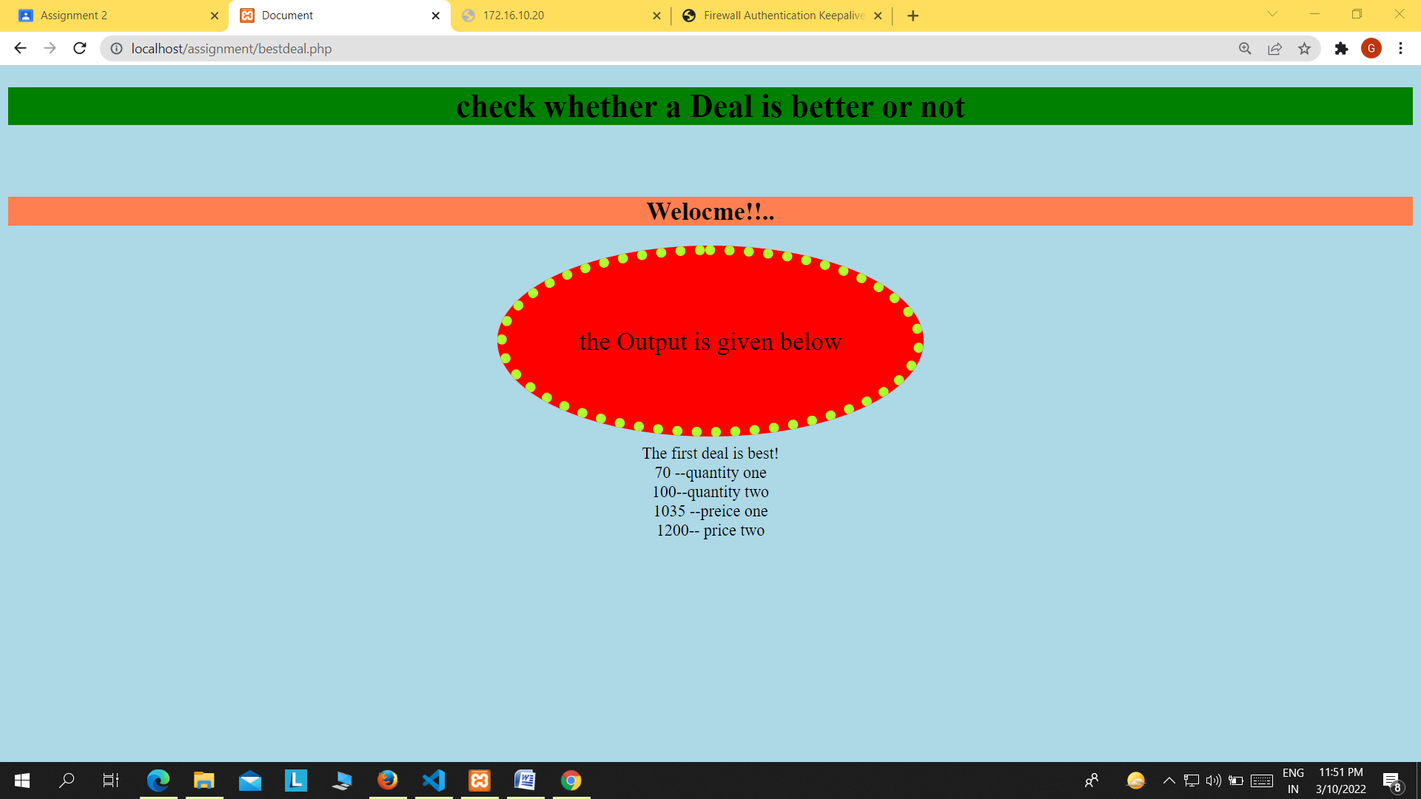

<!DOCTYPE html>

<html lang="en">

<head>

    <meta charset="UTF-8">

    <meta http-equiv="X-UA-Compatible" content="IE=edge">

    <meta name="viewport" content="width=device-width, initial-scale=1.0">

    <title>Document</title>

    <style>

        h1

        {

            font-size: xx-large;

            background-color: blue;

            text-align: center;

        }

        .mycode h2{

            background-color: blue;

            text-align: center;

            font-size: 25px;

            margin-top: 70px;

            background-color: violet;

        }

       .my{

           font-size: 25px;

           background-color: red;

           text-align: center;

           border-radius:50%;

           padding-top: 70px;

           padding-bottom: 70px;

           padding-left: 70px;

           padding-right: 70px;

           border-style: dotted;

           border-color: greenyellow;

           border-width: 10px;

           }

        .new

        {

            margin-top: 100px;

            text-align: center;

        }

        .code{

            text-align: center;

            margin-top: 30px;

        }

        body{

            background-color:

        }

    </style>

</head>

<body>

    <h1>String To Array Convertion</h1>

    <div class="mycode">

        <h2>Welocme!!..</h2>

    </div>

    <div class="new">

        <span class="my">Have a WonderFull Day</span>

    </div>

    <br>

    <br>

    <br>

   <div class="code">

       <form action="" method="post">

           <br>

           <br>

        <b>Given string Was: </b> <p> 'Burch Jr, Philip H., The American establishment, Research in political economy 6(1983), 83-156' <br></p>

        <?php

        $a = 'Burch Jr, Philip H., The American establishment, Research in political economy 6(1983), 83-156';

        $arru = explode(",",$a);

        echo "THE OUTPUT OF THE STRING IS <br>";

        for ($x = 0; $x <count($arru); $x++) {

        echo "value at [ $x ]: $arru[$x] <br>";

       }

?>

       </form>

   </div>

</body>

</html>

Q5. Write a PHP script to find the first character that is different between two strings.

String1 : 'National'

String2 : 'Nationel'

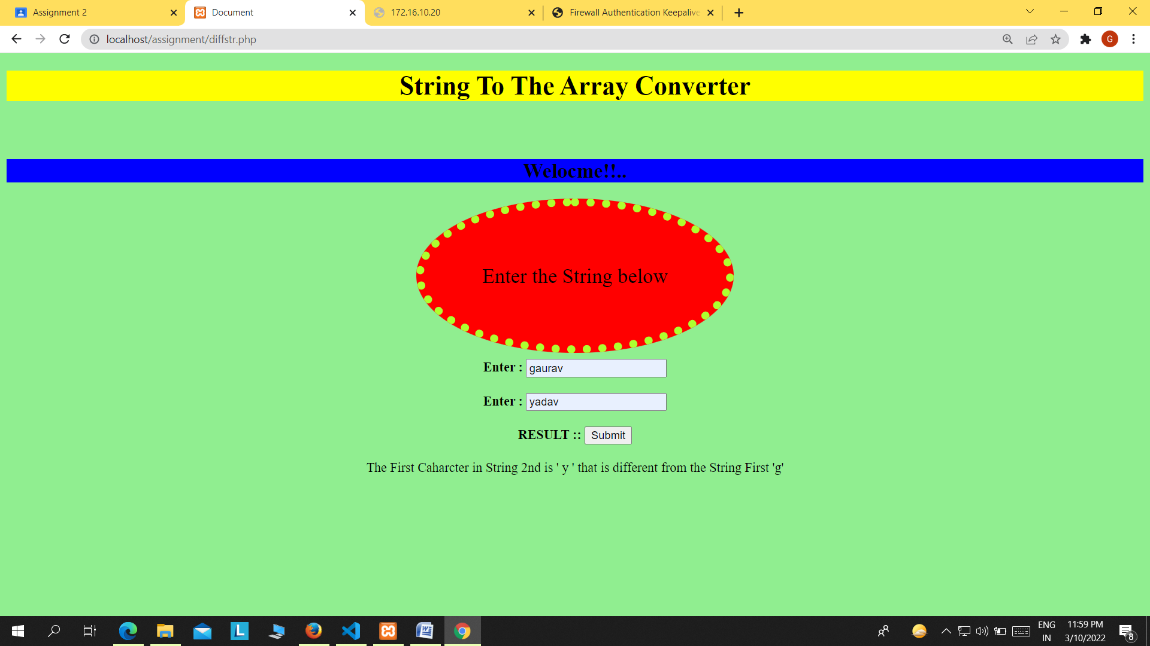

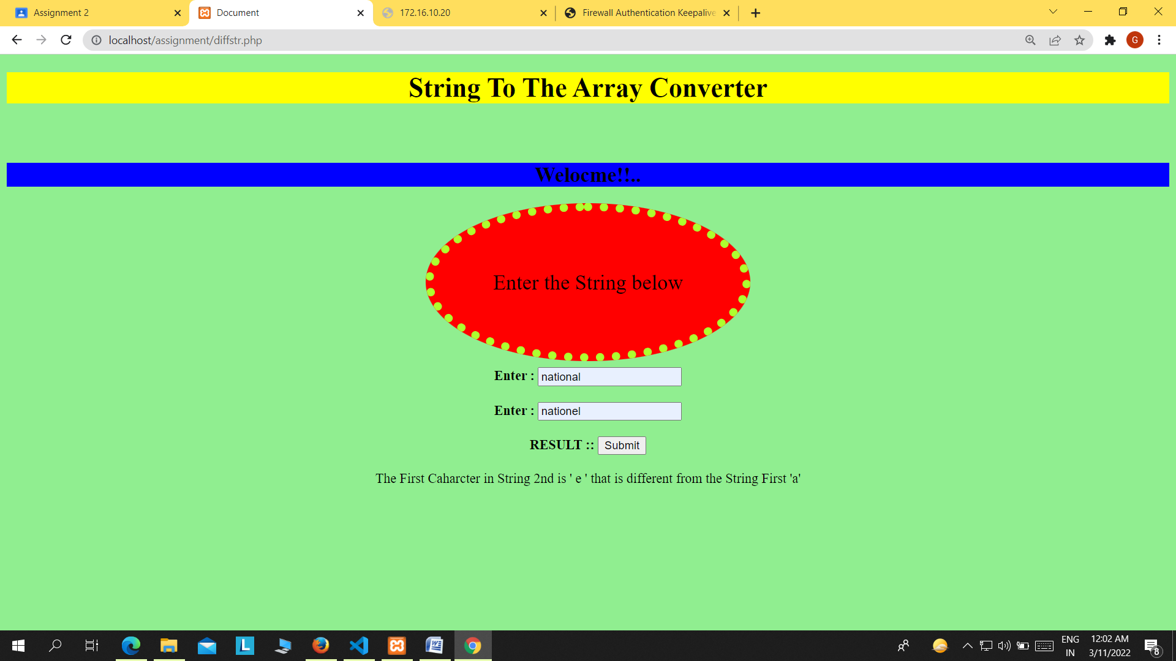

<!DOCTYPE html>

<html lang="en">

<head>

    <meta charset="UTF-8">

    <meta http-equiv="X-UA-Compatible" content="IE=edge">

    <meta name="viewport" content="width=device-width, initial-scale=1.0">

    <title>Document</title>

    <style>

        h1

        {

            font-size: xx-large;

            background-color: yellow;

            text-align: center;

        }

        .mycode h2{

            background-color: blue;

            text-align: center;

            font-size: 25px;

            margin-top: 70px;

            background-color: blue;

        }

       .my{

           font-size: 25px;

           background-color: red;

           text-align: center;

           border-radius:50%;

           padding-top: 70px;

           padding-bottom: 70px;

           padding-left: 70px;

           padding-right: 70px;

           border-style: dotted;

           border-color: greenyellow;

           border-width: 10px;

           }

        .new

        {

            margin-top: 100px;

            text-align: center;

        }

        .code{

            text-align: center;

            margin-top: 30px;

        }

        body

        {

            background-color:lightgreen;

        }

    </style>

</head>

<body>

    <h1>String To The Array Converter</h1>

    <div class="mycode">

        <h2>Welocme!!..</h2>

    </div>

    <div class="new">

        <span class="my">Enter the String below</span>

    </div>

    <br>

    <br>

    <br>

   <div class="code">

       <form action="" method="post">

          <b> Enter :</b> <input type="text" name="st1" placeholder="enter text">

           <br>

           <br>

           <b> Enter :</b> <input type="text" name="st2" placeholder="enter text">

           <br>

           <br>

           <b>RESULT ::</b> <input type="submit" name="submit" >

           <br>

           <br>

        <?php

        if(isset($_POST['submit']))

        {

        $str1 =$_POST['st1'];

        $str2 =$_POST['st2'];

        if($str1!=null and $str2!=null)

        {

        $str_pos = strspn($str1 ^ $str2, "\0");

        $result=$str2[$str_pos];

        echo "The First Caharcter in String 2nd is ' $result ' that is different from the String First '$str1[$str_pos]' ";

        }

        }

        ?>

       </form>

   </div>

</body>

</html>