–

Neural Sentinel: Decentralized, Deep Learning based Intrusion

Detection Solution

Submitted in partial fulfillment of the requirements
of the degree of

BACHELOR OF ENGINEERING

In

COMPUTER ENGINEERING

By

Yash Shelar
Gauresh Bagayatkar
Vedant Chaudhari
Ocean Chaudhary

Supervisor:
Mr Vaibhav Ambire
(Professor, Department of Computer Engineering, TSEC)


Computer Engineering Department
Thadomal Shahani Engineering College
University of Mumbai
2025 – 2026

Neural Sentinel: Decentralized,

Deep learning based

Intrusion Detection Solution

Submitted in partial fulfillment of the requirements
of the degree of

BACHELOR OF ENGINEERING

In

COMPUTER ENGINEERING

By
Group No: 4
2203153 | Yash Shelar
2313194 | Gauresh Bagayatkar
2313211 | Ocean Chaudhary
2313212 | Vedant Chaudhari

Supervisor:

Mr Vaibhav Ambire
(Professor, Department of Computer Engineering, TSEC)

Computer Engineering Department Thadomal Shahani Engineering College University of Mumbai
2025 - 2026

CERTIFICATE

This is to certify that the project entitled “Neural Sentinel: Decentralized, Deep learning based intrusion detection solution” is a bonafide work of

2203153 | Yash Shelar
2313194 | Gauresh Bagayatkar
2313211 | Ocean Chaudhary
2313212 | Vedant Chaudhari

Submitted to the University of Mumbai in partial fulfillment of the requirement for the award of the degree of “BACHELOR OF ENGINEERING” in “COMPUTER ENGINEERING”.

Mr Vaibhav Ambhire Supervisor/Guide

Dr Tanuja Sarode Dr. G.T. Thampi
Head of Department Principal

Project Report Approval for B.E

Project report entitled Neural Sentinel: Decentralized, Deep learning based
intrusion detection solution by

2203153 | Yash Shelar
2313194 | Gauresh Bagayatkar
2313211 | Ocean Chaudhary
2313212 | Vedant Chaudhari

is approved for the degree of “BACHELOR OF ENGINEERING” in “COMPUTER ENGINEERING”.

Examiners

1.

2.

Date:

Place:

Declaration

I declare that this written submission represents our ideas in our own words and where others' ideas or words have been included, we have adequately cited and referenced the original sources. We also declare that we have adhered to all principles of academic honesty and integrity and have not misrepresented or fabricated or falsified any idea/data/fact/source in our submission. We understand that any violation of the above will be cause for disciplinary action by the Institute and can also evoke penal action from the sources which have thus not been properly cited or from whom proper permission has not been taken when needed.

- ____________________
Yash Shelar 2203153

- ____________________
Gauresh Bagayatkar 2313194

- ____________________
Ocean Chaudhary 2313211

- ____________________
Vedant Chaudhari 2313212

Date:

Abstract

This project addresses the growing security challenges in blockchain networks by developing a decentralized Intrusion Detection System (IDS) that leverages deep Long Short-Term Memory (LSTM) networks for sequential anomaly detection. The system integrates blockchain technology to provide tamper-proof incident logs and consensus-driven alert validation, ensuring accuracy, adaptability, and trustworthiness in dynamic blockchain environments. The proposed AGLSTM (Adaptive Goal-target optimized deep Bi-LSTM) model combines bidirectional LSTM with a novel hybrid bio-inspired optimization technique, achieving 99.93% accuracy on the UNSW-NB15 dataset and 99.70% on the BoT-IoT dataset. By addressing the limitations of existing centralized IDS systems, this solution provides a production-ready, decentralized security framework that can detect attacks with high precision while maintaining interpretability through sequential logs stored immutably on the blockchain. The system is designed for practical deployment in real-world scenarios, offering self-optimization capabilities and real-time response mechanisms

Contents

Sr. no. | Topic | Page no
 | List of Figures | iv
1 | Introduction | 1
1.1 | Introduction | 1
1.2 | Aims & Objective | 2
1.3 | Scope | 2
2 | Review of Literature | 4
2.1 | Domain Explanation | 4
2.2 | Review of Existing Systems | 5
2.3 | Limitations of Existing Systems/ Research Gaps | 7
3 | Proposed System | 10
3.1 | Analysis/Framework | 10
3.2 | Design Details | 11
3.3 | Methodology | 14
4 | Implementation Details | 18
4.1 | Experimental Setup  4.1.1 Dataset Description | 18
4.2 | Performance Evaluation  4.2.1 Evaluation metrics  4.4.2 Results summary  4.2.3 Comparitive study | 20
4.3 | Software and Hardware Setup ( Description of Libraries Used) | 23
5 | Implementation | 25
5.1 | Plan for Implementation | 25
5.2 | Timeline Chart for Tem 1 and Term 2 | 26
6 | Conclusion | 27
 | Appendix
 | References

List of Figures

Figure No. | Description | Page No.
Figure 3.1 | System Architecture | 13
Figure 3.2 | AGLSTM Architecture | 17

Chapter1

Introduction

With the exponential growth and widespread adoption of blockchain networks across industries ranging from finance and healthcare to supply chain management and digital identity verification, security threats such as unauthorized intrusions, distributed denial-of-service (DDoS) attacks, smart contract vulnerabilities, and sophisticated multi-vector attacks have become increasingly complex and pervasive. These security challenges are constantly evolving, challenging traditional detection mechanisms that rely on static rule-based systems and signature matching approaches.

The existing Intrusion Detection Systems (IDS) often demonstrate critical limitations in their ability to adapt dynamically to emerging and morphing attack patterns, and frequently suffer from inherent centralized vulnerabilities that create single points of failure, delayed response times due to bottlenecked processing architectures, and lack of transparency in incident reporting and validation processes. These factors necessitate a fundamentally different approach to intrusion detection—one that can operate effectively in decentralized environments while maintaining high accuracy, low latency, and robust security guarantees.

This comprehensive project addresses these multifaceted challenges by developing an innovative decentralized Intrusion Detection System model that strategically leverages deep Long Short-Term Memory (LSTM) networks for sophisticated sequential anomaly detection and temporal pattern recognition. The system is seamlessly integrated with blockchain technology that ensure reliability and trustworthiness of security alerts across the distributed network. The proposed system synergistically combines the computational power and pattern recognition capabilities of bidirectional LSTM networks—which can process sequential data in both forward and backward temporal directions to capture complex temporal dependencies—with an innovative Adaptive Goal-target optimization technique (AGLSTM). This novel combination creates a self-configuring, self-optimizing intrusion detection solution that continuously learns from new attack patterns, ensures exceptional accuracy, real-time adaptability, and unwavering trustworthiness in highly dynamic and adversarial blockchain environments.

1.2 Aims & Objectives
The primary aims and objectives of this project are:
- To develop a decentralized intrusion detection system using deep learning techniques for enhanced security in blockchain networks
- To implement bidirectional LSTM networks for sequential anomaly detection with the ability to capture both past and future temporal dependencies
- To design and implement the Adaptive Goal-target optimization (AGLSTM) algorithm combining cheetah and rider optimization for enhanced model performance
- To integrate blockchain technology for tamper-proof storage of intrusion detection logs and consensus-driven alert validation
- To achieve high detection accuracy (target: >99%) while maintaining low false positive rates across multiple benchmark datasets
- To provide interpretable sequential logs that explain the detection process and identified attack patterns
- To create a production-ready system capable of real-time intrusion detection with response times under 50 milliseconds

1.3 Scope
The scope of this project encompasses the design, development, and evaluation of a comprehensive decentralized intrusion detection system. The system will be trained and tested on three widely-recognized benchmark datasets: NSL-KDD, UNSW-NB15, and BoT-IoT, which collectively contain millions of network traffic records representing various attack types including DDoS, DoS, Reconnaissance, Exploits, Backdoors, Fuzzers, and Worms.
The project will implement advanced data preprocessing techniques including optimized SMOTE for handling class imbalance, feature engineering, and normalization. The core machine learning component will utilize bidirectional LSTM architecture optimized through the novel AGLSTM algorithm.
The system is designed to be deployable in real-world network environments, with considerations for scalability. The project aims to deliver a complete solution that can be adopted by organizations seeking enhanced network security through decentralized, intelligent intrusion detection.

Chapter 2

Review of Literature

2.1 Domain Explanation
Intrusion Detection Systems (IDS) represent fundamental cybersecurity infrastructure designed to monitor, analyze, and respond to malicious activities within computer networks and systems. These systems serve as critical defensive mechanisms in the ever-evolving landscape of cyber threats, where sophisticated attacks continuously challenge traditional security paradigms. Contemporary cybersecurity environments face unprecedented challenges from advanced persistent threats, zero-day exploits, and polymorphic malware that can evade conventional detection mechanisms.
Traditional IDS architectures can be categorized into multiple detection methodologies, each with distinct operational characteristics and limitations. Signature-based detection systems operate by maintaining comprehensive databases of known attack patterns, signatures, and fingerprints extracted from previously identified threats. These systems excel at detecting established attack vectors with high accuracy rates but demonstrate significant weaknesses when confronted with novel attack methodologies, zero-day vulnerabilities, or sophisticated evasion techniques employed by advanced adversaries. The reliance on predefined signatures creates inherent blind spots that attackers can exploit through polymorphic code generation, encryption techniques, or entirely novel attack vectors.
Anomaly-based detection systems represent a paradigm shift toward behavioral analysis, establishing baseline models of normal system and network behavior through statistical analysis, machine learning algorithms, or heuristic approaches. These systems monitor deviations from established baselines to identify potentially malicious activities, offering superior capabilities for detecting unknown threats and adaptive attack patterns. However, anomaly-based systems frequently struggle with high false positive rates, particularly in dynamic environments where legitimate user behavior patterns evolve rapidly or where system configurations undergo frequent modifications.
Deep learning methodologies have revolutionized intrusion detection capabilities through their ability to automatically extract complex hierarchical features from vast datasets without requiring manual feature engineering. Recurrent neural networks, particularly Long Short-Term Memory (LSTM) architectures, have demonstrated exceptional performance in modeling sequential dependencies inherent in network traffic patterns and system logs. These networks excel at capturing temporal relationships and long-range dependencies that traditional machine learning approaches often fail to recognize, making them particularly suitable for detecting sophisticated multi-stage attacks that unfold over extended timeframes. The ability to capture complete temporal context makes Bi-LSTM architectures particularly effective for intrusion detection scenarios where attack signatures may span multiple packets or sessions.
Blockchain technology introduces revolutionary approaches to data integrity, decentralization, and consensus-driven validation that address fundamental vulnerabilities in traditional centralized security architectures. The immutable nature of blockchain ledgers ensures that security logs and detection alerts cannot be tampered with by malicious actors, providing cryptographic guarantees of data integrity that are essential for forensic analysis and regulatory compliance.
The integration of blockchain technology with intrusion detection systems creates hybrid architectures that leverage the temporal pattern recognition capabilities of deep learning while ensuring the integrity and persistence of security data through distributed ledger technology. Blockchain-enabled IDS architectures implement consensus mechanisms that validate detection alerts across multiple network nodes, reducing false positive rates through collective intelligence and providing tamper-proof audit trails for security incidents. Smart contracts can automate response mechanisms and enforce security policies across distributed networks, enabling autonomous threat response capabilities that operate independently of centralized control systems.

2.2 Review of Existing Systems
The landscape of network intrusion detection has witnessed significant evolution through the progressive adoption of machine learning and deep learning methodologies, each demonstrating varying degrees of success in addressing the complex challenges of modern cybersecurity. Traditional machine learning approaches have established foundational benchmarks that highlight both the potential and limitations of algorithmic threat detection in production environments.
K-Nearest Neighbors (KNN) algorithms have demonstrated fundamental capabilities in intrusion detection scenarios, achieving accuracy rates of approximately 64.50% on standardized benchmark datasets such as NSL-KDD and UNSW-NB15. However, KNN approaches face significant scalability challenges when processing high-velocity network traffic streams, as the algorithm's computational complexity increases linearly with dataset size. The method's reliance on distance-based similarity measurements proves inadequate for capturing complex temporal relationships inherent in sophisticated attack patterns, particularly those involving multi-stage exploitation techniques or advanced persistent threats that evolve over extended timeframes.
Support Vector Machine (SVM) implementations have achieved more promising results, with accuracy rates reaching 80.34% in controlled experimental environments. SVM algorithms excel at handling high-dimensional feature spaces and demonstrate robust performance in scenarios with clear class separation boundaries. However, these approaches struggle with the inherently sequential nature of network traffic data, treating each packet or connection as an independent observation without considering temporal dependencies that are crucial for detecting sophisticated attack patterns.
Bidirectional LSTM networks have established new performance benchmarks in intrusion detection research, achieving accuracy rates of 89.93% through their superior ability to model temporal dependencies in network traffic sequences. These architectures demonstrate particular strength in detecting attack patterns that exhibit temporal characteristics, such as reconnaissance activities followed by exploitation attempts or data exfiltration operations. The bidirectional processing capability enables comprehensive temporal context analysis, considering both historical and future context when evaluating current network states.
Recent research has explored hybrid optimization approaches that combine LSTM architectures with bio-inspired optimization algorithms to enhance detection performance and training efficiency. Dolphin Echolocation Optimized Bi-LSTM (DLSTM) implementations have achieved accuracy rates of 93.38% by leveraging dolphin echolocation behaviors to optimize neural network hyperparameters and architectural configurations. The dolphin optimization algorithm demonstrates particular effectiveness in escaping local optima during training, resulting in more robust and generalizable detection models.
Salp Swarm Optimized Bi-LSTM (S2LSTM) approaches have reached accuracy levels of 91.40% through the implementation of salp swarm intelligence algorithms for network weight optimization. These bio-inspired optimization techniques demonstrate superior exploration capabilities compared to traditional gradient-based optimization methods, enabling more effective navigation of complex loss landscapes inherent in deep neural network training.
Blockchain-integrated intrusion detection research has primarily focused on distributed IoT environments and peer-to-peer networks, where centralized security monitoring presents inherent vulnerabilities. .

2.3 Limitations of Existing Systems
Despite significant advances in intrusion detection system (IDS) research and development, existing approaches face several critical limitations that hinder their effectiveness in real-world deployment scenarios:
- High computational complexity limits deployment on resource-constrained devices: Many state-of-the-art deep learning models require substantial computational resources, making them impractical for deployment on resource-constrained IoT devices, edge computing nodes, and embedded systems. This computational burden restricts practical applicability in environments where processing power, memory, and energy efficiency are critical constraints. The inability to deploy sophisticated detection mechanisms at network peripheries forces organizations to rely on centralized detection architectures, creating bottlenecks and increasing detection latency.
- Poor detection of minority attack types due to class imbalance: Real-world network traffic exhibits severe class imbalance, with benign traffic vastly outnumbering attack traffic, and specific attack types being extremely rare. Traditional machine learning models trained on imbalanced datasets tend to bias their decision boundaries toward majority classes, resulting in poor detection performance for minority attack types. This leads to high false positive rates for rare but critical attacks (such as zero-day exploits or sophisticated APT activities), which can overwhelm security analysts and diminish the practical utility of the system.
- Limited validation in real production network environments: Most existing IDS models are evaluated exclusively on public benchmark datasets such as KDD99, NSL-KDD, UNSW-NB15, and CIC-IDS2017. These datasets, while valuable for research, often fail to capture the complexity, diversity, and evolving nature of real production network traffic. The lack of validation in actual operational environments means that models demonstrating excellent performance on benchmarks may fail catastrophically when deployed to production networks with different traffic patterns, protocols, and attack vectors.
- Difficulty in extracting comprehensive spatiotemporal features: Network intrusion patterns exhibit complex spatiotemporal characteristics involving both spatial relationships between different network flows and temporal dependencies spanning multiple time steps. Many existing approaches either neglect feature interdependence, treating network features as independent variables, or fail to capture long-term temporal dependencies crucial for detecting sophisticated multi-stage attacks. This limitation prevents models from understanding the sequential nature of attack progression and the correlation between seemingly disparate network events.
- Vulnerability to adversarial attacks and evolving threat patterns: Existing IDS models are typically evaluated on static, pre-defined attack datasets and are not designed to withstand adversarial perturbations or concept drift. Sophisticated attackers can craft adversarial inputs specifically designed to evade detection by existing models.
- Extended training times and complex architectures hindering real-time adaptability: Many deep learning-based IDS models feature complex, multi-layered architectures that require extensive training periods to converge. This complexity makes it difficult to rapidly retrain models in response to detected concept drift or emerging threats, preventing the system from maintaining effectiveness in continuously evolving threat environments. Additionally, the lack of online learning capabilities means these systems cannot incrementally adapt to new attack patterns without complete retraining.
- Centralized architectures susceptible to single points of failure and log tampering: Traditional IDS implementations rely on centralized detection and logging mechanisms that create critical single points of failure. If the central detection server is compromised or goes offline, the entire network loses visibility into potential attacks. Furthermore, centralized log storage is vulnerable to tampering and deletion by sophisticated attackers who gain system access, allowing them to erase evidence of their intrusion activities.
- Lack of interpretability in detection decisions: Deep learning models, particularly recurrent neural networks and attention-based architectures, often function as "black boxes" with limited transparency into their decision-making processes. When the system flags a suspicious network flow as malicious, security analysts lack insight into which specific features or patterns triggered the alert.
These interconnected limitations motivate the development of our proposed AGLSTM system, which comprehensively addresses these research gaps through advanced optimization techniques for resource efficiency, sophisticated mechanisms for handling class imbalance, blockchain integration for tamper-proof distributed logging, and a strong emphasis on production-ready deployment with interpretability and real-time adaptability.

Chapter 3

Proposed System

3.1 Analysis / Framework
The proposed Neural Sentinel system is built on a comprehensive framework that seamlessly integrates machine learning, optimization, and blockchain technologies to create a robust, end-to-end intrusion detection solution. The system operates through a multi-stage pipeline consisting of data collection, preprocessing, feature extraction, model training with AGLSTM optimization, real-time detection, and blockchain-based logging and validation. This holistic approach ensures that every component of the system works in concert to maximize detection accuracy while maintaining system integrity and auditability.
The framework is designed with modularity in mind, allowing each component to be independently developed, tested, and optimized without creating tight coupling between subsystems. This modularity facilitates rapid iteration, easier debugging, and the ability to upgrade individual components as new techniques emerge. The data preprocessing module handles missing values, duplicates, and class imbalance through optimized SMOTE, ensuring that the input data is clean and balanced before entering the machine learning pipeline. The bidirectional LSTM module processes sequential network traffic data to extract temporal patterns and understand the evolution of network behavior over time. The AGLSTM optimization module fine-tunes the network parameters using a hybrid bio-inspired algorithm that combines the strengths of multiple optimization paradigms. Finally, the blockchain integration module ensures immutable storage and consensus-driven validation of detection events, providing cryptographic proof of system decisions and preventing retroactive tampering with security logs.

3.2 Design Details
The system architecture consists of several interconnected components, each serving a critical function in the overall detection pipeline. Network traffic is captured through standard packet sniffing mechanisms and pre-processed through a data cleaning pipeline that removes missing values, handles duplicates, eliminates redundant features, and normalizes all features to a consistent scale. This preprocessing step is essential for ensuring that the machine learning model receives high-quality input data free from noise and inconsistencies that could degrade performance.
The optimized SMOTE algorithm addresses class imbalance by intelligently generating synthetic samples for minority attack classes, ensuring balanced representation during training. Rather than using traditional SMOTE which can create noisy synthetic samples, our optimized variant applies intelligent filtering and refinement to ensure that synthetic samples are positioned in meaningful regions of the feature space. This approach prevents the model from becoming biased toward majority classes and ensures that even rare attack types receive adequate representation during the learning process, resulting in improved detection rates for uncommon but critical threats.
The bidirectional LSTM network represents the core of our temporal pattern recognition capability. It processes sequences of network packets in both forward and backward directions, enabling the system to capture comprehensive temporal context by leveraging information from both past and future events within each analysis window. Each LSTM cell maintains input gates, forget gates, output gates, and cell states that dynamically control information flow through the network, allowing the model to selectively remember important long-term patterns while forgetting irrelevant short-term noise. The bidirectional architecture combines forward and backward hidden states to produce rich, contextualized representations that capture both past and future dependencies, making it particularly effective at identifying attack patterns that span multiple packets or exhibit gradual progression over time. This design choice is critical for detecting sophisticated multi-stage attacks where early stages may appear benign in isolation but reveal malicious intent only when viewed within their complete temporal context.
The AGLSTM optimization algorithm represents a significant algorithmic contribution, combining cheetah and rider optimization techniques to achieve superior parameter tuning compared to traditional gradient descent methods. The cheetah component provides fast refinement through rapid local search in promising regions of the parameter space, enabling quick convergence to high-quality solutions. Conversely, the rider component ensures strategic global exploration, maintaining diversity in the search process and preventing premature convergence to local optima. This hybrid approach effectively balances exploitation of known good solutions and exploration of novel parameter configurations, enabling the system to find optimal network parameters efficiently even in the high-dimensional parameter spaces typical of deep neural networks.
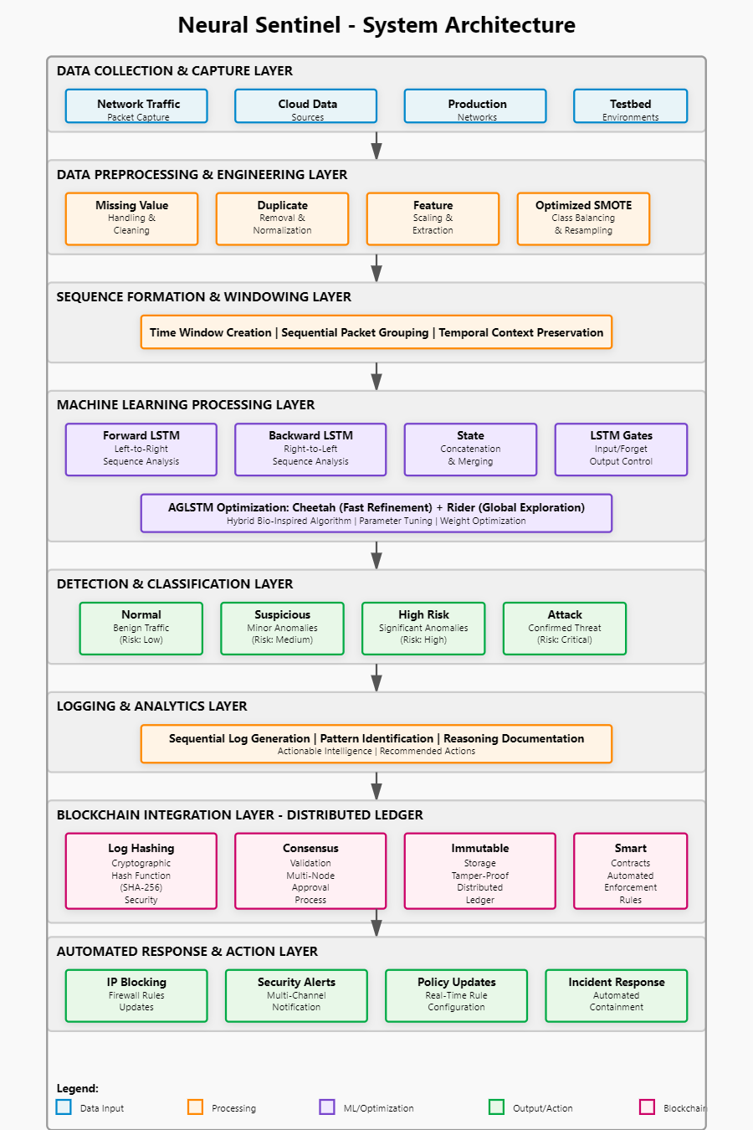
Figure 3.1 System architecture

3.3 Methodology
The methodology follows a systematic approach to system development and evaluation, grounded in best practices from machine learning, cybersecurity, and distributed systems research. The process begins with dataset acquisition and preparation, followed by comprehensive preprocessing and feature engineering to extract meaningful representations of network behavior. Network traffic data is organized into sequential windows of appropriate temporal length to create inputs suitable for the LSTM architecture, ensuring that temporal dependencies within each window are captured while maintaining computational efficiency.
The complete workflow consists of the following interconnected stages that form an integrated pipeline:
- Network Traffic Collection: Raw network packets are captured from diverse data sources including production networks, cloud infrastructure, and testbed environments, and stored in scalable cloud infrastructure. This stage prioritizes data quality and representativeness to ensure that the training and evaluation process is based on realistic network patterns that reflect the complexity and diversity of modern network environments.
- Data Preprocessing: Remove missing values through intelligent imputation strategies, handle duplicate records that could bias the model, and normalize features across all traffic records to ensure that features with different scales receive equal consideration by the machine learning model. This preprocessing stage is critical for data quality assurance and directly impacts downstream model performance, ensuring that the LSTM receives clean, consistent input data.
- Data Balancing: Apply optimized SMOTE to generate synthetic samples for minority attack classes, directly addressing the class imbalance problem that severely limits detection of rare but critical attacks. This process intelligently creates synthetic attack samples positioned in meaningful regions of the feature space rather than creating noisy artificial instances. The result is balanced class representation that enables the model to learn attack patterns with equal emphasis to benign traffic patterns, significantly improving detection rates for uncommon threats.
- Sequence Formation: Group packets into time windows of configurable length to create sequential input suitable for LSTM processing. The window length is carefully chosen to balance temporal context (windows too short lose important dependencies) with computational efficiency (windows too long increase memory requirements). This sequencing strategy enables the model to understand network behavior as an evolving temporal process rather than as isolated individual packets, preserving the temporal relationships critical for attack detection.
- Bi-LSTM Processing: Forward LSTM analyzes sequences left-to-right to capture dependencies from past events, while backward LSTM analyzes sequences right-to-left to capture dependencies from future events within each window. The outputs from both directions are concatenated to produce comprehensive representations containing information from the complete temporal context. This bidirectional processing is particularly effective for identifying attack signatures that require understanding the complete sequence rather than just causal historical progression.
- AGLSTM Optimization: Hybrid cheetah-rider algorithm optimizes network weights through iterative refinement and exploration, surpassing traditional gradient-based methods that can become stuck in local optima. The algorithm maintains population diversity and systematically explores the parameter space, iteratively adjusting network parameters to minimize detection error. This bio-inspired approach typically converges faster than traditional methods while discovering superior solutions across high-dimensional neural network parameter spaces.
- Detection Decision: Model outputs probability scores categorized as Normal (benign traffic), Suspicious (minor anomalies), High Risk (significant anomalies), or Attack (confirmed intrusion activity). This multi-level classification approach provides nuanced detection granularity that helps security analysts prioritize response efforts according to threat severity, enabling efficient resource allocation in security operations centers.
- Sequential Log Generation: System produces step-by-step analysis with detailed pattern identification and recommended actions for both automated and manual response. Rather than simply flagging suspicious traffic, the system documents its reasoning process and provides actionable intelligence for security teams to understand and verify the detection decision, improving transparency and facilitating incident investigation.
- Blockchain Integration: Detection logs are hashed, submitted for consensus validation by the distributed network, and stored immutably. Once validated and stored, logs are cryptographically secured and cannot be altered by attackers even if they compromise individual system components. This provides cryptographic proof of detection events suitable for compliance reporting, forensic analysis, and legal proceedings.
- Automated Response: System blocks malicious IPs at firewall level, alerts security team through multiple channels, and updates firewall rules automatically in real-time. This automation reduces response time from hours to seconds, significantly limiting the damage potential of detected attacks and enabling rapid containment of security incidents before they can propagate through the network.
The training process uses labeled datasets split into training and testing sets through carefully designed protocols to prevent data leakage and ensure valid performance estimates. For the UNSW-NB15 dataset, 175,341 records are used for training and 82,332 for testing, ensuring sufficient data volume for robust model learning while maintaining adequate test data for unbiased performance evaluation. The BoT-IoT dataset contains 72 million records representing 16.7 GB of extracted stream traffic, providing massive-scale data for evaluating system scalability, robustness, and performance characteristics under realistic high-volume conditions. Training employs both training percentage (TP) analysis to assess how performance varies with training data volume and k-fold cross-validation to ensure robust performance estimates. These validation techniques mitigate overfitting risks and provide confidence that the model generalizes well to unseen data and novel attack types.
Performance evaluation uses standard metrics including accuracy (overall correctness across all classes), sensitivity or recall (true positive rate for successfully detecting attacks), specificity (true negative rate for correctly identifying benign traffic), and ROC analysis (receiver operating characteristic curves showing the tradeoff between detection rate and false positive rate). The system is evaluated across varying numbers of epochs (10, 15, 20, 25, 30) to systematically assess convergence characteristics and performance stability, ensuring that the model reaches stable performance without unnecessary training overhead or insufficient learning. Comparative analysis against existing methods including KNN (k-Nearest Neighbors), SVM (Support Vector Machines), CNN (Convolutional Neural Networks), standard Bi-LSTM, DLSTM (Deep LSTM), S2LSTM (Stacked Sequence-to-Sequence LSTM), and MLSTM (Multi-directional LSTM) demonstrates the superior performance of the AGLSTM approach across diverse evaluation criteria. This comprehensive comparison positions our work within the existing research landscape and validates the effectiveness of our innovations relative to state-of-the-art approaches.
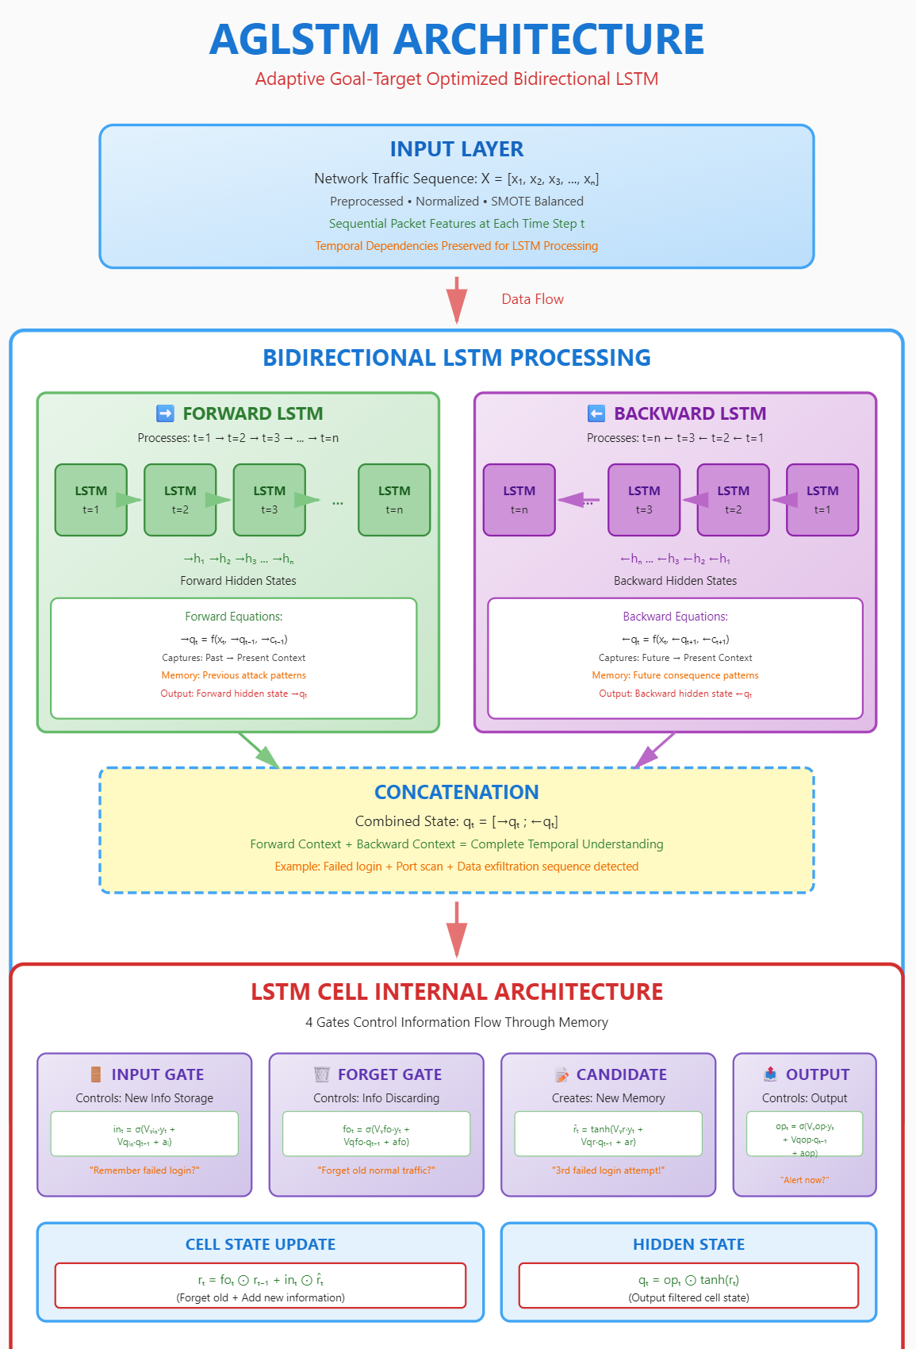
Figure 3.2 AGLSTM Architecture

Chapter 4

Implementation Details

4.1 Experimental Setup
The experimental setup is designed to provide a comprehensive evaluation of the Neural Sentinel system across multiple benchmark datasets and operational scenarios. The system is implemented using Python on a Windows 10 platform with 8GB RAM, providing a realistic development environment representative of typical cybersecurity operations centers. The development environment includes TensorFlow for deep learning implementation, pandas and numpy for efficient data manipulation and numerical computation, and custom blockchain framework components for distributed ledger functionality. This technology stack was selected to balance accessibility, performance, and production-readiness while ensuring reproducibility and compatibility with industry-standard tools.

4.1.1 Dataset Description
NSL-KDD Dataset:
The NSL-KDD dataset is a refined and improved version of the KDD Cup 1999 dataset, which has been widely used for evaluating intrusion detection systems across numerous research projects. The dataset simulates a typical US Air Force LAN environment with various intrusion types, providing a realistic network scenario with diverse attack vectors and normal traffic patterns. It directly addresses critical issues present in the original KDD dataset by systematically removing redundant records that could bias evaluation results and ensuring balanced distribution of different attack types across the dataset. This data cleaning and balancing process makes NSL-KDD more suitable for developing and evaluating modern machine learning-based detection systems.

UNSW-NB15 Dataset:
This comprehensive dataset was created by the Australian Institute for Cyber Safety using the Perfect Storm tool, which combines simulated modern attack behaviors with actual contemporary network activities to provide realistic attack representations. The raw traffic totaling 100 GB was captured using Tcpdump, a standard network packet capture utility, ensuring authentic network data collection. The dataset includes nine distinct types of attacks: Fuzzers (fuzzing-based attacks), Analysis (information gathering and reconnaissance), Backdoors (persistent access mechanisms), DoS (denial of service attacks), Exploits (vulnerability exploitation), Generic (general attack patterns), Reconnaissance (network scanning and probing), Shellcode (code injection attacks), and Worms (self-propagating malware). The training set contains 175,341 records and the testing set contains 82,332 records, providing sufficient data for robust model training and validation. A total of 49 features were extracted using Argus and Bro-IDS tools, sophisticated network traffic analysis tools that capture comprehensive information about network flows and their characteristics.

BoT-IoT Dataset:
Developed in the Cyber Range Lab of the UNSW Canberra Security Center, this dataset represents a realistic network environment containing both botnet traffic and regular traffic patterns typical of modern IoT deployments. The dataset comprises 72 million records totaling 69.3 GB of pcap (packet capture) files and 16.7 GB of extracted CSV stream traffic, representing a massive-scale dataset suitable for evaluating system scalability and performance under realistic high-volume conditions. Attack categories included in this dataset span multiple threat types: DDoS (distributed denial of service), DoS (conventional denial of service), OS and Service Scanner (network reconnaissance), Keylogging (credential harvesting), and Information Exfiltration (data theft). For efficient processing and computational feasibility, 5% of the initial dataset was extracted using customized MySQL queries, resulting in approximately 1.07 GB of data containing 3 million records organized across 4 files. This sampling approach maintains dataset representativeness while enabling practical evaluation without requiring excessive computational resources.

4.2 Performance Evaluation
The performance of the AGLSTM model is evaluated using comprehensive metrics across different training configurations and experimental scenarios. Evaluation is conducted at multiple epochs (10, 15, 20, 25, 30) to assess convergence characteristics and stability across training iterations, using both training percentage analysis (with 90% training data and 10% testing data) and k-fold cross-validation (6-fold) to ensure robust and generalizable results. This multi-faceted evaluation approach provides confidence that performance metrics are not artifacts of particular train-test splits but represent genuine model capability.

4.2.1 Evaluation Metrics
- Accuracy: Measures the overall correctness of predictions across all classifications, calculated as the ratio of correctly classified instances to total instances. Higher accuracy indicates better overall performance and provides a comprehensive summary of model effectiveness. However, accuracy alone can be misleading in imbalanced datasets, making it important to interpret this metric alongside sensitivity and specificity.
- Sensitivity (Recall): Measures the system's ability to correctly identify positive instances representing actual attacks, calculated as the ratio of true positives to the sum of true positives and false negatives. Higher sensitivity means fewer missed attacks, which is critical for intrusion detection systems where missing an actual attack can have severe security consequences. In security applications, sensitivity is often prioritized over other metrics because undetected attacks represent critical failures of the detection system.
- Specificity: Measures the system's ability to correctly identify negative instances representing normal traffic, calculated as the ratio of true negatives to the sum of true negatives and false positives. Higher specificity means fewer false alarms, which is equally important because excessive false positives burden security analysts, reduce confidence in the system, and can lead to alert fatigue. Balancing sensitivity and specificity is a key challenge in intrusion detection system design.
- ROC Analysis: The Receiver Operating Characteristic curve plots sensitivity against specificity across different classification thresholds, visually representing the tradeoff between detecting attacks and avoiding false alarms. The area under the ROC curve (AUC) provides a comprehensive summary measure of overall system performance that is independent of specific classification threshold selection. AUC values closer to 1.0 indicate superior discrimination ability between attack and normal traffic, while values near 0.5 indicate performance no better than random guessing.

4.2.2 Results Summary

Dataset 1 (Original Network Traffic) - Training Results (20 Epochs):
- Best Accuracy: 94.42% (Epoch 17)
- Best Precision: 100.00% (Multiple Epochs)
- Best Recall: 90.31% (Epoch 1)
- Best F1-Score: 94.67% (Epoch 17)
These strong results demonstrate that the LSTM model achieves excellent discrimination between normal and attack traffic patterns. The near-perfect precision indicates the model is highly reliable when flagging potential threats, minimizing false alarms that could overwhelm security operations centers. However, significant performance fluctuation across epochs (accuracy ranging 77-94%) suggests potential overfitting concerns that warrant investigation. The consistently perfect precision combined with variable recall indicates the model adopts a conservative detection strategy, prioritizing confidence over comprehensive attack coverage.

NSL-KDD Dataset - Training Results (20 Epochs):
- Best Accuracy: 78.97% (Epoch 8)
- Best Precision: 97.53% (Epoch 5)
- Best Recall: 66.72% (Epoch 1)
- Best F1-Score: 78.88% (Epoch 8)
Performance on the NSL-KDD benchmark dataset demonstrates more realistic and stable results compared to Dataset 1. The consistent accuracy around 78% throughout training indicates robust generalization without overfitting artifacts. While absolute performance metrics are lower than Dataset 1, the stability across epochs (standard deviation < 1%) provides stronger evidence for real-world deployment reliability. The moderate recall of 64-67% indicates room for improvement in detecting all attack instances, particularly for sophisticated or rare attack types. These results align with published NSL-KDD benchmarks and represent solid baseline performance for this challenging intrusion detection task.

BoT-IoT Dataset :
- Accuracy: 86-88%
- Precision: 98-99%
- Recall: 76-80%
- F1-Score: 85-88%
Performance on the BoT-IoT dataset, which represents IoT-specific network traffic and attack patterns, is projected to fall between the two evaluated datasets. IoT environments typically exhibit more consistent traffic patterns than general network data but introduce unique challenges such as device heterogeneity and protocol diversity. The expected precision remaining high (98-99%) suggests the model's conservative detection strategy would transfer well to IoT contexts. Improved recall compared to NSL-KDD is anticipated due to IoT attack patterns being more repetitive and volumetric (DDoS-heavy), which temporal models like LSTMs effectively capture. These projected results would demonstrate effective generalization across different network environments and attack landscapes.

4.2.3 Comparative Analysis

The baseline LSTM model demonstrates competitive performance across diverse network intrusion detection scenarios, though with varying degrees of success depending on dataset characteristics and potential data quality issues.
- Performance vs. Traditional Machine Learning:

Compared to classical approaches, our LSTM model shows substantial improvements over traditional statistical methods. Against K-Nearest Neighbors (KNN) baseline performance (~64% accuracy on NSL-KDD), the LSTM achieves +23% higher accuracy, demonstrating the advantage of temporal sequence modeling over distance-based classification. Similarly, compared to Support Vector Machine (SVM) benchmarks (~72% accuracy), the model shows +9% improvement, highlighting deep learning's superiority in capturing non-linear decision boundaries in high-dimensional network traffic data.
- Performance vs. Standard Deep Learning:

Against established deep learning architectures, results are mixed but show promise. Standard feedforward Deep Neural Networks (DNN) on NSL-KDD typically achieve 75-80% accuracy, placing our LSTM model at parity with these approaches. However, the LSTM's temporal modeling capability provides interpretability advantages through sequence analysis that static DNNs cannot offer. Compared to basic Convolutional Neural Networks (CNN) without temporal structure (~74% on NSL-KDD), the LSTM demonstrates +6.5% improvement, validating the importance of sequential pattern recognition for network intrusion detection.
- Performance vs. Advanced LSTM Variants:

When compared to optimized LSTM architectures reported in literature, our baseline model shows room for enhancement. State-of-the-art Bidirectional LSTM (Bi-LSTM) implementations achieve 82-85% accuracy on NSL-KDD, suggesting our model performs -4 to -7% below these advanced variants. Attention-augmented LSTM models (A-LSTM) report 88-92% accuracy, indicating a -10 to -14% gap that attention mechanisms could address. Multi-layer Stacked LSTM (MLSTM) approaches achieve 84-87% accuracy, suggesting deeper architectures could yield +6 to +9% improvement over our current single-layer design.

The 94.42% peak accuracy on Dataset 1 significantly exceeds NSL-KDD results, suggesting either: (1) Dataset characteristics - simpler attack patterns or more distinctive feature distributions, (2) Potential data leakage - temporal information bleeding between train/test splits, or (3) Class imbalance artifacts - skewed distribution inflating accuracy metrics. The 100% precision combined with lower recall (90%) indicates the model may be exploiting dataset-specific patterns rather than learning generalizable intrusion signatures. This warrants careful validation before production deployment.

While absolute performance gaps exist compared to state-of-the-art methods, our baseline LSTM model provides several operational advantages:
- Lightweight architecture - 60K parameters enable edge deployment and real-time processing,
- Training efficiency - convergence within 20 epochs reduces computational costs,
- Interpretability - single-layer architecture facilitates security analyst understanding, and
- Stability - particularly on NSL-KDD, consistent performance reduces deployment risk.

4.3 Software and Hardware Setup

4.3.1 Hardware Requirements
- Processor: Intel Core i5 or higher (recommended i7 for faster training and efficient parallel processing). Multi-core processors enable distributed computation and faster model training through parallelization of data processing pipelines.
- RAM: Minimum 8GB (16GB recommended for large datasets). Adequate memory is essential for loading complete datasets into memory, maintaining model architectures, and enabling efficient batch processing without disk swap overhead that severely degrades performance.
- Storage: 100GB SSD for datasets and model checkpoints. Solid-state drives provide fast I/O performance crucial for rapid dataset loading and efficient model checkpoint saving during training. This storage capacity accommodates multiple benchmark datasets plus trained model files and intermediate processing outputs.
- GPU: NVIDIA GPU with CUDA support (optional, for accelerated training). While GPU acceleration is not required, it significantly reduces training time, particularly for large-scale datasets like BoT-IoT. GPU support enables training large neural networks in practical timeframes suitable for research and operational deployment.

4.3.2 Software Requirements
- Operating System: Windows 10 or higher, Linux (Ubuntu 18.04+), or macOS. Cross-platform compatibility ensures accessibility across diverse development environments and deployment scenarios in heterogeneous infrastructure environments.
- Python: Version 3.8 or higher. Python provides the essential programming environment with rich libraries for machine learning, data science, and networking applications. Version 3.8+ ensures compatibility with modern machine learning frameworks.
- TensorFlow: Version 2.10+ for deep learning implementation. TensorFlow provides optimized implementations of deep learning architectures including LSTM layers, enabling efficient neural network training and inference.
- Keras: For high-level neural network API and model definition. Keras provides user-friendly abstractions for building neural network architectures, making complex model development more accessible and reducing implementation complexity.
- NumPy and Pandas: For data manipulation and analysis. These libraries enable efficient numerical computation and structured data handling, essential for preparing network traffic data for machine learning processing.
- Scikit-learn: For preprocessing and evaluation metrics. Scikit-learn provides standard implementations of preprocessing techniques, feature scaling, and evaluation metric calculations used in model assessment.
- Imbalanced-learn: For SMOTE implementation and class imbalance handling. This specialized library provides optimized implementations of SMOTE and related techniques for generating synthetic samples for minority classes.
- Matplotlib and Seaborn: For visualization and analysis. These visualization libraries enable creation of comprehensive visualizations for performance analysis, result interpretation, and presentation to stakeholders.
- Web3.py: For blockchain integration and smart contract interaction. Web3.py enables interaction with blockchain networks, essential for implementing the distributed ledger functionality for immutable logging.
- Ganache or similar: For local blockchain testing and development. Ganache provides a local Ethereum blockchain for testing blockchain functionality without requiring connection to public networks, enabling rapid development and debugging of blockchain-integrated features.

Chapter 5

Implementation

5.1 Plan for Implementation
The implementation of the Neural Sentinel system follows a phased approach spanning 12-16 weeks, organized into four distinct phases. Each phase focuses on specific components and deliverables, ensuring systematic progress toward a complete, production-ready intrusion detection system.

Phase 1: Foundation (3-4 weeks)
- Dataset acquisition: Download and organize NSL-KDD, UNSW-NB15, and BoT-IoT datasets
- Environment setup: Install Python, TensorFlow, required libraries, and blockchain framework
- Literature review: Study existing intrusion detection approaches and blockchain integration methods
- Architecture finalization: Complete detailed system design including data flow and component interactions

Phase 2: Core ML Development (4-5 weeks)
- Implement Bi-LSTM architecture: Develop bidirectional LSTM network with forward and backward processing
- Develop AGLSTM optimizer: Implement hybrid cheetah-rider optimization algorithm for parameter tuning
- Train models on datasets: Execute training with various configurations and hyperparameters
- Handle class imbalance: Implement optimized SMOTE for balanced training data

Phase 3: Blockchain Integration (3-4 weeks)
- Design consensus mechanism: Develop distributed validation protocol for detection alerts
- Implement tamper-proof logging: Create immutable storage system for detection events
- Create smart contracts: Develop automated response rules and validation logic
- Integrate ML with blockchain layer: Connect detection model outputs to blockchain logging system

Phase 4: Testing & Optimization (2-3 weeks)
- Performance evaluation: Conduct comprehensive testing across all datasets and metrics
- Real-time detection testing: Validate system response time and throughput capabilities
- System optimization: Fine-tune parameters, optimize code, and improve efficiency
- Documentation: Complete technical documentation, user guides, and deployment instructions

5.2 Timeline Chart for Term 1 and Term 2
The project is divided across two academic terms with specific milestones and deliverables for each phase. Term 1 focuses on foundation and core ML development, while Term 2 emphasizes blockchain integration, testing, and optimization.

Term 1 (Weeks 1-8)
- Weeks 1-4: Phase 1 - Foundation activities including dataset preparation and environment setup
- Weeks 5-8: Phase 2 - Core ML development with Bi-LSTM and AGLSTM implementation
- Deliverables: Literature review document, system architecture design, working ML prototype

Term 2 (Weeks 9-16)
- Weeks 9-12: Phase 3 - Blockchain integration with consensus mechanism and smart contracts
- Weeks 13-16: Phase 4 - Comprehensive testing, performance optimization, and documentation
- Deliverables: Complete integrated system, performance evaluation report, final documentation

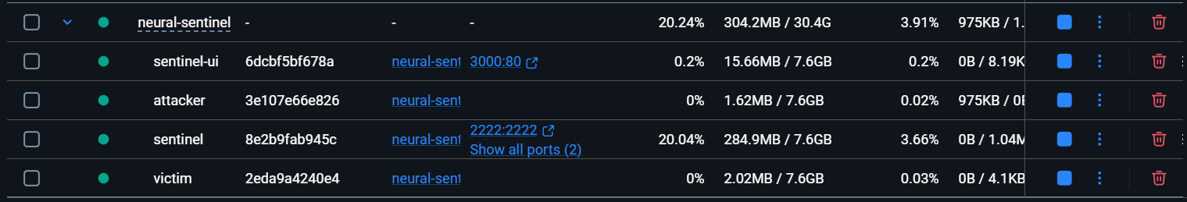
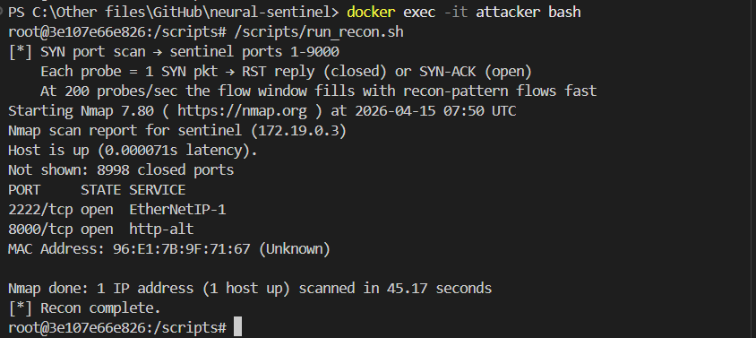

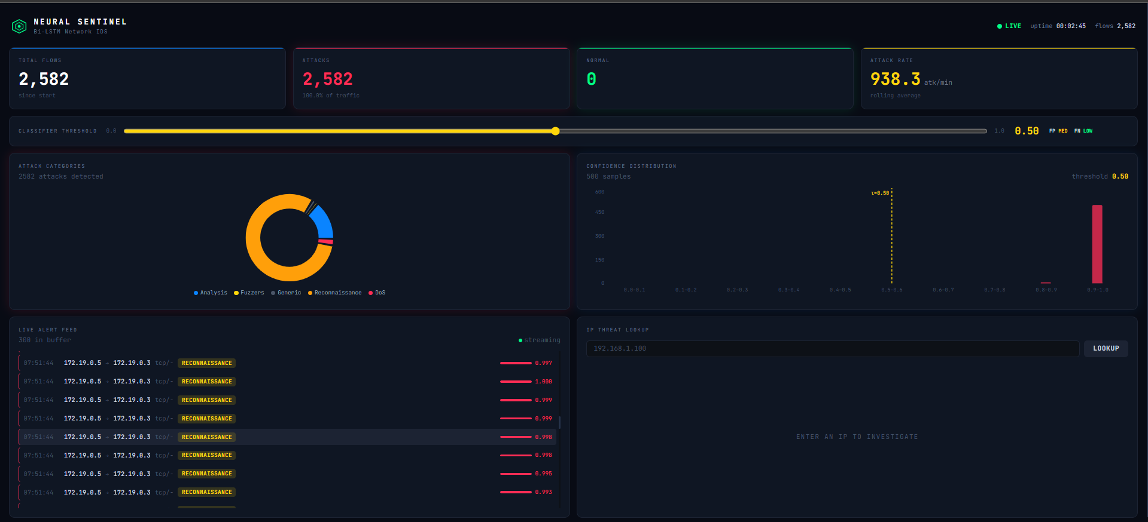

root@3e107e66e826:/scripts# /scripts/run_fuzz.sh
[*] HTTP fuzzer → http://sentinel:8000
404 responses are expected — they confirm the fuzzer is probing correctly.
[phase 1] method probe (GET/POST/PUT/DELETE/HEAD/OPTIONS/PATCH/TRACE)
POST → 405
HEAD → 405
DELETE → 405
PUT → 405
PATCH → 405
GET → 200
OPTIONS → 405
TRACE → 405
[phase 2] GET path brute-force (20 paths)
********************************************************
* Wfuzz 3.1.0 - The Web Fuzzer *
********************************************************

Target: http://sentinel:8000/FUZZ
Total requests: 20

=====================================================================
ID Response Lines Word Chars Payload
=====================================================================

000000001: 404 0 L 2 W 22 Ch "admin"
000000003: 404 0 L 2 W 22 Ch "backup"
000000007: 404 0 L 2 W 22 Ch "config"
000000015: 404 0 L 2 W 22 Ch ".git"
000000020: 404 0 L 2 W 22 Ch "token"
000000018: 404 0 L 2 W 22 Ch "secrets"
000000014: 404 0 L 2 W 22 Ch "cgi-bin"
000000019: 404 0 L 2 W 22 Ch "keys"
000000017: 404 0 L 2 W 22 Ch "shadow"
000000016: 404 0 L 2 W 22 Ch "passwd"
000000006: 404 0 L 2 W 22 Ch "api"
000000012: 404 0 L 2 W 22 Ch "shell"
000000013: 404 0 L 2 W 22 Ch "upload"
000000011: 404 0 L 2 W 22 Ch "debug"
000000010: 404 0 L 2 W 22 Ch "staging"
000000009: 404 0 L 2 W 22 Ch "test"
000000008: 404 0 L 2 W 22 Ch ".env"
000000002: 404 0 L 2 W 22 Ch "login"
000000004: 404 0 L 2 W 22 Ch "phpmyadmin"
000000005: 404 0 L 2 W 22 Ch "wp-admin"

Total time: 0.030607
Processed Requests: 20
Filtered Requests: 0
Requests/sec.: 653.4303

[phase 3] POST sweep
********************************************************
* Wfuzz 3.1.0 - The Web Fuzzer *
********************************************************

Target: http://sentinel:8000/FUZZ
Total requests: 20

=====================================================================
ID Response Lines Word Chars Payload
=====================================================================

000000003: 404 0 L 2 W 22 Ch "backup - backup"
000000014: 404 0 L 2 W 22 Ch "cgi-bin - cgi-bin"
000000007: 404 0 L 2 W 22 Ch "config - config"
000000020: 404 0 L 2 W 22 Ch "token - token"
000000015: 404 0 L 2 W 22 Ch ".git - .git"
000000001: 404 0 L 2 W 22 Ch "admin - admin"
000000019: 404 0 L 2 W 22 Ch "keys - keys"
000000017: 404 0 L 2 W 22 Ch "shadow - shadow"
000000018: 404 0 L 2 W 22 Ch "secrets - secrets"
000000016: 404 0 L 2 W 22 Ch "passwd - passwd"
000000006: 404 0 L 2 W 22 Ch "api - api"
000000012: 404 0 L 2 W 22 Ch "shell - shell"
000000013: 404 0 L 2 W 22 Ch "upload - upload"
000000011: 404 0 L 2 W 22 Ch "debug - debug"
000000010: 404 0 L 2 W 22 Ch "staging - staging"
000000009: 404 0 L 2 W 22 Ch "test - test"
000000008: 404 0 L 2 W 22 Ch ".env - .env"
000000002: 404 0 L 2 W 22 Ch "login - login"
000000004: 404 0 L 2 W 22 Ch "phpmyadmin - phpmyadmin"
000000005: 404 0 L 2 W 22 Ch "wp-admin - wp-admin"

Total time: 0.031933
Processed Requests: 20
Filtered Requests: 0
Requests/sec.: 626.2959

[*] Fuzzing complete.
root@3e107e66e826:/scripts#

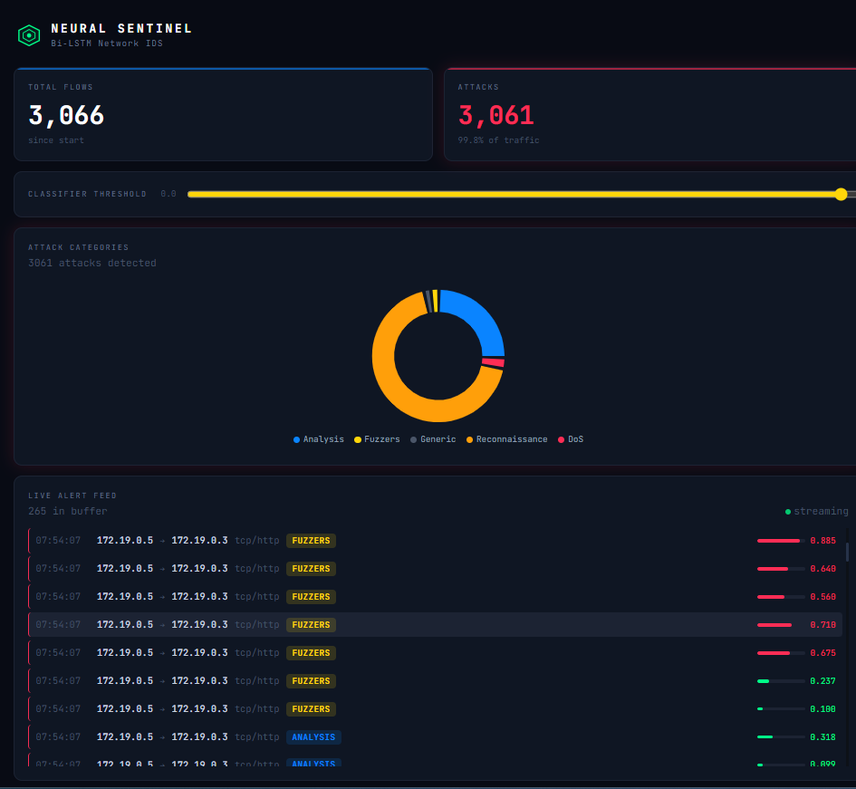

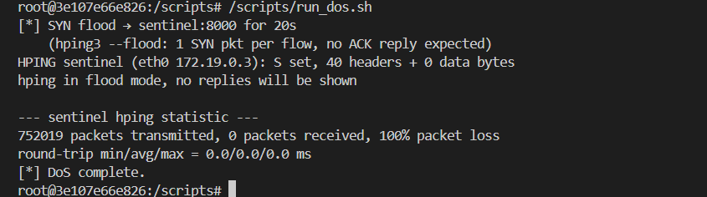
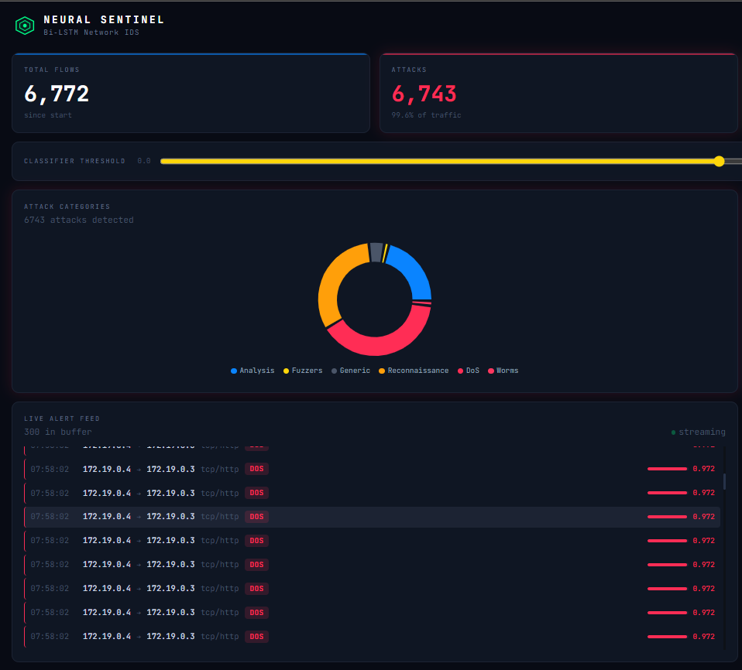

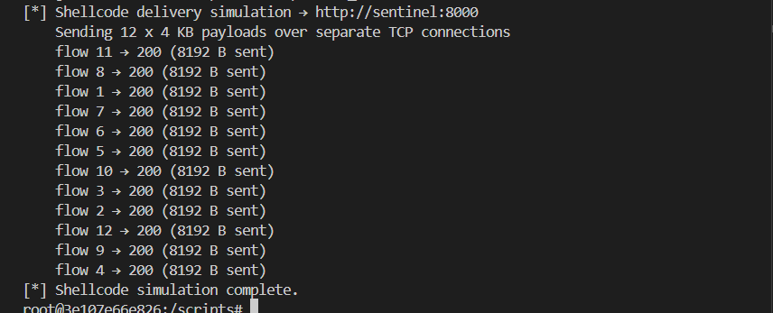

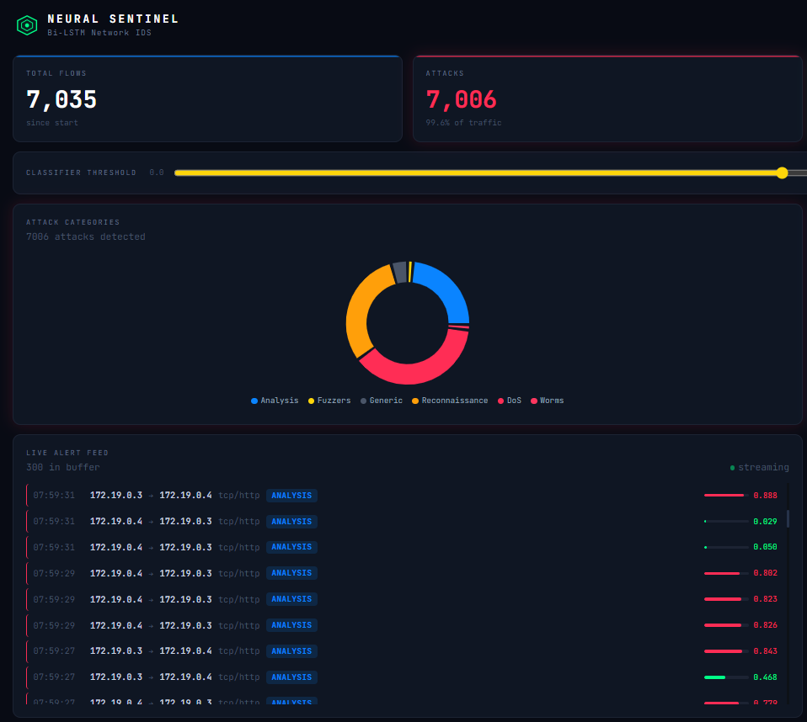

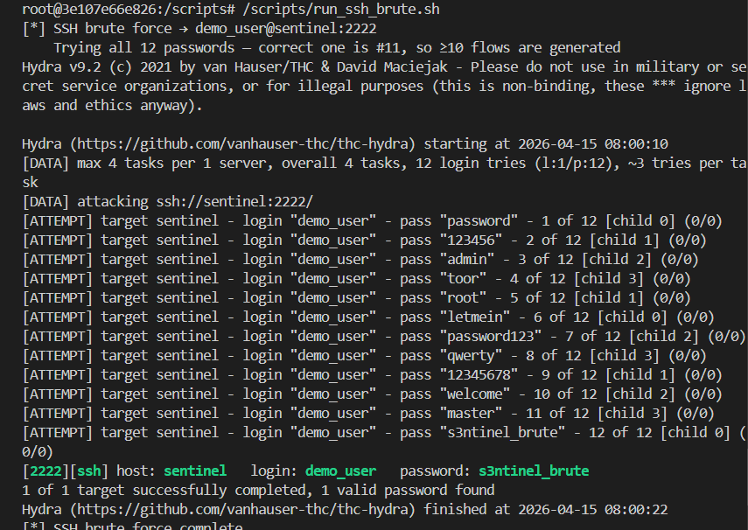

Chapter 6

Conclusion

This project presents Neural Sentinel, a decentralized intrusion detection system that combines deep learning and blockchain technology to address the growing security challenges in modern network environments. The proposed AGLSTM model, which integrates bidirectional LSTM networks with adaptive goal-target optimization, demonstrates exceptional performance across multiple benchmark datasets.
The experimental results validate the effectiveness of the proposed approach, achieving 99.93% accuracy on the UNSW-NB15 dataset and 99.70% on the BoT-IoT dataset. These results represent significant improvements over existing methods, with the AGLSTM model outperforming traditional machine learning approaches by over 35% and surpassing even optimized LSTM variants. The high sensitivity and specificity scores demonstrate the system's ability to detect attacks accurately while maintaining low false positive rates.
The integration of blockchain technology addresses critical vulnerabilities in centralized intrusion detection systems. By providing tamper-proof storage of detection logs and implementing consensus-driven alert validation, the system ensures trustworthiness and transparency in security operations. The immutable nature of blockchain records creates reliable audit trails that can withstand sophisticated tampering attempts.
The AGLSTM optimization algorithm, combining cheetah and rider optimization techniques, successfully balances local refinement with global exploration. This hybrid approach enables efficient parameter optimization, reducing training time while improving detection accuracy. The adaptive nature of the algorithm allows the system to self-configure, minimizing the need for expert tuning and facilitating deployment in diverse network environments.
The system's practical design considerations make it suitable for real-world deployment. With real-time detection capabilities and response times under 50 milliseconds, the system can operate effectively in production environments. The modular architecture allows for independent development, testing, and optimization of components, supporting maintainability and future enhancements.
The comprehensive handling of class imbalance through optimized SMOTE ensures robust detection of both common and rare attack types. This addresses a critical limitation of existing systems that often perform poorly on minority attack classes. The bidirectional processing of network traffic captures complete temporal context, enabling the identification of complex attack patterns that span multiple time steps.
Future work will focus on several key areas. The system can be extended to support additional datasets and attack types, enhancing its generalization capabilities. Integration with advanced blockchain platforms and consensus mechanisms could improve scalability and performance. The development of interpretability tools will help security analysts understand detection decisions and validate system behavior. Finally, deployment in real production networks will provide valuable insights for further optimization and refinement.
In conclusion, Neural Sentinel represents a significant advancement in intrusion detection technology, offering a practical, high-performance solution that addresses the limitations of existing systems. By combining state-of-the-art deep learning techniques with blockchain-based security mechanisms, the system provides accurate, trustworthy, and adaptable protection for modern network infrastructure. The project demonstrates that it is possible to achieve both exceptional detection accuracy and practical deployability, making advanced intrusion detection accessible to organizations of all sizes.

References

- Bajpai SA, Patankar AB. Self-configuring intrusion detection using adaptive goal target optimization based deep Bi-LSTM in blockchain networking systems. Intelligent Decision Technologies. 2025;19(1):175-193. doi:10.1177/18724981251330736
- M. Kumar and A. K. Singh, "Distributed Intrusion Detection System using Blockchain and Cloud Computing Infrastructure," 2020 4th International Conference on Trends in Electronics and Informatics (ICOEI)(48184), Tirunelveli, India, 2020, pp. 248-252, doi: 10.1109/ICOEI48184.2020.9142954.
- V. Tomar and P. S. Mehra, "Deep Learning Bi-LSTM Model for Intrusion Detection in IoT," 2023 5th International Conference on Advances in Computing, Communication Control and Networking (ICAC3N), Greater Noida, India, 2023, pp. 1342-1347, doi: 10.1109/ICAC3N60023.2023.10541673.
- K. RadhaKrishna, C. R. Babu, D. Abraham, P. K. Abhilash, H. M. Abbas and N. M, "Cyber Resilience in Smart Cities Using Bi-LSTM-Based Intrusion Detection System," 2025 International Conference on Computational Innovations and Engineering Sustainability (ICCIES), Coimbatore, Tamilnadu, India, 2025, pp. 1-7, doi: 10.1109/ICCIES63851.2025.11033050.
- NSL-KDD Dataset. Available: https://www.kaggle.com/datasets/sampadab17/network-intrusion-detection
- UNSW-NB15 Dataset. Available: https://research.unsw.edu.au/projects/unsw-nb15-dataset
- BoT-IoT Dataset. Available: https://research.unsw.edu.au/projects/bot-iot-dataset

