**Practical No.:-**

**Aim:- Create Dashboard and Storytelling using tableau**

Create sheet =>

Sheet 1

Double click on **state**

Drag and drop **profit** into Lable.

Rename sheet as State Wise Profit

Sheet 2

Double click on **region**

Add **profit** to label

Select pie chart from shoe me

Drag sum(Profit) from Marks to lable

Drag **region** from data pane and drop in lable

Rename sheet as Region Wise Profit

Sheet 3

Add **Profit** and **Sales** in Columns  
Add **category** In Rows

Rename sheet as Category Wise Profit and Sales

Sheet4

Add **Category** Columns  
Add **Profit** In Rows

Rename sheet as Category Wise Profit

**Step 1:-Create Dashboard**

Drag and drop all sheets in dashboard

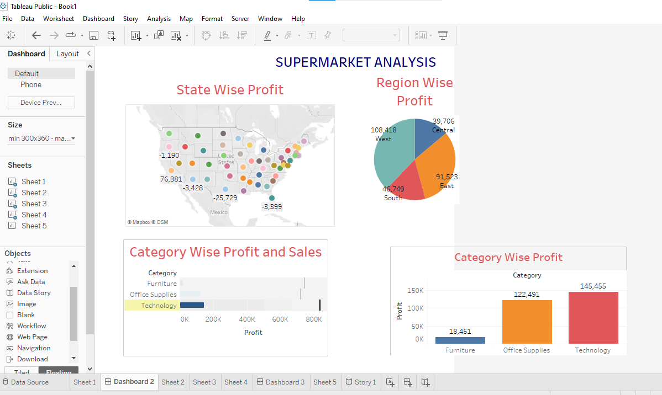

**Step 2:-To Create Story Click on New Story As Shown below**

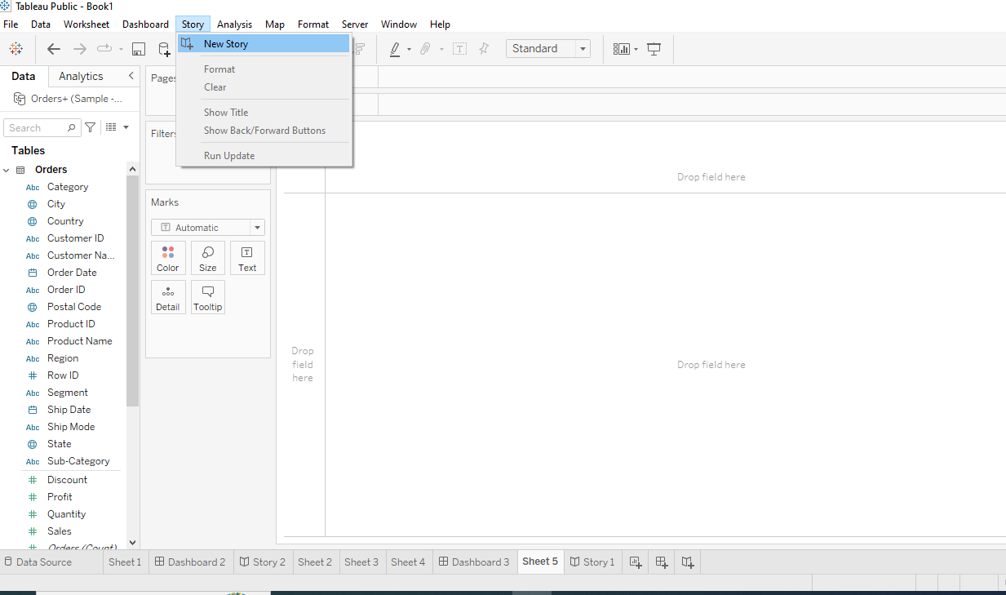

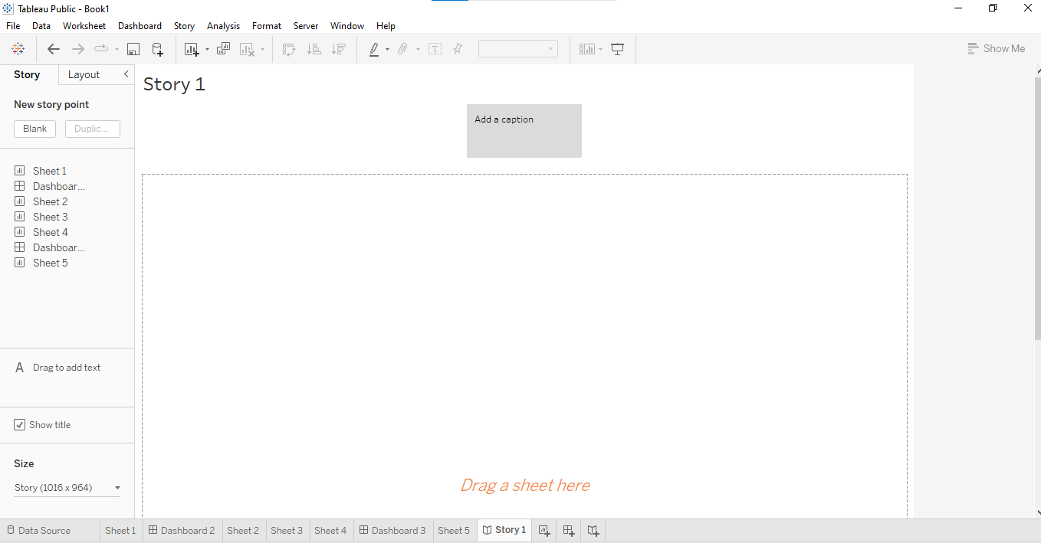

**Step 3:-Drag Different Sheets to Create Story**

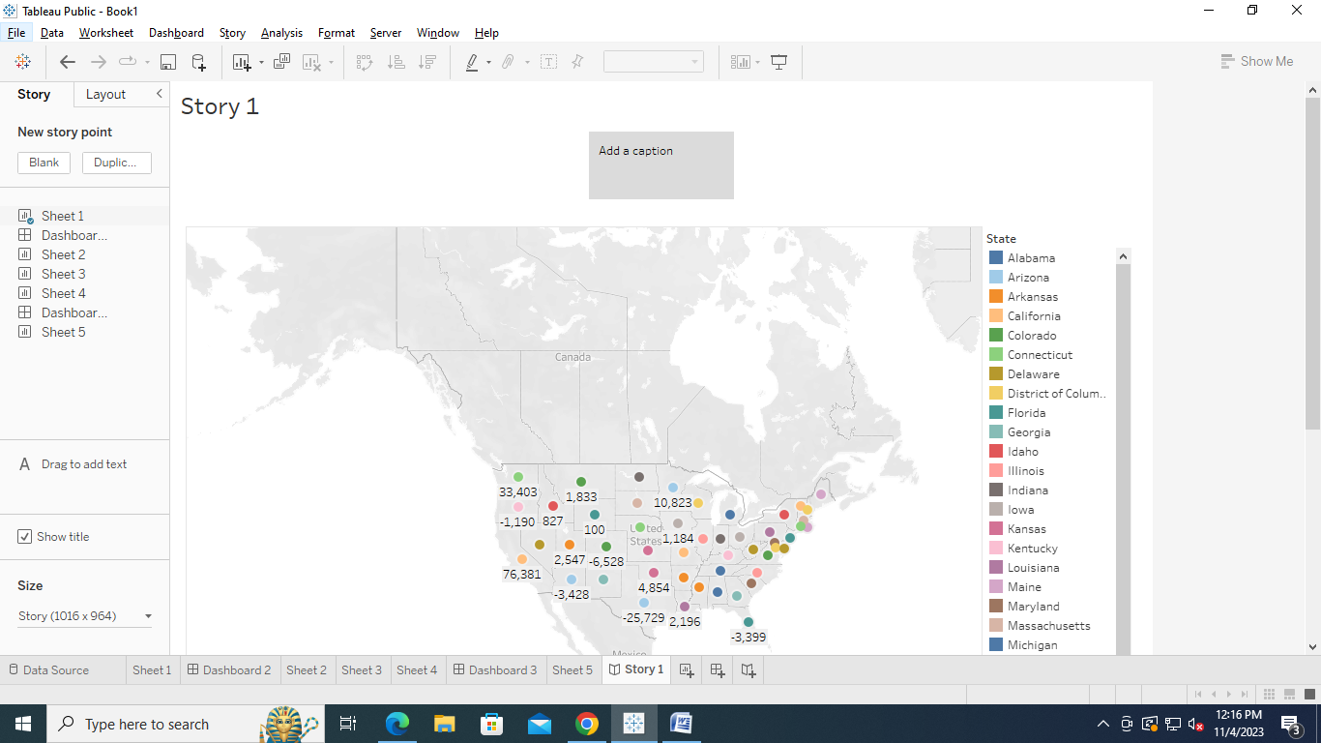

**Step 4:-Add Caption.**

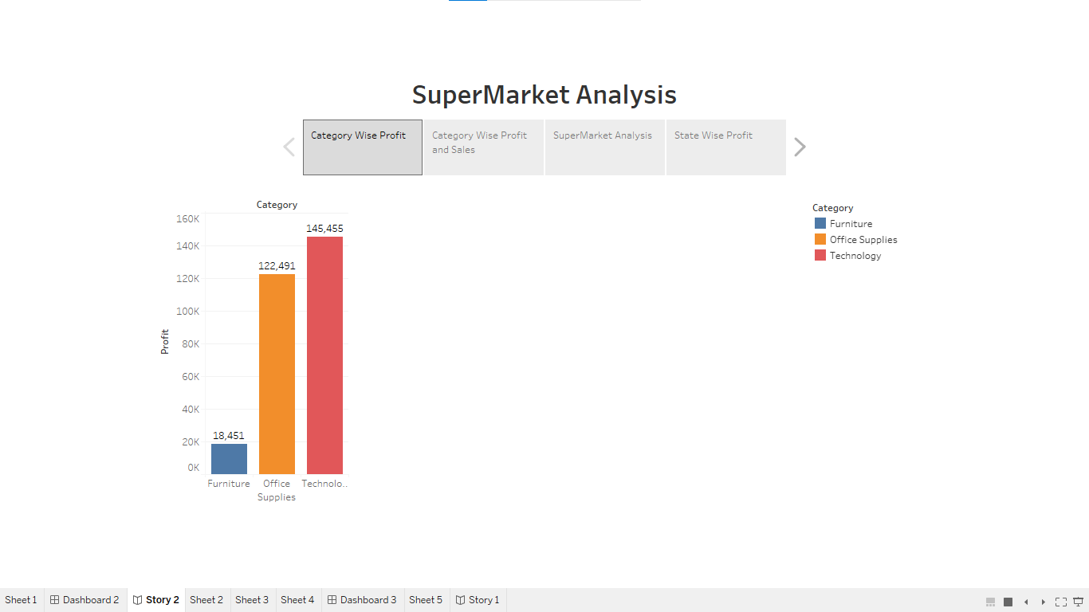

**Step 5:-Run Story.**

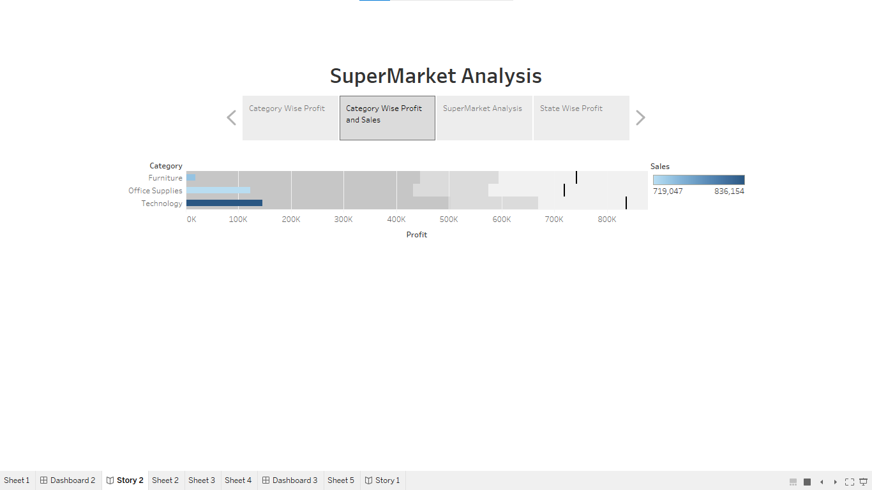

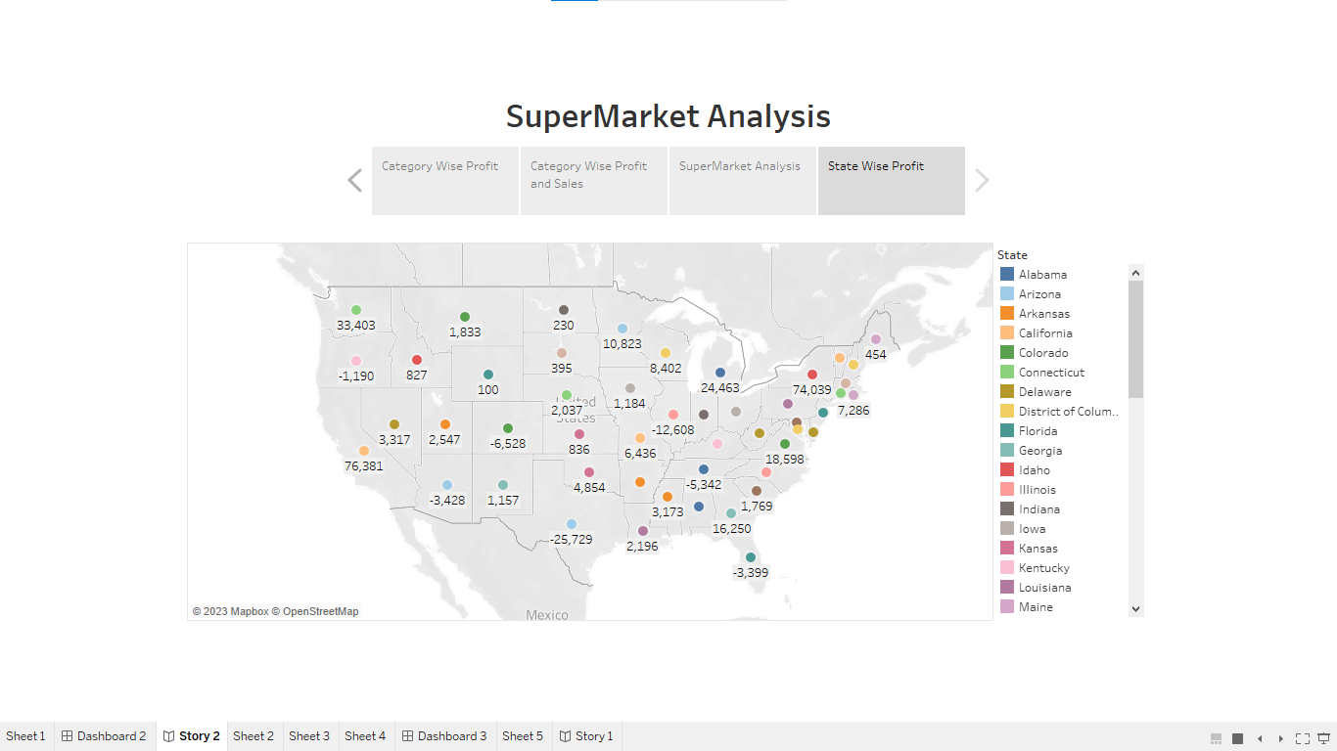

**Finish**