**Practical No.:-**

**Aim:- Create a Trend model using data, Analyse-it and use it for forecasting.**

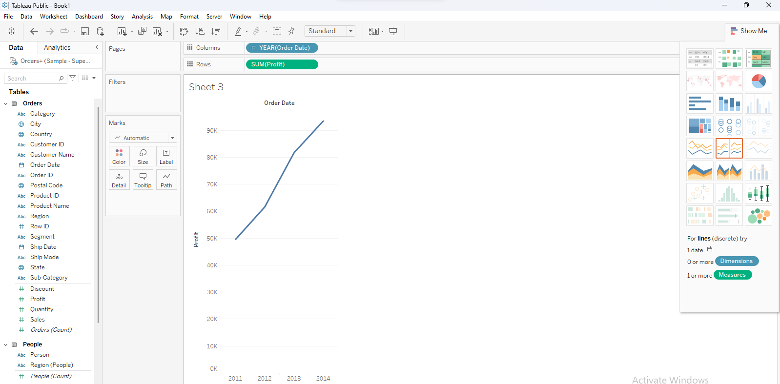

**Click to analysis pane to select the trend line then select show trend lines**

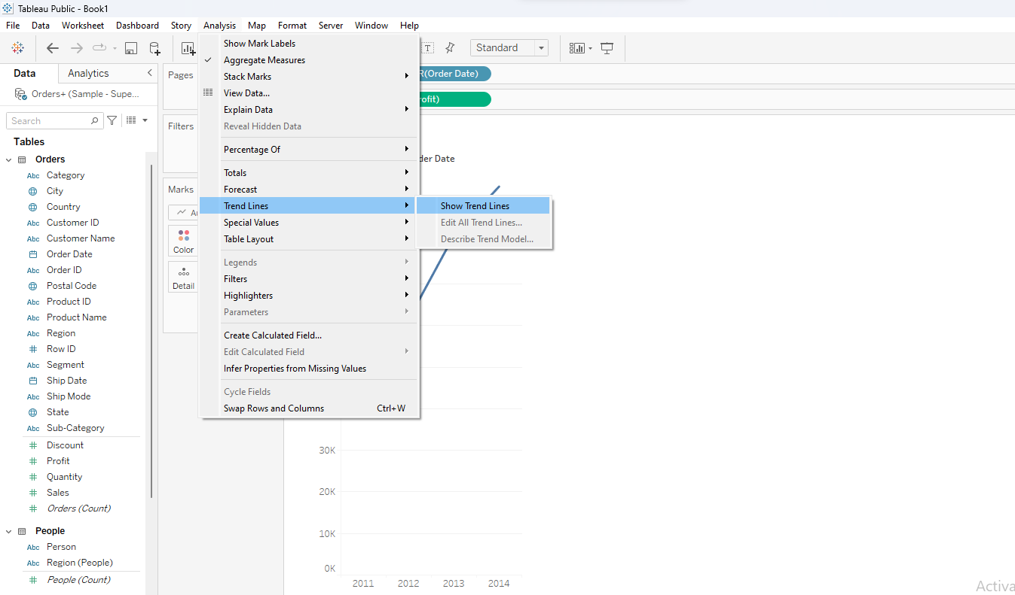

Show the trend line

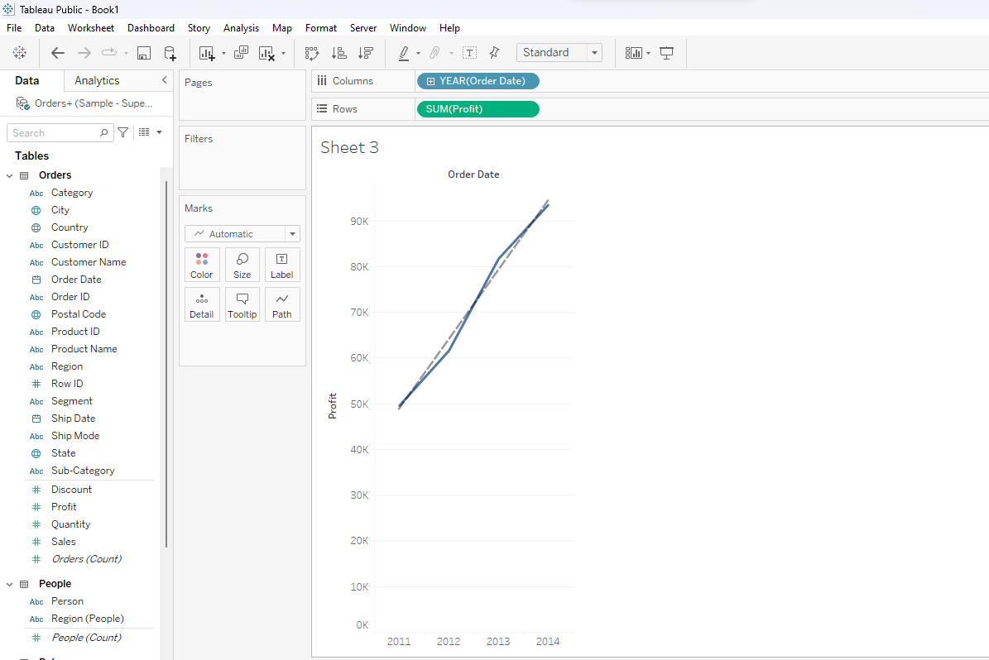

**Click to analysis pane then select to the forecast click and select show forecast.**

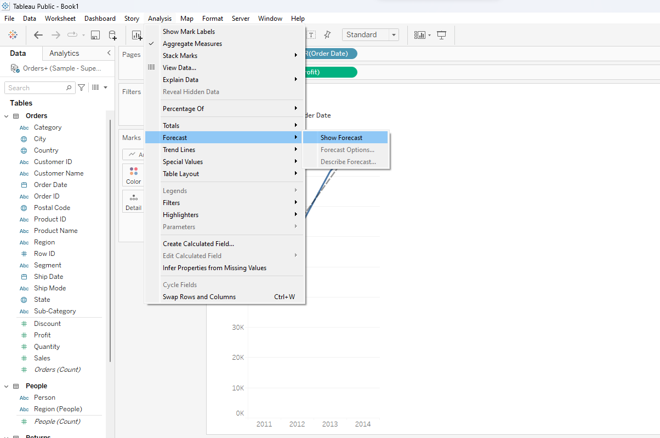

**Show the forecast**

