**STEPS FOR DOCKER CONTAINER CREATION AND DEPLOYING THE APPLICATION TO GCP KUBERNETES CLUSTER**

Create Docker Image and Container on local

=====================================

docker build --tag mlpython-docker .

docker run mlpython-docker

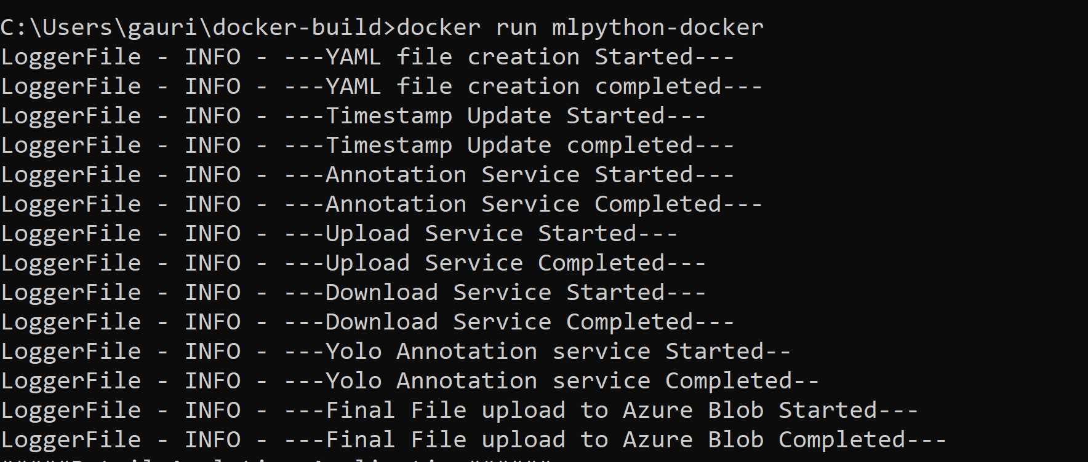

Push the Image to Docker Hub

===========================================

docker tag mlpython-docker gauridocker08/mlpythonanalytics:latest

docker commit 11eb24e0babb gauridocker08/mlpythonanalytics:latest

docker login -u "gauridocker08" -p "*******" docker.io

docker push gauridocker08/mlpythonanalytics:latest

Deploying the Application to GCP Kubernetes cluster

Reference Doc : https://cloud.google.com/kubernetes-engine/docs/tutorials/hello-app

Execute below commands on GCP Cloud Shell

Create a Project in GCP as first step

export PROJECT_ID=retailanalytics-321116

echo $PROJECT_ID

gcloud config set project $PROJECT_ID

Create Repository

==============================

gcloud artifacts repositories create hello-repo \

--repository-format=docker \

--location=us-west1 \

--description="Docker repository"

Create Docker Image and Push to Google Artifact Registry

=============================================

git clone <https://github.com/Gauri-CO/docker-build.git>

cd docker-build

docker build -t us-west1-docker.pkg.dev/${PROJECT_ID}/hello-repo/hello-app:v1 .

docker images

docker run us-west1-docker.pkg.dev/${PROJECT_ID}/hello-repo/hello-app:v1

gcloud auth configure-docker us-west1-docker.pkg.dev

docker push us-west1-docker.pkg.dev/${PROJECT_ID}/hello-repo/hello-app:v1

https://console.cloud.google.com/artifacts/docker/retailanalytics-321116/us-west1/hello-repo?cloudshell=false&project=retailanalytics-321116

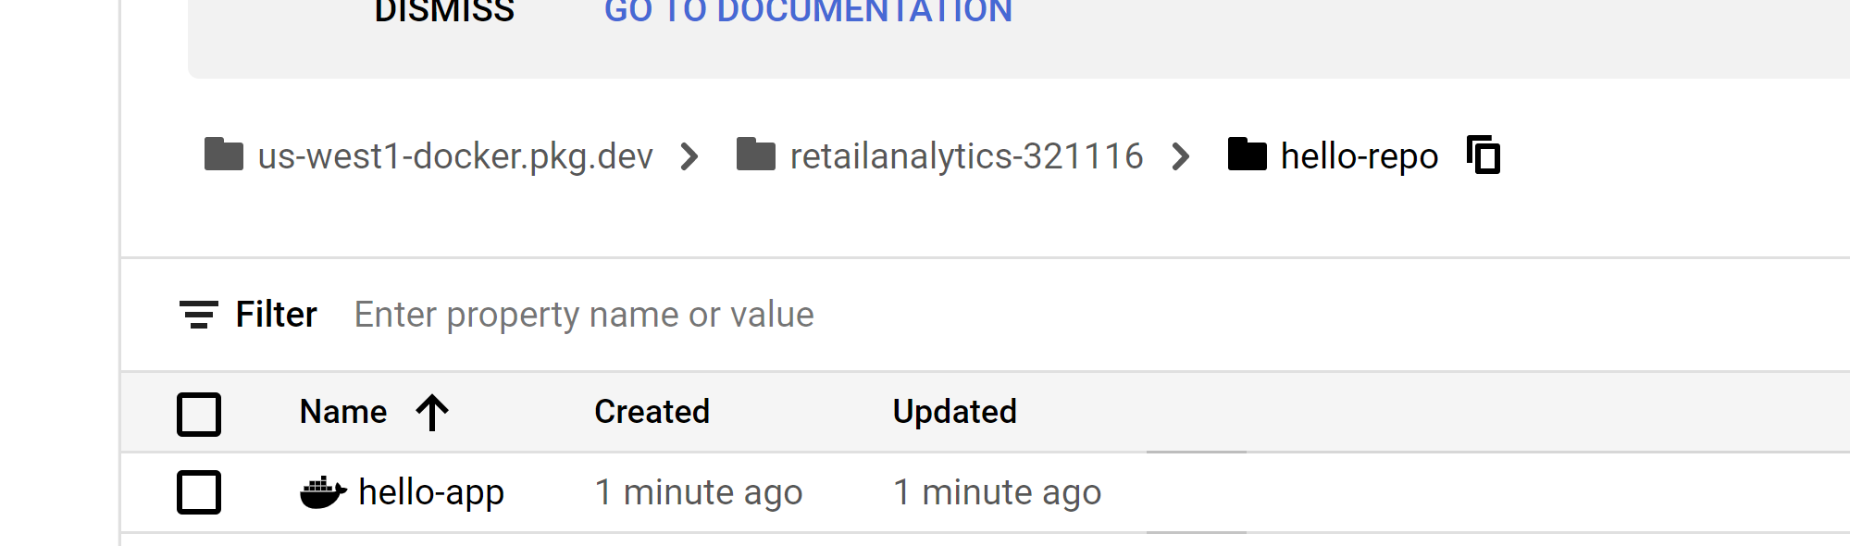

Create Kubernetes Cluster and Deploy the application

gcloud config set compute/zone us-west1-a

gcloud container clusters create hello-cluster

kubectl get nodes

gcloud container clusters get-credentials hello-cluster --zone us-west1-a

kubectl create deployment hello-app --image=us-west1-docker.pkg.dev/${PROJECT_ID}/hello-repo/hello-app:v1

kubectl get pods

kubectl exec --stdin --tty hello-app-897c98d58-kxrjz -- /bin/bash

kubectl expose deployment hello-app --name=hello-app-service --type=LoadBalancer

