**Azure Components used:**

* Azure Resource Group
* Azure Storage Account
* Azure Cosmos DB
* Azure ADF

**Resource Group:**

{

    "id": "/subscriptions/ed9adafd-e391-44da-9704-c3170c3decd7/resourceGroups/retail_analytics",

    "name": "retail_analytics",

    "location": "eastus",

    "properties": {

        "provisioningState": "Succeeded"

    }

}

**Storage Account:**

{

    "sku": {

        "name": "Standard_LRS",

        "tier": "Standard"

    },

    "kind": "StorageV2",

    "id": "/subscriptions/ed9adafd-e391-44da-9704-c3170c3decd7/resourceGroups/retail_analytics/providers/Microsoft.Storage/storageAccounts/retailanalytics08",

    "name": "retailanalytics08",

    "type": "Microsoft.Storage/storageAccounts",

    "location": "eastus",

    "tags": {},

    "properties": {

        "minimumTlsVersion": "TLS1_2",

        "allowBlobPublicAccess": true,

        "allowSharedKeyAccess": true,

        "networkAcls": {

            "bypass": "AzureServices",

            "virtualNetworkRules": [],

            "ipRules": [],

            "defaultAction": "Allow"

        },

        "supportsHttpsTrafficOnly": true,

        "encryption": {

            "services": {

                "file": {

                    "enabled": true,

                    "lastEnabledTime": "2021-07-08T22:05:46.5003464Z"

                },

                "blob": {

                    "enabled": true,

                    "lastEnabledTime": "2021-07-08T22:05:46.5003464Z"

                }

            },

            "keySource": "Microsoft.Storage"

        },

        "accessTier": "Hot",

        "provisioningState": "Succeeded",

        "creationTime": "2021-07-08T22:05:46.3909897Z",

        "primaryEndpoints": {

            "dfs": "https://retailanalytics08.dfs.core.windows.net/",

            "web": "https://retailanalytics08.z13.web.core.windows.net/",

            "blob": "https://retailanalytics08.blob.core.windows.net/",

            "queue": "https://retailanalytics08.queue.core.windows.net/",

            "table": "https://retailanalytics08.table.core.windows.net/",

            "file": "https://retailanalytics08.file.core.windows.net/"

        },

        "primaryLocation": "eastus",

        "statusOfPrimary": "available"

    }

}

**Blob Containers:**

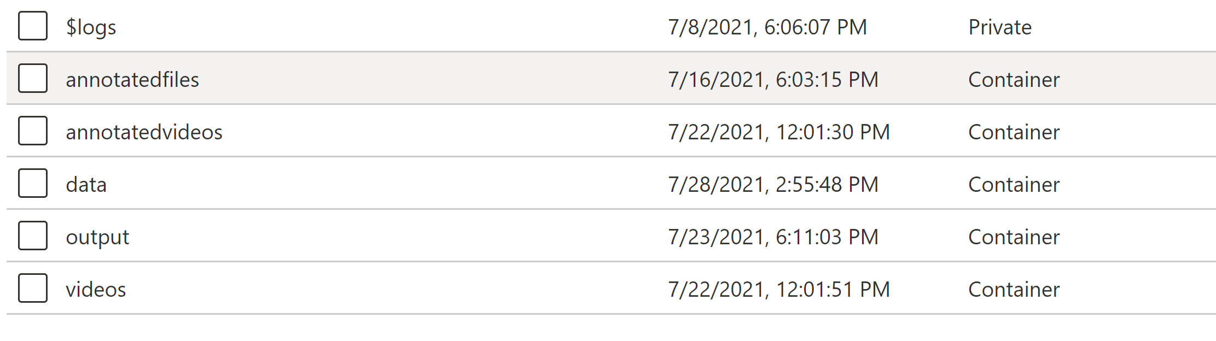

**Azure Cosmos DB**

{

    "id": "/subscriptions/ed9adafd-e391-44da-9704-c3170c3decd7/resourceGroups/retail_analytics/providers/Microsoft.DocumentDB/databaseAccounts/cosmosanalyticsdemo",

    "name": "cosmosanalyticsdemo",

    "location": "West US 2",

    "type": "Microsoft.DocumentDB/databaseAccounts",

    "kind": "GlobalDocumentDB",

    "tags": {

        "defaultExperience": "Core (SQL)",

        "hidden-cosmos-mmspecial": ""

    },

    "systemData": {

        "createdAt": "2021-07-14T20:24:47.6004015Z"

    },

    "properties": {

        "provisioningState": "Succeeded",

        "documentEndpoint": "https://cosmosanalyticsdemo.documents.azure.com:443/",

        "enableAutomaticFailover": false,

        "enableMultipleWriteLocations": false,

        "enablePartitionKeyMonitor": false,

        "isVirtualNetworkFilterEnabled": false,

        "virtualNetworkRules": [],

        "EnabledApiTypes": "Sql",

        "disableKeyBasedMetadataWriteAccess": false,

        "enableFreeTier": false,

        "enableAnalyticalStorage": false,

        "analyticalStorageConfiguration": null,

        "instanceId": "5744186c-d968-41c1-8976-e5edcfe3db07",

        "databaseAccountOfferType": "Standard",

        "ipRangeFilter": "",

        "consistencyPolicy": {

            "defaultConsistencyLevel": "Session",

            "maxIntervalInSeconds": 5,

            "maxStalenessPrefix": 100

        },

        "configurationOverrides": {},

        "writeLocations": [

            {

                "id": "cosmosanalyticsdemo-westus2",

                "locationName": "West US 2",

                "documentEndpoint": "https://cosmosanalyticsdemo-westus2.documents.azure.com:443/",

                "provisioningState": "Succeeded",

                "failoverPriority": 0,

                "isZoneRedundant": false

            }

        ],

        "readLocations": [

            {

                "id": "cosmosanalyticsdemo-westus2",

                "locationName": "West US 2",

                "documentEndpoint": "https://cosmosanalyticsdemo-westus2.documents.azure.com:443/",

                "provisioningState": "Succeeded",

                "failoverPriority": 0,

                "isZoneRedundant": false

            }

        ],

        "locations": [

            {

                "id": "cosmosanalyticsdemo-westus2",

                "locationName": "West US 2",

                "documentEndpoint": "https://cosmosanalyticsdemo-westus2.documents.azure.com:443/",

                "provisioningState": "Succeeded",

                "failoverPriority": 0,

                "isZoneRedundant": false

            }

        ],

        "failoverPolicies": [

            {

                "id": "cosmosanalyticsdemo-westus2",

                "locationName": "West US 2",

                "failoverPriority": 0

            }

        ],

        "cors": [],

        "capabilities": [],

        "backupPolicy": {

            "type": "Periodic",

            "periodicModeProperties": {

                "backupIntervalInMinutes": 240,

                "backupRetentionIntervalInHours": 8,

                "backupStorageRedundancy": "Geo"

            }

        }

    }

}

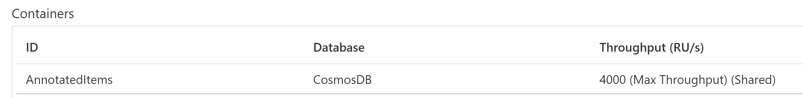

**Azure Data Factory**

{

    "name": "yoloadf2",

    "id": "/subscriptions/ed9adafd-e391-44da-9704-c3170c3decd7/resourceGroups/retail_analytics/providers/Microsoft.DataFactory/factories/yoloadf2",

    "type": "Microsoft.DataFactory/factories",

    "properties": {

        "provisioningState": "Succeeded",

        "createTime": "2021-07-10T01:58:15.1728141Z",

        "version": "2018-06-01",

        "factoryStatistics": {

            "totalResourceCount": 0,

            "maxAllowedResourceCount": 0,

            "factorySizeInGbUnits": 0,

            "maxAllowedFactorySizeInGbUnits": 0

        },

        "publicNetworkAccess": "Enabled"

    },

    "eTag": "\"2b00e02c-0000-0700-0000-60e8feb70000\"",

    "location": "westus",

    "identity": {

        "type": "SystemAssigned",

        "principalId": "a4889758-b40d-43e3-a294-849397e59aa1",

        "tenantId": "d2f55f3d-a9ca-4559-a755-cb1bb8ba048c"

    },

    "tags": {}

}

**Pipeline**

https://github.com/Gauri-CO/CompuerVision_Capstone/blob/main/BlobToComosDbLoadPipeline_support_live.zip