**Computer Vision Data Pipeline—Retail**

Open Ended Capstone Project For Springboard

Mentor: Zuraiz Uddin

Author: Gauri Sharma

**Purpose of the Project:** Build Data Pipeline for Computer Vision Data Analytics

**What is Computer Vision?**

**Computer vision** is a field of artificial intelligence that trains **computers** to interpret and understand the visual world. Using digital images from cameras and videos and deep learning models, machines can accurately identify and classify objects — and then react to what they “see.”

Many of the use cases of computer vision fall into the following clusters:

* Retail and Retail Security
* Automotive
* Healthcare
* Agriculture
* Banking
* Industrial

**What is a Computer Vision Data Pipeline?**

A Computer Vision Data Pipeline start off by acquiring images and data, then processing that data, performing some analysis and recognition steps, and finally make a prediction based on the extracted information.

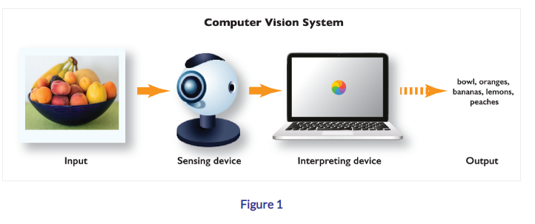

**Capstone Project Implementation (Single File Processing)**

* **Input Data Gathering**

In Capstone Project implementation of Computer Data Vision Pipeline for a Retail Store , VIRAT Video Data set will be used.

<https://viratdata.org/>

The VIRAT Video Dataset is designed to be realistic, natural and challenging for video surveillance domains in terms of its resolution, background clutter, diversity in scenes, and human activity/event categories than existing action recognition datasets.

Dataset Size: 40 GB

* **Data Wrangling for Video Dataset**

Perform Data Wrangling for a Single Video File based on the VIRAT Dataset file and draw bounding boxes on the video frames.

* **Running Machine Learning Algorithm**

The video with bounding boxes will be input to this machine learning algorithm YOLO , which will produce an output text file with information on the bounding boxes coordinates.

* **Text File Storage**

The output from Machine Learning Algorithm will be stored in a relational database like MySQL

* **Storytelling Dashboard**

Storytelling Dashboard will be built using SQL Queries in Tableau or Web Based.

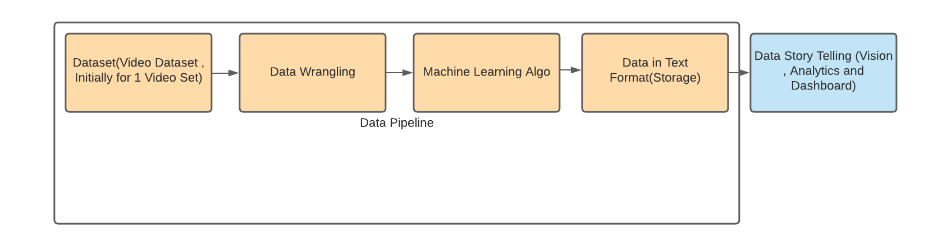

1. Computer Vision Data Pipeline for Single File Processing

**Capstone Project Implementation (Multi File Processing)**

* **Input Data Gathering**

In Capstone Project implementation of Computer Data Vision Pipeline for a Retail Store , VIRAT Video Data set will be used.

<https://viratdata.org/>

The VIRAT Video Dataset is designed to be realistic, natural and challenging for video surveillance domains in terms of its resolution, background clutter, diversity in scenes, and human activity/event categories than existing action recognition datasets.

Dataset Size: 40 GB

Data will be stored in Azure Blob

Optional : implementing real time data streaming using apache Kafka.

* **Data Wrangling for Video Dataset**

Perform Data Wrangling for a Single Video File based on the VIRAT Dataset file and draw bounding boxes on the video frames.

* **Running Machine Learning Algorithm**

The video with bounding boxes will be input to this machine learning algorithm YOLO , which will produce an output text files with information on the bounding boxes coordinates.

* **Text File Storage**

The output from Machine Learning Algorithm will be stored in a NoSQL Database like Cosmos DB Azure

* **Storytelling Dashboard**

Storytelling Dashboard will be built using SQL Queries in Tableau or Web Based.

* **Docker containers**

Containerize all solution and push into the cloud

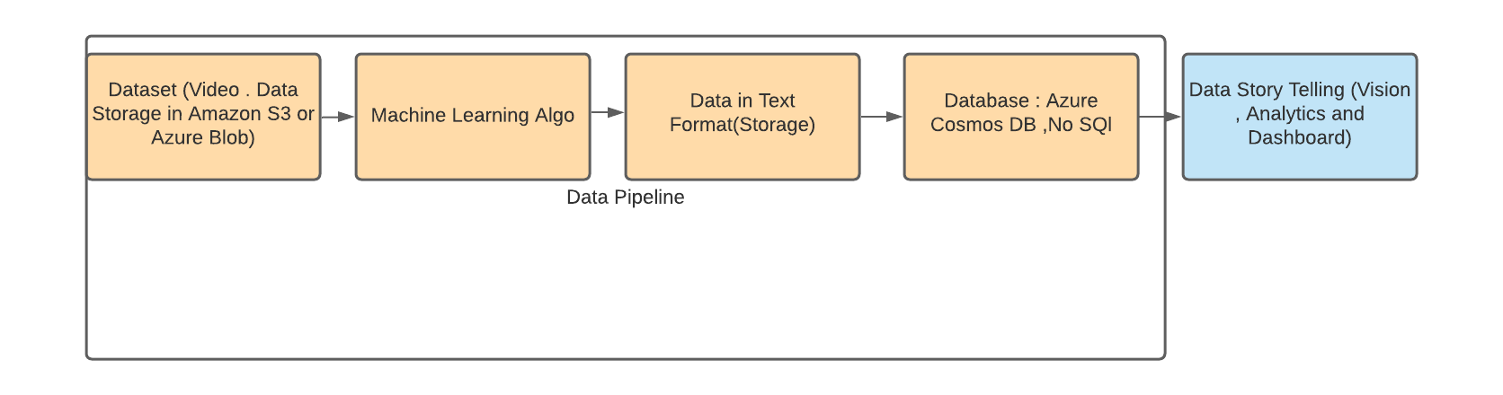

1. Computer Vision Data Pipeline for Multi File Processing