## 

## **FreshMart Dashboard Analysis Report**

## **Name- Gauri**

**Student ID - 224926207**

**Course Code- MIS781**

**MIS781 – Business Intelligence and Database**

**MIS781_Assignment2**

## 

## 

## 

## 

## 

## 

## 

## 

## 

## 

## 

## **FreshMart Dashboard Analysis Report**

### **Executive Summary**

This report provides a clear and insightful analysis of FreshMart's business performance across three main areas: **Sales & Marketing**, **Inventory & Supply Chain**, and **Customer Service & Satisfaction**. Using interactive Power BI dashboards, the analysis uncovers key trends, highlights strengths, and identifies areas for improvement (Power BI Documentation, 2025).

The **Sales & Marketing Dashboard** explores FreshMart's revenue streams, regional sales patterns, and top-selling products. The **Inventory & Supply Chain Dashboard** dives into stock levels, turnover rates, and product availability to optimize supply management. Finally, the **Customer Service & Satisfaction Dashboard** reflects on customer experiences, feedback trends, and the effectiveness of loyalty programs.

These dashboards provide FreshMart with powerful tools to make data-driven decisions, improve its inventory processes, and enhance customer service experiences.

### **Introduction**

FreshMart is a well-established supermarket chain focused on delivering quality products and exceptional customer service. To enhance decision-making, three interactive dashboards were created:

1. **Sales & Marketing Dashboard** – A snapshot of revenue generation, product performance, and regional sales distribution.
2. **Inventory & Supply Chain Dashboard** – A real-time view of stock levels, turnover efficiency, and product line availability.
3. **Customer Service & Satisfaction Dashboard** – A deep dive into customer feedback, loyalty metrics, and service performance.

This report walks through the analysis of each dashboard, outlining key findings and strategic recommendations for better business efficiency and customer experience.

### 

### **Sales & Marketing Dashboard**

**Objective:** To understand FreshMart's sales patterns, identify key revenue sources, and spot top-performing products.

**Key Metrics Displayed:**

* **Total Revenue Amount** – Displays the total income generated from all sales.
* **Total Quantity Sold** – Represents the number of products sold across all categories.
* **Total Tax Collected** – Summarizes the total tax collected on sales.
* **Average Sale Value** – Calculates the average value of each sale.

**Visualizations:**

* **KPI Cards:** Quick overview of the key sales figures for instant insights.
* **Line Chart:** Monthly and yearly sales trends are visualized clearly, highlighting peak periods and seasonal demand patterns. This allows FreshMart to forecast demand accurately and plan marketing strategies around high-sales seasons (Chaffey & Smith, 2022).
* **Bar Charts:** Detailed breakdown of revenue by product line and region. This visualization helps identify top-performing categories and regions where sales can be improved through targeted marketing (Chaffey & Smith, 2022).

**Interactive Filters:**

* **Date Range**, **City**, and **Product Line** filters allow dynamic exploration of sales data to find hidden patterns.

**Insights Gained:**

* Clear visibility into high-revenue regions and top-selling products.
* Easier identification of peak sales periods for targeted marketing.
* Product line analysis enables strategic stocking and promotional pl

### 

### **Inventory & Supply Chain Dashboard**

**Objective:** To maintain optimal inventory levels, monitor stock movement, and prevent shortages or overstocking.

**Key Metrics Displayed:**

* **Total Inventory Levels** – Real-time view of available stock across all product lines.
* **Stock Turnover Rate** – Insights into how frequently products are sold and restocked.
* **Product Line Count** – Shows the number of unique product categories available.

**Visualizations:**

* **KPI Cards:** Display important inventory metrics at a glance.
* **Line Chart:** Displays inventory movement over time, pinpointing fast-moving products and identifying potential bottlenecks in the supply chain. This helps FreshMart adjust restocking schedules and avoid overstocking or shortages (Slack, Chambers, & Johnston, 2021).
* **Bar Chart:** Presents an easy-to-read overview of stock distribution across all product lines, helping FreshMart spot shortages and surpluses at a glance. This visualization aids in efficient stock management and reduces excess holding costs (Slack, Chambers, & Johnston, 2021).

**Interactive Filters:**

* **Date Range** and **Product Line** slicers allow users to focus on specific periods or product categories.

**Insights Gained:**

* Prevents overstocking and understocking by monitoring product movement effectively.
* Helps identify high-demand items for timely reordering.
* Provides clear visibility of product availability for smoother supply chain management.

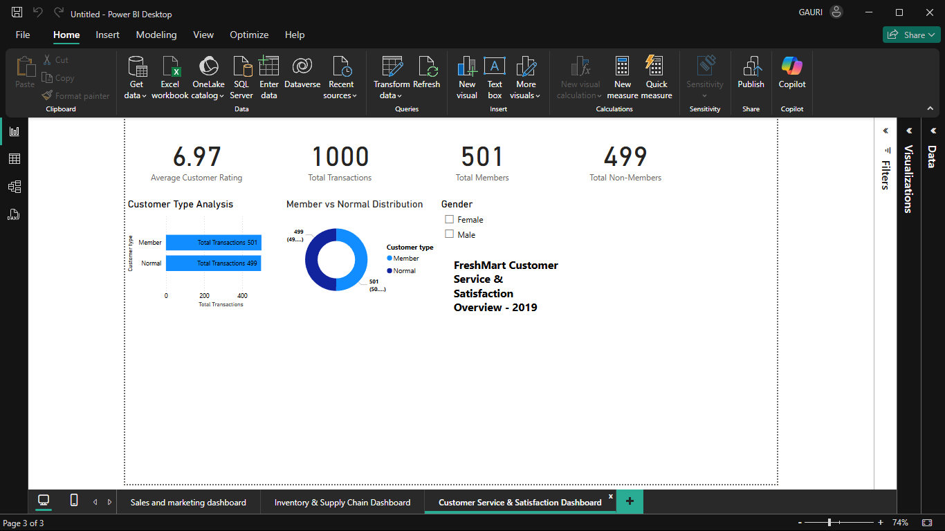

### **Customer Service & Satisfaction Dashboard**

**Objective:** To understand customer experiences, membership distribution, and overall satisfaction levels.

**Key Metrics Displayed:**

* **Average Customer Rating** – Reflects customer satisfaction based on their shopping experience.
* **Total Transactions** – Tracks the number of completed sales transactions.
* **Total Members vs. Non-Members** – Shows the breakdown of loyal customers versus one-time shoppers.

**Visualizations:**

* **KPI Cards:** Provide quick insights into customer service performance.
* **Bar Chart:** Illustrates the transaction volumes of members versus non-members, making it easy to see which customer group drives more revenue. This helps in planning loyalty programs and targeted promotions.
* **Donut Chart:** A clear visualization of the ratio of members to non-members, providing insights into FreshMart's customer loyalty base. This helps evaluate the effectiveness of membership programs and identify opportunities for growth.

**Interactive Filters:**

* **Date Range** and **Customer Type** slicers allow for easy exploration of service metrics.

**Insights Gained:**

* Real-time insights into customer satisfaction and loyalty patterns.
* Better understanding of how membership status influences purchase behavior.
* Identifies opportunities to improve service and customer engagement.

**Business Rules and Assumptions:**

1. **Revenue Calculation:** The total revenue displayed is calculated as the sum of all transactions for the period, including applicable taxes.
2. **Inventory Valuation:** Inventory levels are estimated based on the quantity sold and restocked over time. Reorder levels are assumed to be stable throughout the analysis period.
3. **Customer Satisfaction Scores:** The average customer rating is calculated from the available feedback, assuming unbiased representation of customer experiences.
4. **Product Line Consistency:** It is assumed that product lines remain stable during the analysis to avoid discrepancies in sales and inventory tracking.
5. **Sales Cycle Stability:** The sales cycle is considered consistent with typical retail operations, with no major market disruptions.

### **Assumptions**

To ensure clarity and accuracy, the following assumptions were considered during the analysis:

1. **Data Completeness:** The dataset provided is assumed to be complete and accurately represent FreshMart's operations.
2. **Inventory Calculation:** Since real-time inventory data was unavailable, average inventory was estimated based on product line transactions over unique dates, assuming consistent restocking.
3. **Customer Feedback Representativeness:** It is assumed that the feedback collected reflects the overall customer experience accurately.
4. **Stable Product Lines:** The analysis assumes product lines remained constant throughout the evaluation period.
5. **Consistent Sales Cycles:** It is presumed that sales cycles did not experience major disruptions or anomalies.

These assumptions provided a structured foundation for the analysis and informed the recommendations (GitHub, 2025).

### **References**

* GitHub. (2025). *Supermarket Sales Data Set*. Retrieved from [GitHub Repository](https://github.com/sersun/supermarket-sales-analysis/blob/main/supermarket_sales.csv)
  + This dataset provided transactional data for the analysis of sales, inventory, and customer service insights across FreshMart's operations.
* Power BI Documentation. (2025). *Data Visualization and Interactive Dashboards*. Retrieved from [Microsoft Documentation](https://docs.microsoft.com/en-us/power-bi)
  + Microsoft Power BI's official documentation provided best practices for creating interactive and insightful dashboards.
* Chaffey, D., & Smith, P. R. (2022). *Digital Marketing Excellence: Planning, Optimizing, and Integrating Online Marketing*. Routledge.
  + Concepts of regional sales optimization and customer segmentation were derived from strategic digital marketing principles outlined in this book.
* Slack, N., Chambers, S., & Johnston, R. (2021). *Operations Management*. Pearson.
  + Inventory optimization and supply chain visibility strategies were aligned with best practices from operations management.
* Newbold, P., Carlson, W. L., & Thorne, B. (2020). *Statistics for Business and Economics*. Pearson.
  + Statistical analysis for interpreting sales trends and customer feedback was guided by methodologies from this text.

**Certification-**

