**EBS(ELASTIC BLOCK STORAGE)**

Elastic Block Store volume is a block level storage device that can be associated with an EC2 instance

· EBS Volumes can be used as both primary storage and secondary storage

· The primary EBS volume acts as root volume and should be created and attached to the instance at the time of instance launch. Storage can be increased in the future if needed. This primary EBS volume cannot be detached from the instance.

· The secondary volume can be attached, detached and modified at any time.

· An instance can have one primary EBS volume and n number of secondary volumes

· One EBS Volume can be only associated with one instance

· There are 5 types of EBS volumes:

o General Purpose SSD (gp2)- Provides balance of both price and performance and is generally chosen by default

o Provisioned IOPS SSD (io1)-- Most expensive of the volume types with highest performance and well-suited for tasks with heavy workloads

o Throughput Optimized HDD (st1)- A low-cost volume that focuses on optimizing throughput and is generally used for large sequential workloads dealing with big data warehouses. These volumes cannot be used as root volumes for EC2 instances.

o Cold HDD (sc1)- least expensive of the volume types and specifically designed for workloads which are accessed less frequently. These volumes also cannot be used as root volumes for EC2 instances.

o Magnetic (Standard) Previous generation magnetic volumes which cannot be used as root volumes for EC2 instances

**Advantages of using EBS Volumes:**

· High availability and flexibility

· Data can be kept persistently on a file system even after shut downing the instance

· Enables snapshots, which capture the data stored at a point in time and can be restored at any time.

· The snapshots enables us to create a volume and attach it to another instance if needed.

· Can be resized at any time as and when required

· Comes equipped with encryption (and encryption-at-rest).

· EBS Volumes can be attached, detached and associated with other instances at any point in time (exception the primary volume)

**Lab Steps**

Task 1: Sign in to AWS Management Console

1. Click on the Open Console button, and you will get redirected to AWS Console in a new browser tab.

2. On the AWS sign-in page,

· Leave the Account ID as default

·Now enter your username and password.

3. click on sign-in.

4.After signing in select US East (N. Virginia) us-east- as AWS region.

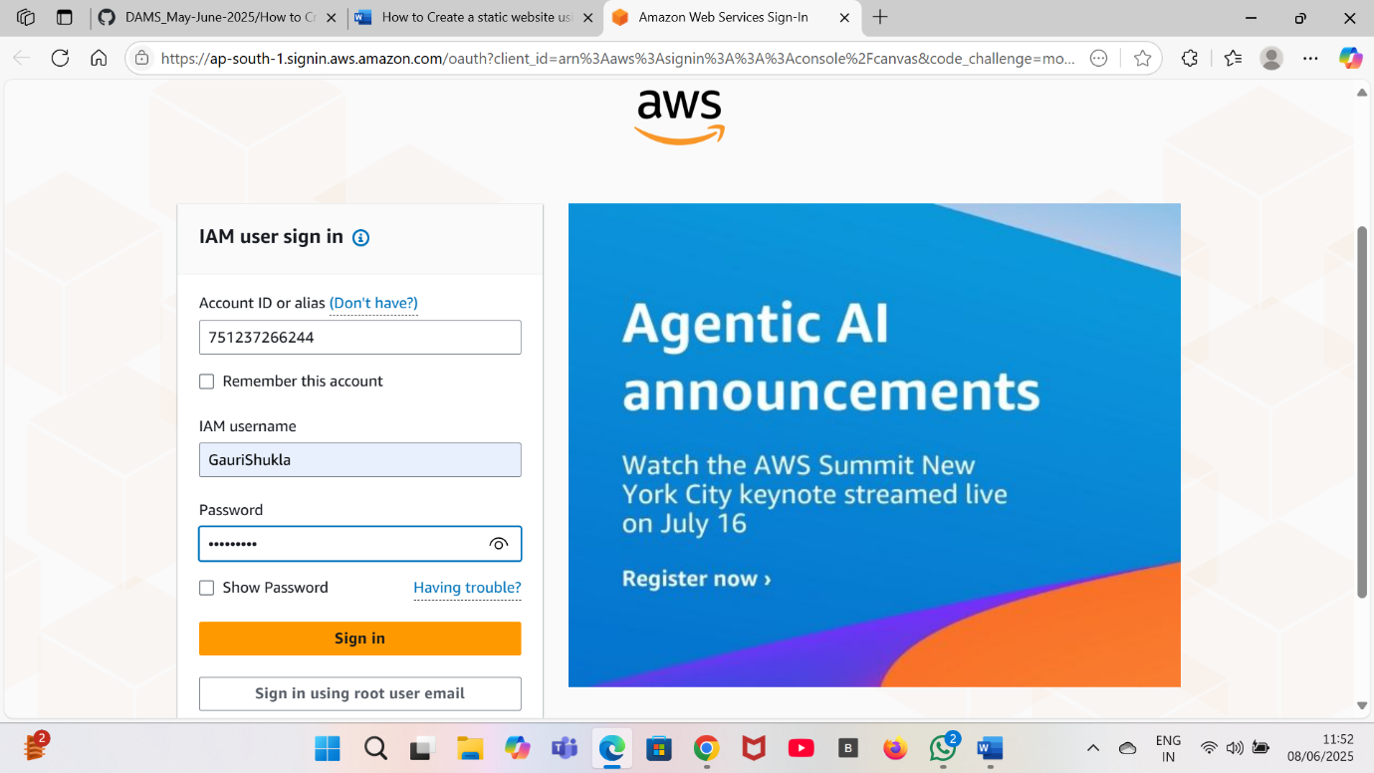

Task 2: Launch an EC2 Instance

1.Click on search bar. Enter EC2. Click on EC2.

2.Click on instances on the left side. Click on create instance.

3.Enter the details:

a. Instance Name:Enter instance name(ebsvolumegauri)

b.AMI:RedHat

c.Keypair: Click on create key pair . Enter key pair name.

d.key pair type:RSA

e.Private key format:.pem

4.Click on launch instance.

5.Your instance is launched.



Task 3: Resizing the EBS Volumes

1. Select EC2 instance created in the above stepp.
2. Navigate to the Storage tab and then click on Volume id present.
3. Select the Volume.
4. Go to the Actions menu dropdown .Click on Modify Volume.
5. Give Volume Size you need to increase to and also note that we are not able to decrease the volume size. I’m modifying it to 20GB and then clicking on Modify.

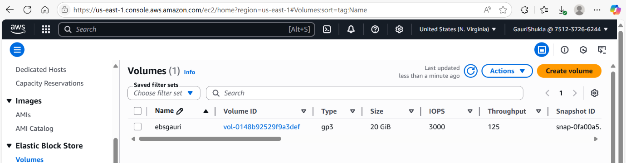

Task 4: Increase the partition and file system

1. :After modifying the volume we need to increase the partition and file system.
2. We have to login into server (EC2-Instance).
3. Now run the commands given below
4. sudo su
5. df -kh(to know the volume)
6. lsblk
7. growpart /dev/xvda 3
8. xfs_growfs /dev/xvda3
9. df -kh(to check that the volume modification has been done)

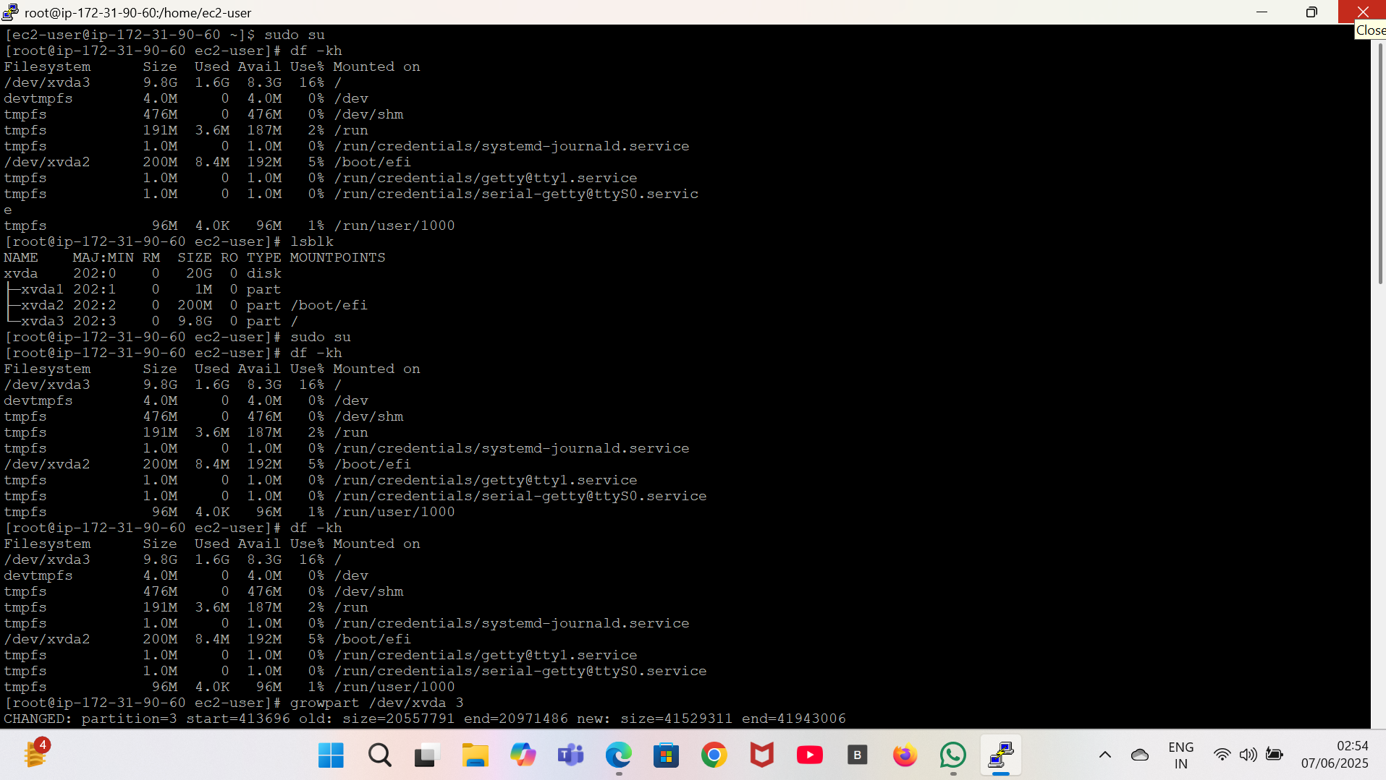

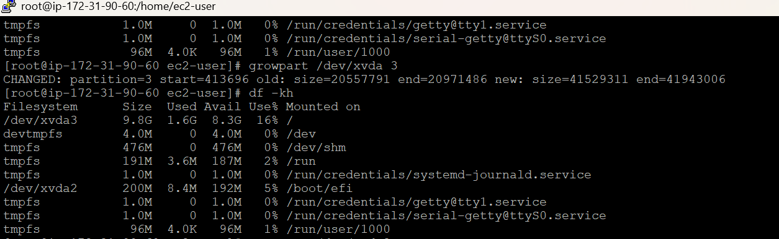

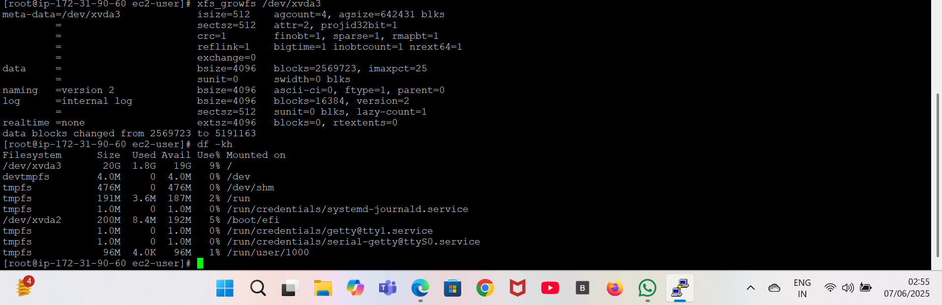

**INTERVIEW QUESTIONS RELATED TO EBS(ELASTIC BLOCK STORAGE)**

1. **What is the maximum size of a single EBS volume?**  
   a) 16 TB  
   b) 32 TB  
   c) 64 TB  
   d) 100 TB  
   **Answer:** b) 32 TB
2. **Can an EBS volume be attached to more than one EC2 instance at the same time?**  
   a) No  
   b) Yes, with EBS Multi-Attach  
   c) Yes, for all EBS volume types  
   d) Only in different availability zones  
   **Answer:** b) Yes, with EBS Multi-Attach
3. **What happens to the data on an EBS volume when the attached EC2 instance is terminated?**  
   a) It is automatically deleted.  
   b) It is preserved unless the “Delete on Termination” option is enabled.  
   c) It is always preserved.  
   d) It depends on the instance type.  
   **Answer:** b) It is preserved unless the “Delete on Termination” option is enabled.
4. **Which EBS feature allows you to increase volume size without downtime?**  
   a) Elastic Volumes  
   b) Multi-Attach  
   c) Volume Snapshot  
   d) Auto Scaling  
   **Answer:** a) Elastic Volumes
5. **Which of the following can affect EBS volume performance?**  
   a) Volume type  
   b) Instance type  
   c) Network bandwidth  
   d) All of the above  
   **Answer:** d) All of the above
6. **What happens when you detach an in-use EBS volume from an EC2 instance?**  
   a) The data on the volume remains intact.  
   b) The volume is deleted.  
   c) The volume is formatted automatically.  
   d) The volume loses all data.  
   **Answer:** a) The data on the volume remains intact.
7. **How does encryption impact EBS performance?**  
   a) Encryption does not impact performance significantly.  
   b) Encryption always reduces performance by 50%.  
   c) Encryption doubles the latency.  
   d) Encryption improves performance for high IOPS workloads.  
   **Answer:** a) Encryption does not impact performance significantly.
8. **Are EBS volumes encrypted by default?**  
   a) Yes, in all AWS accounts  
   b) No, encryption must be manually enabled  
   c) Yes, in supported regions or accounts with default encryption enabled  
   d) No, encryption is only available for gp3 volumes  
   **Answer:** c) Yes, in supported regions or accounts with default encryption enabled
9. **Which AWS service stores EBS snapshots?**  
   a) S3  
   b) Glacier  
   c) RDS  
   d) Lambda  
   **Answer:** a) S3
10. **Which AWS regions support EBS volumes?**  
    a) Only specific regions  
    b) All AWS regions  
    c) Only US-based regions  
    d) Only regions with high-latency connections  
    **Answer:** b) All AWS regions
11. **Which of the following describes the primary advantage of EBS over instance store?**  
    a) Persistent storage  
    b) Lower cost  
    c) Better performance  
    d) No need for snapshots  
    **Answer:** a) Persistent storage

12.What are the differences between instance store (ephemeral) and EBS-backed EC2 instances, and when would you choose one over the other?

Answer: Ephemeral instances use instance store volumes, which provide high-speed, temporary storage. EBS-backed instances use network-attached EBS volumes for durable storage. The choice depends on the need for data durability; EBS-backed instances are preferred for important data, while instance store is suitable for temporary, high-performance storage.

13.Explain the process of attaching and managing EBS volumes to EC2 instances.

Answer: To attach an EBS volume to an EC2 instance, you:  
 Create an EBS volume and specify its size and type.  
 Attach the volume to the instance using the AWS Management   
 Mount and format the volume on the instance to make it usable.