**LAMBDA**

**What are Lambdas Functions?**

AWS lambda are server-less compute functions are fully managed by the AWS where developers can run their code without worrying about servers. AWS lambda functions will allow you to run the code without provisioning or managing servers.

Once you upload the source code file into AWS lambda in the form of ZIP file then AWS lambda will automatically run the code without you provision the servers and also it will automatically scaling your functions up or down based on demand. AWS lambda are mostly used for the event-driven application for the data processing[Amazon S3 buckets](https://www.geeksforgeeks.org/introduction-to-aws-simple-storage-service-aws-s3/), or responding to HTTP requests.

**Example:**

1. Process data from Amazon S3 buckets.
2. Respond to HTTP requests.
3. Build serverless applications.

**Use Cases of AWS Lambda Functions**

You can trigger the lambda in so many ways some of which are mentioned below.

1. **File Processing:**AWS lambda can be triggered by using simple [storage services (S3)](https://www.geeksforgeeks.org/introduction-to-aws-simple-storage-service-aws-s3/). Whenever files are added to the S3 service Lambda data processing will be triggered.
2. **Web Applications:** You can combine both web applications and AWS lambda which will scale up and down automatically based on the incoming traffic.
3. **IoT (Internet of Things) applications:**You can trigger the AWS lambda based on certain conditions while processing the data from the device which are connected to the IOT applications. It will analyze the data which are received from the IOT application.
4. **Stream Processing:** Lambda functions can be integrated with the Amazon kinesis to process real-time streaming data for application tracking, log filtering, and so on.

**Lab Steps**

Task 1: Sign in to AWS Management Console

1. Click on the Open Console button, and you will get redirected to AWS Console in a new browser tab.

2. On the AWS sign-in page,

· Leave the Account ID as default

·Now enter your username and password.

3. click on sign-in.

4.After signing in select US East (N. Virginia) us-east- as AWS region.

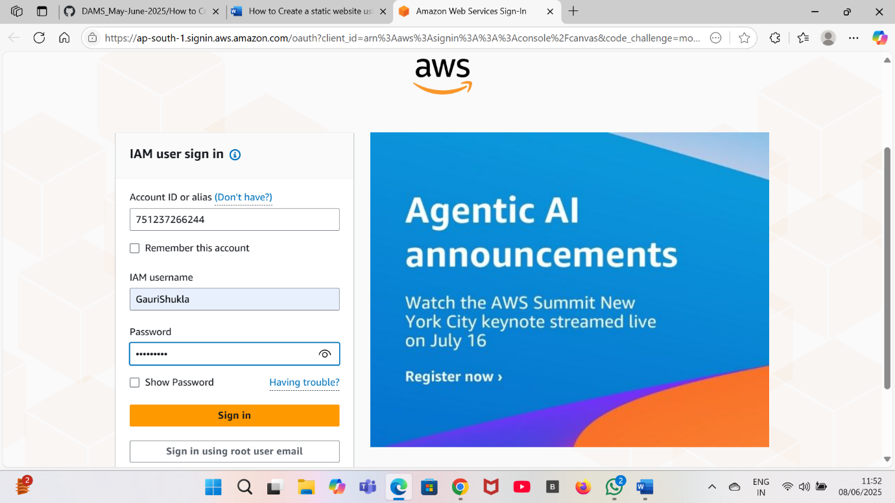

Task 2: Creating Lambda Function

1. Click on the search bar and enter Lambda and click on lambda.
2. Click on Create a Function.
3. Click on Author from scratch.
4. Enter function name.
5. Now click on create function.
6. Your first lambda function is created successfully.

