LINUX

**Lab Steps:**

Task 1: Sign in to AWS Management Console

1. Click on the Open Console button, and you will get redirected to AWS Console in a new browser tab.

2. On the AWS sign-in page,

· Leave the Account ID as default

·Now enter your username and password.

3. click on sign-in.

4.After signing in select Asia Pacific (Mumbai) ap-south- AWS region.

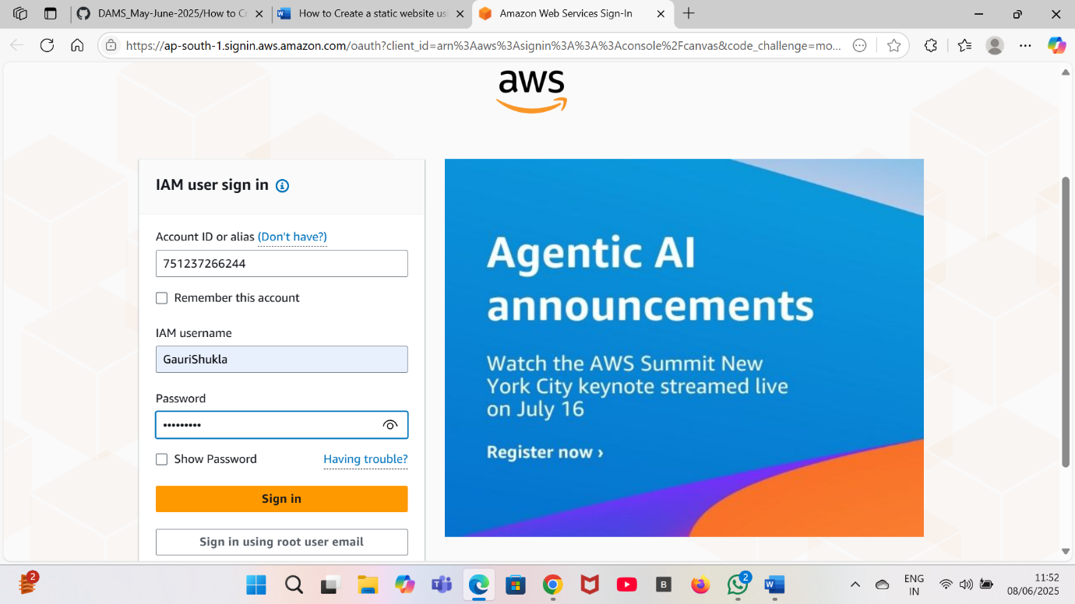

Task 2: Launch an EC2 Instance

1.Click on search bar. Enter EC2. Click on EC2.

2.Click on instances on the left side. Click on create instance.

3.Enter the details:

a. Instance Name:Enter instance name.

b.AMI:Ubuntu

c.Keypair: Click on create key pair . Enter key pair name.

d.key pair type:RSA

e.Private key format:.ppk

5.Your instance is launched.

Task 3: Connecting using Putty

1. Open the instance which you have launched.
2. Click on connect.
3. Under EC2 Instance Connect . Copy the Public IPv4 address.
4. Now open the putty. And paste the Public IPv4 address which you have copied earlier in the Host Name or IP address .
5. Now in the left side in category click on SSH and in SSH click on Auth . Now browse the key pair file which is saved in your system after creating the key pair.
6. And click on open.
7. A dialog box will appear click on accept.
8. Now enter the username present under EC2 Instance Connect.

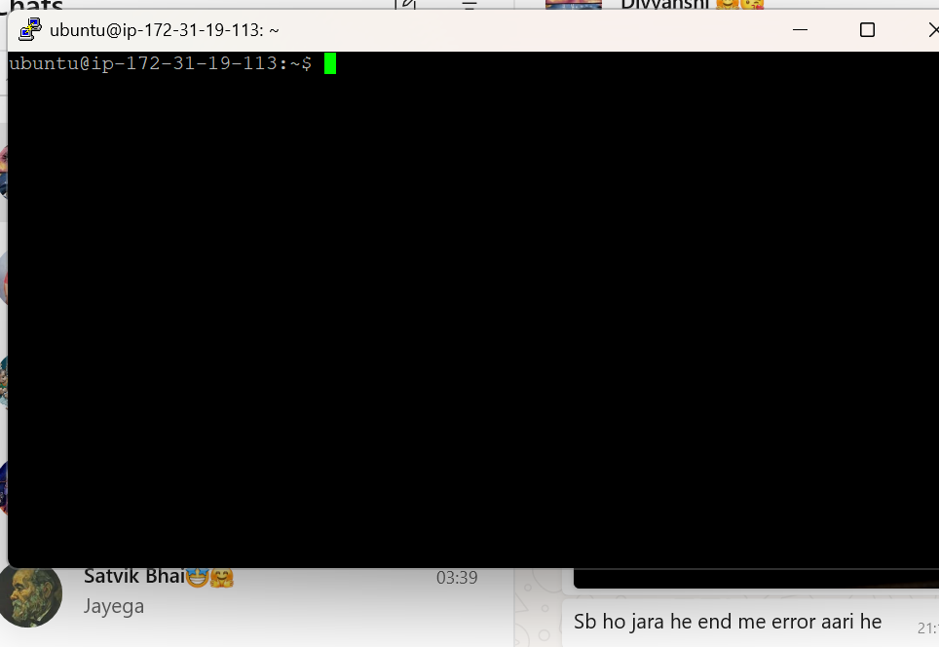

1. Now run the commands.

clear – Clear the terminal screen.

pwd – Show current folder path.

mkdir – Make a new folder.

cd – Change to another folder.

touch – Create a new empty file.

ls – List files in a folder.

ls -lrth – List files by oldest to newest with details and sizes

h means human readable

date – Show date and time.

rmdir – Remove empty folder.

vi – Open and edit a file.(use i to insert and after writing use esc and then : and write wq)

cat – Show file contents.

mv – Move or rename a file.

cp – Copy a file or folder.

rm – Delete a file or folder.

su – Switch to another user.

du – Show folder/file size.

df – Show disk space info.

ps – Show running processes.

id – Show user identity info.

wc – Count words/lines/chars.

grep – Search text in files.

sudo – Run as admin(root)

useradd – Add a new user.

passwd – Change user password.

kill – Stop a running process.

sed – Find and replace in text.

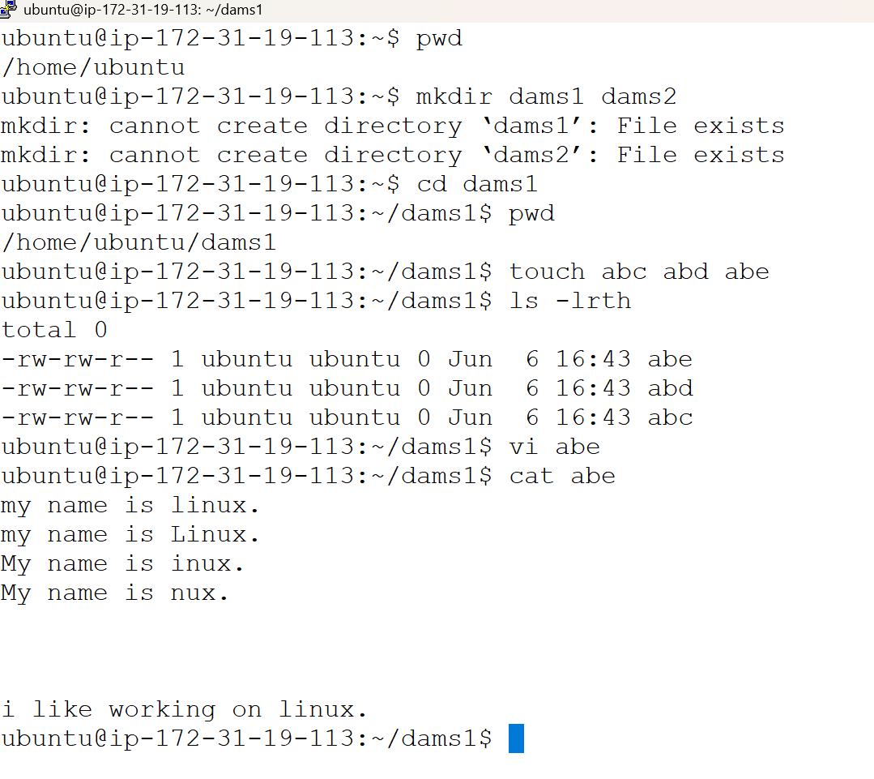

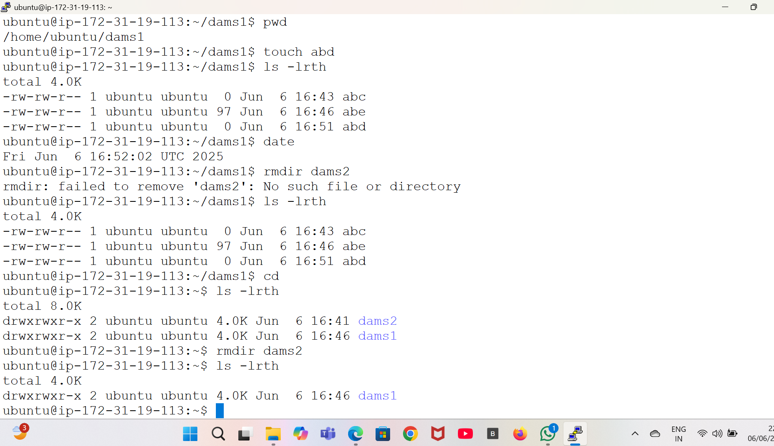

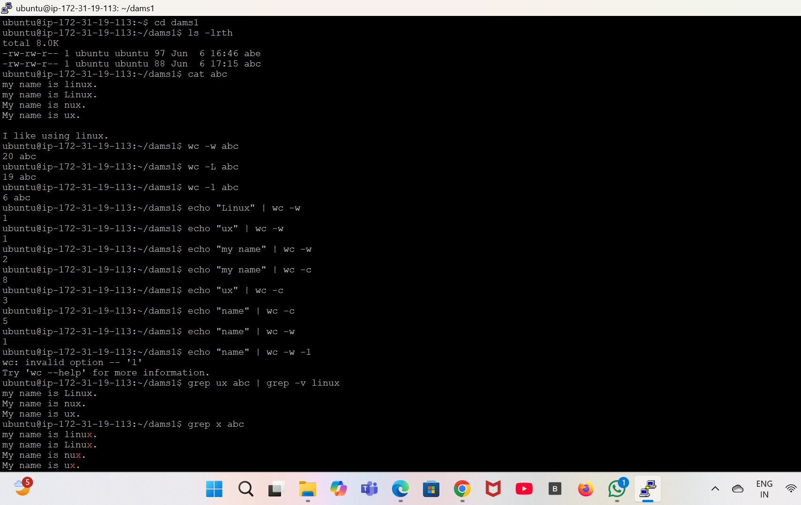

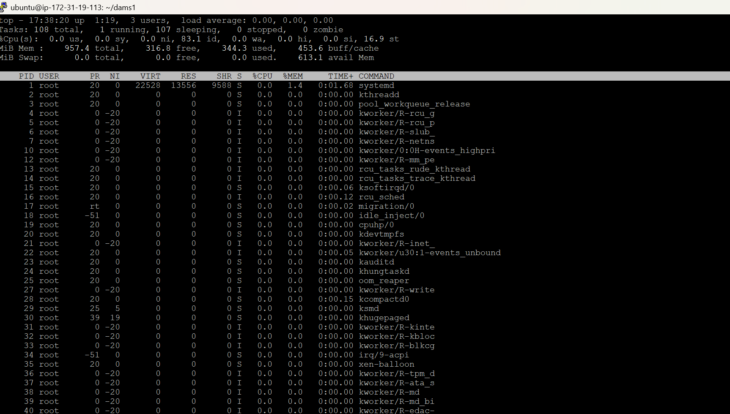

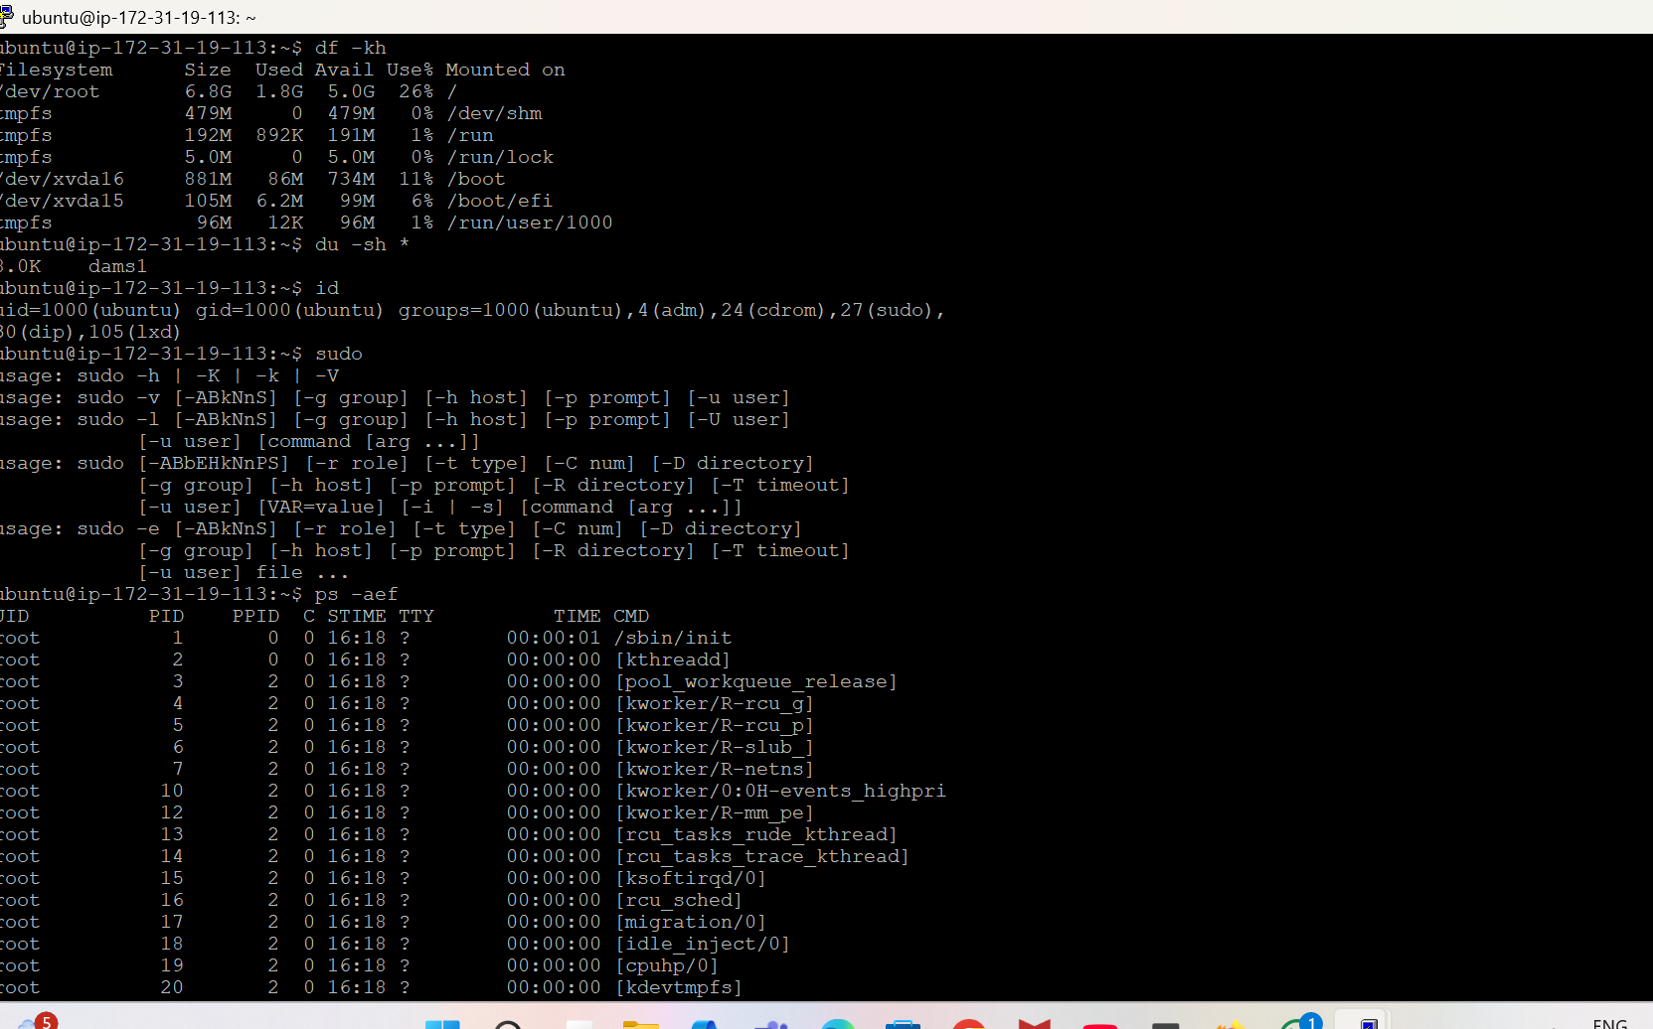

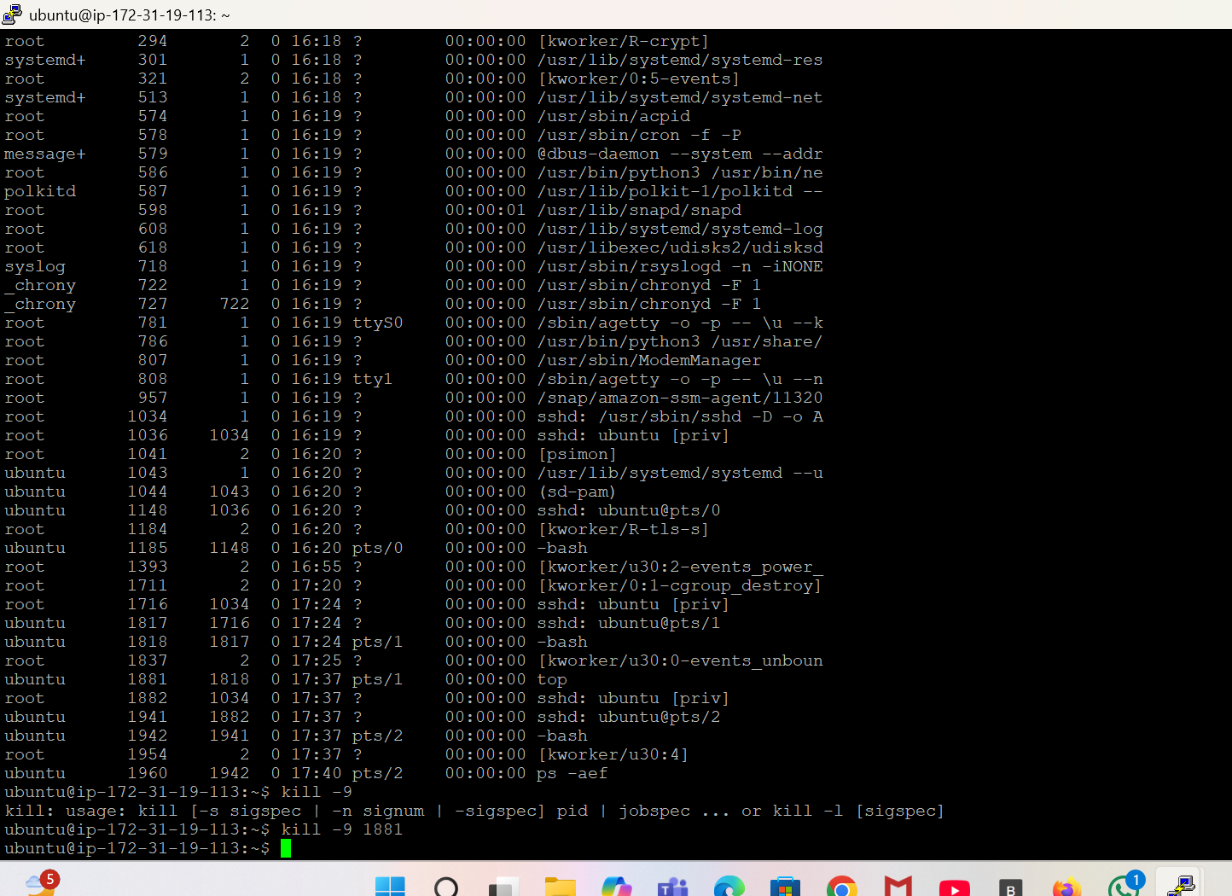

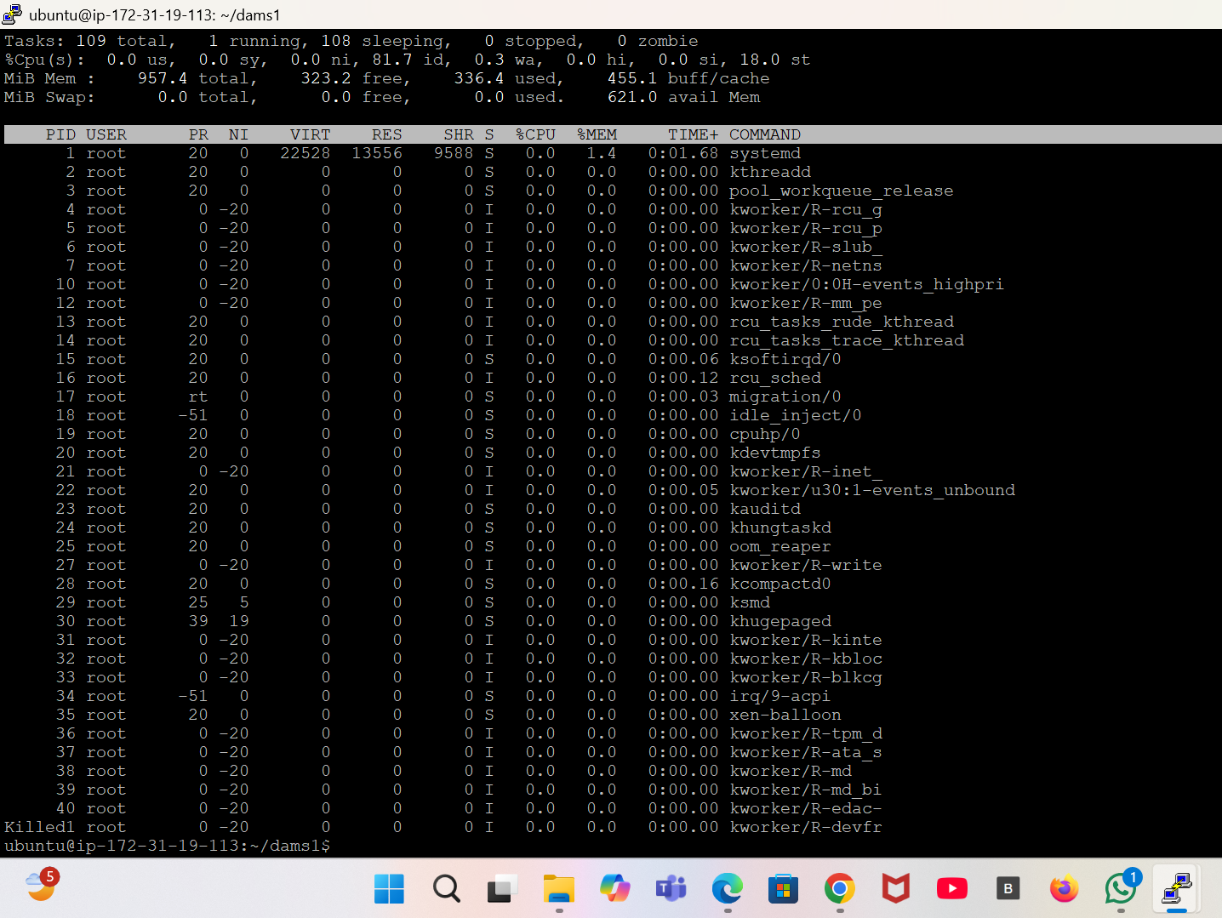

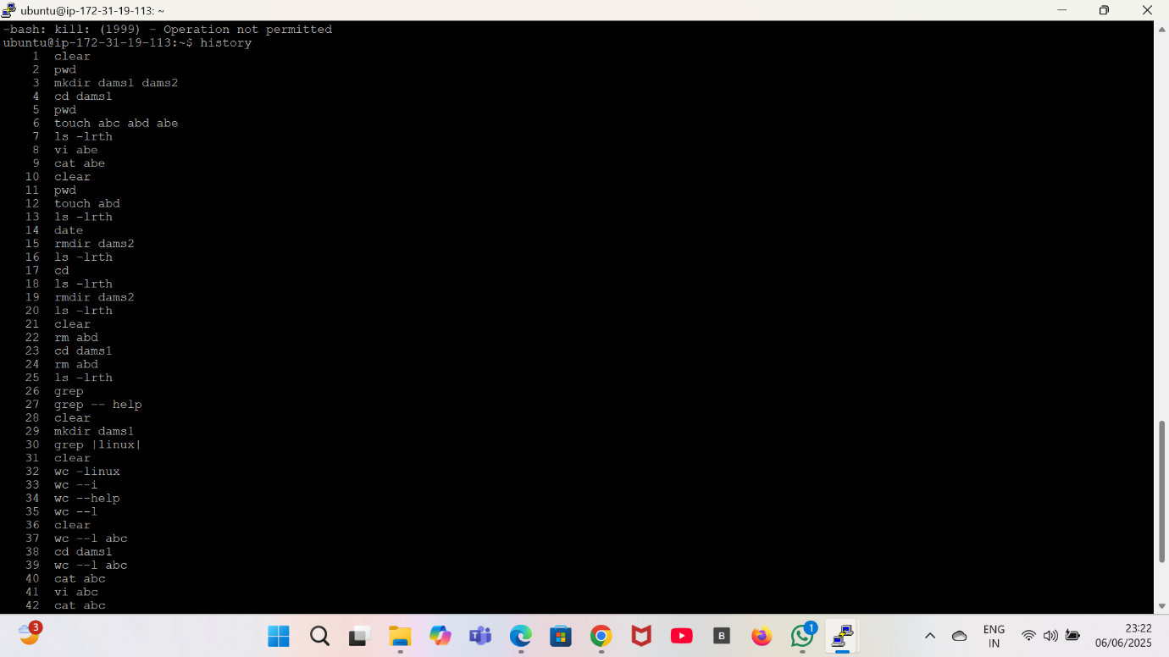

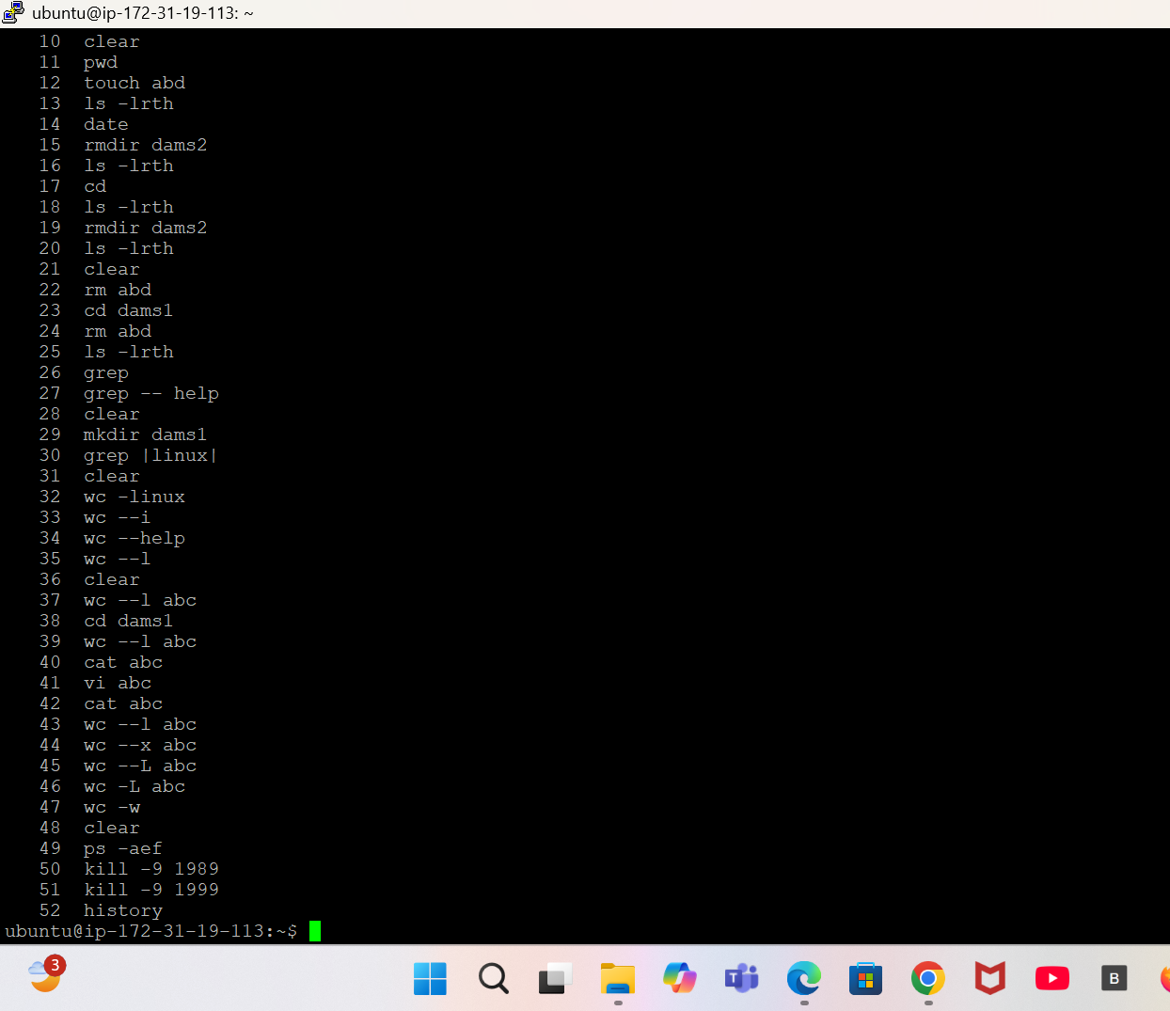

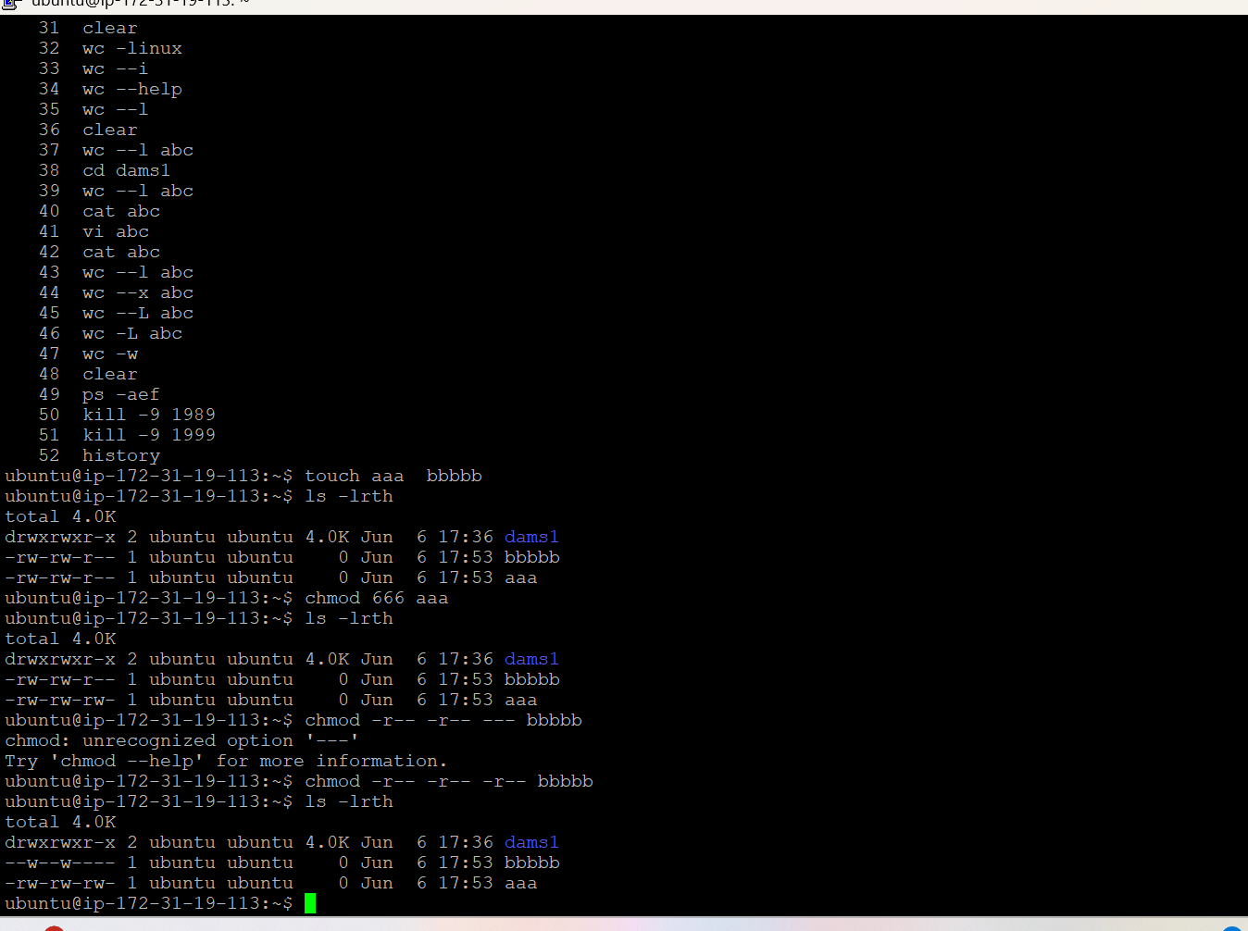

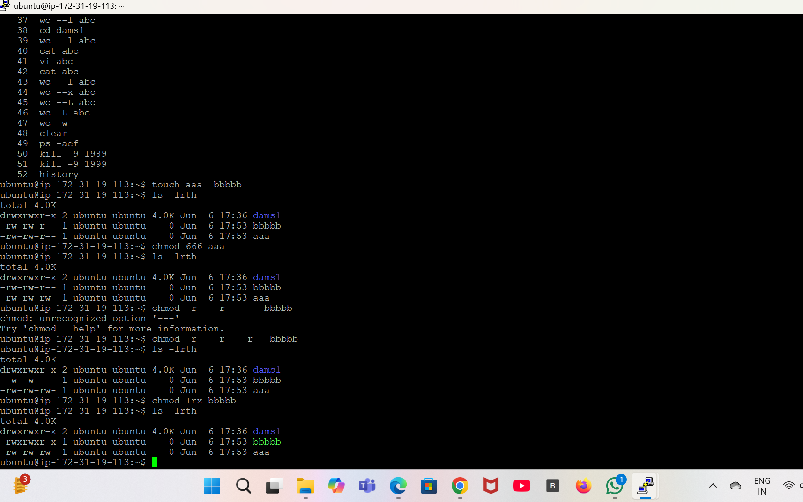

For Creating a Web Server

1. Work in the same terminal opened above .
2. Install the apatche web server using the link given below

<https://www.digitalocean.com/community/tutorials/how-to-install-the-apache-web-server-on-ubuntu-20-04>.

1. After clicking on the link copy the following commands one by one and run them on the terminal :

sudo apt update

sudo apt install apache2

sudo systemctl status apache2

1. Now open the browser and paste the public IPv4 address on the instance with which you have connected the terminal.
2. Now click enter.
3. Now enter the commands:

cd/var/www

Is

pwd

cd html

pwd

ls -lrth

sudo mv index.html (enter the name of the text file which you’ve created earlier in this section using touch command)

sudo vi index.html(for writing inside the html file)

1. Now again run the public IPv4 address on the browser and you’ll be able to see the text which you’ve written in the html file.

