# ULTRASONIC GLOVES FOR BLIND PERSON

Submitted by

**MAHADDEV PUNAM NAVNATH (B190103846) SHETE GAURI JALINDAR (B190103859) NEHE KIRTI LAXMAN (B190103853)**

In partial fulfilment of **Bachelor of Engineering (BE Electrical)**

Savitribai Phule Pune University, Pune



Department of Electrical Engineering

**Amrutvahini College of Engineering, Sangamner.**

# ULTRASONIC GLOVES FOR BLIND PERSON

Submitted by

**MAHADDEV PUNAM NAVNATH (B190103846) SHETE GAURI JALINDAR (B190103859)**

**NEHE KIRTI LAXMAN (B190103853)**

In partial fulfilment of **Bachelor of Engineering (BE Electrical)**



Guided By

#### Er. D. A. Mhaske

Department of Electrical Engineering

**Amrutvahini College of Engineering, Sangamner**

**CERTIFICATE**

This is to certify that, the Mini-project “**ULTRASONIC GLOVES FOR BLIND PERSON**” submitted by **Mahaddev Punam Navnath (B190103846), Shete Gauri Jalindar (B190103859), Nehe Kirti Laxman (B190103853)** is a bonafide work completed under my supervision and guidance in partial fulfilment for award of Bachelor of Engineering (Electrical) degree of Savitribai Phule Pune University, Pune.

Place: Sangamner Date:

##### Er. D.A. Mhaske

Project Guide

Dept. of Electrical Engineering

##### Dr. V. S. Ubale

Project Coordinator

Dept. of Electrical Engineering

##### Dr. S. S. Gundal

Head

Dept. of Electrical Engineering

##### Dr. M. A. Venkatesh

Principal

Amrutvahini College of Engineering, Sangamner

# Savitribai Phule Pune University



**CERTIFICATE**

This is to certify that

**MAHADDEV PUNAM NAVNATH (B190103846) SHETE GAURI JALINDAR(B190103859) NEHE KIRTI LAXMAN (B190103853)**

Students of Electrical was examined in Mini Project entitled

**“Ultrasonic Gloves for Blind Person”**

##### On

**/ / 2024**

**At**

## Department of Electrical Engineering Amrutvahini College of Engineering, Sangamner.

**INTERNAL EXAMINER EXTERNAL EXAMINER**

## ABSTRACT

Vision is the most beautiful and important gift from God to all his creatures especially for human beings. But unfortunately, there are some people who lack this beauty and are unable to capture the beauty of this world from their own eyes. Ultrasonic gloves for blind are a development which involves various areas such as, software engineering, hardware designing and science that enables visually impaired persons to see and explore the world confidently and independently by recognizing the neighboring objects by using ultrasonic waves and inform the person with a beep ring. As per WHO (world health organization) 2.2 billion people suffer from vision impairment [2]. They are facing troubles in their lifestyle. This device can act as an innovation for the visually impaired people. From a lot of advantages, we found the property of being reasonable within a limited cost, a very important merit of the project. The Arduino Pro Mini 328 board is tied like a Gloves. This is provided with ultrasonic sensor, consisting of module. By utilizing this sensor module, the person is able to see the objects near them and can travel effectively. At any point where this sensor senses any object, it informs the person by beep-sound. In this way this becomes a computerized gadget. Accordingly, this gadget will be of utmost use for the blind people and can allow them to move from any place with confidence.

# CONTENTS

##### List of Figurers i

List of Tables ii

List of Photograph iii

1. INTRODUCTION 1
   1. Introduction 1
   2. Need of Project 2
   3. Aim and Objectives of Project 2
   4. Theme of Project 2
   5. Organization of Report 3
2. LITERATURE SURVEY 4
   1. Literature Reviews 4
      1. Waist Belt and Shoes mode of Obstacle Detection 4
      2. Haptic based sensing of obstacles 4
      3. Papers basing on GPS/GSM Technology 4
   2. Components Survey 5
      1. Arduino Nano 5
      2. Ultrasonic Sensor (HCSR-04) 9
      3. Piezo Buzzer 14
   3. Component List and Cost of Component 15
3. SYSTEM DEVELOPMENT 16
   1. The Concept 16
   2. Block Diagram of Project 16
      1. Block Diagram 17
      2. Circuit Diagram
   3. General Description of Flowchart 18
   4. Flow Chart 19
   5. Software 20
4. PERFORMANCE ANALYSIS 23
   1. System Analysis 23
   2. Practical Analysis 24
   3. Analytical Analysis 24
   4. Comparison between Practical and Analytical Analysis 25
   5. Justification for Difference 26
      1. Inaccuracy of measurement 27
   6. Advantages 27
   7. Disadvantage 28
   8. Benefits 28
5. CONCLUSIONS 29
   1. Conclusions 29
   2. Future Scope 29
   3. Application 29

REFERENCES 30

ACKNOWLEDGEMENT 32

**List of Figurers**

|  |  |  |  |
| --- | --- | --- | --- |
| **Sr. No.** | **Figurers** | **Illustration** | **Page** |
| 1 | 3.1 | System Block diagram | 16 |
| 2 | 3.2 | Circuit Diagram | 17 |

##### List of Photographs

|  |  |  |  |
| --- | --- | --- | --- |
| **Sr. No.** | **Photographs** | **Illustration** | **Page** |
| 1 | 2.1 | Arduino Nano | 10 |
| 2 | 2.2 | Ultrasonic Sensor | 10 |
| 3 | 2.3 | Jumper Wire | 13 |
| 4 | 2.4 | Piezo Buzzer | 15 |
| 5 | 3.1 | Arduino IDE | 20 |
| 6 | 3.2 | HCSR04 Interfacing With Arduino Nano | 21 |
| 7 | 3.3 | Final Project | 21 |
| 8 | 3.4 | Testing in Actual Environment | 22 |

##### List of Tables

|  |  |  |  |
| --- | --- | --- | --- |
| **Sr. No.** | **Table** | **Illustration** | **Page** |
| 1 | 2.1 | Arduino Nano Specification | 9 |
| 2 | 2.2 | Cost Analysis | 15 |
| 3 | 3.1 | System Analysis | 23 |
| 4 | 3.2 | Arduino nano Analytical Values | 24 |
| 5 | 3.3 | Arduino nano Practical Values | 24 |
| 6 | 3.4 | Practical Values Vs Analytical Values | 25 |

**CHAPTER 1**

### INTRODUCTION

##### Introduction

Since the running of daily life of blind people is very difficult. This project helps them to run their life as usual. They can make this project as a gadget or a device in their hands which detects the obstacle. This project is more efficient than the existing system with cheaper and accurate one. Here we are using Arduino NANO board to perform this operation. To make the life to be as a normal one for the blind peoples this may be very helpful project for them. By making this as a gadget or a device in their hand they can easily judge an object by their own by knowing the buzzer sound [3]. The system uses ultrasonic sensor as the target of this task.

This project for the blind or visually impaired person will provide a gadget that is helpful to them as well as the persons who depend on any individual due to lack of sight. Third eye for blind task can be an innovation for the sightless individuals, it will help them to move from here and there and among different places with confidence by knowing the nearest obstructions while wearing the gloves which leaves the ultrasonic waves which inform the person with beep-sound. It can let the person who is not able to move and distinguish even snags due to lack of vision. They just have to put on the gadget as a glove or it can be adjusted on the dress on their body.

With the improvement of the living standards of the people, we have become so materialistic that we have forgotten how the physically disabled people live a tough life. They undergo rigorous, apathetic and indifferent behavior towards them for being physically disabled. They become dependent on other people in a way for their day-to- day routine chores. Blind and impaired persons always depend on other people for their locomotion. Eye are prime sense of organ in perceiving the outside environment; function of such prime sense organ severely effects the knowledge perceiving capability of the outside environment. Therefore, going around to places in such environment is a very big challenge because the blind people cannot depend on their own eyes and thus face many difficulties. The objective of this project Ultrasonic Gloves for the Blind is to design a product which is very much useful to those people who are visually impaired and those who often have to rely on others [1]. This project is an innovation which helps the visually impaired people to move around and go from one place to another with speed and confidence by knowing the nearby obstacles using the help of the wearable

gloves which produces the ultrasonic waves which notify them with buzz sound. It allows the user those who are visually impaired to walk freely by detecting the obstacles. They only need to wear this device as a glove. Thus, this project Arduino based obstacle detector for blind people is a new method to resolve their problems. A less complex portable, cost efficient, easy to manage an effective system

##### Need of Project

The purpose of this work is to provide an efficient way to help the blind people to navigate with greater comfort, speed and confidence.

##### Aim of Project and Objectives of Project

It allows the user those who are visually impaired to walk freely by detecting the obstacles. Thus, the aim of the project Ultrasonic Gloves for the Blind is to develop a cheap, affordable and more efficient way to help the blind people to navigate with greater comfort, speed and confidence.

##### Theme of Project

By wearing this device, they can fully avoid the use of white cane and such other devices. This device will help the blind to navigate without holding a stick which is a bit annoying for them. They can simply wear it as a glove and it can function very accurately and they only need a very little training to use it.

##### Organization of Report

The various stages involved in the development of this project have been properly put into five chapters to enhance comprehensive and concise reading. In this project thesis, the project is organized sequentially as follows:

Chapter one of this work is on the introduction to this study. In this chapter, the background of third eye for the blind using ultrasonic sensor, aim of ultrasonic gloves for the blind using ultrasonic sensor, significance of ultrasonic gloves for the blind using ultrasonic sensor, scope of ultrasonic gloves for the blind using ultrasonic sensor, objective of ultrasonic gloves for the blind using ultrasonic sensor, limitation and problem of ultrasonic gloves eye for the blind using ultrasonic sensor, advantages of third eye for the blind using ultrasonic sensor was discussed.

## CHAPTER 2

### LITERATURE SURVEY

##### Literature Reviews

* + 1. Waist Belt and Shoes Mode of Obstacle Detection

Parth Dhall, Pankaj Sharma et al. (2016) [6] proposed “A Review Paper on Assistive Shoe & Cane for Visually Impaired People”. In this paper to provide a talkative assistance for a visually impaired person they provided the system architecture and the block diagram of the assistive shoe. In this they implemented the entire work as two modules, one the shoe module, in which a Bluetooth chip, PIC microcontroller along with three IR Sensors are used. Suryavanshi, Mayuri et al. (2016) proposed “Assistance for visually impaired people”. In this they have given the system architecture for the shoe which detects the obstacles. This shoe model is implemented by using the Arduino uno board on which all the circuit components is deployed on to. And for the obstacle detection they used the ultrasonic sensors and other hardware components they used are Micro SDHC Card Series and Bluetooth. N. Rama Murthy,

N. Sudha (2016) [8] proposed “Smart Navigation System for Visually Challenged People”. In this provided the system architecture of waist belt and shoe through which obstacles are detected by the visual impaired people. In this working is done in such a way that it uses 2 sensors at spectacles, 3 sensors at waist belt which are separated by 12cm from each other and 2 sensors in shoe one facing the front and one facing the down.

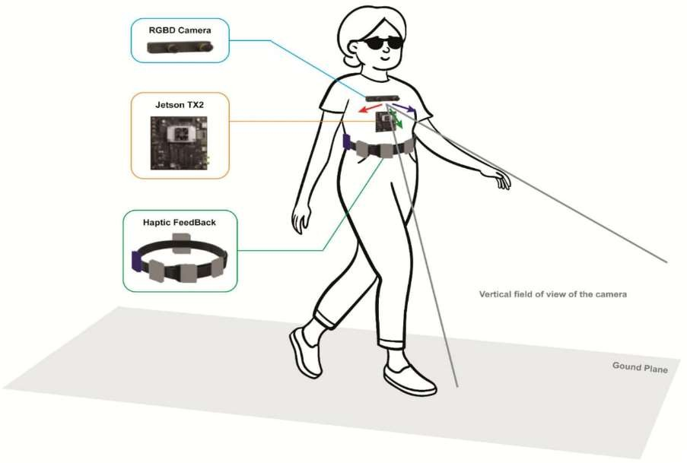

Photograph 2.1.3: Waist Belt Obstacle Detection

* + 1. Haptic Based Sensing of Obstacles

Alejandro, Renato et al. (2012), Chinh Nguyen (2014), and other authors proposed the way of detecting the obstacles based on haptic sensing. These haptic obstacle detectors use the Infrared sensors, Ultrasonic sensors and also for maintaining the time gap they implemented the function avoid tiredness. Haptic sensing can be well accomplished by knowing the surroundings well. By knowing the surrounding environment, it will help a lot from avoiding the obstacles and to choose other way for reaching the desired destination. For the accuracy they tested the cane practically with visual impaired people and got good accuracy in sensing the obstacles.

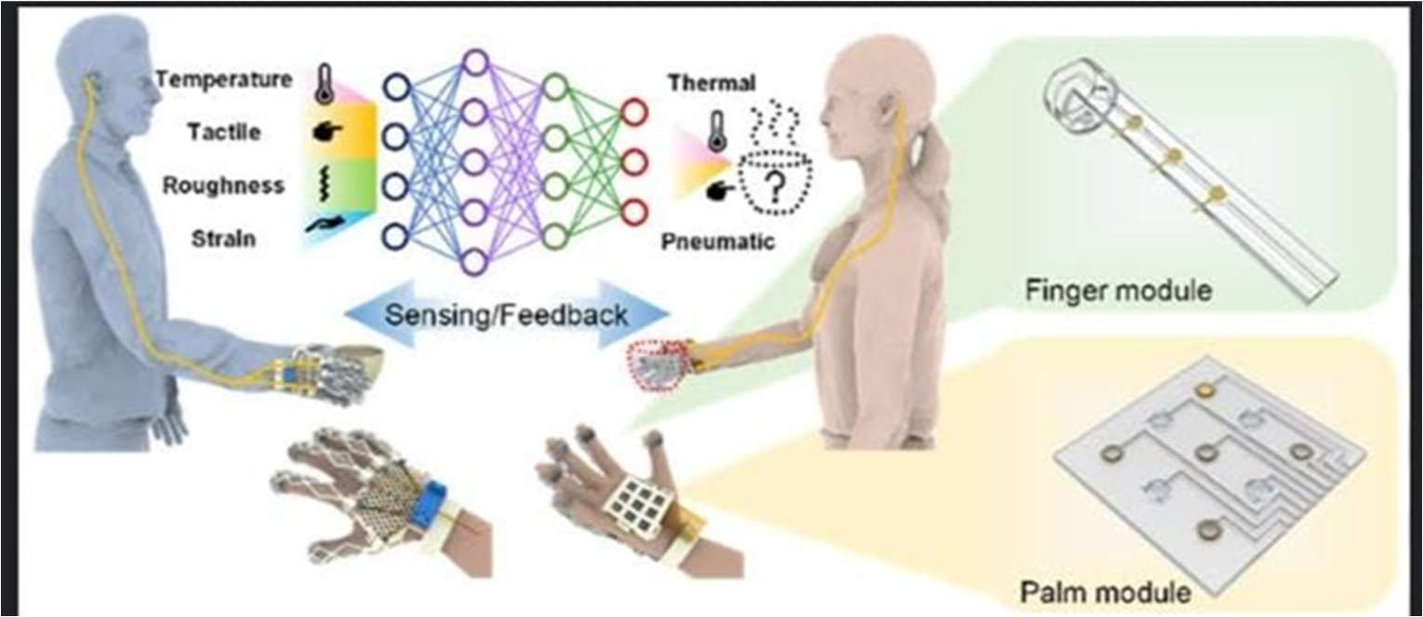

Photograph 2.1.2: Haptic Based Sensing of Obstacles

* + 1. Papers Basing On GPS/GSM Technology

R. Radhika, P.G. Pai, S. Rakshitha and R. Srinath [9] proposed “Implementation of smart stick 9 for obstacle detection and navigation”. This paper refers to the obstacle detection with the help of ultrasonic sensor and IR sensor connected to Arduino AT Mega 328P which has 14 digital input/output pins Ultrasonic sensor detects the range of 3m and IR sensor detects small objects at a range of 50cm, angle +/- 245 degrees upwards and downwards. Arduino is the microcontroller used. By Ljupko Šimunović, Velimir Anđelić, Ivan Pavlinušić (2012) [10], Alberto Rodríguez, Luis M. Bergasa et al. (2012) [8], in this paper they used the stereo camera for capturing the pictures of the location further which are processed by using the image processing technique namely Dense Disparity Map. In which it processes in such a way that it detects the edges of the captured pictures for easy detection of the obstacles. By using those pictures, it is made easy to track the user by equipping the GPS module to the user Somnath koley, Ravi Mishra (2012), S. Madhulika, S. Mohan et al. (2013), Vishwa Rupa, B Santosh (2014), these authors introduced the usage of Braille capacitive touch keypad on the

controller board. It is very helpful for the blind users because they are unable to see the digit buttons. For that as interface for them they used the Braille language. And they equipped the canes with different sensors like Ultrasonic, LDR, Soil moisture sensor, temperature sensor and the major part GPS module through which the location tracking of the user is done. Due to this facility the caretaker of the blind person can know the live location of the process.

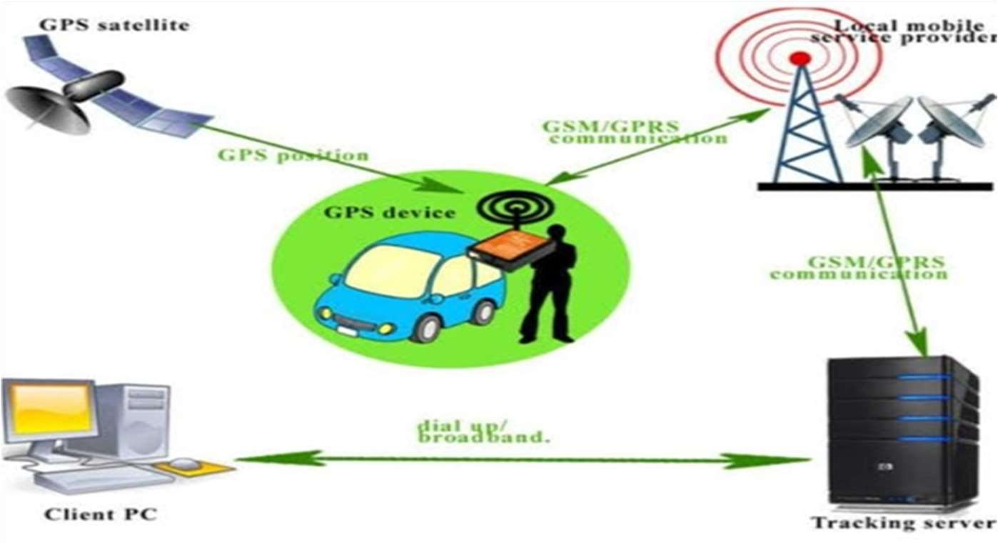

Photograph 2.1.1: GPS/GSM Technology

##### Components Survey

* + 1. Arduino Nano:

The Arduino Nano has a number of facilities for communicating with a computer, another Arduino, or other microcontrollers. The ATmega328 [5] provide UART TTL (5V) serial communication, which is available on digital pins 0 (RX) and 1 (TX). An FTDI FT232RL on the board channels this serial communication over USB and the FTDI drivers (included with the Arduino software) provide a virtual com port to software on the computer. The Arduino software includes a serial monitor which allows simple textual data to be sent to and from the Arduino board. The RX and TX LEDs on the board will flash when data is being transmitted via the FTDI chip and USB connection to the computer (but not for serial communication on pins 0 and 1)[6]. A Software Serial library allows for serial communication on any of the Nano's digital pins. The ATmega328 also support I2C and SPI communication. The Arduino software includes a Wire library to simplify use of the I2C bus.

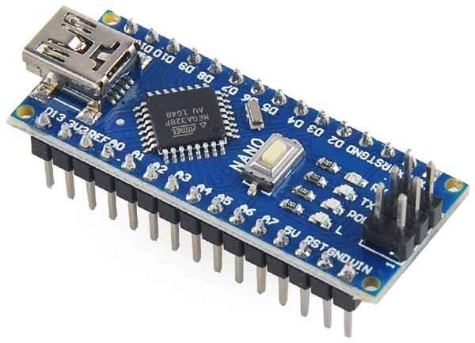

Photograph 2.1: Arduino Nano

Table 2.1: Arduino Nano Specification

|  |  |  |
| --- | --- | --- |
| **Board** | **Name** | **Arduino Nano** |
| SKU | A000005 |
| Microcontroller | ATmega328 |  |
| USB connector | Mini-B USB |  |
| Pins | Built-in LED Pin | 13 |
| Digital I/O Pins | 14 |
| Analog input pins | 8 |
| PWM pins | 6 |
| Communication | UART | RX/TX |
| I2C | A4 (SDA), A5 (SCL) |
| SPI | D11 (COPI), D12 (CIPO), D13 (SCK). Use any  GPIO for Chip Select (CS). |
| Power | I/O Voltage | 5V |
| Input voltage (nominal) | 7-12V |
| DC Current per I/O Pin | 20 mA |

|  |  |  |
| --- | --- | --- |
| Clock speed | Processor | ATmega328 16 MHz |
| Memory | ATmega328P | 2KB SRAM, 32KB flash 1KB EEPROM |
| Dimensions | Weight | 5gr |
| Width | 18 mm |
| Length | 45 mm |

* + 1. HC-SR04 Ultrasonic Sensor Module:

HC-SR04 Ultrasonic Sensor is a very affordable proximity/distance sensor that has been used mainly for object avoidance in various robotics projects. It has also been used in turret applications, water level sensing, and even as a parking sensor [4]. This module is the second generation of the popular HC-SR04 Low-Cost Ultrasonic Sensor. Unlike the first-generation HC-SR04 that can only operate between 4.8V~5V DC, this new version has wider input.

Voltage range, allow it to work with controller operates on 3.3V. HC-SR04 ultrasonic sensor provides a very low-cost and easy method of distance measurement [7]. It measures distance using sonar, an ultrasonic (well above human hearing) pulse (~40KHz) is transmitted from the unit and distance-to-target is determined by measuring the time required for the echo return. This sensor offers excellent range accuracy and stable readings in an easy-to-use package. An on board 2.54mm pitch pin header allows.

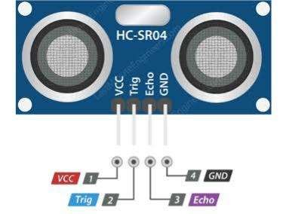

Photograph 2.2: Ultrasonic Sensor

|  |  |
| --- | --- |
| Operating Voltage | 3.3Vdc ~ 5Vdc |
| Quiescent Current | <2mA |
| Operating Current | 15mA |
| Operating Frequency | 40KHz |

|  |  |
| --- | --- |
| Operating Range | 2cm ~ 400cm (1in ~ 13ft) |
| Sensitivity | -65dB min |
| Sound Pressure | 112dB |
| Effective Angle | 15° |

* + 1. Infrared (IR) Sensors:

Infrared sensors work on the principle of reflected light waves. Infrared light reflected from objects or sent from an infrared remote or beacon. Infrared sensors are also used to measure distance or proximity. The reflected light is detected and then an estimate of distance is calculated between sensor and object. Infrared sensor values normally fluctuate in variant light conditions.

When objects pass within the range, the light waves detect those objects and reflect the presence back to the sensor. Their wavelengths are less than that of microwaves. While they’re able to detect motion, they can also measure the emission of heat by an object**.**

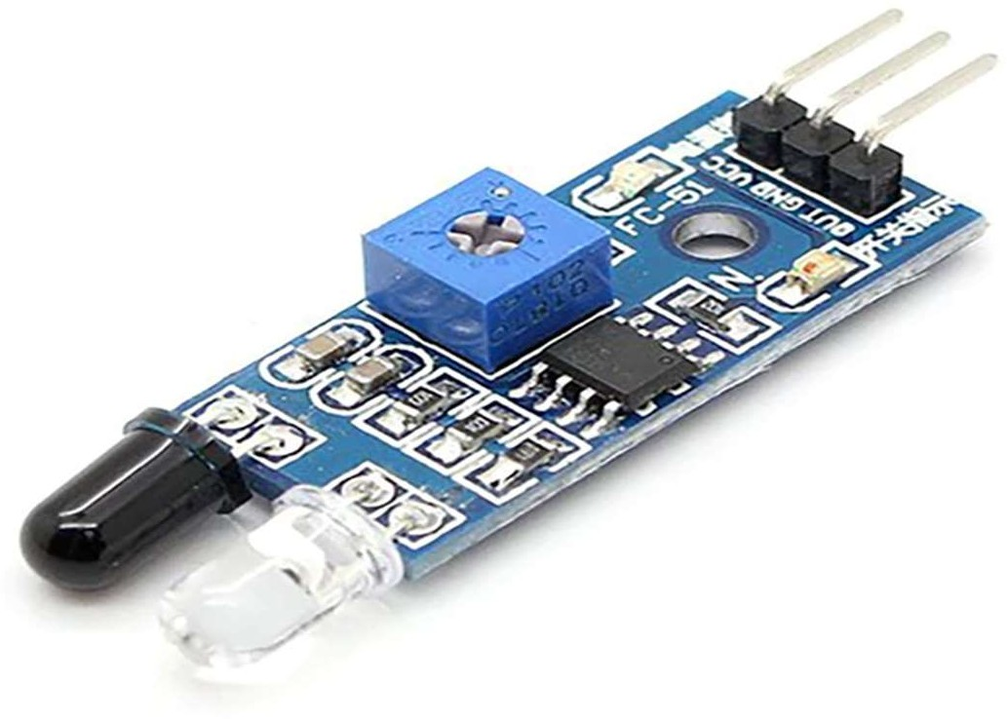

Photograph 2.3: Infrared (IR) Sensors

Conclusion of Ultrasonic vs Infrared:

Choosing your sensor is completely dependent upon your application. There are a lot of limitations in infrared sensors, like the inability to use them in sunlight due to interference. It can make outdoor applications or dark indoor applications difficult. Ultrasonic sensors work using sound waves, detecting obstacles is not affected by as

many factors. If reliability is an important factor in your sensor selection, ultrasonic sensors are more reliable than IR sensors. If you’re willing to compromise reliability for cost, infrared sensors are ideal for your application.

* + 1. PIEZO BUZZER:

The piezo buzzer is an electronic device which generates sound through it. The buzzer is used as an indication to the user. It is used in the car reversing system and braking system as an indication. It is based on the principle of piezoelectricity discovered in 1880 by Jacques and Pierre Curie. An audio signaling device like a beeper or buzzer may be electromechanical or piezoelectric or mechanical type. The main function of this is to convert the signal from audio to sound. Generally, it is powered through DC voltage and used in timers, alarm devices, printers, alarms, computers, etc. Based on the various designs, it can generate different sounds like alarm, music, bell & siren.

Buzzer Pin Configuration

It includes two pins namely positive and negative. The positive terminal of this is represented with the ‘+’ symbol or a longer terminal. This terminal is powered through 6Volts whereas the negative terminal is represented with the ‘- ‘symbol or short terminal and it is connected to the GND terminal.

specifications of the buzzer include the following:

* + - * Color is black
      * The frequency range is 3,300Hz
      * Operating Temperature ranges from – 20° C to +60°C
      * Operating voltage ranges from 3V to 24V DC
      * The sound pressure level is 85dBA or 10cm
      * The supply current is below 15mA

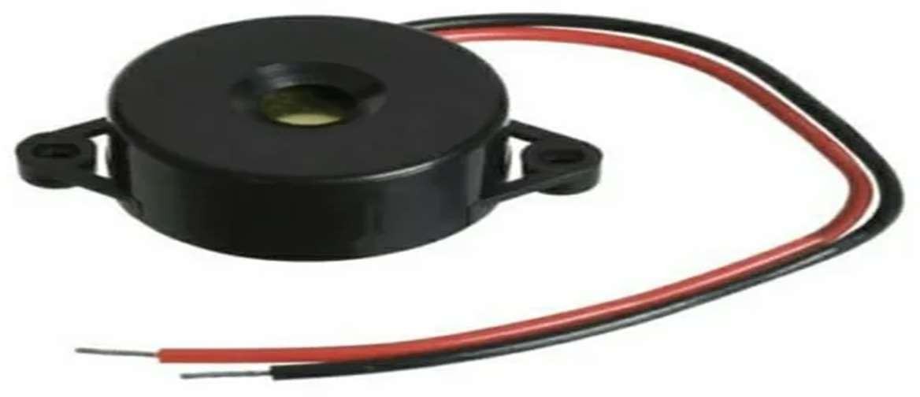

Photograph 2.5: Piezo Buzzer

##### 2.4 Component List and Cost of Component

Table 2.3 Cost Analysis

|  |  |  |  |  |
| --- | --- | --- | --- | --- |
| **Sr. No** | **Name of Component** | **Required number of components** | **Cost per component** | **Total cost** |
| 1 | Arduino nano | 1 | 1200 | 1200 |
| 2 | Ultrasonic sensor | 1 | 105 | 105 |
| 3 | Buzzer | 1 | 10 | 10 |
| 4 | ON/OFF switch | 1 | 20 | 20 |
| 5 | Lithium polymer battery rechargeable | 1 | 550 | 550 |
| 6 | Hand gloves | 1 | 200 | 200 |

## CHAPTER 3

### SYSTEM DEVELOPMENT

##### The Concept

In this project we have decided to developed a system which can detect object and give warning to blind person with beeping sound according to distance between person and obstacle. To developed this system, we have used Arduino nano as a controller and ultrasonic sensor.

##### Block Diagram:

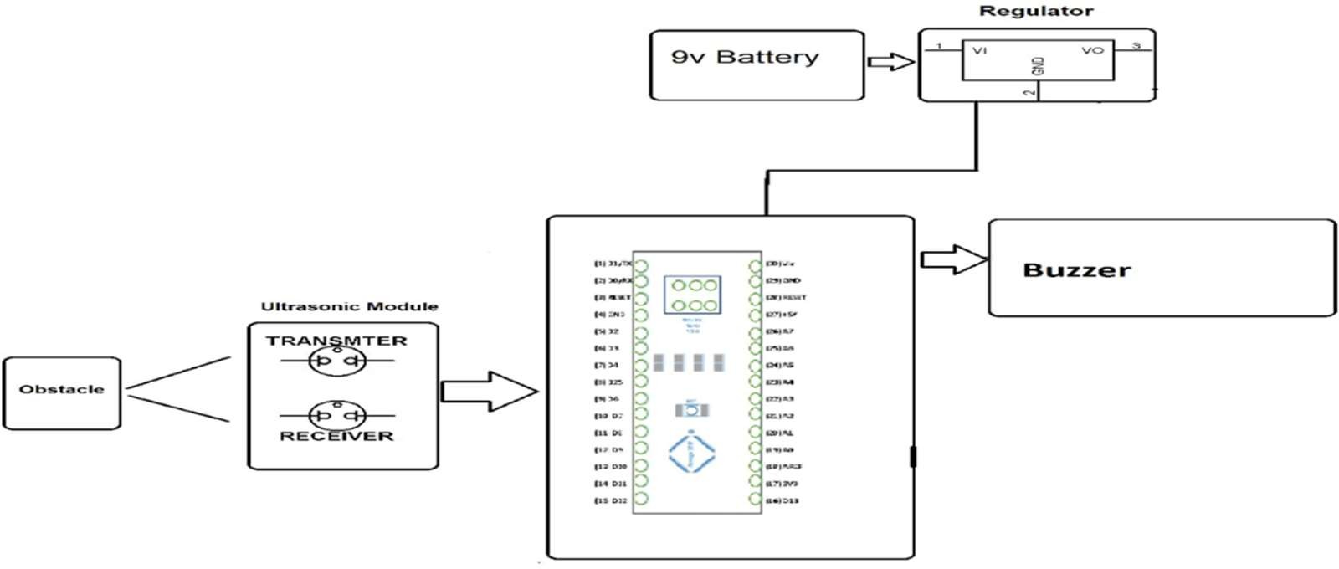

Figure 3.1: Block Diagram

##### Circuit Diagram:

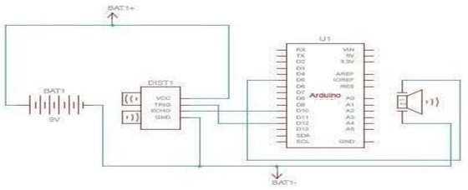

Figure 3.2: Circuit Diagram.

##### General Description of Flowchart:

* + 1. Start the Circuit
    2. System Will Power Up
    3. Ultrasonic Sensor Will Sense the Object
    4. If there is object piezo buzzer Make a Sound
    5. If There is no object Piezo buzzer will not make any sound
    6. It again goes in loop to sense the object
    7. and loop will continue

##### Flow Chart:

Fig. 3.2Flow chart

##### Software

* + 1. Install Arduino IDE – Arduino nano used in system is programable with Arduino IDE that’s why we have to download IDE from Arduino.cc.
    2. Install Arduino nano in Arduino IDE – in Arduino ide we have to install Arduino nano boards without that we cannot upload code
    3. Write code
    4. Check on which com port Arduino nano connected.
    5. Select proper board and com port
    6. Compile code and then Upload it.

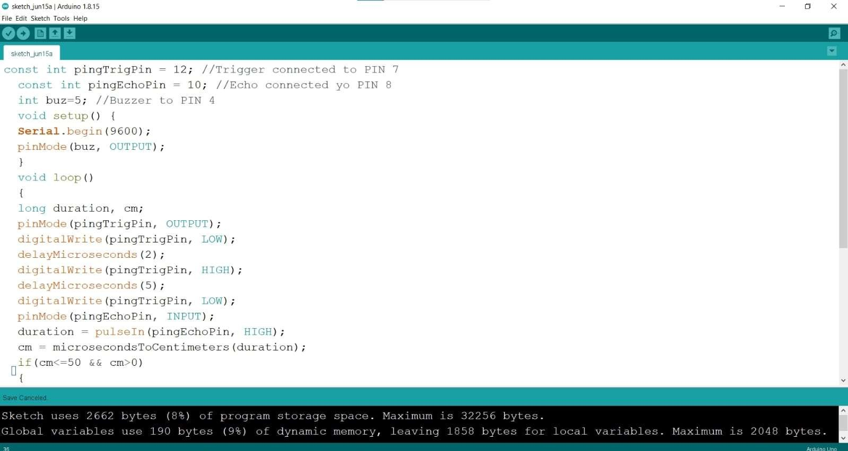

Photograph 3.3: Arduino IDE

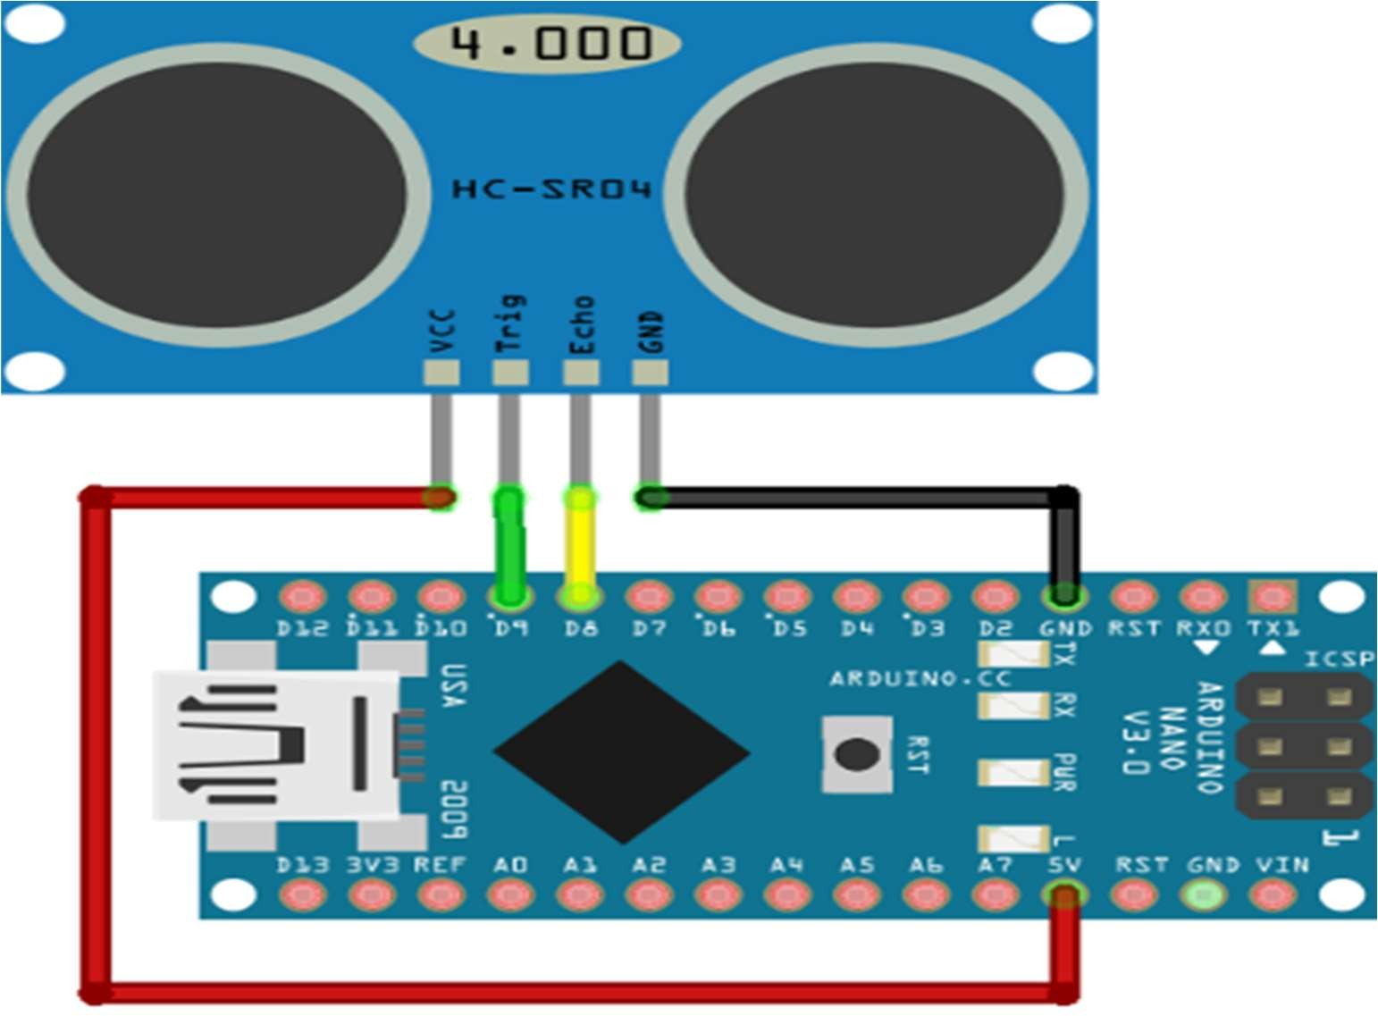

Photograph 3.4: Ultrasonic Sensor Interfacing with Arduino Nano

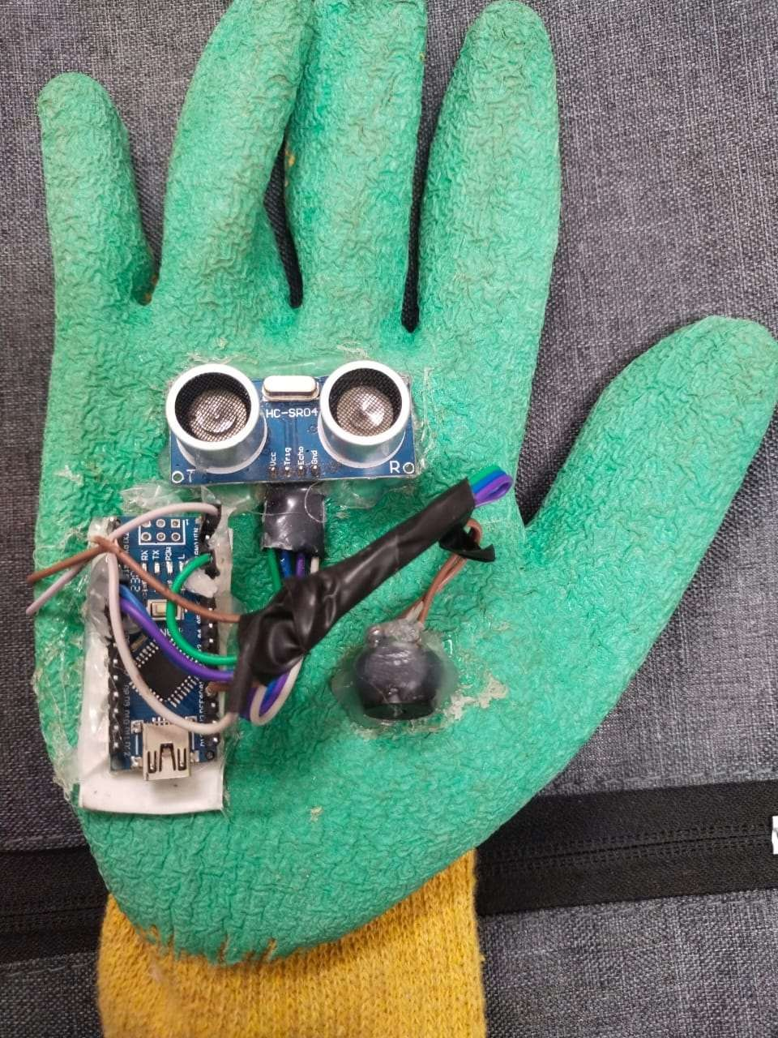

Photograph 3.5: Final Project

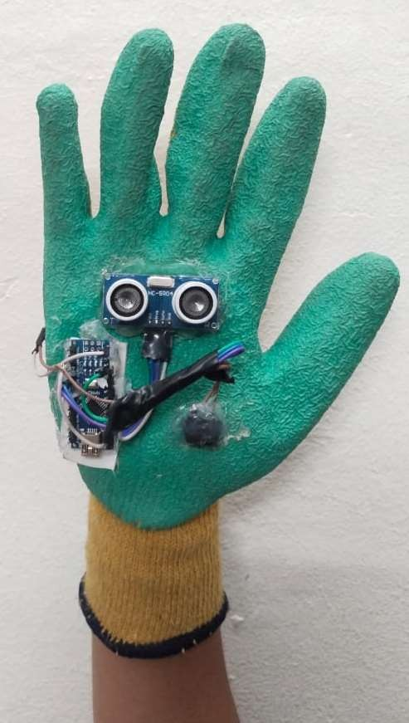

Photograph 3.6: Testing in Actual Environment

## CHAPTER 4

##### System Analysis

* + 1. Arduino Nano
       - IC Used: ATMEGA328
       - Operating Voltage: 5V
       - Input Voltage: 7-12V
       - Digital I/O Pins: 14
       - Analog Input Pins: 8
       - Flash Memory: 32KB
       - SRAM: 2KB
       - EEPROM :1KB
    2. Ultrasonic Sensor
       - Operating Voltage :5V
       - Operating Current: 15mA
       - Operating Frequency: 40KHz
       - Max Range: 400 cm
       - Min Range: 2 cm
       - Measuring Angle: 15 Degree
       - Ranging Accuracy: 3mm

Table 4.1 System Analysis

|  |  |  |
| --- | --- | --- |
| **Obstacles Condition** | **Indication by Buzzer Sound** | **Result** |
| No Obstacles | No Buzzer Sound | No Obstacle |
| Obstacle < 50 Cm | Low Buzzer Sound | Obstacle Are  At 50 Cm |
| Obstacle < 20 Cm | Medium Buzzer Sound | Obstacle Are  At 20 Cm |
| Obstacle < 10 Cm | High Buzzer Sound | Obstacle Are  At 10 Cm |



**4.2. Practical Analysis**

Third eye for blinds is an innovation which helps the blinds people to navigate with speed and confidence by detecting the nearby obstacles using the help of ultrasonic waves and notify them with buzzer sound. They only need to wear this device as a glove.

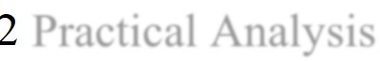

Practical Analysis

Table 4.

2

|  |  |  |
| --- | --- | --- |
| **Sr no** | **component** | **Practical value** |
| 1. | Ultrasonic sensor | 4.75V |
| 2. | Arduino uno | 5.13V |
| 3. | Buzzer | 5.14V |



**4.3. Analytical Analysi**

This is the first wearable technology for blinds which resolves all the problems of existing technologies. Now a days there are so many instruments and smart devices for visually impaired peoples for navigation but most of them have certain problems for carrying and the major drawbacks is those need a lot of training to use. The one of the main peculiarities of this innovation is, it is affordable for everyone, the total cost being less than $30 (~2100INR). There are no such devices available in the market that can be worn like a cloth and having such a low cost and simplicity. When used on a large scale, with improvements in the prototype, it will drastically benefit the community.

**s**

Table 4.

3

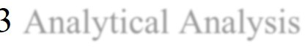

Analytical Analysis

|  |  |  |
| --- | --- | --- |
| **Sr no** | **Component** | **Analytical value** |
| 1. | Ultrasonic sensor | 5V |
| 2. | Arduino nano | 5V |
| 3. | Buzzer | 5V |

##### 4.4. Comparison Between Practical and Analytical Analysis:

Table 4.4 Comparison

|  |  |  |  |  |
| --- | --- | --- | --- | --- |
| **Sr no** | **Component** | **Analytical**  **value** | **Practical**  **value** | **Output** |
| 1. | Ultrasonic sensor | 5V | 4.75V | It detects the  distance of the obstacle |
| 2. | Arduino nano | 5V | 5.13V | It produces the clock  of precise frequency |
| 3. | Buzzer | 5V | 5.14V | These microcontroller devices help in sensing and controlling the objects in the real- time situations and  environment |

Generally speaking, a theoretical approach differs from an analytical approach because each one serves a different purpose. In general, a theoretical approach enjoys a strong evidential foundation collected and verified through extensive applications of scientific methods whose main objective is to explain a phenomenon. For instance, theoretical approaches concerning humanities and social sciences tend to describe various aspects of human behavior, and as a result, provide researchers with practical working models for investigating complex phenomena. By contrast, an analytical approach is methodologically driven and is often used to break a general topic down into its respective constituents in order to provide a lucid explanation about its very nature. Differently stated, it is some kind of formal analysis targeting the reality of a complex structure by explaining the ways by which its internal elements are arranged and function. Ultrasonic Gloves for blind are an innovation which helps the blinds people to navigate with speed and confidence by detecting the nearby obstacles using the help of ultrasonic waves and notify them with buzzer sound. They only need to wear this device as a glove.

This is the first wearable technology for blinds which resolves all the problems of existing technologies. Now a days there are so many instruments and smart devices for visually impaired peoples for navigation but most of them have certain problems for carrying and the major drawbacks is those need a lot of training to use. The one of the main peculiarities of this innovation is, it is affordable for everyone, the total cost being less than $30 (~2100INR). There are no such devices available in the market that can be worn like a cloth and having such a low cost and simplicity. When used on a large scale, with improvements in the prototype, it will drastically benefit the community.

##### Justification of Difference

The project consists of left gloves worn by the user. To begin the gloves activity user, need to direct his hand to know if there were handicap objects around through beep from gloves. Gloves alarm when any object is on its side. In addition, it alarms when any object is in front of the user. Ultrasonic sensor works as input device which sends data of objects around to Arduino microcontroller for processing and sentencing which respond should give Arduino command to buzzer, which work as output device to respond through, gives beep alarm.

* + 1. The proposed device is divided into two main parts:
       - Ultrasonic sensor (input device)
       - Buzzer (output device)

Ultrasonic sensor exports inputs data about objects distance around it to an Arduino to process this data then commanding buzzer to give output in form of beep in accordance with programming of Arduino. Arduino will give buzzer order to alarm with continuous beep when the object is close from the user. When the object keeps away “few” from the user, the Arduino will give buzzer order to alarm with intermittent beep. When the object keeps away “more” from the user, the Arduino will order a buzzer to give no beep. Ultrasonic will back to send waves to find objects. Then repeat the process. Many experiments dedicated to blind gloves was conducted to know the quality of performance expected of them. Here the threshold is set differently to the of the person. I have converted the units coming from the ultrasonic sensor into centimeters. Using this centimeter, it became use to set the threshold and give beep after some distance.

##### 4.4.1 Inaccuracy of Measurement

Every electronic and electrical component have Tolerances of 5% - 10% positive or negative. Tolerances of any component depends on manufacturer as Manufacturer changes Tolerances Changes. Cannot work in a vacuum Because ultrasonic sensors operate using sound, they are completely nonfunctional in a vacuum as there is no air for the sound to travel through. Not designed for underwater use Our sensors have not been properly tested in this environment, so underwater use voids our warranty. This being said, we do supply documentation for customers who would still like to test our sensors underwater. If you are interested in underwater applications with ultrasonics, check out our articles on Water Depth Sensing with Ultrasonics and Underwater Ranging for more information. Sensing accuracy affected by soft materials.

Objects covered in a very soft fabric absorb more sound waves making it hard for the sensor to see the target. Sensing accuracy affected by changes in temperature of 5-10 degrees or more

Although this is true, we have a variety of temperature compensated sensors available that either calibrate upon start-up or before every range reading depending on the sensor model. During this time is when the sensor will calibrate with any change in temperature, voltage, etc. This dramatically decreases this problem. Have a limited detection range .At the moment, our longest range sensors have a maximum range of 10 meters, now our cargo sensor detects up to 16.5m. While this is a disadvantage in certain applications, our sensors have great mid-range capabilities and are still suited for many applications

##### Advantages

1. With the improvement of the living standards of the people, we have become so materialistic that we have forgotten how the physically disabled people live a tough life.
2. They undergo rigorous, indifferent behavior towards them for being physically disabled.
3. They become dependent on other people in a way for their day-to-day routine chores. 4.Blind and impaired persons always depend on other people for their regular activities.
4. Eyes are responsible for observing and listen the outside environment; dysfunction of such prime sense organ severely affects the knowledge perceiving capability of the outside environment.
5. Therefore, going around to places in such an environment is a very big challenge because blind people cannot depend on their own eyes and thus face many difficulties. This project will help them to overcome their obstacles

##### Disadvantages:

1. The smart devices cannot be carried easily, needs a lot of training to use. 2.Battery Common recharging problem.

##### Benefits:

Ultrasonic Gloves for Blind Person is an innovation to help blind people to navigate with greater comfort, speed and confidence, while ultrasonic waves to detect nearby obstacles and to notify the sound of buzzer. This is the first wearable technology for blinds which resolves all the problems of existing technologies Now a days there an instruments and smart devices for visually impaired peoples for navigation but most of them have certain problems for car major drawbacks are: Those need a lot of training use. The one of the main peculiarities of this innovation is, it is affordable for everyone, the total cost being less than$25 (-1500IN There are no such devices available in the market that can be worn like a cloth and having such a low cost and simplicity. With large scale with improvements in the prototype, it will drastically benefit the community.

**CHAPTER 5**

**CONCLUSIONS**

##### Conclusions

Thus, the project, Ultrasonic Gloves for blind people is made sightless individuals to live independently, so as to perform their daily activities easily and more confidently with safety. This Arduino based concept for the blind people is simple, cheap and can be easily carried and maintained. This system is able to scan and detect the hindrances in all directions irrespective of the height or depth the object lies at. With this project, if the construction is done properly, the blind can enjoy the taste of sight and can move freely from one place to another without assistance of the other individual.

##### Future Scope of Project:

The features of Ultrasonic gloves for blind people: By wearing this device they can fully avoid the use of white cane and such other devices. This device will help the blind to navigate without holding a stick which is a bit annoying for them. They can simply wear it as a glove and it can function very accurately and they only need a very little training to use it.

##### Applications:

Ultrasonic gloves for blinds are an innovation which helps the blinds people to navigate with speed and confidence by detecting the nearby obstacles using the help of ultrasonic waves and notify them with buzzer sound. They only need to wear this device as a glove. The rate of beeping increases with decrease in distance and this is a fully automated device.

### REFERENCES

* + 1. Johann Bornstein, Shraga Shovel, Iwan Ulrich. Guide Cane and the Nav Belt, IEEE Transactions on Robotics & Automation. 2003; 10(1):9- 20.
    2. N.G. Bourbakis, D. Demopoulos. "Wearable Obstacle Avoidance Electronic Travel Aids for Blind: A Survey", IEEE Trans. Systems Man and Cybernetics Part C: 3. Applications and Reviews, vol. 40, no. 1, pp. 25-35,2015.
    3. Hugo Fernandes, João Barroso “Blind Guide: an ultrasound sensor-based body area network for guiding blind people “,6th International Conference on Software Development and Technologies for Enhancing Accessibility and Fighting Info exclusion (DSAI 2015)
    4. Sabarish S. Navigation Tool for blind people using Microcontroller, International Journal of Engineering and Advanced Technology (IJEAT), 2013; 2(4):139-143.
    5. Espinosa MA, Ungar S, Ochaíta E. Blades comparing methods for Introducing Blind and Visually Impaired People to unfamiliar urban environments., Journal of Environmental psychology. 1998; 18:277-287.
    6. Pooja Sharma, Shimi SL, Chatterji S. A Review on Obstacle Detection and Vision, International Journal of Science and Research Technology. 2015; 4(1):1-11.
    7. Tahat AA. A wireless ranging system for the blind long cane utilizing a smart- phone, in Proceedings of the 10th International Conference on Telecommunications.
    8. (ConTEL '09), IEEE, Zagreb, Croatia, June. View at Scopus. 2009, 111-117.
    9. Bolgiano D, Meeks Jr E. A laser cane for the blind, IEEE Journal of Quantum Electronics. View at Google Scholar. 1967; 3(6):268.
    10. Amjed Al-Fahoum S, Heba Al-Hmoud B, Ausaila Al- Fraihat A. A Smart Infrared Microcontroller-Based Blind Guidance System”, Hindawi Transactions on Active and Passive Electronic Components. 2013;3(2):1-7.

## ACKNOWLEDGMENT

A project report of **“Ultrasonic Gloves for Blind Person”** such a comprehensive coverage could not have been materialized and would in incomplete without the patient and systematic guidance of my guide **Prof. D.A. Mhaske** would like to express my deep sense of gratitude towards him. I am truly indebted and grateful to our project coordinator **Dr.V.S. Ubale.**

I would like to thank you our **Head of Department Dr. S.S. Gundal** for providing all necessary facilities needed in completion of this project. This project is indeed influenced my skill and knowledge about this topic, which previously I was not aware of. The value stream mapping has given me enough knowledge about this topic including those we see around us to the various application. I am thankful to all those people who help me to complete project report in the allotted time.

#### Mahaddev Punam Navnath (846) Shete Gauri Jalindar (859)

#### Nehe Kirti Laxman (853)

**(BE Electrical)**