**A REPORT**

*On Project*

**GENUINE CHARITY APPLICATION USING BLOCKCHAIN**

*By*

PRANITA SONAWANE (BE B 61, COMPUTER 2022-23)

ANAGHA KULKARNI (BE B 62, COMPUTER 2022-23)

GAURI PAWAR (BE B 63, COMPUTER 2022-23)

NANDINI MARKE (BE B 64, COMPUTER 2022-23)



**K. K. WAGH INSTITUTE OF ENGINEERING EDUCATION AND RESEARCH, NASHIK, MAHARASHTRA.**

**DEPARTMENT OF COMPUTER ENGINEERING**

**DETAILS OF THE PROJECT**

**Problem Statement**

To build Genuine Charity Application using Blockchain Technology.

**Objectives / Motivation Scope**

* To build charity platform where donors can learn charity projects on platform and then donate to beneficiaries or the charity organizations.
* To help the organization so that they can get donation from the platform to help other people and apply money to the cooperative shops for token exchanging.
* One of the main objective of making a charity application using blockchain is to provide transparency between the organizations and donors without any third-party inclusion such that they do not lose hope in online donations.
* To provide Trust, Authenticity, Security, Decentralization.

**Introduction**

Charity is a critical part of a democratic society. Charity is a highly growing sector in today’s world and it has evolved from its traditional organizational concepts to a decentralized crypto-currency based system. So we are going to propose a blockchain based decentralized system that acts as a platform to donate money for donors to other users who have requested for the donation and this entire taking place under maximum security and fulfilled trust. A blockchain is a decentralized ledger of all transactions across peer-to-peer networks. By using blockchain technology participants can confirm the transaction without a need of the central clearing authority, which means the blockchain technology does not require any of the third party interference.

**System Implementation**

There are four roles: donors, beneficiaries, charity organizations and cooperative stores. The charity organizations get the information of seek help and create charity projects through the platform. Donors learn about charity projects on the platform, then donate to beneficiaries or the charity organizations. Beneficiaries upload their information to the platform for help, they can get and spend tokens in cooperative stores. The transactions occurred in the stores will be uploaded to the charity platform. The cooperative stores supply services or goods to the beneficiaries to obtain tokens. The tokens can be exchanged for real money by charity organizations.The flow of funds has been fully recorded on the blockchain, which allows transactions to be tracked and funds prevented from being abused. Donor After successful login, the donor browses the charity projects and select one project to be donated. The system will check the balance of donor account. If the balance is insufficient, the user will be reminded to deposit. Donation can be completed only the balance is sufficient.

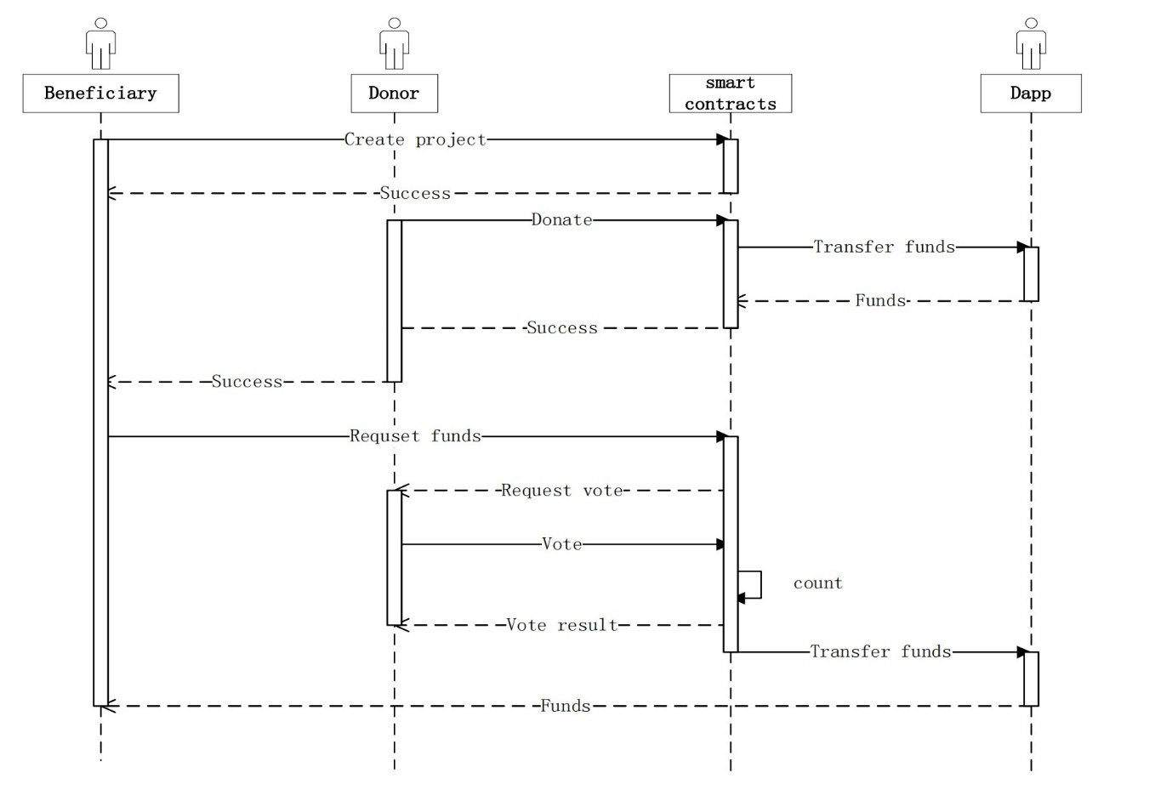

**Conclusion**

We've proposed a decentralised approach for charitable work that uses Blockchain to make it more transparent. Many people have become more altruistic as a result of urbanisation, which has made them more concerned about others. However, there are those who seek to make unlawful money in the process. This system will meet both needs of improved authenticity and security. It will also establish a reliable system and make the entire process more transparent. This will eliminate the need for middlemen between donations and charitable organisations. Blockchain base solution is proposed that would increase trust between NGOs and donor agencies in third world countries.