Data Analysis and Visualization to predict Car Prices based on Used Car Prices Data Set
This project analyzes and visualizes the Used Car Prices from the Automobile dataset in order to predict the most probable car price.
Dataset Source: https://archive.ics.uci.edu/ml/machine-learning-databases/autos/imports-85.data
Project is divided into three sections:
- Data Wrangling
  - Pre processing data
  - Dealing missing values
  - Data formatting
  - Data normalization
  - Binning
- Exploratory Data Analysis
  - Descriptive statistics
  - Analysis of variance
  - Correlation
  - Correlation stats
- Model Development. Review, and Evaluation
  - Simple Linear Regression
  - Multiple Linear Regression
  - Regression Plots
  - Distribution Plots

Software and Libraries Used:
- SAS University Edition

The first procedure used is PROC CONTENTS to generate output documentation about the data set, and data views. The procedure creates printed output documentation.

Data Set Name | AUTO.AUTO_MOB | Observations | 201
Member Type | DATA | Variables | 26
Engine | BASE | Indexes | 0
Created | 05/08/2020 14:15:34 | Observation Length | 208
Last Modified | 05/08/2020 14:15:34 | Deleted Observations | 0
Protection |  | Compressed | NO
Data Set Type |  | Sorted | NO
Label
Data Representation | SOLARIS_X86_64, LINUX_X86_64, ALPHA_TRU64, LINUX_IA64
Encoding | utf-8 Unicode (UTF-8)

Engine/Host Dependent Information
Data Set Page Size | 65536
Number of Data Set Pages | 1
First Data Page | 1
Max Obs per Page | 314
Obs in First Data Page | 201
Number of Data Set Repairs | 0
Filename | /folders/myfolders/projects-automobile/auto_mob.sas7bdat
Release Created | 9.0401M6
Host Created | Linux
Inode Number | 242
Access Permission | rwxrwx---
Owner Name | root
File Size | 128KB
File Size (bytes) | 131072

Alphabetic List of Variables and Attributes
# | Variable | Type | Len
5 | aspiration | Char | 8
7 | body_style | Char | 8
19 | bore | Num | 8
24 | city_mpg | Num | 8
21 | compression_ratio | Num | 8
14 | curb_weight | Num | 8
8 | drive_wheels | Char | 8
9 | engine_location | Char | 8
17 | engine_size | Num | 8
15 | engine_type | Char | 8
18 | fuel_system | Char | 8
4 | fuel_type | Char | 8
13 | height | Num | 8
25 | highway_mpg | Num | 8
22 | horse_power | Num | 8
11 | length | Num | 8
3 | make | Char | 8
2 | normalized_losses | Num | 8
16 | num_of_cylinders | Char | 8
6 | num_of_doors | Char | 8
23 | peak_rpm | Num | 8
26 | price | Num | 8
20 | stroke | Num | 8
1 | symboling | Num | 8
10 | wheel_base | Num | 8
12 | width | Num | 8

Next PROC MEANS was used for analyzing data. It is mainly used to calculate descriptive statistics such as mean, median, count, sum etc. It can also be used to calculate several other metrics such as percentiles, quartiles, standard deviation, variance and sample t-test.

Variable | N | Mean | Std Dev | Minimum | Maximum
symboling  normalized_losses  wheel_base  length  width  height  curb_weight  engine_size  bore  stroke  compression_ratio  horse_power  peak_rpm  city_mpg  highway_mpg  price | 201  164  201  201  201  201  201  201  197  197  201  199  199  201  201  201 | 0.8407960  122.0000000  98.7970149  174.2009950  65.8890547  53.7666667  2555.67  126.8756219  3.3307107  3.2569036  10.1642786  103.3969849  5117.59  25.1791045  30.6865672  13207.13 | 1.2548017  35.4421675  6.0663656  12.3221751  2.1014708  2.4478222  517.2967266  41.5468344  0.2707934  0.3192562  4.0049655  37.5538427  480.5218239  6.4232205  6.8151499  7947.07 | -2.0000000  65.0000000  86.6000000  141.1000000  60.3000000  47.8000000  1488.00  61.0000000  2.5400000  2.0700000  7.0000000  48.0000000  4150.00  13.0000000  16.0000000  5118.00 | 3.0000000  256.0000000  120.9000000  208.1000000  72.0000000  59.8000000  4066.00  326.0000000  3.9400000  4.1700000  23.0000000  262.0000000  6600.00  49.0000000  54.0000000  45400.00

Thereafter SAS procedure PROC FREQ was used to summarize categorical variable, which calculates count/frequency and cumulative frequency of categories of different categorical variables.

make | Frequency | Percent | Cumulative  Frequency | Cumulative  Percent
alfa-rom | 3 | 1.49 | 3 | 1.49
audi | 6 | 2.99 | 9 | 4.48
bmw | 8 | 3.98 | 17 | 8.46
chevrole | 3 | 1.49 | 20 | 9.95
dodge | 9 | 4.48 | 29 | 14.43
honda | 13 | 6.47 | 42 | 20.90
isuzu | 2 | 1.00 | 44 | 21.89
jaguar | 3 | 1.49 | 47 | 23.38
mazda | 17 | 8.46 | 64 | 31.84
mercedes | 8 | 3.98 | 72 | 35.82
mercury | 1 | 0.50 | 73 | 36.32
mitsubis | 13 | 6.47 | 86 | 42.79
nissan | 18 | 8.96 | 104 | 51.74
peugot | 11 | 5.47 | 115 | 57.21
plymouth | 7 | 3.48 | 122 | 60.70
porsche | 4 | 1.99 | 126 | 62.69
renault | 2 | 1.00 | 128 | 63.68
saab | 6 | 2.99 | 134 | 66.67
subaru | 12 | 5.97 | 146 | 72.64
toyota | 32 | 15.92 | 178 | 88.56
volkswag | 12 | 5.97 | 190 | 94.53
volvo | 11 | 5.47 | 201 | 100.00

fuel_type | Frequency | Percent | Cumulative  Frequency | Cumulative  Percent
diesel | 20 | 9.95 | 20 | 9.95
gas | 181 | 90.05 | 201 | 100.00

aspiration | Frequency | Percent | Cumulative  Frequency | Cumulative  Percent
std | 165 | 82.09 | 165 | 82.09
turbo | 36 | 17.91 | 201 | 100.00

num_of_doors | Frequency | Percent | Cumulative  Frequency | Cumulative  Percent
? | 2 | 1.00 | 2 | 1.00
four | 113 | 56.22 | 115 | 57.21
two | 86 | 42.79 | 201 | 100.00

body_style | Frequency | Percent | Cumulative  Frequency | Cumulative  Percent
converti | 6 | 2.99 | 6 | 2.99
hardtop | 8 | 3.98 | 14 | 6.97
hatchbac | 68 | 33.83 | 82 | 40.80
sedan | 94 | 46.77 | 176 | 87.56
wagon | 25 | 12.44 | 201 | 100.00

drive_wheels | Frequency | Percent | Cumulative  Frequency | Cumulative  Percent
4wd | 8 | 3.98 | 8 | 3.98
fwd | 118 | 58.71 | 126 | 62.69
rwd | 75 | 37.31 | 201 | 100.00

engine_location | Frequency | Percent | Cumulative  Frequency | Cumulative  Percent
front | 198 | 98.51 | 198 | 98.51
rear | 3 | 1.49 | 201 | 100.00

engine_type | Frequency | Percent | Cumulative  Frequency | Cumulative  Percent
dohc | 12 | 5.97 | 12 | 5.97
l | 12 | 5.97 | 24 | 11.94
ohc | 145 | 72.14 | 169 | 84.08
ohcf | 15 | 7.46 | 184 | 91.54
ohcv | 13 | 6.47 | 197 | 98.01
rotor | 4 | 1.99 | 201 | 100.00

num_of_cylinders | Frequency | Percent | Cumulative  Frequency | Cumulative  Percent
eight | 4 | 1.99 | 4 | 1.99
five | 10 | 4.98 | 14 | 6.97
four | 157 | 78.11 | 171 | 85.07
six | 24 | 11.94 | 195 | 97.01
three | 1 | 0.50 | 196 | 97.51
twelve | 1 | 0.50 | 197 | 98.01
two | 4 | 1.99 | 201 | 100.00

fuel_system | Frequency | Percent | Cumulative  Frequency | Cumulative  Percent
1bbl | 11 | 5.47 | 11 | 5.47
2bbl | 64 | 31.84 | 75 | 37.31
4bbl | 3 | 1.49 | 78 | 38.81
idi | 20 | 9.95 | 98 | 48.76
mfi | 1 | 0.50 | 99 | 49.25
mpfi | 92 | 45.77 | 191 | 95.02
spdi | 9 | 4.48 | 200 | 99.50
spfi | 1 | 0.50 | 201 | 100.00

Thereafter, missing values were replaced with the means of the variables.
Since the num_of_doors shows maximum frequency count for the value 'four', the missing num_of_doors indicated by '?' will be replaced with 'four'

Variable | N | Mean | Std Dev | Minimum | Maximum
symboling  normalized_losses  wheel_base  length  width  height  curb_weight  engine_size  bore  stroke  compression_ratio  horse_power  peak_rpm  city_mpg  highway_mpg  price | 201  164  201  201  201  201  201  201  201  201  201  199  199  201  201  201 | 0.8407960  122.0000000  98.7970149  174.2009950  65.8890547  53.7666667  2555.67  126.8756219  3.3320896  3.2557711  10.1642786  103.3969849  5117.59  25.1791045  30.6865672  13207.13 | 1.2548017  35.4421675  6.0663656  12.3221751  2.1014708  2.4478222  517.2967266  41.5468344  0.2682473  0.3161480  4.0049655  37.5538427  480.5218239  6.4232205  6.8151499  7947.07 | -2.0000000  65.0000000  86.6000000  141.1000000  60.3000000  47.8000000  1488.00  61.0000000  2.5400000  2.0700000  7.0000000  48.0000000  4150.00  13.0000000  16.0000000  5118.00 | 3.0000000  256.0000000  120.9000000  208.1000000  72.0000000  59.8000000  4066.00  326.0000000  3.9400000  4.1700000  23.0000000  262.0000000  6600.00  49.0000000  54.0000000  45400.00

Variable | N | Mean | Std Dev | Minimum | Maximum
symboling  normalized_losses  wheel_base  length  width  height  curb_weight  engine_size  bore  stroke  compression_ratio  horse_power  peak_rpm  city_mpg  highway_mpg  price | 201  201  201  201  201  201  201  201  201  201  201  201  201  201  201  201 | 0.8407960  122.0000000  98.7970149  174.2009950  65.8890547  53.7666667  2555.67  126.8756219  3.3320896  3.2557711  10.1642786  103.3969849  5117.59  25.1791045  30.6865672  13207.13 | 1.2548017  31.9962498  6.0663656  12.3221751  2.1014708  2.4478222  517.2967266  41.5468344  0.2682473  0.3161480  4.0049655  37.3656017  478.1131781  6.4232205  6.8151499  7947.07 | -2.0000000  65.0000000  86.6000000  141.1000000  60.3000000  47.8000000  1488.00  61.0000000  2.5400000  2.0700000  7.0000000  48.0000000  4150.00  13.0000000  16.0000000  5118.00 | 3.0000000  256.0000000  120.9000000  208.1000000  72.0000000  59.8000000  4066.00  326.0000000  3.9400000  4.1700000  23.0000000  262.0000000  6600.00  49.0000000  54.0000000  45400.00

make | Frequency | Percent | Cumulative  Frequency | Cumulative  Percent
alfa-rom | 3 | 1.49 | 3 | 1.49
audi | 6 | 2.99 | 9 | 4.48
bmw | 8 | 3.98 | 17 | 8.46
chevrole | 3 | 1.49 | 20 | 9.95
dodge | 9 | 4.48 | 29 | 14.43
honda | 13 | 6.47 | 42 | 20.90
isuzu | 2 | 1.00 | 44 | 21.89
jaguar | 3 | 1.49 | 47 | 23.38
mazda | 17 | 8.46 | 64 | 31.84
mercedes | 8 | 3.98 | 72 | 35.82
mercury | 1 | 0.50 | 73 | 36.32
mitsubis | 13 | 6.47 | 86 | 42.79
nissan | 18 | 8.96 | 104 | 51.74
peugot | 11 | 5.47 | 115 | 57.21
plymouth | 7 | 3.48 | 122 | 60.70
porsche | 4 | 1.99 | 126 | 62.69
renault | 2 | 1.00 | 128 | 63.68
saab | 6 | 2.99 | 134 | 66.67
subaru | 12 | 5.97 | 146 | 72.64
toyota | 32 | 15.92 | 178 | 88.56
volkswag | 12 | 5.97 | 190 | 94.53
volvo | 11 | 5.47 | 201 | 100.00

fuel_type | Frequency | Percent | Cumulative  Frequency | Cumulative  Percent
diesel | 20 | 9.95 | 20 | 9.95
gas | 181 | 90.05 | 201 | 100.00

aspiration | Frequency | Percent | Cumulative  Frequency | Cumulative  Percent
std | 165 | 82.09 | 165 | 82.09
turbo | 36 | 17.91 | 201 | 100.00

num_of_doors | Frequency | Percent | Cumulative  Frequency | Cumulative  Percent
four | 115 | 57.21 | 115 | 57.21
two | 86 | 42.79 | 201 | 100.00

body_style | Frequency | Percent | Cumulative  Frequency | Cumulative  Percent
converti | 6 | 2.99 | 6 | 2.99
hardtop | 8 | 3.98 | 14 | 6.97
hatchbac | 68 | 33.83 | 82 | 40.80
sedan | 94 | 46.77 | 176 | 87.56
wagon | 25 | 12.44 | 201 | 100.00

drive_wheels | Frequency | Percent | Cumulative  Frequency | Cumulative  Percent
4wd | 8 | 3.98 | 8 | 3.98
fwd | 118 | 58.71 | 126 | 62.69
rwd | 75 | 37.31 | 201 | 100.00

engine_location | Frequency | Percent | Cumulative  Frequency | Cumulative  Percent
front | 198 | 98.51 | 198 | 98.51
rear | 3 | 1.49 | 201 | 100.00

engine_type | Frequency | Percent | Cumulative  Frequency | Cumulative  Percent
dohc | 12 | 5.97 | 12 | 5.97
l | 12 | 5.97 | 24 | 11.94
ohc | 145 | 72.14 | 169 | 84.08
ohcf | 15 | 7.46 | 184 | 91.54
ohcv | 13 | 6.47 | 197 | 98.01
rotor | 4 | 1.99 | 201 | 100.00

num_of_cylinders | Frequency | Percent | Cumulative  Frequency | Cumulative  Percent
eight | 4 | 1.99 | 4 | 1.99
five | 10 | 4.98 | 14 | 6.97
four | 157 | 78.11 | 171 | 85.07
six | 24 | 11.94 | 195 | 97.01
three | 1 | 0.50 | 196 | 97.51
twelve | 1 | 0.50 | 197 | 98.01
two | 4 | 1.99 | 201 | 100.00

fuel_system | Frequency | Percent | Cumulative  Frequency | Cumulative  Percent
1bbl | 11 | 5.47 | 11 | 5.47
2bbl | 64 | 31.84 | 75 | 37.31
4bbl | 3 | 1.49 | 78 | 38.81
idi | 20 | 9.95 | 98 | 48.76
mfi | 1 | 0.50 | 99 | 49.25
mpfi | 92 | 45.77 | 191 | 95.02
spdi | 9 | 4.48 | 200 | 99.50
spfi | 1 | 0.50 | 201 | 100.00

Finally, using proc print, the first 20 observations in the final dataset are printed. The PRINT procedure offers the flexibility to specify what variables and/or observations to print.

Obs | symboling | normalized_losses | make | fuel_type | aspiration | num_of_doors | body_style
1 | 3 | 0.00000 | alfa-rom | gas | std | two | converti
2 | 3 | 0.00000 | alfa-rom | gas | std | two | converti
3 | 1 | 0.00000 | alfa-rom | gas | std | two | hatchbac
4 | 2 | 1.31265 | audi | gas | std | four | sedan
5 | 2 | 1.31265 | audi | gas | std | four | sedan
6 | 2 | 0.00000 | audi | gas | std | two | sedan
7 | 1 | 1.12513 | audi | gas | std | four | sedan
8 | 1 | 0.00000 | audi | gas | std | four | wagon
9 | 1 | 1.12513 | audi | gas | turbo | four | sedan
10 | 2 | 2.18776 | bmw | gas | std | two | sedan
11 | 0 | 2.18776 | bmw | gas | std | four | sedan
12 | 0 | 2.06274 | bmw | gas | std | two | sedan
13 | 0 | 2.06274 | bmw | gas | std | four | sedan
14 | 1 | 0.00000 | bmw | gas | std | four | sedan
15 | 0 | 0.00000 | bmw | gas | std | four | sedan
16 | 0 | 0.00000 | bmw | gas | std | two | sedan
17 | 0 | 0.00000 | bmw | gas | std | four | sedan
18 | 2 | -0.03125 | chevrole | gas | std | two | hatchbac
19 | 1 | -0.75009 | chevrole | gas | std | two | hatchbac
20 | 0 | -1.28140 | chevrole | gas | std | four | sedan

Obs | drive_wheels | engine_location | wheel_base | length | width | height | curb_weight | engine_type
1 | rwd | front | . | -0.43832 | -0.85133 | -2.02901 | 4.90596 | dohc
2 | rwd | front | . | -0.43832 | -0.85133 | -2.02901 | 4.90596 | dohc
3 | rwd | front | . | -0.24354 | -0.18513 | -0.55832 | 5.43757 | ohcv
4 | fwd | front | . | 0.19469 | 0.14797 | 0.21788 | 4.49807 | ohc
5 | 4wd | front | . | 0.19469 | 0.24314 | 0.21788 | 5.43950 | ohc
6 | fwd | front | . | 0.25150 | 0.19555 | -0.27235 | 4.82670 | ohc
7 | fwd | front | . | 1.50128 | 2.62242 | 0.78982 | 5.47816 | ohc
8 | fwd | front | . | 1.50128 | 2.62242 | 0.78982 | 5.69081 | ohc
9 | fwd | front | . | 1.50128 | 2.62242 | 0.87152 | 5.94598 | ohc
10 | rwd | front | . | 0.21092 | -0.51823 | 0.21788 | 4.61019 | ohc
11 | rwd | front | . | 0.21092 | -0.51823 | 0.21788 | 4.61019 | ohc
12 | rwd | front | . | 0.21092 | -0.51823 | 0.21788 | 5.21912 | ohc
13 | rwd | front | . | 0.21092 | -0.51823 | 0.21788 | 5.32545 | ohc
14 | rwd | front | . | 1.20101 | 0.48107 | 0.78982 | 5.88605 | ohc
15 | rwd | front | . | 1.20101 | 0.48107 | 0.78982 | 6.22435 | ohc
16 | rwd | front | . | 1.59055 | 0.95692 | -0.02724 | 6.51432 | ohc
17 | rwd | front | . | 1.85024 | 2.38449 | 1.03493 | 6.75596 | ohc
18 | fwd | front | . | -2.68629 | -2.65959 | -0.23150 | 2.85684 | l
19 | fwd | front | . | -1.48521 | -1.08926 | -0.72173 | 3.60303 | ohc
20 | fwd | front | . | -1.24986 | -1.08926 | -0.72173 | 3.67069 | ohc

Obs | num_of_cylinders | engine_size | fuel_system | bore | stroke | compression_ratio | horse_power
1 | four | 2.39040 | mpfi | 0.51412 | -1.82121 | -4.03976 | 111
2 | four | 2.39040 | mpfi | 0.51412 | -1.82121 | -4.03976 | 111
3 | six | 2.91992 | mpfi | -2.43093 | 0.67762 | -4.03976 | 154
4 | four | 1.88494 | mpfi | -0.52970 | 0.45621 | -3.79007 | 102
5 | five | 2.53481 | mpfi | -0.52970 | 0.45621 | -4.28945 | 115
6 | five | 2.53481 | mpfi | -0.52970 | 0.45621 | -4.16461 | 110
7 | five | 2.53481 | mpfi | -0.52970 | 0.45621 | -4.16461 | 110
8 | five | 2.53481 | mpfi | -0.52970 | 0.45621 | -4.16461 | 110
9 | five | 2.41447 | mpfi | -0.75337 | 0.45621 | -4.21454 | 140
10 | four | 1.86087 | mpfi | 0.62595 | -1.44164 | -4.08970 | 101
11 | four | 1.86087 | mpfi | 0.62595 | -1.44164 | -4.08970 | 101
12 | six | 3.20875 | mpfi | -0.08235 | -0.20804 | -4.03976 | 121
13 | six | 3.20875 | mpfi | -0.08235 | -0.20804 | -4.03976 | 121
14 | six | 3.20875 | mpfi | -0.08235 | -0.20804 | -4.03976 | 121
15 | six | 4.29187 | mpfi | 1.07330 | 0.42458 | -4.28945 | 182
16 | six | 4.29187 | mpfi | 1.07330 | 0.42458 | -4.28945 | 182
17 | six | 4.29187 | mpfi | 1.07330 | 0.42458 | -4.28945 | 182
18 | three | 0.72962 | 2bbl | -1.57351 | -0.71413 | -3.91492 | 48
19 | four | 1.42763 | 2bbl | -1.12616 | -0.46109 | -3.88995 | 70
20 | four | 1.42763 | 2bbl | -1.12616 | -0.46109 | -3.88995 | 70

Obs | peak_rpm | city_mpg | highway_mpg | price | bin_hp
1 | -0.24594 | -16.4833 | -10.5349 | 13495 | Medium
2 | -0.24594 | -16.4833 | -10.5349 | 16500 | Medium
3 | -0.24594 | -16.7946 | -10.6816 | 16500 | High
4 | 0.79984 | -16.0162 | -10.0947 | 13950 | Medium
5 | 0.79984 | -16.9503 | -11.2686 | 17450 | Medium
6 | 0.79984 | -16.7946 | -10.8284 | 15250 | Medium
7 | 0.79984 | -16.7946 | -10.8284 | 17710 | Medium
8 | 0.79984 | -16.7946 | -10.8284 | 18920 | Medium
9 | 0.79984 | -17.1060 | -11.5620 | 23875 | High
10 | 1.42730 | -16.1719 | -10.2414 | 16430 | Medium
11 | 1.42730 | -16.1719 | -10.2414 | 16925 | Medium
12 | -1.81461 | -16.4833 | -10.3882 | 20970 | High
13 | -1.81461 | -16.4833 | -10.3882 | 21105 | High
14 | -1.81461 | -16.6389 | -10.8284 | 24565 | High
15 | 0.59068 | -17.2617 | -11.2686 | 30760 | High
16 | 0.59068 | -17.2617 | -11.2686 | 41315 | High
17 | 0.59068 | -17.4174 | -11.5620 | 36880 | High
18 | -0.03679 | -12.4354 | -6.7199 | 5151 | Low
19 | 0.59068 | -13.8366 | -8.1872 | 6295 | Low
20 | 0.59068 | -13.8366 | -8.1872 | 6575 | Low

1 With Variables: | price
14 Variables: | horse_power normalized_losses peak_rpm stroke bore length width height curb_weight compression_ratio city_mpg engine_size highway_mpg wheel_base

Simple Statistics
Variable | N | Mean | Std Dev | Sum | Minimum | Maximum
price | 201 | 13207 | 7947 | 2654633 | 5118 | 45400
horse_power | 201 | 103.39698 | 37.36560 | 20783 | 48.00000 | 262.00000
normalized_losses | 201 | 0 | 1.00000 | 0 | -1.78146 | 4.18799
peak_rpm | 201 | 0 | 1.00000 | 0 | -2.02376 | 3.10055
stroke | 201 | 0 | 1.00000 | 0 | -3.75068 | 2.89178
bore | 201 | 0 | 1.00000 | 0 | -2.95283 | 2.26623
length | 201 | 0 | 1.00000 | 0 | -2.68629 | 2.75106
width | 201 | 0 | 1.00000 | 0 | -2.65959 | 2.90794
height | 201 | 0 | 1.00000 | 0 | -2.43754 | 2.46478
curb_weight | 201 | 4.92078 | 1.00000 | 989.07639 | 2.85684 | 7.84044
compression_ratio | 201 | -3.74905 | 1.00000 | -753.55955 | -4.53914 | -0.54410
city_mpg | 201 | -15.83264 | 1.00000 | -3182 | -17.72874 | -12.12408
engine_size | 201 | 2.31520 | 1.00000 | 465.35435 | 0.72962 | 7.10796
highway_mpg | 201 | -9.99398 | 1.00000 | -2009 | -12.14896 | -6.57315
wheel_base | 0 | . | . | . | . | .

Pearson Correlation Coefficients
Prob > |r| under H0: Rho=0
Number of Observations
price | engine_size  0.87234  <.0001  201 | curb_weight  0.83441  <.0001  201 | horse_power  0.80968  <.0001  201 | width  0.75127  <.0001  201 | highway_mpg  -0.70469  <.0001  201 | length  0.69063  <.0001  201 | city_mpg  -0.68657  <.0001  201 | bore  0.54268  <.0001  201 | height  0.13549  0.0551  201

Pearson Correlation Coefficients
Prob > |r| under H0: Rho=0
Number of Observations
price | normalized_losses  0.13400  0.0579  201 | peak_rpm  -0.10154  0.1515  201 | stroke  0.08233  0.2453  201 | compression_ratio  0.07111  0.3158  201 | wheel_base  .  .  0

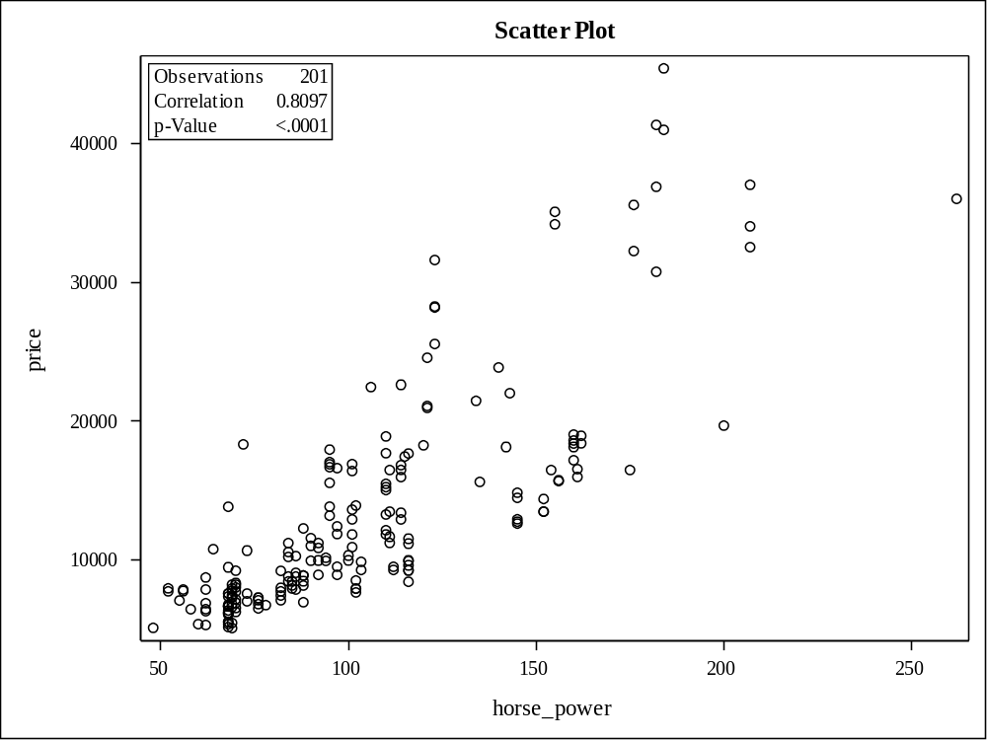

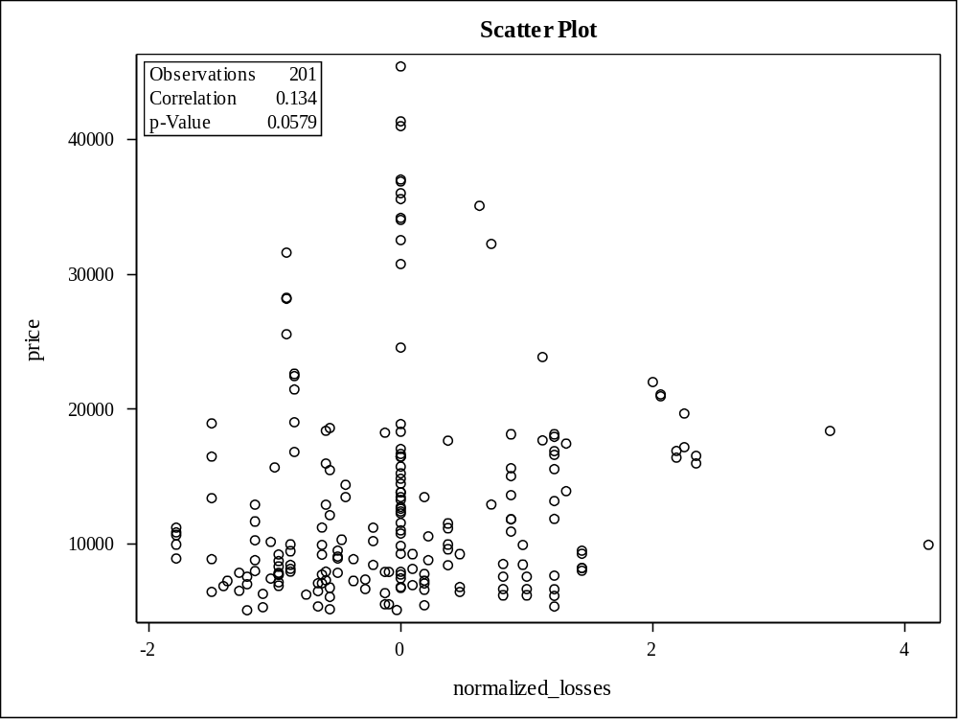

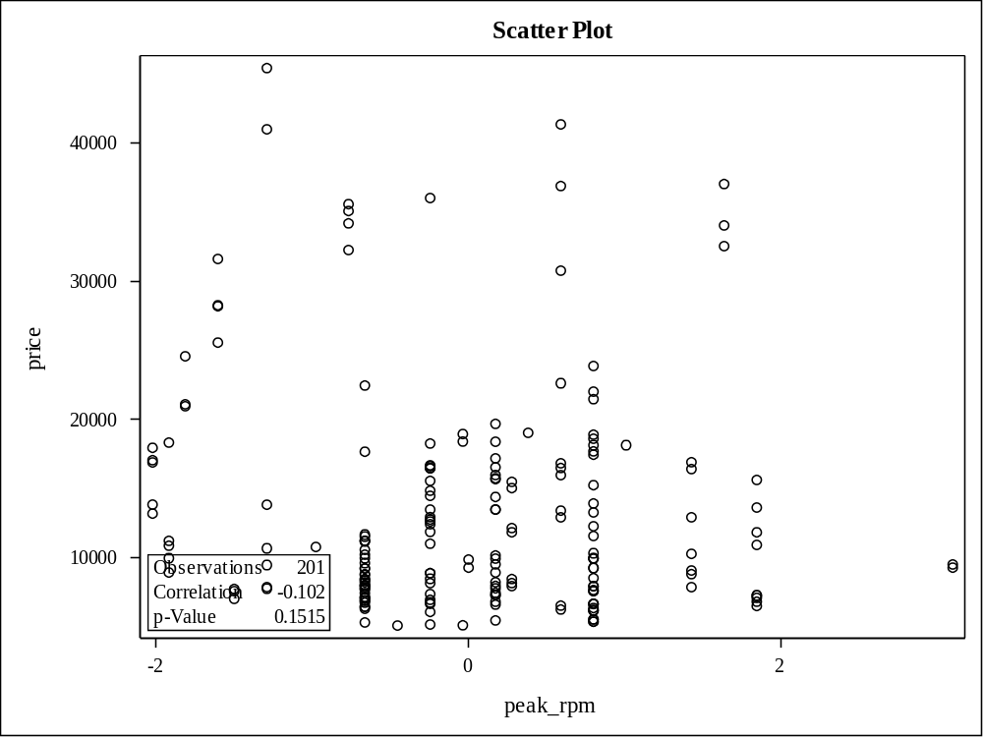

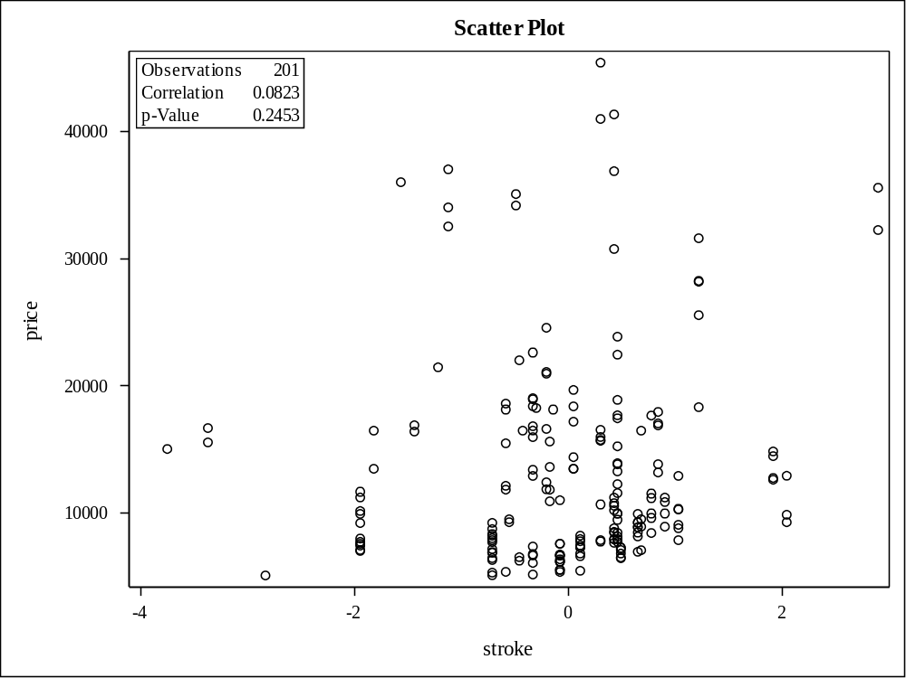

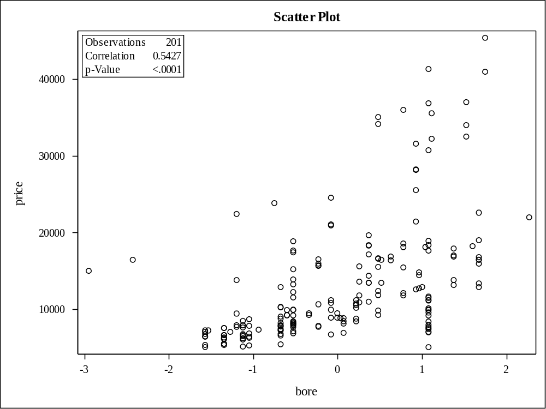

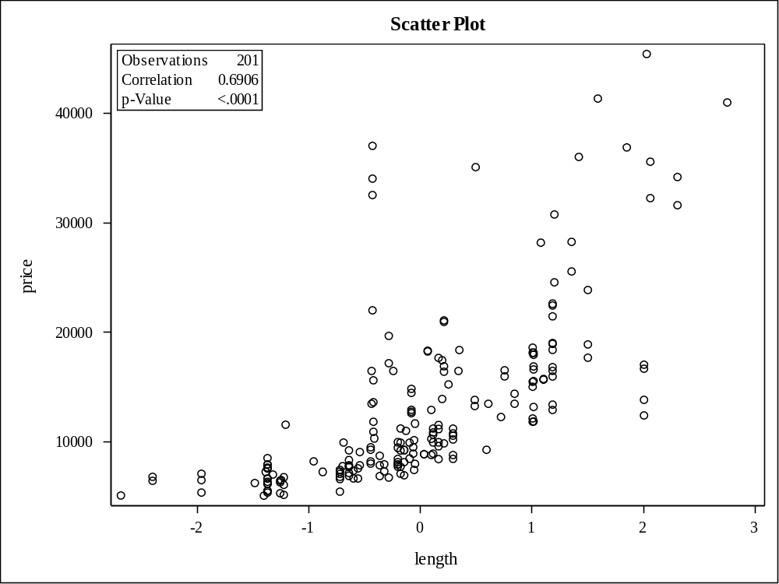

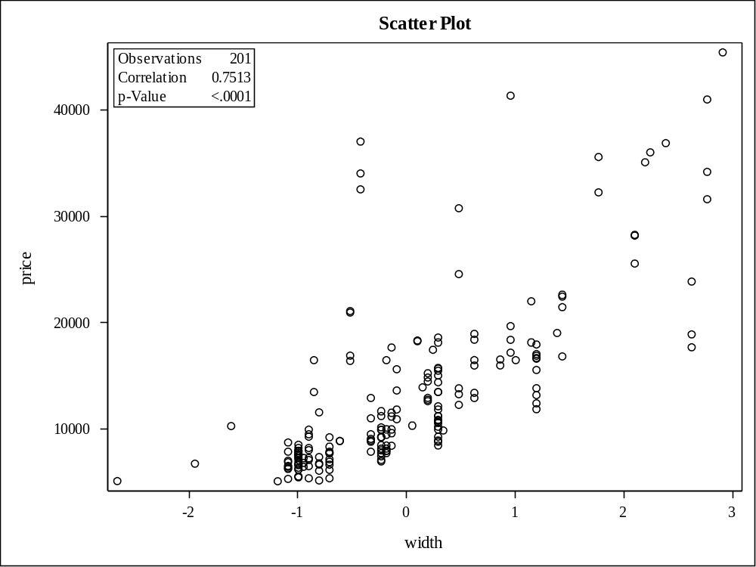

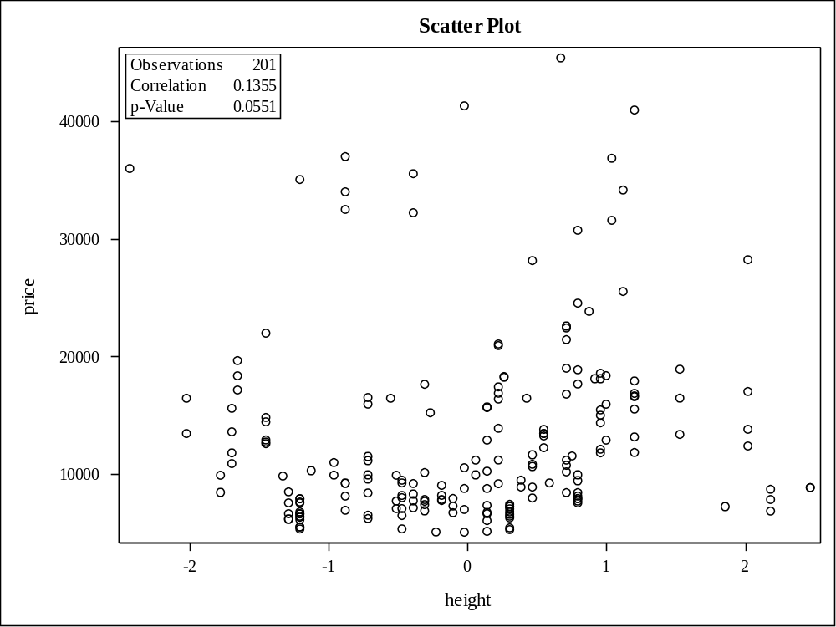

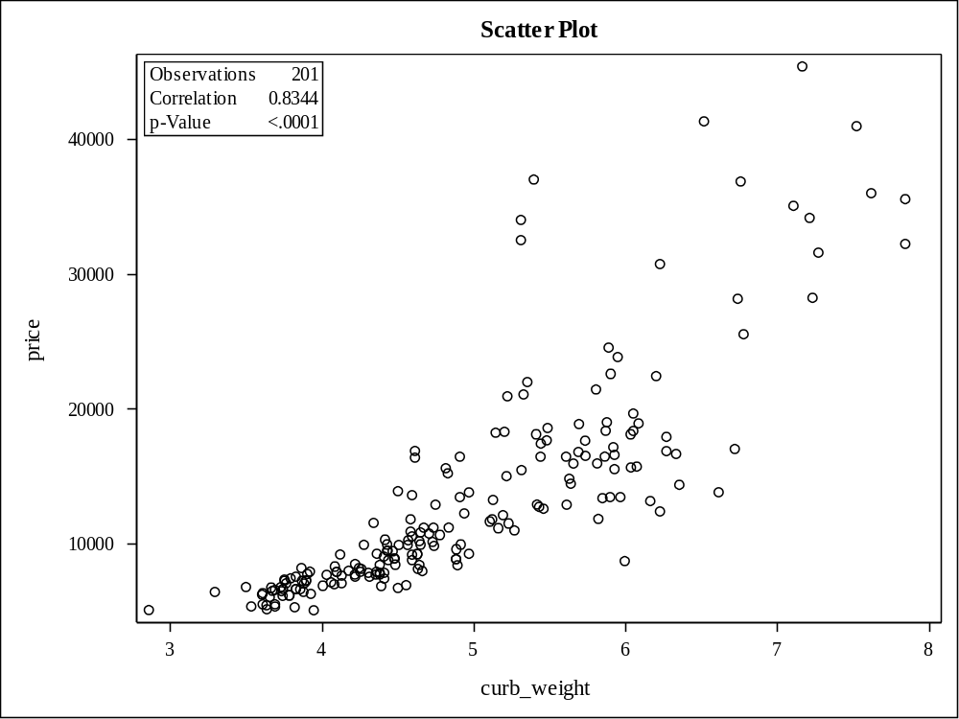

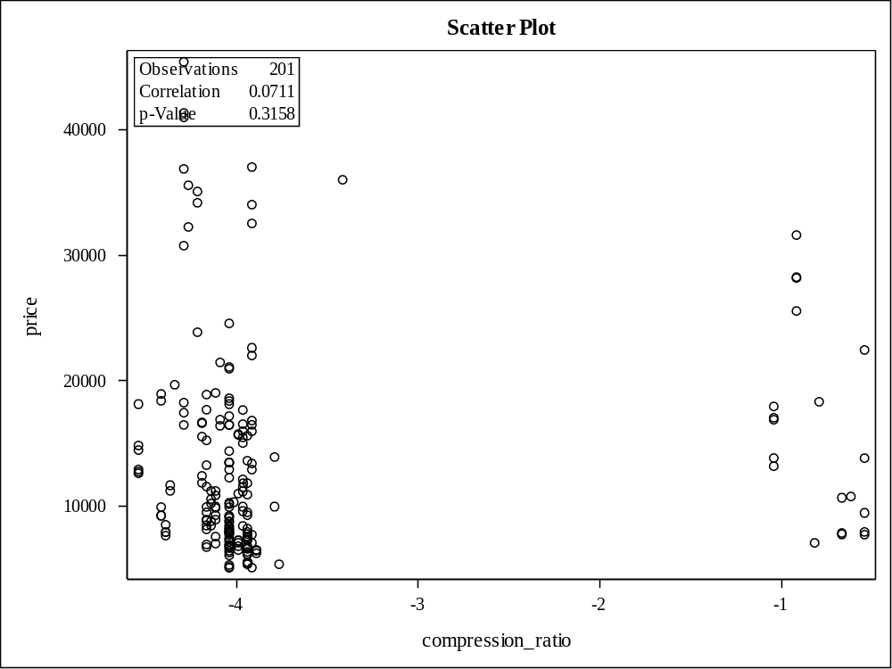

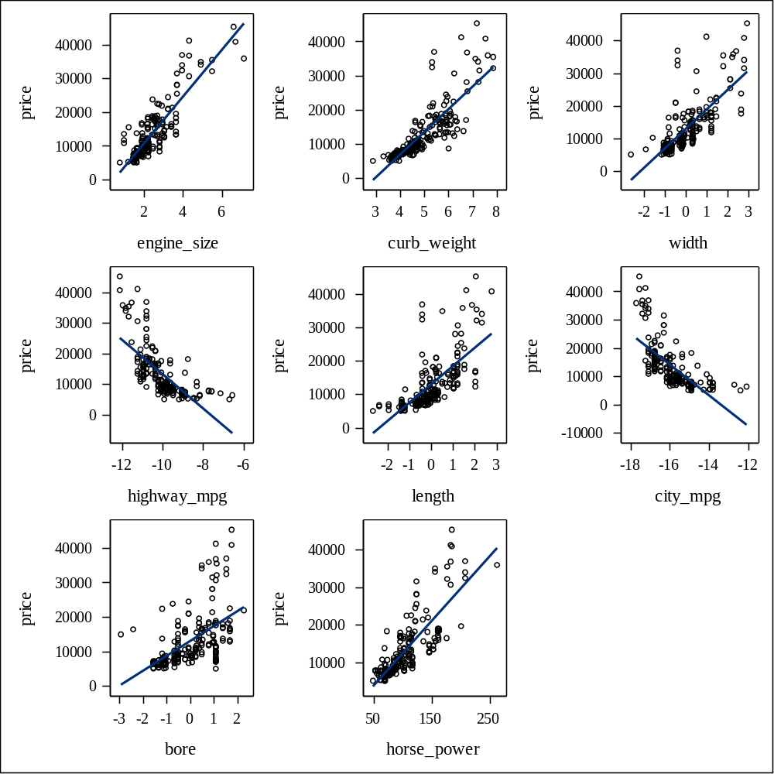

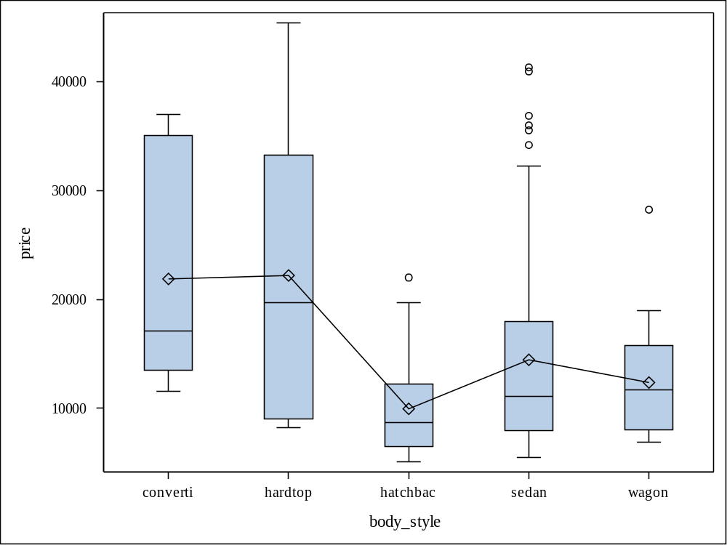

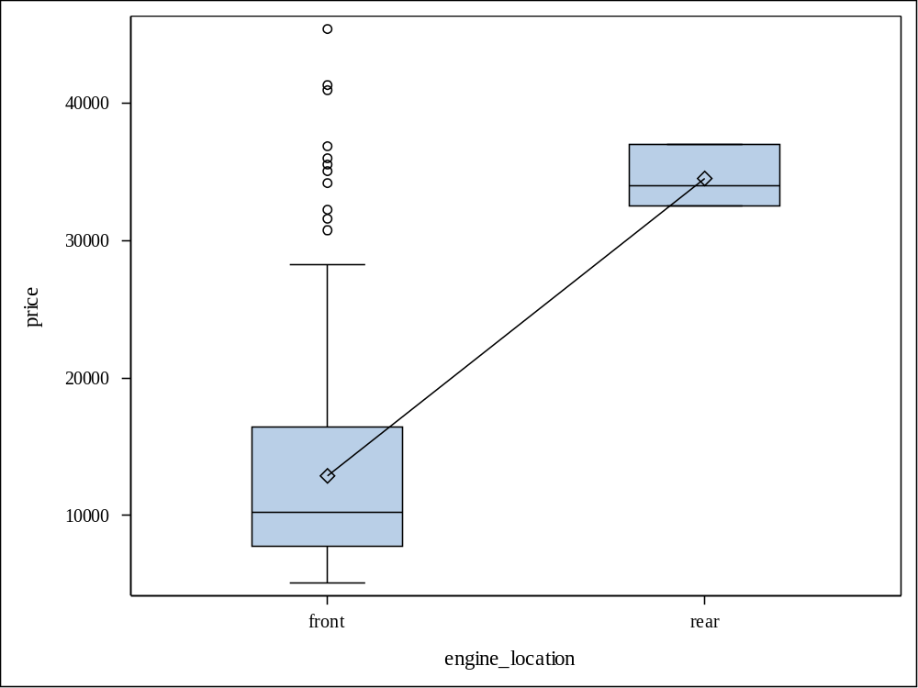

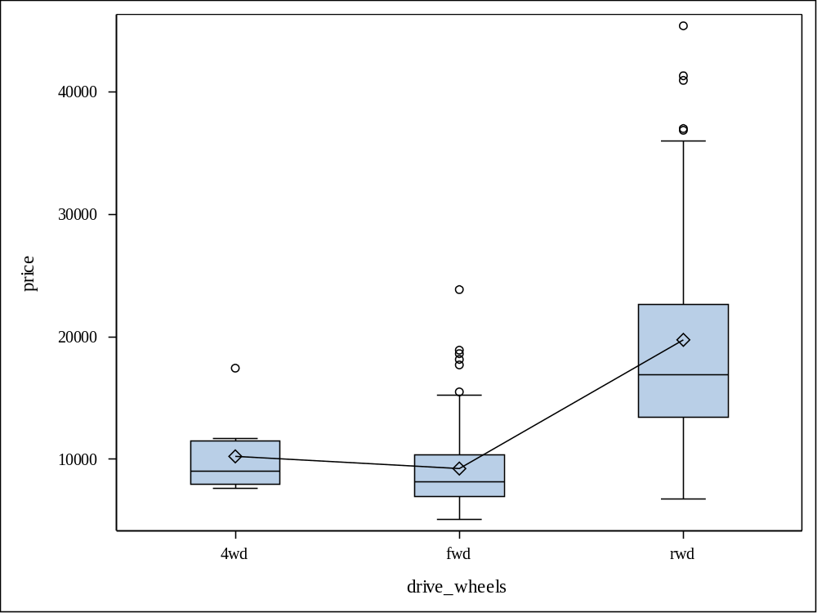

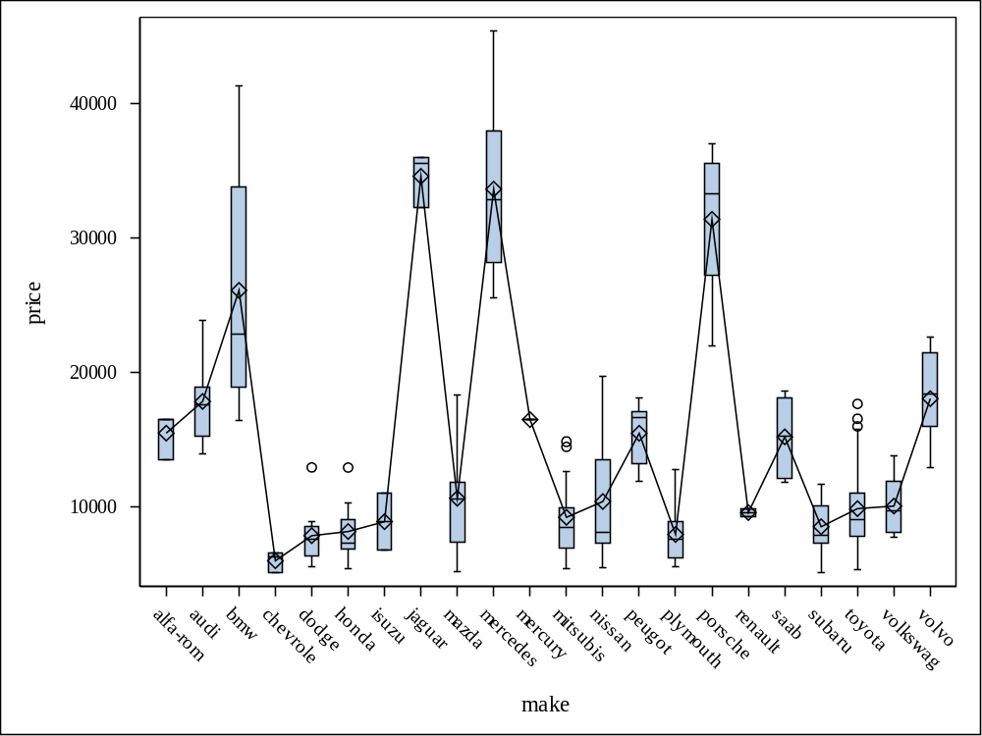

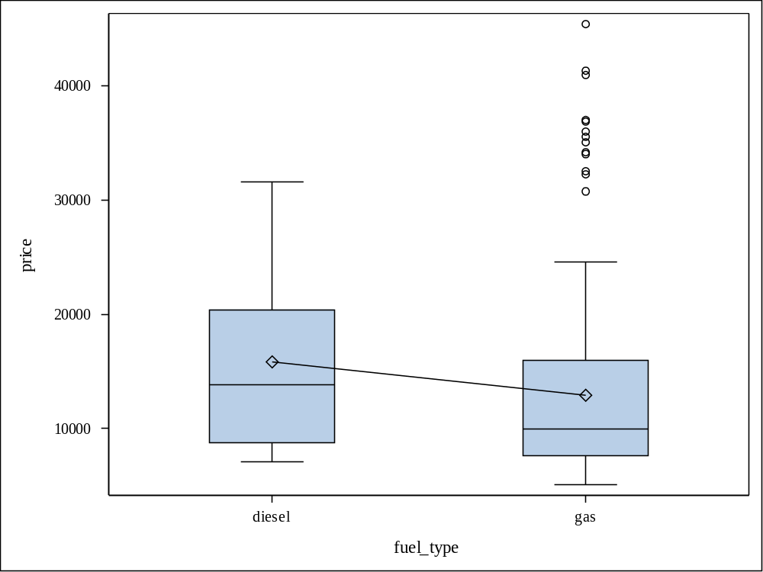

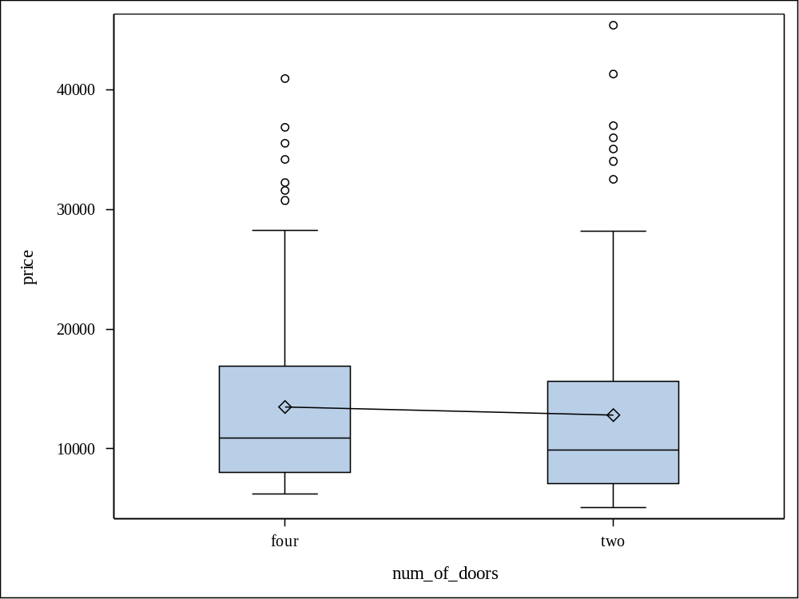

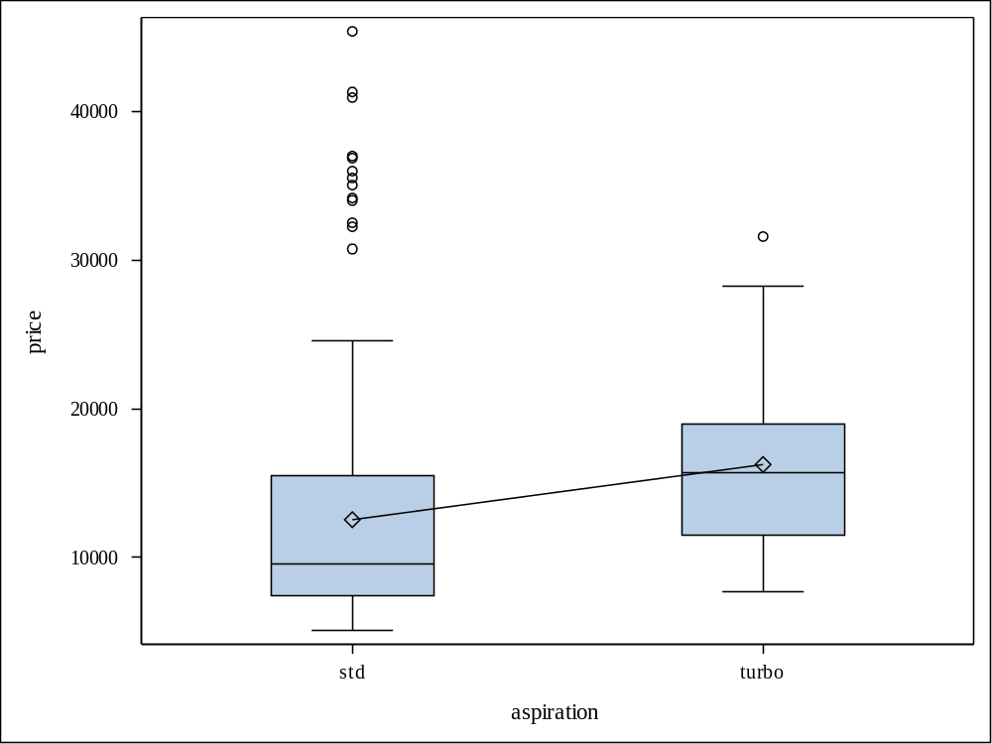

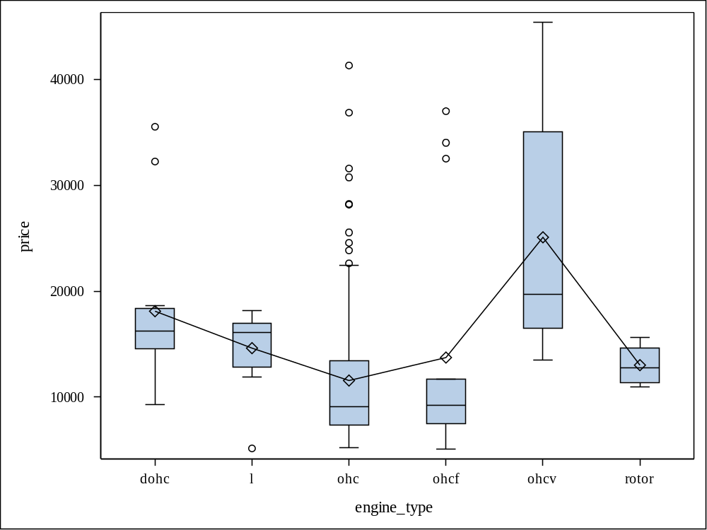

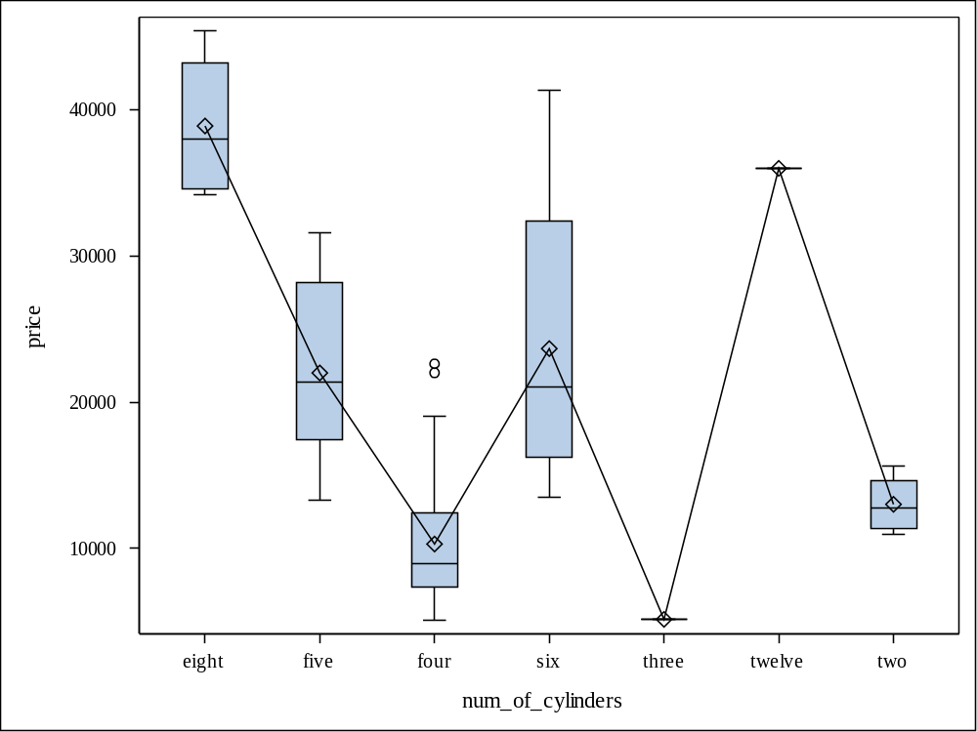

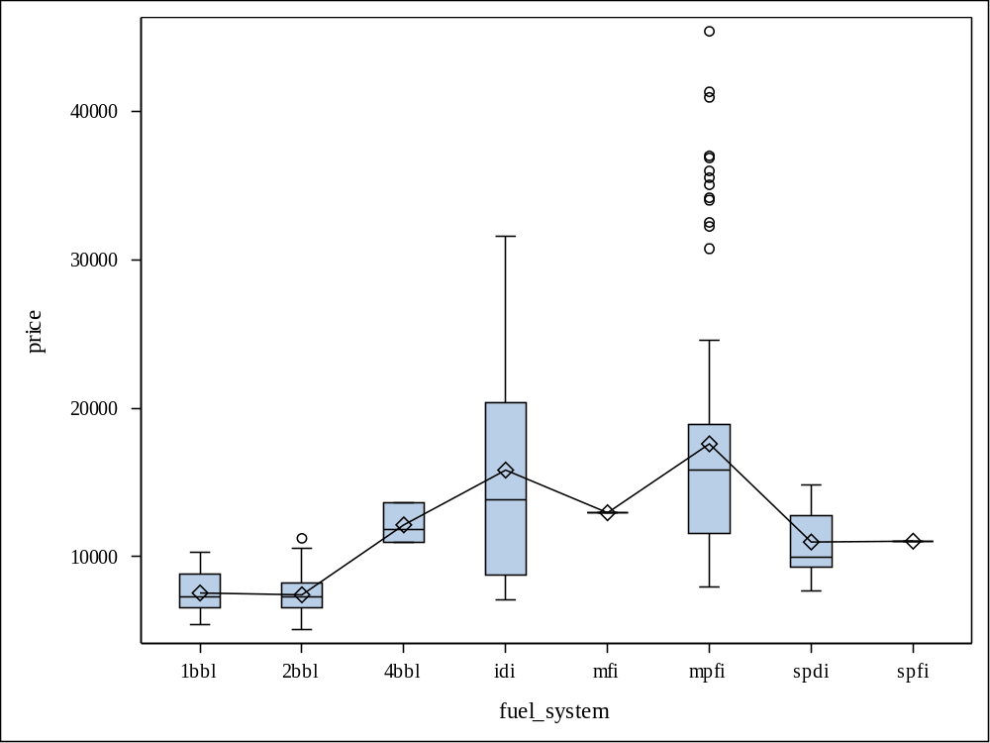

make | Frequency | Percent | Cumulative  Frequency | Cumulative  Percent
alfa-rom | 3 | 1.49 | 3 | 1.49
audi | 6 | 2.99 | 9 | 4.48
bmw | 8 | 3.98 | 17 | 8.46
chevrole | 3 | 1.49 | 20 | 9.95
dodge | 9 | 4.48 | 29 | 14.43
honda | 13 | 6.47 | 42 | 20.90
isuzu | 2 | 1.00 | 44 | 21.89
jaguar | 3 | 1.49 | 47 | 23.38
mazda | 17 | 8.46 | 64 | 31.84
mercedes | 8 | 3.98 | 72 | 35.82
mercury | 1 | 0.50 | 73 | 36.32
mitsubis | 13 | 6.47 | 86 | 42.79
nissan | 18 | 8.96 | 104 | 51.74
peugot | 11 | 5.47 | 115 | 57.21
plymouth | 7 | 3.48 | 122 | 60.70
porsche | 4 | 1.99 | 126 | 62.69
renault | 2 | 1.00 | 128 | 63.68
saab | 6 | 2.99 | 134 | 66.67
subaru | 12 | 5.97 | 146 | 72.64
toyota | 32 | 15.92 | 178 | 88.56
volkswag | 12 | 5.97 | 190 | 94.53
volvo | 11 | 5.47 | 201 | 100.00

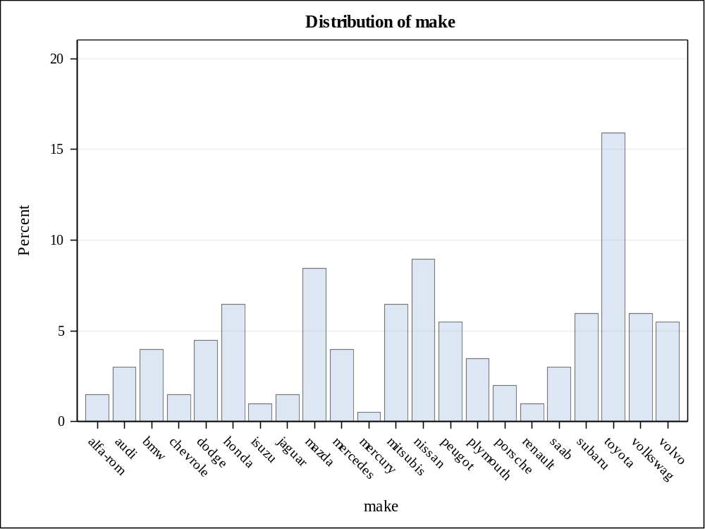

fuel_type | Frequency | Percent | Cumulative  Frequency | Cumulative  Percent
diesel | 20 | 9.95 | 20 | 9.95
gas | 181 | 90.05 | 201 | 100.00

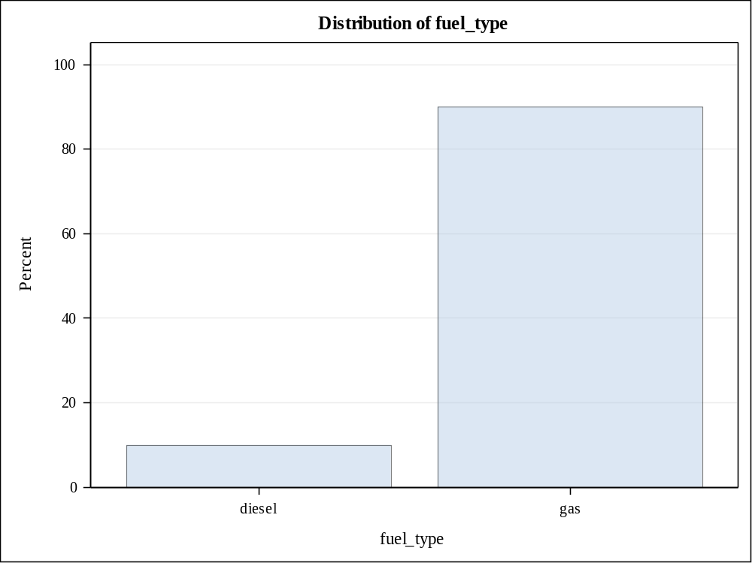

aspiration | Frequency | Percent | Cumulative  Frequency | Cumulative  Percent
std | 165 | 82.09 | 165 | 82.09
turbo | 36 | 17.91 | 201 | 100.00

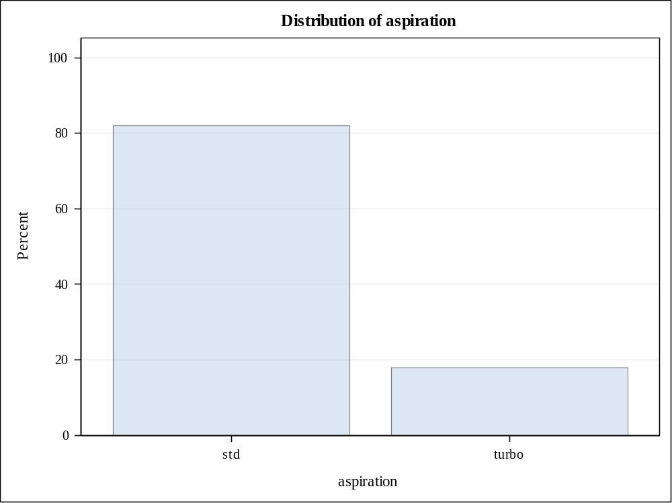

num_of_doors | Frequency | Percent | Cumulative  Frequency | Cumulative  Percent
four | 115 | 57.21 | 115 | 57.21
two | 86 | 42.79 | 201 | 100.00

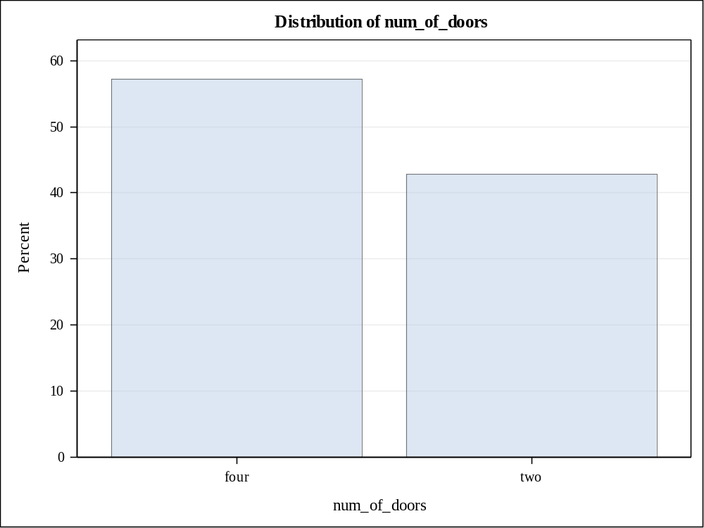

body_style | Frequency | Percent | Cumulative  Frequency | Cumulative  Percent
converti | 6 | 2.99 | 6 | 2.99
hardtop | 8 | 3.98 | 14 | 6.97
hatchbac | 68 | 33.83 | 82 | 40.80
sedan | 94 | 46.77 | 176 | 87.56
wagon | 25 | 12.44 | 201 | 100.00

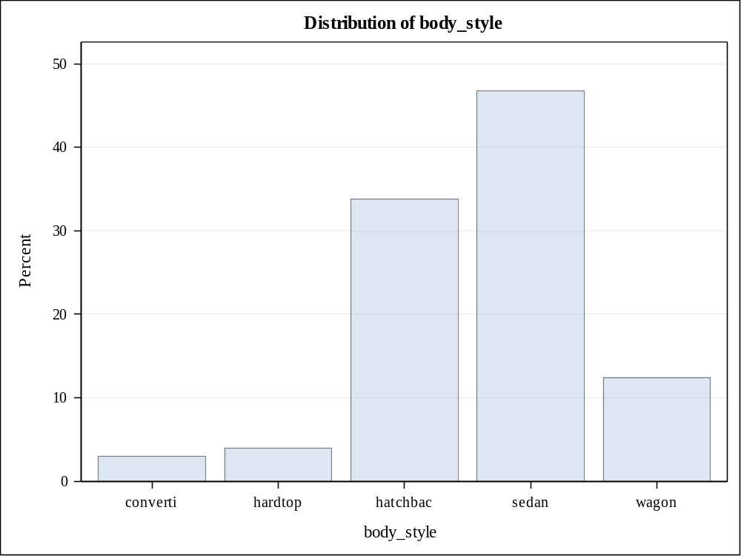

drive_wheels | Frequency | Percent | Cumulative  Frequency | Cumulative  Percent
4wd | 8 | 3.98 | 8 | 3.98
fwd | 118 | 58.71 | 126 | 62.69
rwd | 75 | 37.31 | 201 | 100.00

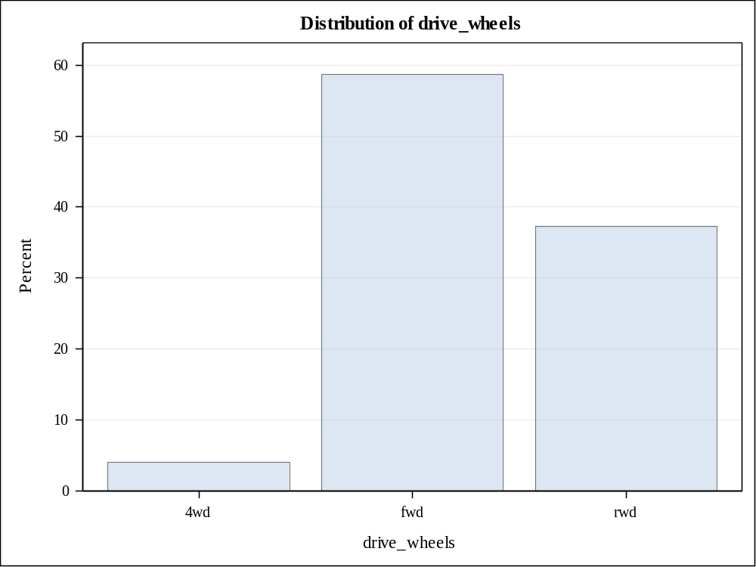

engine_location | Frequency | Percent | Cumulative  Frequency | Cumulative  Percent
front | 198 | 98.51 | 198 | 98.51
rear | 3 | 1.49 | 201 | 100.00

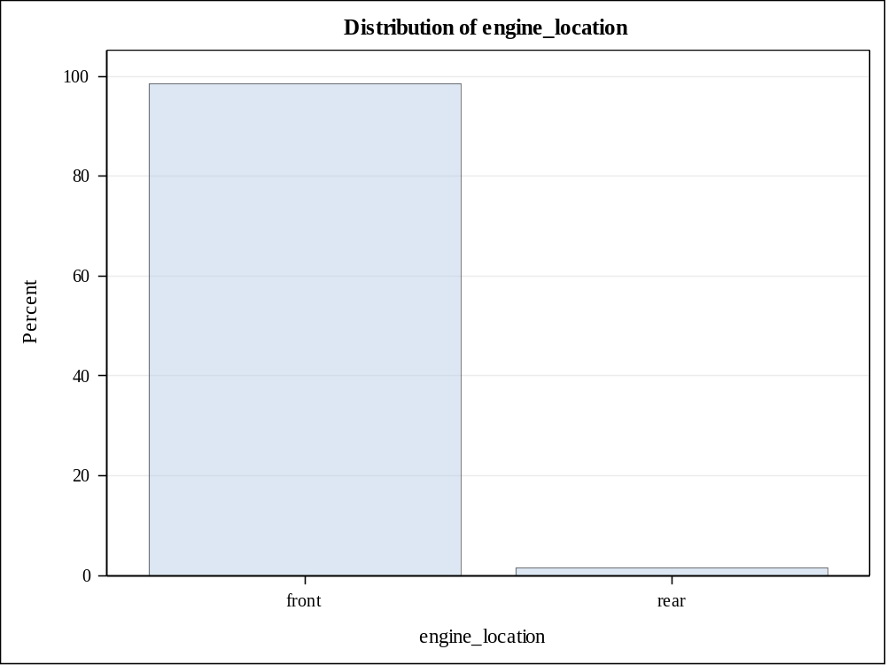

engine_type | Frequency | Percent | Cumulative  Frequency | Cumulative  Percent
dohc | 12 | 5.97 | 12 | 5.97
l | 12 | 5.97 | 24 | 11.94
ohc | 145 | 72.14 | 169 | 84.08
ohcf | 15 | 7.46 | 184 | 91.54
ohcv | 13 | 6.47 | 197 | 98.01
rotor | 4 | 1.99 | 201 | 100.00

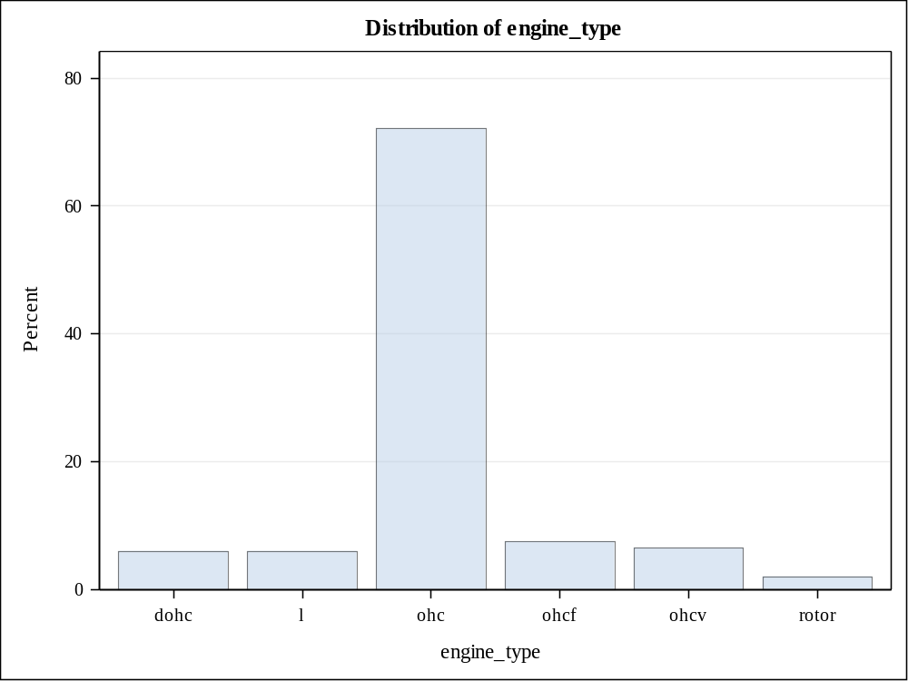

num_of_cylinders | Frequency | Percent | Cumulative  Frequency | Cumulative  Percent
eight | 4 | 1.99 | 4 | 1.99
five | 10 | 4.98 | 14 | 6.97
four | 157 | 78.11 | 171 | 85.07
six | 24 | 11.94 | 195 | 97.01
three | 1 | 0.50 | 196 | 97.51
twelve | 1 | 0.50 | 197 | 98.01
two | 4 | 1.99 | 201 | 100.00

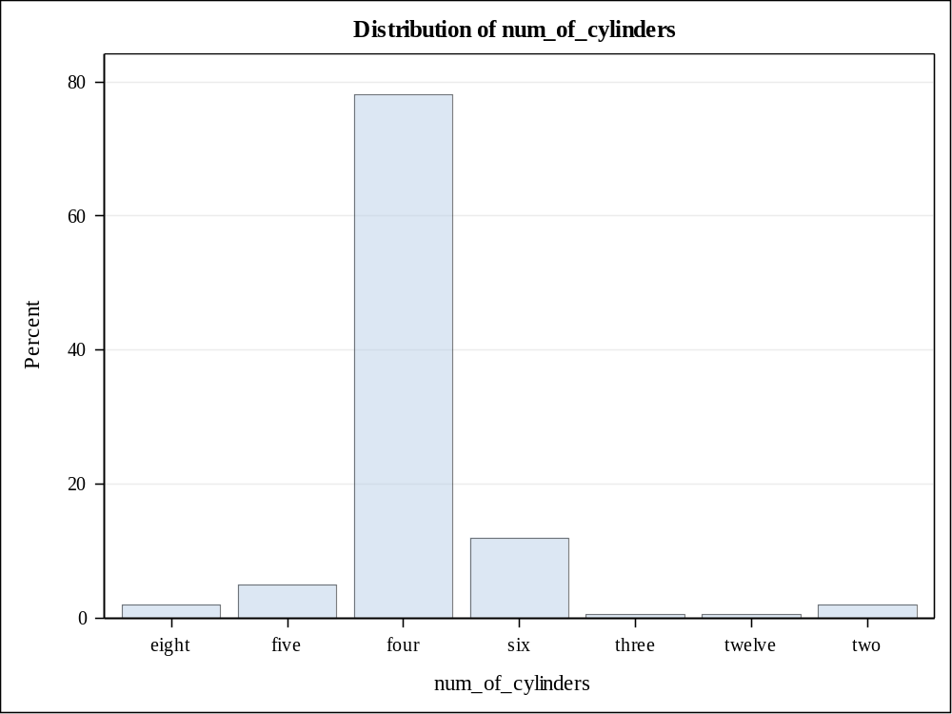

fuel_system | Frequency | Percent | Cumulative  Frequency | Cumulative  Percent
1bbl | 11 | 5.47 | 11 | 5.47
2bbl | 64 | 31.84 | 75 | 37.31
4bbl | 3 | 1.49 | 78 | 38.81
idi | 20 | 9.95 | 98 | 48.76
mfi | 1 | 0.50 | 99 | 49.25
mpfi | 92 | 45.77 | 191 | 95.02
spdi | 9 | 4.48 | 200 | 99.50
spfi | 1 | 0.50 | 201 | 100.00

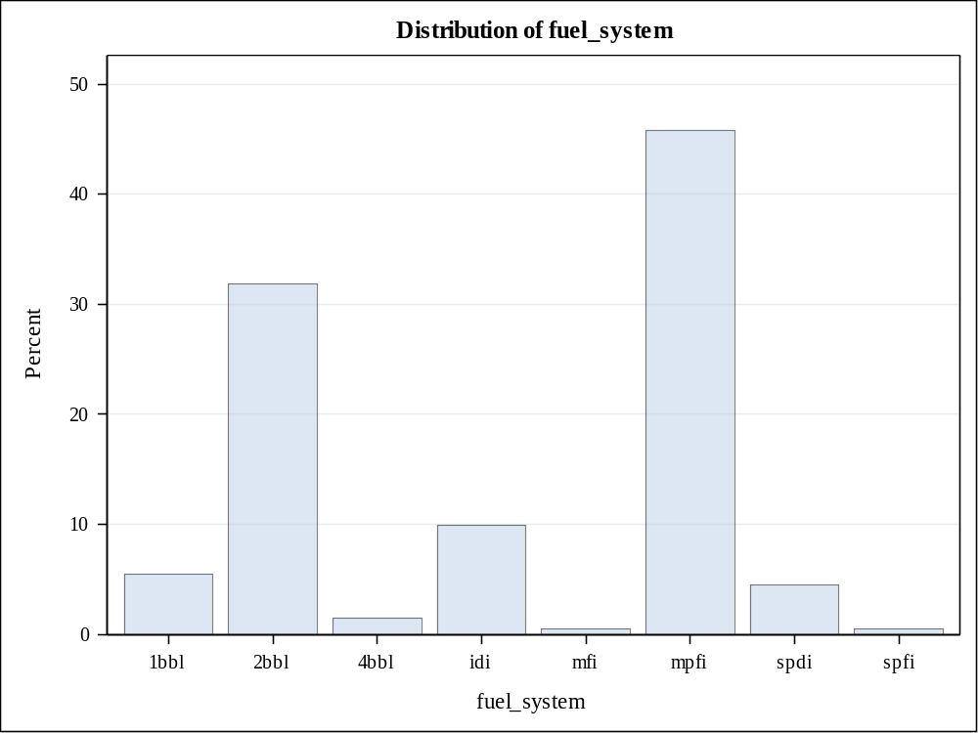

bin_hp | Frequency | Percent | Cumulative  Frequency | Cumulative  Percent
0 | 53 | 26.37 | 53 | 26.37
1 | 49 | 24.38 | 102 | 50.75
2 | 51 | 25.37 | 153 | 76.12
3 | 48 | 23.88 | 201 | 100.00

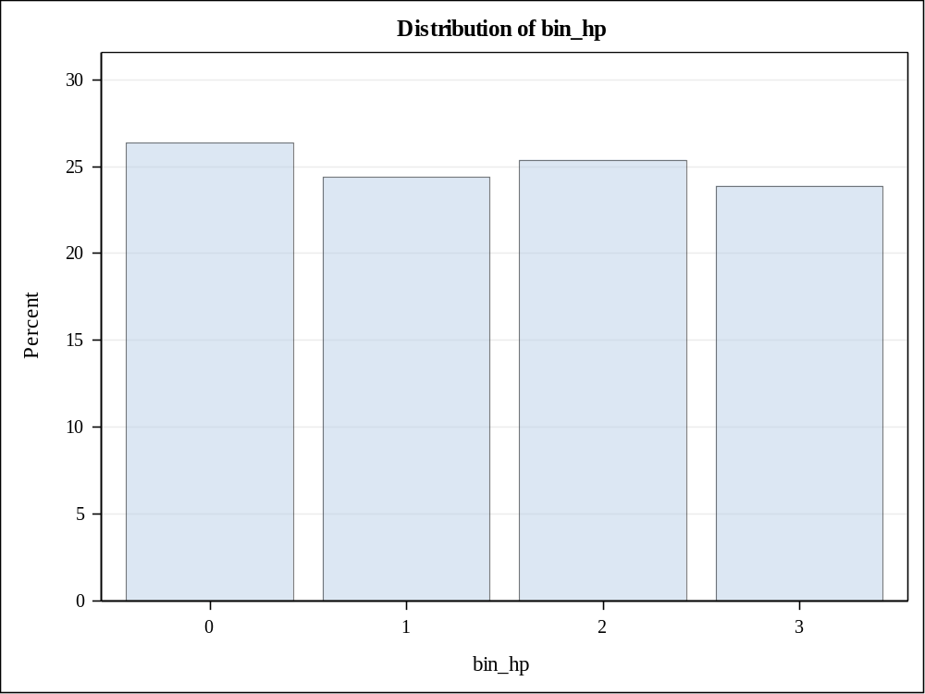

bin_hp | Frequency | Percent | Cumulative  Frequency | Cumulative  Percent
0 | 53 | 26.37 | 53 | 26.37
1 | 49 | 24.38 | 102 | 50.75
2 | 51 | 25.37 | 153 | 76.12
3 | 48 | 23.88 | 201 | 100.00

categories
engine_location
drive_wheels
make
fuel_type
aspiration
engine_type
num_of_cylinders
fuel_system
bin_hp

Class Level Information
Class | Levels | Values
engine_location | 2 | front rear

Number of Observations Read | 201
Number of Observations Used | 201

Source | DF | Sum of Squares | Mean Square | F Value | Pr > F
Model | 1 | 1384401281 | 1384401281 | 24.50 | <.0001
Error | 199 | 11246771408 | 56516439
Corrected Total | 200 | 12631172689

R-Square | Coeff Var | Root MSE | price Mean
0.109602 | 56.92184 | 7517.742 | 13207.13

Source | DF | Type I SS | Mean Square | F Value | Pr > F
engine_location | 1 | 1384401281 | 1384401281 | 24.50 | <.0001

Source | DF | Type III SS | Mean Square | F Value | Pr > F
engine_location | 1 | 1384401281 | 1384401281 | 24.50 | <.0001

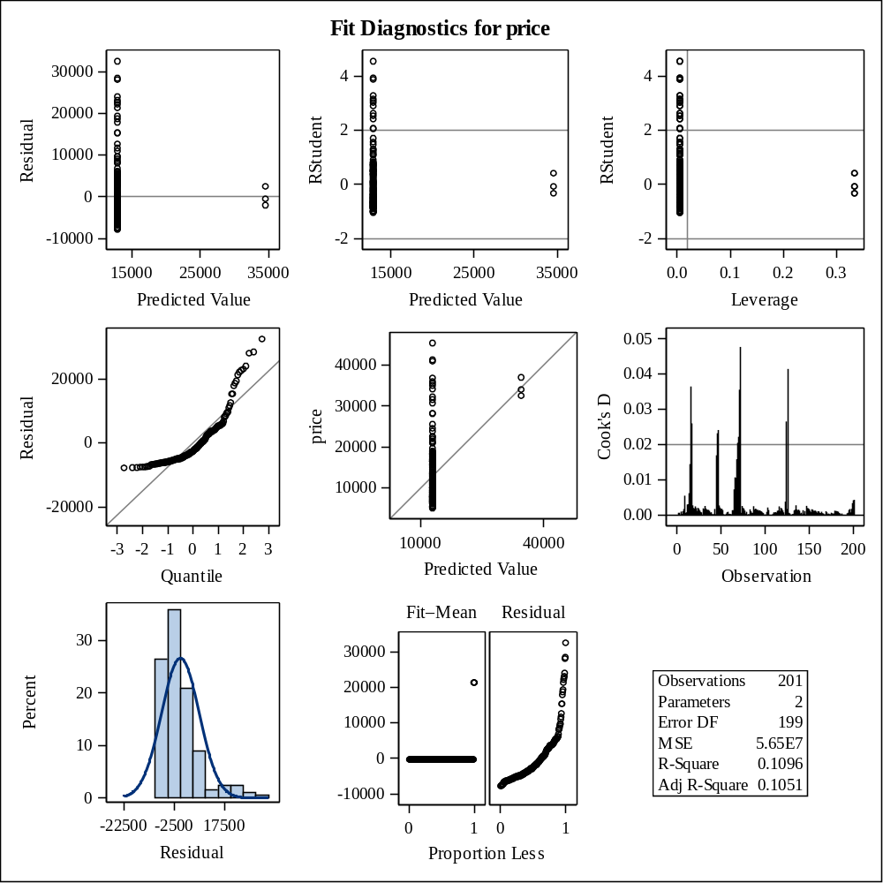

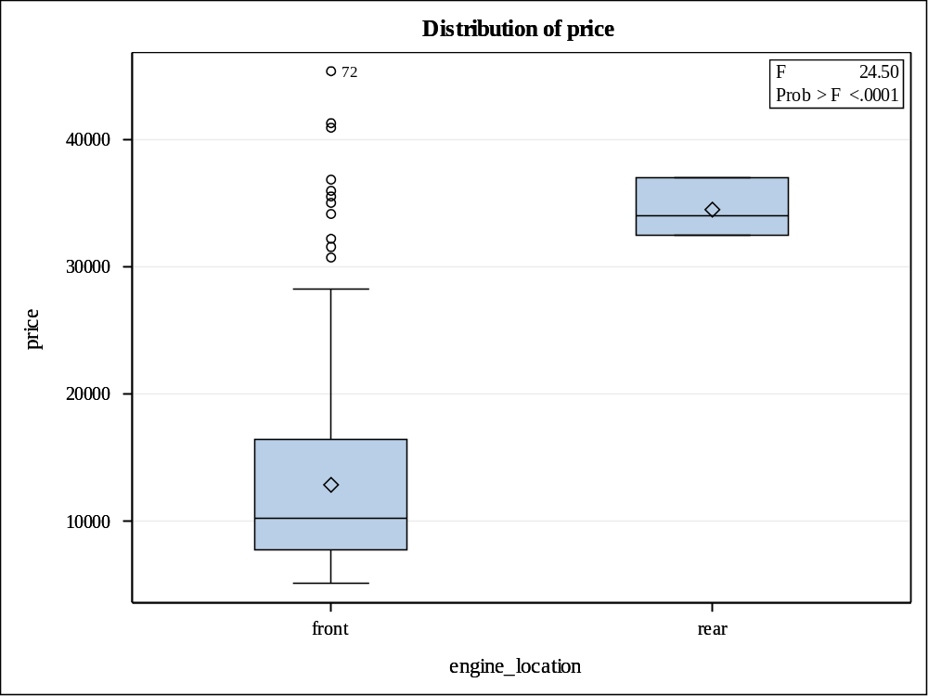

Levene's Test for Homogeneity of price Variance
ANOVA of Squared Deviations from Group Means
Source | DF | Sum of Squares | Mean Square | F Value | Pr > F
engine_location | 1 | 8.379E15 | 8.379E15 | 0.44 | 0.5070
Error | 199 | 3.774E18 | 1.896E16

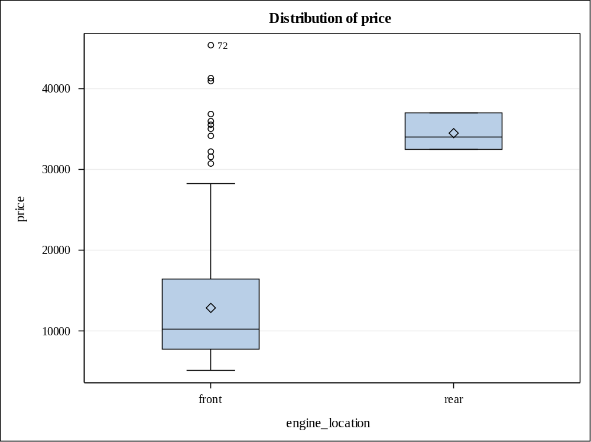

Level of  engine_location | N | price
Level of  engine_location | N | Mean | Std Dev
front | 198 | 12884.0859 | 7552.27851
rear | 3 | 34528.0000 | 2291.28785

Class Level Information
Class | Levels | Values
drive_wheels | 3 | 4wd fwd rwd

Number of Observations Read | 201
Number of Observations Used | 201

Source | DF | Sum of Squares | Mean Square | F Value | Pr > F
Model | 2 | 5141171795 | 2570585897 | 67.95 | <.0001
Error | 198 | 7490000894 | 37828287
Corrected Total | 200 | 12631172689

R-Square | Coeff Var | Root MSE | price Mean
0.407023 | 46.56932 | 6150.470 | 13207.13

Source | DF | Type I SS | Mean Square | F Value | Pr > F
drive_wheels | 2 | 5141171795 | 2570585897 | 67.95 | <.0001

Source | DF | Type III SS | Mean Square | F Value | Pr > F
drive_wheels | 2 | 5141171795 | 2570585897 | 67.95 | <.0001

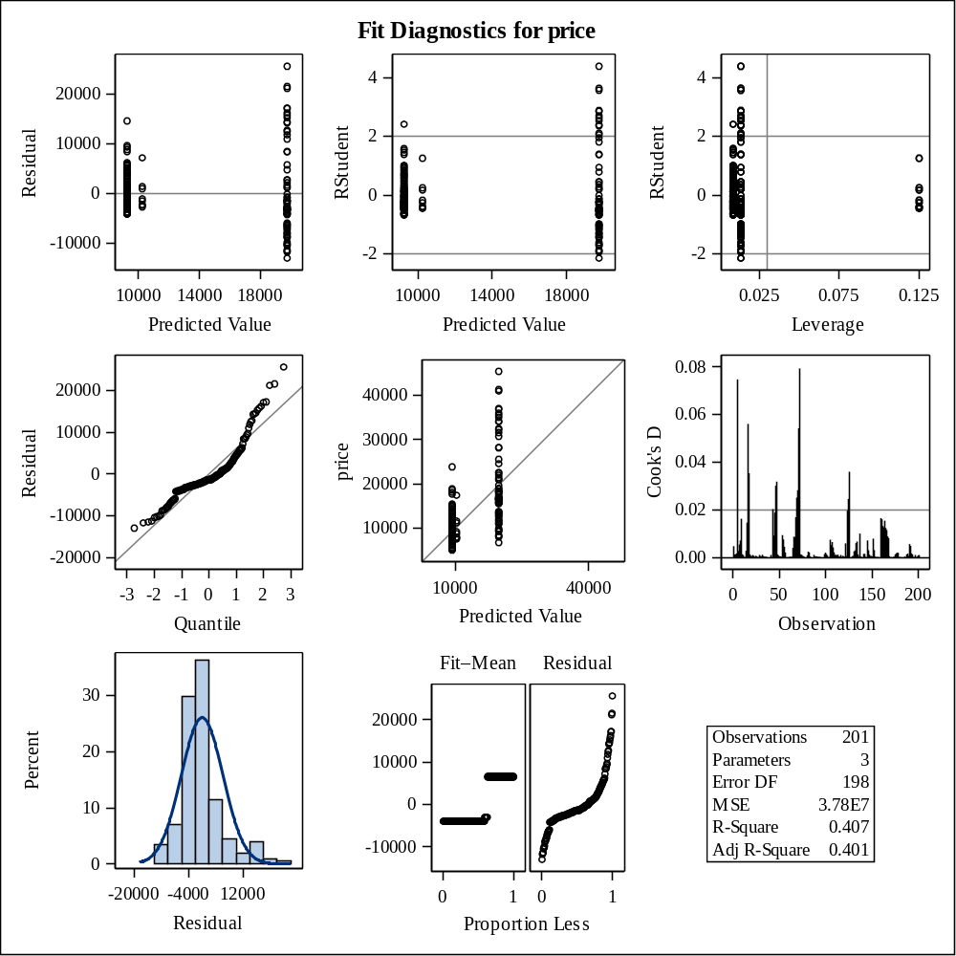

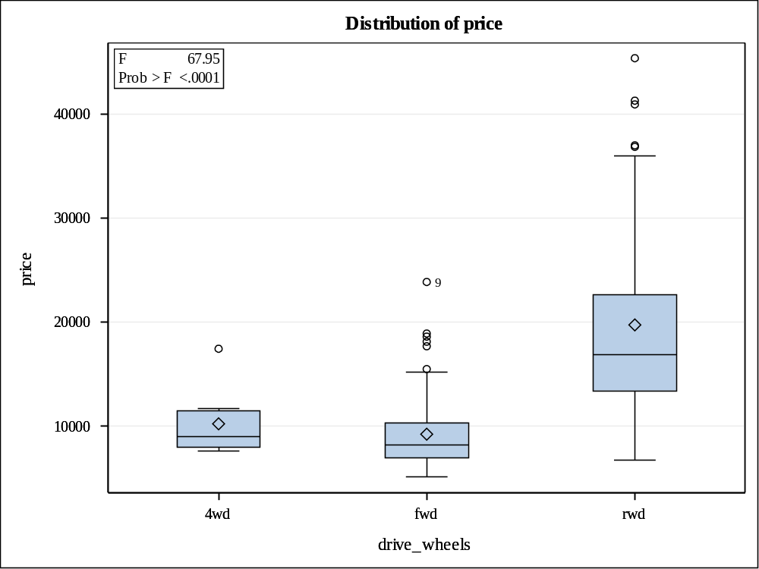

Levene's Test for Homogeneity of price Variance
ANOVA of Squared Deviations from Group Means
Source | DF | Sum of Squares | Mean Square | F Value | Pr > F
drive_wheels | 2 | 2.33E17 | 1.165E17 | 20.21 | <.0001
Error | 198 | 1.142E18 | 5.766E15

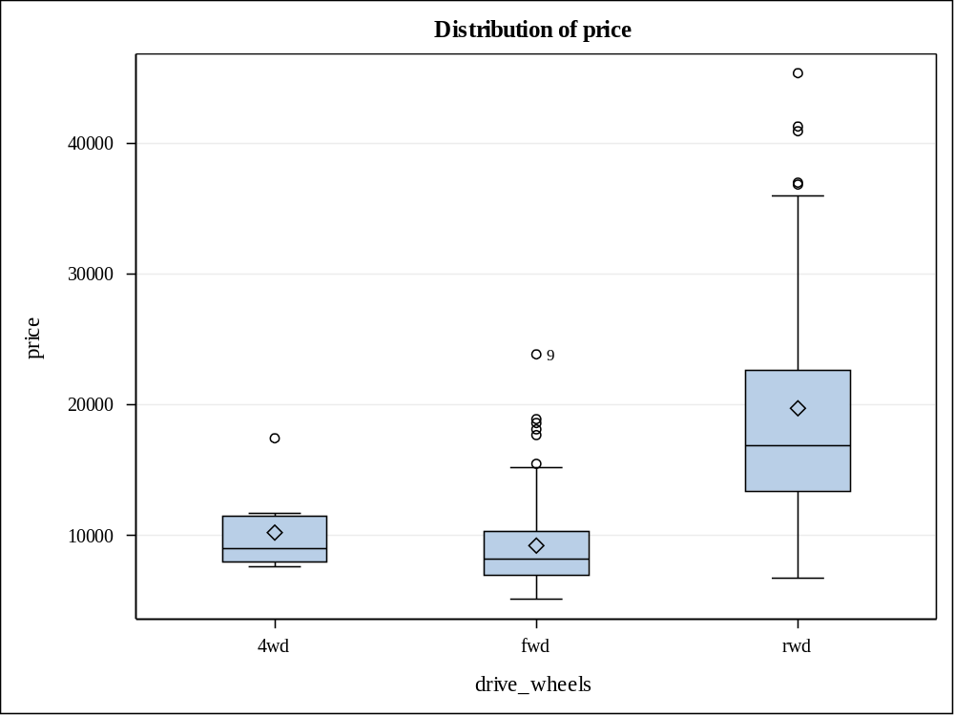

Level of  drive_wheels | N | price
Level of  drive_wheels | N | Mean | Std Dev
4wd | 8 | 10241.0000 | 3288.21106
fwd | 118 | 9244.7797 | 3345.89826
rwd | 75 | 19757.6133 | 9082.57573

Class Level Information
Class | Levels | Values
make | 22 | alfa-rom audi bmw chevrole dodge honda isuzu jaguar mazda mercedes mercury mitsubis nissan peugot plymouth porsche renault saab subaru toyota volkswag volvo

Number of Observations Read | 201
Number of Observations Used | 201

Source | DF | Sum of Squares | Mean Square | F Value | Pr > F
Model | 21 | 10052718409 | 478700877 | 33.23 | <.0001
Error | 179 | 2578454279 | 14404773
Corrected Total | 200 | 12631172689

R-Square | Coeff Var | Root MSE | price Mean
0.795866 | 28.73722 | 3795.362 | 13207.13

Source | DF | Type I SS | Mean Square | F Value | Pr > F
make | 21 | 10052718409 | 478700877 | 33.23 | <.0001

Source | DF | Type III SS | Mean Square | F Value | Pr > F
make | 21 | 10052718409 | 478700877 | 33.23 | <.0001

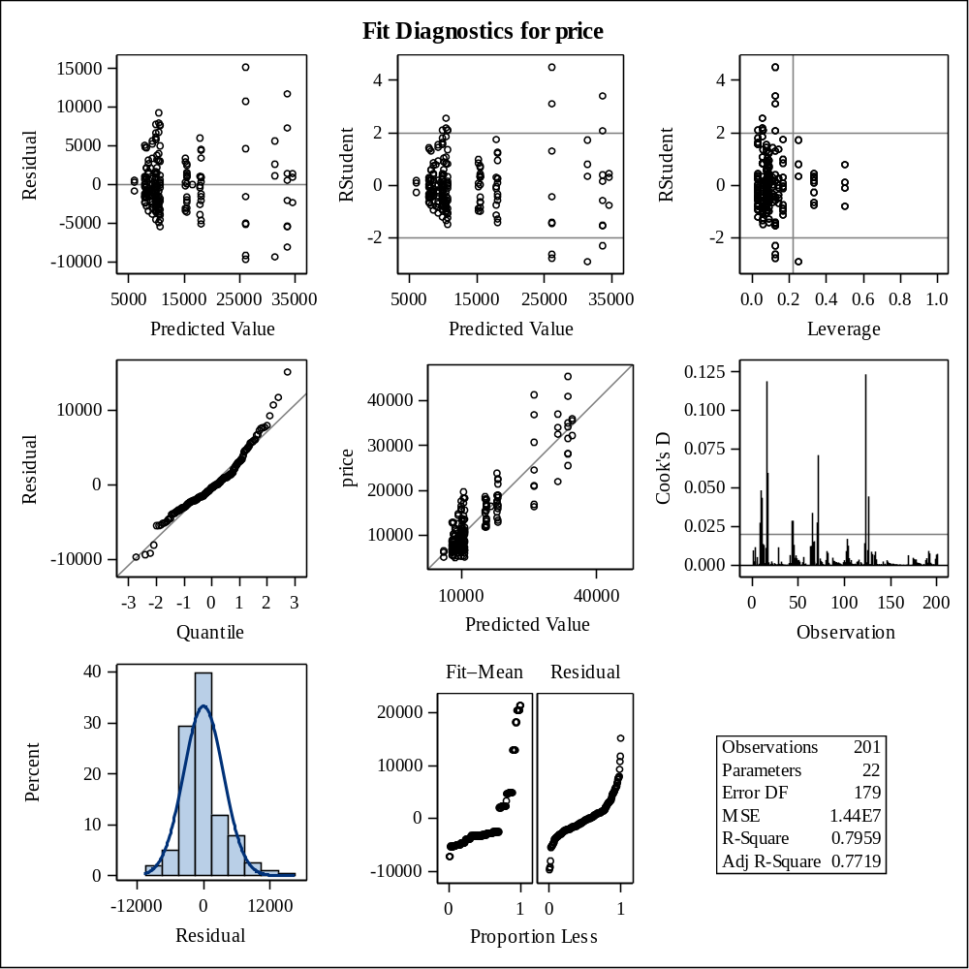

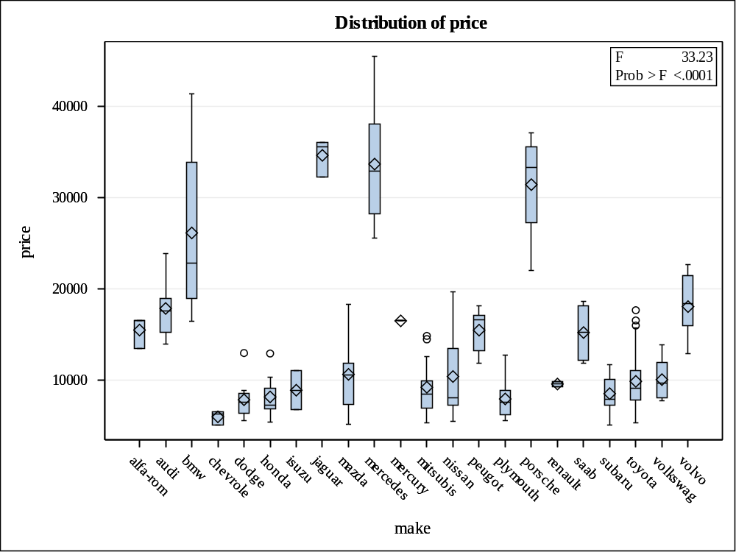

Levene's Test for Homogeneity of price Variance
ANOVA of Squared Deviations from Group Means
Source | DF | Sum of Squares | Mean Square | F Value | Pr > F
make | 18 | 4.602E16 | 2.556E15 | 5.23 | <.0001
Error | 177 | 8.653E16 | 4.889E14

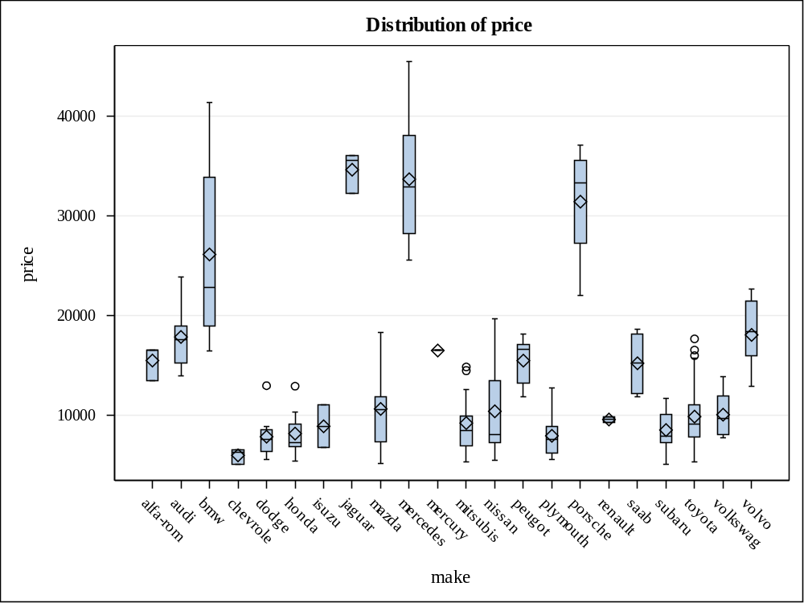

Level of  make | N | price
Level of  make | N | Mean | Std Dev
alfa-rom | 3 | 15498.3333 | 1734.93756
audi | 6 | 17859.1667 | 3452.37949
bmw | 8 | 26118.7500 | 9263.83203
chevrole | 3 | 6007.0000 | 754.42163
dodge | 9 | 7875.4444 | 2213.38604
honda | 13 | 8184.6923 | 2061.67211
isuzu | 2 | 8916.5000 | 3014.39621
jaguar | 3 | 34600.0000 | 2047.55952
mazda | 17 | 10652.8824 | 3975.68209
mercedes | 8 | 33647.0000 | 6789.56031
mercury | 1 | 16503.0000 | .
mitsubis | 13 | 9239.7692 | 3042.99869
nissan | 18 | 10415.6667 | 4477.39420
peugot | 11 | 15489.0909 | 2246.74967
plymouth | 7 | 7963.4286 | 2395.54426
porsche | 4 | 31400.5000 | 6528.78434
renault | 2 | 9595.0000 | 424.26407
saab | 6 | 15223.3333 | 2860.79476
subaru | 12 | 8541.2500 | 1940.19147
toyota | 32 | 9885.8125 | 3204.98211
volkswag | 12 | 10077.5000 | 2178.54987
volvo | 11 | 18063.1818 | 3314.65026

Class Level Information
Class | Levels | Values
fuel_type | 2 | diesel gas

Number of Observations Read | 201
Number of Observations Used | 201

Source | DF | Sum of Squares | Mean Square | F Value | Pr > F
Model | 1 | 153743226 | 153743226 | 2.45 | 0.1190
Error | 199 | 12477429462 | 62700651
Corrected Total | 200 | 12631172689

R-Square | Coeff Var | Root MSE | price Mean
0.012172 | 59.95530 | 7918.374 | 13207.13

Source | DF | Type I SS | Mean Square | F Value | Pr > F
fuel_type | 1 | 153743226.3 | 153743226.3 | 2.45 | 0.1190

Source | DF | Type III SS | Mean Square | F Value | Pr > F
fuel_type | 1 | 153743226.3 | 153743226.3 | 2.45 | 0.1190

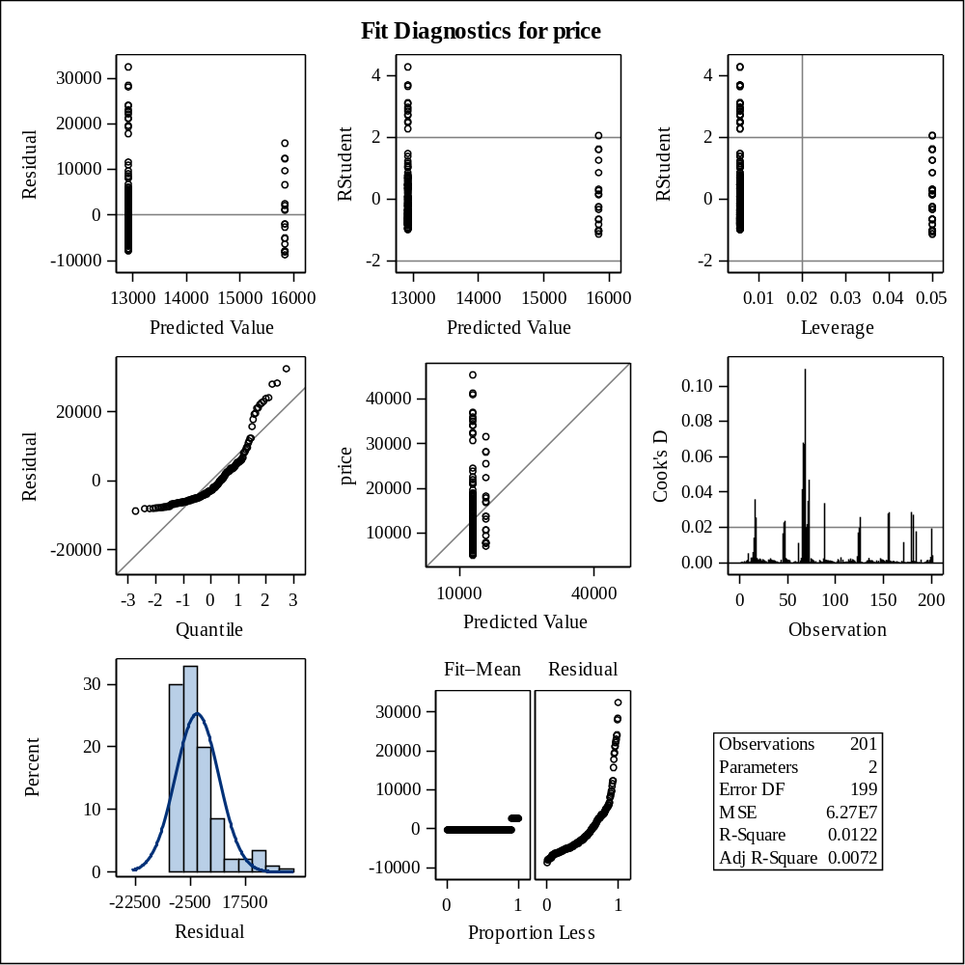

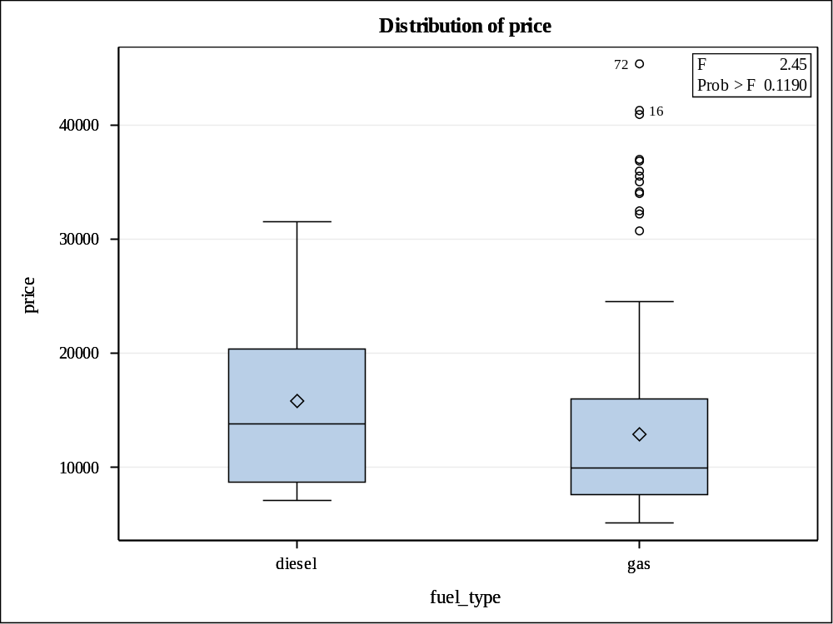

Levene's Test for Homogeneity of price Variance
ANOVA of Squared Deviations from Group Means
Source | DF | Sum of Squares | Mean Square | F Value | Pr > F
fuel_type | 1 | 5.273E14 | 5.273E14 | 0.03 | 0.8742
Error | 199 | 4.173E18 | 2.097E16

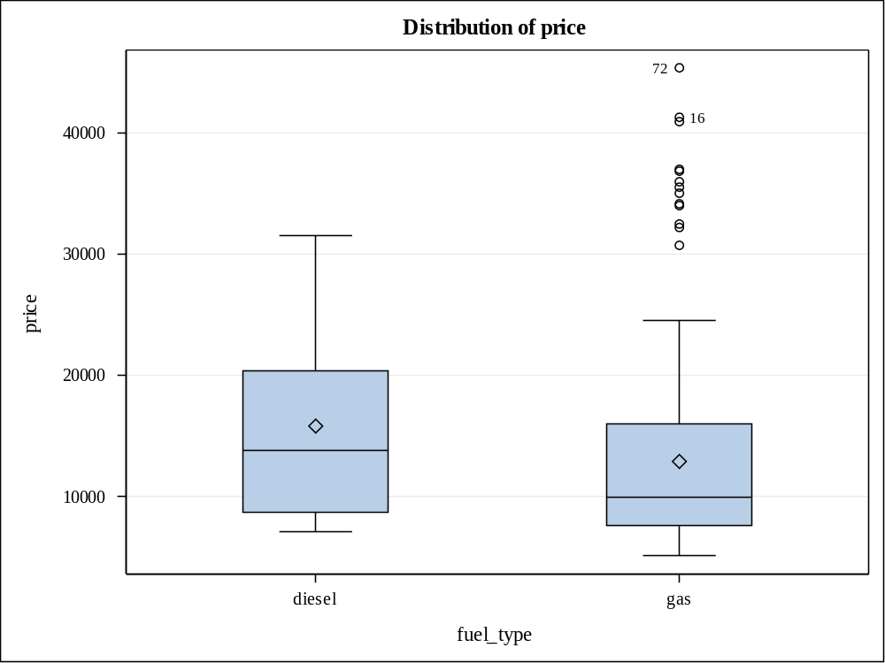

Level of  fuel_type | N | price
Level of  fuel_type | N | Mean | Std Dev
diesel | 20 | 15838.1500 | 7759.84371
gas | 181 | 12916.4088 | 7934.92321

Class Level Information
Class | Levels | Values
aspiration | 2 | std turbo

Number of Observations Read | 201
Number of Observations Used | 201

Source | DF | Sum of Squares | Mean Square | F Value | Pr > F
Model | 1 | 407335500 | 407335500 | 6.63 | 0.0107
Error | 199 | 12223837188 | 61426318
Corrected Total | 200 | 12631172689

R-Square | Coeff Var | Root MSE | price Mean
0.032248 | 59.34291 | 7837.494 | 13207.13

Source | DF | Type I SS | Mean Square | F Value | Pr > F
aspiration | 1 | 407335500.5 | 407335500.5 | 6.63 | 0.0107

Source | DF | Type III SS | Mean Square | F Value | Pr > F
aspiration | 1 | 407335500.5 | 407335500.5 | 6.63 | 0.0107

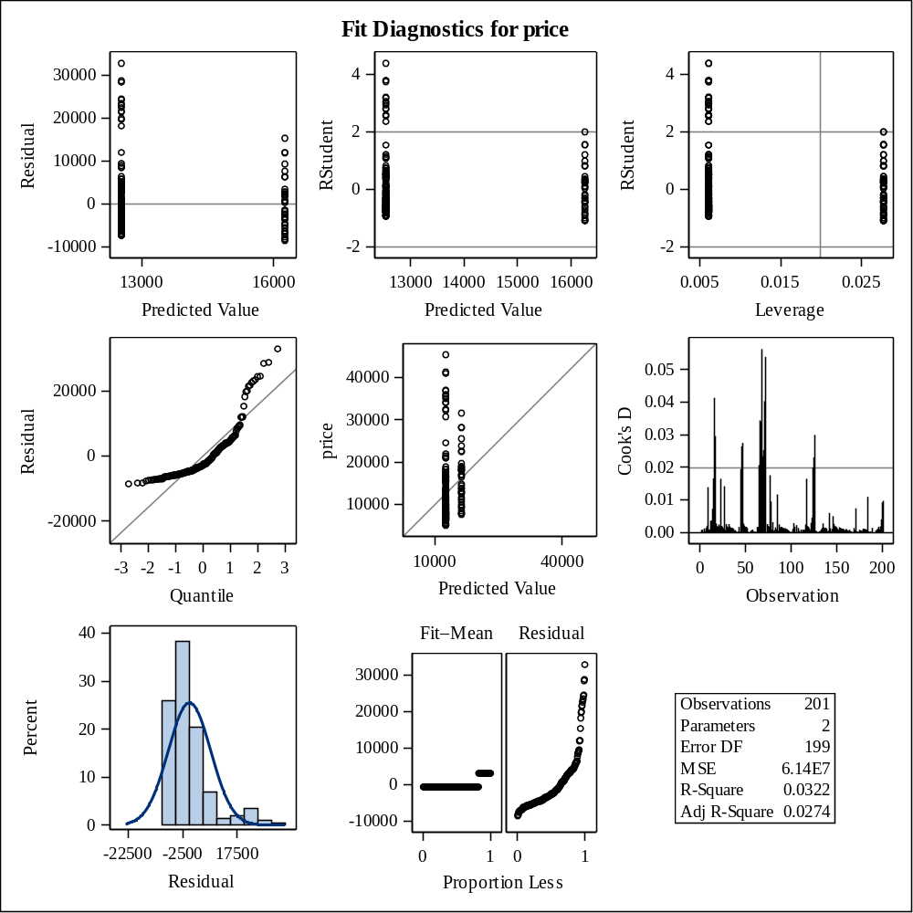

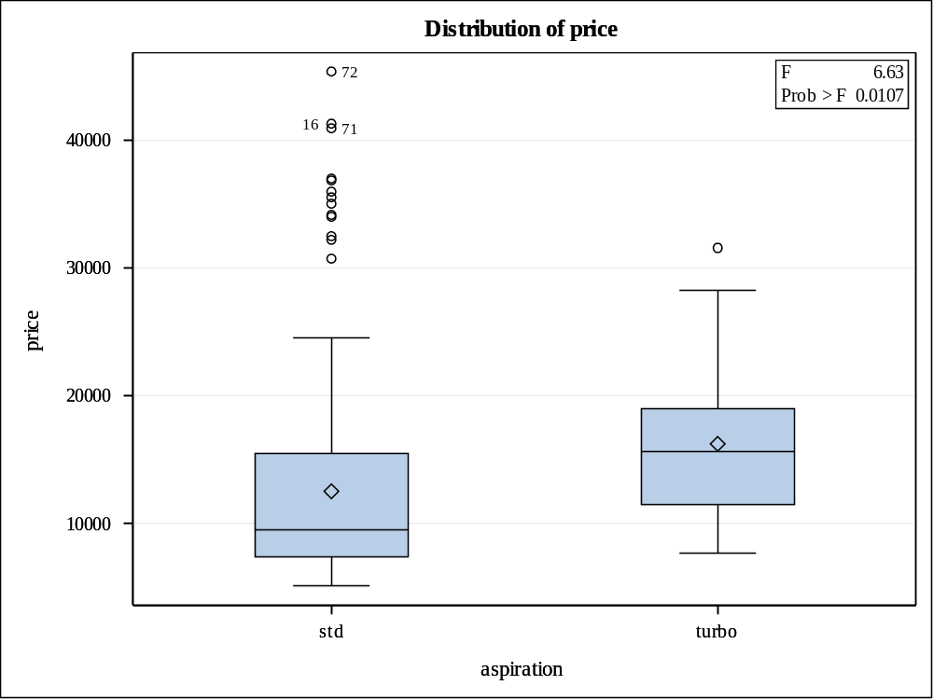

Levene's Test for Homogeneity of price Variance
ANOVA of Squared Deviations from Group Means
Source | DF | Sum of Squares | Mean Square | F Value | Pr > F
aspiration | 1 | 2.461E16 | 2.461E16 | 1.11 | 0.2932
Error | 199 | 4.409E18 | 2.215E16

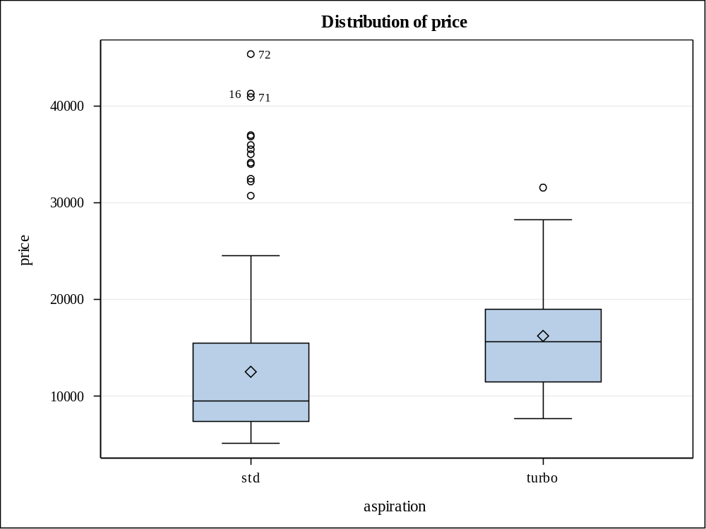

Level of  aspiration | N | price
Level of  aspiration | N | Mean | Std Dev
std | 165 | 12542.1818 | 8147.74746
turbo | 36 | 16254.8056 | 6179.61592

Class Level Information
Class | Levels | Values
engine_type | 6 | dohc l ohc ohcf ohcv rotor

Number of Observations Read | 201
Number of Observations Used | 201

Source | DF | Sum of Squares | Mean Square | F Value | Pr > F
Model | 5 | 2545910823 | 509182165 | 9.85 | <.0001
Error | 195 | 10085261866 | 51719292
Corrected Total | 200 | 12631172689

R-Square | Coeff Var | Root MSE | price Mean
0.201558 | 54.45250 | 7191.613 | 13207.13

Source | DF | Type I SS | Mean Square | F Value | Pr > F
engine_type | 5 | 2545910823 | 509182165 | 9.85 | <.0001

Source | DF | Type III SS | Mean Square | F Value | Pr > F
engine_type | 5 | 2545910823 | 509182165 | 9.85 | <.0001

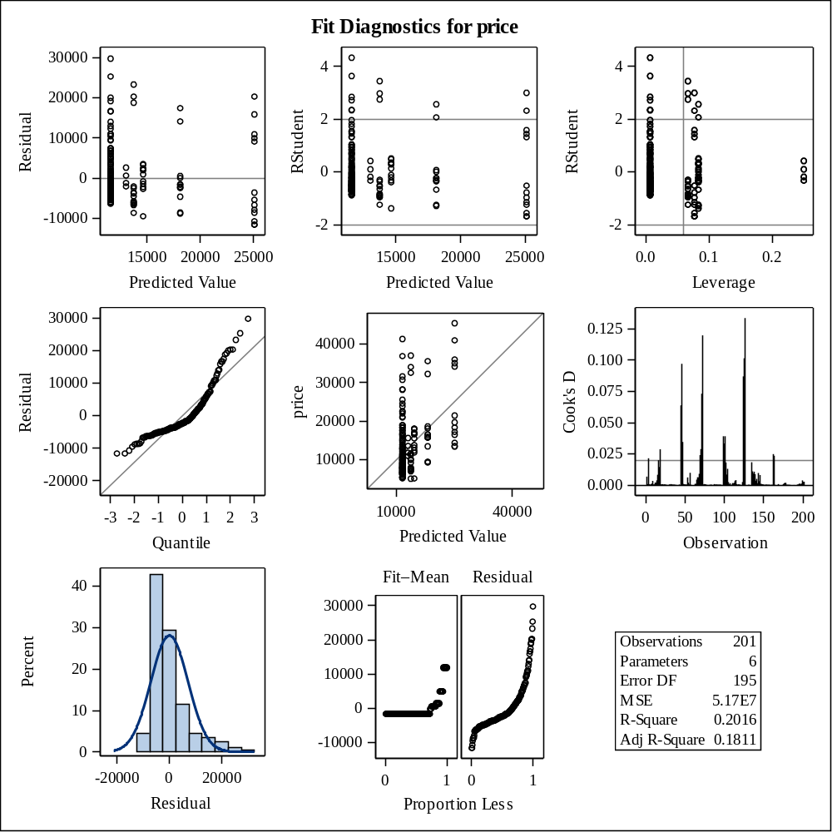

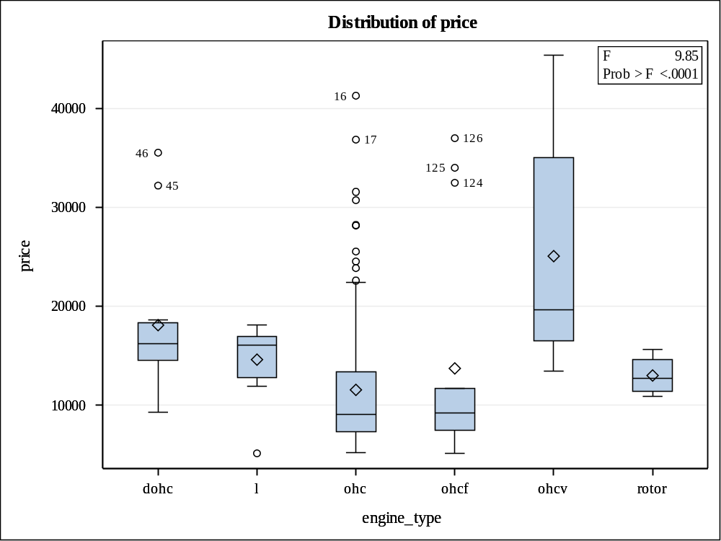

Levene's Test for Homogeneity of price Variance
ANOVA of Squared Deviations from Group Means
Source | DF | Sum of Squares | Mean Square | F Value | Pr > F
engine_type | 5 | 1.597E17 | 3.193E16 | 2.75 | 0.0200
Error | 195 | 2.264E18 | 1.161E16

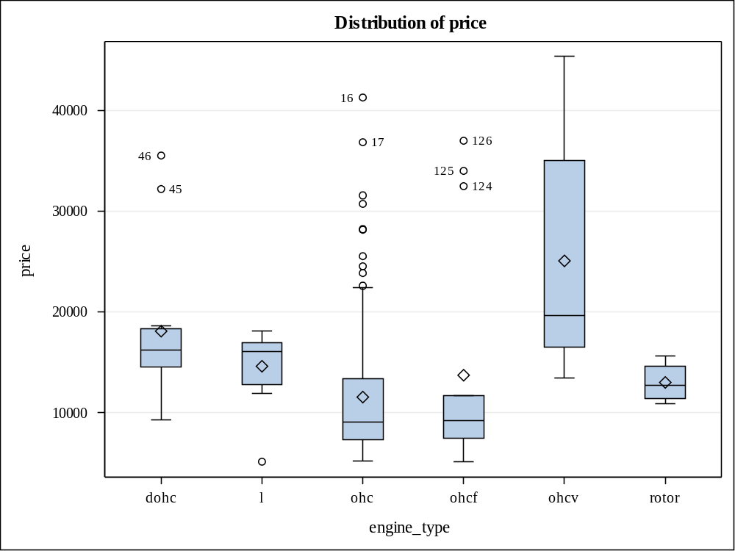

Level of  engine_type | N | price
Level of  engine_type | N | Mean | Std Dev
dohc | 12 | 18116.4167 | 7963.9558
l | 12 | 14627.5833 | 3673.5989
ohc | 145 | 11567.3586 | 6445.4086
ohcf | 15 | 13738.6000 | 10930.4770
ohcv | 13 | 25098.3846 | 11442.9257
rotor | 4 | 13020.0000 | 2079.0623

Class Level Information
Class | Levels | Values
num_of_cylinders | 7 | eight five four six three twelve two

Number of Observations Read | 201
Number of Observations Used | 201

Source | DF | Sum of Squares | Mean Square | F Value | Pr > F
Model | 6 | 7951727008 | 1325287835 | 54.94 | <.0001
Error | 194 | 4679445681 | 24120854
Corrected Total | 200 | 12631172689

R-Square | Coeff Var | Root MSE | price Mean
0.629532 | 37.18672 | 4911.299 | 13207.13

Source | DF | Type I SS | Mean Square | F Value | Pr > F
num_of_cylinders | 6 | 7951727008 | 1325287835 | 54.94 | <.0001

Source | DF | Type III SS | Mean Square | F Value | Pr > F
num_of_cylinders | 6 | 7951727008 | 1325287835 | 54.94 | <.0001

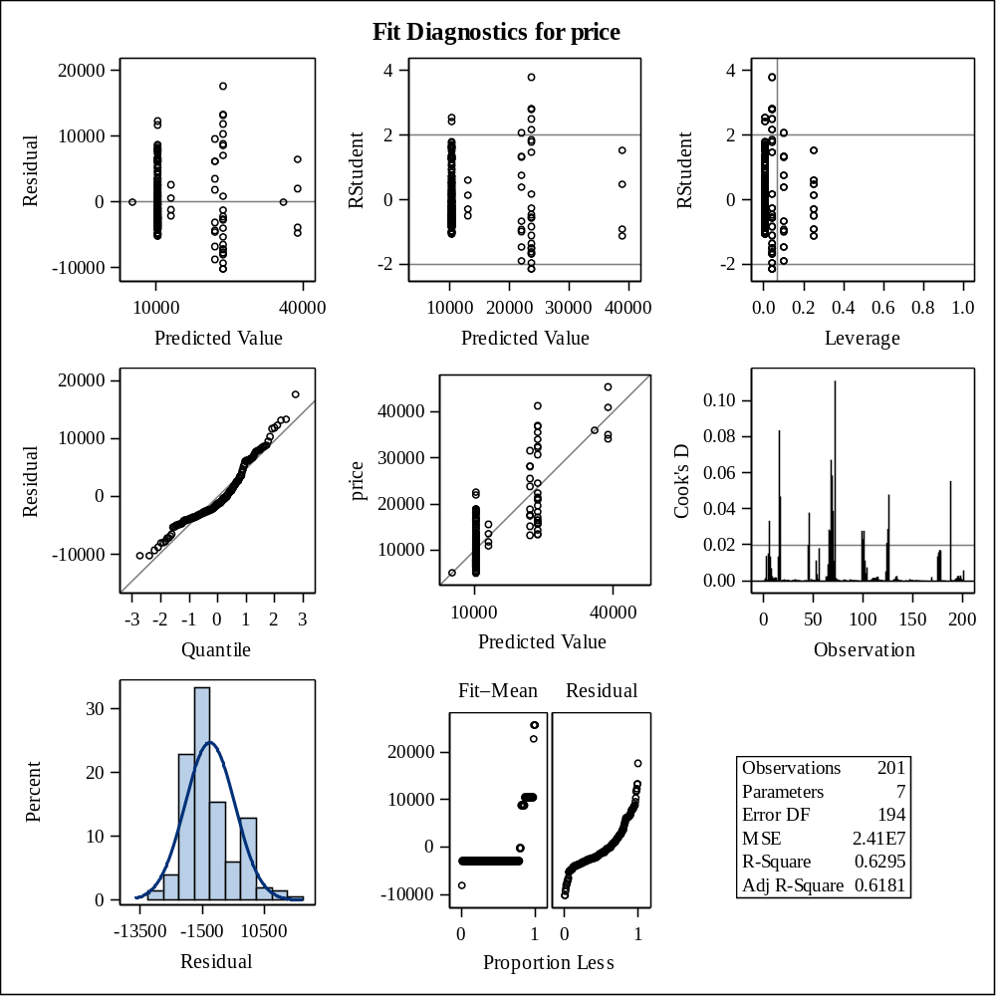

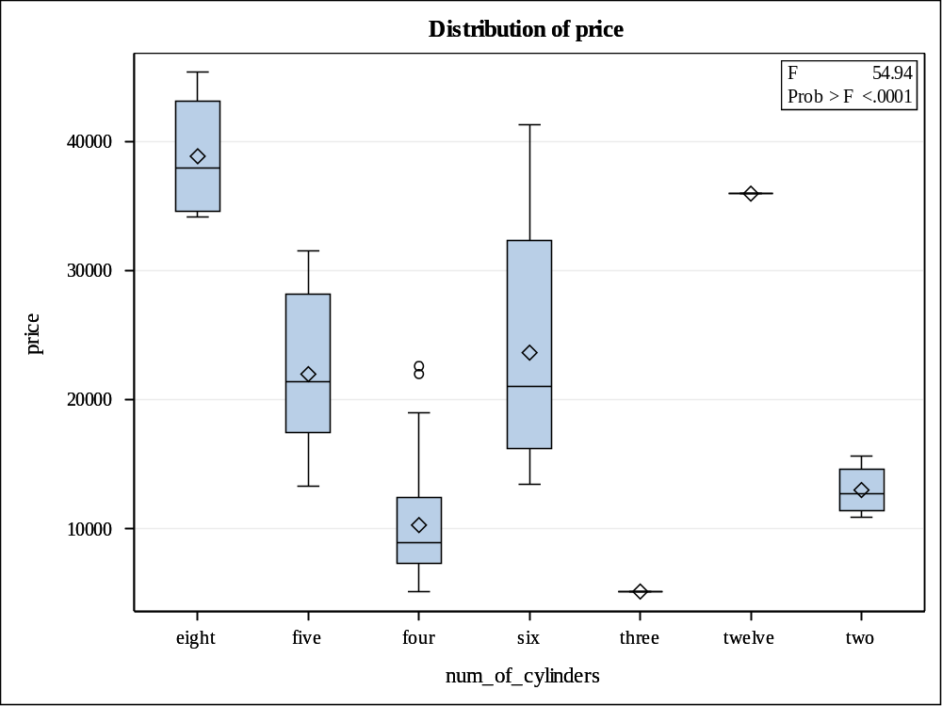

Levene's Test for Homogeneity of price Variance
ANOVA of Squared Deviations from Group Means
Source | DF | Sum of Squares | Mean Square | F Value | Pr > F
num_of_cylinders | 4 | 7.709E16 | 1.927E16 | 18.12 | <.0001
Error | 194 | 2.063E17 | 1.063E15

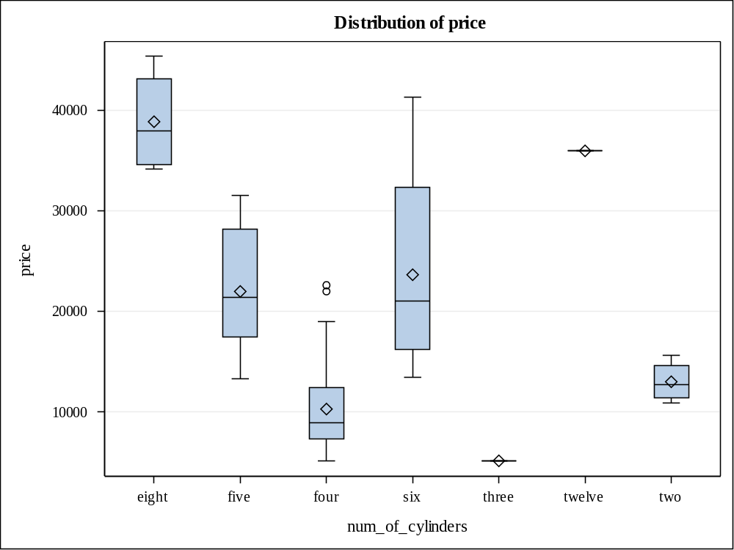

Level of  num_of_cylinders | N | price
Level of  num_of_cylinders | N | Mean | Std Dev
eight | 4 | 38900.0000 | 5276.06520
five | 10 | 22007.6000 | 6284.06058
four | 157 | 10303.1975 | 3943.58376
six | 24 | 23671.8333 | 8850.13826
three | 1 | 5151.0000 | .
twelve | 1 | 36000.0000 | .
two | 4 | 13020.0000 | 2079.06229

Class Level Information
Class | Levels | Values
fuel_system | 8 | 1bbl 2bbl 4bbl idi mfi mpfi spdi spfi

Number of Observations Read | 201
Number of Observations Used | 201

Source | DF | Sum of Squares | Mean Square | F Value | Pr > F
Model | 7 | 4455275516 | 636467931 | 15.02 | <.0001
Error | 193 | 8175897173 | 42362162
Corrected Total | 200 | 12631172689

R-Square | Coeff Var | Root MSE | price Mean
0.352721 | 49.28113 | 6508.622 | 13207.13

Source | DF | Type I SS | Mean Square | F Value | Pr > F
fuel_system | 7 | 4455275516 | 636467931 | 15.02 | <.0001

Source | DF | Type III SS | Mean Square | F Value | Pr > F
fuel_system | 7 | 4455275516 | 636467931 | 15.02 | <.0001

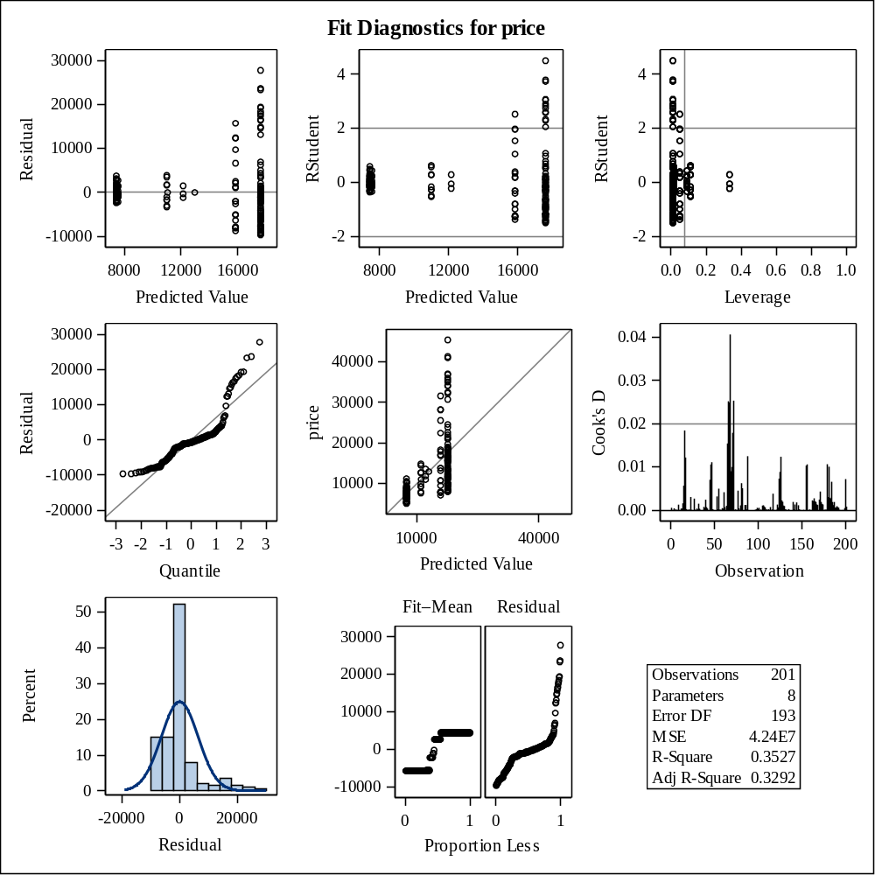

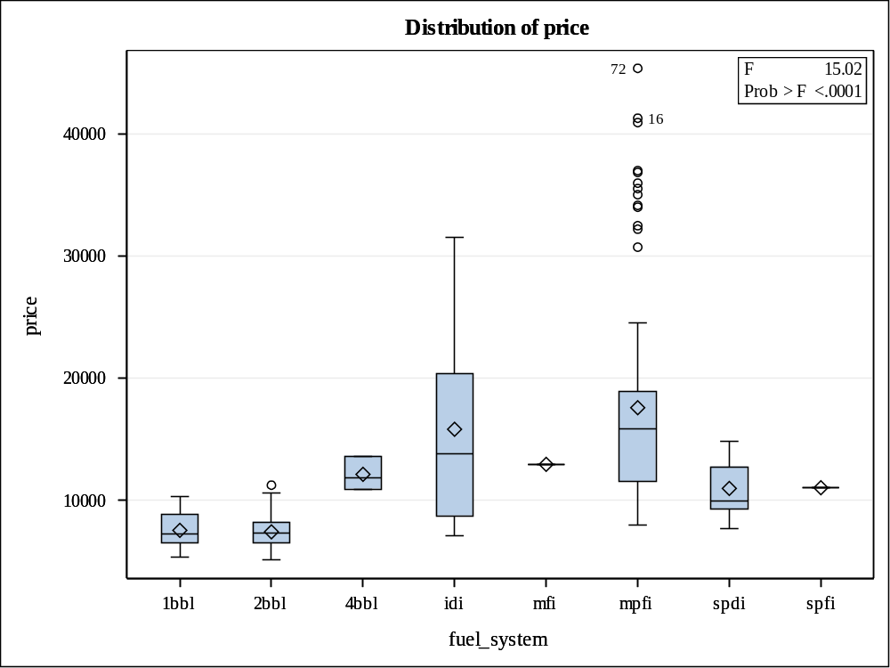

Levene's Test for Homogeneity of price Variance
ANOVA of Squared Deviations from Group Means
Source | DF | Sum of Squares | Mean Square | F Value | Pr > F
fuel_system | 5 | 2.37E17 | 4.74E16 | 5.18 | 0.0002
Error | 193 | 1.765E18 | 9.144E15

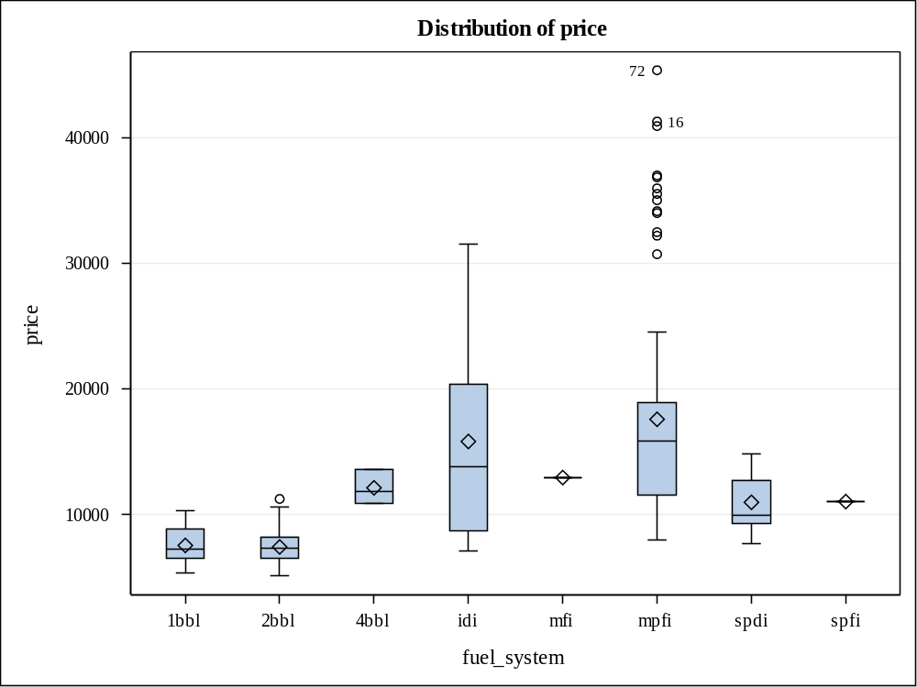

Level of  fuel_system | N | price
Level of  fuel_system | N | Mean | Std Dev
1bbl | 11 | 7555.5455 | 1390.12088
2bbl | 64 | 7433.2031 | 1382.90472
4bbl | 3 | 12145.0000 | 1374.77271
idi | 20 | 15838.1500 | 7759.84371
mfi | 1 | 12964.0000 | .
mpfi | 92 | 17605.1413 | 8662.21107
spdi | 9 | 10990.4444 | 2741.73144
spfi | 1 | 11048.0000 | .

Class Level Information
Class | Levels | Values
bin_hp | 4 | 0 1 2 3

Number of Observations Read | 201
Number of Observations Used | 201

Source | DF | Sum of Squares | Mean Square | F Value | Pr > F
Model | 3 | 7470225632 | 2490075211 | 95.05 | <.0001
Error | 197 | 5160947057 | 26197701
Corrected Total | 200 | 12631172689

R-Square | Coeff Var | Root MSE | price Mean
0.591412 | 38.75459 | 5118.369 | 13207.13

Source | DF | Type I SS | Mean Square | F Value | Pr > F
bin_hp | 3 | 7470225632 | 2490075211 | 95.05 | <.0001

Source | DF | Type III SS | Mean Square | F Value | Pr > F
bin_hp | 3 | 7470225632 | 2490075211 | 95.05 | <.0001

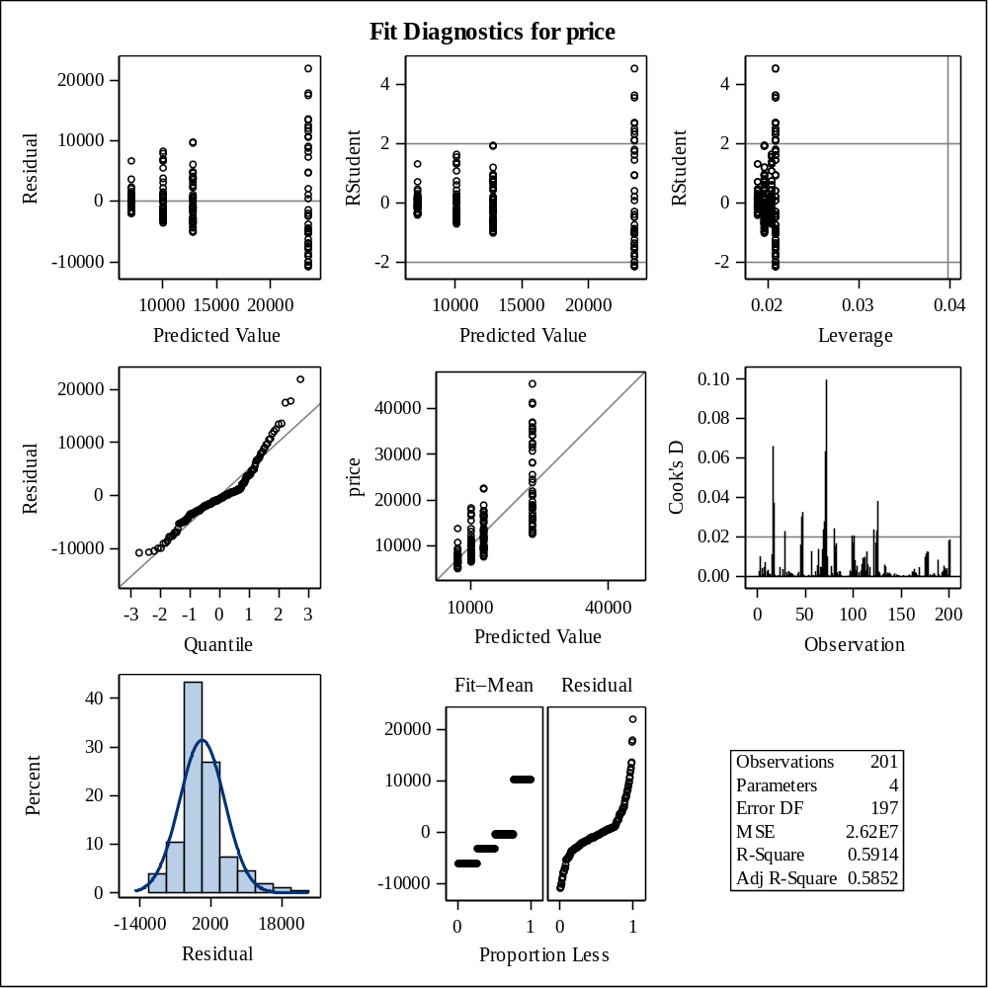

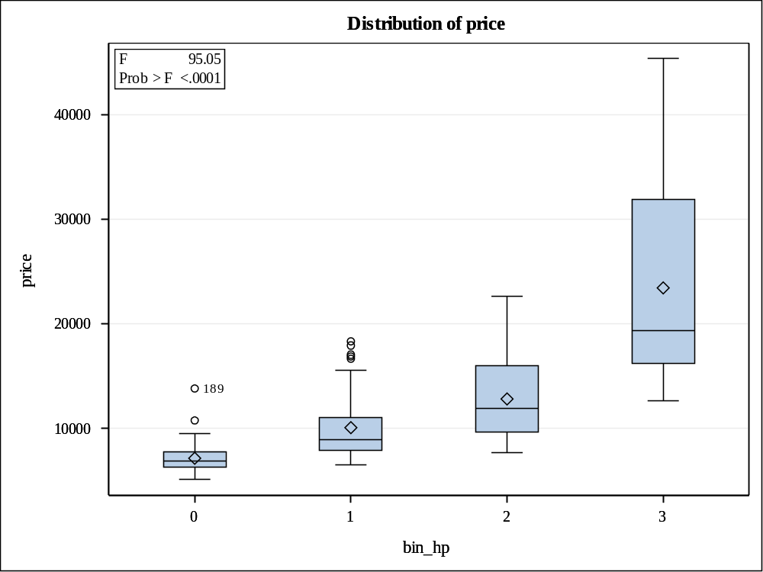

Levene's Test for Homogeneity of price Variance
ANOVA of Squared Deviations from Group Means
Source | DF | Sum of Squares | Mean Square | F Value | Pr > F
bin_hp | 3 | 1.968E17 | 6.561E16 | 30.36 | <.0001
Error | 197 | 4.257E17 | 2.161E15

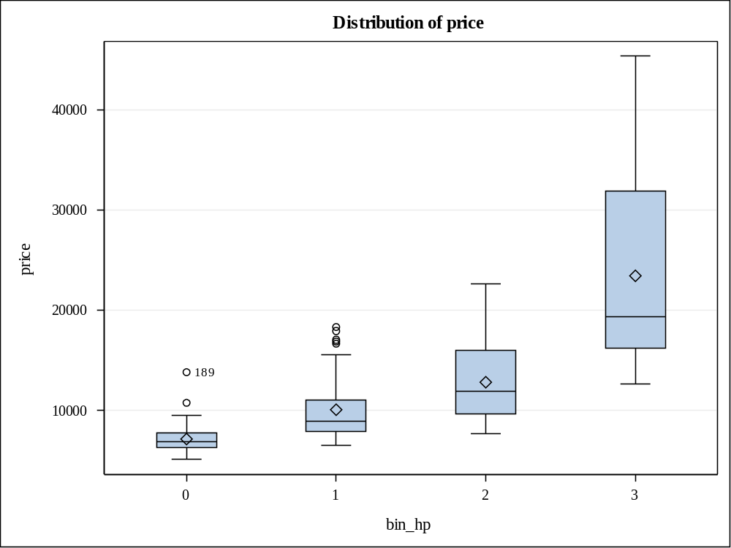

Level of  bin_hp | N | price
Level of  bin_hp | N | Mean | Std Dev
0 | 53 | 7159.5283 | 1503.79403
1 | 49 | 10088.7347 | 3151.19030
2 | 51 | 12835.8627 | 3674.86306
3 | 48 | 23462.5208 | 9099.31433

Number of Observations Read | 201
Number of Observations Used | 201

Analysis of Variance
Source | DF | Sum of  Squares | Mean  Square | F Value | Pr > F
Model | 8 | 10330109290 | 1291263661 | 107.74 | <.0001
Error | 192 | 2301063398 | 11984705
Corrected Total | 200 | 12631172689

Root MSE | 3461.89330 | R-Square | 0.8178
Dependent Mean | 13207 | Adj R-Sq | 0.8102
Coeff Var | 26.21231

Parameter Estimates
Variable | DF | Parameter  Estimate | Standard  Error | t Value | Pr > |t| | Variance  Inflation
Intercept | 1 | -11463 | 9657.75444 | -1.19 | 0.2367 | 0
engine_size | 1 | 3299.27266 | 590.64106 | 5.59 | <.0001 | 5.82170
curb_weight | 1 | 1754.69294 | 851.23344 | 2.06 | 0.0406 | 12.09205
width | 1 | 1508.53506 | 541.30945 | 2.79 | 0.0059 | 4.88983
highway_mpg | 1 | 975.93711 | 1178.73245 | 0.83 | 0.4087 | 23.18639
length | 1 | -478.28085 | 616.46899 | -0.78 | 0.4388 | 6.34198
city_mpg | 1 | -796.46945 | 1185.91702 | -0.67 | 0.5026 | 23.46990
bore | 1 | -232.28601 | 331.34556 | -0.70 | 0.4841 | 1.83217
horse_power | 1 | 53.58169 | 16.59552 | 3.23 | 0.0015 | 6.41695

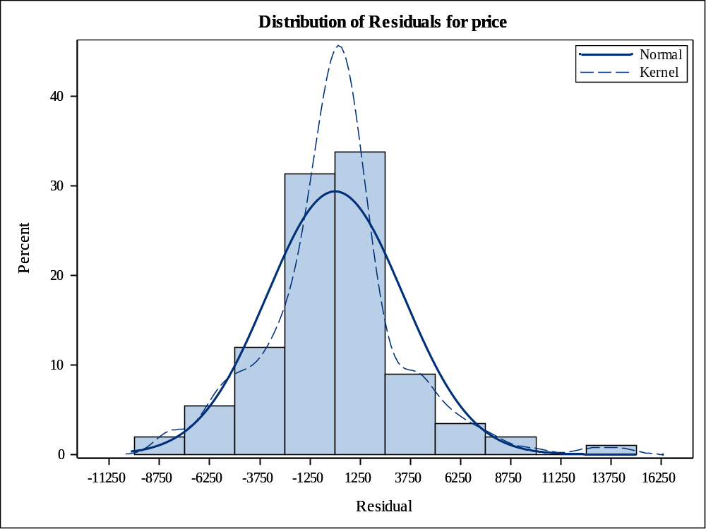

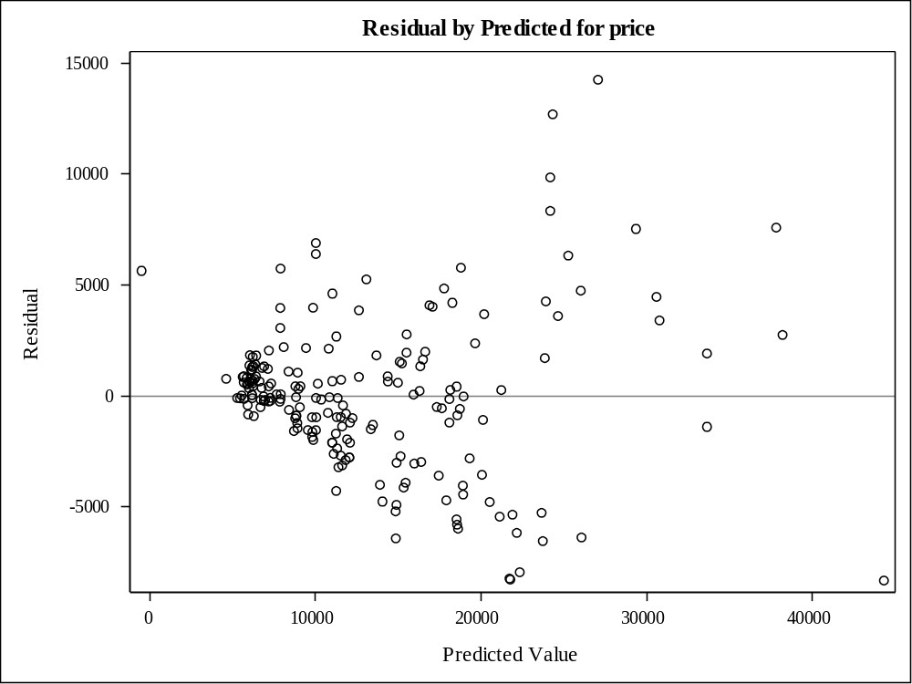

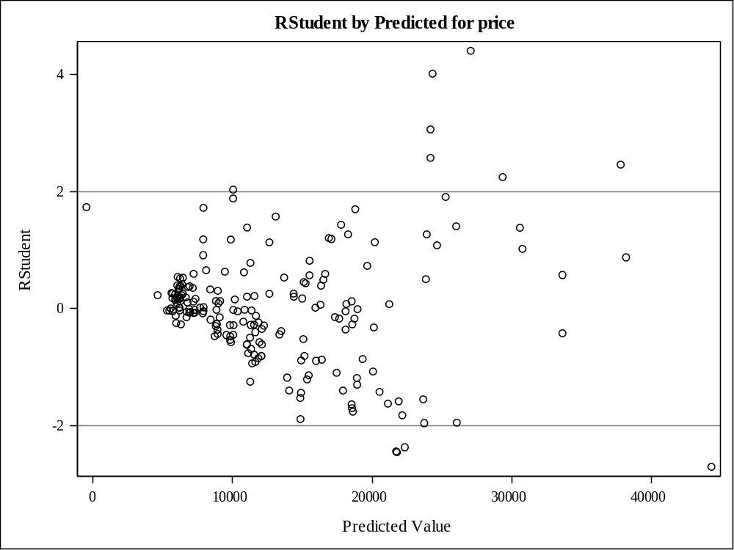

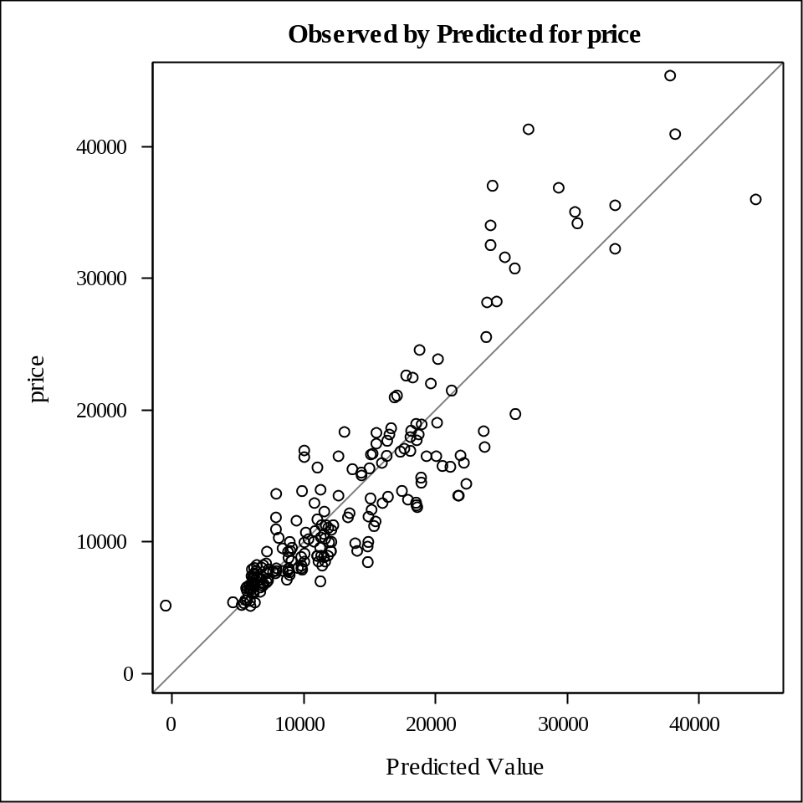

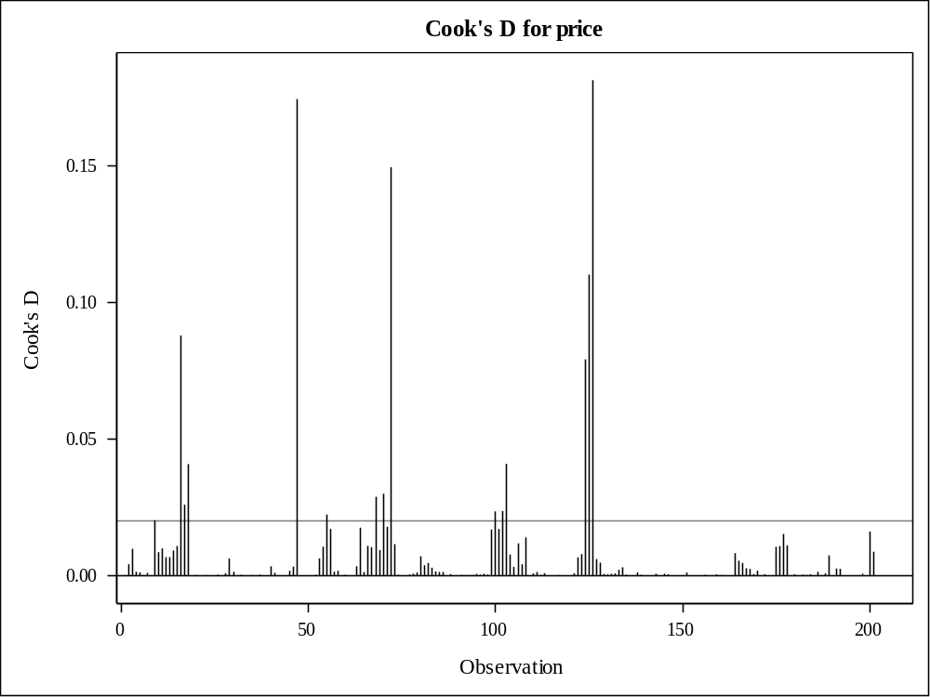

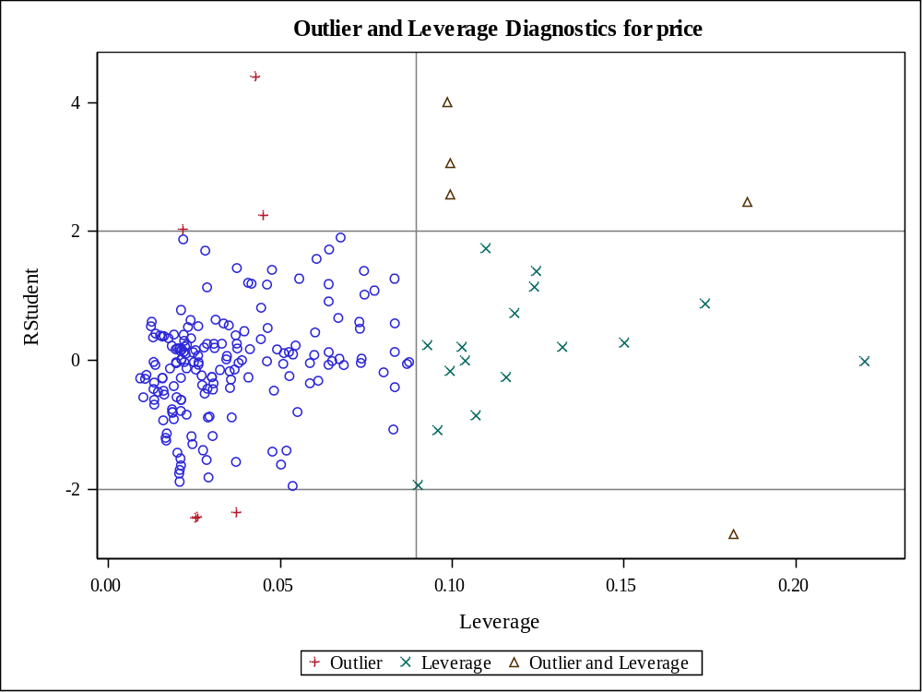

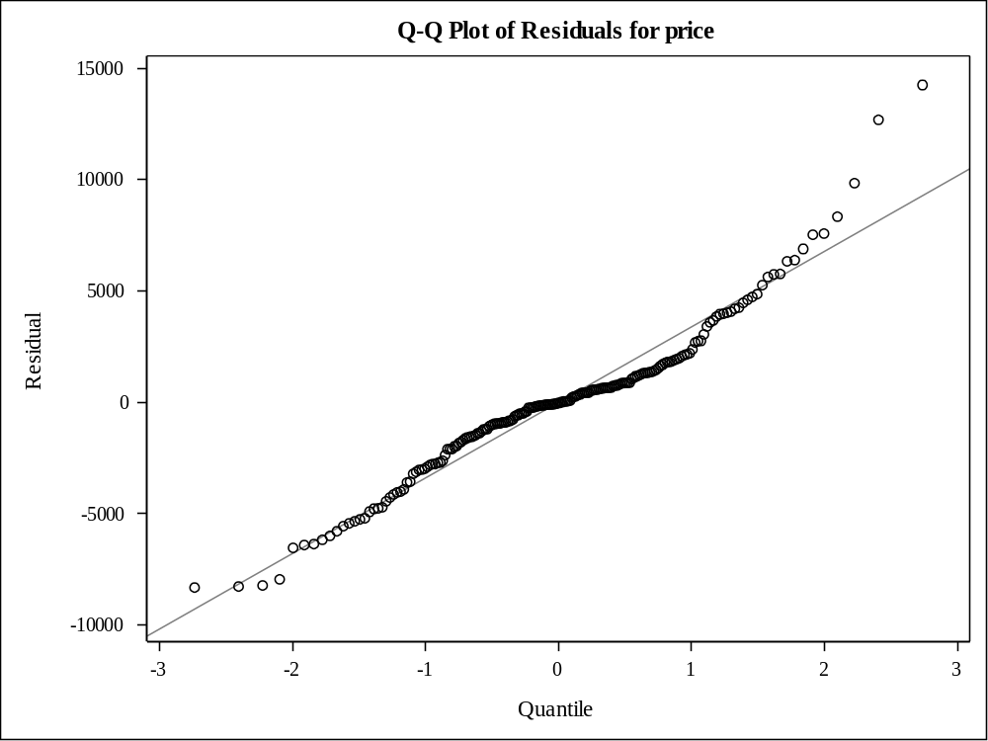

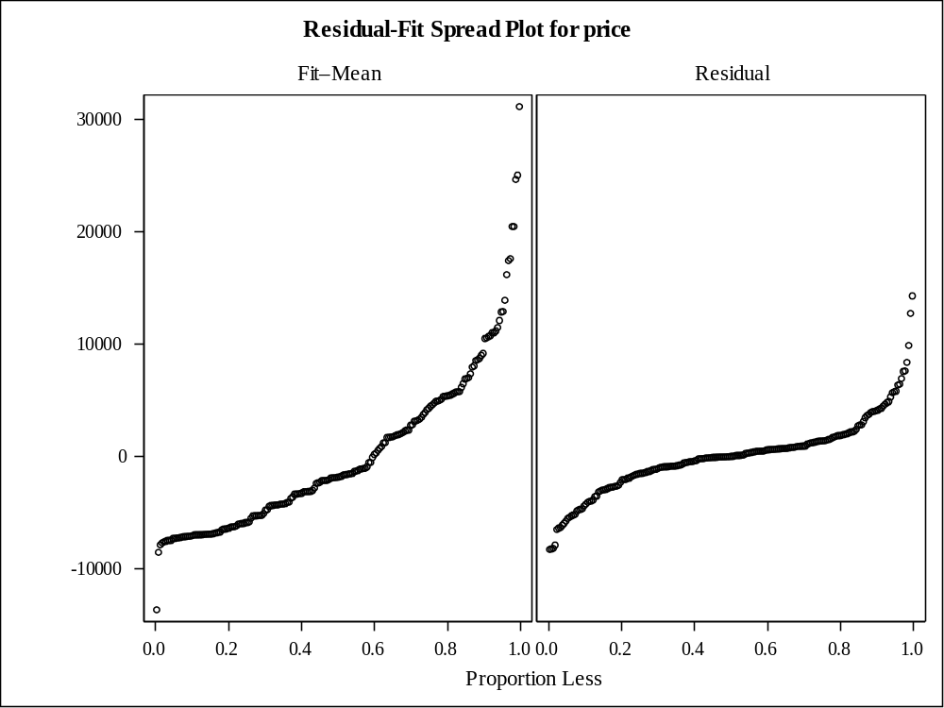

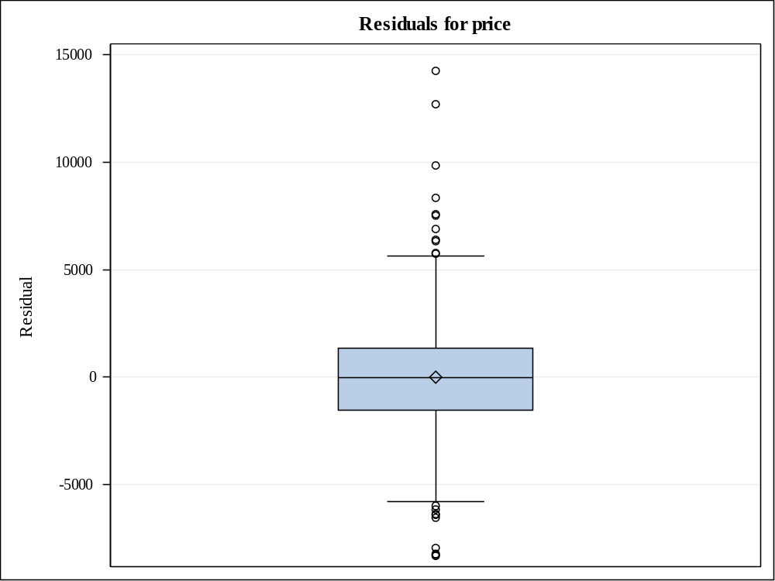

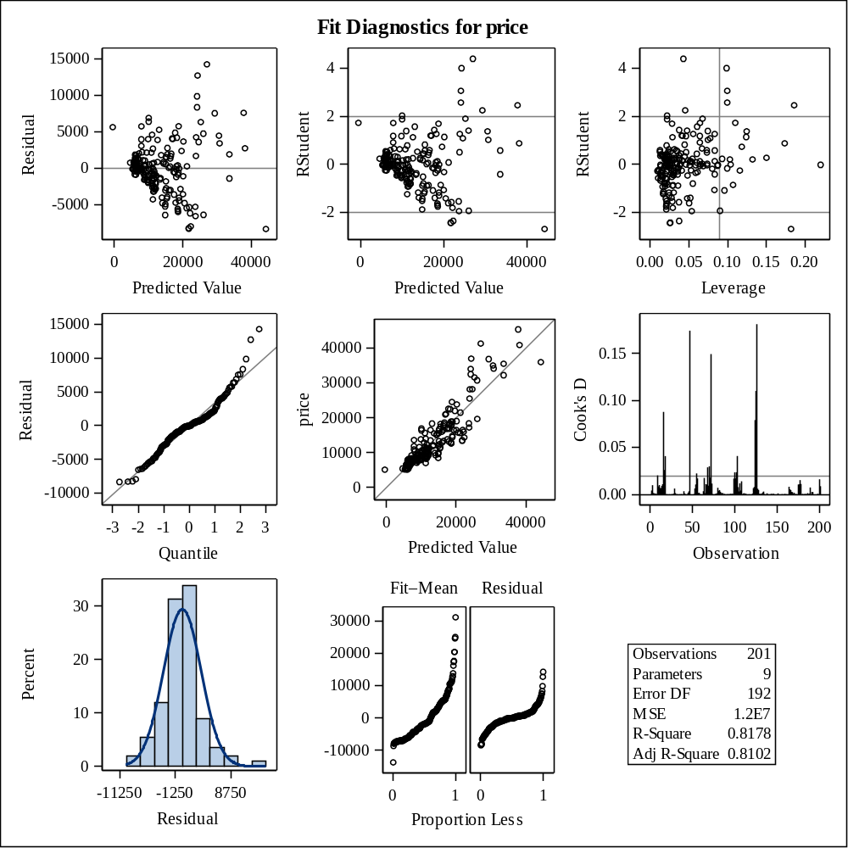

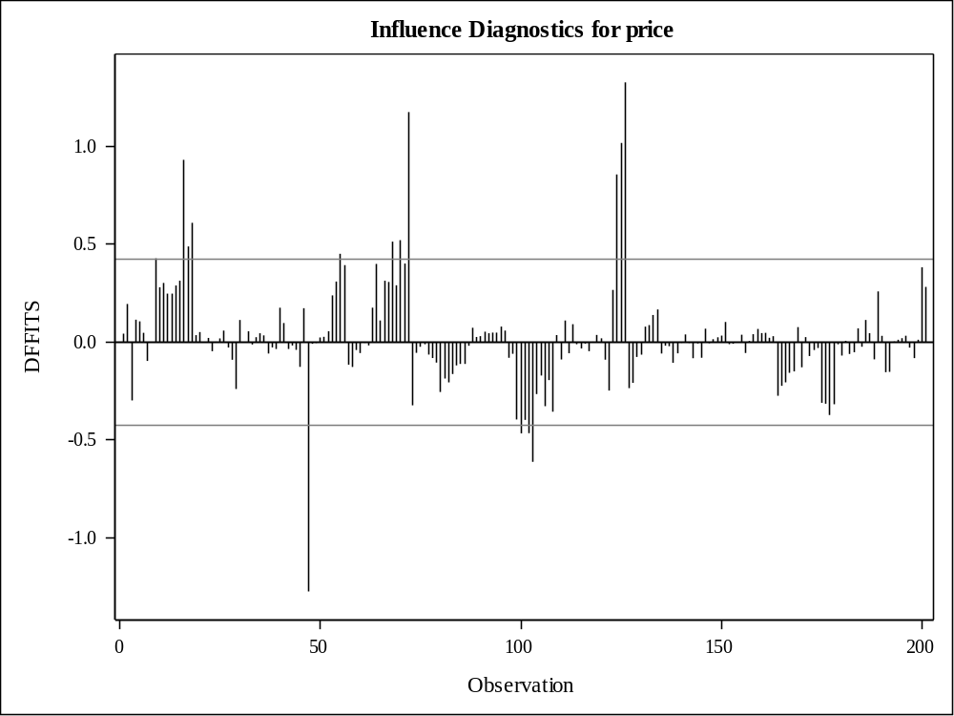

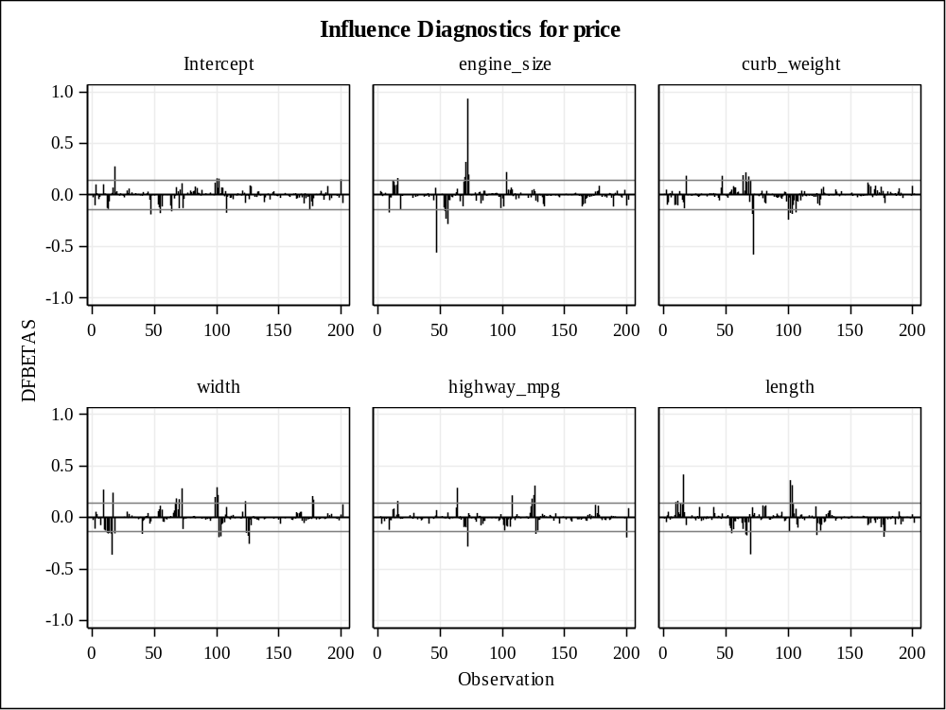

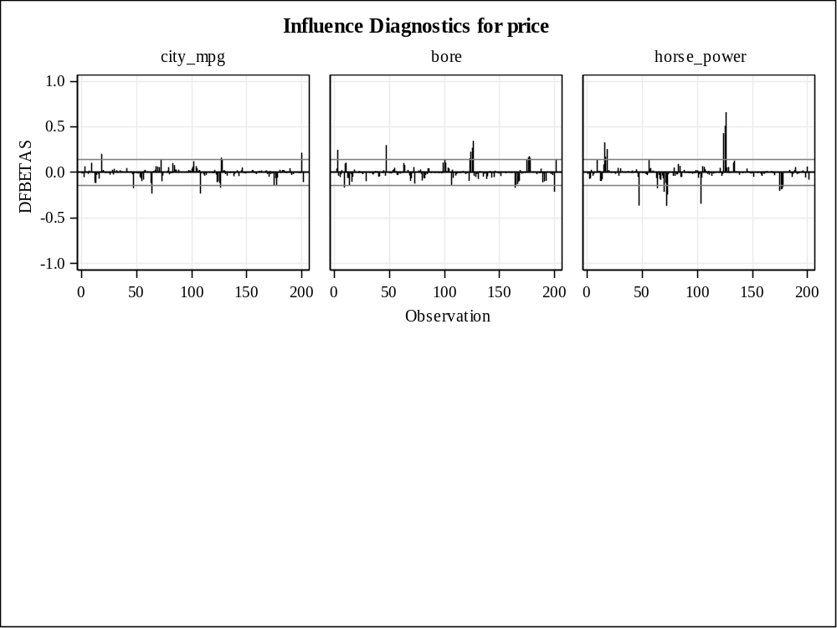

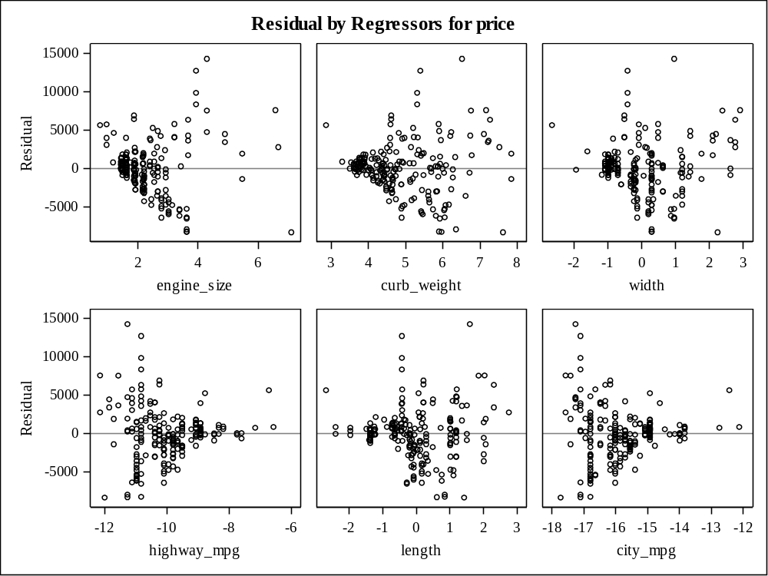

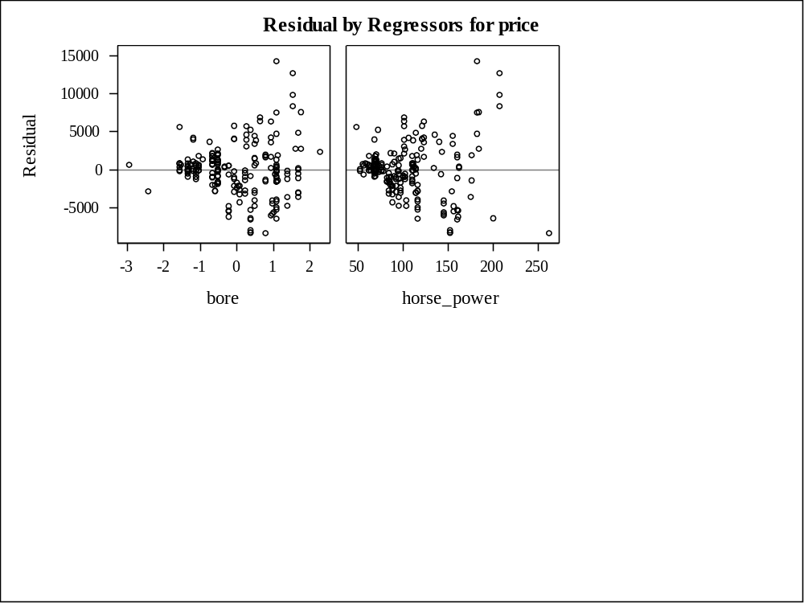

8 Variables: | engine_size curb_weight width highway_mpg length city_mpg bore horse_power

Pearson Correlation Coefficients, N = 201
Prob > |r| under H0: Rho=0
engine_size | engine_size  1.00000 | curb_weight  0.84907  <.0001 | horse_power  0.82265  <.0001
curb_weight | curb_weight  1.00000 | length  0.88066  <.0001 | width  0.86620  <.0001
width | width  1.00000 | curb_weight  0.86620  <.0001 | length  0.85717  <.0001
highway_mpg | highway_mpg  1.00000 | city_mpg  0.97204  <.0001 | horse_power  -0.80459  <.0001
length | length  1.00000 | curb_weight  0.88066  <.0001 | width  0.85717  <.0001
city_mpg | city_mpg  1.00000 | highway_mpg  0.97204  <.0001 | horse_power  -0.82214  <.0001
bore | bore  1.00000 | curb_weight  0.64218  <.0001 | length  0.60636  <.0001
horse_power | horse_power  1.00000 | engine_size  0.82265  <.0001 | city_mpg  -0.82214  <.0001

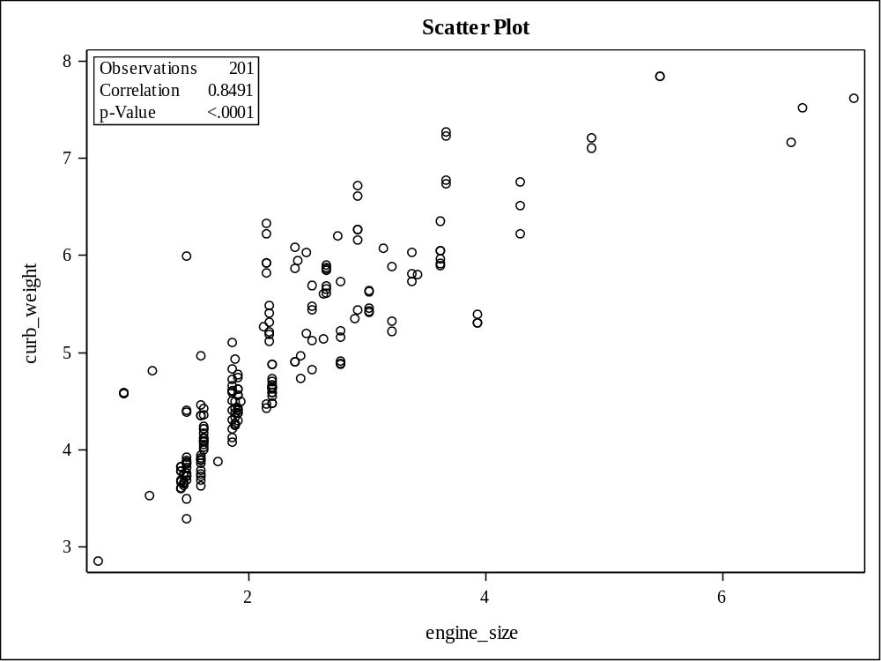

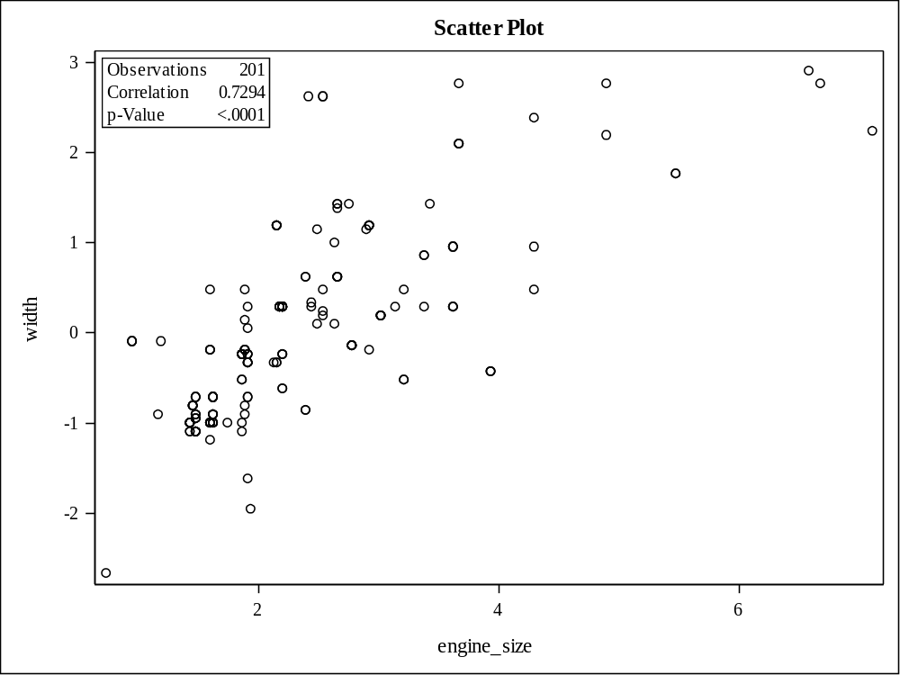

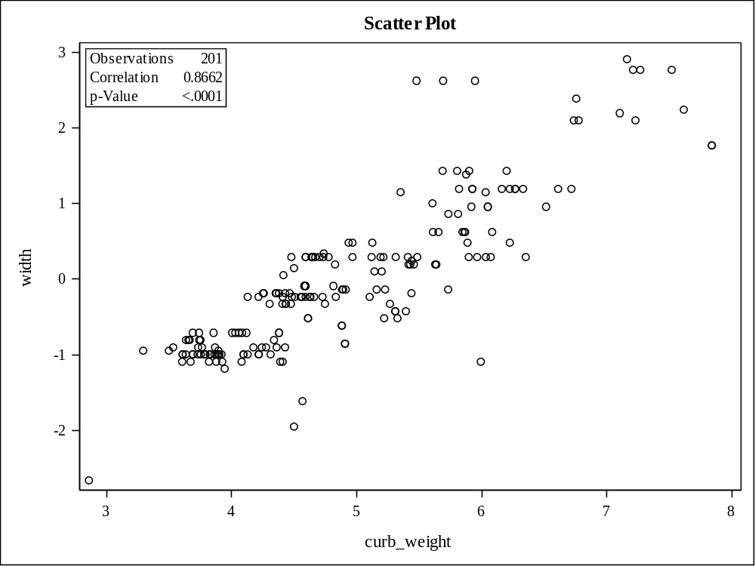

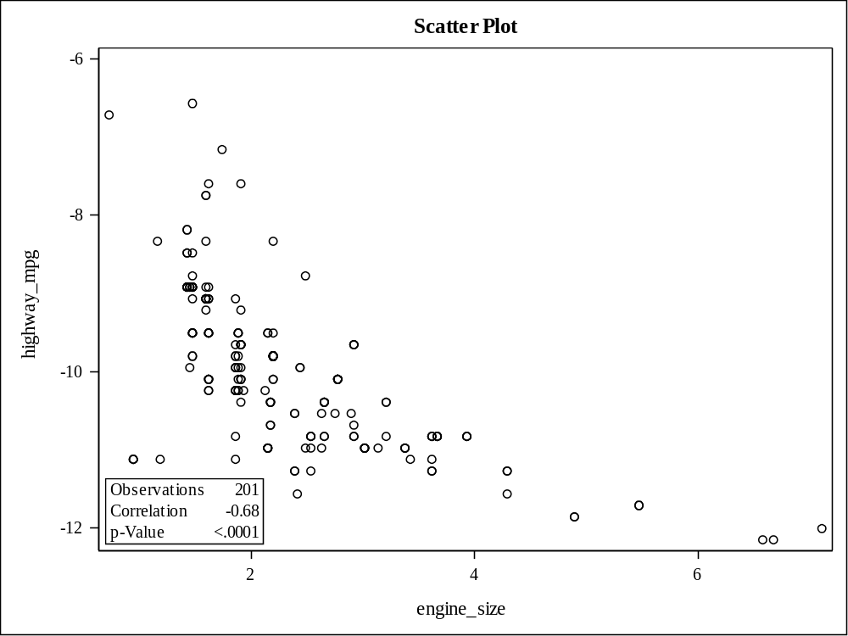

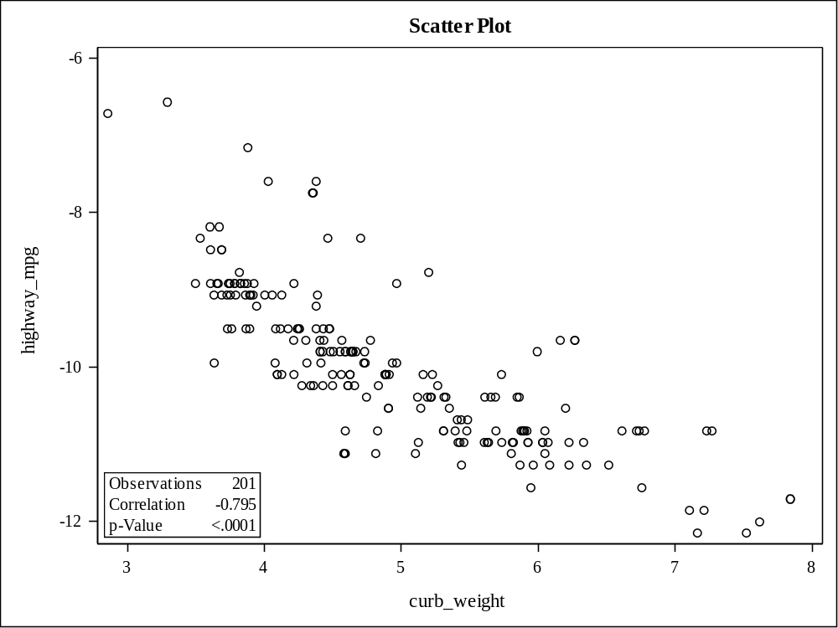

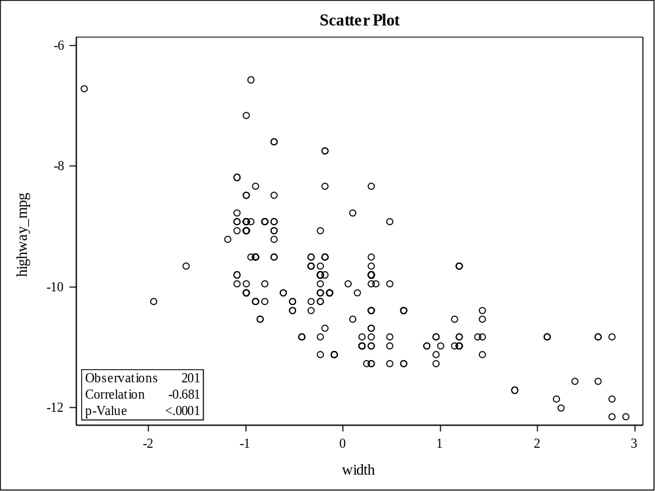

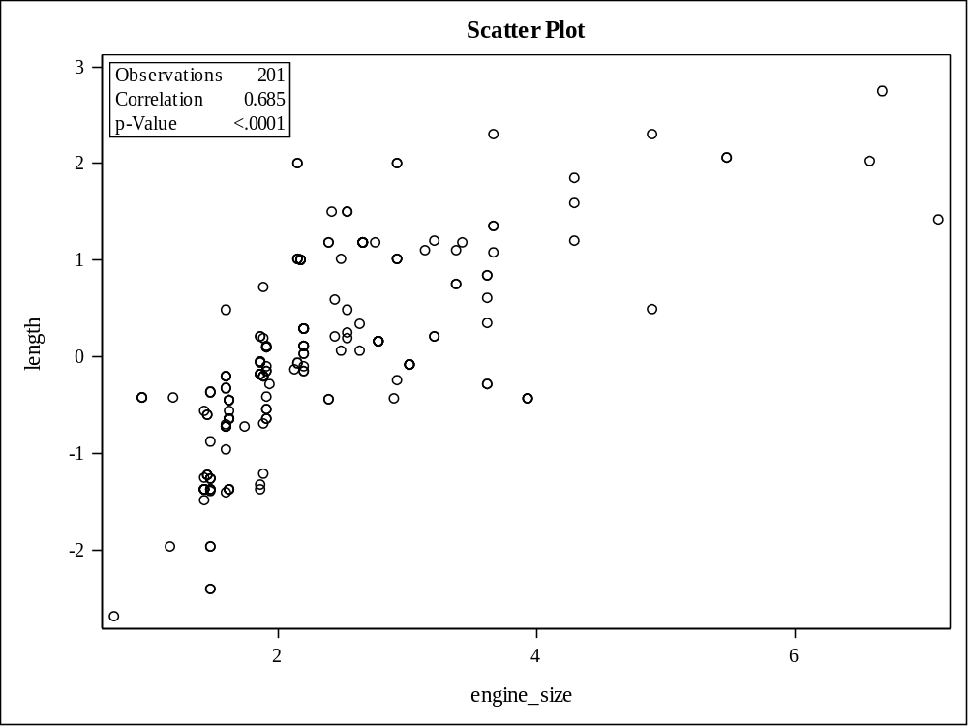

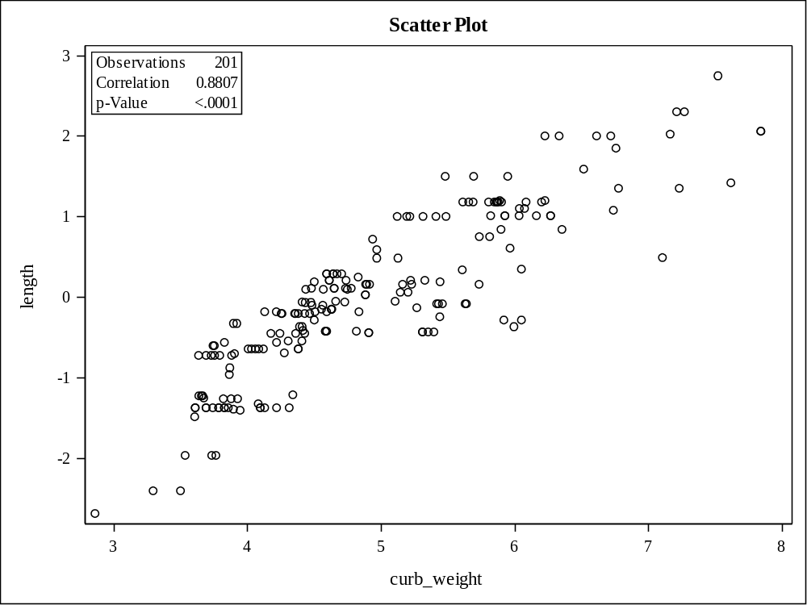

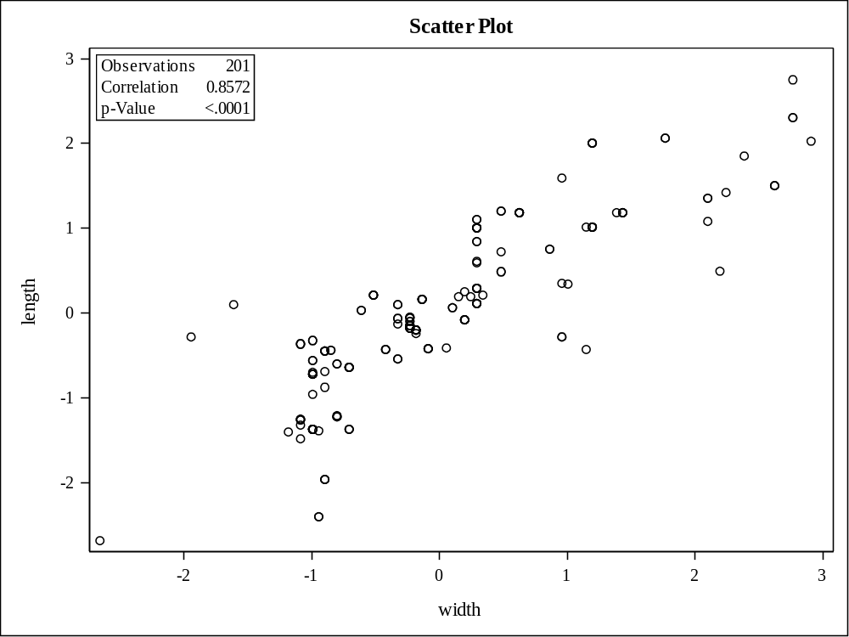

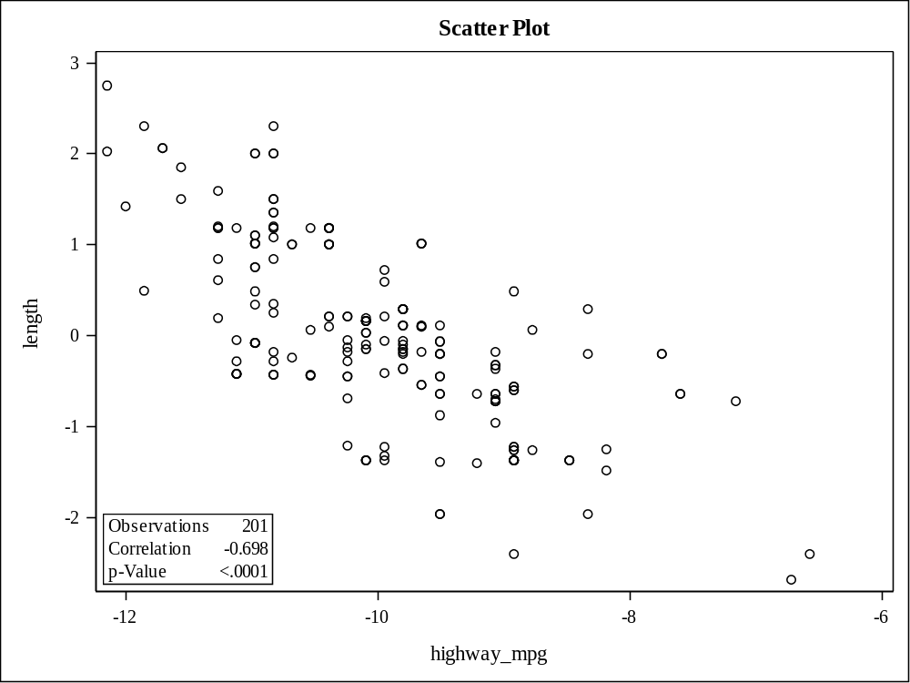

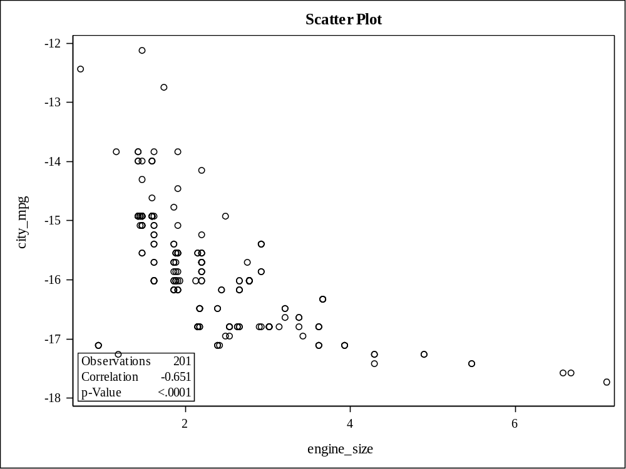

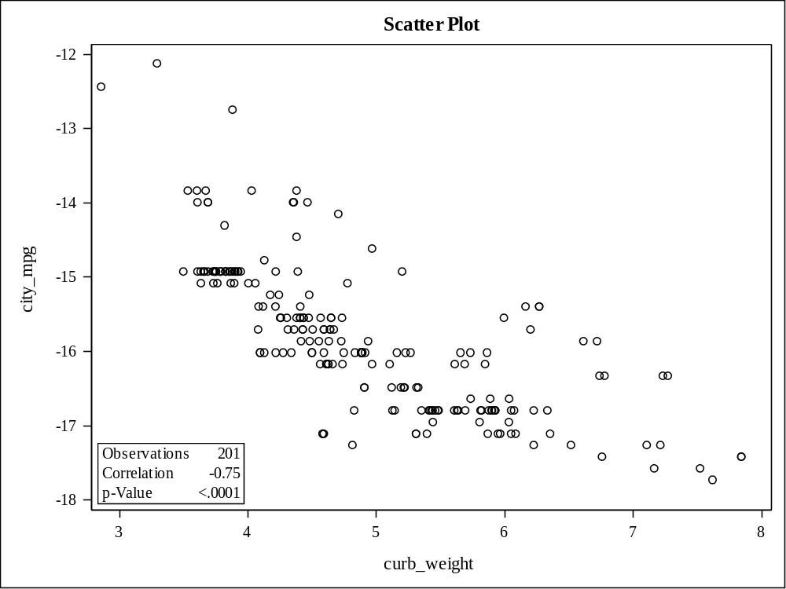

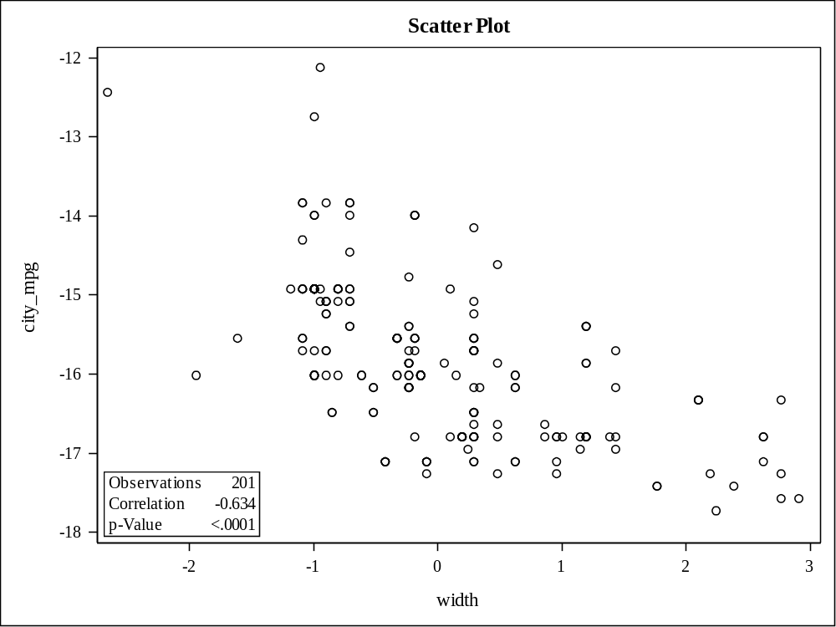

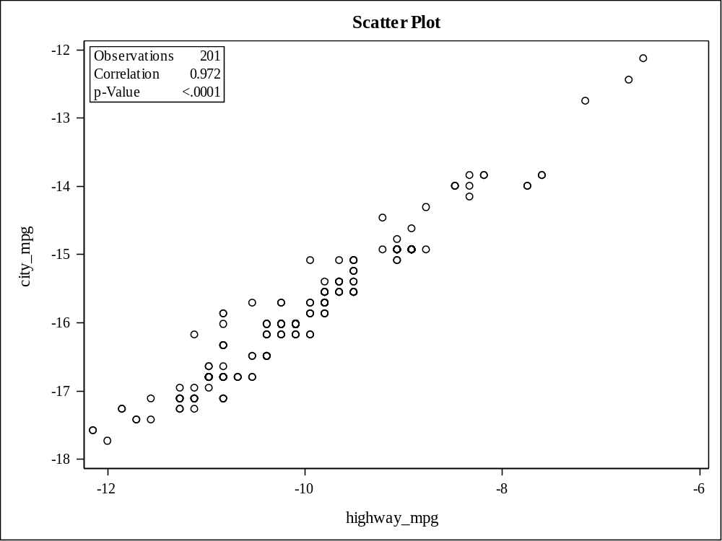

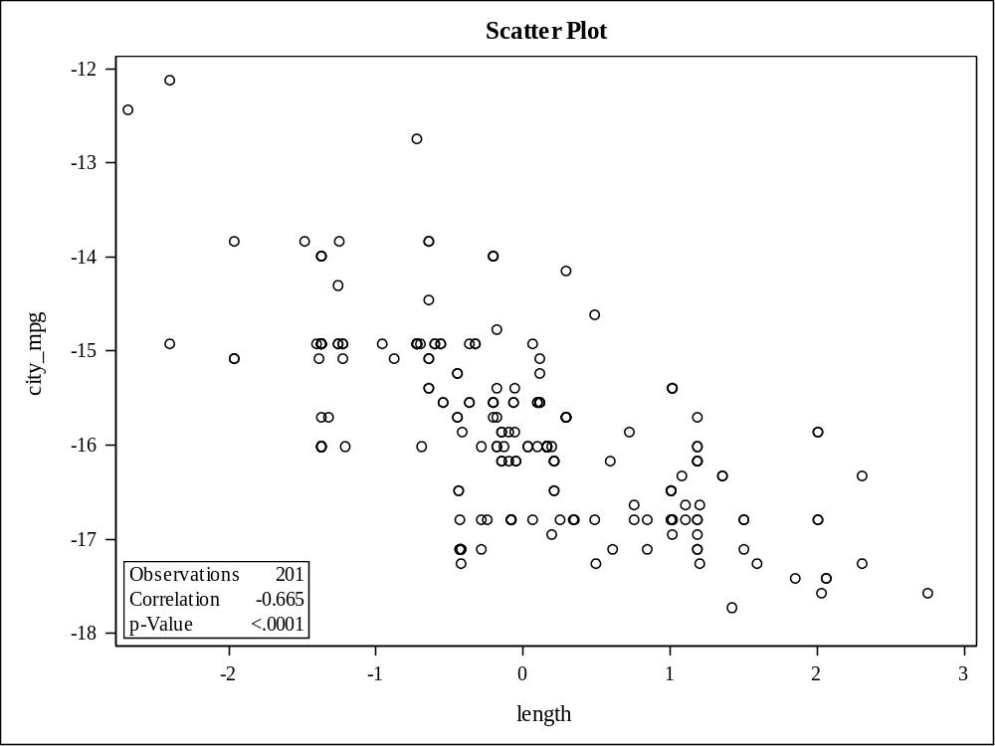

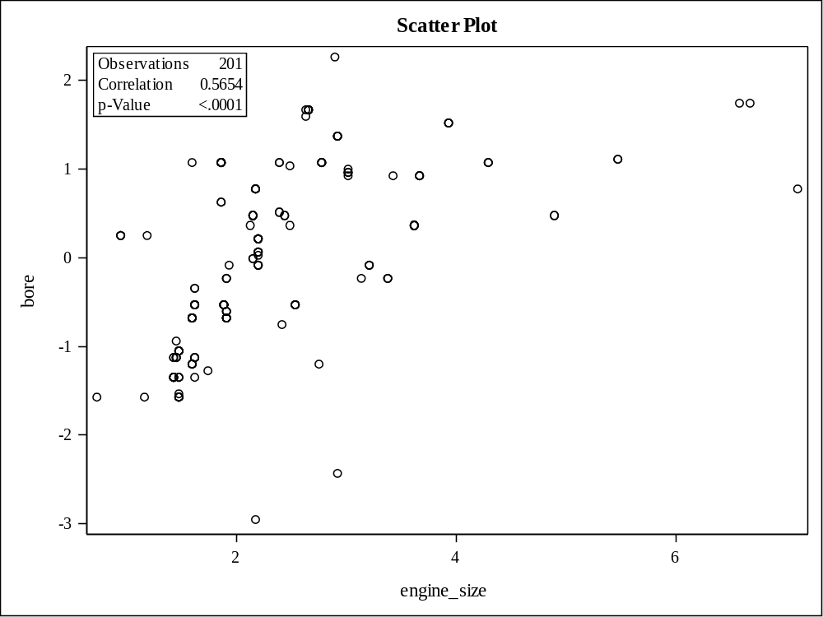

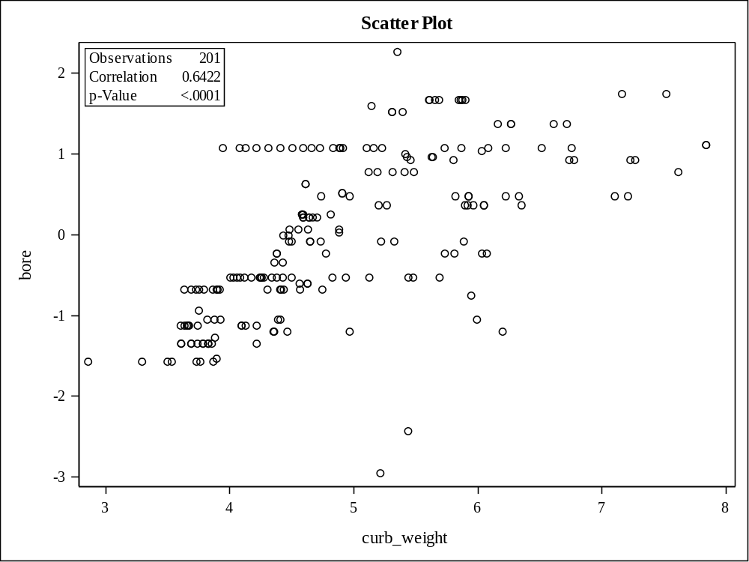

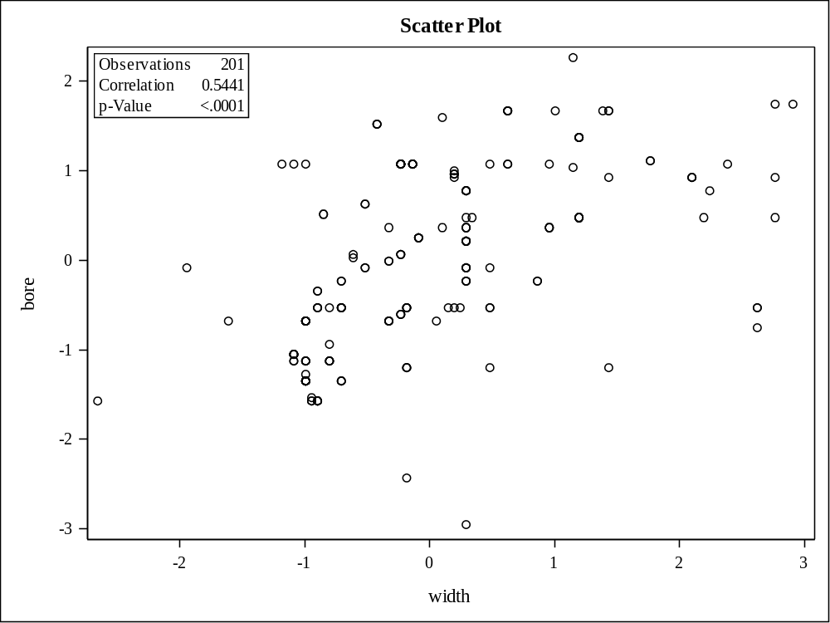

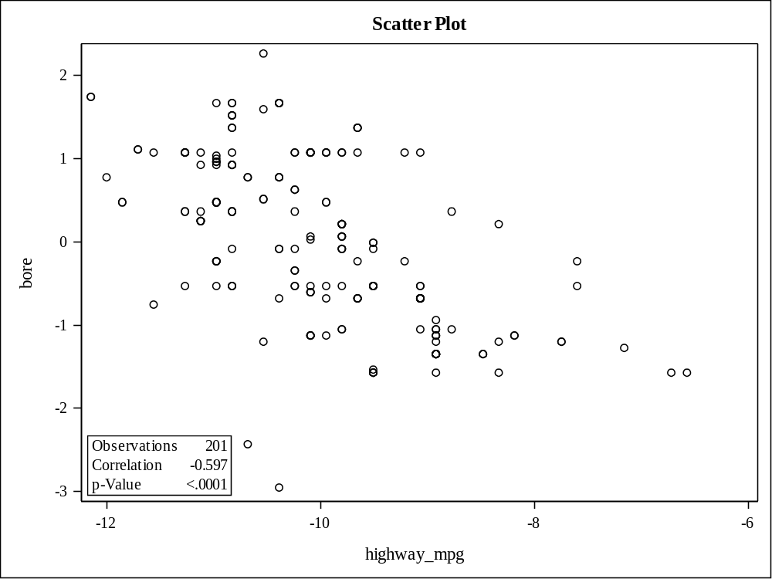

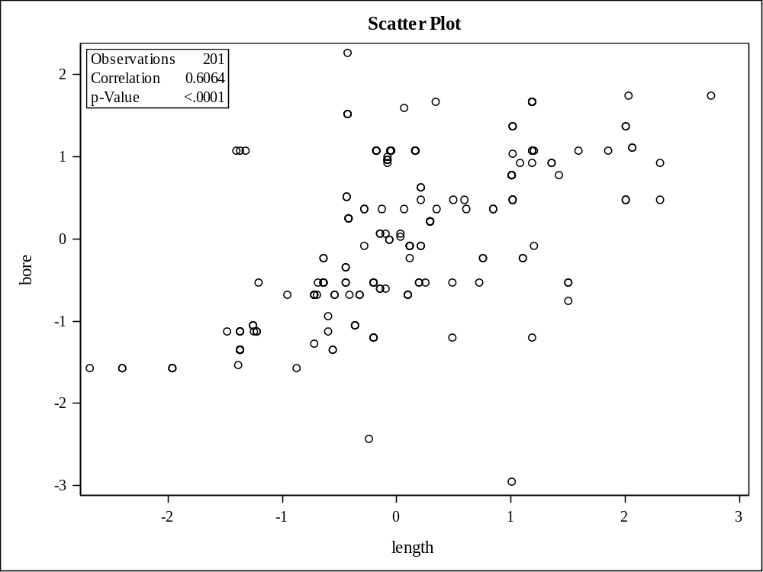

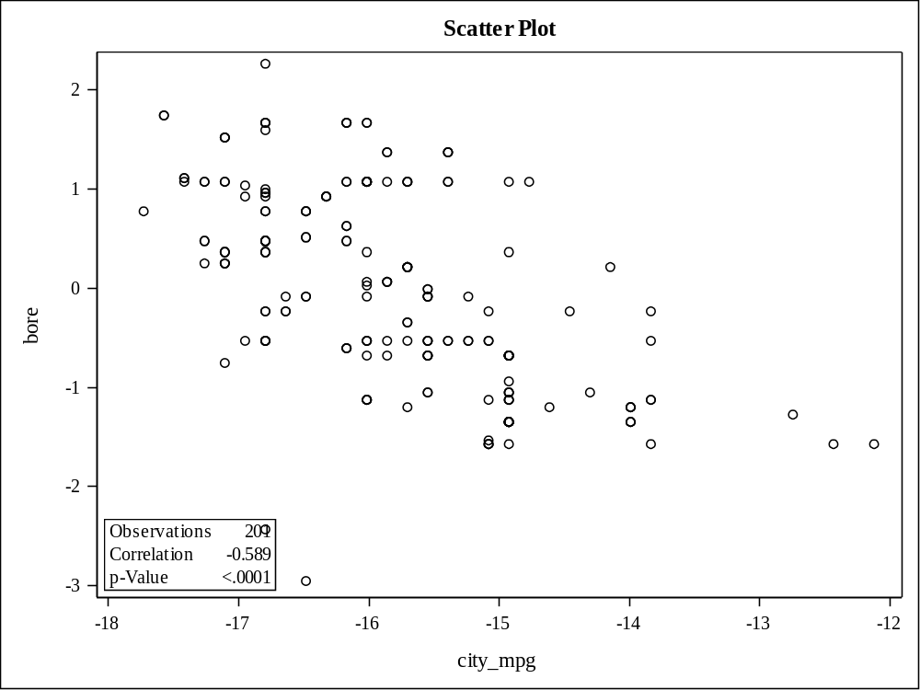

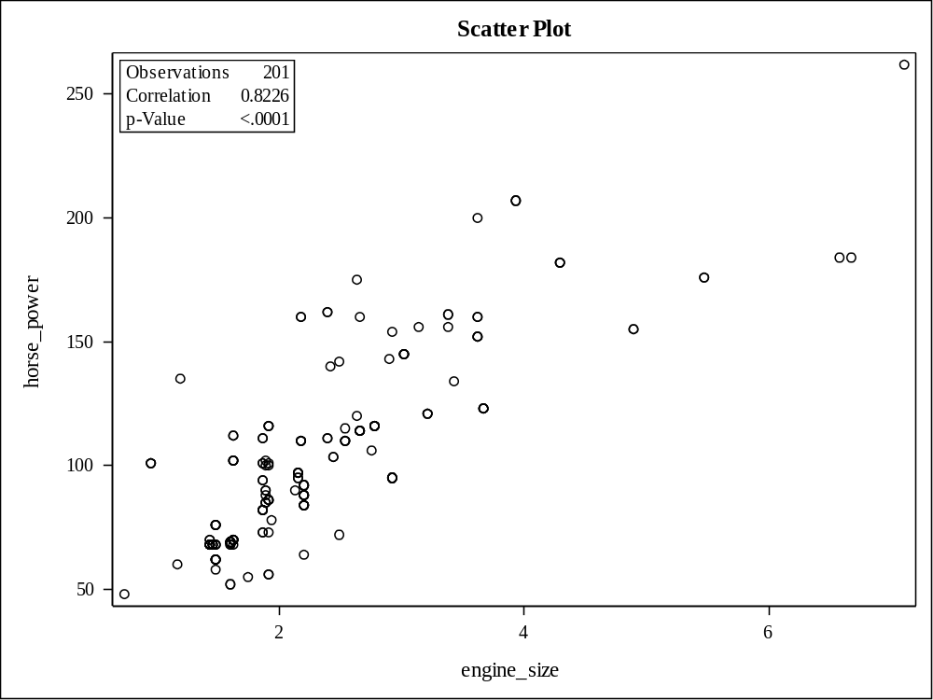

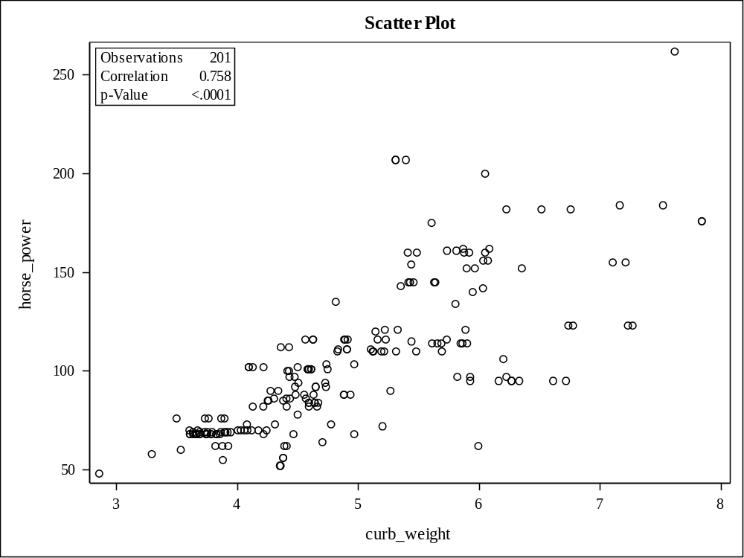

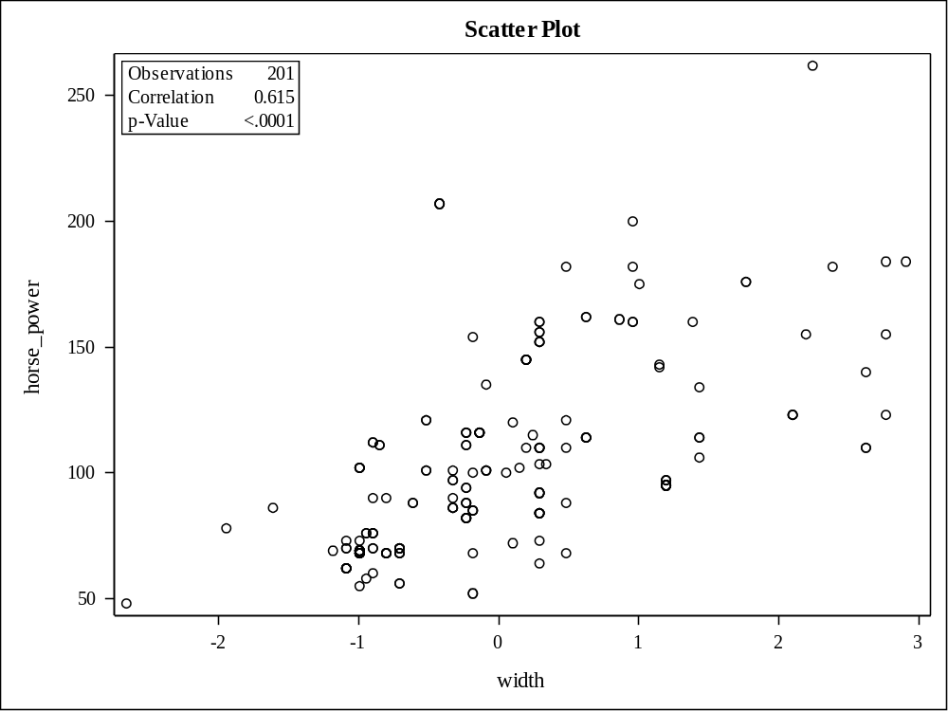

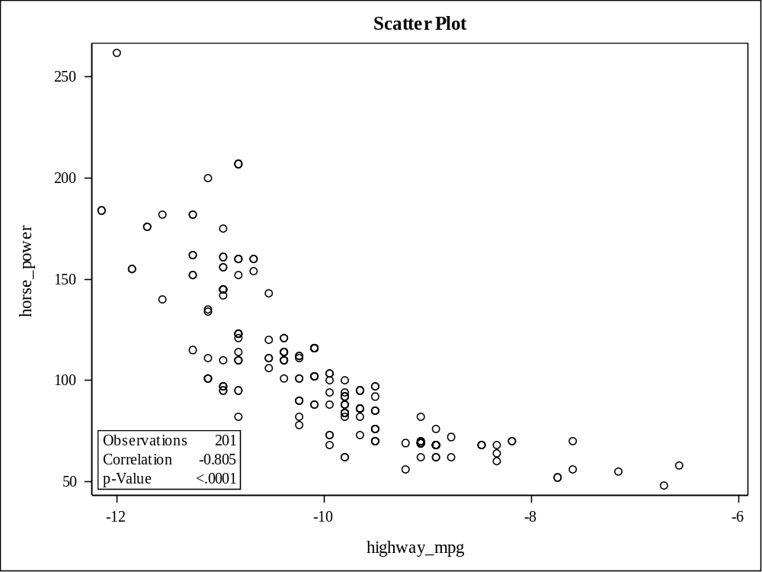

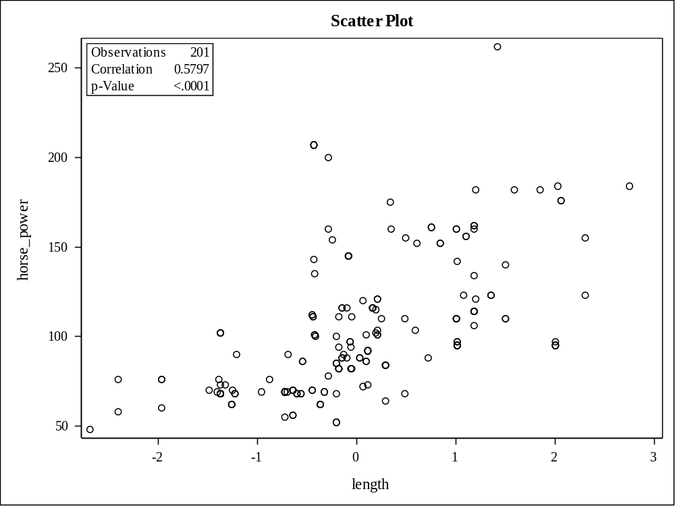

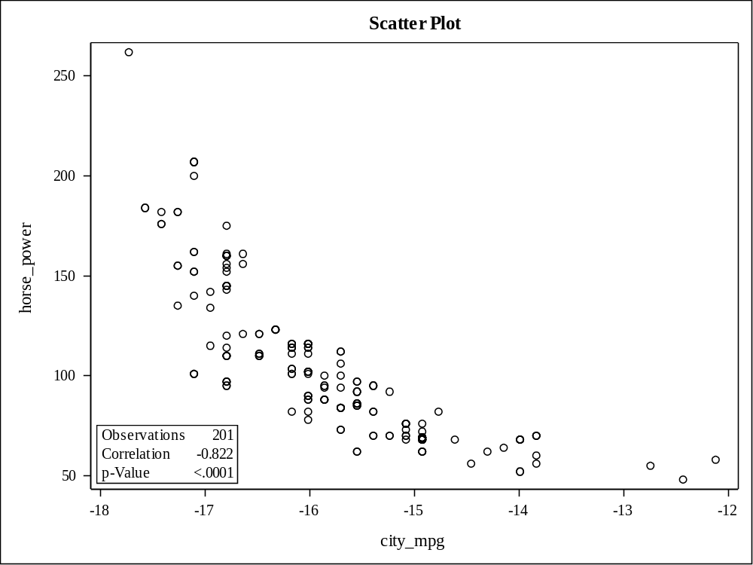

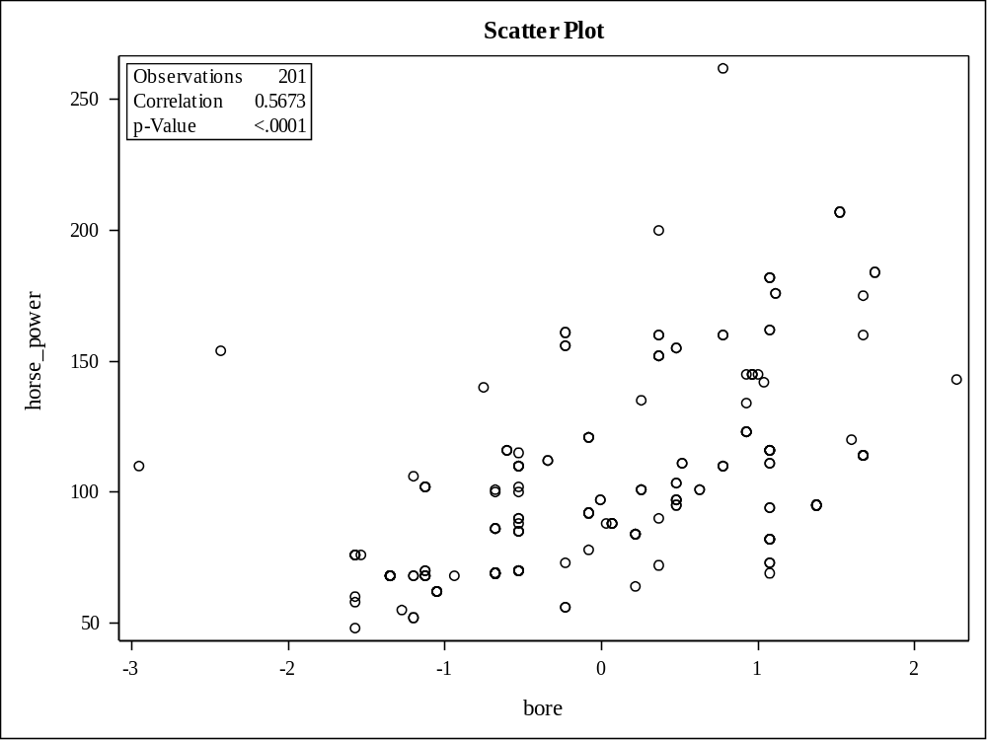

Number of Observations Read | 201
Number of Observations Used | 201

Analysis of Variance
Source | DF | Sum of  Squares | Mean  Square | F Value | Pr > F
Model | 6 | 10316630312 | 1719438385 | 144.12 | <.0001
Error | 194 | 2314542377 | 11930631
Corrected Total | 200 | 12631172689

Root MSE | 3454.07452 | R-Square | 0.8168
Dependent Mean | 13207 | Adj R-Sq | 0.8111
Coeff Var | 26.15311

Parameter Estimates
Variable | DF | Parameter  Estimate | Standard  Error | t Value | Pr > |t| | Variance  Inflation
Intercept | 1 | -4488.93319 | 6885.44423 | -0.65 | 0.5152 | 0
engine_size | 1 | 3321.71015 | 587.58376 | 5.65 | <.0001 | 5.78770
curb_weight | 1 | 1289.91205 | 709.09400 | 1.82 | 0.0704 | 8.42896
width | 1 | 1327.90381 | 494.37680 | 2.69 | 0.0079 | 4.09716
city_mpg | 1 | 150.24349 | 500.06299 | 0.30 | 0.7642 | 4.19195
bore | 1 | -265.40792 | 326.42986 | -0.81 | 0.4172 | 1.78627
horse_power | 1 | 58.38693 | 15.85568 | 3.68 | 0.0003 | 5.88411

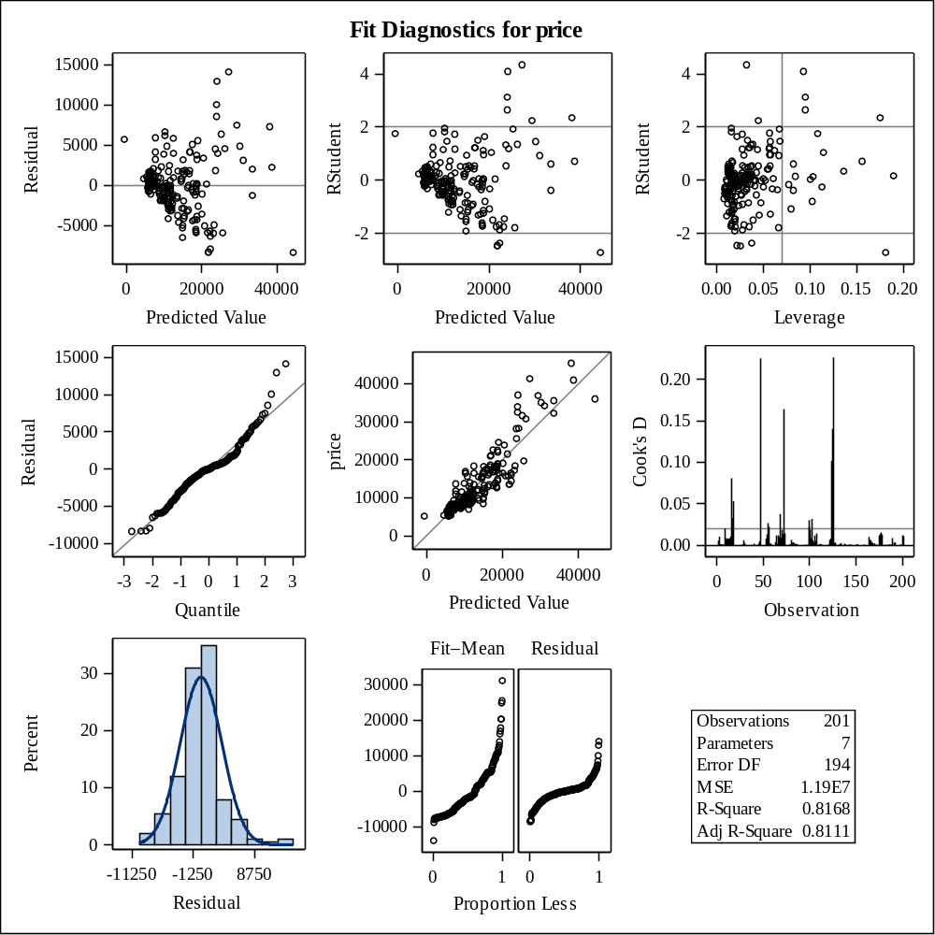

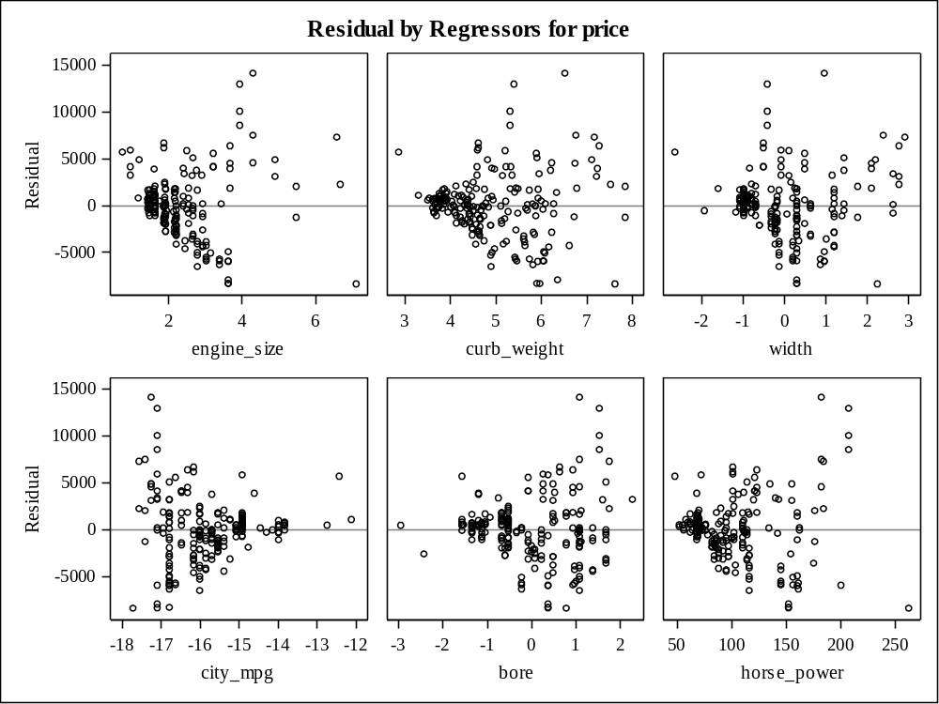

Data Set | AUTO.AUTO_MOB_BIN
Dependent Variable | price
Selection Method | Stepwise
Select Criterion | Significance Level
Stop Criterion | Significance Level
Choose Criterion | Validation ASE
Entry Significance Level (SLE) | 0.05
Stay Significance Level (SLS) | 0.05
Effect Hierarchy Enforced | Single
Random Number Seed | 123455

Number of Observations Read | 201
Number of Observations Used | 201
Number of Observations Used for Training | 157
Number of Observations Used for Validation | 44

Class Level Information
Class | Levels | Values
drive_wheels | 3 | fwd rwd 4wd
make | 22 | audi bmw chevrole dodge honda isuzu jaguar mazda mercedes mercury mitsubis nissan peugot plymouth porsche renault saab subaru toyota volkswag volvo alfa-rom
engine_type | 6 | l ohc ohcf ohcv rotor dohc
num_of_cylinders | 7 | five four six three twelve two eight
bin_hp | 4 | 1 2 3 0
aspiration | 2 | turbo std

Dimensions
Number of Effects | 79
Number of Parameters | 625

Stepwise Selection Summary
Step | Effect  Entered | Effect  Removed | Number  Effects In | Number  Parms In | ASE | Validation  ASE | F Value | Pr > F
0 | Intercept |  | 1 | 1 | 53881469.6 | 95623197.1 | 0.00 | 1.0000
1 | engine_size |  | 2 | 2 | 13486864.9 | 21302834.9 | 464.24 | <.0001
2 | make |  | 3 | 22 | 4638514.6 | 11472763.0 | 12.88 | <.0001
3 | horse_power |  | 4 | 23 | 3403287.3 | 9821740.0 | 48.64 | <.0001
4 | curb_weight |  | 5 | 24 | 3032103.7 | 9388895.6 | 16.28 | <.0001
5 | engine_size*make |  | 6 | 41 | 1605503.6 | 12430343.4 | 6.06 | <.0001
6 | curb_weight*horse_power |  | 7 | 42 | 1411733.6 | 9986135.0 | 15.78 | 0.0001
7 | drive_wheels |  | 8 | 44 | 1251476.8 | 9306414.9 | 7.24 | 0.0011
8 | drive_wheels*make |  | 9 | 49 | 1010873.6 | 9849004.0 | 5.14 | 0.0003
9 | engine_size*horse_power |  | 10 | 50 | 947611.8 | 9194944.4 | 7.14 | 0.0087
10 | num_of_cylinders |  | 11 | 54 | 843944.8 | 8155178.0* | 3.16 | 0.0170
11 | curb_weight*drive_wheels |  | 12 | 56 | 777722.3 | 8210173.4 | 4.30 | 0.0161
* Optimal Value of Criterion

Selection stopped because the candidate for entry has SLE > 0.05 and the candidate for removal has SLS < 0.05.

Stop Details
Candidate  For | Effect | Candidate  Significance |  | Compare  Significance
Entry | bore | 0.0657 | > | 0.0500 | (SLE)
Removal | curb_weight*drive_wheels | 0.0161 | < | 0.0500 | (SLS)

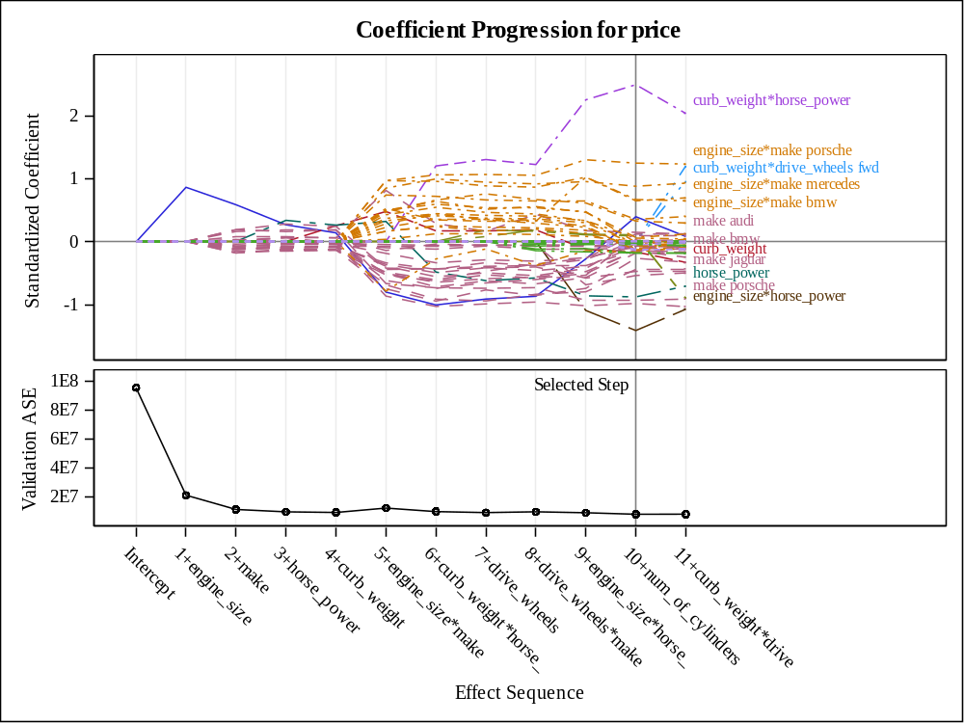

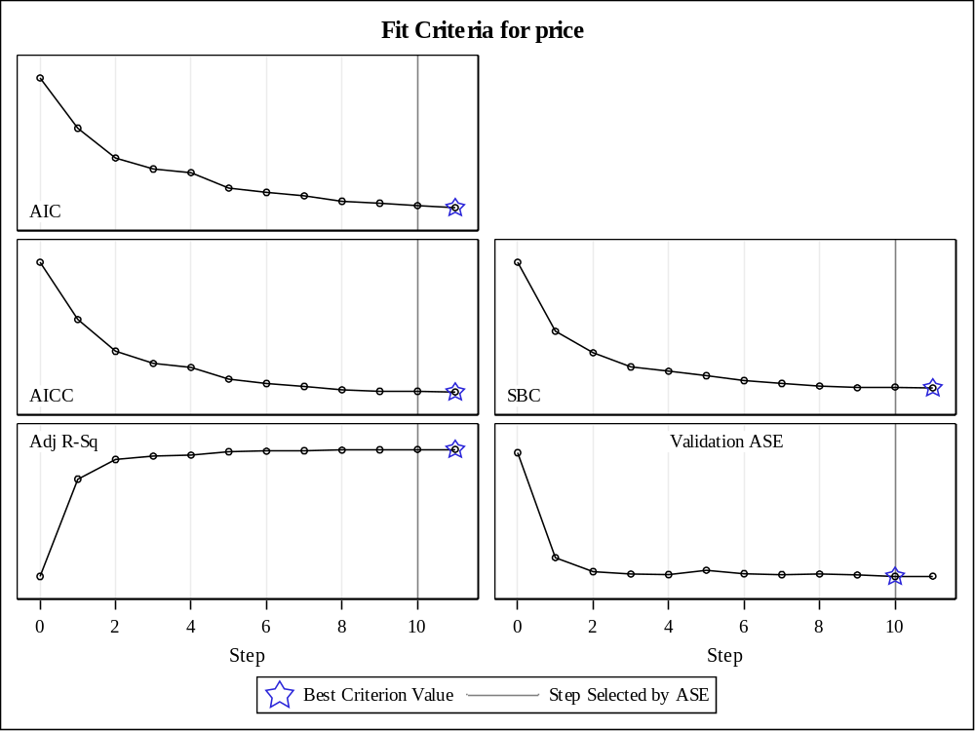

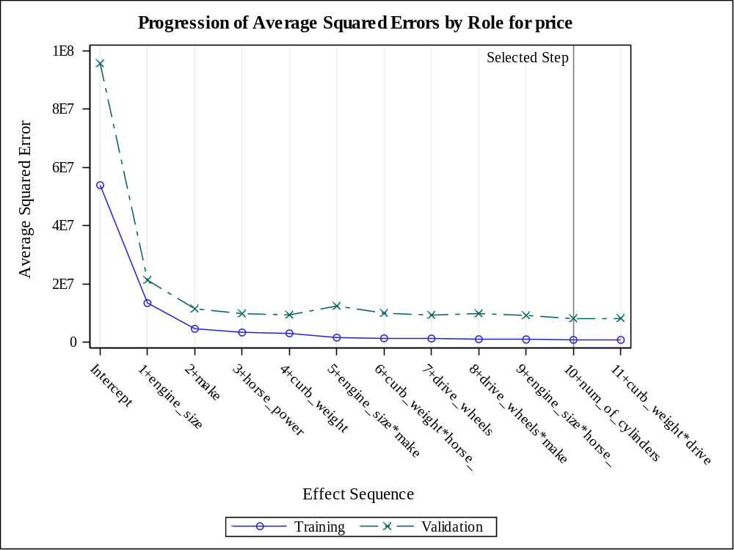

The selected model, based on Validation ASE, is the model at Step 10.

Effects: | Intercept engine_size curb_weight horse_power engine_size*horse_power curb_weight*horse_power drive_wheels make engine_size*make drive_wheels*make num_of_cylinders

Note: | The p-values for parameters and effects are not adjusted for the fact that the terms in the model have been selected and so are generally liberal.

Analysis of Variance
Source | DF | Sum of  Squares | Mean  Square | F Value | Pr > F
Model | 53 | 8326891395 | 157111158 | 122.13 | <.0001
Error | 103 | 132499332 | 1286401
Corrected Total | 156 | 8459390728

Root MSE | 1134.19632
Dependent Mean | 12786
R-Square | 0.9843
Adj R-Sq | 0.9763
AIC | 2409.39725
AICC | 2470.38735
SBC | 2415.43452
ASE (Train) | 843945
ASE (Validate) | 8155178

Parameter Estimates
Parameter | DF | Estimate | Standard  Error | t Value | Pr > |t|
Intercept | 1 | 9531.675437 | 9498.396800 | 1.00 | 0.3180
engine_size | 1 | 3055.966676 | 3854.089965 | 0.79 | 0.4296
curb_weight | 1 | -1188.030909 | 1170.826042 | -1.01 | 0.3126
horse_power | 1 | -172.901986 | 41.939187 | -4.12 | <.0001
engine_size*horse_power | 1 | -44.430739 | 13.441447 | -3.31 | 0.0013
curb_weight*horse_power | 1 | 63.030794 | 12.038164 | 5.24 | <.0001
drive_wheels fwd | 1 | 1702.603741 | 1138.993564 | 1.49 | 0.1380
drive_wheels rwd | 1 | 1484.607836 | 1208.486315 | 1.23 | 0.2221
drive_wheels 4wd | 0 | 0 | . | . | .
make audi | 1 | 8191.387143 | 36375 | 0.23 | 0.8223
make bmw | 1 | -4711.422192 | 8090.978349 | -0.58 | 0.5616
make chevrole | 1 | -3916.839040 | 10940 | -0.36 | 0.7211
make dodge | 1 | -2173.904854 | 8471.368612 | -0.26 | 0.7980
make honda | 1 | -4989.858149 | 8735.390689 | -0.57 | 0.5691
make isuzu | 0 | 0 | . | . | .
make jaguar | 1 | -34749 | 23602 | -1.47 | 0.1440
make mazda | 1 | 3176.802600 | 9090.600731 | 0.35 | 0.7275
make mercedes | 1 | -19531 | 9866.062176 | -1.98 | 0.0504
make mercury | 1 | -6173.682151 | 1504.375896 | -4.10 | <.0001
make mitsubis | 1 | -3786.581843 | 8473.765371 | -0.45 | 0.6559
make nissan | 1 | 2958.267213 | 8052.635874 | 0.37 | 0.7141
make peugot | 1 | -4257.626012 | 8844.772964 | -0.48 | 0.6313
make plymouth | 1 | 757.482728 | 10186 | 0.07 | 0.9409
make porsche | 1 | -49333 | 9495.841355 | -5.20 | <.0001
make renault | 1 | -5023.869444 | 1230.550107 | -4.08 | <.0001
make saab | 1 | -3782.274185 | 1557.977723 | -2.43 | 0.0169
make subaru | 1 | -13700 | 12152 | -1.13 | 0.2622
make toyota | 1 | -5267.061573 | 8227.879843 | -0.64 | 0.5235
make volkswag | 1 | 1008.694129 | 10055 | 0.10 | 0.9203
make volvo | 1 | -37273 | 8393.663259 | -4.44 | <.0001
make alfa-rom | 0 | 0 | . | . | .
engine_size*make audi | 1 | -3479.832799 | 14294 | -0.24 | 0.8081
engine_size*make bmw | 1 | 3893.848504 | 3096.514989 | 1.26 | 0.2114
engine_size*make chevrole | 1 | 287.689135 | 5942.366333 | 0.05 | 0.9615
engine_size*make dodge | 1 | -1149.781994 | 3390.659441 | -0.34 | 0.7352
engine_size*make honda | 1 | 1055.717330 | 3624.597845 | 0.29 | 0.7714
engine_size*make isuzu | 0 | 0 | . | . | .
engine_size*make jaguar | 1 | 6939.752402 | 5172.812470 | 1.34 | 0.1827
engine_size*make mazda | 1 | -146.082219 | 3610.491644 | -0.04 | 0.9678
engine_size*make mercedes | 1 | 5570.714277 | 3464.358703 | 1.61 | 0.1109
engine_size*make mercury | 0 | 0 | . | . | .
engine_size*make mitsubis | 1 | -595.431622 | 3366.762395 | -0.18 | 0.8600
engine_size*make nissan | 1 | -1137.953551 | 3047.333057 | -0.37 | 0.7096
engine_size*make peugot | 1 | -384.737980 | 3522.204146 | -0.11 | 0.9132
engine_size*make plymouth | 1 | -2004.481290 | 3818.153535 | -0.52 | 0.6007
engine_size*make porsche | 1 | 18501 | 3402.400358 | 5.44 | <.0001
engine_size*make renault | 0 | 0 | . | . | .
engine_size*make saab | 0 | 0 | . | . | .
engine_size*make subaru | 1 | 5704.704070 | 5779.562626 | 0.99 | 0.3259
engine_size*make toyota | 1 | 707.607192 | 3238.321383 | 0.22 | 0.8275
engine_size*make volkswag | 1 | -2129.791647 | 4518.819720 | -0.47 | 0.6384
engine_size*make volvo | 1 | 12245 | 3200.499984 | 3.83 | 0.0002
engine_size*make alfa-rom | 0 | 0 | . | . | .
drive_wheels*make fwd audi | 1 | -1378.081517 | 1974.387746 | -0.70 | 0.4868
drive_wheels*make fwd chevrole | 0 | 0 | . | . | .
drive_wheels*make fwd dodge | 0 | 0 | . | . | .
drive_wheels*make fwd honda | 0 | 0 | . | . | .
drive_wheels*make fwd mazda | 1 | -6570.087135 | 1346.539597 | -4.88 | <.0001
drive_wheels*make fwd mitsubis | 0 | 0 | . | . | .
drive_wheels*make fwd nissan | 1 | -4371.242990 | 1112.119419 | -3.93 | 0.0002
drive_wheels*make fwd plymouth | 1 | -1844.980764 | 2856.691017 | -0.65 | 0.5198
drive_wheels*make fwd renault | 0 | 0 | . | . | .
drive_wheels*make fwd saab | 0 | 0 | . | . | .
drive_wheels*make fwd subaru | 1 | -1202.352217 | 1372.509692 | -0.88 | 0.3831
drive_wheels*make fwd toyota | 0 | 0 | . | . | .
drive_wheels*make fwd volkswag | 0 | 0 | . | . | .
drive_wheels*make rwd bmw | 0 | 0 | . | . | .
drive_wheels*make rwd isuzu | 0 | 0 | . | . | .
drive_wheels*make rwd jaguar | 0 | 0 | . | . | .
drive_wheels*make rwd mazda | 0 | 0 | . | . | .
drive_wheels*make rwd mercedes | 0 | 0 | . | . | .
drive_wheels*make rwd mercury | 0 | 0 | . | . | .
drive_wheels*make rwd nissan | 0 | 0 | . | . | .
drive_wheels*make rwd peugot | 0 | 0 | . | . | .
drive_wheels*make rwd plymouth | 0 | 0 | . | . | .
drive_wheels*make rwd porsche | 0 | 0 | . | . | .
drive_wheels*make rwd toyota | 0 | 0 | . | . | .
drive_wheels*make rwd volvo | 0 | 0 | . | . | .
drive_wheels*make rwd alfa-rom | 0 | 0 | . | . | .
drive_wheels*make 4wd audi | 0 | 0 | . | . | .
drive_wheels*make 4wd subaru | 0 | 0 | . | . | .
drive_wheels*make 4wd toyota | 0 | 0 | . | . | .
num_of_cylinders five | 1 | 670.651672 | 1873.915602 | 0.36 | 0.7212
num_of_cylinders four | 1 | -838.347746 | 3057.089035 | -0.27 | 0.7845
num_of_cylinders six | 1 | -3154.553548 | 3210.379500 | -0.98 | 0.3281
num_of_cylinders three | 0 | 0 | . | . | .
num_of_cylinders twelve | 0 | 0 | . | . | .
num_of_cylinders two | 1 | -7396.249293 | 3830.138888 | -1.93 | 0.0562
num_of_cylinders eight | 0 | 0 | . | . | .

Data Set | AUTO.AUTO_MOB_BIN
Dependent Variable | price
Selection Method | Forward
Select Criterion | Significance Level
Stop Criterion | Significance Level
Choose Criterion | Validation ASE
Entry Significance Level (SLE) | 0.05
Effect Hierarchy Enforced | Single
Random Number Seed | 123455

Number of Observations Read | 201
Number of Observations Used | 201
Number of Observations Used for Training | 157
Number of Observations Used for Validation | 44

Class Level Information
Class | Levels | Values
drive_wheels | 3 | fwd rwd 4wd
make | 22 | audi bmw chevrole dodge honda isuzu jaguar mazda mercedes mercury mitsubis nissan peugot plymouth porsche renault saab subaru toyota volkswag volvo alfa-rom
engine_type | 6 | l ohc ohcf ohcv rotor dohc
num_of_cylinders | 7 | five four six three twelve two eight
bin_hp | 4 | 1 2 3 0
aspiration | 2 | turbo std

Dimensions
Number of Effects | 79
Number of Parameters | 625

Forward Selection Summary
Step | Effect  Entered | Number  Effects In | Number  Parms In | ASE | Validation  ASE | F Value | Pr > F
0 | Intercept | 1 | 1 | 53881469.6 | 95623197.1 | 0.00 | 1.0000
1 | engine_size | 2 | 2 | 13486864.9 | 21302834.9 | 464.24 | <.0001
2 | make | 3 | 22 | 4638514.6 | 11472763.0 | 12.88 | <.0001
3 | horse_power | 4 | 23 | 3403287.3 | 9821740.0 | 48.64 | <.0001
4 | curb_weight | 5 | 24 | 3032103.7 | 9388895.6 | 16.28 | <.0001
5 | engine_size*make | 6 | 41 | 1605503.6 | 12430343.4 | 6.06 | <.0001
6 | curb_weight*horse_power | 7 | 42 | 1411733.6 | 9986135.0 | 15.78 | 0.0001
7 | drive_wheels | 8 | 44 | 1251476.8 | 9306414.9 | 7.24 | 0.0011
8 | drive_wheels*make | 9 | 49 | 1010873.6 | 9849004.0 | 5.14 | 0.0003
9 | engine_size*horse_power | 10 | 50 | 947611.8 | 9194944.4 | 7.14 | 0.0087
10 | num_of_cylinders | 11 | 54 | 843944.8 | 8155178.0* | 3.16 | 0.0170
11 | curb_weight*drive_wheels | 12 | 56 | 777722.3 | 8210173.4 | 4.30 | 0.0161
* Optimal Value of Criterion

Selection stopped as the candidate for entry has SLE > 0.05.

Stop Details
Candidate  For | Effect | Candidate  Significance |  | Compare  Significance
Entry | bore | 0.0657 | > | 0.0500 | (SLE)

The selected model, based on Validation ASE, is the model at Step 10.

Effects: | Intercept engine_size curb_weight horse_power engine_size*horse_power curb_weight*horse_power drive_wheels make engine_size*make drive_wheels*make num_of_cylinders

Note: | The p-values for parameters and effects are not adjusted for the fact that the terms in the model have been selected and so are generally liberal.

Analysis of Variance
Source | DF | Sum of  Squares | Mean  Square | F Value | Pr > F
Model | 53 | 8326891395 | 157111158 | 122.13 | <.0001
Error | 103 | 132499332 | 1286401
Corrected Total | 156 | 8459390728

Root MSE | 1134.19632
Dependent Mean | 12786
R-Square | 0.9843
Adj R-Sq | 0.9763
AIC | 2409.39725
AICC | 2470.38735
SBC | 2415.43452
ASE (Train) | 843945
ASE (Validate) | 8155178

Parameter Estimates
Parameter | DF | Estimate | Standard  Error | t Value | Pr > |t|
Intercept | 1 | 9531.675437 | 9498.396800 | 1.00 | 0.3180
engine_size | 1 | 3055.966676 | 3854.089965 | 0.79 | 0.4296
curb_weight | 1 | -1188.030909 | 1170.826042 | -1.01 | 0.3126
horse_power | 1 | -172.901986 | 41.939187 | -4.12 | <.0001
engine_size*horse_power | 1 | -44.430739 | 13.441447 | -3.31 | 0.0013
curb_weight*horse_power | 1 | 63.030794 | 12.038164 | 5.24 | <.0001
drive_wheels fwd | 1 | 1702.603741 | 1138.993564 | 1.49 | 0.1380
drive_wheels rwd | 1 | 1484.607836 | 1208.486315 | 1.23 | 0.2221
drive_wheels 4wd | 0 | 0 | . | . | .
make audi | 1 | 8191.387143 | 36375 | 0.23 | 0.8223
make bmw | 1 | -4711.422192 | 8090.978349 | -0.58 | 0.5616
make chevrole | 1 | -3916.839040 | 10940 | -0.36 | 0.7211
make dodge | 1 | -2173.904854 | 8471.368612 | -0.26 | 0.7980
make honda | 1 | -4989.858149 | 8735.390689 | -0.57 | 0.5691
make isuzu | 0 | 0 | . | . | .
make jaguar | 1 | -34749 | 23602 | -1.47 | 0.1440
make mazda | 1 | 3176.802600 | 9090.600731 | 0.35 | 0.7275
make mercedes | 1 | -19531 | 9866.062176 | -1.98 | 0.0504
make mercury | 1 | -6173.682151 | 1504.375896 | -4.10 | <.0001
make mitsubis | 1 | -3786.581843 | 8473.765371 | -0.45 | 0.6559
make nissan | 1 | 2958.267213 | 8052.635874 | 0.37 | 0.7141
make peugot | 1 | -4257.626012 | 8844.772964 | -0.48 | 0.6313
make plymouth | 1 | 757.482728 | 10186 | 0.07 | 0.9409
make porsche | 1 | -49333 | 9495.841355 | -5.20 | <.0001
make renault | 1 | -5023.869444 | 1230.550107 | -4.08 | <.0001
make saab | 1 | -3782.274185 | 1557.977723 | -2.43 | 0.0169
make subaru | 1 | -13700 | 12152 | -1.13 | 0.2622
make toyota | 1 | -5267.061573 | 8227.879843 | -0.64 | 0.5235
make volkswag | 1 | 1008.694129 | 10055 | 0.10 | 0.9203
make volvo | 1 | -37273 | 8393.663259 | -4.44 | <.0001
make alfa-rom | 0 | 0 | . | . | .
engine_size*make audi | 1 | -3479.832799 | 14294 | -0.24 | 0.8081
engine_size*make bmw | 1 | 3893.848504 | 3096.514989 | 1.26 | 0.2114
engine_size*make chevrole | 1 | 287.689135 | 5942.366333 | 0.05 | 0.9615
engine_size*make dodge | 1 | -1149.781994 | 3390.659441 | -0.34 | 0.7352
engine_size*make honda | 1 | 1055.717330 | 3624.597845 | 0.29 | 0.7714
engine_size*make isuzu | 0 | 0 | . | . | .
engine_size*make jaguar | 1 | 6939.752402 | 5172.812470 | 1.34 | 0.1827
engine_size*make mazda | 1 | -146.082219 | 3610.491644 | -0.04 | 0.9678
engine_size*make mercedes | 1 | 5570.714277 | 3464.358703 | 1.61 | 0.1109
engine_size*make mercury | 0 | 0 | . | . | .
engine_size*make mitsubis | 1 | -595.431622 | 3366.762395 | -0.18 | 0.8600
engine_size*make nissan | 1 | -1137.953551 | 3047.333057 | -0.37 | 0.7096
engine_size*make peugot | 1 | -384.737980 | 3522.204146 | -0.11 | 0.9132
engine_size*make plymouth | 1 | -2004.481290 | 3818.153535 | -0.52 | 0.6007
engine_size*make porsche | 1 | 18501 | 3402.400358 | 5.44 | <.0001
engine_size*make renault | 0 | 0 | . | . | .
engine_size*make saab | 0 | 0 | . | . | .
engine_size*make subaru | 1 | 5704.704070 | 5779.562626 | 0.99 | 0.3259
engine_size*make toyota | 1 | 707.607192 | 3238.321383 | 0.22 | 0.8275
engine_size*make volkswag | 1 | -2129.791647 | 4518.819720 | -0.47 | 0.6384
engine_size*make volvo | 1 | 12245 | 3200.499984 | 3.83 | 0.0002
engine_size*make alfa-rom | 0 | 0 | . | . | .
drive_wheels*make fwd audi | 1 | -1378.081517 | 1974.387746 | -0.70 | 0.4868
drive_wheels*make fwd chevrole | 0 | 0 | . | . | .
drive_wheels*make fwd dodge | 0 | 0 | . | . | .
drive_wheels*make fwd honda | 0 | 0 | . | . | .
drive_wheels*make fwd mazda | 1 | -6570.087135 | 1346.539597 | -4.88 | <.0001
drive_wheels*make fwd mitsubis | 0 | 0 | . | . | .
drive_wheels*make fwd nissan | 1 | -4371.242990 | 1112.119419 | -3.93 | 0.0002
drive_wheels*make fwd plymouth | 1 | -1844.980764 | 2856.691017 | -0.65 | 0.5198
drive_wheels*make fwd renault | 0 | 0 | . | . | .
drive_wheels*make fwd saab | 0 | 0 | . | . | .
drive_wheels*make fwd subaru | 1 | -1202.352217 | 1372.509692 | -0.88 | 0.3831
drive_wheels*make fwd toyota | 0 | 0 | . | . | .
drive_wheels*make fwd volkswag | 0 | 0 | . | . | .
drive_wheels*make rwd bmw | 0 | 0 | . | . | .
drive_wheels*make rwd isuzu | 0 | 0 | . | . | .
drive_wheels*make rwd jaguar | 0 | 0 | . | . | .
drive_wheels*make rwd mazda | 0 | 0 | . | . | .
drive_wheels*make rwd mercedes | 0 | 0 | . | . | .
drive_wheels*make rwd mercury | 0 | 0 | . | . | .
drive_wheels*make rwd nissan | 0 | 0 | . | . | .
drive_wheels*make rwd peugot | 0 | 0 | . | . | .
drive_wheels*make rwd plymouth | 0 | 0 | . | . | .
drive_wheels*make rwd porsche | 0 | 0 | . | . | .
drive_wheels*make rwd toyota | 0 | 0 | . | . | .
drive_wheels*make rwd volvo | 0 | 0 | . | . | .
drive_wheels*make rwd alfa-rom | 0 | 0 | . | . | .
drive_wheels*make 4wd audi | 0 | 0 | . | . | .
drive_wheels*make 4wd subaru | 0 | 0 | . | . | .
drive_wheels*make 4wd toyota | 0 | 0 | . | . | .
num_of_cylinders five | 1 | 670.651672 | 1873.915602 | 0.36 | 0.7212
num_of_cylinders four | 1 | -838.347746 | 3057.089035 | -0.27 | 0.7845
num_of_cylinders six | 1 | -3154.553548 | 3210.379500 | -0.98 | 0.3281
num_of_cylinders three | 0 | 0 | . | . | .
num_of_cylinders twelve | 0 | 0 | . | . | .
num_of_cylinders two | 1 | -7396.249293 | 3830.138888 | -1.93 | 0.0562
num_of_cylinders eight | 0 | 0 | . | . | .

Data Set | AUTO.AUTO_MOB_BIN
Dependent Variable | price
Selection Method | Backward
Select Criterion | Significance Level
Stop Criterion | Significance Level
Choose Criterion | Validation ASE
Stay Significance Level (SLS) | 0.05
Effect Hierarchy Enforced | None
Random Number Seed | 123455

Number of Observations Read | 201
Number of Observations Used | 201
Number of Observations Used for Training | 157
Number of Observations Used for Validation | 44

Class Level Information
Class | Levels | Values
drive_wheels | 3 | fwd rwd 4wd
make | 22 | audi bmw chevrole dodge honda isuzu jaguar mazda mercedes mercury mitsubis nissan peugot plymouth porsche renault saab subaru toyota volkswag volvo alfa-rom
engine_type | 6 | l ohc ohcf ohcv rotor dohc
num_of_cylinders | 7 | five four six three twelve two eight
bin_hp | 4 | 1 2 3 0
aspiration | 2 | turbo std

Dimensions
Number of Effects | 79
Number of Parameters | 625

Full Least Squares Model

Analysis of Variance
Source | DF | Sum of  Squares | Mean  Square | F Value | Pr > F
Model | 133 | 8445015570 | 63496358 | 101.59 | <.0001
Error | 23 | 14375158 | 625007
Corrected Total | 156 | 8459390728

Root MSE | 790.57375
Dependent Mean | 12786
R-Square | 0.9983
Adj R-Sq | 0.9885
AIC | 2220.68831
AICC | 3969.25974
SBC | 2471.22525
ASE (Train) | 91562
ASE (Validate) | 2.588865E14

Parameter Estimates
Parameter | DF | Estimate | Standard  Error | t Value | Pr > |t|
Intercept | 1 | 138659234 | 138412985 | 1.00 | 0.3269
engine_size | 1 | -102947516 | 46977433 | -2.19 | 0.0388
curb_weight | 1 | 457647 | 577961 | 0.79 | 0.4366
engine_size*curb_weight | 1 | 80648 | 166231 | 0.49 | 0.6322
width | 1 | 2312310 | 5515281 | 0.42 | 0.6789
engine_size*width | 1 | -15492297 | 7345010 | -2.11 | 0.0460
curb_weight*width | 1 | 38870 | 22930 | 1.70 | 0.1035
city_mpg | 1 | -18539039 | 6959364 | -2.66 | 0.0139
engine_size*city_mpg | 1 | 5473520 | 2710343 | 2.02 | 0.0552
curb_weight*city_mpg | 1 | 17795 | 28781 | 0.62 | 0.5425
width*city_mpg | 1 | -1010696 | 448726 | -2.25 | 0.0341
bore | 1 | -45247602 | 21905115 | -2.07 | 0.0503
engine_size*bore | 1 | 9455817 | 5550647 | 1.70 | 0.1019
curb_weight*bore | 1 | 7374.525782 | 65915 | 0.11 | 0.9119
width*bore | 1 | 6263871 | 3077633 | 2.04 | 0.0535
city_mpg*bore | 1 | -2474894 | 1281285 | -1.93 | 0.0658
horse_power | 1 | -201657 | 121445 | -1.66 | 0.1104
engine_size*horse_power | 1 | 41850 | 23587 | 1.77 | 0.0893
curb_weight*horse_power | 1 | -2789.608192 | 3552.972388 | -0.79 | 0.4404
width*horse_power | 1 | -14861 | 6449.415931 | -2.30 | 0.0306
city_mpg*horse_power | 1 | -5743.870935 | 6125.157854 | -0.94 | 0.3581
bore*horse_power | 1 | -160640 | 99149 | -1.62 | 0.1188
drive_wheels fwd | 1 | 180979938 | 93479302 | 1.94 | 0.0652
drive_wheels rwd | 1 | 78199214 | 63117176 | 1.24 | 0.2279
drive_wheels 4wd | 0 | 0 | . | . | .
engine_size*drive_wheels fwd | 1 | 27894547 | 10011465 | 2.79 | 0.0105
engine_size*drive_wheels rwd | 1 | 43550954 | 13596881 | 3.20 | 0.0040
engine_size*drive_wheels 4wd | 0 | 0 | . | . | .
curb_weight*drive_wheels fwd | 1 | -10369 | 18035 | -0.57 | 0.5709
curb_weight*drive_wheels rwd | 1 | -10529 | 29590 | -0.36 | 0.7252
curb_weight*drive_wheels 4wd | 0 | 0 | . | . | .
width*drive_wheels fwd | 1 | 12968292 | 6402763 | 2.03 | 0.0546
width*drive_wheels rwd | 1 | 13495884 | 4402027 | 3.07 | 0.0055
width*drive_wheels 4wd | 0 | 0 | . | . | .
city_mpg*drive_wheels fwd | 1 | 14248717 | 6504995 | 2.19 | 0.0389
city_mpg*drive_wheels rwd | 1 | 9339188 | 4007730 | 2.33 | 0.0289
city_mpg*drive_wheels 4wd | 0 | 0 | . | . | .
bore*drive_wheels fwd | 1 | -7942895 | 2785932 | -2.85 | 0.0090
bore*drive_wheels rwd | 1 | -25136310 | 11719130 | -2.14 | 0.0428
bore*drive_wheels 4wd | 0 | 0 | . | . | .
horse_power*drive_wheels fwd | 1 | 84226 | 36587 | 2.30 | 0.0307
horse_power*drive_wheels rwd | 0 | 0 | . | . | .
horse_power*drive_wheels 4wd | 0 | 0 | . | . | .
make audi | 1 | -480134337 | 272739645 | -1.76 | 0.0916
make bmw | 1 | 1583957949 | 746692341 | 2.12 | 0.0449
make chevrole | 1 | -397004320 | 162753186 | -2.44 | 0.0228
make dodge | 1 | -337208704 | 100811923 | -3.34 | 0.0028
make honda | 1 | -463917848 | 163434126 | -2.84 | 0.0093
make isuzu | 0 | 0 | . | . | .
make jaguar | 1 | -531100227 | 244223310 | -2.17 | 0.0402
make mazda | 1 | -469785265 | 153136371 | -3.07 | 0.0054
make mercedes | 1 | -623597151 | 385589348 | -1.62 | 0.1195
make mercury | 1 | 80124936 | 35470964 | 2.26 | 0.0337
make mitsubis | 1 | -510200831 | 182489185 | -2.80 | 0.0103
make nissan | 1 | -604580529 | 224239287 | -2.70 | 0.0129
make peugot | 1 | -122571626 | 80959475 | -1.51 | 0.1437
make plymouth | 1 | -425617748 | 143964624 | -2.96 | 0.0071
make porsche | 1 | -224108548 | 98306231 | -2.28 | 0.0322
make renault | 1 | 11070067 | 4604802 | 2.40 | 0.0247
make saab | 1 | -261837774 | 109753267 | -2.39 | 0.0257
make subaru | 1 | -322281498 | 96604140 | -3.34 | 0.0029
make toyota | 1 | -486651769 | 172612271 | -2.82 | 0.0097
make volkswag | 1 | -528803043 | 192998023 | -2.74 | 0.0117
make volvo | 1 | -334616856 | 153304397 | -2.18 | 0.0395
make alfa-rom | 0 | 0 | . | . | .
engine_size*make audi | 1 | 209334032 | 113524647 | 1.84 | 0.0781
engine_size*make bmw | 1 | 179761780 | 79586947 | 2.26 | 0.0337
engine_size*make chevrole | 1 | 148433802 | 60673746 | 2.45 | 0.0225
engine_size*make dodge | 1 | 89740468 | 40504735 | 2.22 | 0.0369
engine_size*make honda | 1 | 144683736 | 70534677 | 2.05 | 0.0518
engine_size*make isuzu | 0 | 0 | . | . | .
engine_size*make jaguar | 1 | 194358088 | 87826983 | 2.21 | 0.0371
engine_size*make mazda | 1 | 149939228 | 63662768 | 2.36 | 0.0274
engine_size*make mercedes | 1 | 173998204 | 74093328 | 2.35 | 0.0278
engine_size*make mercury | 0 | 0 | . | . | .
engine_size*make mitsubis | 1 | 167360635 | 79726133 | 2.10 | 0.0470
engine_size*make nissan | 1 | 159864517 | 76228891 | 2.10 | 0.0472
engine_size*make peugot | 1 | 171295010 | 75601866 | 2.27 | 0.0332
engine_size*make plymouth | 1 | 105741032 | 50674045 | 2.09 | 0.0482
engine_size*make porsche | 1 | 118592005 | 52286126 | 2.27 | 0.0330
engine_size*make renault | 0 | 0 | . | . | .
engine_size*make saab | 0 | 0 | . | . | .
engine_size*make subaru | 1 | 98944445 | 41232835 | 2.40 | 0.0249
engine_size*make toyota | 1 | 152958513 | 73374329 | 2.08 | 0.0484
engine_size*make volkswag | 1 | 174837586 | 84199711 | 2.08 | 0.0492
engine_size*make volvo | 1 | 151001504 | 68804295 | 2.19 | 0.0385
engine_size*make alfa-rom | 0 | 0 | . | . | .
curb_weight*make audi | 0 | 0 | . | . | .
curb_weight*make bmw | 1 | -40743 | 237124 | -0.17 | 0.8651
curb_weight*make chevrole | 1 | 44752 | 60126 | 0.74 | 0.4642
curb_weight*make dodge | 1 | 55379 | 69009 | 0.80 | 0.4305
curb_weight*make honda | 1 | 96359 | 72732 | 1.32 | 0.1982
curb_weight*make isuzu | 0 | 0 | . | . | .
curb_weight*make jaguar | 0 | 0 | . | . | .
curb_weight*make mazda | 1 | 22693 | 48037 | 0.47 | 0.6411
curb_weight*make mercedes | 1 | -38670801 | 18419548 | -2.10 | 0.0470
curb_weight*make mercury | 0 | 0 | . | . | .
curb_weight*make mitsubis | 1 | 42568 | 46293 | 0.92 | 0.3674
curb_weight*make nissan | 1 | 43424 | 43747 | 0.99 | 0.3312
curb_weight*make peugot | 1 | -81701 | 153420 | -0.53 | 0.5995
curb_weight*make plymouth | 1 | 22337776 | 11768404 | 1.90 | 0.0703
curb_weight*make porsche | 1 | 77234 | 214855 | 0.36 | 0.7225
curb_weight*make renault | 1 | -929873 | 475638 | -1.95 | 0.0628
curb_weight*make saab | 1 | 70449 | 63700 | 1.11 | 0.2802
curb_weight*make subaru | 1 | -73324 | 116573 | -0.63 | 0.5355
curb_weight*make toyota | 1 | 34525 | 50714 | 0.68 | 0.5028
curb_weight*make volkswag | 1 | 61690 | 47562 | 1.30 | 0.2075
curb_weight*make volvo | 0 | 0 | . | . | .
curb_weight*make alfa-rom | 0 | 0 | . | . | .
width*make audi | 0 | 0 | . | . | .
width*make bmw | 1 | 39767275 | 18632176 | 2.13 | 0.0437
width*make chevrole | 0 | 0 | . | . | .
width*make dodge | 1 | 33552644 | 14981574 | 2.24 | 0.0351
width*make honda | 1 | 3933946 | 2629122 | 1.50 | 0.1482
width*make isuzu | 0 | 0 | . | . | .
width*make jaguar | 0 | 0 | . | . | .
width*make mazda | 1 | -4853846 | 6409443 | -0.76 | 0.4566
width*make mercedes | 1 | 48770353 | 23195050 | 2.10 | 0.0466
width*make mercury | 0 | 0 | . | . | .
width*make mitsubis | 1 | 6957241 | 3299883 | 2.11 | 0.0461
width*make nissan | 1 | -2571882 | 4792820 | -0.54 | 0.5967
width*make peugot | 1 | -258638604 | 98547526 | -2.62 | 0.0152
width*make plymouth | 1 | 37602415 | 19551409 | 1.92 | 0.0669
width*make porsche | 0 | 0 | . | . | .
width*make renault | 0 | 0 | . | . | .
width*make saab | 0 | 0 | . | . | .
width*make subaru | 0 | 0 | . | . | .
width*make toyota | 1 | 67316 | 3414895 | 0.02 | 0.9844
width*make volkswag | 1 | 2269035 | 2816342 | 0.81 | 0.4287
width*make volvo | 0 | 0 | . | . | .
width*make alfa-rom | 0 | 0 | . | . | .
city_mpg*make audi | 0 | 0 | . | . | .
city_mpg*make bmw | 1 | 123683319 | 56847458 | 2.18 | 0.0401
city_mpg*make chevrole | 0 | 0 | . | . | .
city_mpg*make dodge | 1 | -7543595 | 3055420 | -2.47 | 0.0214
city_mpg*make honda | 1 | -8031419 | 3016325 | -2.66 | 0.0139
city_mpg*make isuzu | 0 | 0 | . | . | .
city_mpg*make jaguar | 0 | 0 | . | . | .
city_mpg*make mazda | 1 | -6391096 | 3115126 | -2.05 | 0.0518
city_mpg*make mercedes | 1 | -22903512 | 18288796 | -1.25 | 0.2230
city_mpg*make mercury | 0 | 0 | . | . | .
city_mpg*make mitsubis | 1 | -7519793 | 3050593 | -2.47 | 0.0216
city_mpg*make nissan | 1 | -13546831 | 4159767 | -3.26 | 0.0035
city_mpg*make peugot | 1 | -1715753 | 974685 | -1.76 | 0.0916
city_mpg*make plymouth | 1 | -4271029 | 3809776 | -1.12 | 0.2738
city_mpg*make porsche | 0 | 0 | . | . | .
city_mpg*make renault | 0 | 0 | . | . | .
city_mpg*make saab | 1 | -13599570 | 5797220 | -2.35 | 0.0280
city_mpg*make subaru | 1 | -3077815 | 3884928 | -0.79 | 0.4363
city_mpg*make toyota | 1 | -7204130 | 3066408 | -2.35 | 0.0278
city_mpg*make volkswag | 1 | -8094919 | 2877948 | -2.81 | 0.0099
city_mpg*make volvo | 0 | 0 | . | . | .
city_mpg*make alfa-rom | 0 | 0 | . | . | .
bore*make audi | 0 | 0 | . | . | .
bore*make bmw | 1 | 58705518 | 24827394 | 2.36 | 0.0269
bore*make chevrole | 0 | 0 | . | . | .
bore*make dodge | 1 | 38243862 | 18370260 | 2.08 | 0.0487
bore*make honda | 1 | 20988614 | 8389674 | 2.50 | 0.0199
bore*make isuzu | 0 | 0 | . | . | .
bore*make jaguar | 0 | 0 | . | . | .
bore*make mazda | 1 | 18854550 | 12863807 | 1.47 | 0.1563
bore*make mercedes | 0 | 0 | . | . | .
bore*make mercury | 0 | 0 | . | . | .
bore*make mitsubis | 1 | 5306295 | 3494077 | 1.52 | 0.1425
bore*make nissan | 1 | -1154222 | 4400246 | -0.26 | 0.7954
bore*make peugot | 0 | 0 | . | . | .
bore*make plymouth | 1 | 13646971 | 4503166 | 3.03 | 0.0059
bore*make porsche | 0 | 0 | . | . | .
bore*make renault | 0 | 0 | . | . | .
bore*make saab | 1 | 7651784 | 3665899 | 2.09 | 0.0481
bore*make subaru | 0 | 0 | . | . | .
bore*make toyota | 1 | 12970467 | 5040286 | 2.57 | 0.0170
bore*make volkswag | 1 | 5420031 | 3244939 | 1.67 | 0.1084
bore*make volvo | 0 | 0 | . | . | .
bore*make alfa-rom | 0 | 0 | . | . | .
horse_power*make audi | 0 | 0 | . | . | .
horse_power*make bmw | 0 | 0 | . | . | .
horse_power*make chevrole | 0 | 0 | . | . | .
horse_power*make dodge | 0 | 0 | . | . | .
horse_power*make honda | 1 | -177482 | 90185 | -1.97 | 0.0612
horse_power*make isuzu | 0 | 0 | . | . | .
horse_power*make jaguar | 0 | 0 | . | . | .
horse_power*make mazda | 1 | 10882 | 30614 | 0.36 | 0.7255
horse_power*make mercedes | 0 | 0 | . | . | .
horse_power*make mercury | 0 | 0 | . | . | .
horse_power*make mitsubis | 1 | -155488 | 78977 | -1.97 | 0.0611
horse_power*make nissan | 0 | 0 | . | . | .
horse_power*make peugot | 0 | 0 | . | . | .
horse_power*make plymouth | 0 | 0 | . | . | .
horse_power*make porsche | 0 | 0 | . | . | .
horse_power*make renault | 0 | 0 | . | . | .
horse_power*make saab | 0 | 0 | . | . | .
horse_power*make subaru | 1 | 131230 | 97030 | 1.35 | 0.1894
horse_power*make toyota | 0 | 0 | . | . | .
horse_power*make volkswag | 1 | -214213 | 119779 | -1.79 | 0.0869
horse_power*make volvo | 0 | 0 | . | . | .
horse_power*make alfa-rom | 0 | 0 | . | . | .
curb_weight*engine_type l | 0 | 0 | . | . | .
curb_weight*engine_type ohc | 1 | -110892 | 134976 | -0.82 | 0.4198
curb_weight*engine_type ohcf | 0 | 0 | . | . | .
curb_weight*engine_type ohcv | 1 | -164576 | 299505 | -0.55 | 0.5880
curb_weight*engine_type rotor | 0 | 0 | . | . | .
curb_weight*engine_type dohc | 0 | 0 | . | . | .
curb_weight*bin_hp 1 | 1 | -21837 | 65076 | -0.34 | 0.7402
curb_weight*bin_hp 2 | 1 | 20882 | 68811 | 0.30 | 0.7643
curb_weight*bin_hp 3 | 1 | 98615 | 223348 | 0.44 | 0.6630
curb_weight*bin_hp 0 | 0 | 0 | . | . | .
aspiration turbo | 1 | 265792 | 482162 | 0.55 | 0.5868
aspiration std | 0 | 0 | . | . | .
curb_weight*aspiration turbo | 1 | -57460 | 104236 | -0.55 | 0.5868
curb_weight*aspiration std | 0 | 0 | . | . | .

Effect Removed: curb_weight*bore

Analysis of Variance
Source | DF | Sum of  Squares | Mean  Square | F Value | Pr > F
Model | 132 | 8445007747 | 63977331 | 106.76 | <.0001
Error | 24 | 14382981 | 599291
Corrected Total | 156 | 8459390728

Root MSE | 774.13879
Dependent Mean | 12786
R-Square | 0.9983
Adj R-Sq | 0.9889
AIC | 2218.77373
AICC | 3863.31918
SBC | 2466.25442
ASE (Train) | 91611
ASE (Validate) | 2.634969E14

Parameter Estimates
Parameter | DF | Estimate | Standard  Error | t Value | Pr > |t|
Intercept | 1 | 143878068 | 127606616 | 1.13 | 0.2707
engine_size | 1 | -104211497 | 44650738 | -2.33 | 0.0283
curb_weight | 1 | 418452 | 450122 | 0.93 | 0.3618
engine_size*curb_weight | 1 | 94419 | 109400 | 0.86 | 0.3966
width | 1 | 2389562 | 5358132 | 0.45 | 0.6596
engine_size*width | 1 | -15610708 | 7117255 | -2.19 | 0.0382
curb_weight*width | 1 | 39511 | 21742 | 1.82 | 0.0817
city_mpg | 1 | -18458038 | 6777709 | -2.72 | 0.0119
engine_size*city_mpg | 1 | 5497878 | 2645422 | 2.08 | 0.0485
curb_weight*city_mpg | 1 | 16264 | 24797 | 0.66 | 0.5181
width*city_mpg | 1 | -1021284 | 429512 | -2.38 | 0.0257
bore | 1 | -45455738 | 21372239 | -2.13 | 0.0439
engine_size*bore | 1 | 9579071 | 5327126 | 1.80 | 0.0847
width*bore | 1 | 6330277 | 2957075 | 2.14 | 0.0427
city_mpg*bore | 1 | -2480882 | 1253554 | -1.98 | 0.0594
horse_power | 1 | -199319 | 117147 | -1.70 | 0.1018
engine_size*horse_power | 1 | 42349 | 22680 | 1.87 | 0.0741
curb_weight*horse_power | 1 | -2793.807869 | 3478.916707 | -0.80 | 0.4298
width*horse_power | 1 | -14958 | 6258.421809 | -2.39 | 0.0251
city_mpg*horse_power | 1 | -5616.762361 | 5893.743497 | -0.95 | 0.3501
bore*horse_power | 1 | -162862 | 95119 | -1.71 | 0.0998
drive_wheels fwd | 1 | 177165622 | 85230900 | 2.08 | 0.0485
drive_wheels rwd | 1 | 75830134 | 58222968 | 1.30 | 0.2051
drive_wheels 4wd | 0 | 0 | . | . | .
engine_size*drive_wheels fwd | 1 | 27753033 | 9724781 | 2.85 | 0.0088
engine_size*drive_wheels rwd | 1 | 43597320 | 13308034 | 3.28 | 0.0032
engine_size*drive_wheels 4wd | 0 | 0 | . | . | .
curb_weight*drive_wheels fwd | 1 | -9393.639871 | 15458 | -0.61 | 0.5491
curb_weight*drive_wheels rwd | 1 | -9277.239577 | 26821 | -0.35 | 0.7324
curb_weight*drive_wheels 4wd | 0 | 0 | . | . | .
width*drive_wheels fwd | 1 | 12996488 | 6264800 | 2.07 | 0.0489
width*drive_wheels rwd | 1 | 13458289 | 4297937 | 3.13 | 0.0045
width*drive_wheels 4wd | 0 | 0 | . | . | .
city_mpg*drive_wheels fwd | 1 | 13984147 | 5933947 | 2.36 | 0.0269
city_mpg*drive_wheels rwd | 1 | 9204591 | 3743425 | 2.46 | 0.0215
city_mpg*drive_wheels 4wd | 0 | 0 | . | . | .
bore*drive_wheels fwd | 1 | -7972508 | 2715676 | -2.94 | 0.0072
bore*drive_wheels rwd | 1 | -25296410 | 11389631 | -2.22 | 0.0360
bore*drive_wheels 4wd | 0 | 0 | . | . | .
horse_power*drive_wheels fwd | 1 | 82696 | 33230 | 2.49 | 0.0202
horse_power*drive_wheels rwd | 0 | 0 | . | . | .
horse_power*drive_wheels 4wd | 0 | 0 | . | . | .
make audi | 1 | -486225801 | 261693983 | -1.86 | 0.0755
make bmw | 1 | 1590178999 | 729139401 | 2.18 | 0.0392
make chevrole | 1 | -400629976 | 156178476 | -2.57 | 0.0170
make dodge | 1 | -338238868 | 98303547 | -3.44 | 0.0021
make honda | 1 | -465911940 | 159082004 | -2.93 | 0.0073
make isuzu | 0 | 0 | . | . | .
make jaguar | 1 | -535913215 | 235406818 | -2.28 | 0.0320
make mazda | 1 | -471162601 | 149467520 | -3.15 | 0.0043
make mercedes | 1 | -632249327 | 369901383 | -1.71 | 0.1003
make mercury | 1 | 80968562 | 33939661 | 2.39 | 0.0253
make mitsubis | 1 | -512306507 | 177742557 | -2.88 | 0.0082
make nissan | 1 | -607323722 | 218261042 | -2.78 | 0.0103
make peugot | 1 | -123425361 | 78923498 | -1.56 | 0.1309
make plymouth | 1 | -427303082 | 140197934 | -3.05 | 0.0055
make porsche | 1 | -225959417 | 94889703 | -2.38 | 0.0255
make renault | 1 | 11105701 | 4498275 | 2.47 | 0.0211
make saab | 1 | -265040318 | 103751952 | -2.55 | 0.0174
make subaru | 1 | -323139782 | 94297122 | -3.43 | 0.0022
make toyota | 1 | -488660603 | 168106939 | -2.91 | 0.0077
make volkswag | 1 | -531193162 | 187824472 | -2.83 | 0.0093
make volvo | 1 | -338046228 | 147086067 | -2.30 | 0.0306
make alfa-rom | 0 | 0 | . | . | .
engine_size*make audi | 1 | 211798735 | 109051430 | 1.94 | 0.0639
engine_size*make bmw | 1 | 181346576 | 76688103 | 2.36 | 0.0265
engine_size*make chevrole | 1 | 149859638 | 58086973 | 2.58 | 0.0164
engine_size*make dodge | 1 | 91013266 | 38066095 | 2.39 | 0.0250
engine_size*make honda | 1 | 146370325 | 67472420 | 2.17 | 0.0402
engine_size*make isuzu | 0 | 0 | . | . | .
engine_size*make jaguar | 1 | 196143290 | 84569886 | 2.32 | 0.0292
engine_size*make mazda | 1 | 151289047 | 61209583 | 2.47 | 0.0209
engine_size*make mercedes | 1 | 175484500 | 71377271 | 2.46 | 0.0215
engine_size*make mercury | 0 | 0 | . | . | .
engine_size*make mitsubis | 1 | 169118252 | 76538074 | 2.21 | 0.0369
engine_size*make nissan | 1 | 161606831 | 73069887 | 2.21 | 0.0368
engine_size*make peugot | 1 | 172974392 | 72556317 | 2.38 | 0.0254
engine_size*make plymouth | 1 | 107193039 | 47965561 | 2.23 | 0.0350
engine_size*make porsche | 1 | 119702795 | 50267632 | 2.38 | 0.0255
engine_size*make renault | 0 | 0 | . | . | .
engine_size*make saab | 0 | 0 | . | . | .
engine_size*make subaru | 1 | 100019889 | 39263135 | 2.55 | 0.0177
engine_size*make toyota | 1 | 154630072 | 70343668 | 2.20 | 0.0378
engine_size*make volkswag | 1 | 176673993 | 80867459 | 2.18 | 0.0389
engine_size*make volvo | 1 | 152560957 | 65976908 | 2.31 | 0.0297
engine_size*make alfa-rom | 0 | 0 | . | . | .
curb_weight*make audi | 0 | 0 | . | . | .
curb_weight*make bmw | 1 | -56521 | 186664 | -0.30 | 0.7647
curb_weight*make chevrole | 1 | 41224 | 50129 | 0.82 | 0.4190
curb_weight*make dodge | 1 | 48465 | 30062 | 1.61 | 0.1200
curb_weight*make honda | 1 | 91401 | 56474 | 1.62 | 0.1186
curb_weight*make isuzu | 0 | 0 | . | . | .
curb_weight*make jaguar | 0 | 0 | . | . | .
curb_weight*make mazda | 1 | 19254 | 36144 | 0.53 | 0.5991
curb_weight*make mercedes | 1 | -38985681 | 17824833 | -2.19 | 0.0387
curb_weight*make mercury | 0 | 0 | . | . | .
curb_weight*make mitsubis | 1 | 38213 | 24543 | 1.56 | 0.1326
curb_weight*make nissan | 1 | 39148 | 20852 | 1.88 | 0.0727
curb_weight*make peugot | 1 | -91358 | 124198 | -0.74 | 0.4691
curb_weight*make plymouth | 1 | 22465852 | 11469103 | 1.96 | 0.0619
curb_weight*make porsche | 1 | 56283 | 103134 | 0.55 | 0.5903
curb_weight*make renault | 1 | -932627 | 465126 | -2.01 | 0.0564
curb_weight*make saab | 1 | 70475 | 62376 | 1.13 | 0.2697
curb_weight*make subaru | 1 | -71327 | 112803 | -0.63 | 0.5332
curb_weight*make toyota | 1 | 29205 | 17271 | 1.69 | 0.1038
curb_weight*make volkswag | 1 | 57677 | 30584 | 1.89 | 0.0715
curb_weight*make volvo | 0 | 0 | . | . | .
curb_weight*make alfa-rom | 0 | 0 | . | . | .
width*make audi | 0 | 0 | . | . | .
width*make bmw | 1 | 40045064 | 18082111 | 2.21 | 0.0365
width*make chevrole | 0 | 0 | . | . | .
width*make dodge | 1 | 33733430 | 14584543 | 2.31 | 0.0296
width*make honda | 1 | 3940413 | 2573843 | 1.53 | 0.1389
width*make isuzu | 0 | 0 | . | . | .
width*make jaguar | 0 | 0 | . | . | .
width*make mazda | 1 | -4953049 | 6215849 | -0.80 | 0.4334
width*make mercedes | 1 | 49160474 | 22454731 | 2.19 | 0.0385
width*make mercury | 0 | 0 | . | . | .
width*make mitsubis | 1 | 7009827 | 3198336 | 2.19 | 0.0383
width*make nissan | 1 | -2551689 | 4689855 | -0.54 | 0.5914
width*make peugot | 1 | -261142269 | 93977875 | -2.78 | 0.0104
width*make plymouth | 1 | 37898910 | 18968268 | 2.00 | 0.0572
width*make porsche | 0 | 0 | . | . | .
width*make renault | 0 | 0 | . | . | .
width*make saab | 0 | 0 | . | . | .
width*make subaru | 0 | 0 | . | . | .
width*make toyota | 1 | 62563 | 3343645 | 0.02 | 0.9852
width*make volkswag | 1 | 2258133 | 2756143 | 0.82 | 0.4207
width*make volvo | 0 | 0 | . | . | .
width*make alfa-rom | 0 | 0 | . | . | .
city_mpg*make audi | 0 | 0 | . | . | .
city_mpg*make bmw | 1 | 124290081 | 55411772 | 2.24 | 0.0344
city_mpg*make chevrole | 0 | 0 | . | . | .
city_mpg*make dodge | 1 | -7416535 | 2777540 | -2.67 | 0.0134
city_mpg*make honda | 1 | -7911474 | 2760753 | -2.87 | 0.0085
city_mpg*make isuzu | 0 | 0 | . | . | .
city_mpg*make jaguar | 0 | 0 | . | . | .
city_mpg*make mazda | 1 | -6254114 | 2804872 | -2.23 | 0.0354
city_mpg*make mercedes | 1 | -23319958 | 17533750 | -1.33 | 0.1960
city_mpg*make mercury | 0 | 0 | . | . | .
city_mpg*make mitsubis | 1 | -7390574 | 2764796 | -2.67 | 0.0133
city_mpg*make nissan | 1 | -13456442 | 3995726 | -3.37 | 0.0026
city_mpg*make peugot | 1 | -1714582 | 954367 | -1.80 | 0.0850
city_mpg*make plymouth | 1 | -4124009 | 3501627 | -1.18 | 0.2504
city_mpg*make porsche | 0 | 0 | . | . | .
city_mpg*make renault | 0 | 0 | . | . | .
city_mpg*make saab | 1 | -13762720 | 5494169 | -2.50 | 0.0194
city_mpg*make subaru | 1 | -2939721 | 3607049 | -0.81 | 0.4231
city_mpg*make toyota | 1 | -7076369 | 2786678 | -2.54 | 0.0180
city_mpg*make volkswag | 1 | -7984005 | 2645638 | -3.02 | 0.0059
city_mpg*make volvo | 0 | 0 | . | . | .
city_mpg*make alfa-rom | 0 | 0 | . | . | .
bore*make audi | 0 | 0 | . | . | .
bore*make bmw | 1 | 59049917 | 24123669 | 2.45 | 0.0221
bore*make chevrole | 0 | 0 | . | . | .
bore*make dodge | 1 | 38593870 | 17725597 | 2.18 | 0.0395
bore*make honda | 1 | 21198736 | 8006767 | 2.65 | 0.0141
bore*make isuzu | 0 | 0 | . | . | .
bore*make jaguar | 0 | 0 | . | . | .
bore*make mazda | 1 | 19243642 | 12127303 | 1.59 | 0.1256
bore*make mercedes | 0 | 0 | . | . | .
bore*make mercury | 0 | 0 | . | . | .
bore*make mitsubis | 1 | 5423755 | 3263333 | 1.66 | 0.1095
bore*make nissan | 1 | -1127944 | 4302628 | -0.26 | 0.7954
bore*make peugot | 0 | 0 | . | . | .
bore*make plymouth | 1 | 13777781 | 4258324 | 3.24 | 0.0035
bore*make porsche | 0 | 0 | . | . | .
bore*make renault | 0 | 0 | . | . | .
bore*make saab | 1 | 7786500 | 3390517 | 2.30 | 0.0307
bore*make subaru | 0 | 0 | . | . | .
bore*make toyota | 1 | 13126171 | 4743628 | 2.77 | 0.0107
bore*make volkswag | 1 | 5537583 | 3006294 | 1.84 | 0.0779
bore*make volvo | 0 | 0 | . | . | .
bore*make alfa-rom | 0 | 0 | . | . | .
horse_power*make audi | 0 | 0 | . | . | .
horse_power*make bmw | 0 | 0 | . | . | .
horse_power*make chevrole | 0 | 0 | . | . | .
horse_power*make dodge | 0 | 0 | . | . | .
horse_power*make honda | 1 | -178911 | 87419 | -2.05 | 0.0518
horse_power*make isuzu | 0 | 0 | . | . | .
horse_power*make jaguar | 0 | 0 | . | . | .
horse_power*make mazda | 1 | 12845 | 24567 | 0.52 | 0.6059
horse_power*make mercedes | 0 | 0 | . | . | .
horse_power*make mercury | 0 | 0 | . | . | .
horse_power*make mitsubis | 1 | -156225 | 77066 | -2.03 | 0.0539
horse_power*make nissan | 0 | 0 | . | . | .
horse_power*make peugot | 0 | 0 | . | . | .
horse_power*make plymouth | 0 | 0 | . | . | .
horse_power*make porsche | 0 | 0 | . | . | .
horse_power*make renault | 0 | 0 | . | . | .
horse_power*make saab | 0 | 0 | . | . | .
horse_power*make subaru | 1 | 133856 | 92191 | 1.45 | 0.1595
horse_power*make toyota | 0 | 0 | . | . | .
horse_power*make volkswag | 1 | -216752 | 115165 | -1.88 | 0.0720
horse_power*make volvo | 0 | 0 | . | . | .
horse_power*make alfa-rom | 0 | 0 | . | . | .
curb_weight*engine_type l | 0 | 0 | . | . | .
curb_weight*engine_type ohc | 1 | -117290 | 119720 | -0.98 | 0.3370
curb_weight*engine_type ohcf | 0 | 0 | . | . | .
curb_weight*engine_type ohcv | 1 | -185897 | 226248 | -0.82 | 0.4194
curb_weight*engine_type rotor | 0 | 0 | . | . | .
curb_weight*engine_type dohc | 0 | 0 | . | . | .
curb_weight*bin_hp 1 | 1 | -26388 | 49740 | -0.53 | 0.6006
curb_weight*bin_hp 2 | 1 | 16305 | 54180 | 0.30 | 0.7660
curb_weight*bin_hp 3 | 1 | 89557 | 203829 | 0.44 | 0.6643
curb_weight*bin_hp 0 | 0 | 0 | . | . | .
aspiration turbo | 1 | 275844 | 463869 | 0.59 | 0.5576
aspiration std | 0 | 0 | . | . | .
curb_weight*aspiration turbo | 1 | -59633 | 100281 | -0.59 | 0.5576
curb_weight*aspiration std | 0 | 0 | . | . | .

Best 10 Removal Candidates
Rank | Effect | Log  pValue | Pr > F
1 | curb_weight*bore | -0.0922 | 0.9119
2 | width*drive_wheels | -0.1409 | 0.8686
3 | curb_weight*drive_wheels | -0.1644 | 0.8484
4 | width | -0.3873 | 0.6789
5 | engine_size*curb_weight | -0.4586 | 0.6322
6 | aspiration | -0.5331 | 0.5868
7 | curb_weight*aspiration | -0.5331 | 0.5868
8 | curb_weight*city_mpg | -0.6116 | 0.5425
9 | curb_weight*engine_type | -0.6138 | 0.5413
10 | curb_weight*horse_power | -0.8201 | 0.4404

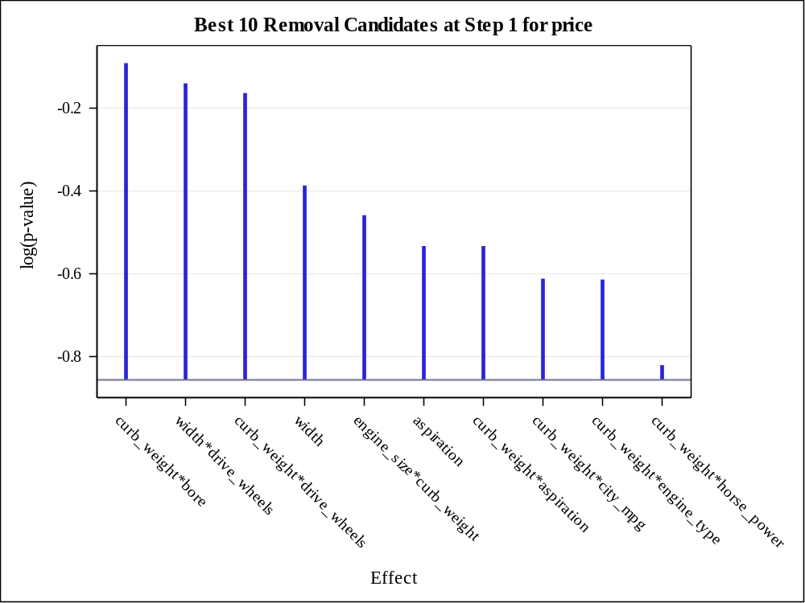

Effect Removed: width*drive_wheels

Analysis of Variance
Source | DF | Sum of  Squares | Mean  Square | F Value | Pr > F
Model | 131 | 8444994252 | 64465605 | 111.95 | <.0001
Error | 25 | 14396476 | 575859
Corrected Total | 156 | 8459390728

Root MSE | 758.85376
Dependent Mean | 12786
R-Square | 0.9983
Adj R-Sq | 0.9894
AIC | 2216.92096
AICC | 3766.66009
SBC | 2461.34541
ASE (Train) | 91697
ASE (Validate) | 2.828349E14

Parameter Estimates
Parameter | DF | Estimate | Standard  Error | t Value | Pr > |t|
Intercept | 1 | 188104693 | 117180603 | 1.61 | 0.1210
engine_size | 1 | -122134085 | 44804871 | -2.73 | 0.0115
curb_weight | 1 | 468377 | 321882 | 1.46 | 0.1581
engine_size*curb_weight | 1 | 109766 | 53661 | 2.05 | 0.0515
width | 1 | 16836949 | 5158789 | 3.26 | 0.0032
engine_size*width | 1 | -16465512 | 4711646 | -3.49 | 0.0018
curb_weight*width | 1 | 41003 | 19335 | 2.12 | 0.0440
city_mpg | 1 | -19044716 | 5619408 | -3.39 | 0.0023
engine_size*city_mpg | 1 | 5848335 | 1497825 | 3.90 | 0.0006
curb_weight*city_mpg | 1 | 18107 | 21612 | 0.84 | 0.4101
width*city_mpg | 1 | -1069989 | 301601 | -3.55 | 0.0016
bore | 1 | -50874241 | 13348188 | -3.81 | 0.0008
engine_size*bore | 1 | 10213859 | 3563463 | 2.87 | 0.0083
width*bore | 1 | 6661658 | 2106553 | 3.16 | 0.0041
city_mpg*bore | 1 | -2650202 | 680746 | -3.89 | 0.0007
horse_power | 1 | -209467 | 97118 | -2.16 | 0.0408
engine_size*horse_power | 1 | 44456 | 18265 | 2.43 | 0.0224
curb_weight*horse_power | 1 | -3204.830864 | 2329.339605 | -1.38 | 0.1811
width*horse_power | 1 | -15562 | 4923.431818 | -3.16 | 0.0041
city_mpg*horse_power | 1 | -6373.672291 | 3519.592546 | -1.81 | 0.0822
bore*horse_power | 1 | -173906 | 65468 | -2.66 | 0.0136
drive_wheels fwd | 1 | 137828900 | 74923939 | 1.84 | 0.0777
drive_wheels rwd | 1 | 38841691 | 52722159 | 0.74 | 0.4681
drive_wheels 4wd | 0 | 0 | . | . | .
engine_size*drive_wheels fwd | 1 | 42878923 | 11370240 | 3.77 | 0.0009
engine_size*drive_wheels rwd | 1 | 60336674 | 16136307 | 3.74 | 0.0010
engine_size*drive_wheels 4wd | 0 | 0 | . | . | .
curb_weight*drive_wheels fwd | 1 | -10547 | 13458 | -0.78 | 0.4406
curb_weight*drive_wheels rwd | 1 | -8750.313530 | 26085 | -0.34 | 0.7401
curb_weight*drive_wheels 4wd | 0 | 0 | . | . | .
city_mpg*drive_wheels fwd | 1 | 13627422 | 5400812 | 2.52 | 0.0184
city_mpg*drive_wheels rwd | 1 | 9249346 | 3659112 | 2.53 | 0.0182
city_mpg*drive_wheels 4wd | 0 | 0 | . | . | .
bore*drive_wheels fwd | 1 | -5534866 | 1776760 | -3.12 | 0.0046
bore*drive_wheels rwd | 1 | -23994615 | 7084207 | -3.39 | 0.0023
bore*drive_wheels 4wd | 0 | 0 | . | . | .
horse_power*drive_wheels fwd | 1 | 80743 | 30347 | 2.66 | 0.0134
horse_power*drive_wheels rwd | 0 | 0 | . | . | .
horse_power*drive_wheels 4wd | 0 | 0 | . | . | .
make audi | 1 | -517405892 | 175029397 | -2.96 | 0.0067
make bmw | 1 | 1682735232 | 446215288 | 3.77 | 0.0009
make chevrole | 1 | -414672101 | 127985080 | -3.24 | 0.0034
make dodge | 1 | -343872727 | 90356264 | -3.81 | 0.0008
make honda | 1 | -479964739 | 131279520 | -3.66 | 0.0012
make isuzu | 0 | 0 | . | . | .
make jaguar | 1 | -562854821 | 164357823 | -3.42 | 0.0021
make mazda | 1 | -482502117 | 129914120 | -3.71 | 0.0010
make mercedes | 1 | -678922731 | 229196347 | -2.96 | 0.0066
make mercury | 1 | 84422529 | 26033438 | 3.24 | 0.0033
make mitsubis | 1 | -528907001 | 143004957 | -3.70 | 0.0011
make nissan | 1 | -629522604 | 167316205 | -3.76 | 0.0009
make peugot | 1 | -134381887 | 40193293 | -3.34 | 0.0026
make plymouth | 1 | -438879051 | 118702873 | -3.70 | 0.0011
make porsche | 1 | -235433268 | 73666116 | -3.20 | 0.0038
make renault | 1 | 10639675 | 3361039 | 3.17 | 0.0040
make saab | 1 | -266618668 | 101353597 | -2.63 | 0.0144
make subaru | 1 | -421130165 | 113660564 | -3.71 | 0.0011
make toyota | 1 | -503919082 | 137093980 | -3.68 | 0.0011
make volkswag | 1 | -549030865 | 149857298 | -3.66 | 0.0012
make volvo | 1 | -354044757 | 107512877 | -3.29 | 0.0030
make alfa-rom | 0 | 0 | . | . | .
engine_size*make audi | 1 | 224542531 | 74542686 | 3.01 | 0.0059
engine_size*make bmw | 1 | 189740800 | 55755801 | 3.40 | 0.0022
engine_size*make chevrole | 1 | 154679882 | 49128393 | 3.15 | 0.0042
engine_size*make dodge | 1 | 94730699 | 29937679 | 3.16 | 0.0041
engine_size*make honda | 1 | 153737680 | 49170847 | 3.13 | 0.0044
engine_size*make isuzu | 0 | 0 | . | . | .
engine_size*make jaguar | 1 | 205521489 | 60809979 | 3.38 | 0.0024
engine_size*make mazda | 1 | 157445290 | 47299023 | 3.33 | 0.0027
engine_size*make mercedes | 1 | 183023840 | 53356938 | 3.43 | 0.0021
engine_size*make mercury | 0 | 0 | . | . | .
engine_size*make mitsubis | 1 | 177728080 | 54340605 | 3.27 | 0.0031
engine_size*make nissan | 1 | 169805460 | 52001182 | 3.27 | 0.0032
engine_size*make peugot | 1 | 180580940 | 54541978 | 3.31 | 0.0028
engine_size*make plymouth | 1 | 112227325 | 36034789 | 3.11 | 0.0046
engine_size*make porsche | 1 | 124774160 | 38773677 | 3.22 | 0.0036
engine_size*make renault | 0 | 0 | . | . | .
engine_size*make saab | 0 | 0 | . | . | .
engine_size*make subaru | 1 | 152562552 | 44320205 | 3.44 | 0.0020
engine_size*make toyota | 1 | 162446736 | 50499567 | 3.22 | 0.0036
engine_size*make volkswag | 1 | 185841679 | 56998777 | 3.26 | 0.0032
engine_size*make volvo | 1 | 159681017 | 48531100 | 3.29 | 0.0030
engine_size*make alfa-rom | 0 | 0 | . | . | .
curb_weight*make audi | 0 | 0 | . | . | .
curb_weight*make bmw | 1 | -78560 | 124985 | -0.63 | 0.5353
curb_weight*make chevrole | 1 | 43072 | 47843 | 0.90 | 0.3766
curb_weight*make dodge | 1 | 51357 | 23712 | 2.17 | 0.0401
curb_weight*make honda | 1 | 96169 | 47367 | 2.03 | 0.0531
curb_weight*make isuzu | 0 | 0 | . | . | .
curb_weight*make jaguar | 0 | 0 | . | . | .
curb_weight*make mazda | 1 | 15894 | 28947 | 0.55 | 0.5878
curb_weight*make mercedes | 1 | -41118412 | 11855062 | -3.47 | 0.0019
curb_weight*make mercury | 0 | 0 | . | . | .
curb_weight*make mitsubis | 1 | 37406 | 23533 | 1.59 | 0.1245
curb_weight*make nissan | 1 | 39887 | 19945 | 2.00 | 0.0565
curb_weight*make peugot | 1 | -107273 | 74450 | -1.44 | 0.1620
curb_weight*make plymouth | 1 | 23845782 | 7580634 | 3.15 | 0.0042
curb_weight*make porsche | 1 | 42882 | 60529 | 0.71 | 0.4852
curb_weight*make renault | 1 | -878394 | 312858 | -2.81 | 0.0095
curb_weight*make saab | 1 | 78953 | 33232 | 2.38 | 0.0255
curb_weight*make subaru | 1 | -86998 | 56804 | -1.53 | 0.1382
curb_weight*make toyota | 1 | 29028 | 16894 | 1.72 | 0.0981
curb_weight*make volkswag | 1 | 59761 | 27261 | 2.19 | 0.0379
curb_weight*make volvo | 0 | 0 | . | . | .
curb_weight*make alfa-rom | 0 | 0 | . | . | .
width*make audi | 0 | 0 | . | . | .
width*make bmw | 1 | 42238642 | 11820023 | 3.57 | 0.0015
width*make chevrole | 0 | 0 | . | . | .
width*make dodge | 1 | 35313125 | 10697124 | 3.30 | 0.0029
width*make honda | 1 | 3634431 | 1692837 | 2.15 | 0.0417
width*make isuzu | 0 | 0 | . | . | .
width*make jaguar | 0 | 0 | . | . | .
width*make mazda | 1 | -5923807 | 1610680 | -3.68 | 0.0011
width*make mercedes | 1 | 51831681 | 15036880 | 3.45 | 0.0020
width*make mercury | 0 | 0 | . | . | .
width*make mitsubis | 1 | 6951183 | 3112026 | 2.23 | 0.0347
width*make nissan | 1 | -3144505 | 2856537 | -1.10 | 0.2815
width*make peugot | 1 | -268708010 | 80282356 | -3.35 | 0.0026
width*make plymouth | 1 | 40103438 | 13043094 | 3.07 | 0.0050
width*make porsche | 0 | 0 | . | . | .
width*make renault | 0 | 0 | . | . | .
width*make saab | 0 | 0 | . | . | .
width*make subaru | 1 | -13817780 | 3615569 | -3.82 | 0.0008
width*make toyota | 1 | -456572 | 890888 | -0.51 | 0.6128
width*make volkswag | 1 | 1864920 | 1248924 | 1.49 | 0.1479
width*make volvo | 0 | 0 | . | . | .
width*make alfa-rom | 0 | 0 | . | . | .
city_mpg*make audi | 0 | 0 | . | . | .
city_mpg*make bmw | 1 | 131185514 | 34968360 | 3.75 | 0.0009
city_mpg*make chevrole | 0 | 0 | . | . | .
city_mpg*make dodge | 1 | -7205602 | 2403262 | -3.00 | 0.0061
city_mpg*make honda | 1 | -7729825 | 2471121 | -3.13 | 0.0044
city_mpg*make isuzu | 0 | 0 | . | . | .
city_mpg*make jaguar | 0 | 0 | . | . | .
city_mpg*make mazda | 1 | -5983860 | 2208986 | -2.71 | 0.0120
city_mpg*make mercedes | 1 | -25671447 | 9724519 | -2.64 | 0.0141
city_mpg*make mercury | 0 | 0 | . | . | .
city_mpg*make mitsubis | 1 | -7182893 | 2399575 | -2.99 | 0.0061
city_mpg*make nissan | 1 | -13600816 | 3819740 | -3.56 | 0.0015
city_mpg*make peugot | 1 | -1845584 | 498273 | -3.70 | 0.0011
city_mpg*make plymouth | 1 | -3710893 | 2356133 | -1.57 | 0.1278
city_mpg*make porsche | 0 | 0 | . | . | .
city_mpg*make renault | 0 | 0 | . | . | .
city_mpg*make saab | 1 | -13710176 | 5374018 | -2.55 | 0.0172
city_mpg*make subaru | 1 | -2423625 | 1657759 | -1.46 | 0.1562
city_mpg*make toyota | 1 | -6841377 | 2330541 | -2.94 | 0.0070
city_mpg*make volkswag | 1 | -7805837 | 2356071 | -3.31 | 0.0028
city_mpg*make volvo | 0 | 0 | . | . | .
city_mpg*make alfa-rom | 0 | 0 | . | . | .
bore*make audi | 0 | 0 | . | . | .
bore*make bmw | 1 | 61839325 | 16654040 | 3.71 | 0.0010
bore*make chevrole | 0 | 0 | . | . | .
bore*make dodge | 1 | 40484117 | 13157392 | 3.08 | 0.0050
bore*make honda | 1 | 21914507 | 6576008 | 3.33 | 0.0027
bore*make isuzu | 0 | 0 | . | . | .
bore*make jaguar | 0 | 0 | . | . | .
bore*make mazda | 1 | 20772496 | 7525461 | 2.76 | 0.0107
bore*make mercedes | 0 | 0 | . | . | .
bore*make mercury | 0 | 0 | . | . | .
bore*make mitsubis | 1 | 5215034 | 2930040 | 1.78 | 0.0873
bore*make nissan | 1 | -1775910 | 1514086 | -1.17 | 0.2519
bore*make peugot | 0 | 0 | . | . | .
bore*make plymouth | 1 | 13865213 | 4145216 | 3.34 | 0.0026
bore*make porsche | 0 | 0 | . | . | .
bore*make renault | 0 | 0 | . | . | .
bore*make saab | 1 | 7715032 | 3292366 | 2.34 | 0.0274
bore*make subaru | 0 | 0 | . | . | .
bore*make toyota | 1 | 13351034 | 4457456 | 3.00 | 0.0061
bore*make volkswag | 1 | 5334931 | 2670437 | 2.00 | 0.0567
bore*make volvo | 0 | 0 | . | . | .
bore*make alfa-rom | 0 | 0 | . | . | .
horse_power*make audi | 0 | 0 | . | . | .
horse_power*make bmw | 0 | 0 | . | . | .
horse_power*make chevrole | 0 | 0 | . | . | .
horse_power*make dodge | 0 | 0 | . | . | .
horse_power*make honda | 1 | -189460 | 57573 | -3.29 | 0.0030
horse_power*make isuzu | 0 | 0 | . | . | .
horse_power*make jaguar | 0 | 0 | . | . | .
horse_power*make mazda | 1 | 13267 | 23962 | 0.55 | 0.5847
horse_power*make mercedes | 0 | 0 | . | . | .
horse_power*make mercury | 0 | 0 | . | . | .
horse_power*make mitsubis | 1 | -165915 | 47976 | -3.46 | 0.0020
horse_power*make nissan | 0 | 0 | . | . | .
horse_power*make peugot | 0 | 0 | . | . | .
horse_power*make plymouth | 0 | 0 | . | . | .
horse_power*make porsche | 0 | 0 | . | . | .
horse_power*make renault | 0 | 0 | . | . | .
horse_power*make saab | 0 | 0 | . | . | .
horse_power*make subaru | 1 | 143731 | 68192 | 2.11 | 0.0452
horse_power*make toyota | 0 | 0 | . | . | .
horse_power*make volkswag | 1 | -230365 | 77750 | -2.96 | 0.0066
horse_power*make volvo | 0 | 0 | . | . | .
horse_power*make alfa-rom | 0 | 0 | . | . | .
curb_weight*engine_type l | 0 | 0 | . | . | .
curb_weight*engine_type ohc | 1 | -133924 | 60498 | -2.21 | 0.0362
curb_weight*engine_type ohcf | 0 | 0 | . | . | .
curb_weight*engine_type ohcv | 1 | -217220 | 115214 | -1.89 | 0.0711
curb_weight*engine_type rotor | 0 | 0 | . | . | .
curb_weight*engine_type dohc | 0 | 0 | . | . | .
curb_weight*bin_hp 1 | 1 | -25674 | 48547 | -0.53 | 0.6016
curb_weight*bin_hp 2 | 1 | 17467 | 52621 | 0.33 | 0.7427
curb_weight*bin_hp 3 | 1 | 109416 | 159324 | 0.69 | 0.4986
curb_weight*bin_hp 0 | 0 | 0 | . | . | .
aspiration turbo | 1 | 340942 | 227479 | 1.50 | 0.1465
aspiration std | 0 | 0 | . | . | .
curb_weight*aspiration turbo | 1 | -73707 | 49176 | -1.50 | 0.1464
curb_weight*aspiration std | 0 | 0 | . | . | .

Best 10 Removal Candidates
Rank | Effect | Log  pValue | Pr > F
1 | width*drive_wheels | -0.1256 | 0.8820
2 | curb_weight*drive_wheels | -0.1845 | 0.8315
3 | width | -0.4161 | 0.6596
4 | aspiration | -0.5840 | 0.5576
5 | curb_weight*aspiration | -0.5840 | 0.5576
6 | curb_weight*city_mpg | -0.6575 | 0.5181
7 | curb_weight*engine_type | -0.6667 | 0.5134
8 | curb_weight*horse_power | -0.8444 | 0.4298
9 | engine_size*curb_weight | -0.9247 | 0.3966
10 | bore*make | -0.9771 | 0.3764

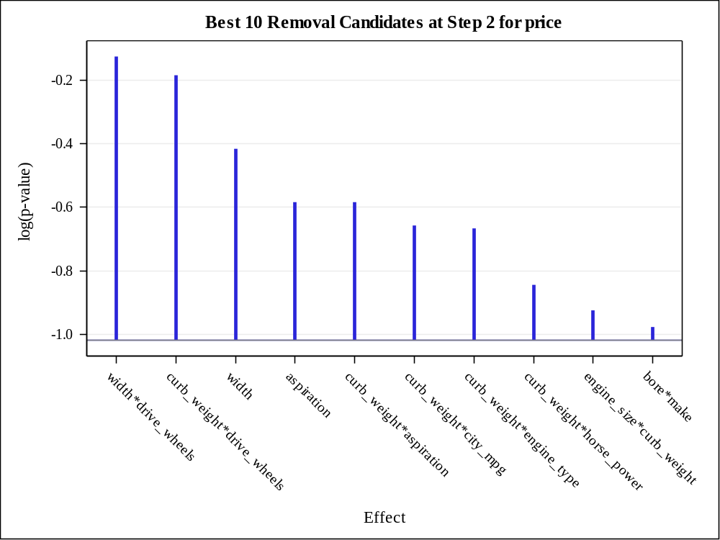

Effect Removed: curb_weight*drive_wheels

Analysis of Variance
Source | DF | Sum of  Squares | Mean  Square | F Value | Pr > F
Model | 130 | 8444786413 | 64959895 | 115.65 | <.0001
Error | 26 | 14604315 | 561704
Corrected Total | 156 | 8459390728

Root MSE | 749.46942
Dependent Mean | 12786
R-Square | 0.9983
Adj R-Sq | 0.9896
AIC | 2217.17134
AICC | 3680.17134
SBC | 2458.53954
ASE (Train) | 93021
ASE (Validate) | 2.11699E14

Parameter Estimates
Parameter | DF | Estimate | Standard  Error | t Value | Pr > |t|
Intercept | 1 | 133387253 | 117095761 | 1.14 | 0.2650
engine_size | 1 | -105525073 | 46157809 | -2.29 | 0.0306
curb_weight | 1 | 177778 | 119023 | 1.49 | 0.1473
engine_size*curb_weight | 1 | 70904 | 72642 | 0.98 | 0.3380
width | 1 | 13313944 | 6920596 | 1.92 | 0.0654
engine_size*width | 1 | -13850110 | 6503007 | -2.13 | 0.0428
curb_weight*width | 1 | 41734 | 20747 | 2.01 | 0.0547
city_mpg | 1 | -18053740 | 5755757 | -3.14 | 0.0042
engine_size*city_mpg | 1 | 4946793 | 2232521 | 2.22 | 0.0357
curb_weight*city_mpg | 1 | 1328.703624 | 3163.654336 | 0.42 | 0.6779
width*city_mpg | 1 | -966868 | 409487 | -2.36 | 0.0260
bore | 1 | -42985239 | 17941064 | -2.40 | 0.0241
engine_size*bore | 1 | 7908250 | 4503428 | 1.76 | 0.0909
width*bore | 1 | 5550856 | 2714271 | 2.05 | 0.0511
city_mpg*bore | 1 | -2191965 | 1009296 | -2.17 | 0.0392
horse_power | 1 | -173863 | 63131 | -2.75 | 0.0106
engine_size*horse_power | 1 | 37062 | 16554 | 2.24 | 0.0339
curb_weight*horse_power | 1 | -2470.071661 | 1833.063056 | -1.35 | 0.1894
width*horse_power | 1 | -14712 | 5996.367639 | -2.45 | 0.0212
city_mpg*horse_power | 1 | -3855.494345 | 2747.433929 | -1.40 | 0.1724
bore*horse_power | 1 | -132210 | 78274 | -1.69 | 0.1032
drive_wheels fwd | 1 | 174099148 | 75408934 | 2.31 | 0.0292
drive_wheels rwd | 1 | 58396612 | 44248284 | 1.32 | 0.1984
drive_wheels 4wd | 0 | 0 | . | . | .
engine_size*drive_wheels fwd | 1 | 39644673 | 12804418 | 3.10 | 0.0047
engine_size*drive_wheels rwd | 1 | 53640597 | 20156100 | 2.66 | 0.0132
engine_size*drive_wheels 4wd | 0 | 0 | . | . | .
city_mpg*drive_wheels fwd | 1 | 15635456 | 5112689 | 3.06 | 0.0051
city_mpg*drive_wheels rwd | 1 | 9633896 | 2910075 | 3.31 | 0.0027
city_mpg*drive_wheels 4wd | 0 | 0 | . | . | .
bore*drive_wheels fwd | 1 | -4608956 | 2241472 | -2.06 | 0.0499
bore*drive_wheels rwd | 1 | -19904388 | 9684944 | -2.06 | 0.0500
bore*drive_wheels 4wd | 0 | 0 | . | . | .
horse_power*drive_wheels fwd | 1 | 91377 | 28977 | 3.15 | 0.0040
horse_power*drive_wheels rwd | 0 | 0 | . | . | .
horse_power*drive_wheels 4wd | 0 | 0 | . | . | .
make audi | 1 | -411190011 | 215302050 | -1.91 | 0.0672
make bmw | 1 | 1432468559 | 667298376 | 2.15 | 0.0413
make chevrole | 1 | -359576282 | 143035376 | -2.51 | 0.0185
make dodge | 1 | -332618176 | 91493338 | -3.64 | 0.0012
make honda | 1 | -438678609 | 141419364 | -3.10 | 0.0046
make isuzu | 0 | 0 | . | . | .
make jaguar | 1 | -476122107 | 211701926 | -2.25 | 0.0332
make mazda | 1 | -454658630 | 133203230 | -3.41 | 0.0021
make mercedes | 1 | -515373221 | 311114952 | -1.66 | 0.1096
make mercury | 1 | 72166538 | 30196725 | 2.39 | 0.0244
make mitsubis | 1 | -480936528 | 158144856 | -3.04 | 0.0053
make nissan | 1 | -567840356 | 193677453 | -2.93 | 0.0069
make peugot | 1 | -99266004 | 68003897 | -1.46 | 0.1563
make plymouth | 1 | -406334051 | 125823258 | -3.23 | 0.0033
make porsche | 1 | -200415084 | 84173369 | -2.38 | 0.0249
make renault | 1 | 9682543 | 3635557 | 2.66 | 0.0131
make saab | 1 | -245358784 | 93308362 | -2.63 | 0.0142
make subaru | 1 | -399954702 | 115665896 | -3.46 | 0.0019
make toyota | 1 | -459393570 | 149499939 | -3.07 | 0.0049
make volkswag | 1 | -496290998 | 166614356 | -2.98 | 0.0062
make volvo | 1 | -298749696 | 131535069 | -2.27 | 0.0316
make alfa-rom | 0 | 0 | . | . | .
engine_size*make audi | 1 | 179723627 | 92398546 | 1.95 | 0.0627
engine_size*make bmw | 1 | 161541556 | 68583557 | 2.36 | 0.0263
engine_size*make chevrole | 1 | 133915092 | 53962949 | 2.48 | 0.0199
engine_size*make dodge | 1 | 82778496 | 33710169 | 2.46 | 0.0211
engine_size*make honda | 1 | 128577737 | 58119495 | 2.21 | 0.0359
engine_size*make isuzu | 0 | 0 | . | . | .
engine_size*make jaguar | 1 | 174326787 | 75930385 | 2.30 | 0.0300
engine_size*make mazda | 1 | 137817756 | 52891640 | 2.61 | 0.0150
engine_size*make mercedes | 1 | 157862058 | 64577741 | 2.44 | 0.0216
engine_size*make mercury | 0 | 0 | . | . | .
engine_size*make mitsubis | 1 | 149423261 | 66499527 | 2.25 | 0.0334
engine_size*make nissan | 1 | 142884082 | 63534873 | 2.25 | 0.0332
engine_size*make peugot | 1 | 154119023 | 64904373 | 2.37 | 0.0252
engine_size*make plymouth | 1 | 95497462 | 41820909 | 2.28 | 0.0308
engine_size*make porsche | 1 | 106326154 | 44697982 | 2.38 | 0.0250
engine_size*make renault | 0 | 0 | . | . | .
engine_size*make saab | 0 | 0 | . | . | .
engine_size*make subaru | 1 | 134202929 | 50546234 | 2.66 | 0.0134
engine_size*make toyota | 1 | 136395983 | 60819081 | 2.24 | 0.0337
engine_size*make volkswag | 1 | 155601553 | 70046588 | 2.22 | 0.0352
engine_size*make volvo | 1 | 135035207 | 59021029 | 2.29 | 0.0305
engine_size*make alfa-rom | 0 | 0 | . | . | .
curb_weight*make audi | 0 | 0 | . | . | .
curb_weight*make bmw | 1 | -10032 | 74163 | -0.14 | 0.8934
curb_weight*make chevrole | 1 | 59898 | 32952 | 1.82 | 0.0806
curb_weight*make dodge | 1 | 51298 | 23512 | 2.18 | 0.0384
curb_weight*make honda | 1 | 95014 | 54392 | 1.75 | 0.0925
curb_weight*make isuzu | 0 | 0 | . | . | .
curb_weight*make jaguar | 0 | 0 | . | . | .
curb_weight*make mazda | 1 | 25271 | 23646 | 1.07 | 0.2950
curb_weight*make mercedes | 1 | -34517935 | 16275076 | -2.12 | 0.0436
curb_weight*make mercury | 0 | 0 | . | . | .
curb_weight*make mitsubis | 1 | 41815 | 18360 | 2.28 | 0.0312
curb_weight*make nissan | 1 | 45603 | 15465 | 2.95 | 0.0067
curb_weight*make peugot | 1 | -88850 | 92934 | -0.96 | 0.3479
curb_weight*make plymouth | 1 | 18940664 | 9464835 | 2.00 | 0.0559
curb_weight*make porsche | 1 | 101674 | 65855 | 1.54 | 0.1347
curb_weight*make renault | 1 | -725673 | 373160 | -1.94 | 0.0627
curb_weight*make saab | 1 | 56454 | 34424 | 1.64 | 0.1131
curb_weight*make subaru | 1 | -47405 | 70680 | -0.67 | 0.5083
curb_weight*make toyota | 1 | 35398 | 13099 | 2.70 | 0.0120
curb_weight*make volkswag | 1 | 59487 | 29420 | 2.02 | 0.0536
curb_weight*make volvo | 0 | 0 | . | . | .
curb_weight*make alfa-rom | 0 | 0 | . | . | .
width*make audi | 0 | 0 | . | . | .
width*make bmw | 1 | 35638784 | 16504311 | 2.16 | 0.0402
width*make chevrole | 0 | 0 | . | . | .
width*make dodge | 1 | 28415249 | 14332287 | 1.98 | 0.0581
width*make honda | 1 | 2937381 | 1785536 | 1.65 | 0.1120
width*make isuzu | 0 | 0 | . | . | .
width*make jaguar | 0 | 0 | . | . | .
width*make mazda | 1 | -5351335 | 1832151 | -2.92 | 0.0071
width*make mercedes | 1 | 43509042 | 20526939 | 2.12 | 0.0437
width*make mercury | 0 | 0 | . | . | .
width*make mitsubis | 1 | 5236437 | 3477866 | 1.51 | 0.1442
width*make nissan | 1 | -3251157 | 2706521 | -1.20 | 0.2405
width*make peugot | 1 | -240970172 | 85407023 | -2.82 | 0.0090
width*make plymouth | 1 | 30860541 | 17748263 | 1.74 | 0.0939
width*make porsche | 0 | 0 | . | . | .
width*make renault | 0 | 0 | . | . | .
width*make saab | 0 | 0 | . | . | .
width*make subaru | 1 | -13108353 | 3978820 | -3.29 | 0.0028
width*make toyota | 1 | -453177 | 719061 | -0.63 | 0.5340
width*make volkswag | 1 | 1433805 | 1174229 | 1.22 | 0.2330
width*make volvo | 0 | 0 | . | . | .
width*make alfa-rom | 0 | 0 | . | . | .
city_mpg*make audi | 0 | 0 | . | . | .
city_mpg*make bmw | 1 | 111741301 | 50461103 | 2.21 | 0.0358
city_mpg*make chevrole | 0 | 0 | . | . | .
city_mpg*make dodge | 1 | -8307206 | 2591380 | -3.21 | 0.0036
city_mpg*make honda | 1 | -8743080 | 2588520 | -3.38 | 0.0023
city_mpg*make isuzu | 0 | 0 | . | . | .
city_mpg*make jaguar | 0 | 0 | . | . | .
city_mpg*make mazda | 1 | -7521258 | 2910239 | -2.58 | 0.0157
city_mpg*make mercedes | 1 | -17396965 | 14398164 | -1.21 | 0.2378
city_mpg*make mercury | 0 | 0 | . | . | .
city_mpg*make mitsubis | 1 | -8269027 | 2586640 | -3.20 | 0.0036
city_mpg*make nissan | 1 | -13819132 | 3695554 | -3.74 | 0.0009
city_mpg*make peugot | 1 | -1470893 | 709255 | -2.07 | 0.0481
city_mpg*make plymouth | 1 | -5531851 | 3048123 | -1.81 | 0.0811
city_mpg*make porsche | 0 | 0 | . | . | .
city_mpg*make renault | 0 | 0 | . | . | .
city_mpg*make saab | 1 | -12880841 | 4915813 | -2.62 | 0.0145
city_mpg*make subaru | 1 | -4350044 | 3081305 | -1.41 | 0.1699
city_mpg*make toyota | 1 | -8007754 | 2587821 | -3.09 | 0.0047
city_mpg*make volkswag | 1 | -8745605 | 2507776 | -3.49 | 0.0018
city_mpg*make volvo | 0 | 0 | . | . | .
city_mpg*make alfa-rom | 0 | 0 | . | . | .
bore*make audi | 0 | 0 | . | . | .
bore*make bmw | 1 | 53698868 | 21955375 | 2.45 | 0.0215
bore*make chevrole | 0 | 0 | . | . | .
bore*make dodge | 1 | 33207646 | 15331094 | 2.17 | 0.0397
bore*make honda | 1 | 19064851 | 7455277 | 2.56 | 0.0167
bore*make isuzu | 0 | 0 | . | . | .
bore*make jaguar | 0 | 0 | . | . | .
bore*make mazda | 1 | 15467405 | 10417642 | 1.48 | 0.1496
bore*make mercedes | 0 | 0 | . | . | .
bore*make mercury | 0 | 0 | . | . | .
bore*make mitsubis | 1 | 5133906 | 2792555 | 1.84 | 0.0775
bore*make nissan | 1 | -666169 | 3134585 | -0.21 | 0.8334
bore*make peugot | 0 | 0 | . | . | .
bore*make plymouth | 1 | 13089353 | 4143429 | 3.16 | 0.0040
bore*make porsche | 0 | 0 | . | . | .
bore*make renault | 0 | 0 | . | . | .
bore*make saab | 1 | 7201637 | 3057885 | 2.36 | 0.0263
bore*make subaru | 0 | 0 | . | . | .
bore*make toyota | 1 | 11919861 | 4470626 | 2.67 | 0.0130
bore*make volkswag | 1 | 5275884 | 2591998 | 2.04 | 0.0521
bore*make volvo | 0 | 0 | . | . | .
bore*make alfa-rom | 0 | 0 | . | . | .
horse_power*make audi | 0 | 0 | . | . | .
horse_power*make bmw | 0 | 0 | . | . | .
horse_power*make chevrole | 0 | 0 | . | . | .
horse_power*make dodge | 0 | 0 | . | . | .
horse_power*make honda | 1 | -154078 | 75096 | -2.05 | 0.0504
horse_power*make isuzu | 0 | 0 | . | . | .
horse_power*make jaguar | 0 | 0 | . | . | .
horse_power*make mazda | 1 | -12602 | 42532 | -0.30 | 0.7694
horse_power*make mercedes | 0 | 0 | . | . | .
horse_power*make mercury | 0 | 0 | . | . | .
horse_power*make mitsubis | 1 | -133948 | 65132 | -2.06 | 0.0499
horse_power*make nissan | 0 | 0 | . | . | .
horse_power*make peugot | 0 | 0 | . | . | .
horse_power*make plymouth | 0 | 0 | . | . | .
horse_power*make porsche | 0 | 0 | . | . | .
horse_power*make renault | 0 | 0 | . | . | .
horse_power*make saab | 0 | 0 | . | . | .
horse_power*make subaru | 1 | 102773 | 73262 | 1.40 | 0.1725
horse_power*make toyota | 0 | 0 | . | . | .
horse_power*make volkswag | 1 | -181879 | 99590 | -1.83 | 0.0793
horse_power*make volvo | 0 | 0 | . | . | .
horse_power*make alfa-rom | 0 | 0 | . | . | .
curb_weight*engine_type l | 0 | 0 | . | . | .
curb_weight*engine_type ohc | 1 | -98014 | 90882 | -1.08 | 0.2907
curb_weight*engine_type ohcf | 0 | 0 | . | . | .
curb_weight*engine_type ohcv | 1 | -138145 | 152759 | -0.90 | 0.3741
curb_weight*engine_type rotor | 1 | 562611 | 1025839 | 0.55 | 0.5881
curb_weight*engine_type dohc | 0 | 0 | . | . | .
curb_weight*bin_hp 1 | 1 | -31214 | 30194 | -1.03 | 0.3108
curb_weight*bin_hp 2 | 1 | 11029 | 29353 | 0.38 | 0.7102
curb_weight*bin_hp 3 | 1 | 46431 | 68443 | 0.68 | 0.5035
curb_weight*bin_hp 0 | 0 | 0 | . | . | .
aspiration turbo | 1 | 109034 | 261207 | 0.42 | 0.6798
aspiration std | 0 | 0 | . | . | .
curb_weight*aspiration turbo | 1 | -23572 | 56469 | -0.42 | 0.6798
curb_weight*aspiration std | 0 | 0 | . | . | .

Best 10 Removal Candidates
Rank | Effect | Log  pValue | Pr > F
1 | curb_weight*drive_wheels | -0.5917 | 0.5534
2 | curb_weight*city_mpg | -0.8914 | 0.4101
3 | city_mpg*make | -1.2915 | 0.2749
4 | bore*make | -1.4562 | 0.2331
5 | make | -1.4677 | 0.2305
6 | curb_weight*make | -1.7158 | 0.1798
7 | width*make | -1.8688 | 0.1543
8 | engine_size*make | -1.9393 | 0.1438
9 | curb_weight*engine_type | -2.2885 | 0.1014
10 | curb_weight*width | -3.1225 | 0.0440

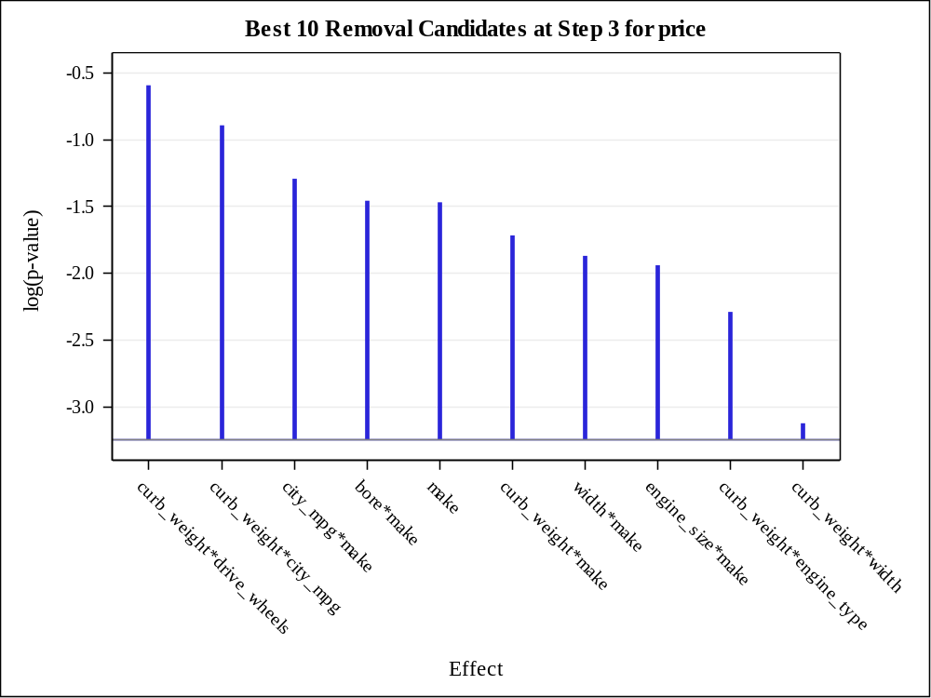

Effect Removed: aspiration

Analysis of Variance
Source | DF | Sum of  Squares | Mean  Square | F Value | Pr > F
Model | 129 | 8444688539 | 65462702 | 120.22 | <.0001
Error | 27 | 14702188 | 544525
Corrected Total | 156 | 8459390728

Root MSE | 737.91970
Dependent Mean | 12786
R-Square | 0.9983
Adj R-Sq | 0.9900
AIC | 2216.21999
AICC | 3599.57999
SBC | 2454.53195
ASE (Train) | 93645
ASE (Validate) | 1.56873E14

Parameter Estimates
Parameter | DF | Estimate | Standard  Error | t Value | Pr > |t|
Intercept | 1 | 95923763 | 74050877 | 1.30 | 0.2062
engine_size | 1 | -90666236 | 28931490 | -3.13 | 0.0041
curb_weight | 1 | 133901 | 54975 | 2.44 | 0.0217
engine_size*curb_weight | 1 | 40886 | 10116 | 4.04 | 0.0004
width | 1 | 10717020 | 2984806 | 3.59 | 0.0013
engine_size*width | 1 | -11431704 | 2907951 | -3.93 | 0.0005
curb_weight*width | 1 | 34838 | 12355 | 2.82 | 0.0089
city_mpg | 1 | -16452543 | 4225102 | -3.89 | 0.0006
engine_size*city_mpg | 1 | 4132374 | 1068420 | 3.87 | 0.0006
curb_weight*city_mpg | 1 | 1207.707169 | 3101.798720 | 0.39 | 0.7001
width*city_mpg | 1 | -825365 | 226167 | -3.65 | 0.0011
bore | 1 | -36359766 | 8234935 | -4.42 | 0.0001
engine_size*bore | 1 | 6217595 | 1938598 | 3.21 | 0.0034
width*bore | 1 | 4544157 | 1226208 | 3.71 | 0.0010
city_mpg*bore | 1 | -1819628 | 464996 | -3.91 | 0.0006
horse_power | 1 | -157282 | 48311 | -3.26 | 0.0030
engine_size*horse_power | 1 | 31380 | 9277.667990 | 3.38 | 0.0022
curb_weight*horse_power | 1 | -1742.073703 | 555.670863 | -3.14 | 0.0041
width*horse_power | 1 | -13096 | 4508.636963 | -2.90 | 0.0073
city_mpg*horse_power | 1 | -2805.564334 | 1088.356621 | -2.58 | 0.0157
bore*horse_power | 1 | -103047 | 34751 | -2.97 | 0.0063
drive_wheels fwd | 1 | 187428932 | 67260994 | 2.79 | 0.0096
drive_wheels rwd | 1 | 67703362 | 37631621 | 1.80 | 0.0832
drive_wheels 4wd | 0 | 0 | . | . | .
engine_size*drive_wheels fwd | 1 | 35462326 | 7849889 | 4.52 | 0.0001
engine_size*drive_wheels rwd | 1 | 46518372 | 10565285 | 4.40 | 0.0002
engine_size*drive_wheels 4wd | 0 | 0 | . | . | .
city_mpg*drive_wheels fwd | 1 | 16048273 | 4938828 | 3.25 | 0.0031
city_mpg*drive_wheels rwd | 1 | 9366140 | 2794757 | 3.35 | 0.0024
city_mpg*drive_wheels 4wd | 0 | 0 | . | . | .
bore*drive_wheels fwd | 1 | -3780384 | 1025171 | -3.69 | 0.0010
bore*drive_wheels rwd | 1 | -16320292 | 4411495 | -3.70 | 0.0010
bore*drive_wheels 4wd | 0 | 0 | . | . | .
horse_power*drive_wheels fwd | 1 | 93518 | 28080 | 3.33 | 0.0025
horse_power*drive_wheels rwd | 0 | 0 | . | . | .
horse_power*drive_wheels 4wd | 0 | 0 | . | . | .
make audi | 1 | -330386753 | 92799833 | -3.56 | 0.0014
make bmw | 1 | 1191049352 | 327728408 | 3.63 | 0.0012
make chevrole | 1 | -309831107 | 77883873 | -3.98 | 0.0005
make dodge | 1 | -308770054 | 70362137 | -4.39 | 0.0002
make honda | 1 | -393385992 | 89300400 | -4.41 | 0.0002
make isuzu | 0 | 0 | . | . | .
make jaguar | 1 | -397881809 | 96898872 | -4.11 | 0.0003
make mazda | 1 | -416848478 | 96159939 | -4.33 | 0.0002
make mercedes | 1 | -396277893 | 122148625 | -3.24 | 0.0031
make mercury | 1 | 61352707 | 15276027 | 4.02 | 0.0004
make mitsubis | 1 | -428942622 | 95940315 | -4.47 | 0.0001
make nissan | 1 | -501987589 | 110620250 | -4.54 | 0.0001
make peugot | 1 | -73079428 | 25844769 | -2.83 | 0.0087
make plymouth | 1 | -367458912 | 83301976 | -4.41 | 0.0001
make porsche | 1 | -170539985 | 43621811 | -3.91 | 0.0006
make renault | 1 | 8443805 | 2067826 | 4.08 | 0.0004
make saab | 1 | -225287829 | 78733286 | -2.86 | 0.0080
make subaru | 1 | -368056965 | 85490906 | -4.31 | 0.0002
make toyota | 1 | -410863107 | 92538281 | -4.44 | 0.0001
make volkswag | 1 | -440833719 | 98997598 | -4.45 | 0.0001
make volvo | 1 | -250478054 | 61712048 | -4.06 | 0.0004
make alfa-rom | 0 | 0 | . | . | .
engine_size*make audi | 1 | 145056042 | 39873012 | 3.64 | 0.0011
engine_size*make bmw | 1 | 136432362 | 32437265 | 4.21 | 0.0003
engine_size*make chevrole | 1 | 115374586 | 30173860 | 3.82 | 0.0007
engine_size*make dodge | 1 | 70976564 | 18074736 | 3.93 | 0.0005
engine_size*make honda | 1 | 107469976 | 28209741 | 3.81 | 0.0007
engine_size*make isuzu | 0 | 0 | . | . | .
engine_size*make jaguar | 1 | 146416571 | 35428616 | 4.13 | 0.0003
engine_size*make mazda | 1 | 119517495 | 29132984 | 4.10 | 0.0003
engine_size*make mercedes | 1 | 134474266 | 31615391 | 4.25 | 0.0002
engine_size*make mercury | 0 | 0 | . | . | .
engine_size*make mitsubis | 1 | 125016882 | 31191066 | 4.01 | 0.0004
engine_size*make nissan | 1 | 119585284 | 29885282 | 4.00 | 0.0004
engine_size*make peugot | 1 | 130615800 | 31787082 | 4.11 | 0.0003
engine_size*make plymouth | 1 | 80505047 | 21094097 | 3.82 | 0.0007
engine_size*make porsche | 1 | 90376659 | 22836602 | 3.96 | 0.0005
engine_size*make renault | 0 | 0 | . | . | .
engine_size*make saab | 0 | 0 | . | . | .
engine_size*make subaru | 1 | 116540695 | 27225041 | 4.28 | 0.0002
engine_size*make toyota | 1 | 114163470 | 28911015 | 3.95 | 0.0005
engine_size*make volkswag | 1 | 129811151 | 32494411 | 3.99 | 0.0004
engine_size*make volvo | 1 | 113427700 | 27917765 | 4.06 | 0.0004
engine_size*make alfa-rom | 0 | 0 | . | . | .
curb_weight*make audi | 0 | 0 | . | . | .
curb_weight*make bmw | 1 | 17071 | 35288 | 0.48 | 0.6325
curb_weight*make chevrole | 1 | 49746 | 21890 | 2.27 | 0.0312
curb_weight*make dodge | 1 | 43126 | 12822 | 3.36 | 0.0023
curb_weight*make honda | 1 | 74959 | 25106 | 2.99 | 0.0059
curb_weight*make isuzu | 0 | 0 | . | . | .
curb_weight*make jaguar | 0 | 0 | . | . | .
curb_weight*make mazda | 1 | 28529 | 21977 | 1.30 | 0.2052
curb_weight*make mercedes | 1 | -28458202 | 7244373 | -3.93 | 0.0005
curb_weight*make mercury | 0 | 0 | . | . | .
curb_weight*make mitsubis | 1 | 38764 | 16584 | 2.34 | 0.0271
curb_weight*make nissan | 1 | 41704 | 12135 | 3.44 | 0.0019
curb_weight*make peugot | 1 | -51913 | 27963 | -1.86 | 0.0743
curb_weight*make plymouth | 1 | 15379401 | 4035198 | 3.81 | 0.0007
curb_weight*make porsche | 1 | 125162 | 33686 | 3.72 | 0.0009
curb_weight*make renault | 1 | -588891 | 175783 | -3.35 | 0.0024
curb_weight*make saab | 1 | 42610 | 9081.727929 | 4.69 | <.0001
curb_weight*make subaru | 1 | -19360 | 21608 | -0.90 | 0.3782
curb_weight*make toyota | 1 | 32320 | 10659 | 3.03 | 0.0053
curb_weight*make volkswag | 1 | 49643 | 17319 | 2.87 | 0.0080
curb_weight*make volvo | 0 | 0 | . | . | .
curb_weight*make alfa-rom | 0 | 0 | . | . | .
width*make audi | 0 | 0 | . | . | .
width*make bmw | 1 | 29518526 | 7460822 | 3.96 | 0.0005
width*make chevrole | 0 | 0 | . | . | .
width*make dodge | 1 | 22996428 | 5980436 | 3.85 | 0.0007
width*make honda | 1 | 2325899 | 1005168 | 2.31 | 0.0285
width*make isuzu | 0 | 0 | . | . | .
width*make jaguar | 0 | 0 | . | . | .
width*make mazda | 1 | -4764655 | 1157226 | -4.12 | 0.0003
width*make mercedes | 1 | 35873306 | 9169940 | 3.91 | 0.0006
width*make mercury | 0 | 0 | . | . | .
width*make mitsubis | 1 | 4011785 | 1838899 | 2.18 | 0.0380
width*make nissan | 1 | -2977434 | 2585416 | -1.15 | 0.2596
width*make peugot | 1 | -213157702 | 52608610 | -4.05 | 0.0004
width*make plymouth | 1 | 24070834 | 6991841 | 3.44 | 0.0019
width*make porsche | 0 | 0 | . | . | .
width*make renault | 0 | 0 | . | . | .
width*make saab | 0 | 0 | . | . | .
width*make subaru | 1 | -11939120 | 2782237 | -4.29 | 0.0002
width*make toyota | 1 | -482624 | 704564 | -0.68 | 0.4992
width*make volkswag | 1 | 1083978 | 809803 | 1.34 | 0.1919
width*make volvo | 0 | 0 | . | . | .
width*make alfa-rom | 0 | 0 | . | . | .
city_mpg*make audi | 0 | 0 | . | . | .
city_mpg*make bmw | 1 | 93269263 | 23876091 | 3.91 | 0.0006
city_mpg*make chevrole | 0 | 0 | . | . | .
city_mpg*make dodge | 1 | -8586231 | 2465100 | -3.48 | 0.0017
city_mpg*make honda | 1 | -8941808 | 2505154 | -3.57 | 0.0014
city_mpg*make isuzu | 0 | 0 | . | . | .
city_mpg*make jaguar | 0 | 0 | . | . | .
city_mpg*make mazda | 1 | -8113027 | 2502430 | -3.24 | 0.0031
city_mpg*make mercedes | 1 | -11837333 | 5385143 | -2.20 | 0.0367
city_mpg*make mercury | 0 | 0 | . | . | .
city_mpg*make mitsubis | 1 | -8549147 | 2459578 | -3.48 | 0.0017
city_mpg*make nissan | 1 | -13222657 | 3355595 | -3.94 | 0.0005
city_mpg*make peugot | 1 | -1204711 | 305718 | -3.94 | 0.0005
city_mpg*make plymouth | 1 | -6332934 | 2331646 | -2.72 | 0.0114
city_mpg*make porsche | 0 | 0 | . | . | .
city_mpg*make renault | 0 | 0 | . | . | .
city_mpg*make saab | 1 | -12027026 | 4401173 | -2.73 | 0.0109
city_mpg*make subaru | 1 | -5300820 | 2043216 | -2.59 | 0.0151
city_mpg*make toyota | 1 | -8338850 | 2425305 | -3.44 | 0.0019
city_mpg*make volkswag | 1 | -8909572 | 2438653 | -3.65 | 0.0011
city_mpg*make volvo | 0 | 0 | . | . | .
city_mpg*make alfa-rom | 0 | 0 | . | . | .
bore*make audi | 0 | 0 | . | . | .
bore*make bmw | 1 | 45715585 | 10616695 | 4.31 | 0.0002
bore*make chevrole | 0 | 0 | . | . | .
bore*make dodge | 1 | 27590833 | 7234037 | 3.81 | 0.0007
bore*make honda | 1 | 16431650 | 3912149 | 4.20 | 0.0003
bore*make isuzu | 0 | 0 | . | . | .
bore*make jaguar | 0 | 0 | . | . | .
bore*make mazda | 1 | 11482858 | 4108221 | 2.80 | 0.0094
bore*make mercedes | 0 | 0 | . | . | .
bore*make mercury | 0 | 0 | . | . | .
bore*make mitsubis | 1 | 4945335 | 2713305 | 1.82 | 0.0795
bore*make nissan | 1 | 151248 | 2409919 | 0.06 | 0.9504
bore*make peugot | 0 | 0 | . | . | .
bore*make plymouth | 1 | 11943933 | 3056733 | 3.91 | 0.0006
bore*make porsche | 0 | 0 | . | . | .
bore*make renault | 0 | 0 | . | . | .
bore*make saab | 1 | 6644716 | 2709075 | 2.45 | 0.0209
bore*make subaru | 0 | 0 | . | . | .
bore*make toyota | 1 | 10561430 | 3018045 | 3.50 | 0.0016
bore*make volkswag | 1 | 5083483 | 2511379 | 2.02 | 0.0529
bore*make volvo | 0 | 0 | . | . | .
bore*make alfa-rom | 0 | 0 | . | . | .
horse_power*make audi | 0 | 0 | . | . | .
horse_power*make bmw | 0 | 0 | . | . | .
horse_power*make chevrole | 0 | 0 | . | . | .
horse_power*make dodge | 0 | 0 | . | . | .
horse_power*make honda | 1 | -125736 | 31591 | -3.98 | 0.0005
horse_power*make isuzu | 0 | 0 | . | . | .
horse_power*make jaguar | 0 | 0 | . | . | .
horse_power*make mazda | 1 | -28522 | 18535 | -1.54 | 0.1355
horse_power*make mercedes | 0 | 0 | . | . | .
horse_power*make mercury | 0 | 0 | . | . | .
horse_power*make mitsubis | 1 | -109262 | 26874 | -4.07 | 0.0004
horse_power*make nissan | 0 | 0 | . | . | .
horse_power*make peugot | 0 | 0 | . | . | .
horse_power*make plymouth | 0 | 0 | . | . | .
horse_power*make porsche | 0 | 0 | . | . | .
horse_power*make renault | 0 | 0 | . | . | .
horse_power*make saab | 0 | 0 | . | . | .
horse_power*make subaru | 1 | 76907 | 38484 | 2.00 | 0.0558
horse_power*make toyota | 0 | 0 | . | . | .
horse_power*make volkswag | 1 | -144367 | 42260 | -3.42 | 0.0020
horse_power*make volvo | 0 | 0 | . | . | .
horse_power*make alfa-rom | 0 | 0 | . | . | .
curb_weight*engine_type l | 0 | 0 | . | . | .
curb_weight*engine_type ohc | 1 | -61276 | 22318 | -2.75 | 0.0106
curb_weight*engine_type ohcf | 0 | 0 | . | . | .
curb_weight*engine_type ohcv | 1 | -75309 | 25588 | -2.94 | 0.0066
curb_weight*engine_type rotor | 1 | 905434 | 605218 | 1.50 | 0.1462
curb_weight*engine_type dohc | 0 | 0 | . | . | .
curb_weight*bin_hp 1 | 1 | -22687 | 21892 | -1.04 | 0.3092
curb_weight*bin_hp 2 | 1 | 17224 | 24933 | 0.69 | 0.4956
curb_weight*bin_hp 3 | 1 | 29131 | 53630 | 0.54 | 0.5915
curb_weight*bin_hp 0 | 0 | 0 | . | . | .
curb_weight*aspiration turbo | 1 | -0.380989 | 225.604306 | -0.00 | 0.9987
curb_weight*aspiration std | 0 | 0 | . | . | .

Best 10 Removal Candidates
Rank | Effect | Log  pValue | Pr > F
1 | aspiration | -0.3860 | 0.6798
2 | curb_weight*aspiration | -0.3860 | 0.6798
3 | curb_weight*city_mpg | -0.3887 | 0.6779
4 | engine_size*curb_weight | -1.0846 | 0.3380
5 | bore*make | -1.2054 | 0.2996
6 | city_mpg*make | -1.3152 | 0.2684
7 | engine_size*make | -1.4880 | 0.2258
8 | make | -1.5543 | 0.2113
9 | curb_weight*horse_power | -1.6637 | 0.1894
10 | city_mpg*horse_power | -1.7582 | 0.1724

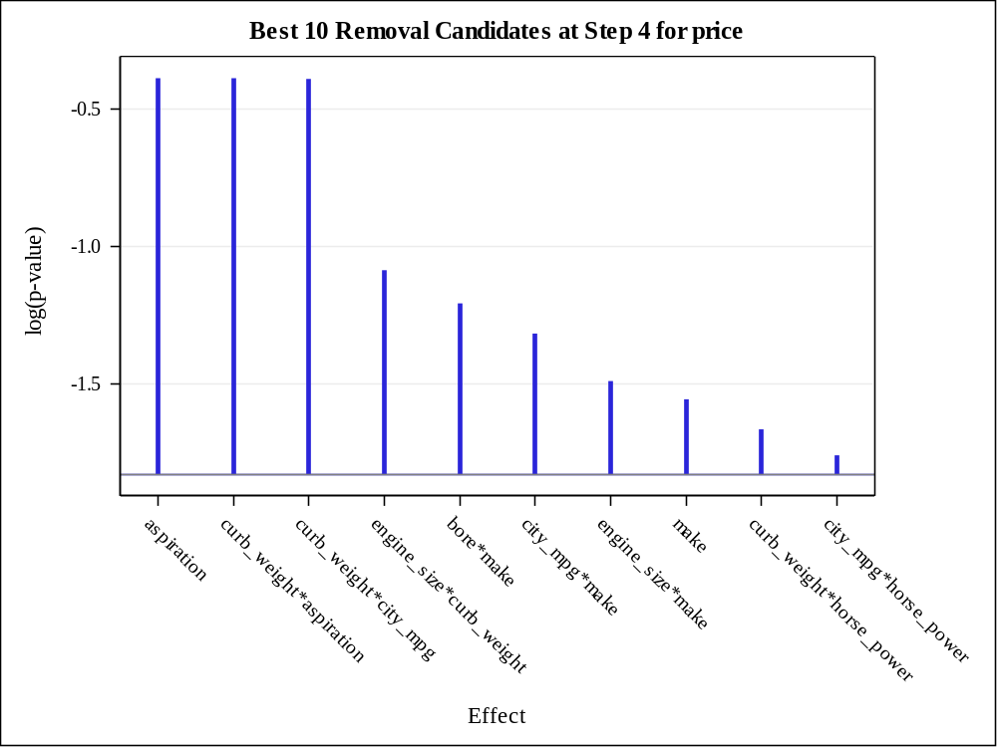

Effect Removed: curb_weight*aspiration

Analysis of Variance
Source | DF | Sum of  Squares | Mean  Square | F Value | Pr > F
Model | 128 | 8444688538 | 65974129 | 125.65 | <.0001
Error | 28 | 14702190 | 525078
Corrected Total | 156 | 8459390728

Root MSE | 724.62280
Dependent Mean | 12786
R-Square | 0.9983
Adj R-Sq | 0.9903
AIC | 2214.22001
AICC | 3524.22001
SBC | 2449.47572
ASE (Train) | 93645
ASE (Validate) | 1.56871E14

Parameter Estimates
Parameter | DF | Estimate | Standard  Error | t Value | Pr > |t|
Intercept | 1 | 95921485 | 72704453 | 1.32 | 0.1977
engine_size | 1 | -90665476 | 28406721 | -3.19 | 0.0035
curb_weight | 1 | 133900 | 53983 | 2.48 | 0.0194
engine_size*curb_weight | 1 | 40886 | 9930.024228 | 4.12 | 0.0003
width | 1 | 10716911 | 2930345 | 3.66 | 0.0010
engine_size*width | 1 | -11431618 | 2855110 | -4.00 | 0.0004
curb_weight*width | 1 | 34837 | 12132 | 2.87 | 0.0077
city_mpg | 1 | -16452534 | 4148965 | -3.97 | 0.0005
engine_size*city_mpg | 1 | 4132355 | 1049109 | 3.94 | 0.0005
curb_weight*city_mpg | 1 | 1207.705205 | 3045.905824 | 0.40 | 0.6947
width*city_mpg | 1 | -825361 | 222081 | -3.72 | 0.0009
bore | 1 | -36359604 | 8085995 | -4.50 | 0.0001
engine_size*bore | 1 | 6217524 | 1903219 | 3.27 | 0.0029
width*bore | 1 | 4544117 | 1203891 | 3.77 | 0.0008
city_mpg*bore | 1 | -1819620 | 456590 | -3.99 | 0.0004
horse_power | 1 | -157282 | 47441 | -3.32 | 0.0025
engine_size*horse_power | 1 | 31380 | 9109.730360 | 3.44 | 0.0018
curb_weight*horse_power | 1 | -1742.061943 | 545.615136 | -3.19 | 0.0035
width*horse_power | 1 | -13096 | 4427.343424 | -2.96 | 0.0062
city_mpg*horse_power | 1 | -2805.547370 | 1068.699517 | -2.63 | 0.0139
bore*horse_power | 1 | -103046 | 34118 | -3.02 | 0.0053
drive_wheels fwd | 1 | 187430091 | 66045547 | 2.84 | 0.0084
drive_wheels rwd | 1 | 67704183 | 36950437 | 1.83 | 0.0776
drive_wheels 4wd | 0 | 0 | . | . | .
engine_size*drive_wheels fwd | 1 | 35462196 | 7708072 | 4.60 | <.0001
engine_size*drive_wheels rwd | 1 | 46518142 | 10374036 | 4.48 | 0.0001
engine_size*drive_wheels 4wd | 0 | 0 | . | . | .
city_mpg*drive_wheels fwd | 1 | 16048335 | 4849700 | 3.31 | 0.0026
city_mpg*drive_wheels rwd | 1 | 9366163 | 2744363 | 3.41 | 0.0020
city_mpg*drive_wheels 4wd | 0 | 0 | . | . | .
bore*drive_wheels fwd | 1 | -3780351 | 1006512 | -3.76 | 0.0008
bore*drive_wheels rwd | 1 | -16320157 | 4331296 | -3.77 | 0.0008
bore*drive_wheels 4wd | 0 | 0 | . | . | .
horse_power*drive_wheels fwd | 1 | 93518 | 27573 | 3.39 | 0.0021
horse_power*drive_wheels rwd | 0 | 0 | . | . | .
horse_power*drive_wheels 4wd | 0 | 0 | . | . | .
make audi | 1 | -330383579 | 91108938 | -3.63 | 0.0011
make bmw | 1 | 1191041649 | 321791752 | 3.70 | 0.0009
make chevrole | 1 | -309829106 | 76471602 | -4.05 | 0.0004
make dodge | 1 | -308769261 | 69092714 | -4.47 | 0.0001
make honda | 1 | -393384429 | 87686543 | -4.49 | 0.0001
make isuzu | 0 | 0 | . | . | .
make jaguar | 1 | -397878935 | 95138135 | -4.18 | 0.0003
make mazda | 1 | -416847207 | 94424298 | -4.41 | 0.0001
make mercedes | 1 | -396273136 | 119915672 | -3.30 | 0.0026
make mercury | 1 | 61352283 | 14998738 | 4.09 | 0.0003
make mitsubis | 1 | -428940853 | 94205907 | -4.55 | <.0001
make nissan | 1 | -501985491 | 108620082 | -4.62 | <.0001
make peugot | 1 | -73078490 | 25373192 | -2.88 | 0.0075
make plymouth | 1 | -367457566 | 81797179 | -4.49 | 0.0001
make porsche | 1 | -170538765 | 42829892 | -3.98 | 0.0004
make renault | 1 | 8443756 | 2030363 | 4.16 | 0.0003
make saab | 1 | -225286210 | 77308825 | -2.91 | 0.0069
make subaru | 1 | -368055875 | 83948014 | -4.38 | 0.0001
make toyota | 1 | -410861445 | 90865653 | -4.52 | 0.0001
make volkswag | 1 | -440831808 | 97207371 | -4.53 | <.0001
make volvo | 1 | -250476167 | 60590101 | -4.13 | 0.0003
make alfa-rom | 0 | 0 | . | . | .
engine_size*make audi | 1 | 145054683 | 39146558 | 3.71 | 0.0009
engine_size*make bmw | 1 | 136431405 | 31847908 | 4.28 | 0.0002
engine_size*make chevrole | 1 | 115373815 | 29626759 | 3.89 | 0.0006
engine_size*make dodge | 1 | 70976039 | 17746413 | 4.00 | 0.0004
engine_size*make honda | 1 | 107469110 | 27696836 | 3.88 | 0.0006
engine_size*make isuzu | 0 | 0 | . | . | .
engine_size*make jaguar | 1 | 146415517 | 34784817 | 4.21 | 0.0002
engine_size*make mazda | 1 | 119516766 | 28604879 | 4.18 | 0.0003
engine_size*make mercedes | 1 | 134473388 | 31041504 | 4.33 | 0.0002
engine_size*make mercury | 0 | 0 | . | . | .
engine_size*make mitsubis | 1 | 125015920 | 30623915 | 4.08 | 0.0003
engine_size*make nissan | 1 | 119584361 | 29341865 | 4.08 | 0.0003
engine_size*make peugot | 1 | 130614882 | 31209735 | 4.19 | 0.0003
engine_size*make plymouth | 1 | 80504401 | 20710581 | 3.89 | 0.0006
engine_size*make porsche | 1 | 90376019 | 22422005 | 4.03 | 0.0004
engine_size*make renault | 0 | 0 | . | . | .
engine_size*make saab | 0 | 0 | . | . | .
engine_size*make subaru | 1 | 116540037 | 26731725 | 4.36 | 0.0002
engine_size*make toyota | 1 | 114162582 | 28385356 | 4.02 | 0.0004
engine_size*make volkswag | 1 | 129810140 | 31903454 | 4.07 | 0.0003
engine_size*make volvo | 1 | 113426856 | 27410312 | 4.14 | 0.0003
engine_size*make alfa-rom | 0 | 0 | . | . | .
curb_weight*make audi | 0 | 0 | . | . | .
curb_weight*make bmw | 1 | 17072 | 34651 | 0.49 | 0.6261
curb_weight*make chevrole | 1 | 49746 | 21496 | 2.31 | 0.0282
curb_weight*make dodge | 1 | 43126 | 12590 | 3.43 | 0.0019
curb_weight*make honda | 1 | 74959 | 24652 | 3.04 | 0.0051
curb_weight*make isuzu | 0 | 0 | . | . | .
curb_weight*make jaguar | 0 | 0 | . | . | .
curb_weight*make mazda | 1 | 28529 | 21581 | 1.32 | 0.1969
curb_weight*make mercedes | 1 | -28457982 | 7112683 | -4.00 | 0.0004
curb_weight*make mercury | 0 | 0 | . | . | .
curb_weight*make mitsubis | 1 | 38764 | 16285 | 2.38 | 0.0243
curb_weight*make nissan | 1 | 41704 | 11916 | 3.50 | 0.0016
curb_weight*make peugot | 1 | -51912 | 27457 | -1.89 | 0.0691
curb_weight*make plymouth | 1 | 15379272 | 3961775 | 3.88 | 0.0006
curb_weight*make porsche | 1 | 125163 | 33078 | 3.78 | 0.0007
curb_weight*make renault | 1 | -588885 | 172581 | -3.41 | 0.0020
curb_weight*make saab | 1 | 42609 | 8917.131359 | 4.78 | <.0001
curb_weight*make subaru | 1 | -19359 | 21217 | -0.91 | 0.3693
curb_weight*make toyota | 1 | 32320 | 10467 | 3.09 | 0.0045
curb_weight*make volkswag | 1 | 49643 | 17007 | 2.92 | 0.0069
curb_weight*make volvo | 0 | 0 | . | . | .
curb_weight*make alfa-rom | 0 | 0 | . | . | .
width*make audi | 0 | 0 | . | . | .
width*make bmw | 1 | 29518310 | 7325307 | 4.03 | 0.0004
width*make chevrole | 0 | 0 | . | . | .
width*make dodge | 1 | 22996232 | 5871566 | 3.92 | 0.0005
width*make honda | 1 | 2325869 | 986898 | 2.36 | 0.0257
width*make isuzu | 0 | 0 | . | . | .
width*make jaguar | 0 | 0 | . | . | .
width*make mazda | 1 | -4764631 | 1136292 | -4.19 | 0.0002
width*make mercedes | 1 | 35873027 | 9003242 | 3.98 | 0.0004
width*make mercury | 0 | 0 | . | . | .
width*make mitsubis | 1 | 4011727 | 1805451 | 2.22 | 0.0345
width*make nissan | 1 | -2977434 | 2538828 | -1.17 | 0.2508
width*make peugot | 1 | -213156612 | 51656746 | -4.13 | 0.0003
width*make plymouth | 1 | 24070582 | 6864282 | 3.51 | 0.0015
width*make porsche | 0 | 0 | . | . | .
width*make renault | 0 | 0 | . | . | .
width*make saab | 0 | 0 | . | . | .
width*make subaru | 1 | -11939096 | 2732067 | -4.37 | 0.0002
width*make toyota | 1 | -482633 | 691846 | -0.70 | 0.4912
width*make volkswag | 1 | 1083958 | 795119 | 1.36 | 0.1837
width*make volvo | 0 | 0 | . | . | .
width*make alfa-rom | 0 | 0 | . | . | .
city_mpg*make audi | 0 | 0 | . | . | .
city_mpg*make bmw | 1 | 93268651 | 23443157 | 3.98 | 0.0004
city_mpg*make chevrole | 0 | 0 | . | . | .
city_mpg*make dodge | 1 | -8586261 | 2420620 | -3.55 | 0.0014
city_mpg*make honda | 1 | -8941835 | 2459962 | -3.63 | 0.0011
city_mpg*make isuzu | 0 | 0 | . | . | .
city_mpg*make jaguar | 0 | 0 | . | . | .
city_mpg*make mazda | 1 | -8113066 | 2457237 | -3.30 | 0.0026
city_mpg*make mercedes | 1 | -11837105 | 5286446 | -2.24 | 0.0333
city_mpg*make mercury | 0 | 0 | . | . | .
city_mpg*make mitsubis | 1 | -8549176 | 2415197 | -3.54 | 0.0014
city_mpg*make nissan | 1 | -13222665 | 3295125 | -4.01 | 0.0004
city_mpg*make peugot | 1 | -1204705 | 300190 | -4.01 | 0.0004
city_mpg*make plymouth | 1 | -6332983 | 2289458 | -2.77 | 0.0099
city_mpg*make porsche | 0 | 0 | . | . | .
city_mpg*make renault | 0 | 0 | . | . | .
city_mpg*make saab | 1 | -12026943 | 4321593 | -2.78 | 0.0095
city_mpg*make subaru | 1 | -5300865 | 2006230 | -2.64 | 0.0133
city_mpg*make toyota | 1 | -8338880 | 2381536 | -3.50 | 0.0016
city_mpg*make volkswag | 1 | -8909596 | 2394669 | -3.72 | 0.0009
city_mpg*make volvo | 0 | 0 | . | . | .
city_mpg*make alfa-rom | 0 | 0 | . | . | .
bore*make audi | 0 | 0 | . | . | .
bore*make bmw | 1 | 45715320 | 10424252 | 4.39 | 0.0001
bore*make chevrole | 0 | 0 | . | . | .
bore*make dodge | 1 | 27590629 | 7102694 | 3.88 | 0.0006
bore*make honda | 1 | 16431555 | 3841256 | 4.28 | 0.0002
bore*make isuzu | 0 | 0 | . | . | .
bore*make jaguar | 0 | 0 | . | . | .
bore*make mazda | 1 | 11482695 | 4033079 | 2.85 | 0.0082
bore*make mercedes | 0 | 0 | . | . | .
bore*make mercury | 0 | 0 | . | . | .
bore*make mitsubis | 1 | 4945323 | 2664405 | 1.86 | 0.0740
bore*make nissan | 1 | 151258 | 2366487 | 0.06 | 0.9495
bore*make peugot | 0 | 0 | . | . | .
bore*make plymouth | 1 | 11943897 | 3001576 | 3.98 | 0.0004
bore*make porsche | 0 | 0 | . | . | .
bore*make renault | 0 | 0 | . | . | .
bore*make saab | 1 | 6644690 | 2660217 | 2.50 | 0.0186
bore*make subaru | 0 | 0 | . | . | .
bore*make toyota | 1 | 10561377 | 2963497 | 3.56 | 0.0013
bore*make volkswag | 1 | 5083476 | 2466122 | 2.06 | 0.0487
bore*make volvo | 0 | 0 | . | . | .
bore*make alfa-rom | 0 | 0 | . | . | .
horse_power*make audi | 0 | 0 | . | . | .
horse_power*make bmw | 0 | 0 | . | . | .
horse_power*make chevrole | 0 | 0 | . | . | .
horse_power*make dodge | 0 | 0 | . | . | .
horse_power*make honda | 1 | -125735 | 31017 | -4.05 | 0.0004
horse_power*make isuzu | 0 | 0 | . | . | .
horse_power*make jaguar | 0 | 0 | . | . | .
horse_power*make mazda | 1 | -28523 | 18197 | -1.57 | 0.1282
horse_power*make mercedes | 0 | 0 | . | . | .
horse_power*make mercury | 0 | 0 | . | . | .
horse_power*make mitsubis | 1 | -109262 | 26386 | -4.14 | 0.0003
horse_power*make nissan | 0 | 0 | . | . | .
horse_power*make peugot | 0 | 0 | . | . | .
horse_power*make plymouth | 0 | 0 | . | . | .
horse_power*make porsche | 0 | 0 | . | . | .
horse_power*make renault | 0 | 0 | . | . | .
horse_power*make saab | 0 | 0 | . | . | .
horse_power*make subaru | 1 | 76906 | 37783 | 2.04 | 0.0514
horse_power*make toyota | 0 | 0 | . | . | .
horse_power*make volkswag | 1 | -144365 | 41491 | -3.48 | 0.0017
horse_power*make volvo | 0 | 0 | . | . | .
horse_power*make alfa-rom | 0 | 0 | . | . | .
curb_weight*engine_type l | 0 | 0 | . | . | .
curb_weight*engine_type ohc | 1 | -61276 | 21913 | -2.80 | 0.0092
curb_weight*engine_type ohcf | 0 | 0 | . | . | .
curb_weight*engine_type ohcv | 1 | -75308 | 25120 | -3.00 | 0.0056
curb_weight*engine_type rotor | 1 | 905443 | 594291 | 1.52 | 0.1388
curb_weight*engine_type dohc | 0 | 0 | . | . | .
curb_weight*bin_hp 1 | 1 | -22687 | 21497 | -1.06 | 0.3003
curb_weight*bin_hp 2 | 1 | 17224 | 24484 | 0.70 | 0.4876
curb_weight*bin_hp 3 | 1 | 29131 | 52664 | 0.55 | 0.5845
curb_weight*bin_hp 0 | 0 | 0 | . | . | .

Best 10 Removal Candidates
Rank | Effect | Log  pValue | Pr > F
1 | curb_weight*aspiration | -0.0013 | 0.9987
2 | curb_weight*city_mpg | -0.3566 | 0.7001
3 | city_mpg*make | -3.1718 | 0.0419
4 | city_mpg*horse_power | -4.1528 | 0.0157
5 | curb_weight*engine_type | -4.5311 | 0.0108
6 | curb_weight*width | -4.7221 | 0.0089
7 | width*horse_power | -4.9267 | 0.0073
8 | bore*horse_power | -5.0743 | 0.0063
9 | width*make | -5.1838 | 0.0056
10 | city_mpg*drive_wheels | -5.2714 | 0.0051

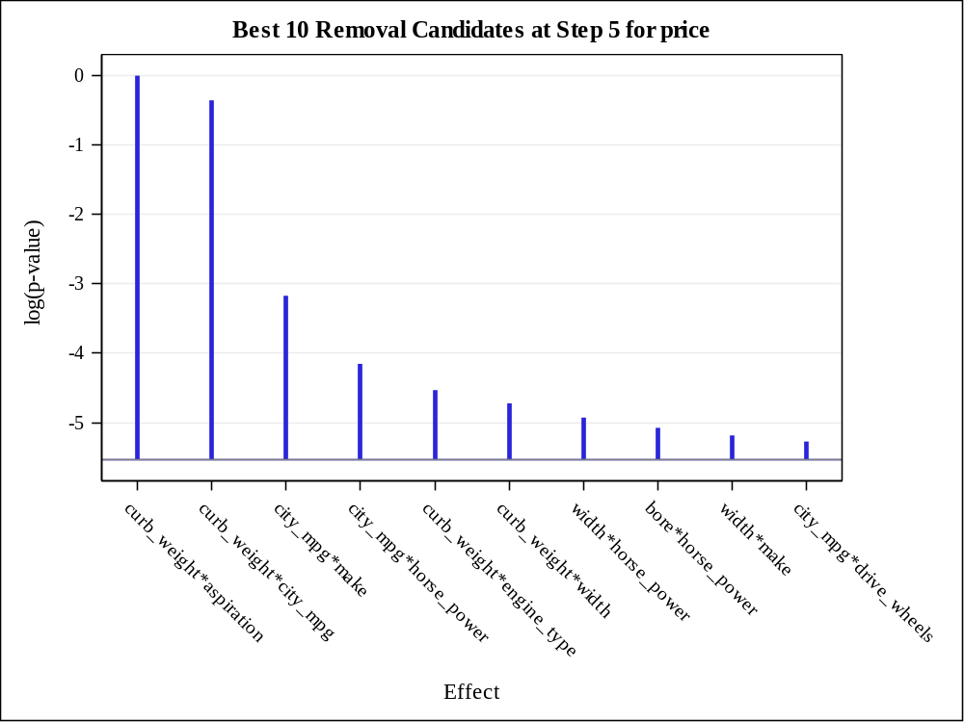

Effect Removed: curb_weight*city_mpg

Analysis of Variance
Source | DF | Sum of  Squares | Mean  Square | F Value | Pr > F
Model | 127 | 8444605989 | 66492961 | 130.42 | <.0001
Error | 29 | 14784739 | 509819
Corrected Total | 156 | 8459390728

Root MSE | 714.01582
Dependent Mean | 12786
R-Square | 0.9983
Adj R-Sq | 0.9906
AIC | 2213.09906
AICC | 3455.32128
SBC | 2445.29852
ASE (Train) | 94170
ASE (Validate) | 1.593052E14

Parameter Estimates
Parameter | DF | Estimate | Standard  Error | t Value | Pr > |t|
Intercept | 1 | 96583857 | 71621296 | 1.35 | 0.1879
engine_size | 1 | -91146713 | 27965344 | -3.26 | 0.0029
curb_weight | 1 | 119194 | 38649 | 3.08 | 0.0045
engine_size*curb_weight | 1 | 42731 | 8644.466560 | 4.94 | <.0001
width | 1 | 10814251 | 2877299 | 3.76 | 0.0008
engine_size*width | 1 | -11580140 | 2788999 | -4.15 | 0.0003
curb_weight*width | 1 | 35972 | 11617 | 3.10 | 0.0043
city_mpg | 1 | -16598087 | 4072199 | -4.08 | 0.0003
engine_size*city_mpg | 1 | 4186862 | 1024839 | 4.09 | 0.0003
width*city_mpg | 1 | -838921 | 216220 | -3.88 | 0.0006
bore | 1 | -36720444 | 7917008 | -4.64 | <.0001
engine_size*bore | 1 | 6277704 | 1869387 | 3.36 | 0.0022
width*bore | 1 | 4600264 | 1178033 | 3.91 | 0.0005
city_mpg*bore | 1 | -1840755 | 446830 | -4.12 | 0.0003
horse_power | 1 | -156555 | 46711 | -3.35 | 0.0022
engine_size*horse_power | 1 | 31543 | 8967.295212 | 3.52 | 0.0015
curb_weight*horse_power | 1 | -1794.667115 | 521.491767 | -3.44 | 0.0018
width*horse_power | 1 | -13293 | 4334.904954 | -3.07 | 0.0047
city_mpg*horse_power | 1 | -2775.588898 | 1050.420811 | -2.64 | 0.0131
bore*horse_power | 1 | -103833 | 33561 | -3.09 | 0.0043
drive_wheels fwd | 1 | 187556519 | 65078017 | 2.88 | 0.0074
drive_wheels rwd | 1 | 67614008 | 36408869 | 1.86 | 0.0735
drive_wheels 4wd | 0 | 0 | . | . | .
engine_size*drive_wheels fwd | 1 | 35740688 | 7563644 | 4.73 | <.0001
engine_size*drive_wheels rwd | 1 | 46980741 | 10157330 | 4.63 | <.0001
engine_size*drive_wheels 4wd | 0 | 0 | . | . | .
city_mpg*drive_wheels fwd | 1 | 16086588 | 4777765 | 3.37 | 0.0022
city_mpg*drive_wheels rwd | 1 | 9414404 | 2701532 | 3.48 | 0.0016
city_mpg*drive_wheels 4wd | 0 | 0 | . | . | .
bore*drive_wheels fwd | 1 | -3824234 | 985764 | -3.88 | 0.0006
bore*drive_wheels rwd | 1 | -16526758 | 4236899 | -3.90 | 0.0005
bore*drive_wheels 4wd | 0 | 0 | . | . | .
horse_power*drive_wheels fwd | 1 | 93707 | 27165 | 3.45 | 0.0017
horse_power*drive_wheels rwd | 0 | 0 | . | . | .
horse_power*drive_wheels 4wd | 0 | 0 | . | . | .
make audi | 1 | -333328616 | 89476463 | -3.73 | 0.0008
make bmw | 1 | 1208301190 | 314166903 | 3.85 | 0.0006
make chevrole | 1 | -311928811 | 75171325 | -4.15 | 0.0003
make dodge | 1 | -310364674 | 67965792 | -4.57 | <.0001
make honda | 1 | -395664099 | 86217060 | -4.59 | <.0001
make isuzu | 0 | 0 | . | . | .
make jaguar | 1 | -402152553 | 93141957 | -4.32 | 0.0002
make mazda | 1 | -418783420 | 92917614 | -4.51 | <.0001
make mercedes | 1 | -400874278 | 117605788 | -3.41 | 0.0019
make mercury | 1 | 61832772 | 14730870 | 4.20 | 0.0002
make mitsubis | 1 | -431724747 | 92568755 | -4.66 | <.0001
make nissan | 1 | -505846381 | 106599168 | -4.75 | <.0001
make peugot | 1 | -74362339 | 24797368 | -3.00 | 0.0055
make plymouth | 1 | -369517475 | 80437104 | -4.59 | <.0001
make porsche | 1 | -171715026 | 42101592 | -4.08 | 0.0003
make renault | 1 | 8523080 | 1990907 | 4.28 | 0.0002
make saab | 1 | -225168840 | 76176625 | -2.96 | 0.0061
make subaru | 1 | -369789490 | 82606917 | -4.48 | 0.0001
make toyota | 1 | -413381143 | 89316334 | -4.63 | <.0001
make volkswag | 1 | -443723545 | 95514490 | -4.65 | <.0001
make volvo | 1 | -252787727 | 59426177 | -4.25 | 0.0002
make alfa-rom | 0 | 0 | . | . | .
engine_size*make audi | 1 | 146380123 | 38432638 | 3.81 | 0.0007
engine_size*make bmw | 1 | 137682905 | 31227220 | 4.41 | 0.0001
engine_size*make chevrole | 1 | 116105754 | 29136361 | 3.98 | 0.0004
engine_size*make dodge | 1 | 71585721 | 17420878 | 4.11 | 0.0003
engine_size*make honda | 1 | 108356750 | 27202116 | 3.98 | 0.0004
engine_size*make isuzu | 0 | 0 | . | . | .
engine_size*make jaguar | 1 | 147852482 | 34089103 | 4.34 | 0.0002
engine_size*make mazda | 1 | 120329796 | 28113651 | 4.28 | 0.0002
engine_size*make mercedes | 1 | 135688419 | 30437713 | 4.46 | 0.0001
engine_size*make mercury | 0 | 0 | . | . | .
engine_size*make mitsubis | 1 | 126164241 | 30040401 | 4.20 | 0.0002
engine_size*make nissan | 1 | 120688019 | 28781973 | 4.19 | 0.0002
engine_size*make peugot | 1 | 131721872 | 30629594 | 4.30 | 0.0002
engine_size*make plymouth | 1 | 81203818 | 20333265 | 3.99 | 0.0004
engine_size*make porsche | 1 | 91040880 | 22031924 | 4.13 | 0.0003
engine_size*make renault | 0 | 0 | . | . | .
engine_size*make saab | 0 | 0 | . | . | .
engine_size*make subaru | 1 | 117402764 | 26253026 | 4.47 | 0.0001
engine_size*make toyota | 1 | 115160461 | 27859700 | 4.13 | 0.0003
engine_size*make volkswag | 1 | 131004841 | 31295936 | 4.19 | 0.0002
engine_size*make volvo | 1 | 114459776 | 26886822 | 4.26 | 0.0002
engine_size*make alfa-rom | 0 | 0 | . | . | .
curb_weight*make audi | 0 | 0 | . | . | .
curb_weight*make bmw | 1 | 18219 | 34025 | 0.54 | 0.5964
curb_weight*make chevrole | 1 | 53174 | 19392 | 2.74 | 0.0104
curb_weight*make dodge | 1 | 45025 | 11474 | 3.92 | 0.0005
curb_weight*make honda | 1 | 78238 | 22884 | 3.42 | 0.0019
curb_weight*make isuzu | 0 | 0 | . | . | .
curb_weight*make jaguar | 0 | 0 | . | . | .
curb_weight*make mazda | 1 | 28893 | 21246 | 1.36 | 0.1843
curb_weight*make mercedes | 1 | -28823420 | 6949479 | -4.15 | 0.0003
curb_weight*make mercury | 0 | 0 | . | . | .
curb_weight*make mitsubis | 1 | 39709 | 15874 | 2.50 | 0.0183
curb_weight*make nissan | 1 | 43347 | 11009 | 3.94 | 0.0005
curb_weight*make peugot | 1 | -56405 | 24643 | -2.29 | 0.0296
curb_weight*make plymouth | 1 | 15495419 | 3893097 | 3.98 | 0.0004
curb_weight*make porsche | 1 | 125495 | 32583 | 3.85 | 0.0006
curb_weight*make renault | 1 | -595656 | 169221 | -3.52 | 0.0014
curb_weight*make saab | 1 | 43287 | 8623.590455 | 5.02 | <.0001
curb_weight*make subaru | 1 | -20694 | 20641 | -1.00 | 0.3244
curb_weight*make toyota | 1 | 33256 | 10049 | 3.31 | 0.0025
curb_weight*make volkswag | 1 | 51327 | 16227 | 3.16 | 0.0036
curb_weight*make volvo | 0 | 0 | . | . | .
curb_weight*make alfa-rom | 0 | 0 | . | . | .
width*make audi | 0 | 0 | . | . | .
width*make bmw | 1 | 29900077 | 7155456 | 4.18 | 0.0002
width*make chevrole | 0 | 0 | . | . | .
width*make dodge | 1 | 23235357 | 5755018 | 4.04 | 0.0004
width*make honda | 1 | 2351272 | 970401 | 2.42 | 0.0219
width*make isuzu | 0 | 0 | . | . | .
width*make jaguar | 0 | 0 | . | . | .
width*make mazda | 1 | -4802548 | 1115687 | -4.30 | 0.0002
width*make mercedes | 1 | 36331548 | 8797968 | 4.13 | 0.0003
width*make mercury | 0 | 0 | . | . | .
width*make mitsubis | 1 | 4042240 | 1777407 | 2.27 | 0.0305
width*make nissan | 1 | -3053436 | 2494525 | -1.22 | 0.2308
width*make peugot | 1 | -214400786 | 50806601 | -4.22 | 0.0002
width*make plymouth | 1 | 24336978 | 6731326 | 3.62 | 0.0011
width*make porsche | 0 | 0 | . | . | .
width*make renault | 0 | 0 | . | . | .
width*make saab | 0 | 0 | . | . | .
width*make subaru | 1 | -12037531 | 2680938 | -4.49 | 0.0001
width*make toyota | 1 | -487054 | 681630 | -0.71 | 0.4806
width*make volkswag | 1 | 1092307 | 783205 | 1.39 | 0.1737
width*make volvo | 0 | 0 | . | . | .
width*make alfa-rom | 0 | 0 | . | . | .
city_mpg*make audi | 0 | 0 | . | . | .
city_mpg*make bmw | 1 | 94510272 | 22892988 | 4.13 | 0.0003
city_mpg*make chevrole | 0 | 0 | . | . | .
city_mpg*make dodge | 1 | -8596468 | 2385053 | -3.60 | 0.0012
city_mpg*make honda | 1 | -8956572 | 2423677 | -3.70 | 0.0009
city_mpg*make isuzu | 0 | 0 | . | . | .
city_mpg*make jaguar | 0 | 0 | . | . | .
city_mpg*make mazda | 1 | -8103607 | 2421154 | -3.35 | 0.0023
city_mpg*make mercedes | 1 | -12034229 | 5185977 | -2.32 | 0.0275
city_mpg*make mercury | 0 | 0 | . | . | .
city_mpg*make mitsubis | 1 | -8558067 | 2379741 | -3.60 | 0.0012
city_mpg*make nissan | 1 | -13298343 | 3241440 | -4.10 | 0.0003
city_mpg*make peugot | 1 | -1216406 | 294363 | -4.13 | 0.0003
city_mpg*make plymouth | 1 | -6326305 | 2255884 | -2.80 | 0.0089
city_mpg*make porsche | 0 | 0 | . | . | .
city_mpg*make renault | 0 | 0 | . | . | .
city_mpg*make saab | 1 | -12005142 | 4257989 | -2.82 | 0.0086
city_mpg*make subaru | 1 | -5272940 | 1975645 | -2.67 | 0.0123
city_mpg*make toyota | 1 | -8346526 | 2346598 | -3.56 | 0.0013
city_mpg*make volkswag | 1 | -8922286 | 2359405 | -3.78 | 0.0007
city_mpg*make volvo | 0 | 0 | . | . | .
city_mpg*make alfa-rom | 0 | 0 | . | . | .
bore*make audi | 0 | 0 | . | . | .
bore*make bmw | 1 | 46221406 | 10194373 | 4.53 | <.0001
bore*make chevrole | 0 | 0 | . | . | .
bore*make dodge | 1 | 27779432 | 6982979 | 3.98 | 0.0004
bore*make honda | 1 | 16553483 | 3772880 | 4.39 | 0.0001
bore*make isuzu | 0 | 0 | . | . | .
bore*make jaguar | 0 | 0 | . | . | .
bore*make mazda | 1 | 11659743 | 3949611 | 2.95 | 0.0062
bore*make mercedes | 0 | 0 | . | . | .
bore*make mercury | 0 | 0 | . | . | .
bore*make mitsubis | 1 | 4919641 | 2624628 | 1.87 | 0.0710
bore*make nissan | 1 | 71019 | 2323305 | 0.03 | 0.9758
bore*make peugot | 0 | 0 | . | . | .
bore*make plymouth | 1 | 12000468 | 2954296 | 4.06 | 0.0003
bore*make porsche | 0 | 0 | . | . | .
bore*make renault | 0 | 0 | . | . | .
bore*make saab | 1 | 6640429 | 2621255 | 2.53 | 0.0170
bore*make subaru | 0 | 0 | . | . | .
bore*make toyota | 1 | 10604359 | 2918163 | 3.63 | 0.0011
bore*make volkswag | 1 | 5062042 | 2429440 | 2.08 | 0.0461
bore*make volvo | 0 | 0 | . | . | .
bore*make alfa-rom | 0 | 0 | . | . | .
horse_power*make audi | 0 | 0 | . | . | .
horse_power*make bmw | 0 | 0 | . | . | .
horse_power*make chevrole | 0 | 0 | . | . | .
horse_power*make dodge | 0 | 0 | . | . | .
horse_power*make honda | 1 | -126971 | 30408 | -4.18 | 0.0002
horse_power*make isuzu | 0 | 0 | . | . | .
horse_power*make jaguar | 0 | 0 | . | . | .
horse_power*make mazda | 1 | -27766 | 17832 | -1.56 | 0.1303
horse_power*make mercedes | 0 | 0 | . | . | .
horse_power*make mercury | 0 | 0 | . | . | .
horse_power*make mitsubis | 1 | -110321 | 25866 | -4.27 | 0.0002
horse_power*make nissan | 0 | 0 | . | . | .
horse_power*make peugot | 0 | 0 | . | . | .
horse_power*make plymouth | 0 | 0 | . | . | .
horse_power*make porsche | 0 | 0 | . | . | .
horse_power*make renault | 0 | 0 | . | . | .
horse_power*make saab | 0 | 0 | . | . | .
horse_power*make subaru | 1 | 77183 | 37224 | 2.07 | 0.0471
horse_power*make toyota | 0 | 0 | . | . | .
horse_power*make volkswag | 1 | -145872 | 40712 | -3.58 | 0.0012
horse_power*make volvo | 0 | 0 | . | . | .
horse_power*make alfa-rom | 0 | 0 | . | . | .
curb_weight*engine_type l | 0 | 0 | . | . | .
curb_weight*engine_type ohc | 1 | -64423 | 20126 | -3.20 | 0.0033
curb_weight*engine_type ohcf | 0 | 0 | . | . | .
curb_weight*engine_type ohcv | 1 | -79740 | 22167 | -3.60 | 0.0012
curb_weight*engine_type rotor | 1 | 883164 | 582969 | 1.51 | 0.1406
curb_weight*engine_type dohc | 0 | 0 | . | . | .
curb_weight*bin_hp 1 | 1 | -24091 | 20893 | -1.15 | 0.2583
curb_weight*bin_hp 2 | 1 | 15939 | 23913 | 0.67 | 0.5103
curb_weight*bin_hp 3 | 1 | 26964 | 51613 | 0.52 | 0.6053
curb_weight*bin_hp 0 | 0 | 0 | . | . | .

Best 10 Removal Candidates
Rank | Effect | Log  pValue | Pr > F
1 | curb_weight*city_mpg | -0.3642 | 0.6947
2 | city_mpg*make | -3.3558 | 0.0349
3 | city_mpg*horse_power | -4.2778 | 0.0139
4 | curb_weight*engine_type | -4.7204 | 0.0089
5 | curb_weight*width | -4.8664 | 0.0077
6 | width*horse_power | -5.0780 | 0.0062
7 | bore*horse_power | -5.2322 | 0.0053
8 | city_mpg*drive_wheels | -5.4350 | 0.0044
9 | width*make | -5.4549 | 0.0043
10 | horse_power*make | -5.5465 | 0.0039

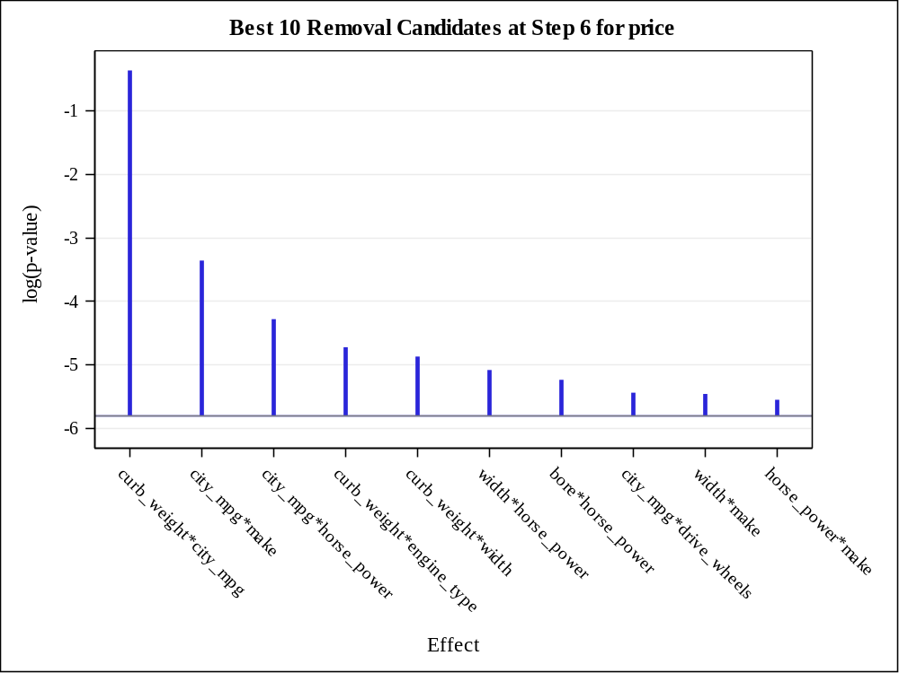

Backward Selection Summary
Step | Effect  Removed | Number  Effects In | Number  Parms In | ASE | Validation  ASE | F Value | Pr > F
0 |  | 79 | 134 | 91561.5141 | 2.58886E14
 | bin_hp*aspiration | 78 | 134 | 91561.5141 | 2.58886E14
 | num_of_cylinders*aspiration | 77 | 134 | 91561.5141 | 2.58886E14
 | engine_type*aspiration | 76 | 134 | 91561.5141 | 2.58886E14
 | make*aspiration | 75 | 134 | 91561.5141 | 2.58886E14
 | drive_wheels*aspiration | 74 | 134 | 91561.5141 | 2.58886E14
 | horse_power*aspiration | 73 | 134 | 91561.5141 | 2.58886E14
 | bore*aspiration | 72 | 134 | 91561.5141 | 2.58886E14
 | city_mpg*aspiration | 71 | 134 | 91561.5141 | 2.58886E14
 | width*aspiration | 70 | 134 | 91561.5141 | 2.58886E14
 | engine_size*aspiration | 69 | 134 | 91561.5141 | 2.58886E14
 | num_of_cylinders*bin_hp | 68 | 134 | 91561.5141 | 2.58886E14
 | engine_type*bin_hp | 67 | 134 | 91561.5141 | 2.58886E14
 | make*bin_hp | 66 | 134 | 91561.5141 | 2.58886E14
 | drive_wheels*bin_hp | 65 | 134 | 91561.5141 | 2.58886E14
 | horse_power*bin_hp | 64 | 134 | 91561.5141 | 2.58886E14
 | bore*bin_hp | 63 | 134 | 91561.5141 | 2.58886E14
 | city_mpg*bin_hp | 62 | 134 | 91561.5141 | 2.58886E14
 | width*bin_hp | 61 | 134 | 91561.5141 | 2.58886E14
 | engine_size*bin_hp | 60 | 134 | 91561.5141 | 2.58886E14
 | bin_hp | 59 | 134 | 91561.5141 | 2.58886E14
 | engine_type*num_of_cylinders | 58 | 134 | 91561.5141 | 2.58886E14
 | make*num_of_cylinders | 57 | 134 | 91561.5141 | 2.58886E14
 | drive_wheels*num_of_cylinders | 56 | 134 | 91561.5141 | 2.58886E14
 | horse_power*num_of_cylinders | 55 | 134 | 91561.5141 | 2.58886E14
 | bore*num_of_cylinders | 54 | 134 | 91561.5141 | 2.58886E14
 | city_mpg*num_of_cylinders | 53 | 134 | 91561.5141 | 2.58886E14
 | width*num_of_cylinders | 52 | 134 | 91561.5141 | 2.58886E14
 | curb_weight*num_of_cylinders | 51 | 134 | 91561.5141 | 2.58886E14
 | engine_size*num_of_cylinders | 50 | 134 | 91561.5141 | 2.58886E14
 | num_of_cylinders | 49 | 134 | 91561.5141 | 2.58886E14
 | make*engine_type | 48 | 134 | 91561.5141 | 2.58886E14
 | drive_wheels*engine_type | 47 | 134 | 91561.5141 | 2.58886E14
 | horse_power*engine_type | 46 | 134 | 91561.5141 | 2.58886E14
 | bore*engine_type | 45 | 134 | 91561.5141 | 2.58886E14
 | city_mpg*engine_type | 44 | 134 | 91561.5141 | 2.58886E14
 | width*engine_type | 43 | 134 | 91561.5141 | 2.58886E14
 | engine_size*engine_type | 42 | 134 | 91561.5141 | 2.58886E14
 | engine_type | 41 | 134 | 91561.5141 | 2.58886E14
 | drive_wheels*make | 40 | 134 | 91561.5141 | 2.58886E14
1 | curb_weight*bore | 39 | 133 | 91611.3427 | 2.63497E14 | 0.01 | 0.9119
2 | width*drive_wheels | 38 | 132 | 91697.2969 | 2.82835E14 | 0.02 | 0.8820
3 | curb_weight*drive_wheels | 37 | 131 | 93021.1132 | 2.11699E14 | 0.36 | 0.5534
4 | aspiration | 36 | 130 | 93644.5108 | 1.56873E14 | 0.17 | 0.6798
5 | curb_weight*aspiration | 35 | 129 | 93644.5207 | 1.56871E14* | 0.00 | 0.9987
6 | curb_weight*city_mpg | 34 | 128 | 94170.3118 | 1.59305E14 | 0.16 | 0.6947
* Optimal Value of Criterion

Note: | Effects dropped at step 0 are redundant.

Selection stopped because the next candidate for removal has SLS < 0.05.

Stop Details
Candidate  For | Effect | Candidate  Significance |  | Compare  Significance
Removal | city_mpg*make | 0.0268 | < | 0.0500 | (SLS)

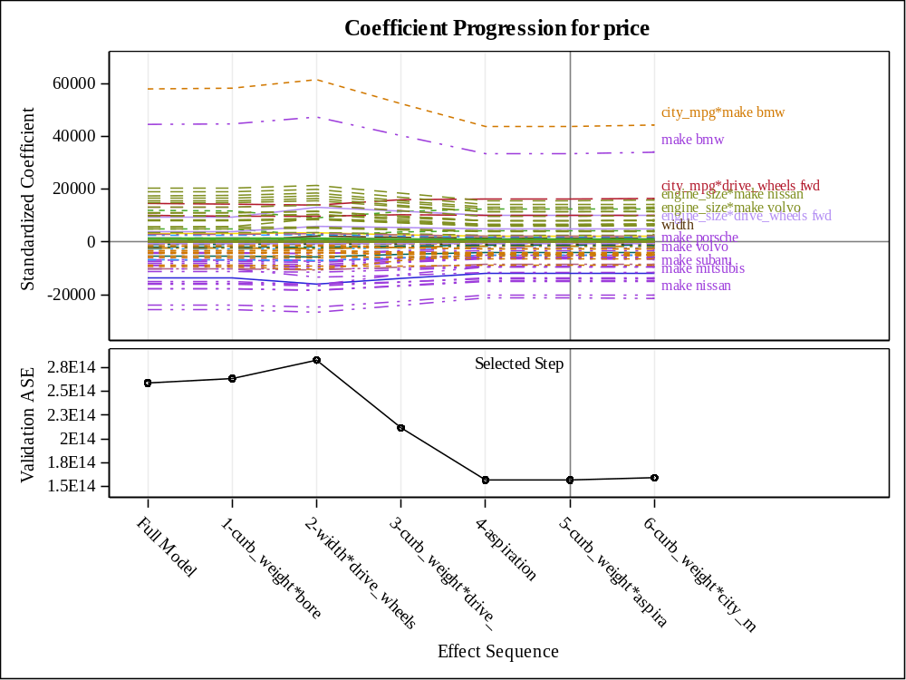

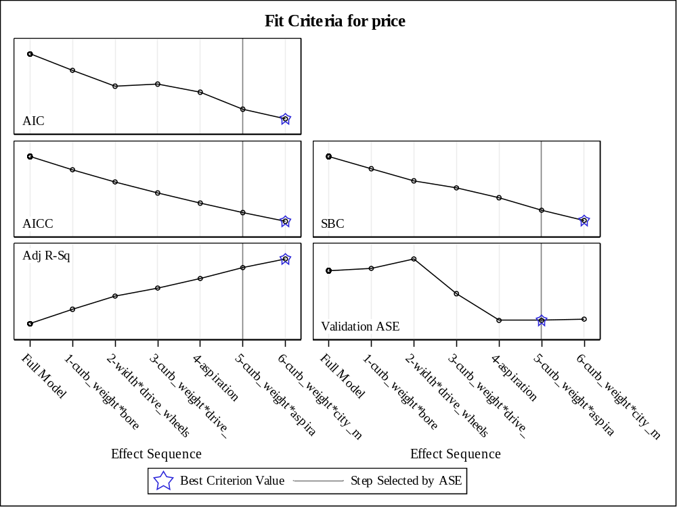

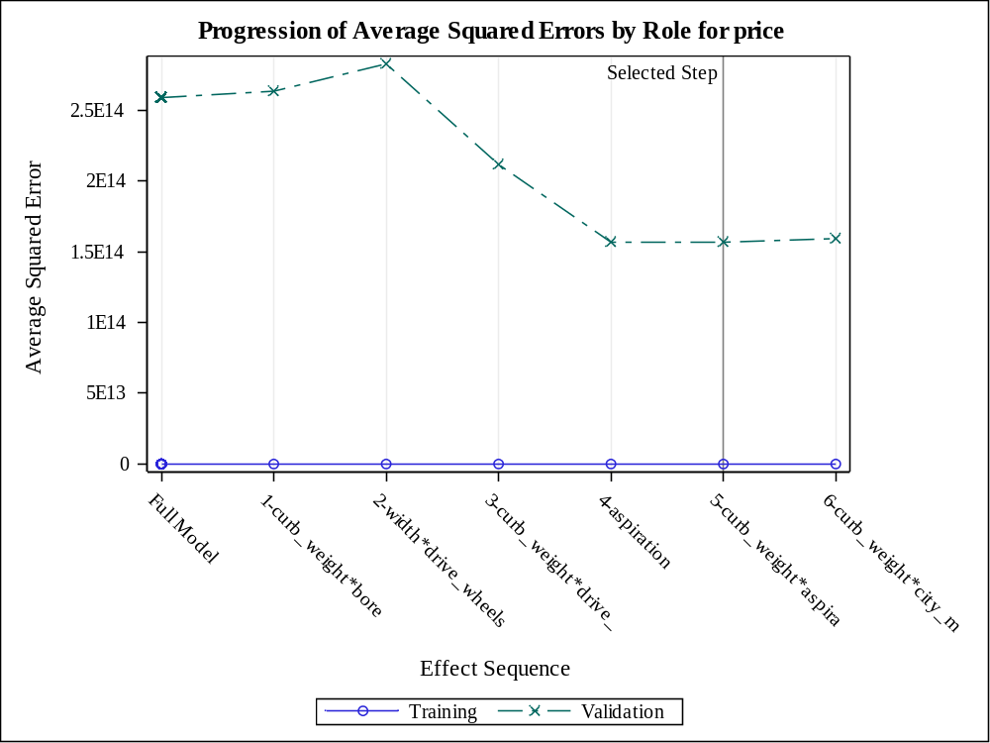

The selected model, based on Validation ASE, is the model at Step 5.

Effects: | Intercept engine_size curb_weight engine_size*curb_weight width engine_size*width curb_weight*width city_mpg engine_size*city_mpg curb_weight*city_mpg width*city_mpg bore engine_size*bore width*bore city_mpg*bore horse_power engine_size*horse_power curb_weight*horse_power width*horse_power city_mpg*horse_power bore*horse_power drive_wheels engine_size*drive_wheels city_mpg*drive_wheels bore*drive_wheels horse_power*drive_wheels make engine_size*make curb_weight*make width*make city_mpg*make bore*make horse_power*make curb_weight*engine_type curb_weight*bin_hp

Note: | The p-values for parameters and effects are not adjusted for the fact that the terms in the model have been selected and so are generally liberal.

Analysis of Variance
Source | DF | Sum of  Squares | Mean  Square | F Value | Pr > F
Model | 128 | 8444688538 | 65974129 | 125.65 | <.0001
Error | 28 | 14702190 | 525078
Corrected Total | 156 | 8459390728

Root MSE | 724.62280
Dependent Mean | 12786
R-Square | 0.9983
Adj R-Sq | 0.9903
AIC | 2214.22001
AICC | 3524.22001
SBC | 2449.47572
ASE (Train) | 93645
ASE (Validate) | 1.56871E14

Parameter Estimates
Parameter | DF | Estimate | Standard  Error | t Value | Pr > |t|
Intercept | 1 | 95921485 | 72704453 | 1.32 | 0.1977
engine_size | 1 | -90665476 | 28406721 | -3.19 | 0.0035
curb_weight | 1 | 133900 | 53983 | 2.48 | 0.0194
engine_size*curb_weight | 1 | 40886 | 9930.024228 | 4.12 | 0.0003
width | 1 | 10716911 | 2930345 | 3.66 | 0.0010
engine_size*width | 1 | -11431618 | 2855110 | -4.00 | 0.0004
curb_weight*width | 1 | 34837 | 12132 | 2.87 | 0.0077
city_mpg | 1 | -16452534 | 4148965 | -3.97 | 0.0005
engine_size*city_mpg | 1 | 4132355 | 1049109 | 3.94 | 0.0005
curb_weight*city_mpg | 1 | 1207.705205 | 3045.905824 | 0.40 | 0.6947
width*city_mpg | 1 | -825361 | 222081 | -3.72 | 0.0009
bore | 1 | -36359604 | 8085995 | -4.50 | 0.0001
engine_size*bore | 1 | 6217524 | 1903219 | 3.27 | 0.0029
width*bore | 1 | 4544117 | 1203891 | 3.77 | 0.0008
city_mpg*bore | 1 | -1819620 | 456590 | -3.99 | 0.0004
horse_power | 1 | -157282 | 47441 | -3.32 | 0.0025
engine_size*horse_power | 1 | 31380 | 9109.730360 | 3.44 | 0.0018
curb_weight*horse_power | 1 | -1742.061943 | 545.615136 | -3.19 | 0.0035
width*horse_power | 1 | -13096 | 4427.343424 | -2.96 | 0.0062
city_mpg*horse_power | 1 | -2805.547370 | 1068.699517 | -2.63 | 0.0139
bore*horse_power | 1 | -103046 | 34118 | -3.02 | 0.0053
drive_wheels fwd | 1 | 187430091 | 66045547 | 2.84 | 0.0084
drive_wheels rwd | 1 | 67704183 | 36950437 | 1.83 | 0.0776
drive_wheels 4wd | 0 | 0 | . | . | .
engine_size*drive_wheels fwd | 1 | 35462196 | 7708072 | 4.60 | <.0001
engine_size*drive_wheels rwd | 1 | 46518142 | 10374036 | 4.48 | 0.0001
engine_size*drive_wheels 4wd | 0 | 0 | . | . | .
city_mpg*drive_wheels fwd | 1 | 16048335 | 4849700 | 3.31 | 0.0026
city_mpg*drive_wheels rwd | 1 | 9366163 | 2744363 | 3.41 | 0.0020
city_mpg*drive_wheels 4wd | 0 | 0 | . | . | .
bore*drive_wheels fwd | 1 | -3780351 | 1006512 | -3.76 | 0.0008
bore*drive_wheels rwd | 1 | -16320157 | 4331296 | -3.77 | 0.0008
bore*drive_wheels 4wd | 0 | 0 | . | . | .
horse_power*drive_wheels fwd | 1 | 93518 | 27573 | 3.39 | 0.0021
horse_power*drive_wheels rwd | 0 | 0 | . | . | .
horse_power*drive_wheels 4wd | 0 | 0 | . | . | .
make audi | 1 | -330383579 | 91108938 | -3.63 | 0.0011
make bmw | 1 | 1191041649 | 321791752 | 3.70 | 0.0009
make chevrole | 1 | -309829106 | 76471602 | -4.05 | 0.0004
make dodge | 1 | -308769261 | 69092714 | -4.47 | 0.0001
make honda | 1 | -393384429 | 87686543 | -4.49 | 0.0001
make isuzu | 0 | 0 | . | . | .
make jaguar | 1 | -397878935 | 95138135 | -4.18 | 0.0003
make mazda | 1 | -416847207 | 94424298 | -4.41 | 0.0001
make mercedes | 1 | -396273136 | 119915672 | -3.30 | 0.0026
make mercury | 1 | 61352283 | 14998738 | 4.09 | 0.0003
make mitsubis | 1 | -428940853 | 94205907 | -4.55 | <.0001
make nissan | 1 | -501985491 | 108620082 | -4.62 | <.0001
make peugot | 1 | -73078490 | 25373192 | -2.88 | 0.0075
make plymouth | 1 | -367457566 | 81797179 | -4.49 | 0.0001
make porsche | 1 | -170538765 | 42829892 | -3.98 | 0.0004
make renault | 1 | 8443756 | 2030363 | 4.16 | 0.0003
make saab | 1 | -225286210 | 77308825 | -2.91 | 0.0069
make subaru | 1 | -368055875 | 83948014 | -4.38 | 0.0001
make toyota | 1 | -410861445 | 90865653 | -4.52 | 0.0001
make volkswag | 1 | -440831808 | 97207371 | -4.53 | <.0001
make volvo | 1 | -250476167 | 60590101 | -4.13 | 0.0003
make alfa-rom | 0 | 0 | . | . | .
engine_size*make audi | 1 | 145054683 | 39146558 | 3.71 | 0.0009
engine_size*make bmw | 1 | 136431405 | 31847908 | 4.28 | 0.0002
engine_size*make chevrole | 1 | 115373815 | 29626759 | 3.89 | 0.0006
engine_size*make dodge | 1 | 70976039 | 17746413 | 4.00 | 0.0004
engine_size*make honda | 1 | 107469110 | 27696836 | 3.88 | 0.0006
engine_size*make isuzu | 0 | 0 | . | . | .
engine_size*make jaguar | 1 | 146415517 | 34784817 | 4.21 | 0.0002
engine_size*make mazda | 1 | 119516766 | 28604879 | 4.18 | 0.0003
engine_size*make mercedes | 1 | 134473388 | 31041504 | 4.33 | 0.0002
engine_size*make mercury | 0 | 0 | . | . | .
engine_size*make mitsubis | 1 | 125015920 | 30623915 | 4.08 | 0.0003
engine_size*make nissan | 1 | 119584361 | 29341865 | 4.08 | 0.0003
engine_size*make peugot | 1 | 130614882 | 31209735 | 4.19 | 0.0003
engine_size*make plymouth | 1 | 80504401 | 20710581 | 3.89 | 0.0006
engine_size*make porsche | 1 | 90376019 | 22422005 | 4.03 | 0.0004
engine_size*make renault | 0 | 0 | . | . | .
engine_size*make saab | 0 | 0 | . | . | .
engine_size*make subaru | 1 | 116540037 | 26731725 | 4.36 | 0.0002
engine_size*make toyota | 1 | 114162582 | 28385356 | 4.02 | 0.0004
engine_size*make volkswag | 1 | 129810140 | 31903454 | 4.07 | 0.0003
engine_size*make volvo | 1 | 113426856 | 27410312 | 4.14 | 0.0003
engine_size*make alfa-rom | 0 | 0 | . | . | .
curb_weight*make audi | 0 | 0 | . | . | .
curb_weight*make bmw | 1 | 17072 | 34651 | 0.49 | 0.6261
curb_weight*make chevrole | 1 | 49746 | 21496 | 2.31 | 0.0282
curb_weight*make dodge | 1 | 43126 | 12590 | 3.43 | 0.0019
curb_weight*make honda | 1 | 74959 | 24652 | 3.04 | 0.0051
curb_weight*make isuzu | 0 | 0 | . | . | .
curb_weight*make jaguar | 0 | 0 | . | . | .
curb_weight*make mazda | 1 | 28529 | 21581 | 1.32 | 0.1969
curb_weight*make mercedes | 1 | -28457982 | 7112683 | -4.00 | 0.0004
curb_weight*make mercury | 0 | 0 | . | . | .
curb_weight*make mitsubis | 1 | 38764 | 16285 | 2.38 | 0.0243
curb_weight*make nissan | 1 | 41704 | 11916 | 3.50 | 0.0016
curb_weight*make peugot | 1 | -51912 | 27457 | -1.89 | 0.0691
curb_weight*make plymouth | 1 | 15379272 | 3961775 | 3.88 | 0.0006
curb_weight*make porsche | 1 | 125163 | 33078 | 3.78 | 0.0007
curb_weight*make renault | 1 | -588885 | 172581 | -3.41 | 0.0020
curb_weight*make saab | 1 | 42609 | 8917.131359 | 4.78 | <.0001
curb_weight*make subaru | 1 | -19359 | 21217 | -0.91 | 0.3693
curb_weight*make toyota | 1 | 32320 | 10467 | 3.09 | 0.0045
curb_weight*make volkswag | 1 | 49643 | 17007 | 2.92 | 0.0069
curb_weight*make volvo | 0 | 0 | . | . | .
curb_weight*make alfa-rom | 0 | 0 | . | . | .
width*make audi | 0 | 0 | . | . | .
width*make bmw | 1 | 29518310 | 7325307 | 4.03 | 0.0004
width*make chevrole | 0 | 0 | . | . | .
width*make dodge | 1 | 22996232 | 5871566 | 3.92 | 0.0005
width*make honda | 1 | 2325869 | 986898 | 2.36 | 0.0257
width*make isuzu | 0 | 0 | . | . | .
width*make jaguar | 0 | 0 | . | . | .
width*make mazda | 1 | -4764631 | 1136292 | -4.19 | 0.0002
width*make mercedes | 1 | 35873027 | 9003242 | 3.98 | 0.0004
width*make mercury | 0 | 0 | . | . | .
width*make mitsubis | 1 | 4011727 | 1805451 | 2.22 | 0.0345
width*make nissan | 1 | -2977434 | 2538828 | -1.17 | 0.2508
width*make peugot | 1 | -213156612 | 51656746 | -4.13 | 0.0003
width*make plymouth | 1 | 24070582 | 6864282 | 3.51 | 0.0015
width*make porsche | 0 | 0 | . | . | .
width*make renault | 0 | 0 | . | . | .
width*make saab | 0 | 0 | . | . | .
width*make subaru | 1 | -11939096 | 2732067 | -4.37 | 0.0002
width*make toyota | 1 | -482633 | 691846 | -0.70 | 0.4912
width*make volkswag | 1 | 1083958 | 795119 | 1.36 | 0.1837
width*make volvo | 0 | 0 | . | . | .
width*make alfa-rom | 0 | 0 | . | . | .
city_mpg*make audi | 0 | 0 | . | . | .
city_mpg*make bmw | 1 | 93268651 | 23443157 | 3.98 | 0.0004
city_mpg*make chevrole | 0 | 0 | . | . | .
city_mpg*make dodge | 1 | -8586261 | 2420620 | -3.55 | 0.0014
city_mpg*make honda | 1 | -8941835 | 2459962 | -3.63 | 0.0011
city_mpg*make isuzu | 0 | 0 | . | . | .
city_mpg*make jaguar | 0 | 0 | . | . | .
city_mpg*make mazda | 1 | -8113066 | 2457237 | -3.30 | 0.0026
city_mpg*make mercedes | 1 | -11837105 | 5286446 | -2.24 | 0.0333
city_mpg*make mercury | 0 | 0 | . | . | .
city_mpg*make mitsubis | 1 | -8549176 | 2415197 | -3.54 | 0.0014
city_mpg*make nissan | 1 | -13222665 | 3295125 | -4.01 | 0.0004
city_mpg*make peugot | 1 | -1204705 | 300190 | -4.01 | 0.0004
city_mpg*make plymouth | 1 | -6332983 | 2289458 | -2.77 | 0.0099
city_mpg*make porsche | 0 | 0 | . | . | .
city_mpg*make renault | 0 | 0 | . | . | .
city_mpg*make saab | 1 | -12026943 | 4321593 | -2.78 | 0.0095
city_mpg*make subaru | 1 | -5300865 | 2006230 | -2.64 | 0.0133
city_mpg*make toyota | 1 | -8338880 | 2381536 | -3.50 | 0.0016
city_mpg*make volkswag | 1 | -8909596 | 2394669 | -3.72 | 0.0009
city_mpg*make volvo | 0 | 0 | . | . | .
city_mpg*make alfa-rom | 0 | 0 | . | . | .
bore*make audi | 0 | 0 | . | . | .
bore*make bmw | 1 | 45715320 | 10424252 | 4.39 | 0.0001
bore*make chevrole | 0 | 0 | . | . | .
bore*make dodge | 1 | 27590629 | 7102694 | 3.88 | 0.0006
bore*make honda | 1 | 16431555 | 3841256 | 4.28 | 0.0002
bore*make isuzu | 0 | 0 | . | . | .
bore*make jaguar | 0 | 0 | . | . | .
bore*make mazda | 1 | 11482695 | 4033079 | 2.85 | 0.0082
bore*make mercedes | 0 | 0 | . | . | .
bore*make mercury | 0 | 0 | . | . | .
bore*make mitsubis | 1 | 4945323 | 2664405 | 1.86 | 0.0740
bore*make nissan | 1 | 151258 | 2366487 | 0.06 | 0.9495
bore*make peugot | 0 | 0 | . | . | .
bore*make plymouth | 1 | 11943897 | 3001576 | 3.98 | 0.0004
bore*make porsche | 0 | 0 | . | . | .
bore*make renault | 0 | 0 | . | . | .
bore*make saab | 1 | 6644690 | 2660217 | 2.50 | 0.0186
bore*make subaru | 0 | 0 | . | . | .
bore*make toyota | 1 | 10561377 | 2963497 | 3.56 | 0.0013
bore*make volkswag | 1 | 5083476 | 2466122 | 2.06 | 0.0487
bore*make volvo | 0 | 0 | . | . | .
bore*make alfa-rom | 0 | 0 | . | . | .
horse_power*make audi | 0 | 0 | . | . | .
horse_power*make bmw | 0 | 0 | . | . | .
horse_power*make chevrole | 0 | 0 | . | . | .
horse_power*make dodge | 0 | 0 | . | . | .
horse_power*make honda | 1 | -125735 | 31017 | -4.05 | 0.0004
horse_power*make isuzu | 0 | 0 | . | . | .
horse_power*make jaguar | 0 | 0 | . | . | .
horse_power*make mazda | 1 | -28523 | 18197 | -1.57 | 0.1282
horse_power*make mercedes | 0 | 0 | . | . | .
horse_power*make mercury | 0 | 0 | . | . | .
horse_power*make mitsubis | 1 | -109262 | 26386 | -4.14 | 0.0003
horse_power*make nissan | 0 | 0 | . | . | .
horse_power*make peugot | 0 | 0 | . | . | .
horse_power*make plymouth | 0 | 0 | . | . | .
horse_power*make porsche | 0 | 0 | . | . | .
horse_power*make renault | 0 | 0 | . | . | .
horse_power*make saab | 0 | 0 | . | . | .
horse_power*make subaru | 1 | 76906 | 37783 | 2.04 | 0.0514
horse_power*make toyota | 0 | 0 | . | . | .
horse_power*make volkswag | 1 | -144365 | 41491 | -3.48 | 0.0017
horse_power*make volvo | 0 | 0 | . | . | .
horse_power*make alfa-rom | 0 | 0 | . | . | .
curb_weight*engine_type l | 0 | 0 | . | . | .
curb_weight*engine_type ohc | 1 | -61276 | 21913 | -2.80 | 0.0092
curb_weight*engine_type ohcf | 0 | 0 | . | . | .
curb_weight*engine_type ohcv | 1 | -75308 | 25120 | -3.00 | 0.0056
curb_weight*engine_type rotor | 1 | 905443 | 594291 | 1.52 | 0.1388
curb_weight*engine_type dohc | 0 | 0 | . | . | .
curb_weight*bin_hp 1 | 1 | -22687 | 21497 | -1.06 | 0.3003
curb_weight*bin_hp 2 | 1 | 17224 | 24484 | 0.70 | 0.4876
curb_weight*bin_hp 3 | 1 | 29131 | 52664 | 0.55 | 0.5845
curb_weight*bin_hp 0 | 0 | 0 | . | . | .

Class Level Information
Class | Levels | Values
drive_wheels | 3 | fwd rwd 4wd
num_of_cylinders | 7 | five four six three twelve two eight
make | 22 | audi bmw chevrole dodge honda isuzu jaguar mazda mercedes mercury mitsubis nissan peugot plymouth porsche renault saab subaru toyota volkswag volvo alfa-rom

Number of Observations Read | 201
Number of Observations Used | 201

Source | DF | Sum of Squares | Mean Square | F Value | Pr > F
Model | 55 | 12307261938 | 223768399 | 100.17 | <.0001
Error | 145 | 323910751 | 2233867
Corrected Total | 200 | 12631172689

R-Square | Coeff Var | Root MSE | price Mean
0.974356 | 11.31671 | 1494.613 | 13207.13

Source | DF | Type I SS | Mean Square | F Value | Pr > F
engine_size | 1 | 9611926358 | 9611926358 | 4302.82 | <.0001
curb_weight | 1 | 397707700 | 397707700 | 178.04 | <.0001
horse_power | 1 | 211242583 | 211242583 | 94.56 | <.0001
engine_si*horse_powe | 1 | 48995896 | 48995896 | 21.93 | <.0001
curb_weig*horse_powe | 1 | 122345 | 122345 | 0.05 | 0.8153
drive_wheels | 2 | 106378069 | 53189034 | 23.81 | <.0001
make | 21 | 1533022044 | 73001050 | 32.68 | <.0001
engine_size*make | 18 | 341646745 | 18980375 | 8.50 | <.0001
drive_wheels*make | 5 | 46280205 | 9256041 | 4.14 | 0.0015
num_of_cylinders | 4 | 9939994 | 2484999 | 1.11 | 0.3530

Source | DF | Type III SS | Mean Square | F Value | Pr > F
engine_size | 1 | 1139248.9 | 1139248.9 | 0.51 | 0.4763
curb_weight | 1 | 2467241.8 | 2467241.8 | 1.10 | 0.2950
horse_power | 1 | 9739327.8 | 9739327.8 | 4.36 | 0.0385
engine_si*horse_powe | 1 | 1178898.9 | 1178898.9 | 0.53 | 0.4687
curb_weig*horse_powe | 1 | 13985534.4 | 13985534.4 | 6.26 | 0.0135
drive_wheels | 2 | 19759613.8 | 9879806.9 | 4.42 | 0.0137
make | 16 | 91832367.6 | 5739523.0 | 2.57 | 0.0016
engine_size*make | 16 | 182977231.5 | 11436077.0 | 5.12 | <.0001
drive_wheels*make | 5 | 49936837.4 | 9987367.5 | 4.47 | 0.0008
num_of_cylinders | 4 | 9939994.2 | 2484998.6 | 1.11 | 0.3530

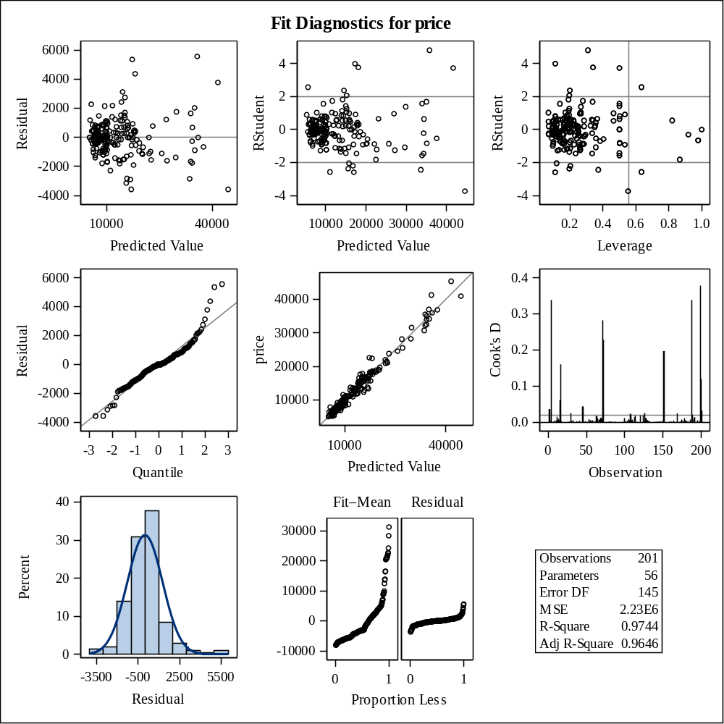

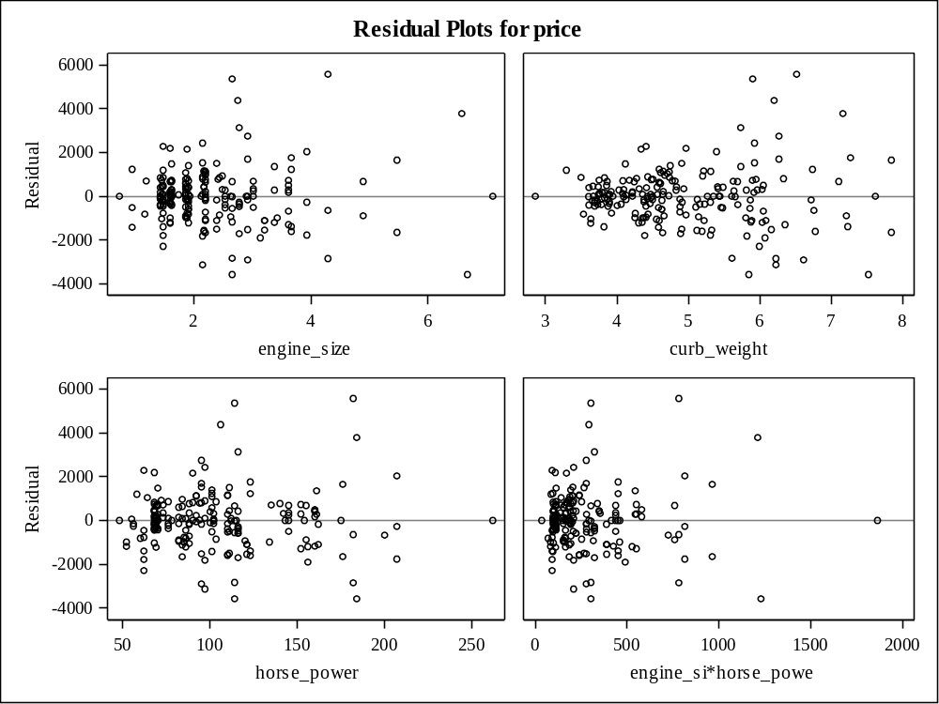

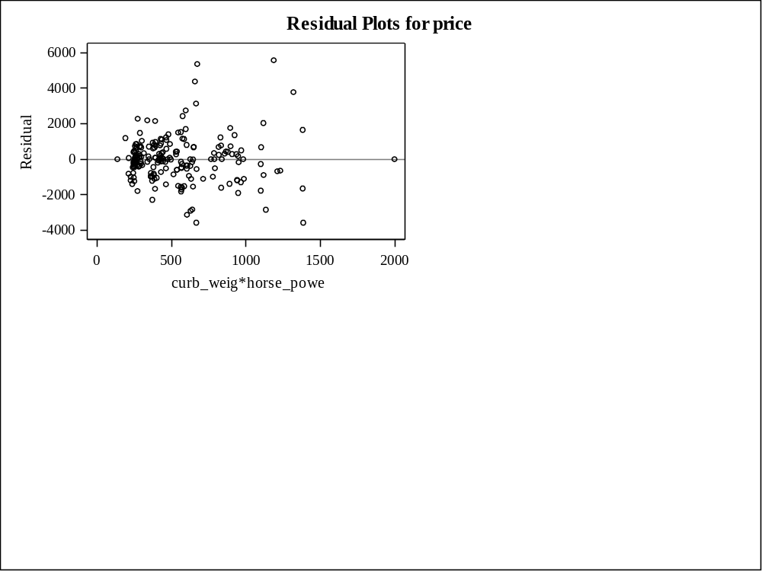

Store Information
Item Store | WORK.ITEM_AUTO
Data Set Created From | AUTO.AUTO_MOB_BIN
Created By | PROC GLMSELECT
Date Created | 08MAY20:09:00:37
Response Variable | price
Class Variables | drive_wheels make engine_type num_of_cylinders bin_hp aspiration
Model Effects | Intercept engine_size curb_weight horse_power engine_size*horse_power curb_weight*horse_power ...

Class Level Information
Class | Levels | Values
drive_wheels | 3 | fwd rwd 4wd
make | 22 | audi bmw chevrole dodge honda isuzu jaguar mazda mercedes mercury mitsubis nissan peugot plymouth porsche renault saab subaru toyota volkswag volvo alfa-rom
engine_type | 6 | l ohc ohcf ohcv rotor dohc
num_of_cylinders | 7 | five four six three twelve two eight
bin_hp | 4 | 1 2 3 0
aspiration | 2 | turbo std

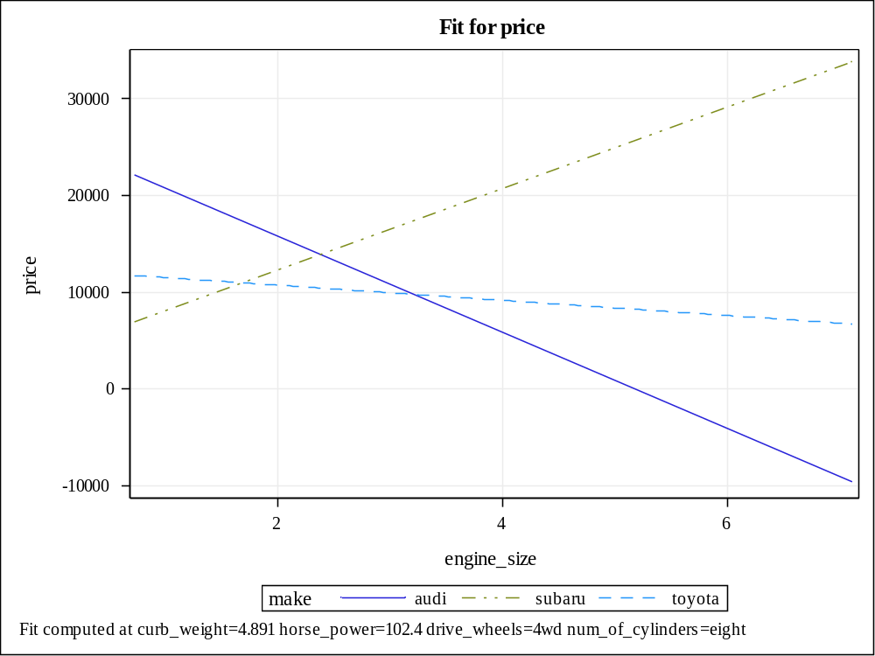

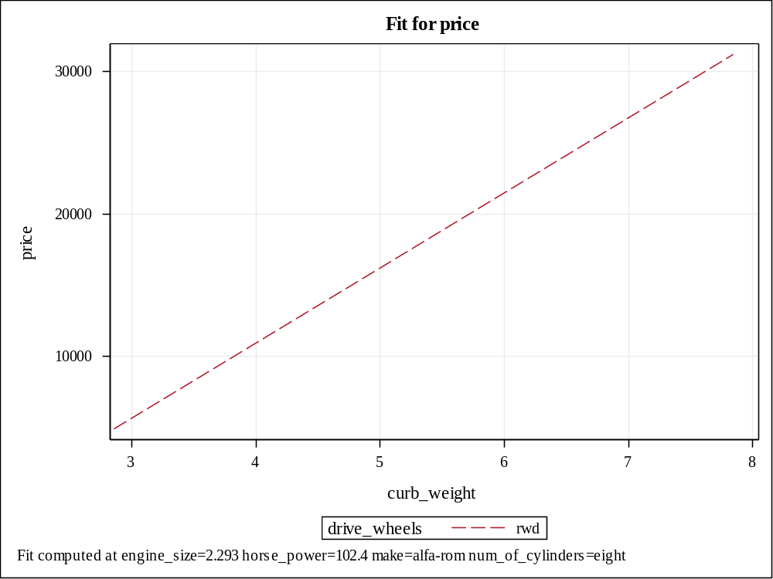

The COMPARE Procedure
Comparison of WORK.SCORED_DATA with WORK.SCORED_DATA_NEW
(Method=RELATIVE(2.22E-10), Criterion=0.0001)
Data Set Summary
Dataset Created Modified NVar NObs Label
WORK.SCORED_DATA 08MAY20:09:01:02 08MAY20:09:01:02 28 201 Scoring Results for DATA=AUTO.AUTO_MOB_BIN
WORK.SCORED_DATA_NEW 08MAY20:09:01:04 08MAY20:09:01:04 28 201
Variables Summary
Number of Variables in Common: 27.
Number of Variables in WORK.SCORED_DATA but not in WORK.SCORED_DATA_NEW: 1.
Number of Variables in WORK.SCORED_DATA_NEW but not in WORK.SCORED_DATA: 1.
Number of VAR Statement Variables: 1.
Number of WITH Statement Variables: 1.
Observation Summary
Observation Base Compare
First Obs 1 1
Last Obs 201 201
Number of Observations in Common: 201.
Total Number of Observations Read from WORK.SCORED_DATA: 201.
Total Number of Observations Read from WORK.SCORED_DATA_NEW: 201.
Number of Observations with Some Compared Variables Unequal: 0.
Number of Observations with All Compared Variables Equal: 201.
Values Comparison Summary
Number of Variables Compared with All Observations Equal: 1.
Number of Variables Compared with Some Observations Unequal: 0.
Total Number of Values which Compare Unequal: 0.
Total Number of Values not EXACTLY Equal: 200.
Maximum Difference Criterion Value: 1.1373E-14.

