1. What are the differences between operators and values in the following?

\* - Operator

'hello' - Value

-87.8 - value

- - operator

/ - operator

+ - operator

6 - value

2. What is the difference between string and variable?

Spam – This is a variable, since we can store a value in it.

'spam' - This is a string, since this is enclosed in quotes

3. Describe three different data forms.

Int – this can hold integer values like 3, -3 etc

Float – this can hold floating numbers like 9.5, 3.14, -3.14

Bool – this can hold true/ false kind of values

String – example “abc” OR can be represented as ‘abc’ (both single/ double quotes would work)

4. What makes up an expression? What are the functions of all expressions?

Expressions are something which is a combination of literals, identifiers, operator and they represent a value.

Example

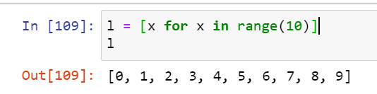

5. In this chapter, assignment statements such as spam = 10 were added. What's the difference between a declaration and an expression?

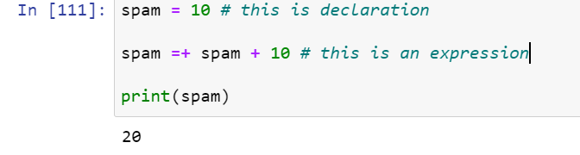

Declaration is assigning some initial value to a variable, expression is something of a combination of operators, literals and identifiers.

6. After running the following code, what does the variable bacon contain?

bacon = 22

bacon + 1

ans - 23

7. What should the values of the following two terms be?

'spam' + 'spamspam' = >

'spam' \* 3

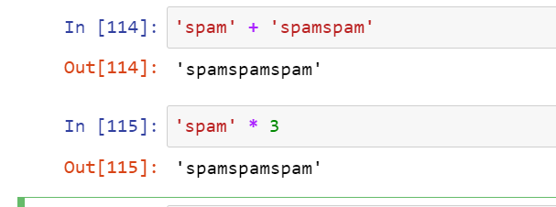

8. Why is it that eggs is a true variable name but 100 is not?

There should be some naming convention to be followed, variable can contain alphabets, number and some special characters (like | is not allowed while defining a variable name) see the below error

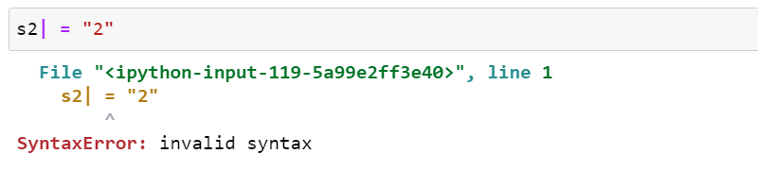

Also, variable name should not be starting from a number but it can be added after a character/ string. For example, below is a valid variable name

s2 = "2"

9. Which of the following three functions may be used to convert a value to an integer, a floating-point number, or a string?

int(“2”) will return integer 2, float(2) will return 2.0, str(2) will return string 2

enclosed the value to be converted in () brackets

10. What is the error caused by this expression? What would you do about it?

'I have eaten ' + 99 + ' burritos.'

While concatenating all the values in question should be of similar datatype, since the value in above expression are string, int and then string again, we will get below error

