1. What are the Boolean data type's two values? How do you go about writing them?

True and False are the two Booleans values

a = true

b = false

2. What are the three different types of Boolean operators?

and, or, not

3. Make a list of each Boolean operator's truth tables (i.e. every possible combination of Boolean values for the operator and what it evaluate ).

For **and** operator

|  |  |  |
| --- | --- | --- |
| 0 | 0 | 0 |
| 0 | 1 | 0 |
| 1 | 0 | 0 |
| 1 | 1 | 1 |

For **or** operator

|  |  |  |
| --- | --- | --- |
| 0 | 0 | 0 |
| 1 | 0 | 1 |
| 0 | 1 | 1 |
| 1 | 1 | 1 |

4. What are the values of the following expressions?

(5 > 4) and (3 == 5) False

not (5 > 4) False

(5 > 4) or (3 == 5) True

not ((5 > 4) or (3 == 5)) False

(True and True) and (True == False) False

(not False) or (not True) True

5. What are the six different types of reference operators?

<, >, <=, >= , ==, !=

6. How do you tell the difference between the equal to and assignment operators?

Equal operator is used in Boolean expressions while assignment operator is used to assign some value to a variable

7. Describe a condition and when you would use one.

a = 5

b = (9-4)

if(a == b): #this is a condition

print(“Condition is true)

else:

print(“condition is false)

8. Recognize the following three blocks in this code:

spam = 0 #this is a declaration

if spam == 10: #this is an if condition

print('eggs')

if spam > 5: # this is a nested if condition

print('bacon')

else: #this is an else part

print('ham')

print('spam')

print('spam')

9. Create a programme that prints. If 1 is stored in spam, prints Hello; if 2 is stored in spam, prints Howdy; and if 3 is stored in spam, prints Salutations! if there's something else in spam.

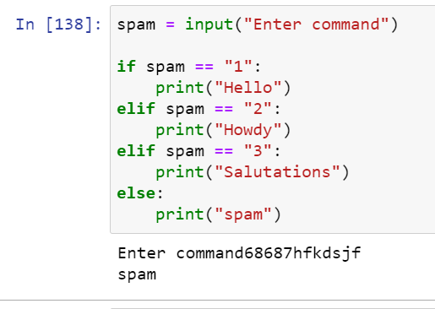

10.If your programme is stuck in an endless loop, what keys can you press?

By using the interrupt kernel on the jupyter notebook editor

11. How can you tell the difference between break and continue?

Break -> will break out of the current loop

Continue -> use to end the current iteration and continuous with the next iteration

Example of break

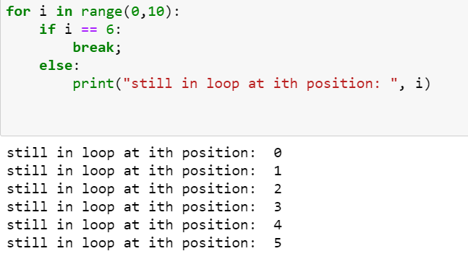

When I will be 6, control will break out of the loop and in this case execution will be ended

Example of continue

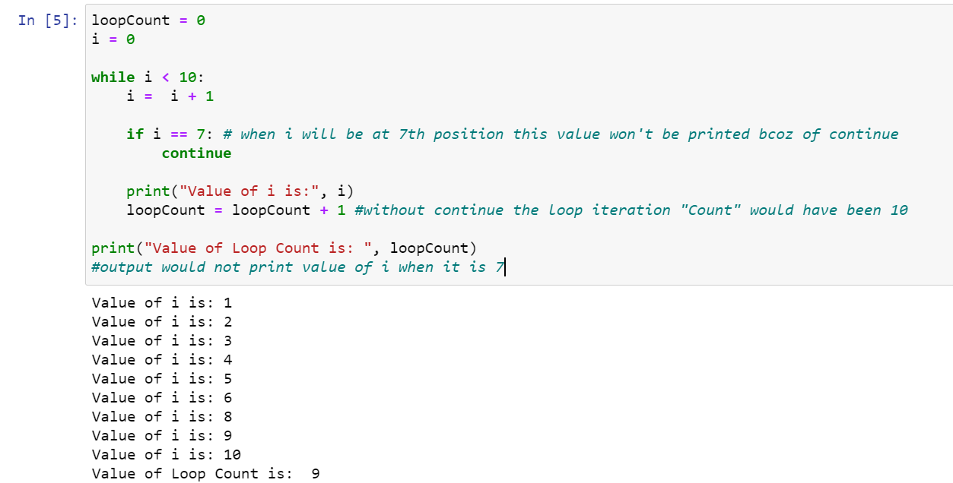

12. In a for loop, what is the difference between range(10), range(0, 10), and range(0, 10, 1)?

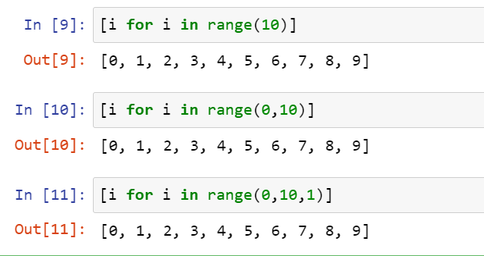

All three will return the same output, but range takes three parameters, 1st is start position, 2nd is stop, though the highest bound will not be printed that is anything prior to the upper bound would be printed (in this case it is 9), and the last parameter is jump parameter(default is 1 but we can have change it to a desired number)

13. Using a for loop, write a short programme that prints the numbers 1 to 10 Then, using a while loop, create an identical programme that prints the numbers 1 to 10.

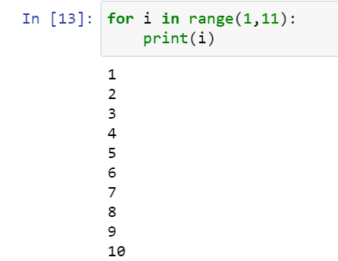

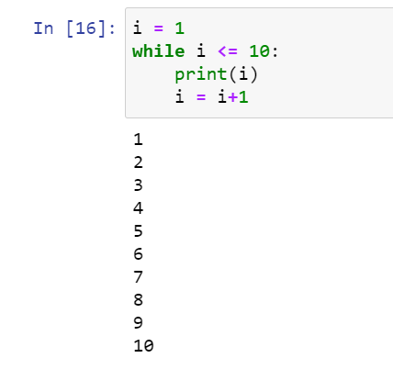

14. If you had a bacon() function within a spam module, how would you call it after importing spam?

By using dot(.)