ELECTRONICS & ROBOTICS CLUB · IIT BOMBAY
WattIsElectronics· Biometrics Edition
Written by:-Gaurish Bansal
Your Phone Knows Your Touch.
But How?
Every time you press your thumb to unlock your phone, something fascinating happens in under a second. So here's the full story - from skin ridges to silicon sensors.
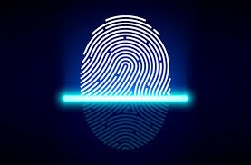
Let's start with something you probably do a hundred times a day without thinking - pressing your thumb on your phone to unlock it.
Takes about 0.3 seconds. Feels like nothing. But inside that tiny moment, your phone captures an image of your fingerprint, pulls out its unique features, runs a matching algorithm, and decides whether to let you in before you can even lift your finger.

WAIT - THAT'S ACTUALLY WILD
No two fingerprints are alike - not even between identical twins who share the exact same DNA. The ridges on your fingertip form entirely at random during fetal development, shaped by tiny physical forces in the womb. Your fingerprint is basically just a biological accident that became your unique ID.

So how does a piece of glass and silicon learn to recognize that random accident? That's what this blog is about. Let's go from your skin all the way down to the chip.
SECTION 01
What Even Is a Fingerprint?
Your fingertips are covered in tiny raised lines of skin called ridges, separated by lower areas called valleys. This ridge-valley pattern, unique to every person, is what we call a fingerprint.
These ridges fall into three broad pattern types: loops (most common, ~65% of people), whorls (~30%), and arches (~5%). But the real uniqueness isn't the overall pattern - it's the tiny details within it.
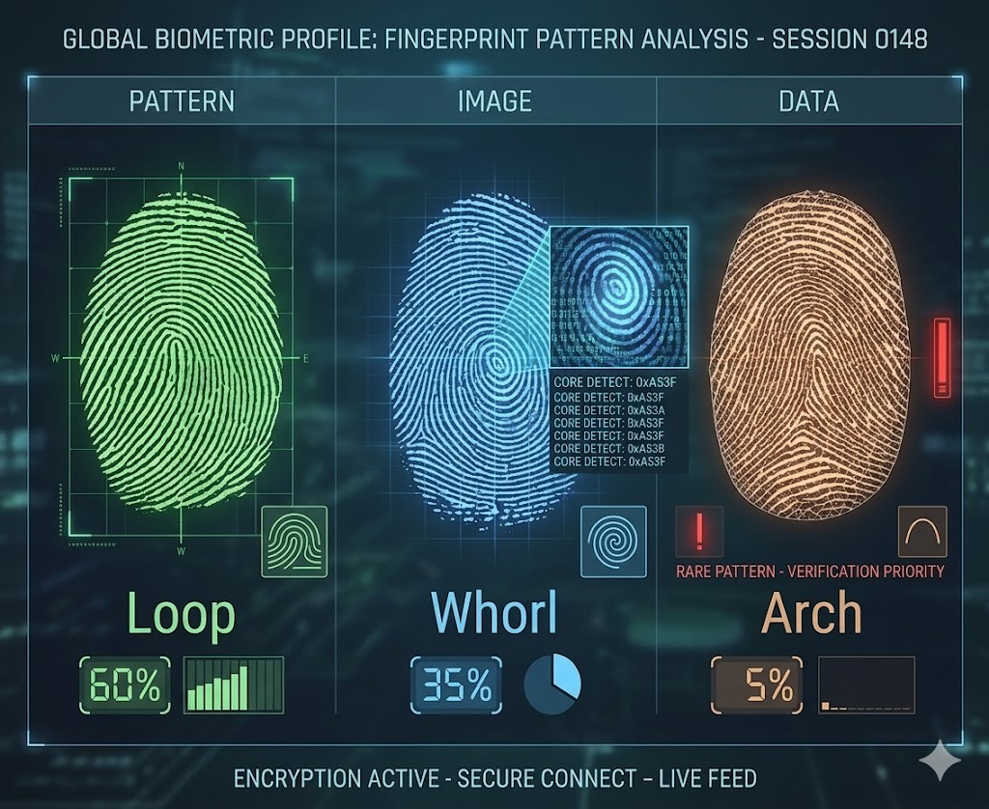

Minutiae - the real secret
Zoom in on any fingerprint and you'll see the ridges aren't just straight parallel lines. They split into two (called bifurcations), they end abruptly (ridge endings), they form little islands. These micro-features are called minutiae points, and they're the actual currency of fingerprint recognition.
A typical fingerprint has between 40 to 100 minutiae points. Your phone doesn't try to match the entire fingerprint image - it extracts and compares just these key points. Think of it like recognizing a friend not by memorizing their whole face, but by noting the exact position of their mole, the shape of their eyebrow, the curve of their jaw.

Imagine verifying a document's authenticity. You don't read every word, you just look for specific signatures in specific places. Minutiae points are the fingerprint's signature: unique locations, unique orientations, uniquely yours.

SECTION 02
How Does Your Phone "See" Your Finger?
We know what a fingerprint is. But how does the phone capture it? This is where it gets interesting - because there isn't just one way. There are three completely different technologies doing this job, and your phone uses one depending on its design.

1. Capacitive Sensors - the classic
The most common type. It is found in most phones with a side or rear fingerprint sensor.
The sensor is a grid of tiny capacitors - microscopic components that store a small electrical charge (sound familiar?). When your finger touches the sensor, the ridges sit very close to the capacitors beneath them, while the valleys leave a small air gap.
A capacitor's stored charge depends on the distance between its plates. Ridges sit closer → higher capacitance. Valleys leave a gap → lower capacitance. The sensor reads the entire grid and produces a map of your fingerprint in electrical form.
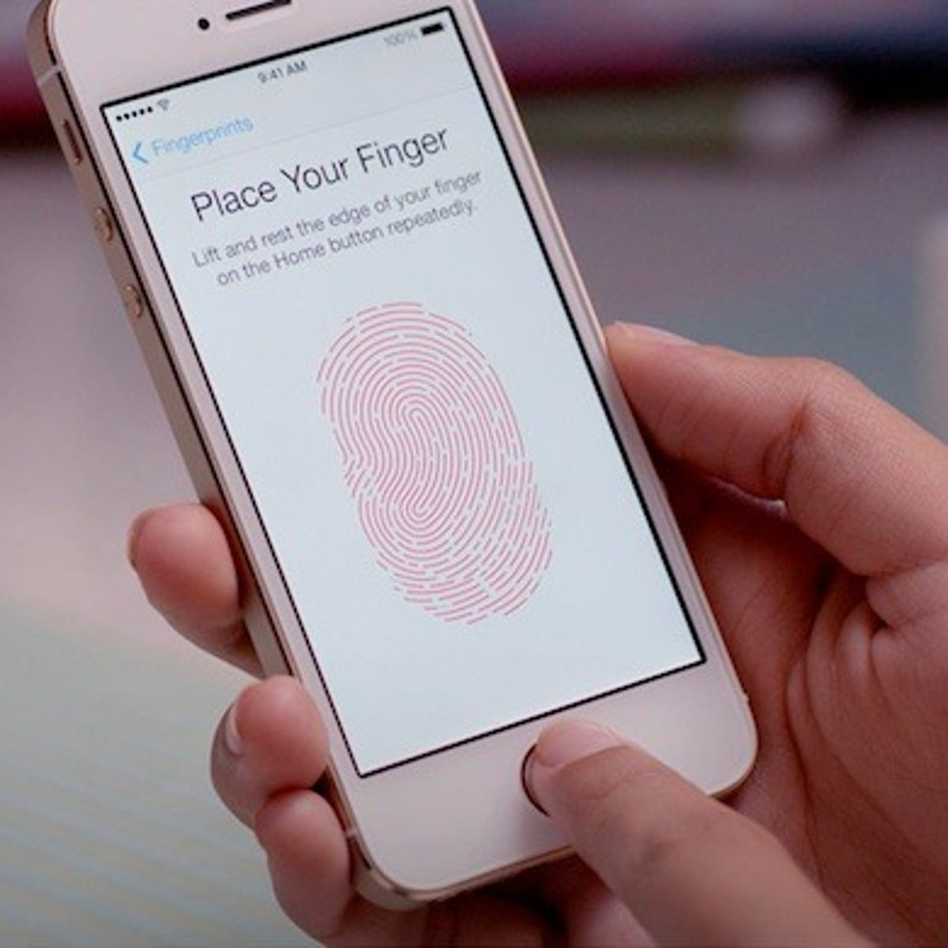

KEY INSIGHT
The fingerprint never "looks" like an image to the sensor. It's really a 2D array of capacitance readings - a number grid that the processor converts into the ridge-valley pattern we recognize as a fingerprint.

2. Optical Sensors - under-display
You know those phones where you press your thumb anywhere on the screen to unlock? That's an optical fingerprint sensor.
The idea is almost simple: shine light on your finger, take a photo of what bounces back. The OLED display flashes bright light onto your fingertip. Ridges in contact with the glass reflect light differently than valleys, which have a tiny air gap. A camera sensor beneath the display captures this pattern.
The resulting image is then processed just like a capacitive scan - feature extraction, matching, decision. Optical sensors are easier to embed under displays but were historically a bit less accurate, though modern ones have caught up significantly.
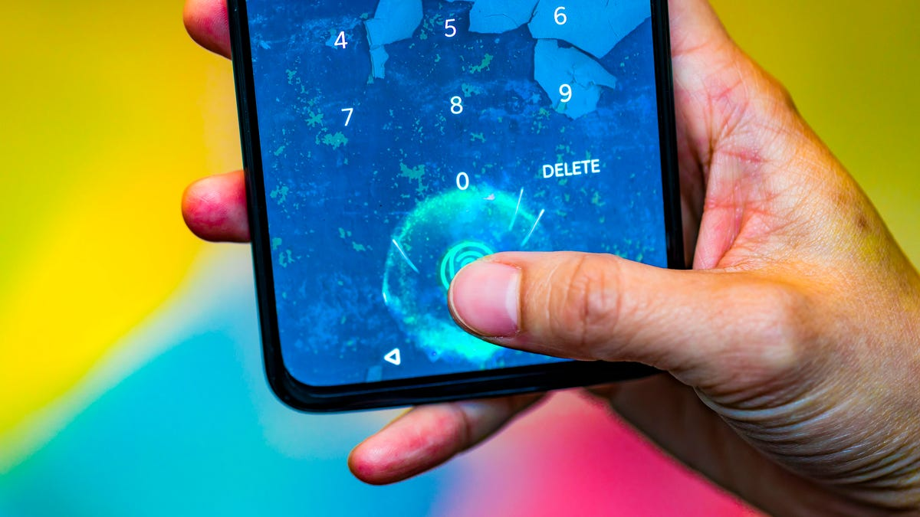

SECTION 03
From Image to Decision - What Happens Inside the Chip
The sensor has captured either a capacitance grid, a camera image, or a 3D sound map. Now what? This is where the real work happens - a multi-step pipeline running entirely inside your phone's processor, in milliseconds.

01 | Image Enhancement  The raw sensor data is cleaned up. Real-world fingerprints are messy - your finger might be slightly rotated, smudged, or partially pressed. Noise reduction algorithms smooth the signal, and contrast enhancement makes ridges and valleys sharper.  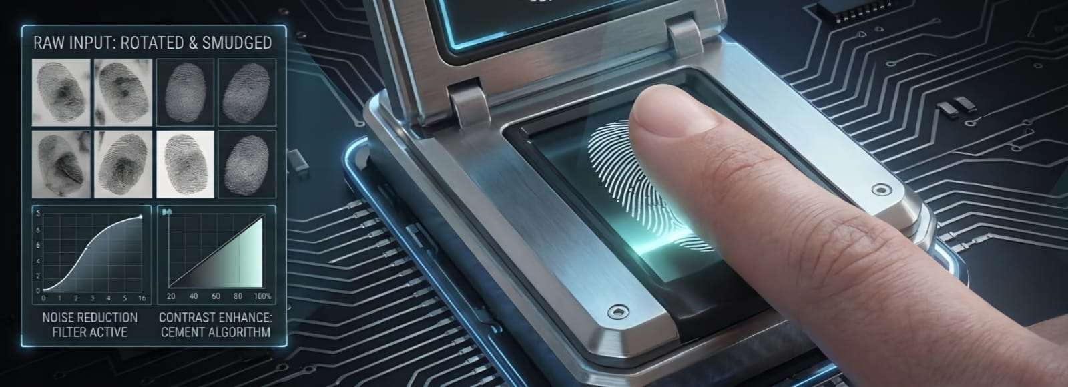

02 | Feature Extraction - Finding the Minutiae  The processor scans the cleaned image to find minutiae points. For each one, it records three things: the x, y position on the image, the orientation angle of the ridge at that point, and the type - ridge ending or bifurcation. This set of data, not the image itself, is what gets compared.  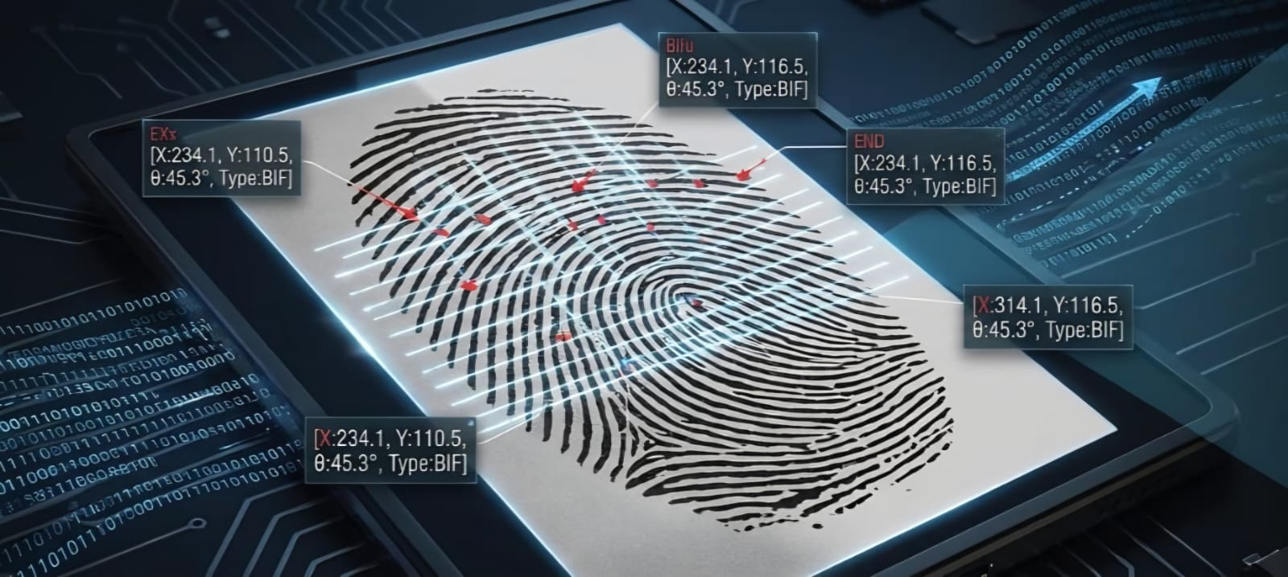

03 | Template Matching  When you first set up fingerprint unlock, the phone captured multiple scans and built a reference template - a clean, averaged set of minutiae data. Now it compares the current scan's features against that stored template. Because your finger lands slightly differently each time, the algorithm uses geometric transformations to align both sets before scoring.  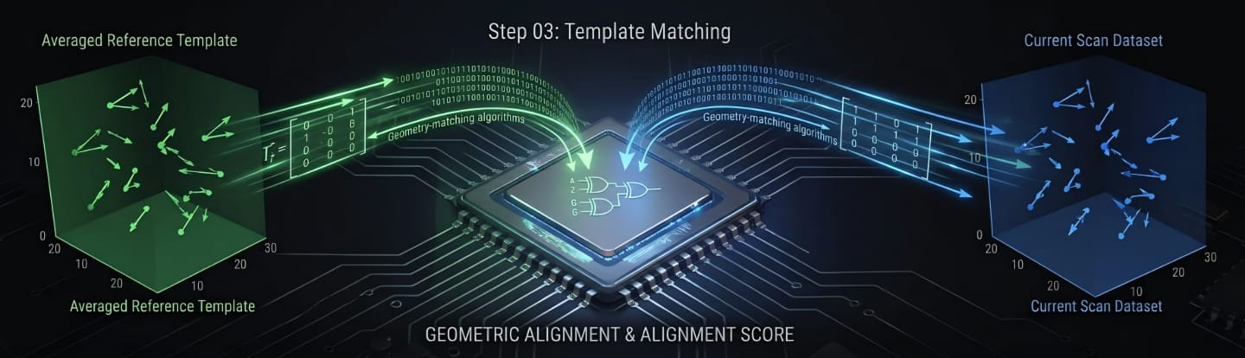

04 | Scoring and Decision  The algorithm produces a match score - a number representing how similar the two minutiae sets are. If the score clears a set threshold: unlock. If not: rejected. The threshold is carefully tuned - too strict and your own finger gets rejected, too loose and someone else could slip through.  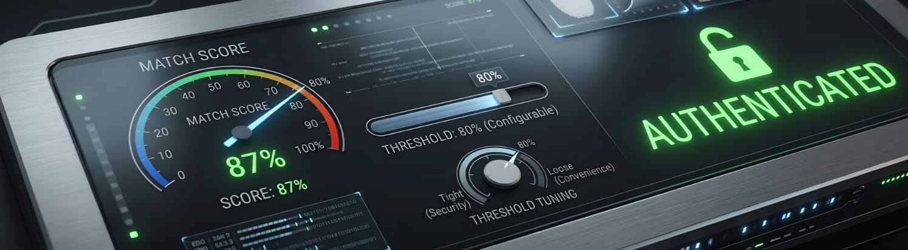

GOOD TO KNOW
The system doesn't require every minutiae point to match. Matching just 12–15 points in the correct geometric relationship is usually enough for a confident identification. Requiring all points would make the system too rigid to handle real-world variation in how your finger lands each time.

SECTION 04
Security - Where Does Your Fingerprint Actually Live?
Ask yourself this: once your phone "knows" your fingerprint, where does it store it? And is anyone (your phone maker, an app, some server) holding a copy?
The answer is no, or well, at least, it's supposed to be. Here's how modern phones handle this properly.
The Secure Enclave
Your fingerprint template, the minutiae data, never lives in your phone's regular memory where apps can reach it. It's stored inside a completely isolated piece of hardware called the Secure Enclave (Apple's name) or Trusted Execution Environment on Android.
Think of it as a vault built into your phone's main chip. The main processor handles apps, calls, and everything normal. The secure enclave sits beside it, completely walled off with its own memory, its own tiny processor, its own encrypted storage. Even the main processor cannot directly read what's inside.
What's actually stored
Your phone doesn't store your fingerprint image. It stores a mathematical representation - the extracted minutiae data. You cannot reconstruct the original fingerprint image from it. It's one-way, like a hash function. And this data never leaves your device.
FAR and FRR - the security trade-off
Engineers who design these systems track two key numbers:

Metric | Full name | What it means
FAR | False Acceptance Rate | How often a stranger's fingerprint gets incorrectly accepted
FRR | False Rejection Rate | How often your own fingerprint gets incorrectly rejected

These two are always in tension. A stricter threshold lowers FAR (more secure) but raises FRR (you get locked out more). Apple's Touch ID targets a FAR of roughly 1 in 50,000 - meaning a random person has about a 0.002% chance of unlocking your phone with their thumb.

WAIT - THAT'S ACTUALLY WILD
That 1-in-50,000 number sounds solid - but if you have a sibling, the odds improve because ridge similarities can run in families. For identical twins, FAR rises noticeably. They share the same DNA but not the same fingerprints - still, their ridge patterns are similar enough to occasionally push the matching score dangerously close to the threshold.

PUTTING IT ALL TOGETHER
So What's Actually Happening in 0.3 Seconds?
Let's replay that moment - thumb on sensor, phone unlocks - but now you know what's inside it:
That's it. A cascade of physics, signal processing, and cryptography – all running silently and invisibly, a hundred times a day, so you never have to type a password.
Next time you tap that sensor, maybe give it a moment of appreciation. It's doing a lot.
You now know how your phone knows it's you.
From biological ridge patterns to capacitive grids to cryptographic vaults, the fingerprint scanner is one of the most elegant everyday intersections of biology, physics, and electronics.
Curious about face unlock next? Or how the Secure Enclave handles encryption keys? Stay tuned to our blogs.

