Connect 4
Idea
I have planned a fun weekend Game activity. In which we will give the freshers the task to make Connect 4. Why ? This is a type of game most of us have played and this game is also easy to Implement. Freshers would enjoy this activity that they are going to make a game by programming and basics of electronic circuits

Basic working of the Game

The Connect 4 game works by connecting physical button inputs to a microcontroller that manages the game state and drives a visual display. When a player presses the Left or Right button, the Arduino shifts a blinking cursor across the top of the LED matrix to indicate which column the piece will drop into. When the Drop button is pressed, the Arduino applies a gravity logic internally — it finds the lowest empty slot in that column, records the move, and immediately updates the LED matrix to reflect the new board state. The MAX7219 LED matrix handles all the complexity of lighting the correct LEDs, receiving instructions from the Arduino over just three wires. After every move, the Arduino silently scans the board in all four directions — horizontal, vertical, and both diagonals — to check if any player has achieved four in a row. If a winner is found, the corresponding LED in front of that player glows and the buzzer sounds a victory tone. If not, the turn flips to the other player and the cycle continues. The Restart button wipes the board clean and resets everything back to the starting state. Throughout the entire game, both players share the same four buttons and take turns using them, with the matrix display and the turn indicator keeping both players informed of the game state at all times.

Bill of Material
S. No | Component | Quantity | Unit Cost | Total Cost
1 | Arduino Nano Every | 1 | 320 | 320
2 | MAX7219 8x8 LED Matrix Module | 2 | 160 | 320
3 | Push Buttons -with caps | 5 | 10 | 50
4 | Active Buzzer Module | 1 | 20 | 20
5 | Breadboard (830 tie-points) | 1 | 80 | 80
6 | Jumper Wires (Male-Male + Male-Female set) | 1set | 80 | 80
7 | Resistor Kit (220Ω,10kΩ) | 1 | 40 | 40
8 | USB Cable (for Arduino Nano) | 1 | 50 | 50
9 | LEDs (Red/Green for player indicator) | 2 | 5 | 10
 | Total cost (per kit) |  |  | 970

Implementation
First we will give the basic idea to the freshers and tell them how all the components are used . We will so provide them with a basic code with some functions left and ask them to complete it and also a basic circuit as it is the most important part in which most of the freshers are new .

Schematic diagram of circuit
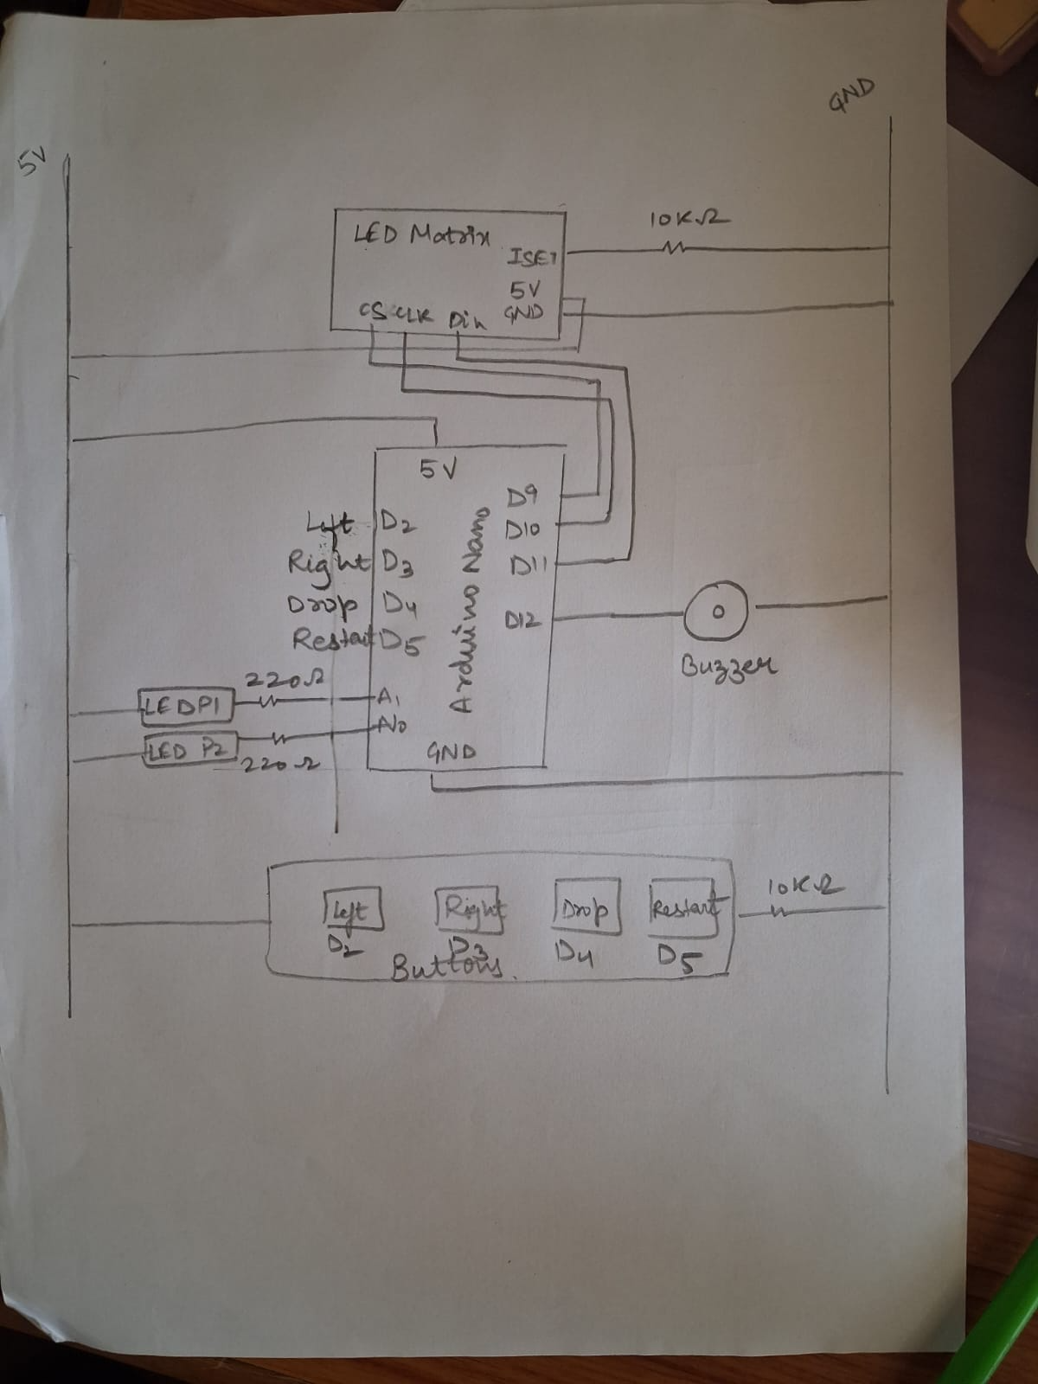
Component | Pin Function | Arduino Uno Pin | Connection Details
LED Matrix | CS (Chip Select) | D9 | MAX7219 SPI Interface
(MAX7219 8x8) | CLK (Clock) | D10 | MAX7219 SPI Interface
 | DIN (Data In) | D11 | MAX7219 SPI Interface
Control Panel | LEFT | D2 | Push button (10k pull-down)
Push Buttons | RIGHT | D3 | Push button (10k pull-down)
 | DROP | D4 | Push button (10k pull-down)
 | RESTART | D5 | Push button (10k pull-down)
Indicators | P1 Win LED | A0 | Red LED + 220Ω resistor
 | P2 Win LED | A1 | Green LED + 220Ω resistor
Audio | Passive Buzzer | D12 | Signal Pin (D12 to GND)

