Step1: Setup Sonar cloud and generate a authentication token

<https://sonarcloud.io/login>

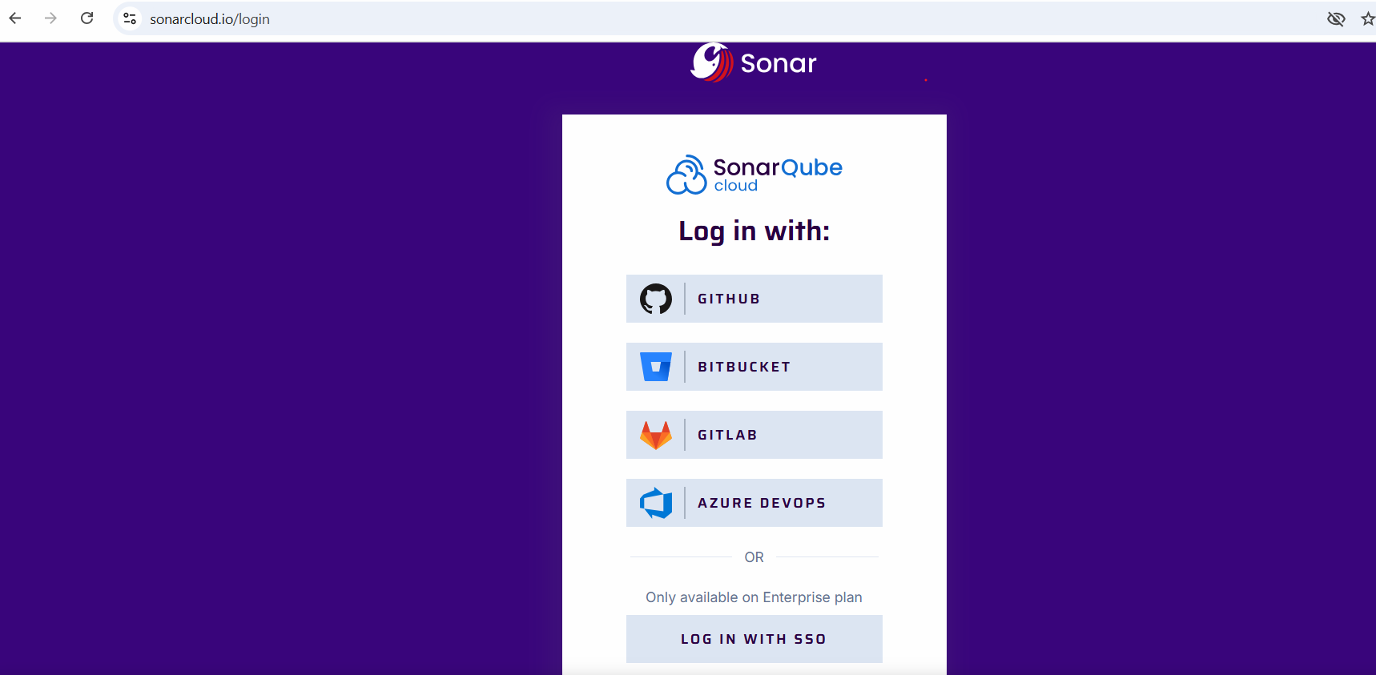

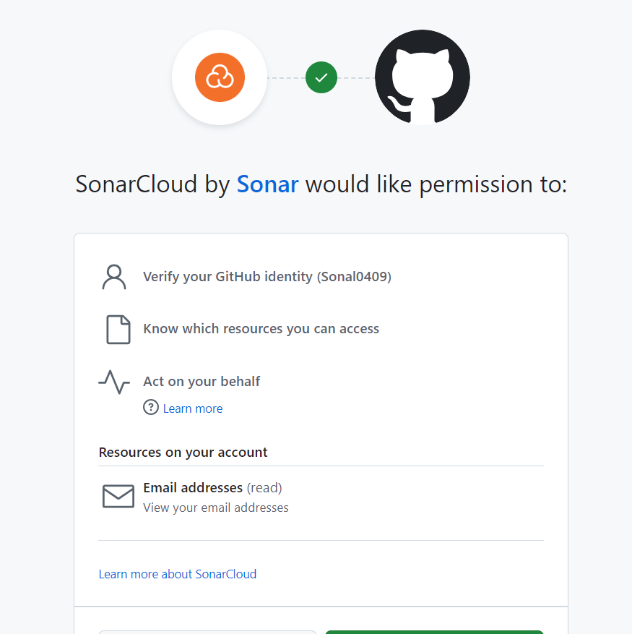

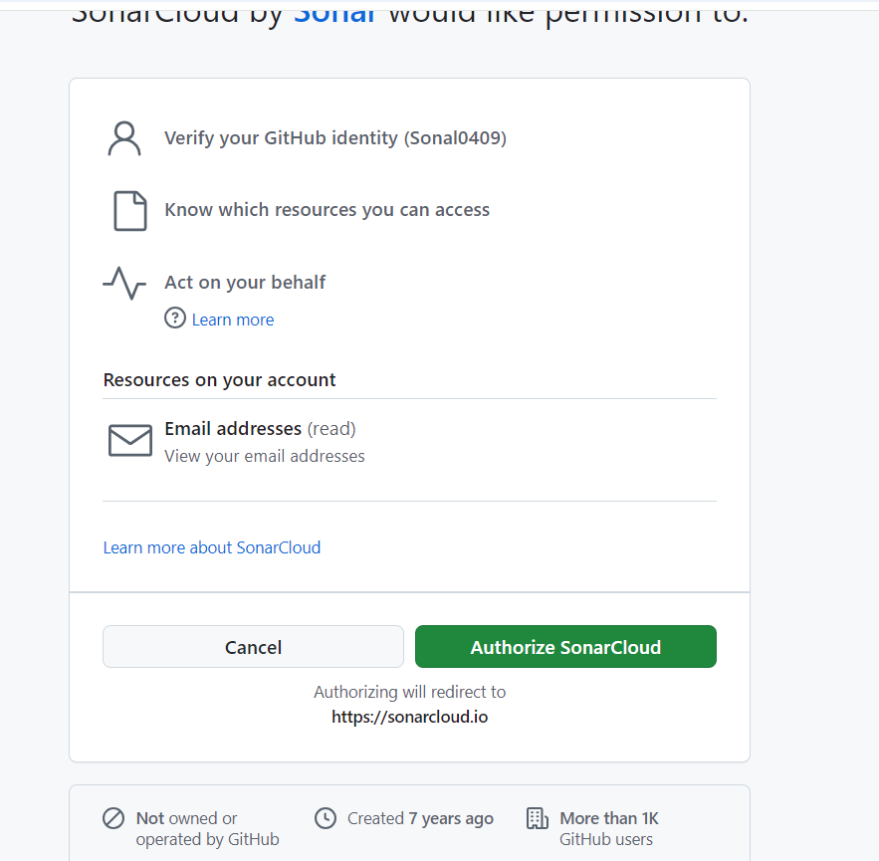

Se;ect Orgranizations

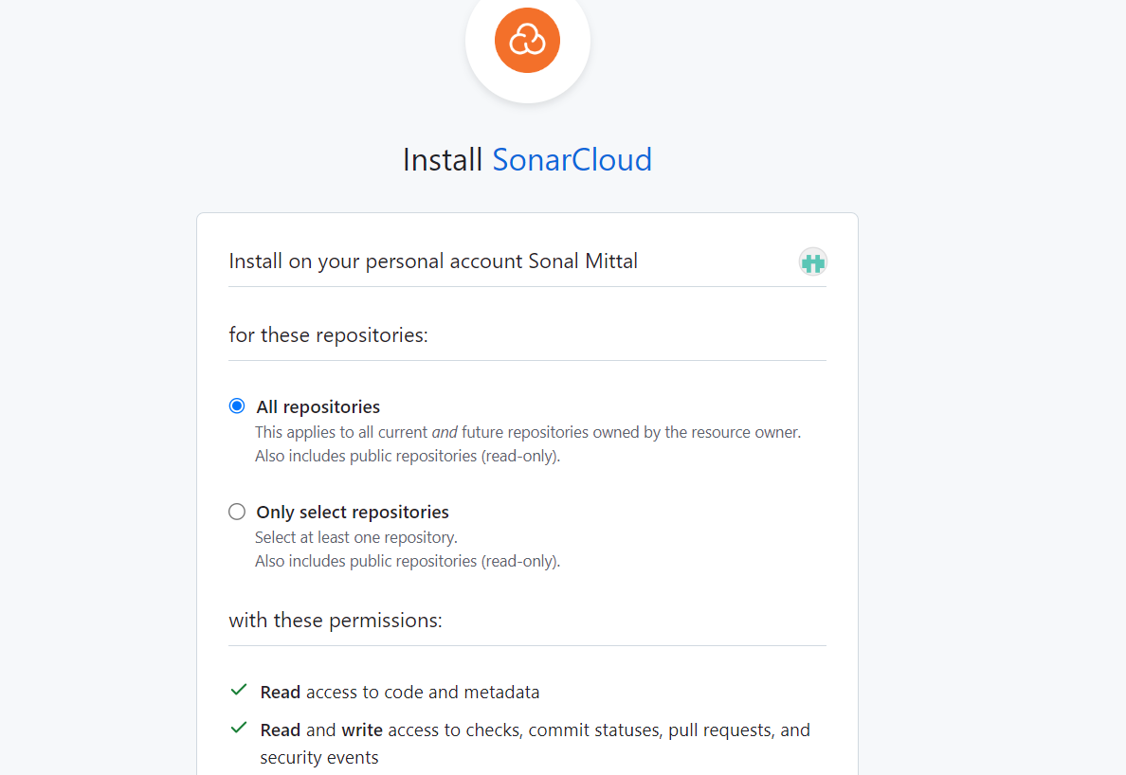

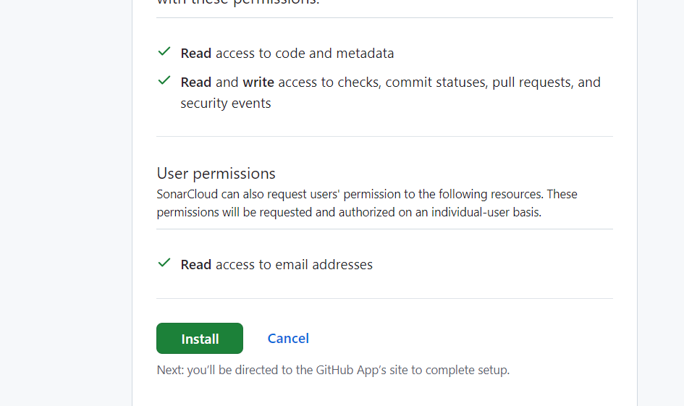

You will be on sonar qube cloud dashboard

Click on user account on right side 🡪 click on account –click on Security and generate token

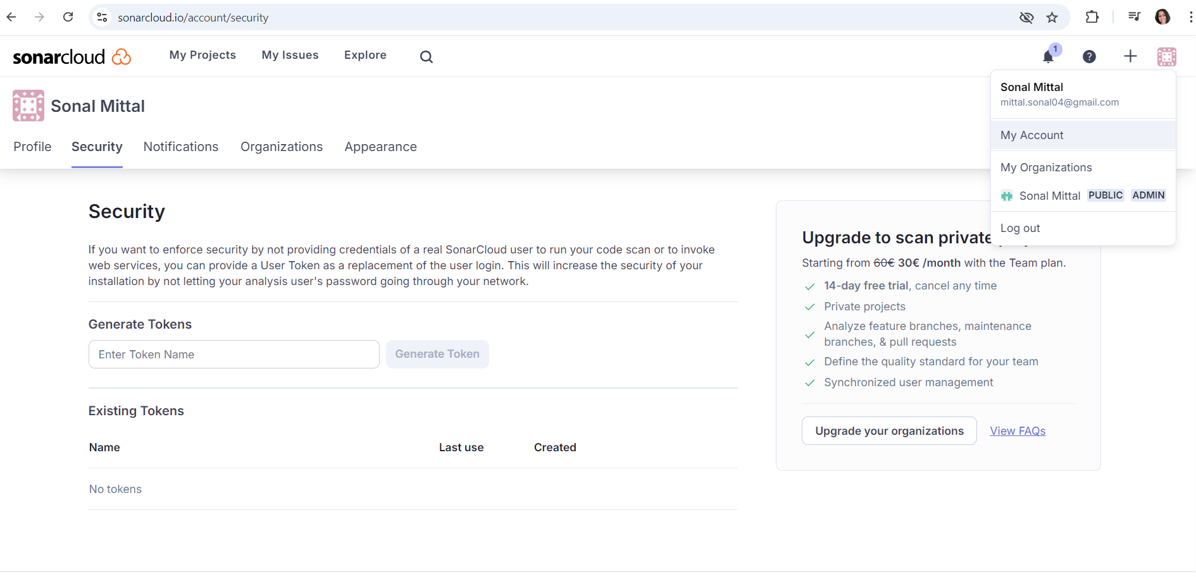

Give a name to token and click on generate token

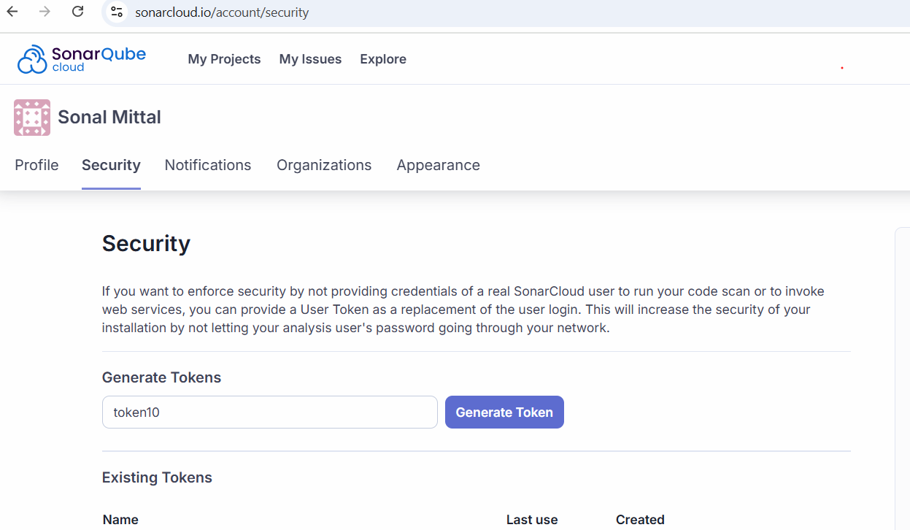

Step 2: Create an organization in sonar cloud

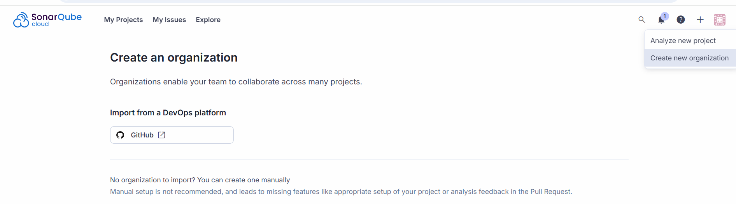

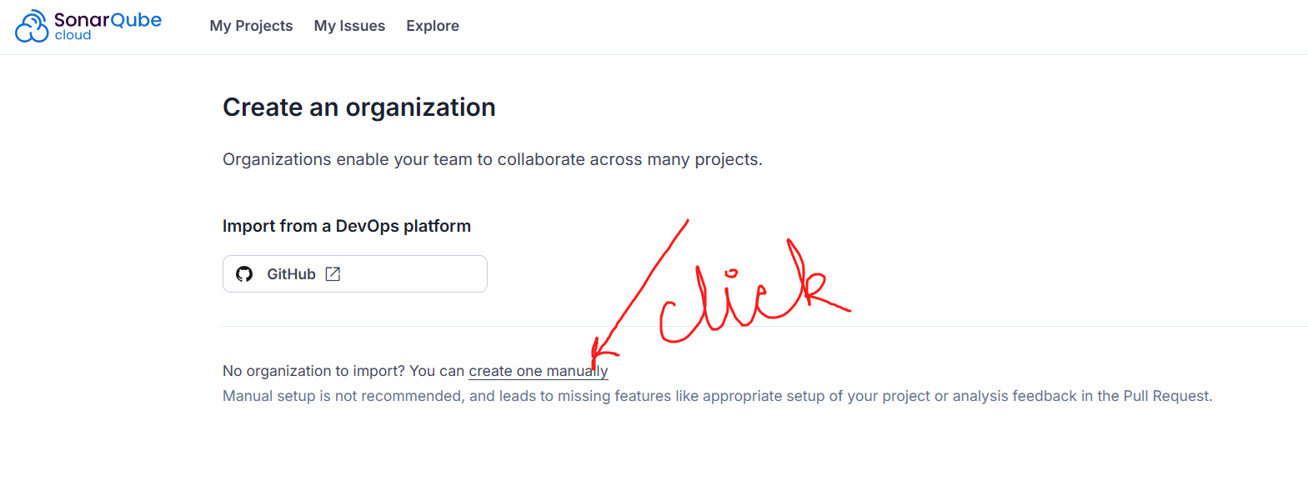

Give a unique org name

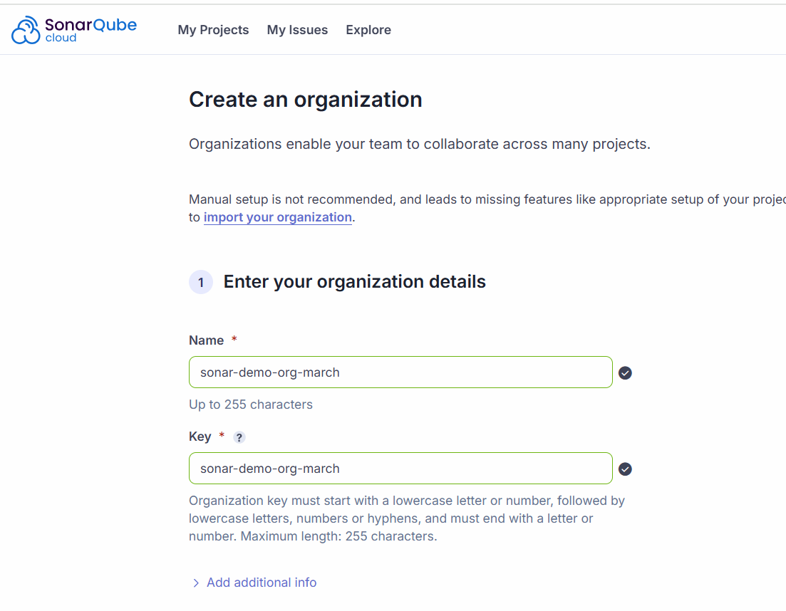

Select the free plan

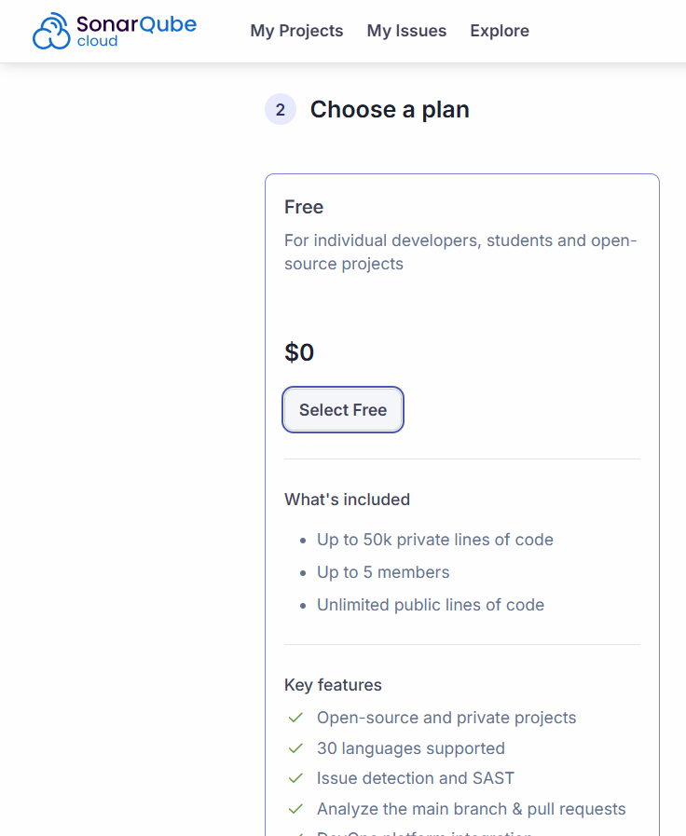

Scroll down and click on create organization

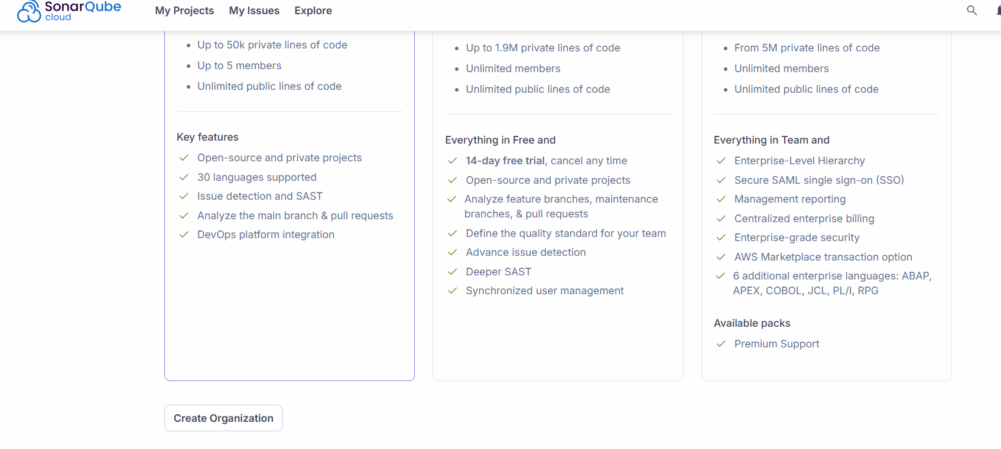

Step 3: Create a project in the organization

Click on analyze project button and enter below details

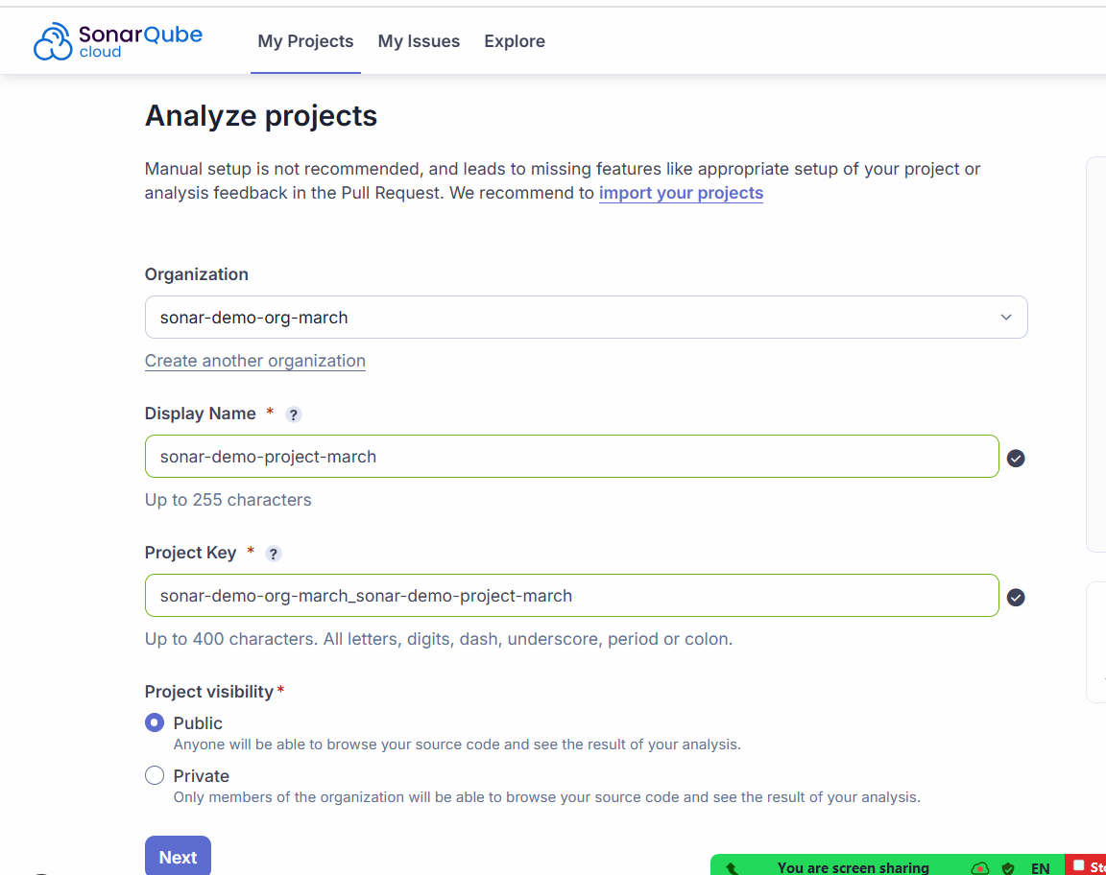

Press next and select previous version

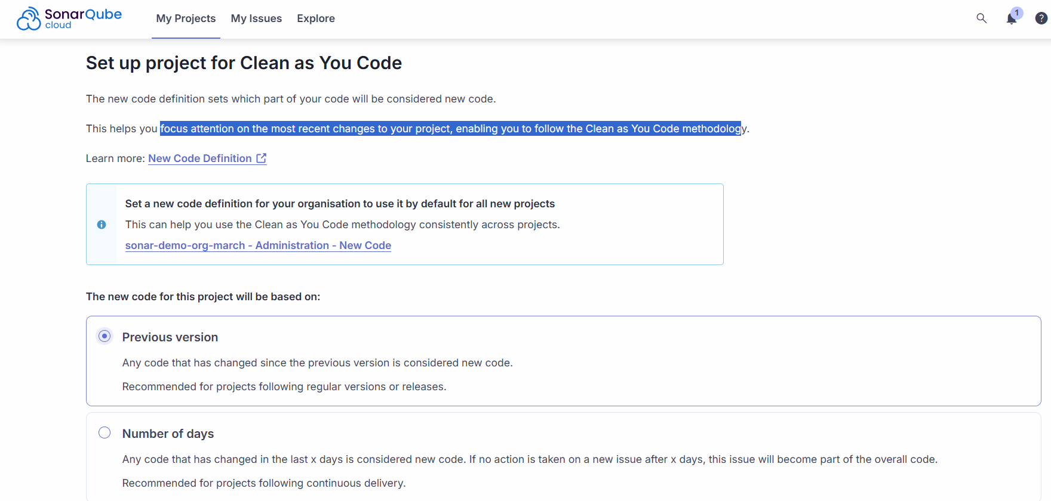

Click on create project

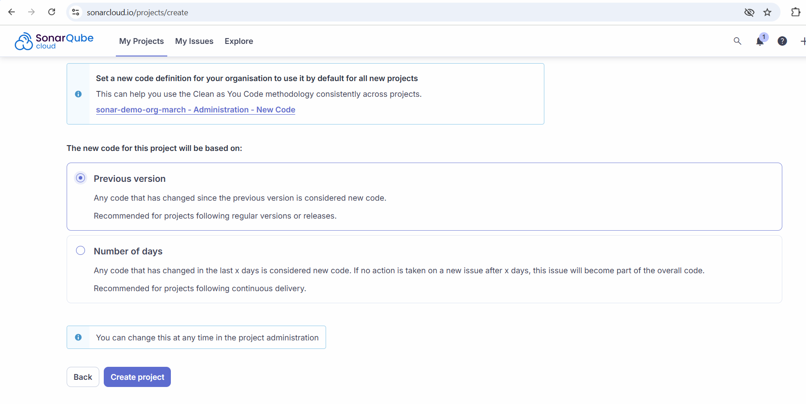

Step 4: Go to Jenkins server and Create a credentials to store the sonar token

Go to manage Jenkins 🡪 go to credentials 🡪 click on global -> click on Add crednetials -> add below details 🡪 click on create button

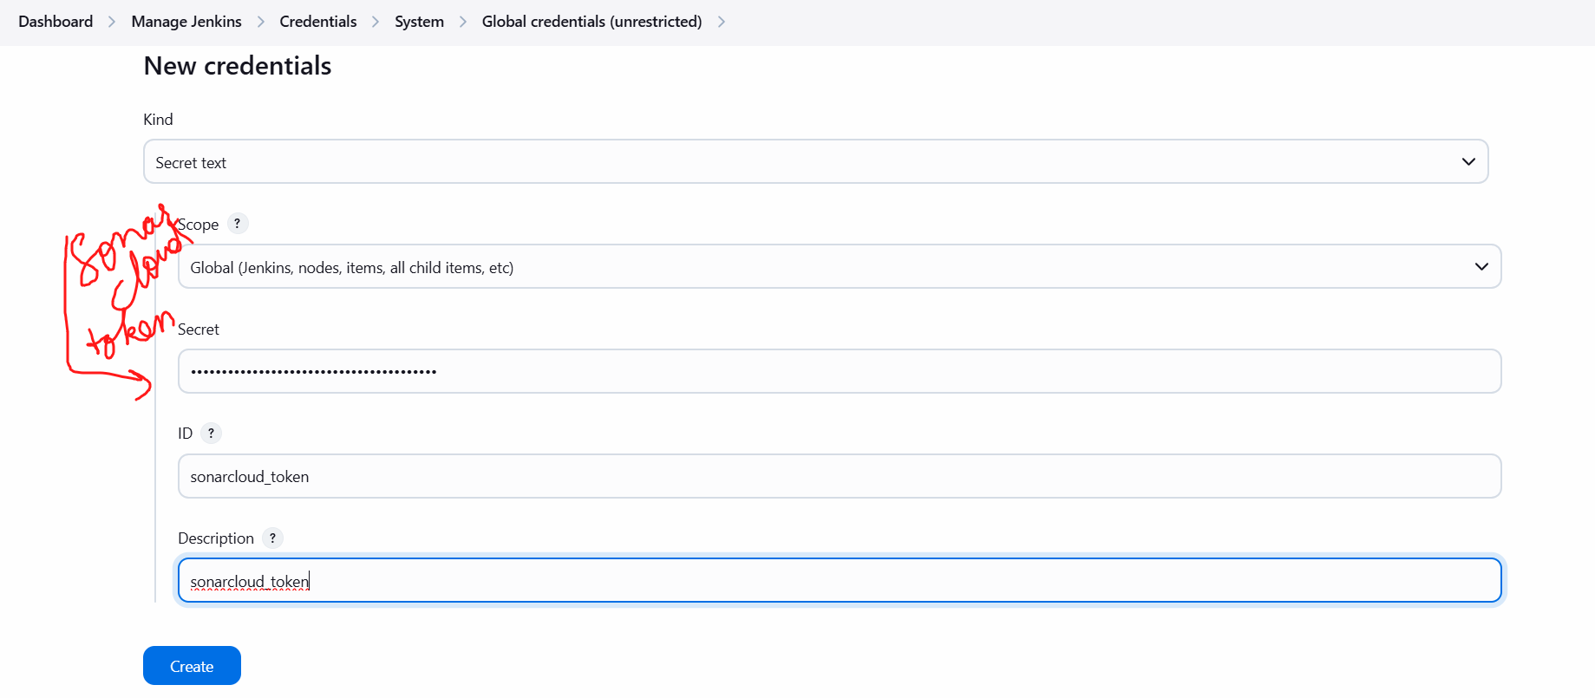

Step 5: Download the sonar cloud scanner plugin

Go to manage Jenkins 🡪 go to Plugins 🡪 available plugins 🡪 search for [SonarQube Scanner](https://plugins.jenkins.io/sonar) 🡪 select it and click on install

After installation

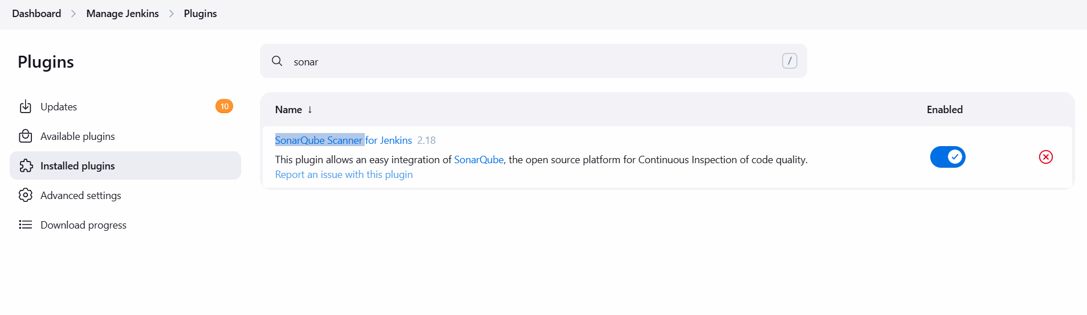

Step 6: Tell jenkins where is our sonar server

Manage Jenkins 🡪 System -> scroll down and search for SonarQube servers -> enter below details and save

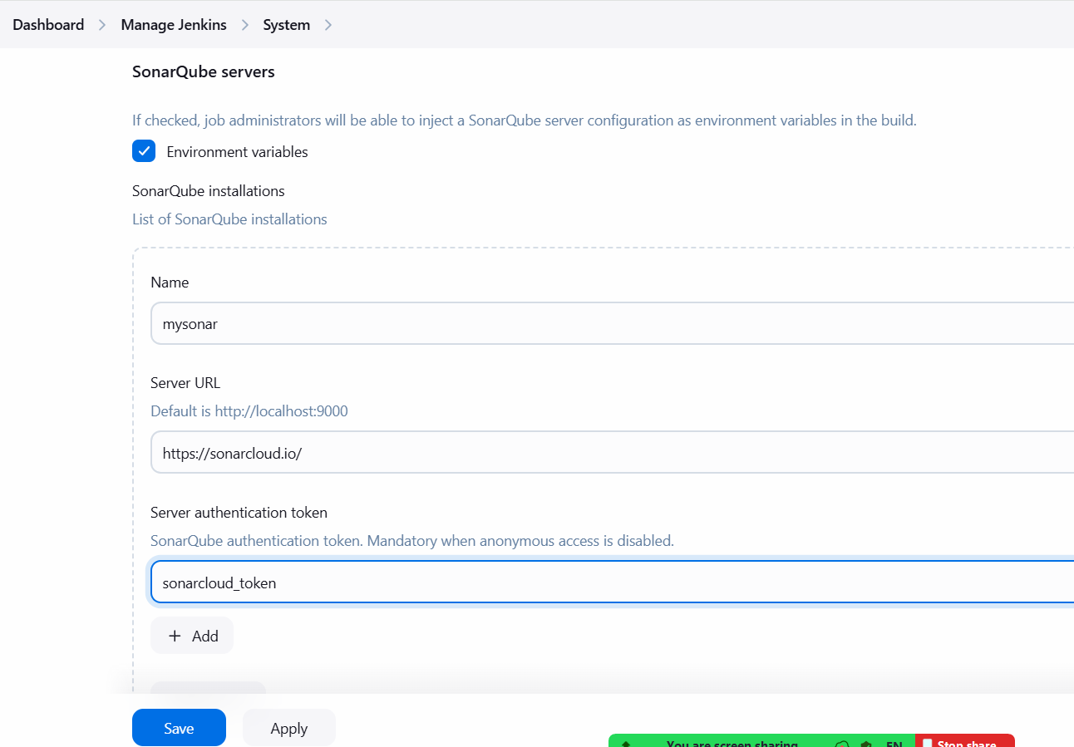

Step 7: Setup Sonar tool on Jenkins

Manage Jenkins 🡪 tools 🡪 scroll down to SonarQube Scanner installations -> click on Add SonarQube scanner -> add below details as same. -> save the page

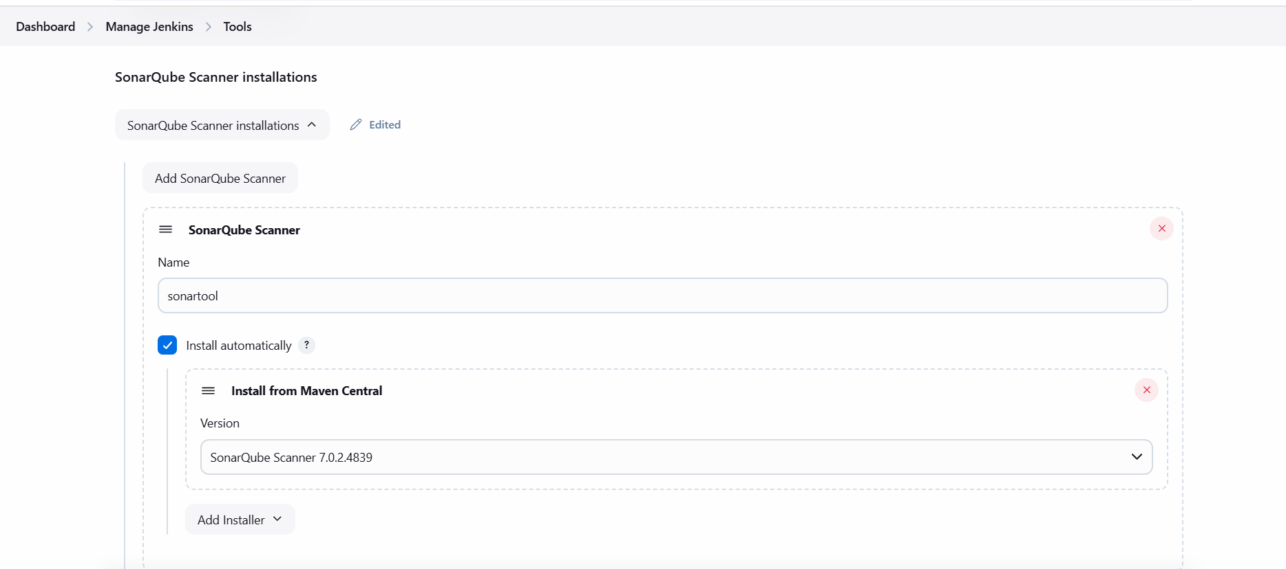

Save this page

Create a pipeline job and add below code

pipeline{

agent any

tools{

maven 'mymaven'

}

stages{

stage('checkout Code')

{

steps{

git 'https://github.com/demo1orgtoday/SonarQubeCoverageJava.git'

}

}

stage('Build Code')

{

steps{

sh 'mvn package'

}

}

stage('SonarScan'){

environment{

scannerHome = tool 'sonartool'

}

steps{

withSonarQubeEnv('mysonar'){

sh '''${scannerHome}/bin/sonar-scanner \

-Dsonar.projectKey=sonar-demo-org-march_sonar-demo-project-march \

-Dsonar.java.binaries=target/classes \

-Dsonar.organization=sonar-demo-org-march

'''

}

}

}

}

}