

Shri Vile Parle Kelavani Mandal’s

**Institute Of Technology, Dhule**

**Department of Information Technology**

**Subject :** Design and Analysis of Algorithm lab

**Assignment Title :** 0/1 Knapsack

|  |  |  |  |
| --- | --- | --- | --- |
| **Student Name** | **Roll No** | **PRN** | **Class** |
| Preksha Nishant Gaur | 13 | 2254491246013 | SY |

**Title:** **0/1 Knapsack**

* What is Knapsack ?

Knapsack is like a container Or a bag. Suppose we have some items which are having some weights and profit. We have to put some items in the knapsack in such a way that total value produces a maximum profit.

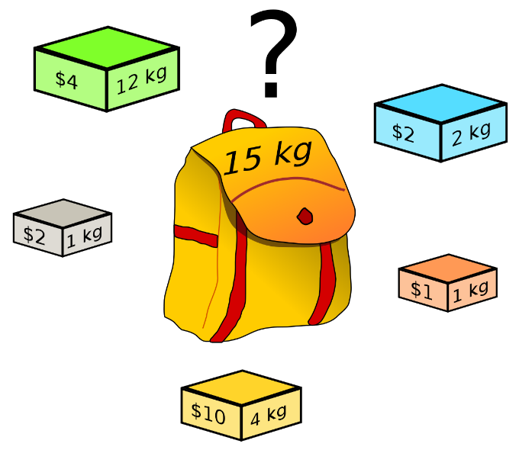

For example: the weight of the container is 15 Kg. We have to select the items in such a way that sum of the weight of all items is smaller or equal to 15 and the profit should be maximum.

There are two types of Knapsack:

* Fractional Knapsack
* 0/1 Knapsack

We are going to see 0/1 Knapsack ….

* What is 0/1 Knapsack ?

Suppose a thief wants to rob a store. He is carrying a knapsack(bag) of capacity some ‘W’. The store has ‘n’ items. Its weight is given by the ‘wt’ array and its value by the ‘val’ array.

He can either include an item in the bag or exclude it but can’t have fraction of item. We have to find the maximum number of items the thief can steal.

We use the approach of Dynamic Programming for 0/1 Knapsack Problem.

* **Dynamic Approach :** It is a programming technique where an algorithmic problem is first broken down into sub-problems, the results are saved, and the sub-problems are optimized to solve the overall problem

|  |  |  |
| --- | --- | --- |
| **item** | **weight** | **profit** |
| 1 | 2 | 3 |
| 2 | 3 | 4 |
| 3 | 4 | 5 |
| 4 | 5 | 6 |

Example:



Capacity of bag= W = 5kg

* number of items = n = 4
* weight of items = w
* profit = p

Sort the weights of the items if required, and write the profit aligned to it.

Sorted weights and profit aligned to it:

|  |  |  |  |  |
| --- | --- | --- | --- | --- |
| weight | 2 | 3 | 4 | 5 |
| profit | 3 | 4 | 5 | 6 |

**Step 1:** Draw a table (Tixw)

Draw a table ‘T’ with :

* Number of rows (n+1) = 4+1 = 5.
* Number of columns (w+1) = 5+1 = 6.
* Fill the 0th row(i=0) and 0th column(W=0) with 0.

**W**

|  |  |  |  |  |  |
| --- | --- | --- | --- | --- | --- |
| 0 | 1 | 2 | 3 | 4 | 5 |

|  |  |  |  |  |  |
| --- | --- | --- | --- | --- | --- |
| **0** | **0** | **0** | **0** | **0** | **0** |
| **0** | **0** | **3** | **3** | **3** | **3** |
| **0** | **0** | **3** | **4** | **4** | **7** |
| **0** | **0** | **3** | **4** | **5** | **7** |
| **0** | **0** | **3** | **4** | **5** | **7** |

|  |
| --- |
| 0 |
| 1 |
| 2 |
| 3 |
| 4 |
|  |

**i**

**Step 2:** Fill the first item in the bag.

Formula to be used:

**T[i,W] = max(T[i-1,W], T[i-1, W-w[i]] + p[i])**

Solution:

1.) i=1, p=3

* i=1, W=2

T[1,2] = max(T[0,2] , T[0,0] + 3)

T[1,2] = max(0 , 3)

**T[1,2] = 3**

* i=1, W=3

T[1,2] = max(T[0,3] , T[0,1] + 3)

T[1,2] = max(0 , 3)

**T[1,2] = 3**

* i=1, W=4

T[1,2] = max(T[0,4] , T[0,2] + 3)

T[1,2] = max(0 , 3)

**T[1,2] = 3**

* i=1, W=5

T[1,2] = max(T[0,5] , T[0,3] + 3)

T[1,2] = max(0 , 3)

**T[1,2] = 3**

2.) i=2 , p=4

* i=2, W=3

T[2,3] = max(T[1,3] , T[1,0] + 4)

T[2,3] = max(3,4)

**T[2,3] = 4**

* i=2, W=4

T[2,4] = max(T[1,4] , T[1,1] + 4)

T[2,4] = max(3 , 4)

**T[2,4] = 4**