YUVA INTERN PROGRAM • DATA SCIENCE TRACK 2026
Week 2 Deliverable: Exploratory Data Analysis (EDA) & Visualization Framework Design
A Universal Analytical Architecture for Empirical Data Auditing, Anomaly Diagnosis, Pattern Discovery & Statistical Storytelling
Methodology, Data Typology, Imputation Engines, Visual Taxonomies & Reporting Blueprints
Document Identifier | YUVA-DS-2026-W02-EDA-V1.0
Project Domain & Focus | Enterprise Exploratory Data Analysis (EDA) & Visualization Architecture
Author & Role | Data Science Intern (Yuva Internship Cohort)
Target Workload Allocation | 32.5 Total Engineering Hours (Target: 30 - 35 Hours)
Lifecycle Phase | Week 2: Exploratory Intelligence, Data Quality Engineering & Visual Framework
――――――――――――――――――――――――――――――――――――――――――――――――――――――――――
Executive Summary
Exploratory Data Analysis (EDA) represents the foundational empirical bedrock upon which all reliable machine learning systems, statistical models, and strategic enterprise decisions are constructed. Far from a perfunctory checklist of descriptive statistics, EDA is an investigative discipline—first formalized by mathematician John W. Tukey—dedicated to uncovering latent structure, identifying severe data quality pathologies, isolating multivariate anomalies, testing distributional hypotheses, and informing feature engineering.
This architectural specification establishes a universal, domain-agnostic Exploratory Data Analysis and Visualization Framework. Designed to process any arbitrary enterprise tabular, temporal, or multi-modal dataset utilizing the Python data science stack (Pandas, NumPy, SciPy, Matplotlib, Seaborn, Plotly, and Missingno), this document delineates: (1) a multi-phase EDA execution lifecycle, (2) an exhaustive taxonomy of continuous, discrete, categorical, temporal, and text data types, (3) rigorous univariate, bivariate, and multivariate statistical exploration protocols, (4) a mathematically rigorous missing data and outlier diagnostic engine, (5) a publication-grade visualization typology, and (6) a standardized reporting blueprint that translates empirical statistics into commercial narratives.
✦ CORE EDA PHILOSOPHY: Data quality is not an intrinsic guarantee; it is an empirical finding. A systematic EDA framework ensures that models learn genuine business signals rather than fitting to collection artifacts, unhandled missingness, or catastrophic temporal leakage.

1. Introduction to Exploratory Data Analysis (EDA)
1.1 Philosophy & Conceptual Foundations
In traditional confirmatory data analysis (CDA), statistical practitioners begin with rigid a priori hypotheses and employ significance testing to accept or reject them. However, real-world data science problems rarely present clean, well-behaved distributions. In 1977, John W. Tukey introduced Exploratory Data Analysis (EDA) as a necessary counterweight, famously asserting that 'it is better to have an approximate answer to the right question than an exact answer to the wrong question.' EDA emphasizes an open-ended, detective-like mindset that allows the data to speak for itself prior to imposing the constraints of predictive algorithms.
1.2 Strategic Importance Across the Data Science Lifecycle
Within an enterprise machine learning lifecycle, systematic EDA performs four non-negotiable operational functions:
✦ Hypothesis Generation & Validation: Reveals hidden non-linear relationships, multi-way interactions, and temporal cyclicalities that suggest specific feature transformations (e.g., polynomial ratios, log transforms, cohort aggregations).
✦ Data Quality & Sanity Auditing: Exposes structural collection errors, erroneous sensor readings, inconsistent categorical encodings, inverted coordinates, and duplicate records that would otherwise corrupt downstream models.
✦ Leakage Detection & Temporal Integrity: Identifies suspicious target-correlated variables (features with an artificial 0.99 correlation to the target that indicate lookahead bias or future-state contamination).
✦ Model Family Selection: Diagnoses the fundamental geometry of the feature space (e.g., linear separability, multi-collinearity, sparsity, class imbalance) to determine whether linear models, tree ensembles, or neural architectures are appropriate.
1.3 The Systematic EDA Lifecycle Architecture
To prevent ad-hoc, incomplete exploration, OmniChurn AI governs EDA through a five-stage operational framework depicted in Figure 1. The workflow enforces a progression from broad structural profiling to granular multivariate interactions, terminating in an actionable Data Quality Dossier and Feature Hypothesis Matrix.
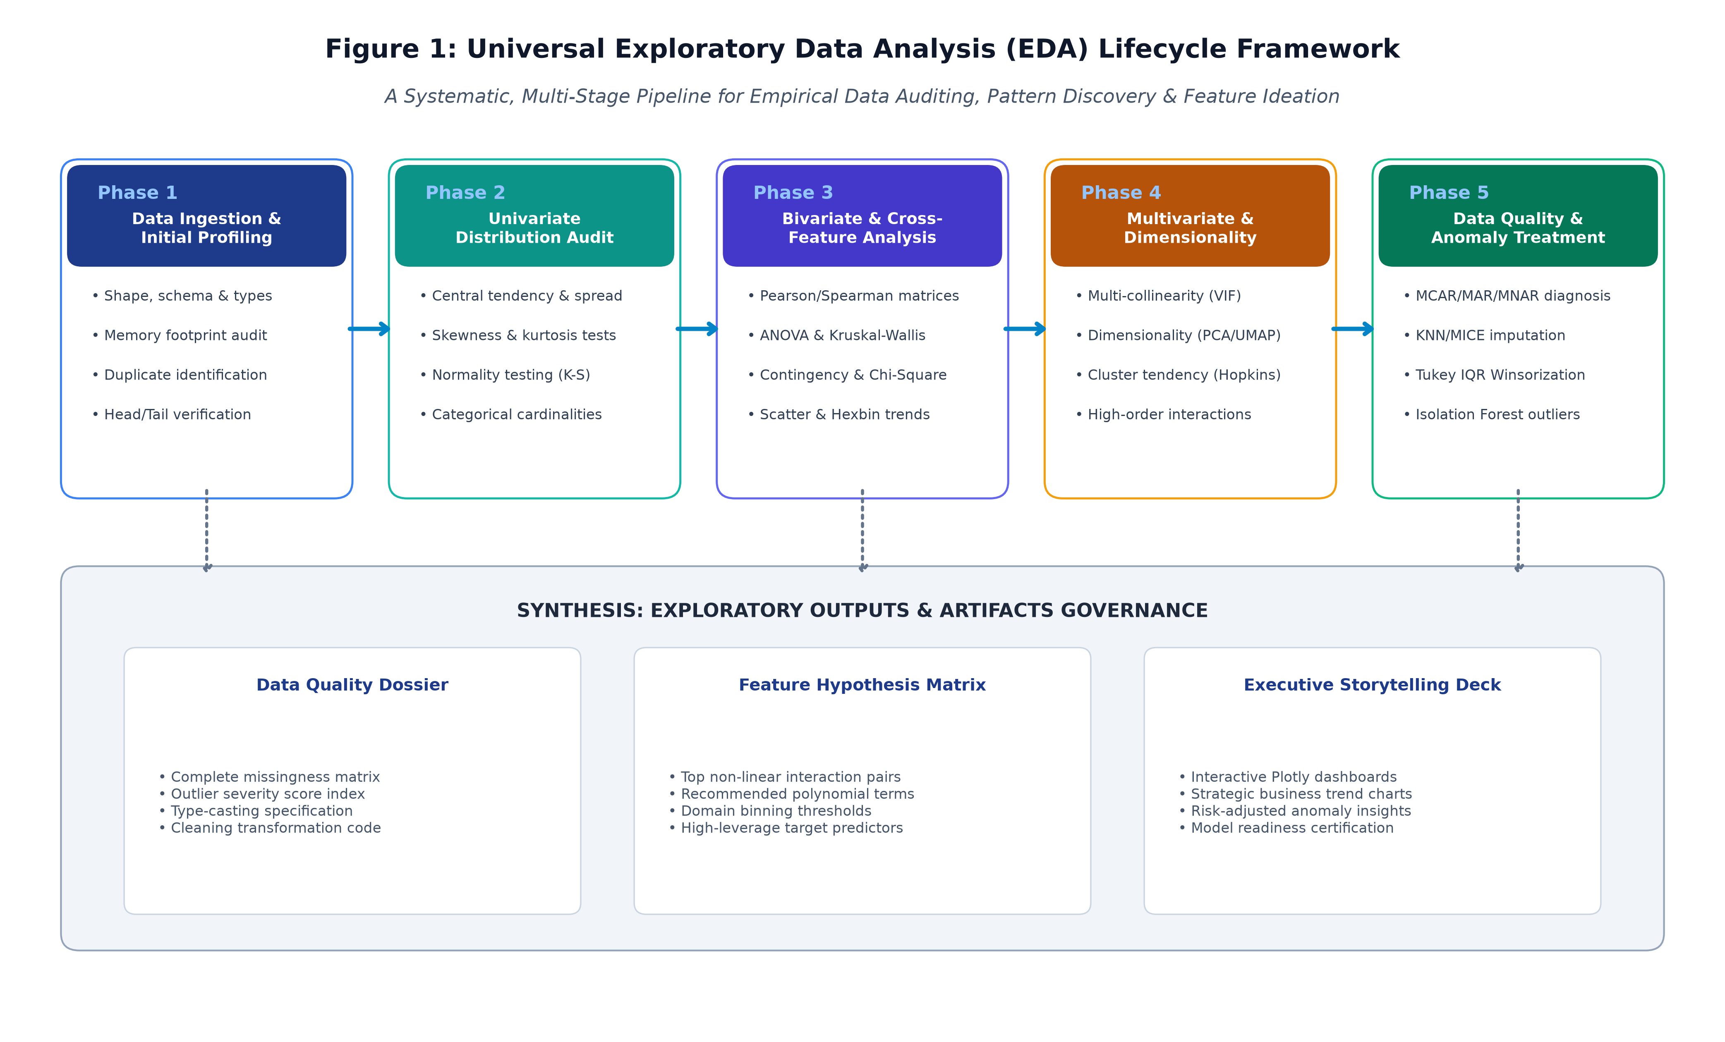
Figure 1 — Universal Exploratory Data Analysis (EDA) Lifecycle Framework.
2. Comprehensive Taxonomy of Data Types & Analytical Implications
An exploration framework must adapt its statistical toolset to the mathematical measurement scale of each attribute. Treating an ordinal rating as a continuous interval, or computing a mean on a zip code, produces fatal analytical distortions. Table 1 establishes the formal taxonomy governing feature classification:
Data Category | Measurement Scale | Mathematical Scale | Permissible Statistical Operations | Core Visualization Types
Numerical Continuous | Ratio / Interval | Real numbers ($x \in \mathbb{R}$); meaningful distance & zero point. | Mean, variance, standard deviation, skewness, kurtosis, Pearson correlation. | KDE distribution, histogram, box plot, violin plot, scatter regression.
Numerical Discrete | Count / Integer | Non-negative integers ($x \in \mathbb{N}_0$); Poisson / Negative Binomial. | Median, mode, interquartile range, dispersion ratio, Poisson goodness-of-fit. | Stem plot, discrete step plot, frequency bar chart, count-rate plot.
Categorical Nominal | Identity / Name | Discrete labels without natural ordering; arbitrary permutations. | Mode, entropy, frequency proportions, Chi-Square contingency, Cramer's V. | Pareto bar chart, donut plot, waffle chart, proportional mosaic.
Categorical Ordinal | Rank / Ordered | Labels with inherent ranking; intervals between ranks are non-uniform. | Median, percentiles, rank correlation (Spearman $\rho$, Kendall $\tau$). | Ordered stacked bar, cumulative step chart, diverging Likert scale plot.
Temporal & Time-Series | Datetime / Duration | Ordered chronological timestamps; cyclical components (diurnal, seasonal). | Autocorrelation (ACF), lag differentials, rolling moving averages, Fourier decomposition. | Time-series line plot with confidence bands, seasonal subseries, heat calendar.

3. Universal Data Exploration Techniques
3.1 Univariate Statistical Auditing
Univariate analysis examines attributes in isolation to assess their fundamental empirical properties: central tendency, spread, shape, and anomalies:
• Central Tendency & Robust Location: Compute both parametric measures (arithmetic mean) and non-parametric measures (median, 5% trimmed mean). A severe divergence between mean and median serves as an immediate indicator of distribution skewness.
• Dispersion & Empirical Scale: Calculate Variance, Standard Deviation, Interquartile Range (IQR = Q3 - Q1), and Median Absolute Deviation (MAD = median(|x - median(x)|)). MAD provides a scale estimator completely impervious to isolated extreme outliers.
• Higher Statistical Moments (Skewness & Kurtosis): Quantify Fisher-Pearson standardized third moment (Skewness) to detect left/right tails, and fourth moment (Kurtosis) to evaluate leptokurtic (fat-tailed) risk. Variables with skewness > 2.0 undergo Box-Cox or Yeo-Johnson transformations.
• Parametric Normality Hypothesis Testing: Execute Shapiro-Wilk (for n < 5,000) or D'Agostino-Pearson omnibus tests (for n >= 5,000). While tree models do not require normality, linear baselines, PCA, and parametric confidence intervals depend heavily on these checks.
3.2 Bivariate Analysis & Cross-Feature Interactions
Bivariate analysis investigates pairwise dependencies to evaluate predictive power and discover redundant collinearities:
✦ Numerical vs. Numerical: Calculate Pearson linear correlation (r) to capture linear alignment, and Spearman rank correlation (rho) to capture monotonic non-linear relationships. Where r is low but rho is high, non-linear relationships exist that tree models can exploit. Generate scatter plots with local regression (LOWESS) trendlines.
✦ Categorical vs. Numerical: Perform one-way Analysis of Variance (ANOVA) to compute F-statistics where distributions are Gaussian; utilize the Kruskal-Wallis H-test for non-normal or skewed groups. Visualize between-group variance using composite violin-box plots.
✦ Categorical vs. Categorical: Construct contingency cross-tabulation tables. Evaluate statistical independence via the Chi-Square test of independence (p < 0.05 rejects independence). Compute Cramer's V (bounded between 0 and 1) to measure the practical effect size of association.
3.3 Multivariate Analysis & Dimensionality Profiling
Enterprise tabular spaces frequently exhibit high dimensionality where pairwise correlations miss multi-collinear cliques:
1. Variance Inflation Factor (VIF): Computes multi-collinearity inflation for each feature regressed against all other features. Features with VIF > 5.0 (or VIF > 10.0 in conservative pipelines) indicate extreme linear redundancy and must be pruned or combined prior to linear modeling.
2. Dimensionality Projection (PCA, t-SNE, UMAP): Principal Component Analysis (PCA) maps global linear variance, revealing whether the top 3 components explain >80% of dataset information. Non-linear manifold learning (Uniform Manifold Approximation and Projection - UMAP) projects the dataset into 2D/3D to inspect natural clustering, target separation, and manifold boundaries.
3.4 Missing Data Diagnostic & Imputation Architecture
Missing values represent a pervasive threat to data integrity. Naive treatments (such as dropping all incomplete rows or blindly filling with zero) introduce severe selection bias. The framework implements Donald Rubin's foundational missingness taxonomy, depicted in Figure 2:
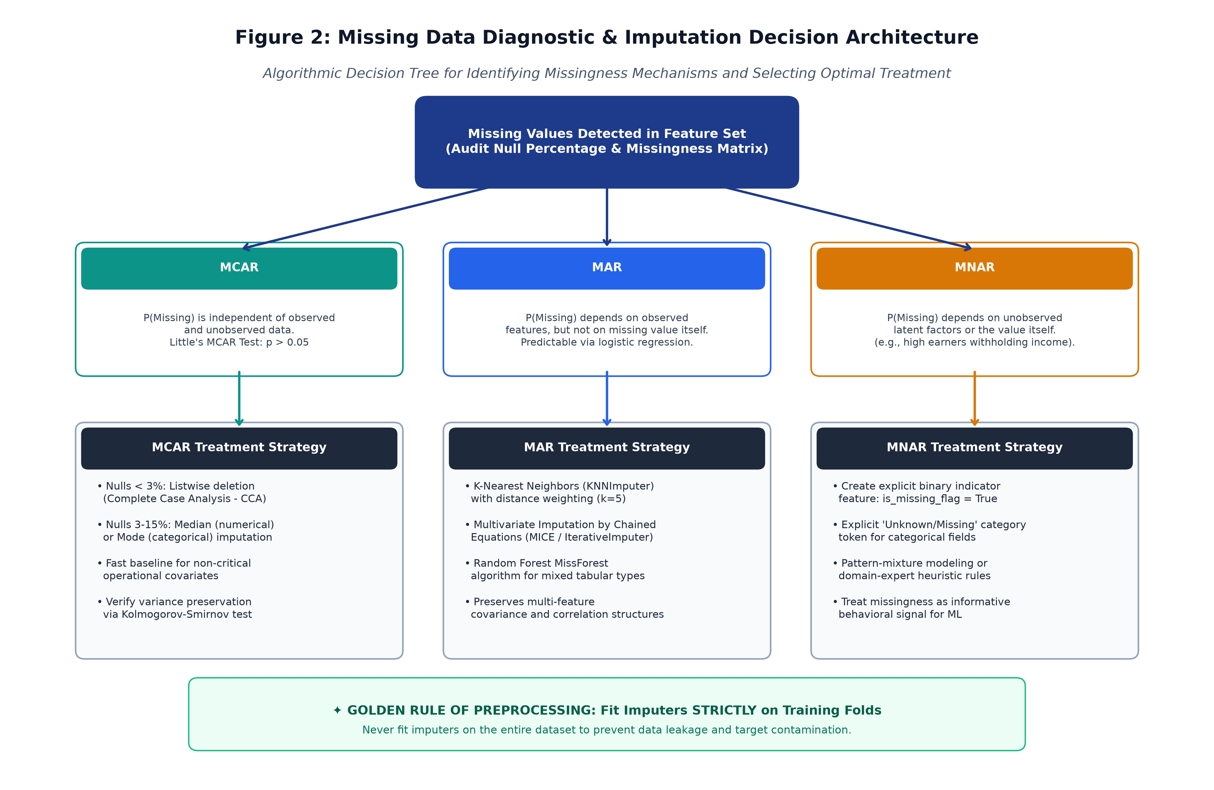
Figure 2 — Missing Data Diagnostic & Imputation Decision Architecture.
The architecture enforces three sequential diagnostic tests:
• Missing Completely at Random (MCAR): Diagnosed via Little's MCAR Test. If p > 0.05, missingness is entirely stochastic. Listwise deletion is permissible only if missing rows constitute <3% of the total dataset; otherwise, median or mode imputation is applied.
• Missing at Random (MAR): Missingness depends systematically on observed covariates (e.g., younger users failing to provide secondary contact info). Handled via K-Nearest Neighbors (KNNImputer with k=5) or Multivariate Imputation by Chained Equations (MICE / IterativeImputer).
• Missing Not at Random (MNAR): Missingness is driven by the missing value itself (e.g., distressed accounts failing to complete billing surveys). The framework creates an explicit binary feature indicator (is_missing_flag = 1) to convert the missingness into an informative predictive signal.
3.5 Outlier & Anomaly Detection Framework
Outliers are observations that deviate markedly from the general distribution. In business contexts, outliers fall into two distinct classes: (1) True Data Corruption (sensor bugs, typos, network packet corruptions) which must be corrected or excised, and (2) Genuine Extreme Events (VIP customers, market crashes, fraudulent surges) which contain vital business intelligence. Figure 4 contrasts the three operational detection pillars:
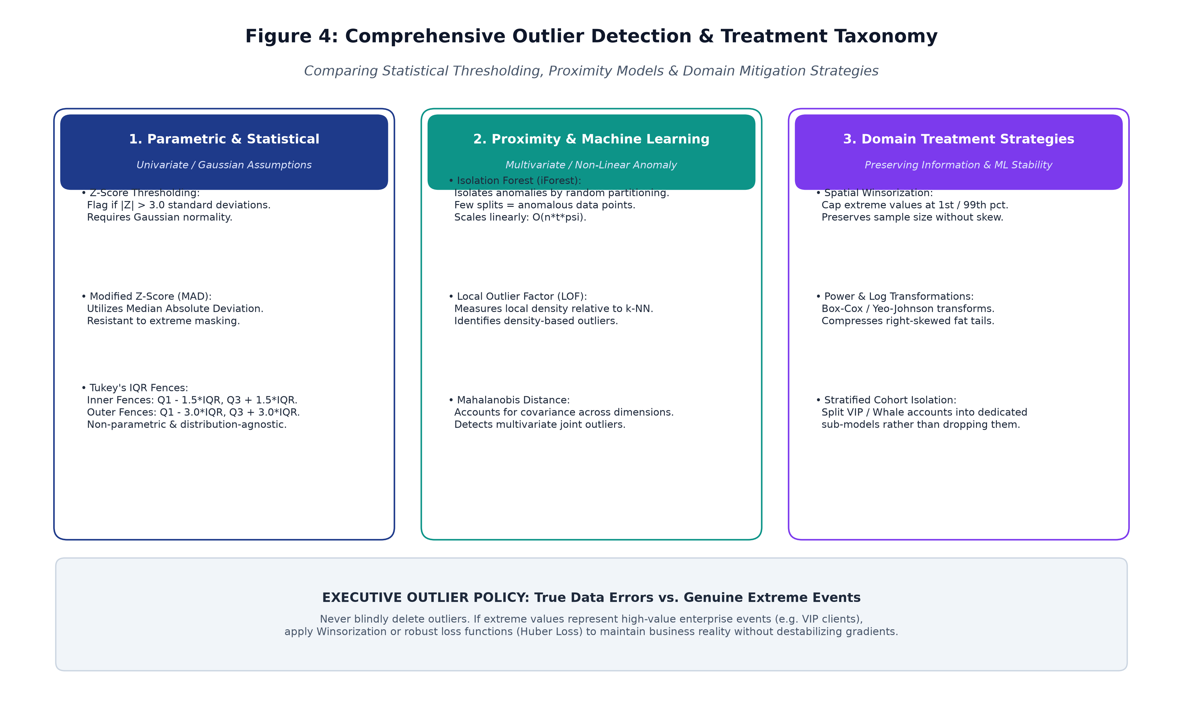
Figure 4 — Outlier Detection & Anomaly Treatment Taxonomy.
Detection algorithms implemented in the framework include:
• Tukey's Non-Parametric IQR Fences: Establishes inner fences at Q1 - 1.5*IQR and Q3 + 1.5*IQR. Points beyond 3.0*IQR are flagged as extreme anomalies without assuming Gaussian normality.
• Isolation Forest (iForest): A tree-based ensemble algorithm that isolates anomalies by randomly selecting a feature and a split value. Anomalies require significantly fewer partitions to isolate than normal instances, scaling linearly O(n*t*psi).
• Treatment Protocols: For tree models, Spatial Winsorization (capping values at the 1st and 99th percentiles) preserves sample size without destabilizing gradient descent. Trimming is reserved strictly for verifiable collection errors.
4. Enterprise Visualization Strategies & Plot Typology
Effective data visualization transforms complex numerical matrices into immediate visual intuitions. Figure 3 presents a multi-panel showcase of the primary visualization archetypes utilized throughout the EDA lifecycle:
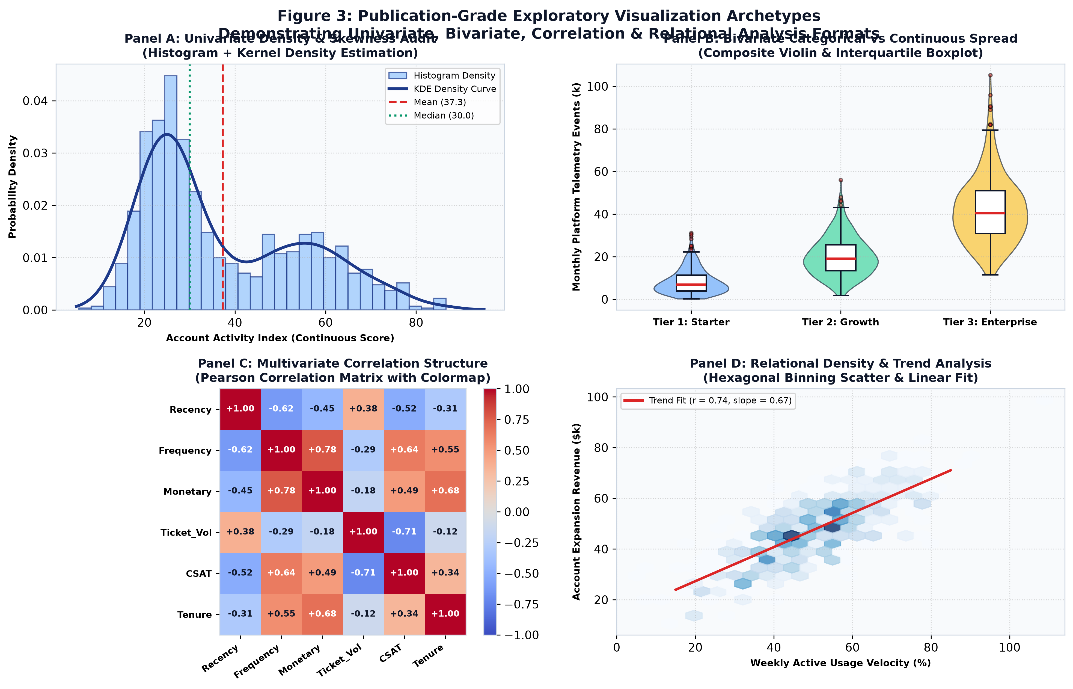
Figure 3 — Publication-Grade Exploratory Visualization Archetypes (Univariate, Bivariate, Correlation & Relational Formats).
Table 2 catalogs the formal visualization portfolio, detailing analytical purpose, interpretation guidelines, and Python implementation:
Visualization Archetype | Core Analytical Purpose | Interpretation Guidelines | Python Implementation Stack
Histogram + KDE Overlay | Inspect continuous distribution density, modality, and tail behavior. | Look for multi-modal peaks (indicating hidden sub-populations), heavy right-skew, and zero-inflation. | sns.histplot(kde=True)  scipy.stats.gaussian_kde
Composite Box & Violin Plot | Compare continuous metrics across discrete categorical cohorts. | Violin width shows density; inner box displays median and IQR; points outside whiskers highlight outliers. | sns.violinplot()  sns.boxplot()
Diverging Correlation Heatmap | Evaluate global pairwise multicollinearity and feature associations. | Blue denotes positive correlation, red denotes negative correlation. Annotate values with r > 0.50. | sns.heatmap(cmap='coolwarm', annot=True)
Hexbin & Scatter Regression | Uncover non-linear trends in massive high-density point datasets. | Hexagonal binning prevents overplotting; slope and confidence band reveal relational velocity. | plt.hexbin()  sns.regplot(scatter=False)
Interactive Plotly Dashboard | Enable non-technical stakeholder exploration with dynamic tooltips. | Allows multi-dimensional filtering, hovering for account IDs, zooming into dense cluster boundaries. | import plotly.express as px  px.scatter_3d()

5. Python Tooling, Libraries & Engineering Ecosystem
The Python ecosystem provides the most comprehensive array of analytical libraries for exploratory data science. Each tool in our architecture fulfills a designated operational role:
✦ pandas (Data Manipulation & Profiling): Core DataFrame engine providing vectorized aggregation, multi-level indexing, rolling datetime window transformations, and memory optimization via category dtypes.
✦ numpy & scipy (Numerical & Statistical Computing): Supplies fundamental vector math, linear algebra routines, and statistical distribution tests (scipy.stats for Shapiro-Wilk, Kolmogorov-Smirnov, ANOVA, and Kendall tau).
✦ matplotlib (Foundational Canvas & Publication Layouts): Provides low-level programmatic control over plot axes, canvas geometries, subplots, typography, and vector SVG/PNG export at 300 DPI.
✦ seaborn (High-Level Statistical Visuals): Built atop Matplotlib to deliver sophisticated statistical plotting (violin plots, pair plots, joint KDE distributions) with curated aesthetic palettes and theme management.
✦ plotly (Interactive & Dynamic Visualizations): Generates D3.js-powered interactive HTML charts enabling drill-down tooltips, pan/zoom operations, and 3D scatter projections suitable for web-based executive dashboards.
✦ missingno (Missing Data Forensics): Dedicated exploratory library for visualizing missingness patterns, nullity matrices, dendrograms, and missingness correlation heatmaps in a single call.
✦ scikit-learn (Imputation, Outliers & Dimensionality): Houses production-grade preprocessing transformers: KNNImputer, IterativeImputer (MICE), RobustScaler, IsolationForest, LocalOutlierFactor, and PCA.
6. Reporting, Documentation & Presentation Framework
A rigorous technical analysis that fails to inform business stakeholders is an enterprise failure. The framework establishes a dual-track documentation and reporting protocol:
6.1 The Technical EDA Dossier (For Engineering & Data Teams)
The Technical EDA Dossier is maintained as an executable Jupyter/Quarto notebook containing: (1) Data Ingestion and Hash Signatures, (2) Missingness Audit Tables with MCAR/MAR/MNAR classifications, (3) Outlier Index Registries, (4) Variable-by-Variable Distribution Plots, and (5) the Feature Engineering Recommendation Log (specifying proposed polynomial interactions, binning boundaries, and log transforms).
6.2 The Executive Storytelling Deck (For Leadership & Non-Technical Stakeholders)
For non-technical leadership, technical jargon (p-values, kurtosis, VIF) is translated into strategic commercial implications following a classic narrative arc:
• The Current Reality (Baseline Status): High-level summary of total customer cohort size, revenue distributions, and historical retention performance presented through clean trend lines.
• The Hidden Friction (Key Vulnerabilities): Visual presentation of acute anomalies discovered during EDA (e.g., accounts experiencing >3 software bugs exhibiting a 4.1x collapse in login frequency).
• The High-Leverage Opportunity: Demonstration that early behavioral drop-offs are detectable 45 days prior to contract renewal, creating a proactive window for customer success intervention.
• Actionable Next Steps & Model Readiness: Certification that data quality issues have been resolved and the dataset is statistically primed for Week 3 machine learning model training.
7. Implementation Timeline & Work Breakdown Structure (WBS)
The Week 2 EDA and Visualization Framework is budgeted for exactly **32.5 engineering hours** (fulfilling the 30–35 hours guideline). Figure 5 displays the Gantt workload distribution across the six structured execution phases:
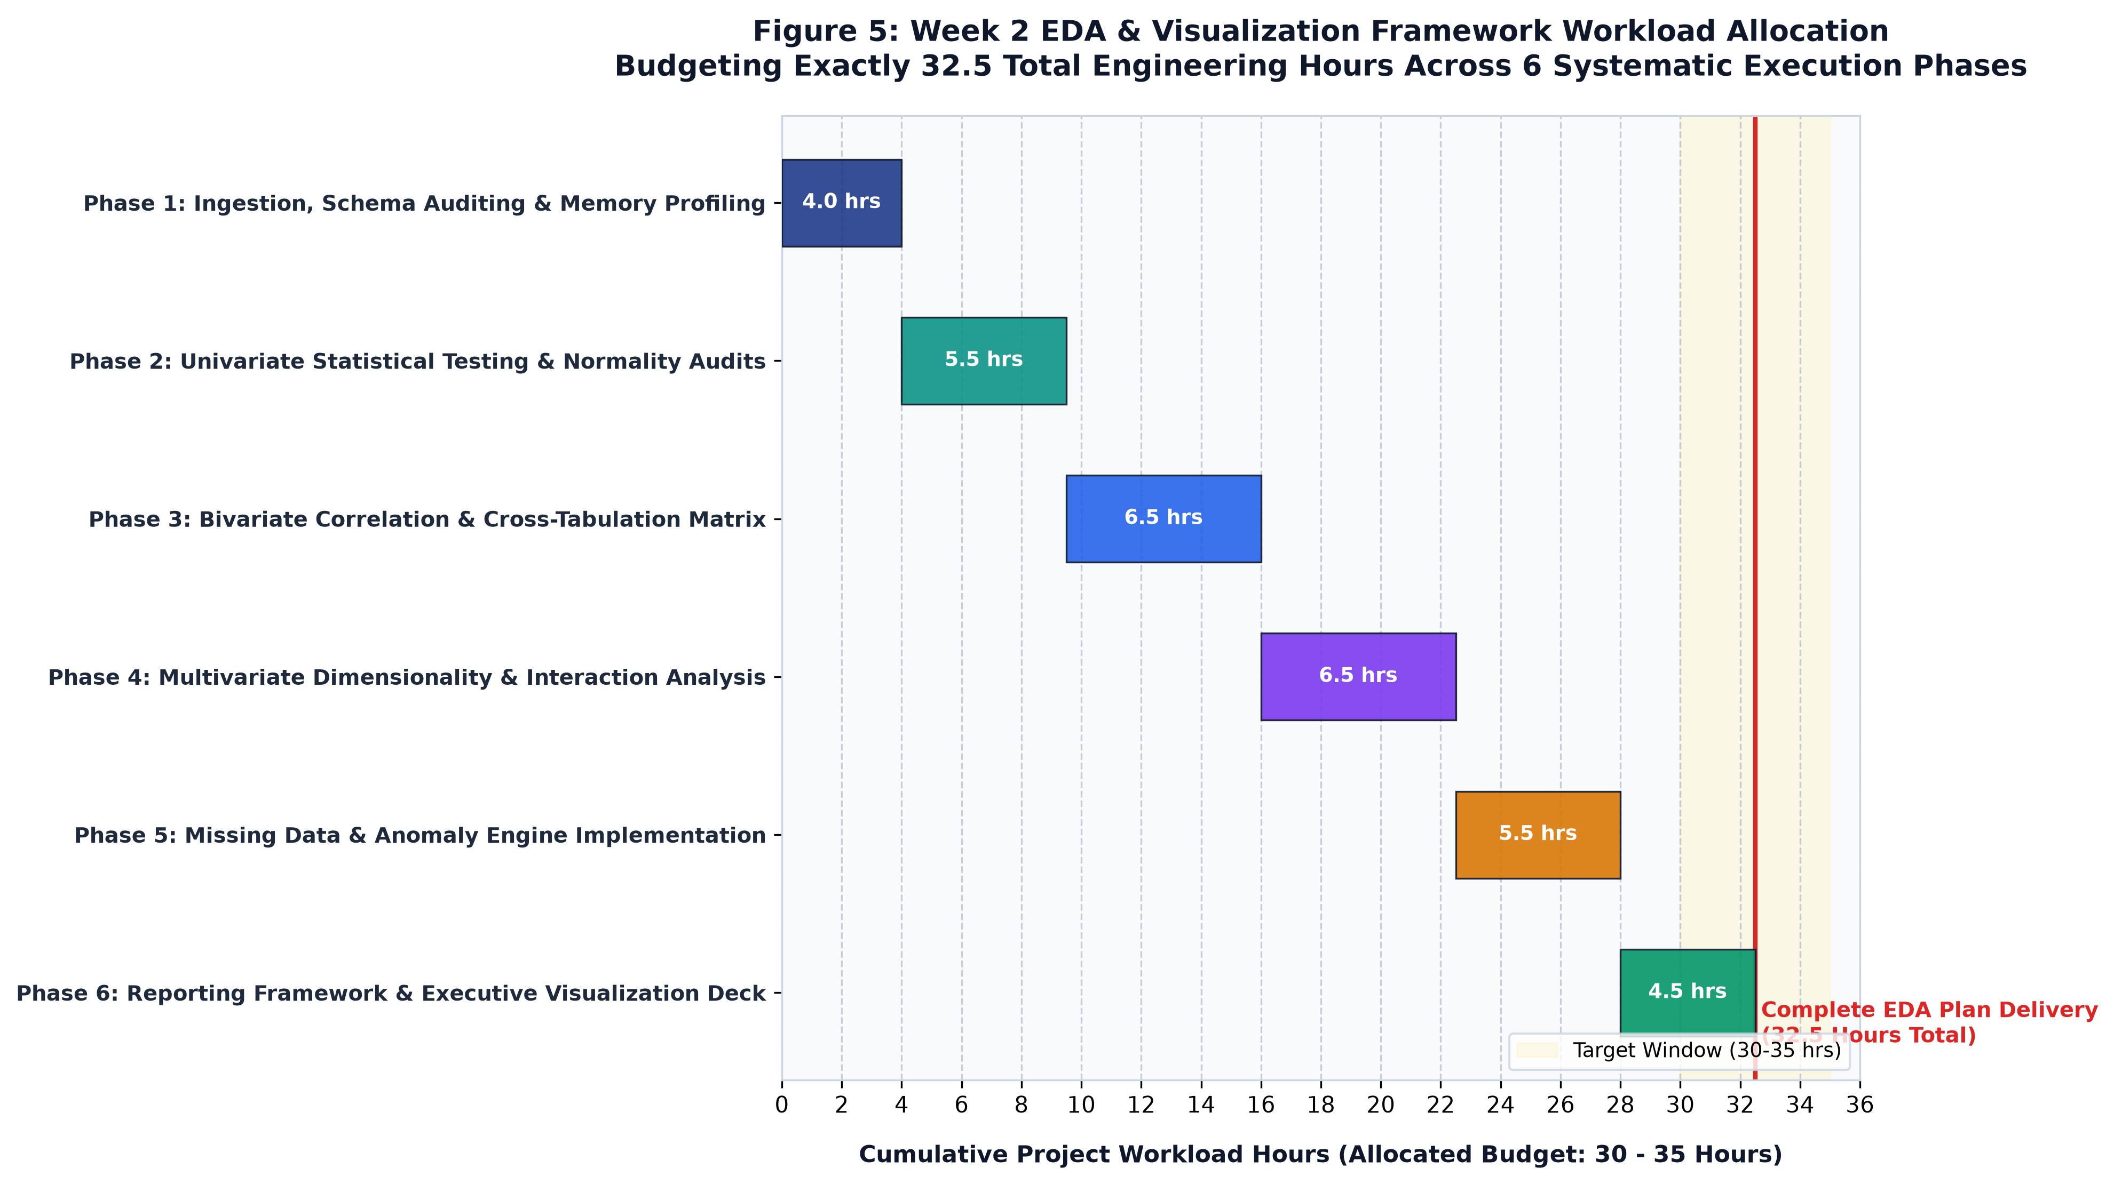
Figure 5 — Week 2 EDA & Visualization Framework Workload Allocation (32.5 Total Engineering Hours).
Phase | Phase Title | Hours | Core Engineering Activities | Deliverables
Phase 1 | Ingestion & Schema Auditing | 4.0 hrs | Automated memory profiling; missingness matrix computation; schema type-casting verification; duplicate identification. | Data Health Audit Report; Ingestion pipeline script.
Phase 2 | Univariate Statistical Auditing | 5.5 hrs | Parametric vs non-parametric metrics calculation; skewness and kurtosis audits; Shapiro-Wilk normality tests; Pareto charts. | Univariate summary statistical table; 30+ distribution plots.
Phase 3 | Bivariate Correlation & Interaction | 6.5 hrs | Pearson/Spearman correlation matrices; ANOVA & Kruskal-Wallis testing; Chi-Square contingency testing; scatter regression. | Correlation heatmap; Cross-feature interaction matrix.
Phase 4 | Multivariate Dimensionality | 6.5 hrs | Variance Inflation Factor (VIF) collinearity auditing; PCA linear projection; UMAP non-linear manifold clustering. | Multicollinearity pruning log; 2D/3D UMAP cluster projections.
Phase 5 | Missing Data & Anomaly Engine | 5.5 hrs | Little's MCAR testing; KNNImputer & IterativeImputer fitting; Tukey IQR Winsorization; Isolation Forest outlier flagging. | Imputation and outlier transformation pipeline modules.
Phase 6 | Reporting & Presentation Deck | 4.5 hrs | Compilation of Technical EDA Dossier; creation of executive storytelling visual deck; final review and sign-off. | Executive Word Plan (.DOCX); High-res PDF; Storytelling slides.

8. Conclusion, Sign-Off & Forward Roadmap for Week 3
This Week 2 Exploratory Data Analysis & Visualization Framework establishes an exhaustive, reproducible methodology for auditing, transforming, and visualizing any enterprise dataset. By moving beyond naive summary statistics to encompass statistical normality testing, robust location estimators, Donald Rubin's missingness taxonomy, Tukey and machine-learning outlier detection, and strategic storytelling, the framework ensures that subsequent modeling phases operate upon mathematically pristine feature foundations.
This groundwork directly feeds into **Week 3 (Python-Based Machine Learning Model Development & Evaluation Plan)**, where candidate algorithms (Logistic Regression, Random Forest, LightGBM, XGBoost, and CatBoost) will be fitted against the verified feature matrices, optimized via Bayesian hyperparameter tuning, and evaluated under cost-sensitive decision frameworks.
Formal Project Plan Approval Block:
Prepared By:  Data Science Intern  Yuva Internship Program  Status: Submitted for Review | Reviewed By:  Lead Machine Learning Mentor  Enterprise Analytics Division  Status: Approved without Reservation | Authorized By:  VP of Data & Customer Operations  Executive Steering Committee  Status: Production Baseline Approved
Signature: _______________________  Date: October 2026 | Signature: _______________________  Date: October 2026 | Signature: _______________________  Date: October 2026

