| **Dynamic Table**  *“Generates an HTML table dynamically from array data using JavaScript.”*  **Developed By: Gaurvi Paneri**  14 August, 2025.  BrainyBeam Placement Task-2 |
| --- |

# **Table of Contents**

1. **Introduction** *Overview and purpose of the Expense Sharing App*
2. **Objective** *What app aims to achieve and why*
3. **Features** *Description of key functionalities*
4. **Technology Stack** *Tools and libraries used in the project*
5. **Application Architecture** *Explanation of frontend structure and data flow*
6. **Implementation Details** *Key code logic, components, and state management*
7. **Usage Instructions** *How to run and use the app locally*
8. **Challenges and Solutions** *Challenges that were faced along with their solutions*
9. **ScreenShots**

*Screenshots of the output*

1. **Conclusion** *Summary of the project and learnings.*
2. **References** *Resources and documentation referred to during development*

### **1. Introduction**

The Dynamic Table project demonstrates how to generate an HTML table using JavaScript based on data stored in an array of objects. Table headers are created from the keys of the first object, and rows are populated automatically from the corresponding values. This approach eliminates the need for manually coding table rows in HTML, making it flexible and adaptable to different datasets.

### **2. Objectives**

* The objective of this project is to create a table that is built dynamically from array data using JavaScript, ensuring that the structure and content adapt automatically without requiring manual modification of HTML elements.

### **3. Features**

The key features of the task include:

1. Generates table headings automatically from the keys of the **first object** in the data array.
2. Dynamically creates rows and cells based on the array’s values.
3. No need to manually write <tr> or <td> tags in HTML.
4. If new keys are added to later objects (but not in the first one), they will create extra empty cells without corresponding headers.

### **4. Tech Stack**

* **HTML5: Structures the table and the page**
* CSS: Styling of the table and Layout
* JavaScript: Handles the logic to dynamically create headers and rows based on predefined data array.

### **5. Application Architecture**

1. **Folder Structure**

**Dynamic_Table**

**├──DynamicTable.html→***Main HTML File*

**└──**[**README.md**](http://readme.md)**→***Documentation*

1. **Main Components & Responsibilities**

* **Dynamicable.html** :This file is the main file that contains HTML, CSS and JavaScript code to structure style and handle the logic of the dynamic table

1. **Data Flow**

* **Data Source** → A JavaScript array of objects holds the table data.
* **Processing** → The script reads the keys of the first object to create table headers.
* **Rendering** → For each object, the script loops through values and generates table rows dynamically.
* **Output** → The completed table is inserted into the HTML DOM and displayed to the user.

### **6. Implementation Details**

* The project uses a single HTML file containing **HTML**, **CSS**, and **JavaScript**.
* A JavaScript array of objects stores the table data.
* The function **createTableFromArray()**:  
  + Reads keys from the first object to generate table headers dynamically.
  + Loops through each object’s values to create table rows and cells.
  + Appends the generated **<thead>** and **<tbody>** to the **<table>** element.
* The generated table is inserted into a container **<div>** in the HTML DOM.
* Styling is applied using basic CSS for borders, spacing, and alignment.

## **7. Usage Instructions**

### **Running the Task Locally**

**Prerequisites:**

* A modern web browser (Chrome, Firefox, Edge, etc.).

1. **Installation and Running Process:**

* Clone the project repository to your local machine:  
   **git clone https://github.com/Gaurvi-P/Javascript_Task_2_DynamicTable.git**
* Navigate to the project folder:  
  **cd Javascript_Task_2_DynamicTable.git**
* Open the **DynamicTable.html** File in any web browser.

Or

Use Go Live in VS Code to Launch it.

* Table will be generated automatically from the array data in the script

1. **Using the App:**

* Open the project folder.
* Locate the file DynamicTable.html.
* Open it in any modern web browser (Chrome, Edge, Firefox, etc.).
* The table will be generated automatically from the predefined JavaScript array.
* To change the data, edit the array values in the JavaScript code and refresh the page.

### **8. Challenges Faced & Solutions**

* No significant challenges were encountered during the development of this project. The implementation was straightforward.

**9. Screenshots**

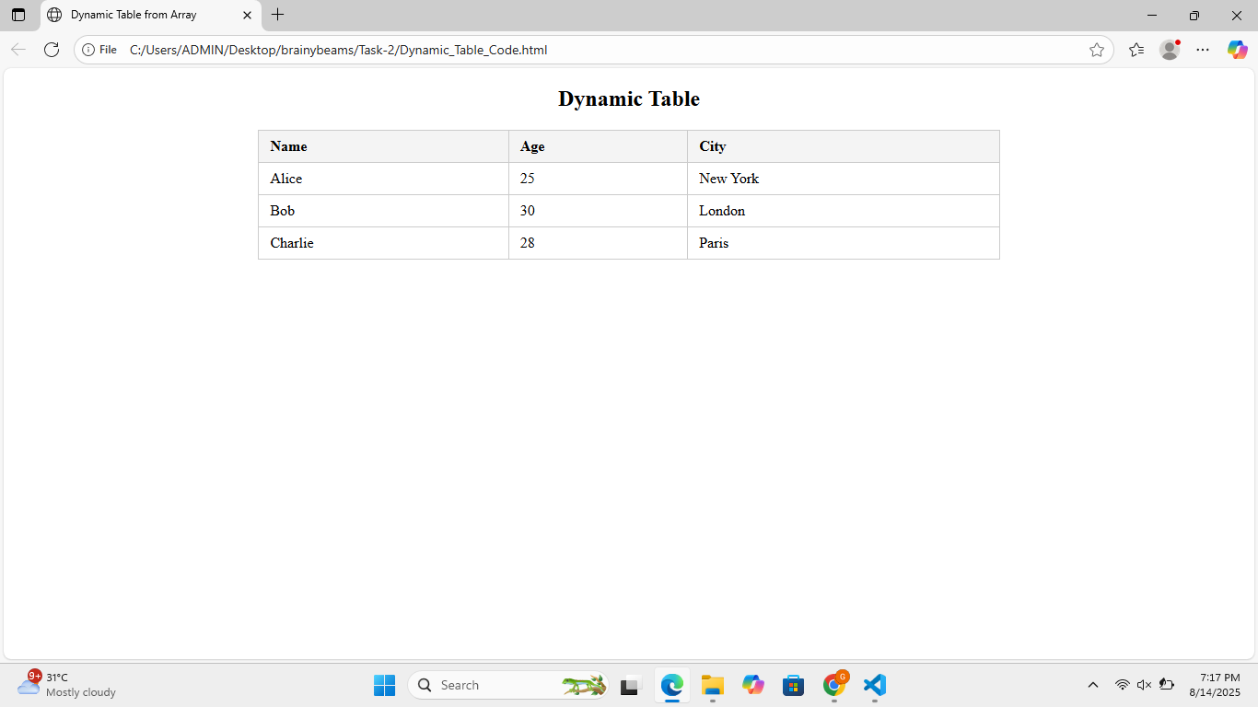

### **9. Conclusion**

The Dynamic Table project successfully demonstrates how JavaScript can be used to generate HTML tables directly from array data. This approach simplifies table creation, reduces repetitive code, and makes the structure easily adaptable for future changes in data.

### **10. References**

* [MDN Web Docs](https://developer.mozilla.org/en-US/)
* [W3Schools](https://www.w3schools.com/)