Software Requirements Specification (SRS)
Online Bookstore

Team: Team 12
Members: Dhanush V Biradar (PES2UG24CS141) | D Sai Karthik (PES2UG24CS155) | Gautam Krishna (PES2UG24CS169) | G Nikhil (PES2UG24CS165)
Version: 1.1
Date: 04-09-2026
Status: Draft for Review — Revised for template compliance

Revision history
Version | Date | Author | Change summary | Approval
1.0 | 04-09-2026 | Team 12 | Initial SRS draft with diagrams embedded | Pending
1.1 | 04-09-2026 | Team 12 | Expanded BOOK-F-009..023 into individual requirement rows; corrected RTM with 3s target and full 33-row trace; renamed PRJ-SR-* to BOOK-SR-*; corrected UML relationship; standardized MERN stack | Pending

Approvals
Role | Name | Signature / Email | Date
Course Coordinator

Table of Contents
1. Introduction
2. Overall description
3. External interfaces
4. System features (detailed)
5. Non-functional requirements (detailed)
6. Quality attributes & Acceptance tests
7. UML Use-Case Diagrams
8. Requirements Traceability Matrix (RTM)

1. Introduction

1.1 Purpose
This document is a Software Requirements Specification (SRS) for the Online Bookstore, an e-commerce platform for buying and selling books. It defines the functional and non-functional requirements, interfaces, and verification criteria for the system, intended as a reference for developers, testers, and evaluators.

1.2 Scope
Covers buyer-facing browsing, search, cart, checkout and order tracking; seller-facing listing creation and sales management; and administrator moderation, analytics, and platform monitoring. Excludes physical warehousing/logistics operations beyond the shipping-status API integration, and excludes core payment-gateway internal implementation beyond its public API.

1.3 Audience
Developers, QA Engineers, Project Mentors, and Assessment Evaluators.

1.4 Definitions
List of acronyms: ISBN, UI, API, JWT, OTP, TLS, MERN, RTO (Return-to-Origin), RTM, PCI-DSS, XSS.

2. Overall description

2.1 Product perspective
The Online Bookstore is a web-based marketplace connecting book buyers and sellers. It comprises a React frontend, a Node.js/Express backend, MongoDB persistence, and integration with a third-party payment gateway and an email/notification service.

2.2 Major product functions
- Register, authenticate, and manage user profiles
- Browse and search the book catalog
- Create and manage book listings (seller)
- Shopping cart, coupons, and checkout
- Payment processing and invoicing
- Order tracking, cancellation, and returns
- Ratings and reviews
- Administrative moderation and analytics

2.3 User roles and characteristics
- Buyer: general public with basic web/e-commerce familiarity; expects fast search and a simple checkout.
- Seller: individual or small vendor listing used/new books; needs a simple listing and sales-tracking flow.
- Administrator: platform operator responsible for moderation, dispute handling, and analytics.

2.4 Operating environment
Modern web browsers (Chrome, Firefox, Edge, Safari) on desktop and mobile; React frontend; Node.js/Express backend; MongoDB for persistence; backend deployed on a cloud VM/container platform.

2.5 Constraints
PCI-DSS considerations for any payment data in transit, use of an approved third-party payment gateway (no raw card storage), and delivery timelines dependent on third-party shipping/courier APIs.

3. External interface requirements

3.1 User interfaces
Responsive web UI with a clear navigation structure (Home, Catalog, Cart, Orders, Seller Dashboard, Admin Panel). Accessible form labels and sufficient colour contrast for readability.

3.2 Hardware interfaces
None beyond standard client devices (desktop/laptop/mobile) with a web browser and internet connectivity.

3.3 Software interfaces
- Payment Gateway API (Razorpay/Stripe-style, JSON over TLS) for checkout and refunds
- Email/Notification service API for order confirmations, OTPs, and alerts
- Shipping/Courier partner API for tracking updates (optional/simulated for the course project)

3.4 Communications
TLS 1.2+ enforced for all client-server and server-to-third-party traffic; JWT-based session tokens for authenticated API calls.
Requirement summary: 23 functional requirements across 7 feature areas, 5 non-functional requirements, 4 security objectives, and 5 security requirements.

4. System features (detailed)
Each requirement below is individually specified with type, priority, source, acceptance criteria, and a reference test case. IDs follow BOOK-F-###.

4.1 User Authentication & Account Management
Description: Allow visitors to register, authenticate securely, recover access, and manage their profile.
Req ID | Requirement (shall...) | Type | Priority | Source | Acceptance Criteria / Test | Comments
BOOK-F-001 | The system shall allow a visitor to register an account with a unique email, name, and a password meeting complexity rules. | Functional | High | All Users | AC-001: Duplicate email is rejected; weak password rejected. Test: TC-Auth-01 | Email verification required
BOOK-F-002 | The system shall authenticate registered users via email and password, storing only salted-hashed passwords. | Functional | High | Security | AC-002: Correct credentials create a session; wrong password denied. Test: TC-Auth-02 | bcrypt/Argon2 hashing
BOOK-F-003 | The system shall allow a user to reset a forgotten password via a time-limited email link. | Functional | Medium | Support | AC-003: Link expires after 30 min; reused link rejected. Test: TC-Auth-03 | Link is single-use
BOOK-F-004 | The system shall let a user view and edit their profile and manage multiple shipping addresses. | Functional | Medium | Business | AC-004: Edited profile persists and default address is usable at checkout. Test: TC-Auth-04 | -

4.2 Catalog & Search
Description: Allow buyers to discover books through browsing, search, and filtering.
Req ID | Requirement (shall...) | Type | Priority | Source | Acceptance Criteria / Test | Comments
BOOK-F-005 | The system shall let any visitor browse the book catalog by category/genre without logging in. | Functional | High | Business | AC-005: Category page lists all active listings in that category. Test: TC-Cat-01 | Guest access allowed
BOOK-F-006 | The system shall provide keyword search across title, author, and ISBN with pagination. | Functional | High | Business | AC-006: Search for a known title returns it within top results in <2s. Test: TC-Cat-02 | Indexed search field
BOOK-F-007 | The system shall display a book detail page showing price, condition, seller, stock, and description. | Functional | High | Business | AC-007: Detail page renders all fields for any active listing. Test: TC-Cat-03 | -
BOOK-F-008 | The system shall allow filtering and sorting of search/browse results by price, rating, and availability. | Functional | Medium | UX | AC-008: Sorting by price ascending reorders results correctly. Test: TC-Cat-04 | -

4.3 Book Listing & Selling
Description: Allow verified sellers to create and manage listings and monitor performance.
Req ID | Requirement (shall...) | Type | Priority | Source | Acceptance Criteria / Test | Comments
BOOK-F-009 | The system shall allow a verified seller to create a book listing with title, author, ISBN, price, condition, cover image, and stock count. | Functional | High | Business | AC-009: Listing is created with all mandatory fields validated (ISBN format checked) and appears in the seller's active listings. Test: TC-List-01 | Requires ISBN format validation
BOOK-F-010 | The system shall allow a verified seller to edit an existing listing's details (price, condition, stock, description). | Functional | Medium | Business | AC-010: Edited fields persist and are reflected on the live listing immediately. Test: TC-List-02 | -
BOOK-F-011 | The system shall allow a verified seller to remove (deactivate) an existing listing, and shall automatically flag duplicate or suspicious listings for moderation. | Functional | High | Security / Business | AC-011: Removed listing no longer appears in the catalog; a duplicate ISBN or suspicious listing raises a moderation flag. Test: TC-List-03 | Feeds admin moderation queue (BOOK-F-022)
BOOK-F-012 | The system shall provide sellers with a dashboard summarising active listings, order status, and earnings. | Functional | Medium | Business | AC-012: Dashboard totals match the underlying listing/order/earnings records. Test: TC-List-04 | -

4.4 Cart & Checkout
Description: Allow buyers to manage a cart, apply discounts, and complete payment.
Req ID | Requirement (shall...) | Type | Priority | Source | Acceptance Criteria / Test | Comments
BOOK-F-013 | The system shall allow a buyer to add and remove books from a persistent shopping cart that survives across sessions. | Functional | High | Business | AC-013: Cart contents persist after logout/login; a removed item is no longer counted in the cart total. Test: TC-Cart-01 | Requires user-linked cart storage
BOOK-F-014 | The system shall allow a buyer to apply a valid coupon/discount code at checkout and shall reject expired or invalid codes. | Functional | Medium | Business | AC-014: A valid code reduces the order total correctly; an invalid/expired code is rejected with a message. Test: TC-Cart-02 | -
BOOK-F-015 | The system shall allow a buyer to select a saved shipping address or add a new one during checkout. | Functional | High | UX | AC-015: The selected or new address is attached to the order at checkout confirmation. Test: TC-Cart-03 | -
BOOK-F-016 | The system shall allow a buyer to complete payment through an integrated payment gateway (card / UPI / wallet) and shall confirm the transaction before finalising the order. | Functional | High | Business / Security | AC-016: Successful payment generates a confirmed order; failed payment leaves the cart intact and the order unconfirmed. Test: TC-Pay-01 | Depends on Payment Gateway API (3.3)

4.5 Order Management
Description: Confirm, track, and manage the lifecycle of a placed order.
Req ID | Requirement (shall...) | Type | Priority | Source | Acceptance Criteria / Test | Comments
BOOK-F-017 | The system shall generate an order confirmation and a downloadable invoice immediately upon successful payment. | Functional | High | Business | AC-017: The invoice PDF is downloadable and matches the order line items and totals. Test: TC-Ord-01 | -
BOOK-F-018 | The system shall allow a buyer to track order status through defined stages (Placed / Shipped / Out for Delivery / Delivered). | Functional | High | Business | AC-018: The status shown to the buyer matches the latest shipping-partner update. Test: TC-Ord-02 | Depends on shipping/courier partner API
BOOK-F-019 | The system shall allow a buyer to request cancellation or return within a configurable policy window (e.g., 7 days of delivery). | Functional | Medium | Business | AC-019: A request submitted within the window is accepted; a request after the window is rejected with a message. Test: TC-Ord-03 | Policy window configurable by admin

4.6 Reviews & Ratings
Description: Allow verified purchasers to rate and review books and sellers.
Req ID | Requirement (shall...) | Type | Priority | Source | Acceptance Criteria / Test | Comments
BOOK-F-020 | The system shall allow a buyer who has completed a purchase to rate and review the book and the seller (1-5 stars plus free text). | Functional | Medium | Business | AC-020: A review is accepted only from buyers with a completed order for that item and appears on the book/seller page. Test: TC-Rev-01 | Purchase verification required
BOOK-F-021 | The system shall compute and display an aggregate rating for each book and seller, recalculated whenever a new review is submitted. | Functional | Low | UX | AC-021: The displayed average matches recalculation from all stored ratings after a new submission. Test: TC-Rev-02 | -

4.7 Administration & Moderation
Description: Allow administrators to moderate content and manage accounts.
Req ID | Requirement (shall...) | Type | Priority | Source | Acceptance Criteria / Test | Comments
BOOK-F-022 | The system shall allow an administrator to moderate flagged listings and user-submitted reports, with the ability to approve, reject, or remove them. | Functional | High | Security / Business | AC-022: A moderation action updates the listing/report status and is recorded in the audit log. Test: TC-Admin-01 | Consumes flags raised by BOOK-F-011
BOOK-F-023 | The system shall allow an administrator to suspend or verify seller/buyer accounts and shall provide a sales analytics dashboard (revenue, top titles, active sellers). | Functional | Medium | Business / Security | AC-023: A suspended account cannot log in; analytics dashboard totals reconcile with order records. Test: TC-Admin-02 | -

5. Non-functional requirements (detailed)
NFRs below are measurable and tied to test plans. IDs follow BOOK-NF-###.
Req ID | Requirement | Category | Priority | Acceptance Criteria / Measurement
BOOK-NF-001 | Page load and search response shall complete within 3 seconds for 90% of requests under normal load (up to 500 concurrent users). | Performance | High | 90th percentile ≤ 3s in load test. Test: TC-Perf-01
BOOK-NF-002 | The platform shall provide 99.5% monthly uptime, excluding scheduled maintenance windows. | Reliability | High | Uptime monitoring reports ≥99.5%/month. Test: Ops reports
BOOK-NF-003 | All cardholder and payment data shall be handled per PCI-DSS guidelines; raw card numbers shall never be stored in application databases. | Security/Compliance | High | PCI-DSS checklist pass; payment tokenisation verified. Test: TC-Sec-01
BOOK-NF-004 | The UI shall be responsive and usable on mobile, tablet, and desktop viewports (WCAG 2.1 AA where practical). | Usability/Accessibility | Medium | Responsive layout audit + accessibility scan pass. Test: TC-UX-01
BOOK-NF-005 | The system architecture shall support horizontal scaling of the catalog and order services to handle seasonal traffic spikes (e.g., exam-season book sales). | Scalability | Medium | Load test shows linear throughput gain when an instance is added. Test: TC-Scale-01

5.1 Security

5.1.1 Security Objectives
- Protect user personal and payment data confidentiality, aligned with PCI-DSS principles.
- Ensure secure authentication and prevent unauthorised access to buyer, seller, and admin accounts.
- Maintain the integrity of catalog, order, and transaction data against tampering.
- Preserve platform availability against common web attacks (e.g., brute-force login, injection attempts).

5.1.2 Security Requirements
Req ID | Requirement (shall...) | Type | Priority | Acceptance Criteria / Test
BOOK-SR-001 | TLS 1.2+ shall be mandatory for all client-server and server-to-payment-gateway connections. | Security | High | TLS scan confirms no plaintext endpoints. Test: TC-Sec-02
BOOK-SR-002 | User passwords shall be stored only as salted cryptographic hashes (bcrypt/Argon2), never in plaintext or reversible form. | Security | High | DB inspection shows hashed values only. Test: TC-Sec-03
BOOK-SR-003 | Payment details shall be tokenised by the payment gateway; the application shall never persist full card numbers or CVV. | Security | High | Code/DB review confirms no raw PAN storage. Test: TC-Sec-04
BOOK-SR-004 | The system shall lock an account for 15 minutes after 5 consecutive failed login attempts and log the event. | Security | Medium | Automated attempt triggers lockout and audit entry. Test: TC-Sec-05
BOOK-SR-005 | All user-supplied input shall be validated and sanitised on both client and server to prevent SQL injection and XSS. | Security | High | OWASP ZAP scan shows no high-severity injection findings. Test: TC-Sec-06

6. Quality attributes & Acceptance tests
Exit criteria for acceptance: all High-priority functional requirements implemented and verified, no critical NFR failures, and the RTM shows all mapped test cases passed.
Acceptance test suites: Authentication, Catalog & Search, Listing Management, Cart & Checkout, Order Management, Reviews, Performance, Security, and Accessibility.
The requirement-level acceptance criteria in Section 4 and the NFR/security criteria in Section 5 provide the pass/fail conditions for the referenced test cases.
Test suite | Primary test cases | Acceptance focus
Authentication | TC-Auth-01 to TC-Auth-04 | Registration, login, password reset, profile/address persistence
Catalog & Search | TC-Cat-01 to TC-Cat-04 | Browsing, search, detail page, filtering/sorting
Listing Management | TC-List-01 to TC-List-04 | Create/edit/remove listings, duplicate/suspicious flagging, seller dashboard
Cart & Checkout | TC-Cart-01 to TC-Cart-03, TC-Pay-01 | Cart persistence, coupon validation, shipping address, successful/failed payment
Order Management | TC-Ord-01 to TC-Ord-03 | Invoice, tracking stages, cancellation/return policy window
Reviews | TC-Rev-01 to TC-Rev-02 | Verified purchase review and aggregate ratings
Performance / Scale | TC-Perf-01, TC-Scale-01 | ≤3s 90th percentile target and horizontal scaling behavior
Security | TC-Sec-01 to TC-Sec-06 | PCI-DSS handling, TLS, password hashing, tokenisation, lockout, input validation
Accessibility | TC-UX-01 | Responsive UI and accessibility scan

7. UML Use-Case Diagrams

7.1 Use-Case Diagram 1 — Book Buyer
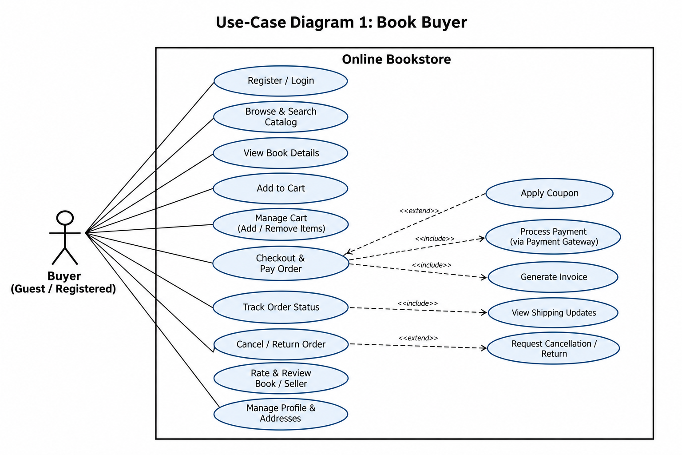
The incorrect Add to Cart <<include>> Checkout relationship has been removed. Applying a coupon remains an optional <<extend>> behavior of checkout.

7.2 Use-Case Diagram 2 — Seller & Administrator
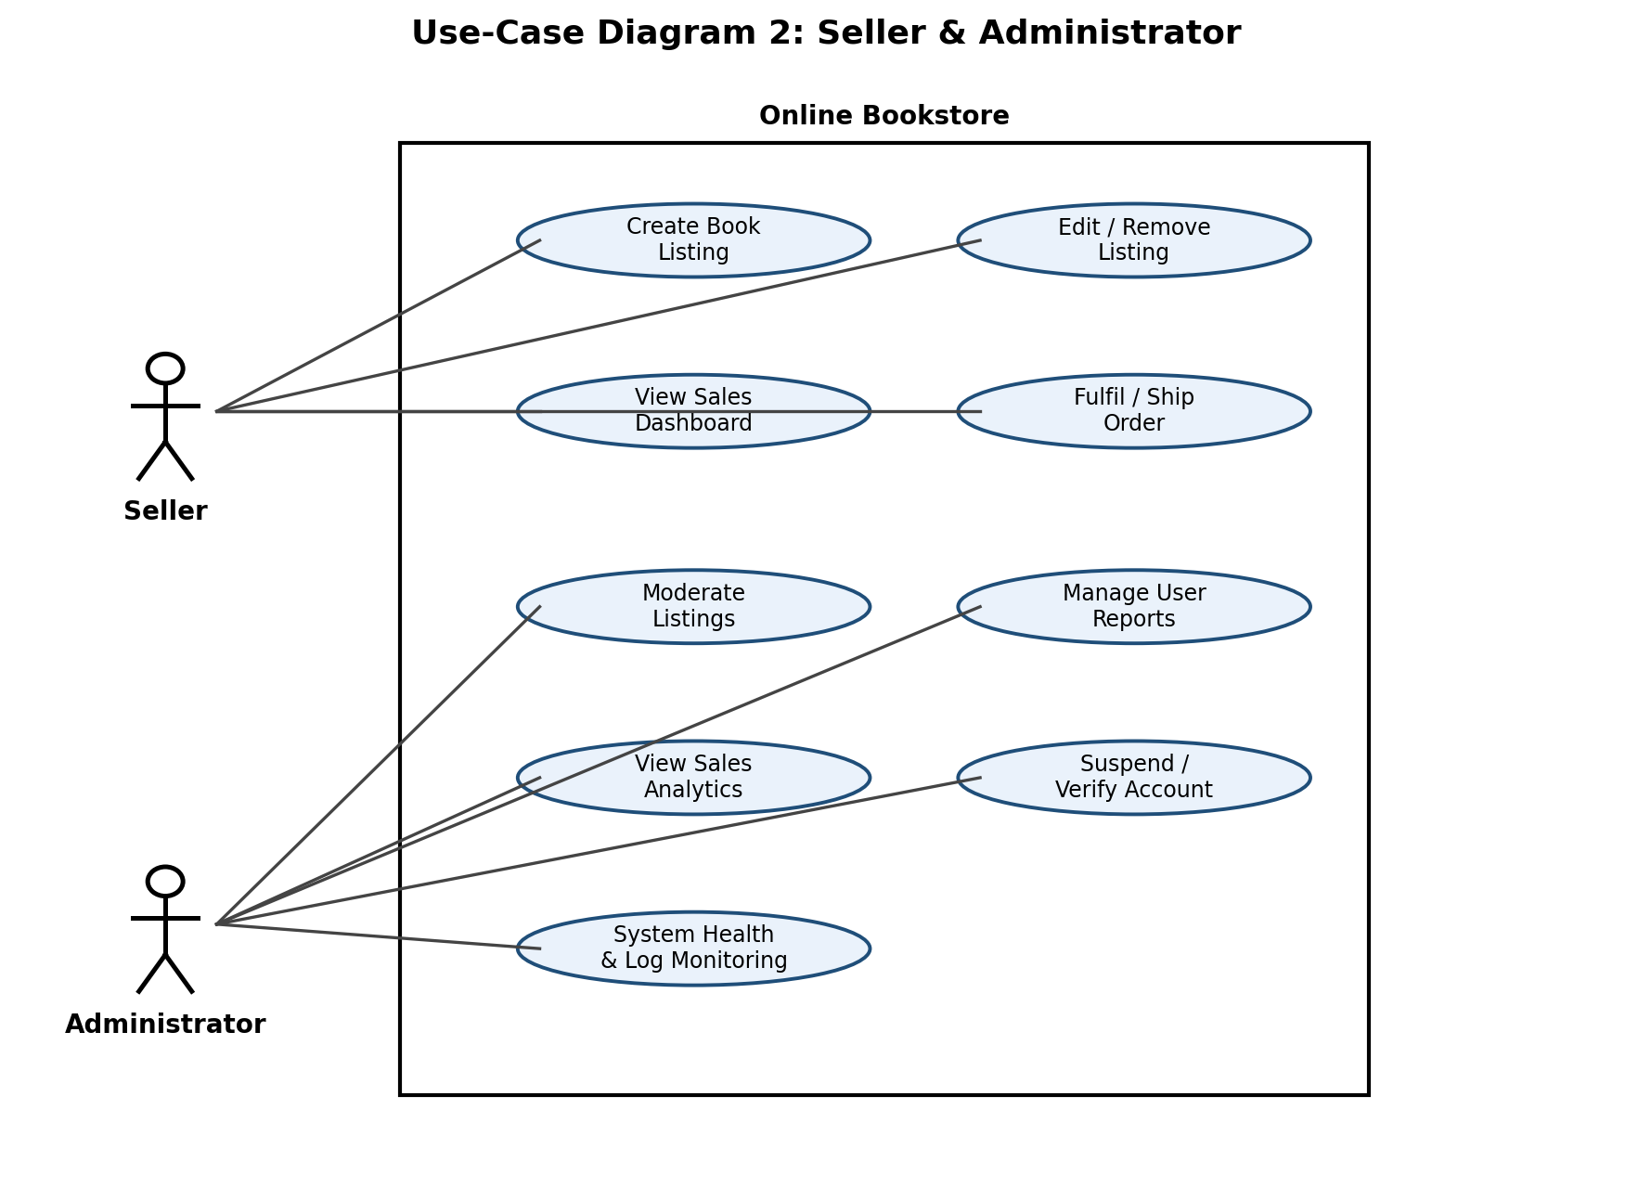

8. Requirements Traceability Matrix (RTM)
The RTM maps every functional, non-functional, and security requirement to its section/design specification, implementation module, and verification test case. Status uses N/P/A as shown in the template.
Req ID | Requirement (short) | Section ref / Design Spec | Module | Test case(s) | Status (N/P/A)
BOOK-F-001 | User registration | 4.1 / DS-Auth-01 | AuthModule | TC-Auth-01 | N
BOOK-F-002 | User login | 4.1 / DS-Auth-01 | AuthModule | TC-Auth-02 | N
BOOK-F-003 | Password reset | 4.1 / DS-Auth-02 | AuthModule | TC-Auth-03 | N
BOOK-F-004 | Profile & address mgmt | 4.1 / DS-Auth-03 | AuthModule | TC-Auth-04 | N
BOOK-F-005 | Browse catalog | 4.2 / DS-Cat-01 | CatalogModule | TC-Cat-01 | N
BOOK-F-006 | Keyword search | 4.2 / DS-Cat-01 | CatalogModule | TC-Cat-02 | N
BOOK-F-007 | Book detail page | 4.2 / DS-Cat-02 | CatalogModule | TC-Cat-03 | N
BOOK-F-008 | Filter/sort results | 4.2 / DS-Cat-02 | CatalogModule | TC-Cat-04 | N
BOOK-F-009 | Create listing | 4.3 / DS-List-01 | ListingModule | TC-List-01 | N
BOOK-F-010 | Edit listing | 4.3 / DS-List-01 | ListingModule | TC-List-02 | N
BOOK-F-011 | Remove/flag listing | 4.3 / DS-List-02 | ListingModule | TC-List-03 | N
BOOK-F-012 | Seller dashboard | 4.3 / DS-List-03 | ListingModule | TC-List-04 | N
BOOK-F-013 | Cart add/remove | 4.4 / DS-Cart-01 | CartModule | TC-Cart-01 | N
BOOK-F-014 | Apply coupon | 4.4 / DS-Cart-02 | CartModule | TC-Cart-02 | N
BOOK-F-015 | Select shipping address | 4.4 / DS-Cart-03 | CheckoutModule | TC-Cart-03 | N
BOOK-F-016 | Payment processing | 4.4 / DS-Pay-01 | CheckoutModule | TC-Pay-01 | N
BOOK-F-017 | Order confirmation/invoice | 4.5 / DS-Ord-01 | OrderModule | TC-Ord-01 | N
BOOK-F-018 | Order tracking | 4.5 / DS-Ord-02 | OrderModule | TC-Ord-02 | N
BOOK-F-019 | Cancel/return | 4.5 / DS-Ord-03 | OrderModule | TC-Ord-03 | N
BOOK-F-020 | Rate & review | 4.6 / DS-Rev-01 | ReviewModule | TC-Rev-01 | N
BOOK-F-021 | Aggregate rating | 4.6 / DS-Rev-02 | ReviewModule | TC-Rev-02 | N
BOOK-F-022 | Moderate listings/reports | 4.7 / DS-Admin-01 | AdminModule | TC-Admin-01 | N
BOOK-F-023 | Suspend/verify + analytics | 4.7 / DS-Admin-02 | AdminModule | TC-Admin-02 | N
BOOK-NF-001 | Response time target (3s) | 5 / DS-Perf-01 | WebUI / API | TC-Perf-01 | N
BOOK-NF-002 | Uptime 99.5% | 5 / DS-Ops-01 | Infra / Monitoring | Ops reports | N
BOOK-NF-003 | PCI-DSS compliance | 5 / DS-Sec-01 | Payment / Security | TC-Sec-01 | N
BOOK-NF-004 | Responsive/accessible UI | 5 / DS-UX-01 | WebUI | TC-UX-01 | N
BOOK-NF-005 | Horizontal scalability | 5 / DS-Scale-01 | Catalog / Order services | TC-Scale-01 | N
BOOK-SR-001 | TLS 1.2+ | 5.1.2 / DS-Sec-02 | Infra / Network | TC-Sec-02 | N
BOOK-SR-002 | Password hashing | 5.1.2 / DS-Sec-03 | AuthModule | TC-Sec-03 | N
BOOK-SR-003 | Payment tokenisation | 5.1.2 / DS-Sec-04 | CheckoutModule | TC-Sec-04 | N
BOOK-SR-004 | Account lockout | 5.1.2 / DS-Sec-05 | AuthModule | TC-Sec-05 | N
BOOK-SR-005 | Input validation/sanitisation | 5.1.2 / DS-Sec-06 | All modules | TC-Sec-06 | N

Document consistency checks completed
- 23 functional requirements are individually specified from BOOK-F-001 through BOOK-F-023.
- 5 non-functional requirements are individually specified from BOOK-NF-001 through BOOK-NF-005.
- 5 security requirements are consistently named BOOK-SR-001 through BOOK-SR-005.
- BOOK-NF-001 uses a 3-second response target consistently in both the requirement and RTM.
- The RTM contains all 33 requirements (23 FR + 5 NFR + 5 SR).
- The Buyer UML diagram no longer shows Add to Cart as <<include>> Checkout.

