To, Date :{qtnDate}
{toName}
Sub: {qutoref}{subjectLine}

We thank you for the valuable enquiry. We have great pleasure in proposing our best & most competitive offer, as enumerated below for your kind perusal.
For your easy evaluation we have segregated the proposal as below:
- Proposal Technical specifications
- Financial Offer
- Term & conditions
In case of any clarifications, please feel free to get in touch with us.
We trust our offer is in line with your requirement and look forward for your valued order. Thanking and assuring you of our best attention and service at all times.

Yours Faithfully,

KVB Green Energies – Dharwad Karnataka. 9545529950.

- Technical specifications

TECHNICAL SPECIFICATION OF SOLAR TUNNEL DRYER
Absorber | Poly Carbonate 6 mm thickness
Absorber | BIS Approved
Absorber Sheets | Top and Bottom Ultra Violet stabilized with 60 Microns
Shape | {productType}
Area | {dimensions}
Center height | {centerHeight}
Temperature | 55 - 65°C ( based on the climatic condition on a full sunny day )
Structure & Door | {structureDoor}
Structure Purlin | {purlin}
Arch | {arch}
Sealing | Silicon sealant with EPDM
Exhaust | AC Fan Provided
Automatic Control Panel | Temp / Moisture
Base Pipes | {purlin} base plate 6 mm thickness
Automatic Control Panel | Temperature sensor and Humidity sensor with IOT integration
Tray and trolley | {traySize}

- Financial Offer:

Capacity Of system |  | Solar Power Generation
DESCRIPTION | Qty | Units | Rate | Amount
{itemDesc} | {qty} | Set | {totalAmt}/- | {totalAmt}/-
Grand Total |  |  |  | {totalAmt}/-

{amountWords}

- Term & condition:

Payment terms:
- Price – Ex works
- Payment Terms – {paymentTerms}
- Packing – 3% extra, (Bubble sheet / corrugated sheet)
- Fright and insurance – {deliveryTerms}
- Taxes and duties- As applicable at time of despatch, {gstRate}

Delivery Time:
- 30 days from the date of Purchase Order (PO), advance payment, and drawing approval

Warranty:
- Structure (GI Square Tube): 5 years
- Electrical Components & Control Panel: 12 months

Other Conditions:
- Accommodation and food for installation team will be in your scope
- Power connection till control panel will be in scope.
- Tray and trolley in your scope
- Solar panel and its controls will be at extra cost
- Civil works in your scope

GST Details:

29AAXFK4926A1Z0 (KVB GREEN ENERGIES)

Bank Details: Bank Name : Bank of Baroda

Account No : 89330500000481

A/c Name : KVB Green Energies

A/c Type : Cash Credit Account

Branch : Ramnagar Branch, Dharwad

IFSC Code : BARB0VJDHMA
Reference Photos
For Moringa Leaf drying
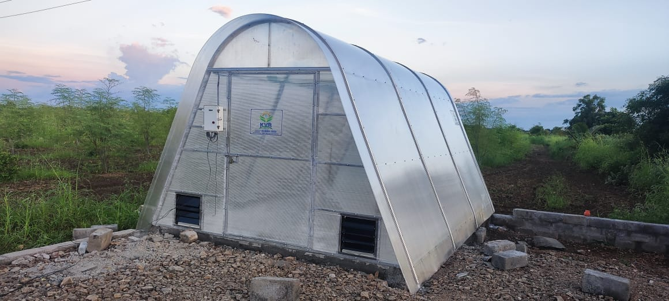

For Coffee Beans Drying
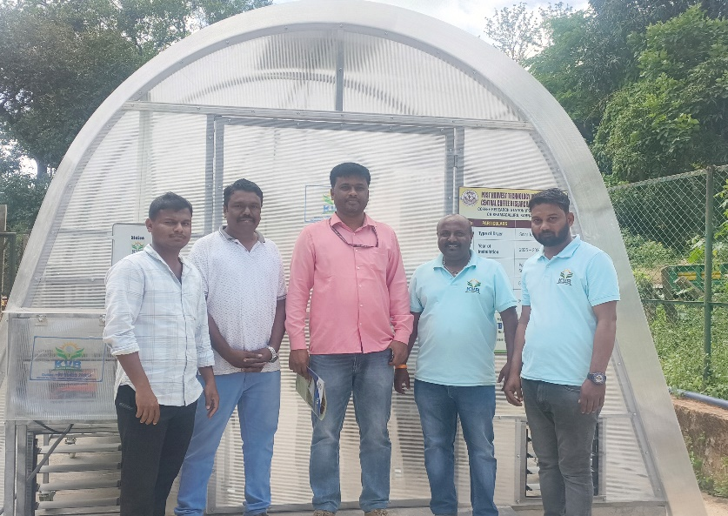

For More details - Follow us on social media
Instagram - https://www.instagram.com/kvb.digital/?igsh=MTRseDExdnN0MGUycQ%3D%3D#
YouTube - https://youtube.com/@kvbgreenenergies?si=VWJSfUEpeOeqk8R1
Website – www.kvbgreenenergies.com

