4 SQ MTR SOLAR PARABOLIC COOKER
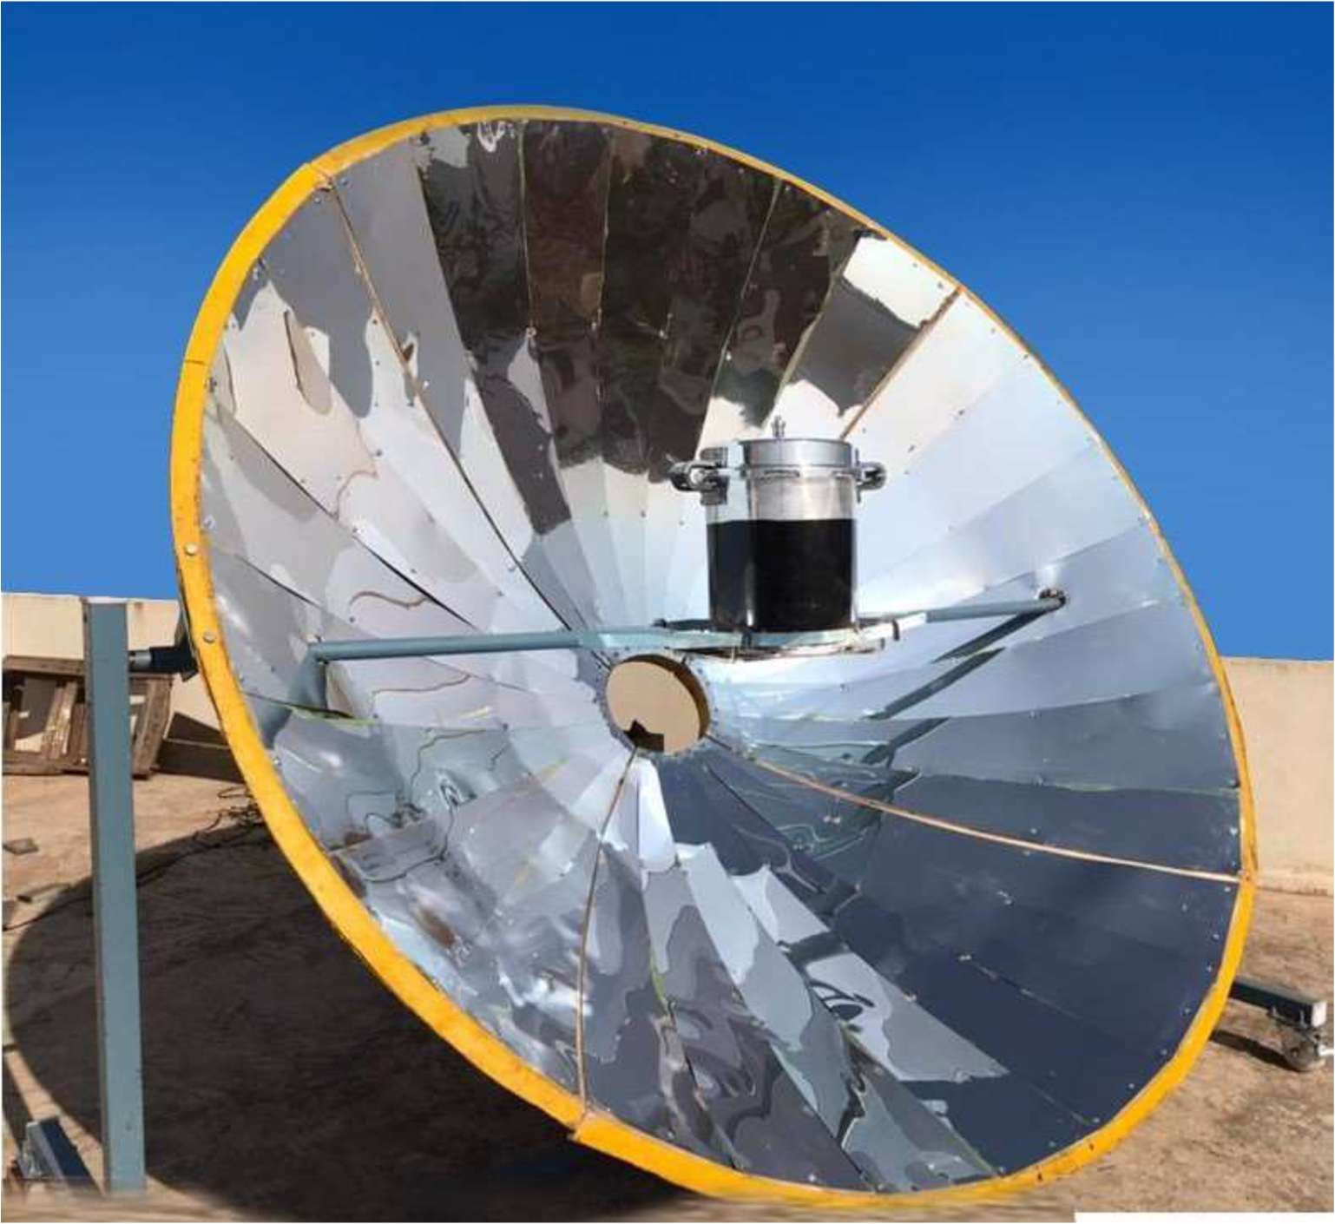
Technical Specification
 | For 25-30 person
1 | Type of concentrator | Point focusing
2 | Aperture Area | 4.83Sq mtr ( Diameter :2.48)
3 | Reflector | Anodized aluminium reflector
4 | Thickness | 0.4mm
5 | Size of focal spot | 0.40 Sq mtr
6 | Shape of focal spot | Circular
7 | Focal Length | 0.58m
8 | Tracking Device | Manually
9 | Construction of materials | MS
10 | Reflectivity of mirror | more than 80%
11 | Type of vessel used materials | Pressure cooker 20Ltr Aluminium
Financial offer: (Ex works)

SL NO | Descriptions | Qty | Amount per Unit
01 | {item_desc} | {item_qty} | {item_price}
GST {gstRate}% |  |  | {gstAmount}
Packing {packingRate}% |  |  | {packingCharge}
Freight and Insurance |  |  | {freightTerms}
Installation and commissioning |  |  | {installCharge}

Feasibility or Payback details:
Pratima Enterprises (DF) LPG consumption and payback period
No of month | No of LPG/month | Kg of LPG | Amount | Total Amount
{#feasibilityRows}{noOfMonth} | {lpgPerMonth} | {kgOfLpg} | {amount} | {totalAmount}{/feasibilityRows}

Based on above details the payback period of Solar Parabolic cooker is less than {paybackPeriod}

