Detailed Project Report on
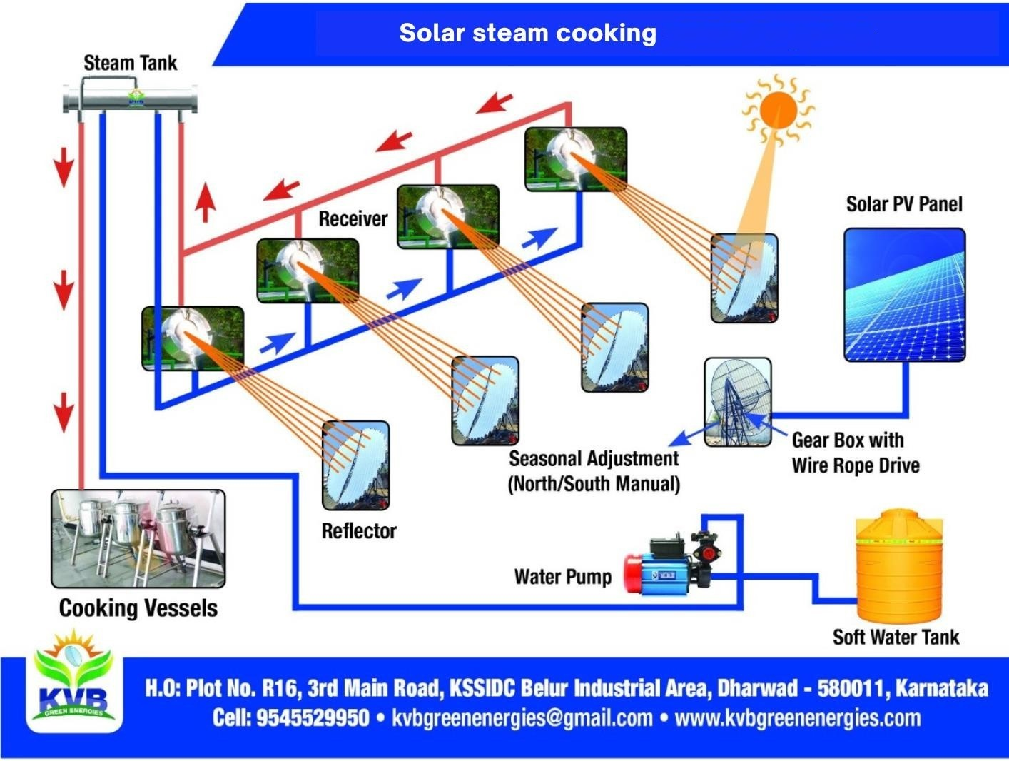
Solar Steam Cooking for {toName}

{quotRef}
Detailed Project Report (DPR) Outline for 16 sq meter Solar Scheffler Dish

SL.No | Title
1 | Executive Summary  - Project Overview  - Key Objectives  - Project Highlights
2 | Introduction  - About KVB Green Energies  - Background and Need for Renewable Energy Solutions  - Overview of Solar Scheffler Dish Technology  - Project Rationale for Siddharodmath, Siddhganga Mathas
3 | Solar Radiation In India
3 | Project Description  - Detailed Specifications of the 16 sq meter Solar Scheffler Dish  - Technology Overview and Working Principle  - Design and Engineering Aspects  - Expected Energy Output and Efficiency
4 | Potential Site Analysis  - Criteria for Site Selection  - Example Locations for Implementation  - Site Suitability Considerations  4.5 Infrastructure Requirements
5 | Project Implementation Plan  - Project Phases and Timeline  - Installation and Commissioning
6 | Financial Analysis  - Cost Breakdown and Estimates  - Funding and Financing Plan  - Economic Viability and ROI
7 | Operation and Maintenance  - O&M Plan and Schedule  - Training and Capacity Building  - Maintenance Requirements
8 | Project Benefits and Outcomes  - Quantifiable Benefits  - Qualitative Benefits  - Long-term Impact Assessment  - Case Studies and Testimonials
9 | Our Clients
10 | Conclusion

Executive Summary

Project Overview

KVB Green Energies, a registered partnership firm founded in 2020, is dedicated to advancing renewable energy technologies. Our primary focus is on developing and implementing innovative solutions such as the solar Scheffler dish and the hybrid solar tunnel dryer. This Detailed Project Report (DPR) outlines the development of a 16 sq meter solar Scheffler dish, a cutting-edge technology designed for efficient steam cooking. This project aims to provide a sustainable and cost-effective alternative to traditional cooking methods, significantly reducing reliance on fossil fuels and minimizing environmental impact.

KVB Green Energies creates world-class Solar Energy Systems for harnessing power from the Sun, with digital ideas that are bigger, bolder, braver, and better. We use precise methods to create high-quality solar systems, ensuring top performance and reliability.

Key Objectives

The key objectives of this project are:

    - Sustainable Energy Utilization: To harness solar energy for steam cooking, thereby promoting the use of renewable energy sources.
    - Cost Efficiency: To provide an economically viable cooking solution that reduces fuel costs for large institutions.
    - Environmental Impact: To decrease greenhouse gas emissions and carbon footprint associated with conventional cooking methods.
    - Scalability and Replicability: To develop a scalable model that can be replicated in various settings, including educational institutions, religious establishments, and community kitchens.
    - Community Empowerment: To train and engage local communities in the operation and maintenance of solar Scheffler dishes, fostering awareness and skill development.

Project Highlights

- Innovative Technology: Utilization of the 16 sq meter solar Scheffler dish for efficient steam cooking, leveraging advanced solar thermal technology.
- Client Base: Proven track record with prestigious clients such as the Indian Army, IIT Dharwad, Siddharodmath, Siddaganga Mathas, INS Mandovi- Goa, YASHADA – Pune, and Mauli prathistana – A’Nagar demonstrating the reliability and effectiveness of our solutions.
- Environmental Benefits: Significant reduction in carbon emissions and dependence on non-renewable energy sources, contributing to a cleaner environment.
- Economic Advantages: Cost savings on fuel, leading to a high return on investment (ROI) over the project lifecycle.
- Implementation Plan: Comprehensive project plan covering design, installation, operation, and maintenance, ensuring seamless execution and long-term sustainability.
- Training and Support: Provision of thorough training programs and ongoing support to ensure successful operation and maintenance of the solar Scheffler dish.
This project embodies our commitment to driving the adoption of renewable energy solutions, enhancing energy security, and fostering sustainable development.

Introduction

About KVB Green Energies

KVB Green Energies, established in 2020, is a registered partnership firm dedicated to promoting renewable energy solutions. Our mission is to develop world-class Solar Energy Systems that harness the power of the Sun through innovative and precise methods. We strive to create high- quality solar systems that ensure top performance and reliability. Our specialized products, including the solar Scheffler dish and hybrid solar tunnel dryer, have earned us a reputable client base, featuring the Indian Army, IIT Dharwad, and Siddharodmath and Siddaganga Mathas.

Background and Need for Renewable Energy Solutions

The global demand for energy continues to rise, placing immense pressure on traditional fossil fuel resources. The adverse environmental impacts of fossil fuel consumption, such as greenhouse gas emissions and pollution, necessitate the shift towards renewable energy sources. Solar energy, being abundant and sustainable, offers a viable alternative. Harnessing solar power not only mitigates environmental degradation but also provides economic benefits by reducing fuel costs and enhancing energy security.

  - Overview of Solar Scheffler Dish Technology

The solar Scheffler dish is an advanced solar thermal technology designed to concentrate sunlight onto a focal point to generate heat. This concentrated solar power can be used for various applications, with steam cooking being one of the most effective. The dish's design allows it to track the sun throughout the day, maximizing energy capture. The 16 sq meter solar Scheffler dish, in particular, is optimized for efficiency and reliability, making it suitable for large-scale cooking needs in institutions and communities.

  - Project Rationale

The 16 sq meter solar Scheffler dish project aims to address the growing need for sustainable and cost-effective cooking solutions. By leveraging solar energy, this project seeks to reduce the dependency on conventional fuels, thereby decreasing carbon emissions and operational costs. The implementation of this technology in institutions Siddharodmath, Siddhagangamath will not only provide an efficient cooking solution but also serve as a model for other organizations to adopt renewable energy technologies.

The project is aligned with our commitment to promoting renewable energy and sustainable development. It exemplifies our expertise in delivering high-quality solar systems and reinforces our role as a leader in the renewable energy sector. By undertaking this project, we aim to showcase the practicality and benefits of solar thermal technology, encouraging wider adoption and contributing to a greener future.

Solar Radiation In India
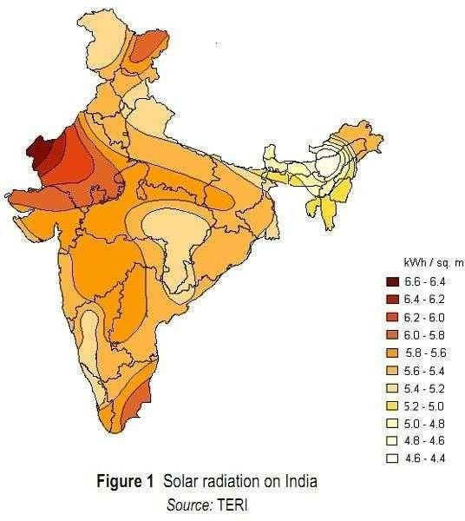

About 5000 trillion kWh/year energy isincident over India’s Land Most parts receiving 4 – 7 kWh/m2/day
Highest annual global radiation is received in Rajasthan (5.5 – 6.8 kWh/m2/day) and Northern Gujrat
250 – 300 clear and sunny days in a year
Most of the India has solar insolation above 1800 kWh/m2/day

Market Potential
Industrial Sector | Process | Temperature Level
Food and Beverages | Dryer | 30 - 90
 | Washing | 40 - 80
 | Pasteurizing | 80 - 110
Textile Industry | Washing | 40 - 80
 | Bleaching | 60 - 100
Machinery Industry | Cleaning | 40 - 80
Chemical Industry including Pharmaceutical | Boiling | 95 - 105
 | Distilling | 110 - 300

Project Description

  - Detailed Specifications of the 16 sq meter Solar Scheffler Dish
Reflective Surface Area: 16 square meters Dish Diameter: Approximately 4.5 meters Focal Length: 2.5 meters
Tracking System: Dual-axis solar tracking system for continuous alignment with the sun
Material: High-quality reflective aluminum or stainless steel Support Structure: Robust steel frame with weather-resistant coating Thermal Efficiency: Up to 70%
Heat Output: Capable of generating temperatures up to 500°C
Steam Generation Capacity: Approximately 15-20 liters per hour
Control System: Automated tracking and safety controls with manual override option Lifespan: Designed for a minimum operational life of 20 years with regular maintenance Maintenance Requirements: Periodic cleaning of reflective surfaces and lubrication of moving parts.

  - Technology Overview and Working Principle

The solar Scheffler dish is a parabolic reflector that concentrates sunlight onto a focal point, converting solar energy into thermal energy. The dish's unique design allows it to track the sun along both azimuth and elevation axes, ensuring maximum solar energy capture throughout the day.
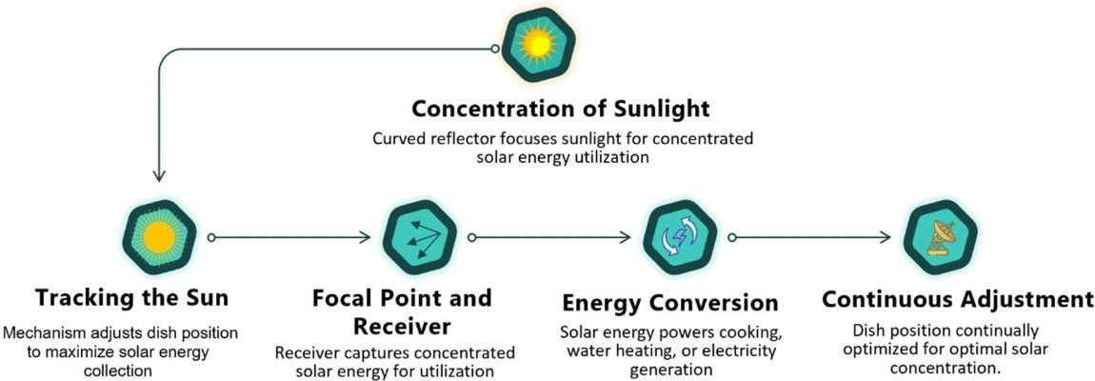

    - Sunlight Collection: The reflective surface of the dish captures and focuses sunlight onto a fixed focal point.
    - Concentration of Heat: The concentrated solar radiation generates high temperatures at the focal point.
    - Heat Transfer: A receiver placed at the focal point absorbs the concentrated heat. This receiver is typically a metal plate or coil through which water or another fluid is circulated.
    - Steam Generation: The absorbed heat converts the water into steam, which can be utilized for various applications such as cooking, sterilization, or other industrial processes.
    - Tracking Mechanism: The dual-axis tracking system adjusts the dish's orientation continuously to follow the sun's movement, optimizing energy capture and maintaining consistent thermal output.
  - Design and Engineering Aspects

    - Reflector Design: The parabolic shape of the dish ensures that all incoming sunlight is focused onto a single point. The reflector is made from highly reflective materials, such as polished aluminum or silver-coated glass, to maximize the efficiency of solar radiation capture.
    - Structural Integrity: The dish is mounted on a sturdy steel frame designed to withstand environmental factors such as wind, rain, and temperature fluctuations. The frame is coated with a weather-resistant material to prevent corrosion and ensure longevity.
    - Tracking System: The dual-axis tracking system is driven by precise motors and controlled by a microprocessor-based system. Sensors detect the sun's position, and the tracking system adjusts the dish's orientation accordingly. This maximizes the exposure to sunlight and enhances the thermal output.
    - Thermal Receiver: The thermal receiver at the focal point is engineered to withstand high temperatures and efficiently transfer heat. It is often made of materials with high thermal conductivity, such as copper or stainless steel, and is designed to minimize heat losses.
    - Safety Features: The system includes safety mechanisms such as overheat protection, manual override controls, and automatic shutdown in case of system malfunctions. These features ensure safe operation and protect the equipment from damage.
    - Installation and Maintenance: The installation process involves site assessment, foundation preparation, assembly of the dish and support structure, and integration of the tracking system. Regular maintenance includes cleaning the reflective surfaces, checking and lubricating the tracking mechanism, and inspecting the thermal receiver for wear and tear.

  - Technology.
The Scheffler-Reflector : The basic idea that lead to the development of the Scheffler- Reflectors was to make solar cooking as comfortable as possible. At the same time the device is built in a way that allows it to be constructed in any rural welding workshop in southern countries after a short period of training. The locally available materials would be adequate enough to build the same.
The Technology: To make cooking simple and comfortable the cooking-place should not have to be moved, even better: it should be inside the house and the concentrating reflector outside in the sun.
The best solution was a eccentric, flexible parabolic reflector which rotates around an axis parallel to earth-axis, synchronous with the sun. Additionally, the reflector is adjusted to the seasons by flexing it in a simple way.
The reflector is a small lateral section of a much larger paraboloid. The inclined cut produces the typical elliptical shape of the Scheffler-Reflector. The sunlight that falls onto this section of the paraboloid is reflected sideways to the focus located at some distance of the reflector.
The axis of daily rotation is located exactly in north-south-direction, parallel to earth axis and runs through the center of gravity of the reflector.

That way the reflector always maintains it's gravitational equilibrium and the mechanical tracking device (clockwork) doesn't need to be driven by much force to rotate it synchronous with the sun. The focus is located on the axis of rotation to prevent it from moving when the reflector rotates. The distance between focus and centre of the reflector depends on the selected parabola. During the day the concentrated light will only rotate around its own center but not move sideways in any direction. That way the focus stays fixed, which is very useful, as it means the cooking-pot doesn't have to be moved either.

Drawing 1:
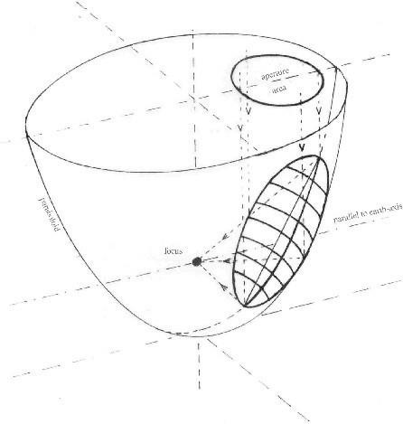
In the course of the seasons the incident angle of the solar radiation varies + / - 23,5° in relation with the perpendicular to earth-axis. The paraboloid has to perform the same change of inclination in order to stay directed at the sun.
Otherwise it's not possible to obtain a sharp focal point. But the center of the reflector and the position of the focus are not allowed to move.
This is only possible by shaping the reflector after another parabola for each seasonal inclination-angle of the sun, i.e. for each day of the year. This means the reflector has to change its shape.
The reflector-frame is built for equinox. By inclining and elastically deforming the reflector- frame all other parabolas can be achieved with sufficient accuracy.

Drawing 2:
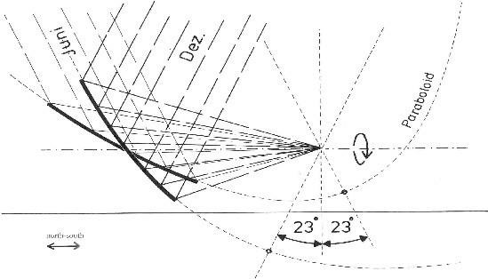

Changing the inclination and deforming the reflector are mechanically combined: the two pivots A, at each side of the reflector-frame, and pivot B, in the center of the reflector, do not form a line, but B is located below. That way inclining the reflector leads to a change in its depth, the Centre of the reflector is lifted up (big radius of crossbars) or pressed down (small radius of crossbars) relative to the reflector-frame. It's enough to adjust the upper and lower end of the reflector (C and D) to their correct position to obtain a sufficiently exact reflector- shape. The setting is done by a telescopic bar at each end of the reflector.
Adjusting the reflector-shape has to be done manually every 2-3 days. When all concentrated light enters the opening of the cooking-place installed at the focal point the correct reflector- shape is achieved.

After passing the opening the light is redirected by a small reflector (secondary reflector) to the black bottom of the cooking pot. There it is absorbed and transformed into heat. The efficiency for cooking, i.e. heating water from 25°C to 100°C, can reach up to 57% and depends on the cleanliness of the reflector- surface and the state of insulation of the cooking- pot. At the focal-point itself we have measured optical efficiency of up to 75% (with 2mm ordinary glass mirrors). Depending on the season an elliptical reflector of 2,8m x 3.8m (standard size of 8m² Scheffler-Reflector) collects the sunlight of a 4,3m² to 6,4m² area, measured perpendicular to the direction of the incident light (aperture). That way the cooking power varies with the season. As an average a 8m² Reflector can bring 22 litres of cold water to boiling temperature within one hour (with 700W/m² direct solar radiation).

There are many options for the design of the cooking-place. Mostly it is integrated into a kitchen building and provides the possibility to use firewood for cooking when the sun doesn't shine. Depending on the type of food which is cooked there is no need for a secondary reflector. This increases the efficiency and simplifies maintenance. Instead of a cooking-place a backing-oven, steam- generator or heat-storage can be installed at the focal- point.

Drawing 3:
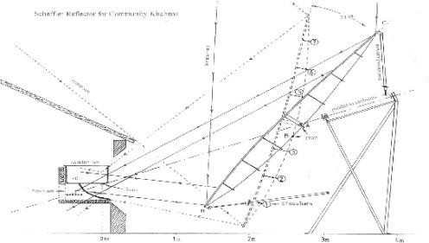

Potential Site Analysis
  - Criteria for Site Selection

Selecting an appropriate site for the installation of the 16 sq meter solar Scheffler dish is crucial for optimizing its performance and ensuring long-term sustainability. The key criteria for site selection include:

- Solar Insolation: High levels of solar radiation throughout the year to maximize energy capture.
- Unobstructed Sunlight: A location free from shading by buildings, trees, or other obstructions that could impede sunlight exposure.
- Accessibility: Easy access for transportation of materials, installation, and maintenance activities.
- Space Availability: Adequate open space to accommodate the dish and its supporting structures without interference.
- Stable Ground: A firm and level ground to ensure the stability of the structure and facilitate proper alignment and tracking.
- Proximity to Usage Site: Close proximity to the area where the generated steam will be utilized to minimize energy loss during transfer.
- Regulatory Compliance: Compliance with local zoning laws, environmental regulations, and safety standards.

  - Example Locations for Implementation

Potential locations for implementing the solar Scheffler dish project include:

- Educational Institutions: Schools and universities with large dining facilities.
- Religious Establishments: Temples, monasteries, and mathas that serve large congregations.
- Community Centers: Public kitchens and community halls used for mass cooking during events and festivals.
- Industrial Canteens: Factories and industrial units with large-scale cooking requirements.
- Military Bases: Army and other defense establishments with significant cooking needs for personnel.

  - Site Suitability Considerations

When evaluating site suitability, consider the following factors:

- Climatic Conditions: Areas with consistent sunny weather and minimal cloud cover are ideal.
- Topography: Flat or gently sloping terrain facilitates easier installation and tracking system alignment.
- Environmental Impact: Assess the potential environmental impact, including effects on local wildlife and ecosystems.
- Community Acceptance: Engagement with local communities to ensure acceptance and support for the project.
- Future Expansion: Potential for future scalability and expansion of the solar energy system if needed.
  - Infrastructure Requirements

The successful implementation of the solar Scheffler dish requires certain infrastructure elements:

- Foundation: A robust foundation to support the dish structure, typically constructed from concrete.
- Power Supply: A reliable power supply for operating the tracking system and control mechanisms.
- Water Supply: Access to a consistent water supply for steam generation.
- Transportation Access: Roads and pathways to facilitate the transport of materials and equipment to the site.
- Storage Facilities: Secure storage for spare parts, tools, and maintenance equipment.
- Operational Space: Sufficient space for installation, routine maintenance, and potential future upgrades.

Project Implementation Plan

  - Project Phases and Timeline

The implementation of the 16 sq meter solar Scheffler dish project will be completed within three months, divided into the following phases:

Phase 1: Planning and Preparation (Weeks 1-2)

- Site assessment and final selection
- Procurement of materials and equipment
- Detailed project planning and scheduling
- Permits and regulatory approvals

Phase 2: Installation (Weeks 3-8)

- Delivery and assembly of the solar Scheffler dish
- Installation of the tracking system and thermal receiver
- Integration of control systems and safety mechanisms
- Connection to the kitchen for steam usage

Phase 3: Commissioning and Testing (Weeks 9-12)

- System testing and calibration
- Performance verification and adjustments
- Training of local operators and maintenance personnel
- Final inspection and handover

  - Installation and Commissioning

Installation Steps:

    - Delivery and Assembly:

      - Deliver all components to the site.
      - Assemble the reflector panels on-site.
      - Mount the dish on the pre-prepared support structure.

    - Tracking System Installation:
      - Install the dual-axis tracking system.
      - Connect the tracking motors and control units.

    - Thermal Receiver Installation:
      - Position the thermal receiver at the focal point.
      - Connect the receiver to the steam generation system.

    - System Integration:
      - Integrate control systems for automated tracking and safety.
      - Ensure all electrical connections and control units are functioning.

    - Connection to Kitchen:
      - Install piping to transfer the generated steam from the dish to the kitchen.
      - Ensure secure and efficient connections to kitchen appliances and systems.

Commissioning Steps:

- System Testing:
  - Conduct thorough testing of the tracking system to ensure accurate sun tracking.
  - Verify the thermal efficiency and steam generation capacity.

- Performance Verification:
  - Monitor system performance under various weather conditions.
  - Adjust and calibrate the system for optimal performance.

- Operator Training:
  - Provide comprehensive training to local operators on system operation and maintenance.
  - Ensure operators are familiar with safety protocols and emergency procedures.

- Final Inspection:
  - Conduct a final inspection with project stakeholders.
  - Address any remaining issues or adjustments before handover.

Financial Estimates

Cost Breakdown and Estimates
The financial estimates for the implementation of the 16 sq meter Solar Scheffler Dish are detailed below. This breakdown includes all necessary components, materials, and services required for the project. {dishesMealsStatement}
SL. No | Description | Quantity | UOM | Unit Rate (₹) | Total (₹)
{#items}{sno} | {desc} | {qty} | {unit} | {rate} | {amount}{/items}
Total Amount |  |  |  |  | {totalAmt}

{amountWords}

Economic Viability and ROI
Parameter | Current Situation | Proposed Situation (Scheffler Dish)
Cylinders per Day | {cylindersPerDay} | {cylindersPerDayProposed}
Cost per Cylinder | {costPerCylinder} | {costPerCylinderProposed}
Cylinder Cost per day (₹) | {cylinderCostPerDay} | {cylinderCostPerDayProposed}
Cylinder Cost Monthly (₹) | {cylinderCostMonthly} | {cylinderCostMonthlyProposed}
Cylinder Cost Annually (₹) | {cylinderCostAnnually} | {cylinderCostAnnuallyProposed}
Electrical Cost Monthly (₹) (convotham machine) | {electricityCostMonthly} | {electricityCostMonthlyProposed}
Elctrical Cost Annually (₹) (convotham machine) | {electricityCostAnnually} | {electricityCostAnnuallyProposed}
Non-Sunny Days Expenses (Rainy Season) 90 Days | {nonSunnyDaysExpensesCurrent} | {nonSunnyDaysExpensesProposed}
Setup Cost | {setupCostCurrent} | {setupCost}
Total Cost for 1Year | {totalCost1YearCurrent} | {totalCost1YearProposed}
ROI | {roi} | Months

Cost Analysis Over 10 Years
Parameter | Current Situation | Proposed Situation (Scheffler Dish)
Annual Cost (₹) | {totalCost1YearCurrent} | {totalCost1YearProposed}
Annual Maintenance Cost (₹) | {annualMaintenanceCostCurrent} | {annualMaintenanceCost}
10-Year Maintenance Cost (₹) | {tenYearMaintenanceCostCurrent} | {tenYearMaintenanceCost}
Total Cost for 10 Years (₹) | {totalCost10YearsCurrent} | {totalCost10YearsProposed}
Savings |  | {savings}

Operation and Maintenance

O&M Plan and Schedule

The Operation and Maintenance (O&M) plan for the Solar Scheffler Dish system ensures its efficient and reliable operation over its lifecycle. The plan includes:
    - Daily Inspections: Conduct visual inspections of all components, focusing on alignment, cleanliness of reflective surfaces, and tracking system functionality.
    - Weekly Checks: Perform detailed checks on mechanical components, lubricate moving parts, and verify the operational parameters of the receivers and steam tank.
    - Monthly Maintenance: Inspect insulation materials, conduct performance tests on control systems, and ensure all safety protocols are in place.
    - Quarterly Reviews: Evaluate overall system performance, review maintenance logs, and conduct any necessary adjustments or repairs.

Training and Capacity Building

Training and capacity building are crucial for ensuring personnel are equipped to operate and maintain the Solar Scheffler Dish system effectively:

    - Initial Training: Provide comprehensive training during installation on system operation, safety procedures, and basic maintenance tasks.
    - Advanced Training: Offer specialized training sessions for key personnel on advanced troubleshooting, system optimization, and emergency response protocols.
    - Periodic Workshops: Conduct regular workshops to update skills, address operational challenges, and introduce new maintenance practices.

Maintenance Requirements

Key maintenance requirements for the Solar Scheffler Dish system include:

    - Cleaning and Maintenance of Reflective Surfaces: Regular cleaning to maintain optimal reflectivity and maximize energy absorption.
    - Inspection and Lubrication: Periodic inspection and lubrication of mechanical components to prevent wear and ensure smooth operation.
    - Monitoring and Calibration: Continuous monitoring of system performance metrics, with periodic calibration of tracking systems for accurate solar tracking.
    - Safety and Compliance Checks: Regular checks to ensure adherence to safety standards, including inspection of electrical and mechanical components.

By implementing a structured O&M plan, providing comprehensive training, and adhering to stringent maintenance requirements, the Solar Scheffler Dish system will operate efficiently, ensuring sustainable energy solutions for cooking needs.

Project Benefits and Outcomes

Quantifiable Benefits:

The implementation of the Solar Scheffler Dish system will yield several quantifiable benefits:

    - Energy Savings: Significant reduction in fuel costs associated with steam cooking, leading to direct cost savings.
    - Operational Efficiency: Enhanced efficiency in cooking processes, reducing cooking times and increasing productivity.
    - Cost Reduction: Lower operational costs due to the utilization of renewable solar energy, minimizing dependency on conventional fuels.
    - Environmental Impact: Reduced carbon footprint and greenhouse gas emissions compared to traditional cooking methods.

Qualitative Benefits

In addition to quantifiable benefits, the Solar Scheffler Dish system will provide qualitative advantages:

    - Reliability: Reliable and consistent supply of solar energy for cooking, ensuring uninterrupted operations.
    - Community Impact: Positive community perception and support due to sustainable energy practices.
    - Enhanced Kitchen Environment: Improved working conditions in the kitchen environment with reduced heat emissions and noise pollution.
    - Educational Opportunities: Potential for educational programs and demonstrations on renewable energy technologies.

Long-term Impact Assessment

The long-term impact of the Solar Scheffler Dish system will be assessed through:

    - Sustainability: Continued use of renewable solar energy, contributing to long-term environmental sustainability.
    - Economic Benefits: Long-term cost savings and financial sustainability through reduced fuel expenses.
    - Social Impact: Improved community well-being through access to sustainable and clean energy solutions.
    - Scalability: Potential for scalability and replication of the technology in other similar settings, fostering broader adoption of renewable energy.

Success Stories

- Indian Army Mess Facilities – Chennai.

- IIT Dharwad Campus - Dharwad

- Siddharodmath - Hubli

- Siddhagangamath - Tumkur

- Yashwantrao Chavan Academy of Development Administration (YASHADA)- Pune.

- Mauli Prathistana – Ahmednagar

- INS Mandovi, Veram- Goa ( Indain Navey )

Impact and Future Prospects

The success stories of implementing Solar Scheffler Dishes underscore KVB Green Energies' commitment to promoting sustainable energy solutions. These installations not only demonstrate the feasibility and effectiveness of solar energy for cooking but also inspire future projects and collaborations in renewable energy technology.
Terms and Condition:

- {exWorksTerms}

- {packingTerms}

- Provision of water, electricity, tables, and ladders is the responsibility of the client.

- Solar grade mirrors are covered under a 5-year warranty, excluding manpower labor costs for installation.

- Food and accommodation for installation team will be provided by the client.

- Any modifications or alterations to the site, excluding our civil work, are the responsibility of the client.

- Payment Terms:
{paymentTerms1}
{paymentTerms2}
{paymentTerms3}

- 1-year warranty from the date of installation or supply at site,

- 5-year warranty for reflective glass

- Warranty is applicable for defective manufacturing and not applicable for mishandling or broken parts

- Civil Work is in your scope

- Power supply to the panel in your scope

- Solar PV panel is in your scope.

