**🚲 Bike Dekho – Bike Sales Analysis Excel Project**

**Project Overview:**

The **Bike Dekho – Bike Sales Analysis** is a hands-on data analysis project that explores sales trends in the biking industry using Microsoft Excel. This project demonstrates how Excel can be effectively utilized for **data cleaning, transformation, analysis, and visualization** to drive meaningful business insights.

**Problem Statement**

A bike manufacturing company wants to understand the demographic and behavioral factors that influence customer decisions to purchase a bike. With increasing urbanization and traffic congestion, bikes are becoming a popular alternative. The company has collected survey data but needs actionable insights to target potential customers more effectively.

**Business Objective**

* Identify the key factors (e.g., income, marital status, commute distance, car ownership, etc.) that impact the likelihood of a customer buying a bike.
* Help the marketing and sales team refine targeting strategy based on customer segmentation.
* Improve decision-making around product positioning and regional promotions.

**Insights from Visual Analysis**

1. **Gender vs. Bike Purchase**

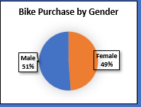

**Insight**: Male customers are more likely to purchase bikes than female customers.  
**Usefulness**: Indicates a gender skew in the customer base, suggesting targeted campaigns can be tailored accordingly.  
**Impact**: Helps in designing gender-specific ads or marketing messages.

1. **Age Group vs. Bike Purchase**

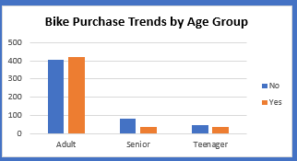

**Insight**: Customers in the 31-45 age range show the highest bike purchase rate.  
**Usefulness**: This group is likely more financially stable and prefers convenience.  
**Impact**: Marketing campaigns can focus more on this age demographic..

1. **Region vs. Bike Purchase**

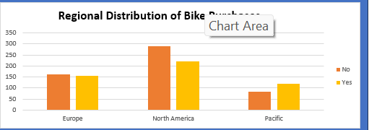

**Insight**: The Western region has the highest number of bike purchases.  
**Usefulness**: Regional differences highlight where bike adoption is stronger.  
**Impact**: Helps prioritize marketing budget allocation by region.

1. **Commute Distance Vs Bike Purchase**

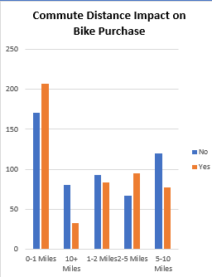

**Insight**:People with smaller commute distances are more likely to buy bikes.  
**Impact**: Focus on promoting bikes in regions with smaller commutes.

1. **Occupation vs. Bike Purchase**

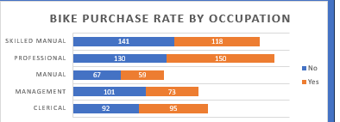

**Insight**: Professionals and Skilled Workers have a higher tendency to buy bikes compared to clerical staff.  
**Usefulness**: Income level and lifestyle may be driving factors.  
**Impact**: Position bikes as a status or lifestyle product for professionals.

1. **Income vs. Bike Purchase**

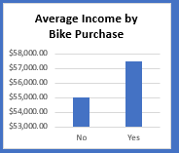

**Insight**: Higher income groups (>$60,000) purchase more bikes.  
**Usefulness**: Suggests affordability and lifestyle are key drivers.  
**Impact**: High-end bike models can be targeted to affluent segments.

1. **Dashboard**

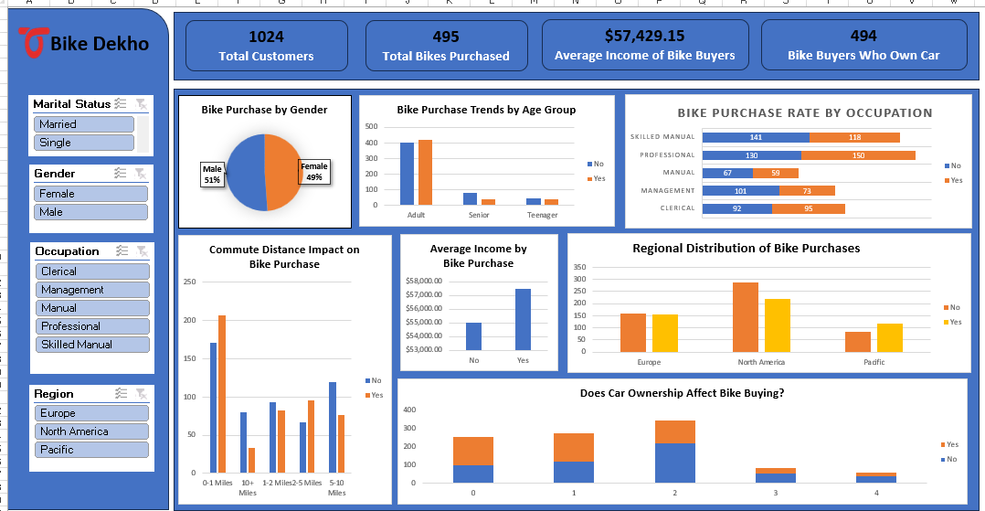

**Recommendations**

1. **Target Professionals aged 31–45**: Create marketing campaigns emphasizing convenience and modern lifestyle.
2. **Focus on Western Region**: Allocate more ad spend and dealer incentives in this region.
3. **Introduce Premium Models**: Cater to higher income customers with value-added features.
4. **Gender-Inclusive Advertising**: While males dominate, campaigns can also be designed to appeal to women by addressing specific needs like safety, design, and ease of use.

**Conclusion**

The analysis provides a comprehensive view of factors influencing bike purchase decisions. Key demographics like **age**, **income**, and **region**, along with behavioral traits like **commute distance** and **car ownership**, play a significant role. These insights can help the business tailor its marketing, improve sales strategy, and ultimately increase conversions and customer satisfaction