Experiment-5
Aim: Exercise on retrieving records from the table.
EMPLOYEES (Employee_Id, First_Name, Last_Name, Email, Phone_Number, Hire_Date, Job_Id, Salary, Commission_Act, Manager_Id, Department_Id).

- Create Database and Table
- Code:
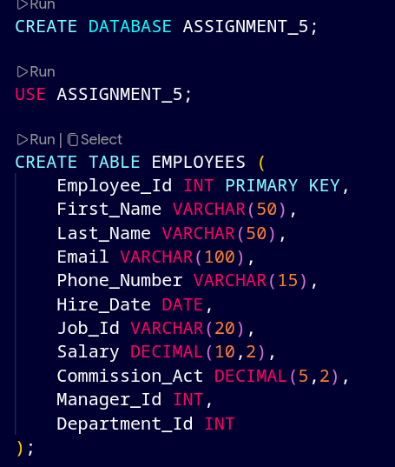
- Explanation:
- This creates a new database named ASSIGNMENT_5.
- This command tells SQL to use the created database.
- This creates a table with employee details like ID, name, salary, department, etc.

- Insert Sample Data
- Code:
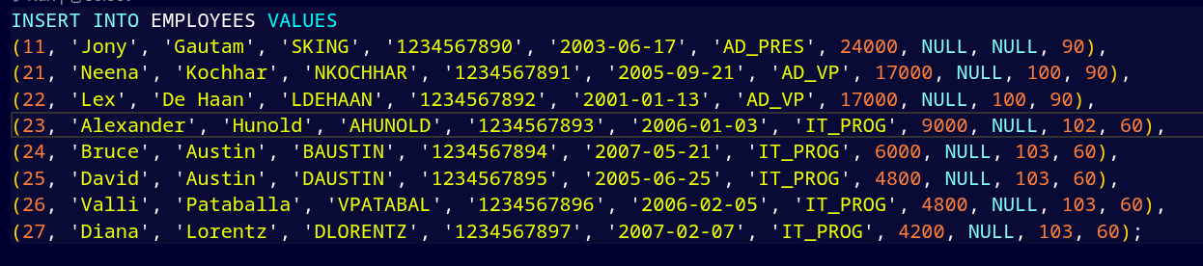
- Explanation:
- Inserts sample employee data for testing queries.

( a) Find out the employee id, names, salaries of all the employees
- Code:

- Output:

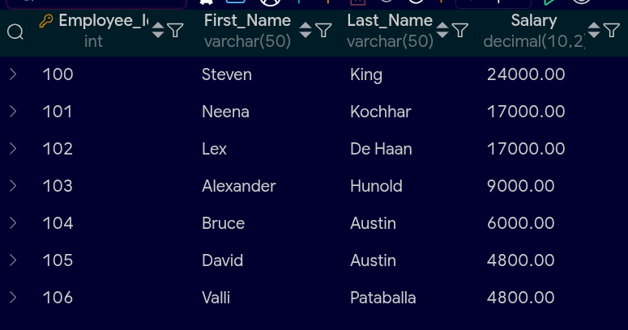
- Explanation:
- SELECT chooses specific columns
- Displays employee ID, first name, last name, and salary

( b) List out the employees who works under manager 100
- Code:
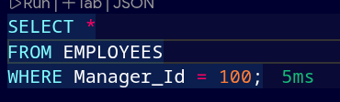

- Output:


  - Explanation:
- WHERE filters records
- Shows employees whose manager ID is 100

( c) Find the names of the employees who have a salary greater than or equal to 4800
- Code:
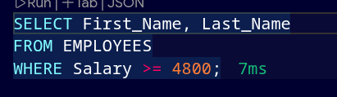

- Output:

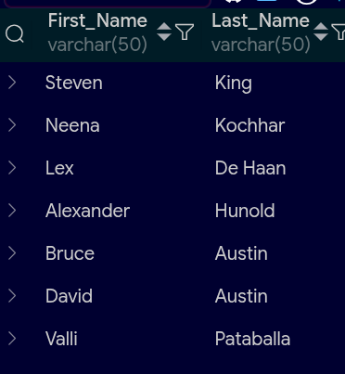
- Explanation:

- >= means greater than or equal
- Filters employees earning 4800 or more

( d) List out the employees whose last name is ‘AUSTIN’
- Code:
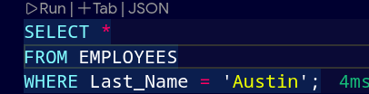
- Output:

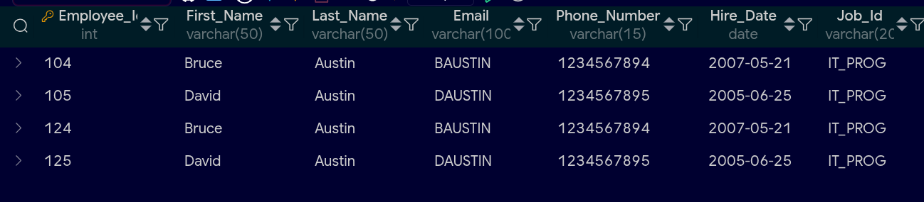
- Explanation:
- Matches exact text
- Displays employees with last name AUSTIN

( e) Find the names of the employees who works in departments 60,70 and 80
- Code:
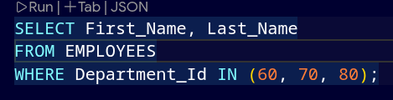

- Output:
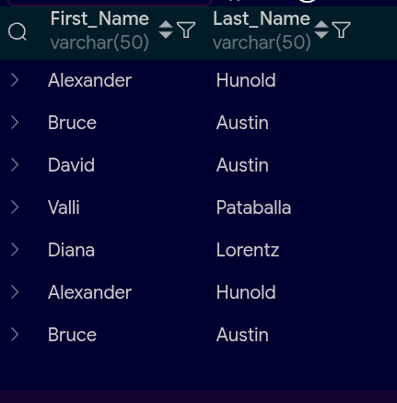
- Explanation:
- IN is used to match multiple values
- Shows employees belonging to given departments

( f ) Display the unique Manager_Id.
- Code:
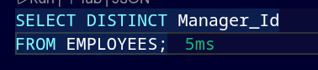
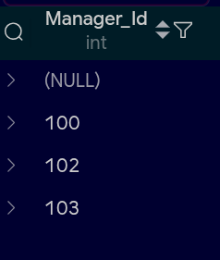
- Output:

- Explanation:
- DISTINCT removes duplicate values
- Shows only unique manager IDs

