Experiment-6
Aim: Exercise on updating records in table. Create Client_master with the following fields (ClientNO, Name, Address, City, State, bal_due)

- Create database and use database
Code:
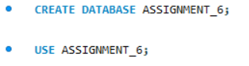
- Explanation:
- This command creates a new database named ASSIGNMENT_6 where tables and records will be stored.
- This command selects the ASSIGNMENT_6 database so that all further operations will be performed inside this database.

- Create table
Code:
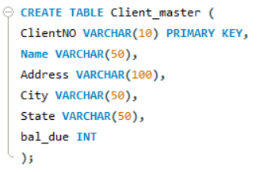
- Explanation:
- This command creates a table named Client_master with fields like client number, name, address, city, state, and balance due.

( a ) Insert five records
Code:
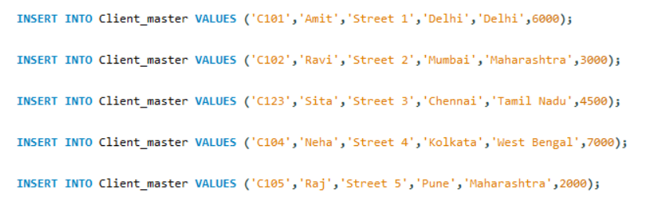

- Explanation:
- The INSERT INTO statement is used to add multiple records into the table.

( b ) Find the names of clients whose bal_due> 5000 .
Code:
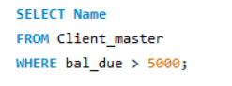
- Explanation
- The WHERE clause filters clients whose balance due is greater than 5000.
Output:
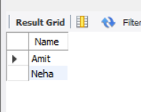
( c ) Change the bal_due of ClientNO “ C123” to Rs. 5100
Code:
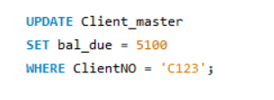
- Explanation:
- The UPDATE statement modifies existing data. Here, it updates the balance due of client C123 to 5100.

( d ) Change the name of Client_master to Client12.
Code:
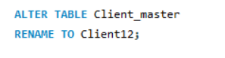
- Explanation:
- The ALTER TABLE command is used to rename the table from Client_master to Client12.

( e ) Display the bal_due heading as “BALANCE”
Code:

- Explanation:
- The AS keyword is used to rename the column heading temporarily. Here, bal_due is displayed as BALANCE.
Output:
