Experiment – 4.1
Aim: Demonstration of COMMIT, SAVEPOINT and ROLLBACK in CLASS Table

ID | Name
1 | Jony
2 | Akansha
3 | Dolly
4 | Priya
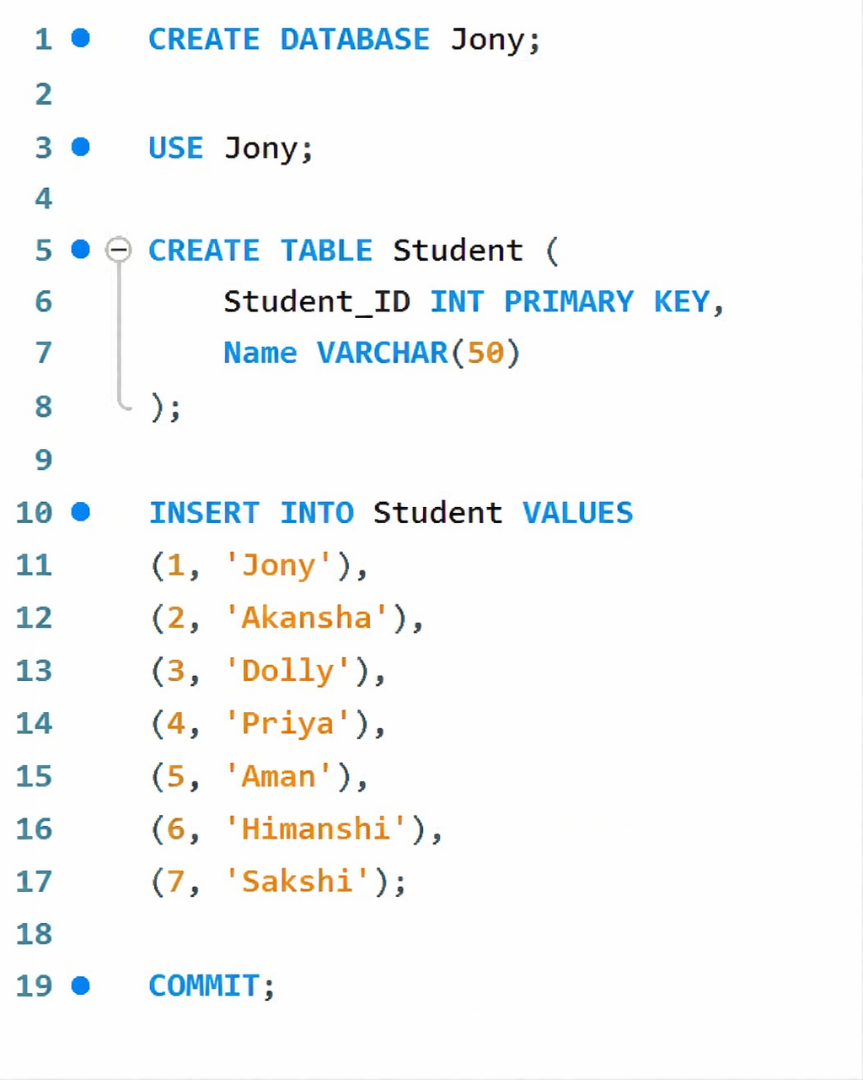  5 | Aman
6 | Himanshi
7 | Sakshi

Code:

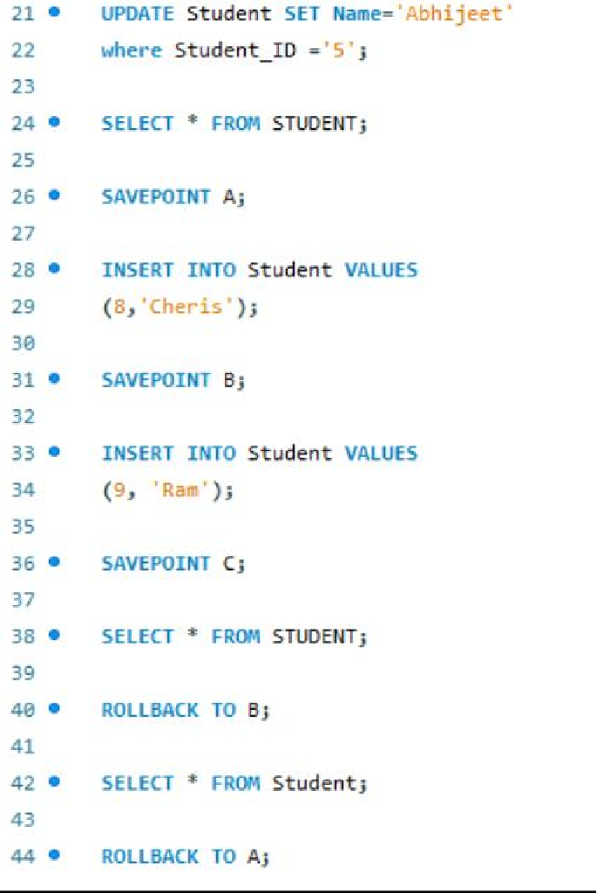
Output:
UPDATE class SET name = 'Abhijeet' WHERE id = '5'; ID 5 name changes from Rahul -> Abhijeet
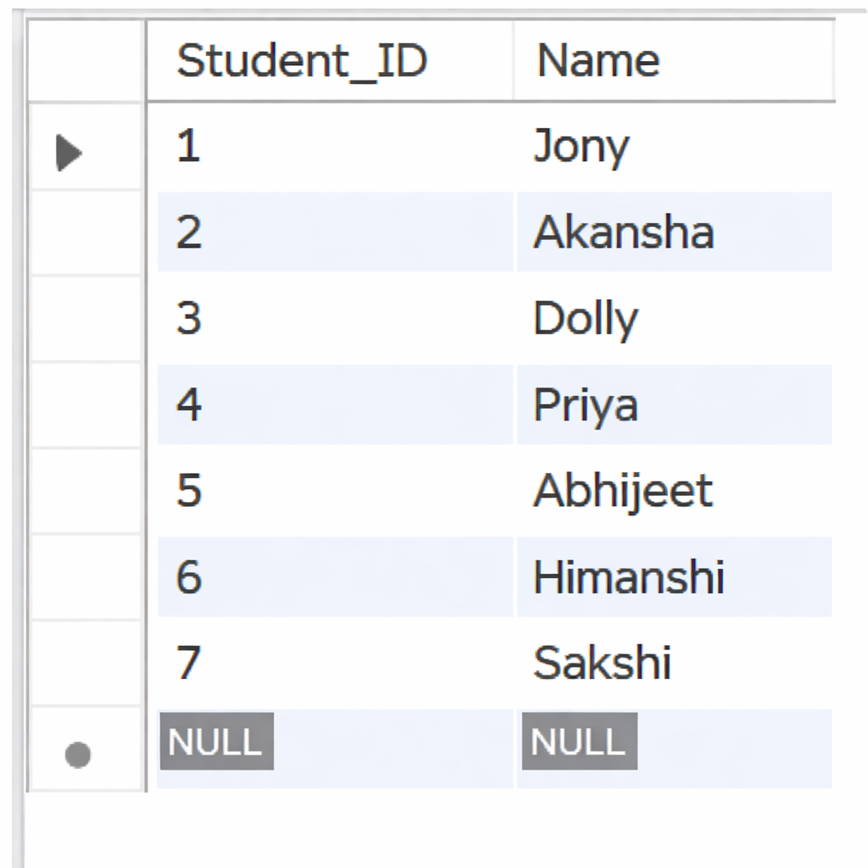
- SELECT 1 Output:

- ROLLBACK TO B;
SELECT 2 Output:
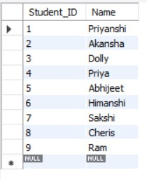

- ROLLBACK TO A;
Final Table State


Experiment – 4.2
Aim: To study and perform Transaction Control Language (TCL) commands such as SAVEPOINT, ROLLBACK, ROLLBACK TO SAVEPOINT, and COMMIT on the given
table ACCOUNT_TXN.

Acc_ID | Holder_Name | Balance
101 | Aman | 5000
102 | Bhavna | 7000
103 | Chirag | 6000

Code:
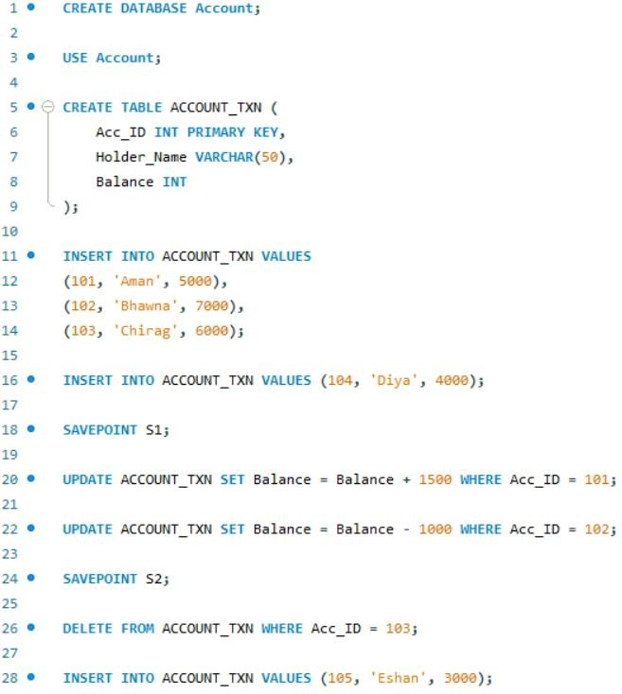
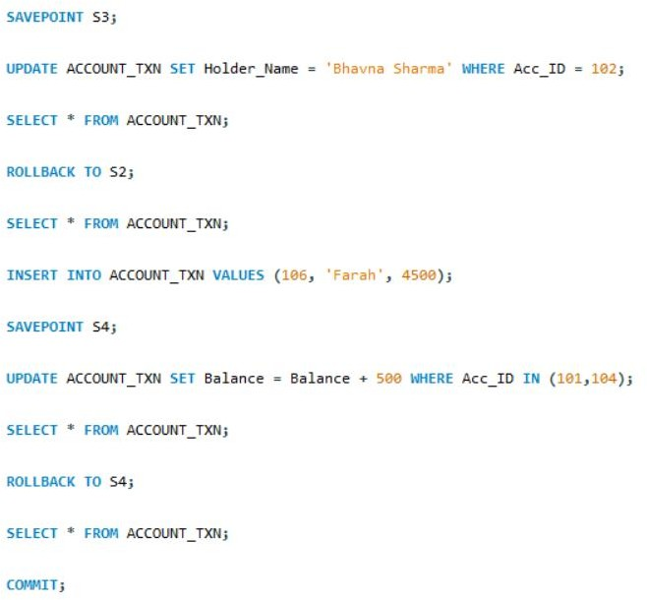

Output:
- SELECT 1 Output:
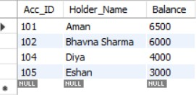

- Select 2 Output (After ROLLBACK TO S2):
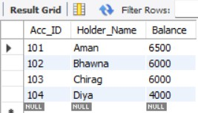
- Select 3 output:
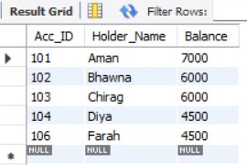

- Select 4 Output (After ROLLBACK TO S4):
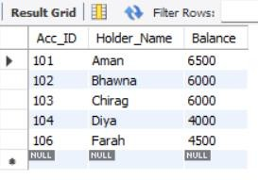
- Rows Permanently Saved After COMMIT:

Acc_ID | Holder_Name | Balance
101 | Aman | 6500
102 | Bhavna | 6000
103 | Chirag | 6000
104 | Diya | 4000
105 | Farah | 4500

- Difference between ROLLBACK and ROLLBACK TO SAVEPOINT
  - ROLLBACK cancels the entire transaction.
  - ROLLBACK TO SAVEPOINT cancels changes only up to a specific savepoint.

- Can we rollback to S3 after ROLLBACK TO S2?

  - No.
Because when we rollback to S2, all savepoints created after S2 (like S3) are removed.

- What happens if COMMIT is executed before creating any savepoint?

  - All changes become permanent and cannot be rolled back.

