SEARCH

Normallly search has four steps there are

1) Web Crawling
2) Inverted Index – Indexing the documents(web pages stored in the database by crawling) by a search term
3) Scoring based on revelance to search term.
4) Retreiving results.

INVERTED INDEX
It splits the words and then matches each word to particular document.

ELASTIC SEARCH

To check if elasticsearch is running
http://localhost:5601/

To start the service

sudo systemctl stop elasticsearch.service

Check this page for info
https://www.elastic.co/guide/en/elasticsearch/reference/7.6/deb.html#deb-repo

KIBANA

It is the visualizer for Elastic Search
http://localhost:9200/
To start service
sudo systemctl start kibana.service
sudo systemctl stop kibana.service

LOGSTASH AND BEATS

Logstash and beats are the two tools which are used to load data into the elastic search

Logstash is full fledged ETL platform. Initially was used to ingest

Beats is used ingest data in near real time

Elastic search

It gets the data which is ingest and creates indexes for them and distributes it to all the nodes in the cluster.
Node – System
Index – Like a table with similar data so that we can run queries based on these indexes
Type – Category or partition of the index. Its is like indexing in SQL.
Shard – Is a portion of the index
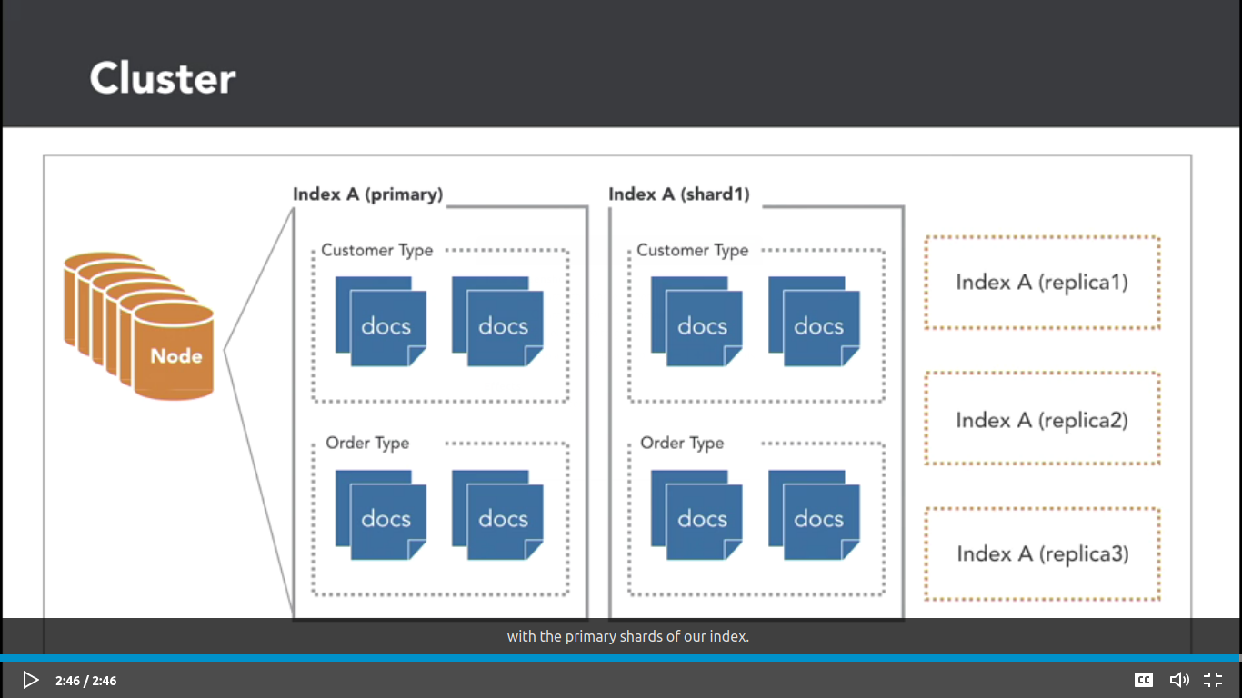
Replica – is a copy of a index

Elastic cloud
user_name: elastic
password: cB6zelqHAMrXzGOlLP1NuxJT

Querys

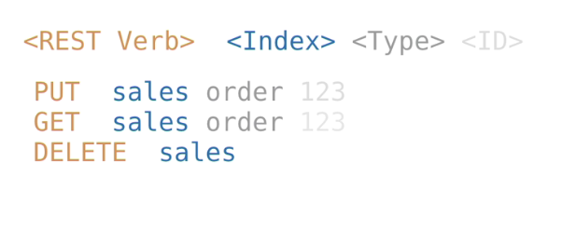
Rest verb – PUT, GET, DELETE
Index – tables like sales etcc
Type – like indexing in sql (here order)
Then ID of the document

Query

1) Find health of the instance

GET _cat/health?v (?v gives headers and does formatting)

(you can also use it along with url for localhost)
Health of the node
GET _cat/nodes?v

Health of indices and view all indices

GET _cat/indices?v

2) Create index

PUT /sales

GET _cat/indices?v

PUT /sales

USAGE OF TYPE IS DEPRECEATED

PUT /sales/order/100
{
"orderID": "100",
"orderAmount": "10000"
}

PUT /sales/_doc/101
{
"type": "order",
"orderID": "101",
"orderAmount": "40000"
}

“Below one doesnt work”
PUT sales/_doc
{
"type": "order",
"orderID": "102",
"orderAmount": "30000"
}

PUT /sales/_create/103
{
"type": "order",
"orderID": "103",
"orderAmount": "50000"
}

DELETE sales

