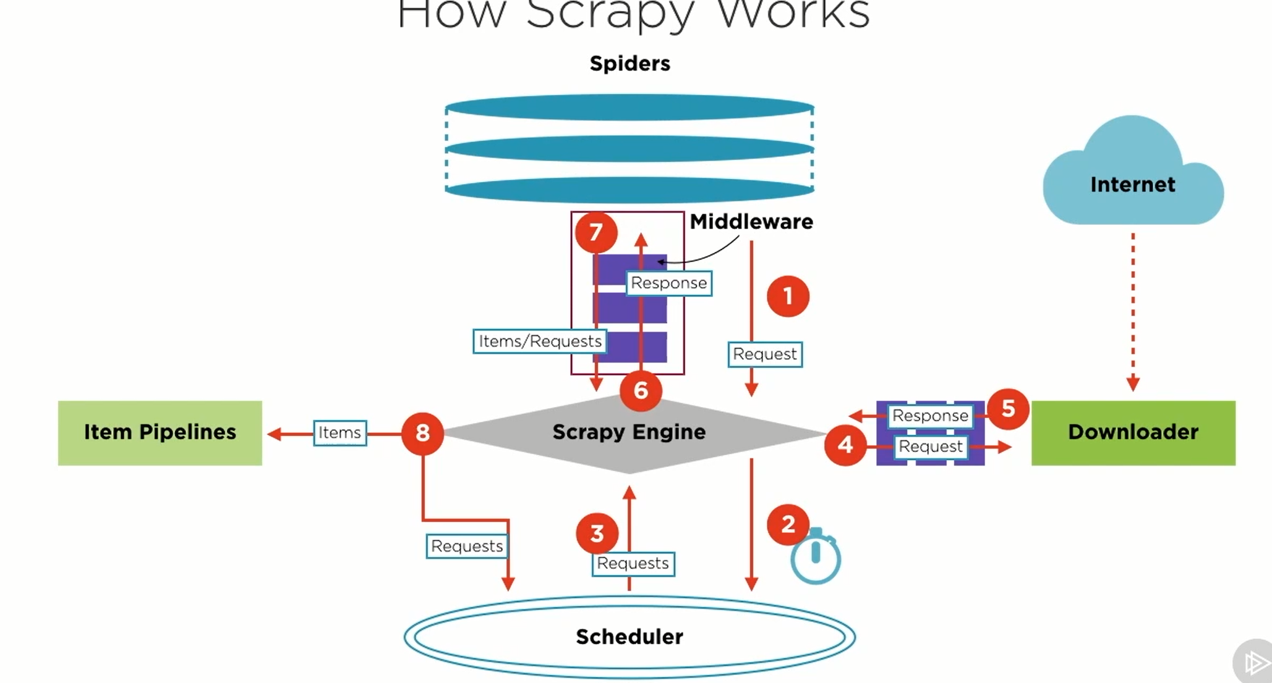

Scrapy Engine – Controls data flow and triggers all events

Spiders – are classes written by users which define how to parse the responses and extract items

Engine forwards requests to scheduler – which defines the interval of the requests

Item pipelines – are used to cleaning, validation , persisting to database etc.