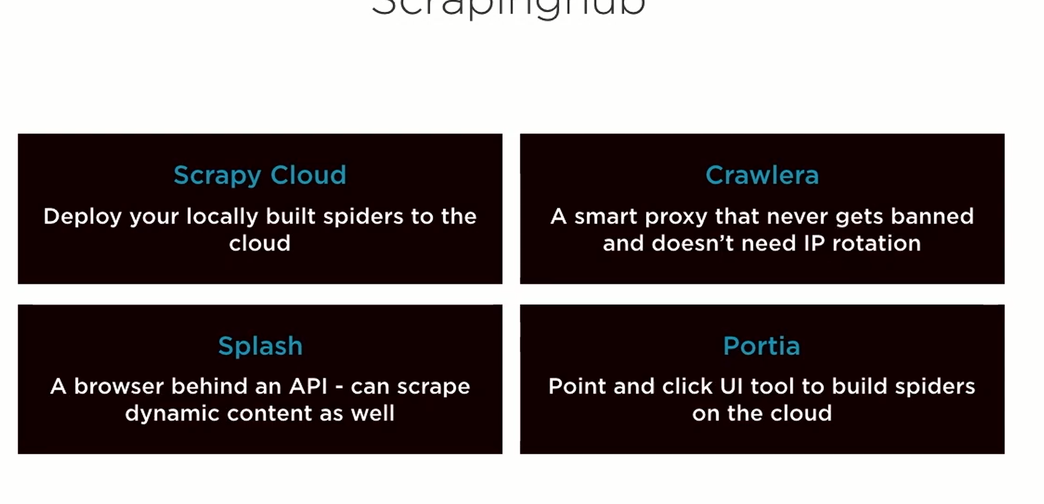

<https://app.scrapinghub.com/p/437211/deploy?state=deploy> Then vist for instructions

You must be in directly of the previously created project and then use those commands.

Add the python requirements in the requirements.txt file and then update

Yaml file.

project: 437222  
requirements:  
 file: requirements.txt