
CKNOWLEDGEMENT
I sincerely express my gratitude to my teacher Mr. Harendra Singh for giving me the opportunity to work on this NoSQL project titled “Employee Management System Using MongoDB”.
This project helped me understand the basic concepts of NoSQL databases and learn how MongoDB is used to create, retrieve, update, sort and delete data. I also learned how different query operators such as greater than, less than, equal to, AND, and OR are used in MongoDB.
I am thankful to my teacher for the guidance and support provided throughout the completion of this project.

INTRODUCTION
MongoDB is a popular NoSQL database management system that stores data in the form of documents. Unlike traditional relational databases, MongoDB does not require data to be stored in fixed rows and columns.
In this project, an Employee Management System has been created using MongoDB. The database contains information about 50 employees, including their employee ID, name, age, salary, department, and city.
Different MongoDB operations have been performed on the employee data, such as inserting, displaying, updating, deleting, sorting, counting, and searching records. Comparison operators such as $eq, $gt, $lt, $gte, and $lte have also been demonstrated, along with logical operators $and and $or.

OBJECTIVES
- To understand the concept of NoSQL databases.
- To learn the basic features of MongoDB.
- To create a database and collection.
- To insert 50 employee records.
- To perform CRUD (Create, Read, Update, Delete) operations.
- To use comparison operators.
- To perform sorting and filtering.
- To understand AND and OR operations.

1. CREATE DATABASE
MongoDB Query:
use EmployeeDB
Explanation:
Creates or switches to the EmployeeDB database.
Output:

2. CREATE COLLECTION
MongoDB Query:
db.createCollection("employees")
Explanation:
Creates a collection named employees inside the EmployeeDB database.
Output:

3. INSERT 50 EMPLOYEES
MongoDB Query:
db.employees.insertMany([
{empId:1, name:"Rohit Verma", age:24, salary:42000, dept:"IT", city:"Delhi"},
{empId:2, name:"Simran Kaur", age:27, salary:58000, dept:"HR", city:"Mumbai"},
{empId:3, name:"Aditya Rathore", age:23, salary:39000, dept:"Sales", city:"Pune"},
{empId:4, name:"Neha Chauhan", age:29, salary:76000, dept:"IT", city:"Bangalore"},
{empId:5, name:"Manish Tiwari", age:31, salary:88000, dept:"Finance", city:"Delhi"},
{empId:6, name:"Kavita Joshi", age:26, salary:47000, dept:"Marketing", city:"Chennai"},
{empId:7, name:"Suresh Nair", age:34, salary:95000, dept:"IT", city:"Hyderabad"},
{empId:8, name:"Pooja Malhotra", age:25, salary:61000, dept:"HR", city:"Mumbai"},
{empId:9, name:"Vikram Sengar", age:28, salary:33000, dept:"Sales", city:"Jaipur"},
{empId:10, name:"Anjali Bhatt", age:22, salary:28000, dept:"Marketing", city:"Noida"},
{empId:11, name:"Deepak Yadav", age:36, salary:72000, dept:"Finance", city:"Delhi"},
{empId:12, name:"Ritu Saxena", age:30, salary:84000, dept:"IT", city:"Bangalore"},
{empId:13, name:"Arjun Mehta", age:23, salary:41000, dept:"Sales", city:"Pune"},
{empId:14, name:"Swati Pandey", age:27, salary:55000, dept:"HR", city:"Chennai"},
{empId:15, name:"Nitin Kapoor", age:24, salary:29500, dept:"Marketing", city:"Noida"},
{empId:16, name:"Preeti Sharma", age:33, salary:91000, dept:"IT", city:"Gurugram"},
{empId:17, name:"Gaurav Bisht", age:26, salary:46000, dept:"Sales", city:"Jaipur"},
{empId:18, name:"Meenal Dubey", age:29, salary:69000, dept:"Finance", city:"Indore"},
{empId:19, name:"Harshad Pillai", age:35, salary:97000, dept:"IT", city:"Hyderabad"},
{empId:20, name:"Snehal Kulkarni", age:22, salary:31000, dept:"Marketing", city:"Pune"},
{empId:21, name:"Rajeev Ranjan", age:38, salary:80000, dept:"Finance", city:"Delhi"},
{empId:22, name:"Isha Agarwal", age:25, salary:54000, dept:"HR", city:"Mumbai"},
{empId:23, name:"Karan Malviya", age:24, salary:37000, dept:"Sales", city:"Jaipur"},
{empId:24, name:"Tanvi Solanki", age:28, salary:63000, dept:"IT", city:"Bangalore"},
{empId:25, name:"Ashish Rawat", age:31, salary:73500, dept:"Finance", city:"Noida"},
{empId:26, name:"Bhavna Chopra", age:26, salary:59000, dept:"Marketing", city:"Chennai"},
{empId:27, name:"Yash Trivedi", age:23, salary:34000, dept:"Sales", city:"Pune"},
{empId:28, name:"Divya Menon", age:30, salary:86000, dept:"IT", city:"Hyderabad"},
{empId:29, name:"Sandeep Rana", age:27, salary:52000, dept:"HR", city:"Delhi"},
{empId:30, name:"Alok Srivastava", age:34, salary:70000, dept:"Finance", city:"Indore"},
{empId:31, name:"Komal Thakur", age:22, salary:27000, dept:"Marketing", city:"Noida"},
{empId:32, name:"Rahul Chatterjee", age:29, salary:78000, dept:"IT", city:"Bangalore"},
{empId:33, name:"Priyanka Ghosh", age:25, salary:56000, dept:"HR", city:"Mumbai"},
{empId:34, name:"Mohit Arora", age:24, salary:40000, dept:"Sales", city:"Jaipur"},
{empId:35, name:"Sonali Deshpande", age:32, salary:92000, dept:"IT", city:"Gurugram"},
{empId:36, name:"Ravi Kant", age:36, salary:75000, dept:"Finance", city:"Delhi"},
{empId:37, name:"Ankita Bose", age:26, salary:48000, dept:"Marketing", city:"Chennai"},
{empId:38, name:"Vivek Bhardwaj", age:23, salary:32000, dept:"Sales", city:"Pune"},
{empId:39, name:"Shalini Reddy", age:31, salary:89000, dept:"IT", city:"Hyderabad"},
{empId:40, name:"Naveen Gowda", age:28, salary:65000, dept:"HR", city:"Bangalore"},
{empId:41, name:"Pallavi Iyer", age:22, salary:26000, dept:"Marketing", city:"Noida"},
empId:43, name:"Richa Mishra", age:27, salary:57000, dept:"HR", city:"Mumbai"},
{empId:44, name:"Abhinav Sood", age:24, salary:38000, dept:"Sales", city:"Jaipur"},
{empId:45, name:"Kirti Vashisht", age:29, salary:77000, dept:"IT", city:"Bangalore"},
{empId:46, name:"Devendra Pal", age:33, salary:93000, dept:"IT", city:"Gurugram"},
{empId:47, name:"Anushka Sinha", age:23, salary:29000, dept:"Marketing", city:"Pune"},
{empId:48, name:"Girish Nagpal", age:37, salary:82000, dept:"Finance", city:"Delhi"},
{empId:49, name:"Tanya Kohli", age:25, salary:60000, dept:"HR", city:"Mumbai"},
{empId:50, name:"Om Prakash", age:34, salary:71000, dept:"Finance", city:"Indore"}
])
Explanation:
Inserts 50 employee documents into the employees collection in a single operation.
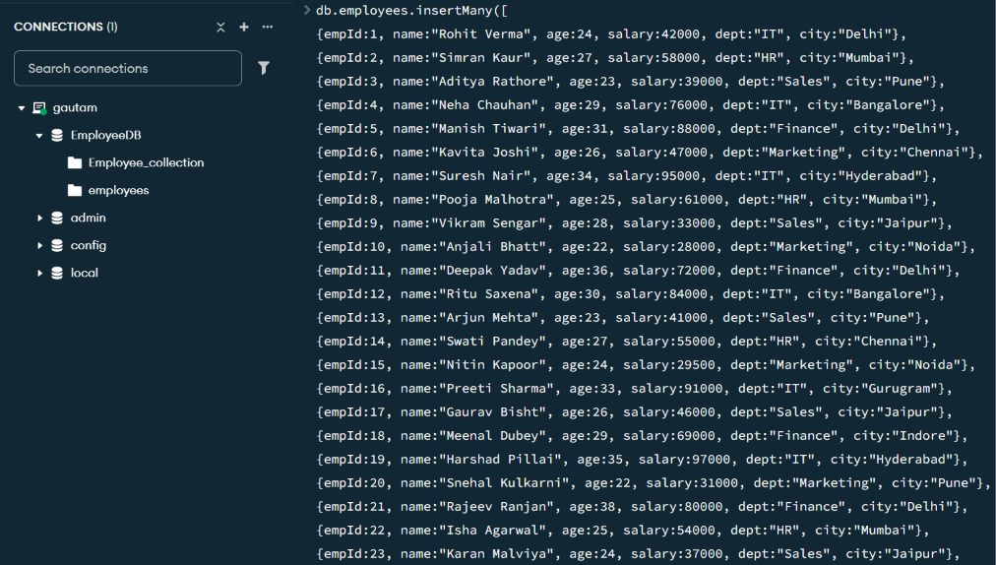
Output:
Inserted 50 documents into the “employees” collection.

4. DISPLAY ALL EMPLOYEES
MongoDB Query:
db.employees.find()
Explanation:
Retrieves and displays all 50 documents from the employees collection.
Output:

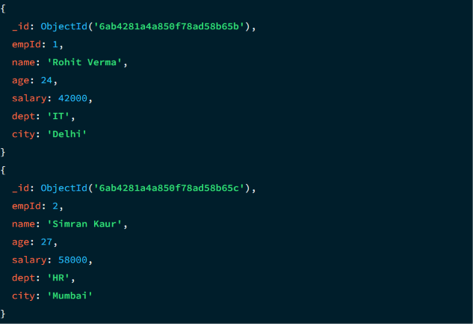

5. EQUAL TO — $EQ
MongoDB Query:
db.employees.find({salary: {$eq: 55000}})
Explanation:
Finds employees whose salary is exactly ₹55,000.
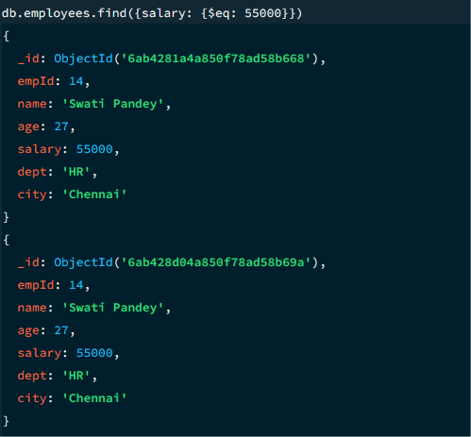
Output:
Emp ID | Name | Age | Salary | Department | City
14 | Swati Pandey | 27 | 55000 | HR | Chennai

6. GREATER THAN — $GT
MongoDB Query:
db.employees.find({salary: {$gt: 80000}})
Explanation:
Finds employees whose salary is greater than ₹80,000.
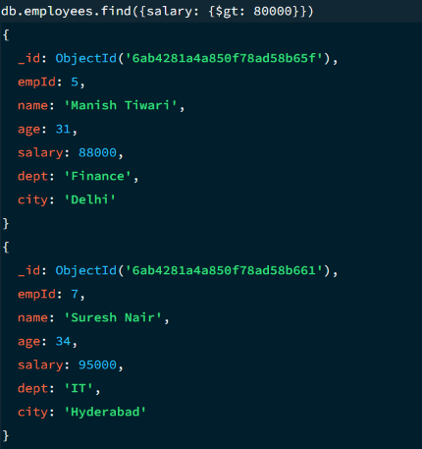
Output:
Emp ID | Name | Age | Salary | Department | City
5 | Manish Tiwari | 31 | 88000 | Finance | Delhi
7 | Suresh Nair | 34 | 95000 | IT | Hyderabad
12 | Ritu Saxena | 30 | 84000 | IT | Bangalore
16 | Preeti Sharma | 33 | 91000 | IT | Gurugram
19 | Harshad Pillai | 35 | 97000 | IT | Hyderabad
28 | Divya Menon | 30 | 86000 | IT | Hyderabad
35 | Sonali Deshpande | 32 | 92000 | IT | Gurugram
39 | Shalini Reddy | 31 | 89000 | IT | Hyderabad
42 | Sanjay Bhalla | 35 | 81000 | Finance | Delhi
46 | Devendra Pal | 33 | 93000 | IT | Gurugram
48 | Girish Nagpal | 37 | 82000 | Finance | Delhi

7. LESS THAN — $LT
MongoDB Query:
db.employees.find({salary: {$lt: 30000}})
Explanation:
Finds employees whose salary is less than ₹30,000.
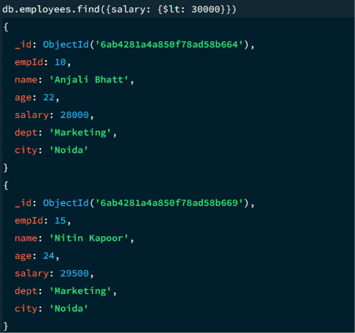
Output:
Emp ID | Name | Age | Salary | Department | City
10 | Anjali Bhatt | 22 | 28000 | Marketing | Noida
15 | Nitin Kapoor | 24 | 29500 | Marketing | Noida
31 | Komal Thakur | 22 | 27000 | Marketing | Noida
41 | Pallavi Iyer | 22 | 26000 | Marketing | Noida
47 | Anushka Sinha | 23 | 29000 | Marketing | Pune

8. GREATER THAN OR EQUAL TO — $GTE
MongoDB Query:
db.employees.find({salary: {$gte: 90000}})
Explanation:
Finds employees whose salary is ₹90,000 or above.
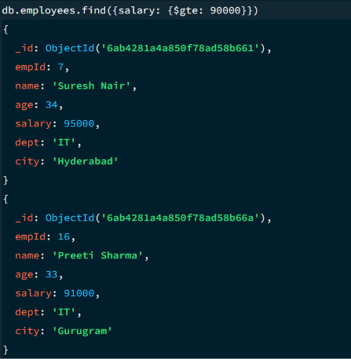
Output:
Emp ID | Name | Age | Salary | Department | City
7 | Suresh Nair | 34 | 95000 | IT | Hyderabad
16 | Preeti Sharma | 33 | 91000 | IT | Gurugram
19 | Harshad Pillai | 35 | 97000 | IT | Hyderabad
35 | Sonali Deshpande | 32 | 92000 | IT | Gurugram
46 | Devendra Pal | 33 | 93000 | IT | Gurugram

9. LESS THAN OR EQUAL TO — $LTE
MongoDB Query:
db.employees.find({salary: {$lte: 30000}})
Explanation:
Finds employees whose salary is ₹30,000 or below.
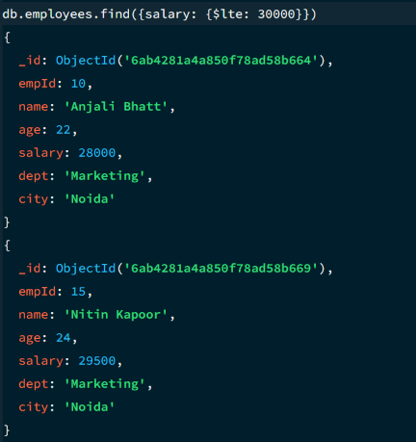
Output:
Emp ID | Name | Age | Salary | Department | City
10 | Anjali Bhatt | 22 | 28000 | Marketing | Noida
15 | Nitin Kapoor | 24 | 29500 | Marketing | Noida
31 | Komal Thakur | 22 | 27000 | Marketing | Noida
41 | Pallavi Iyer | 22 | 26000 | Marketing | Noida
47 | Anushka Sinha | 23 | 29000 | Marketing | Pune

10. UPDATE OPERATION
MongoDB Query:
Explanation:
Updates the salary of the employee with empId 8 (Pooja Malhotra) to ₹90,000.
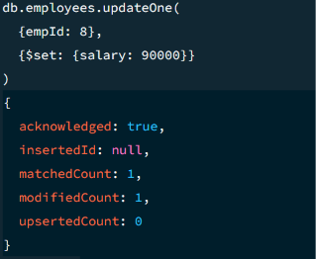

11. DELETE ONE OPERATION
MongoDB Query:
db.employees.deleteOne({empId: 15})
Explanation:
Deletes the single document matching empId 15 (Nitin Kapoor).
Output:
deletedCount: 1
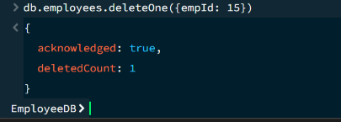

12. DELETE MANY OPERATION
MongoDB Query:
db.employees.deleteMany({
salary: {$lt: 30000}
})
Explanation:
Deletes all employees having a salary below ₹30,000 (evaluated after the previous update and delete).
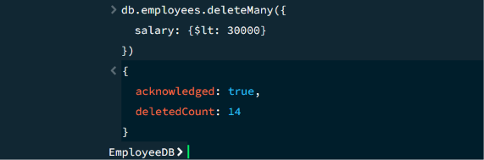
Output:
deletedCount: 4

13. AND OPERATION — $AND
MongoDB Query:
db.employees.find({
$and: [
{salary: {$gt: 70000}},
{dept: "IT"}
]
})
Explanation:
Finds employees whose salary is greater than ₹70,000 AND who work in the IT department.
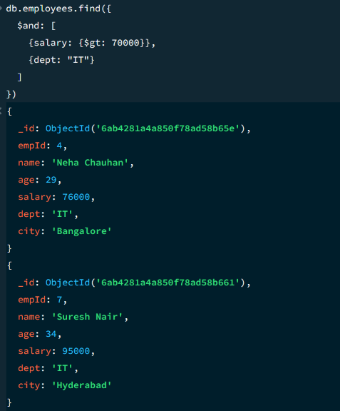
Output:
Emp ID | Name | Age | Salary | Department | City
4 | Neha Chauhan | 29 | 76000 | IT | Bangalore
7 | Suresh Nair | 34 | 95000 | IT | Hyderabad
12 | Ritu Saxena | 30 | 84000 | IT | Bangalore
16 | Preeti Sharma | 33 | 91000 | IT | Gurugram
19 | Harshad Pillai | 35 | 97000 | IT | Hyderabad
28 | Divya Menon | 30 | 86000 | IT | Hyderabad
32 | Rahul Chatterjee | 29 | 78000 | IT | Bangalore
35 | Sonali Deshpande | 32 | 92000 | IT | Gurugram
39 | Shalini Reddy | 31 | 89000 | IT | Hyderabad
45 | Kirti Vashisht | 29 | 77000 | IT | Bangalore
46 | Devendra Pal | 33 | 93000 | IT | Gurugram

14. OR OPERATION — $OR
MongoDB Query:
db.employees.find({
$or: [
{city: "Delhi"},
{city: "Mumbai"}
]
})
Explanation:
Finds employees who live in Delhi OR Mumbai.
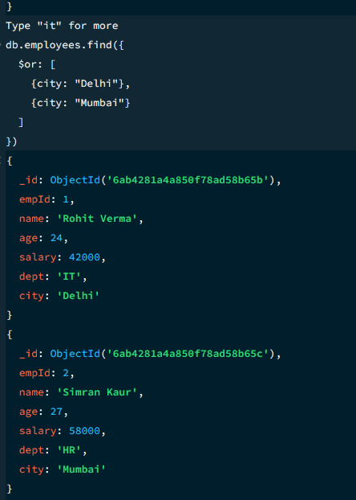
Output:
Emp ID | Name | Age | Salary | Department | City
1 | Rohit Verma | 24 | 42000 | IT | Delhi
2 | Simran Kaur | 27 | 58000 | HR | Mumbai
5 | Manish Tiwari | 31 | 88000 | Finance | Delhi
8 | Pooja Malhotra | 25 | 61000 | HR | Mumbai
11 | Deepak Yadav | 36 | 72000 | Finance | Delhi
21 | Rajeev Ranjan | 38 | 80000 | Finance | Delhi
22 | Isha Agarwal | 25 | 54000 | HR | Mumbai
29 | Sandeep Rana | 27 | 52000 | HR | Delhi
33 | Priyanka Ghosh | 25 | 56000 | HR | Mumbai
36 | Ravi Kant | 36 | 75000 | Finance | Delhi
42 | Sanjay Bhalla | 35 | 81000 | Finance | Delhi
43 | Richa Mishra | 27 | 57000 | HR | Mumbai
48 | Girish Nagpal | 37 | 82000 | Finance | Delhi
49 | Tanya Kohli | 25 | 60000 | HR | Mumbai

15. SORT OPERATION
A. MongoDB Query:
db.employees.find().sort({salary: 1})
Explanation:
Sorts employees by salary from lowest to highest. Use 1 for ascending order.
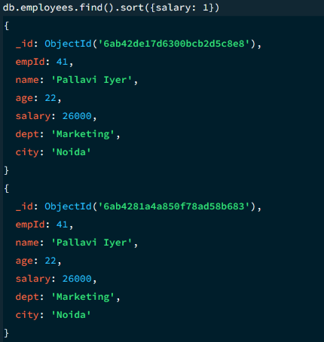
Output (first 5 shown):
Emp ID | Name | Age | Salary | Department | City
41 | Pallavi Iyer | 22 | 26000 | Marketing | Noida
31 | Komal Thakur | 22 | 27000 | Marketing | Noida
10 | Anjali Bhatt | 22 | 28000 | Marketing | Noida
47 | Anushka Sinha | 23 | 29000 | Marketing | Pune
15 | Nitin Kapoor | 24 | 29500 | Marketing | Noida
B. MongoDB Query:
db.employees.find().sort({salary: -1})
Explanation:
Sorts employees by salary from highest to lowest. Use -1 for descending order.
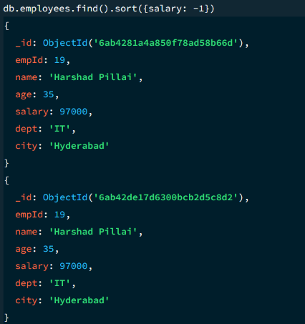
Output (first 5 shown):
Emp ID | Name | Age | Salary | Department | City
19 | Harshad Pillai | 35 | 97000 | IT | Hyderabad
7 | Suresh Nair | 34 | 95000 | IT | Hyderabad
46 | Devendra Pal | 33 | 93000 | IT | Gurugram
35 | Sonali Deshpande | 32 | 92000 | IT | Gurugram
16 | Preeti Sharma | 33 | 91000 | IT | Gurugram

16. LIMIT OPERATION
MongoDB Query:
db.employees.find().limit(5)
Explanation:
Displays only the first five documents from the collection.
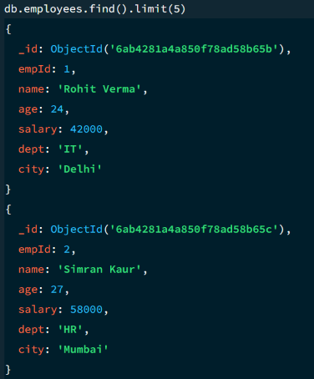
Output:
Emp ID | Name | Age | Salary | Department | City
1 | Rohit Verma | 24 | 42000 | IT | Delhi
2 | Simran Kaur | 27 | 58000 | HR | Mumbai
3 | Aditya Rathore | 23 | 39000 | Sales | Pune
4 | Neha Chauhan | 29 | 76000 | IT | Bangalore
5 | Manish Tiwari | 31 | 88000 | Finance | Delhi

17. SEARCH BY DEPARTMENT
MongoDB Query:
db.employees.find({dept: "IT"})
Explanation:
Finds all employees who work in the IT department.
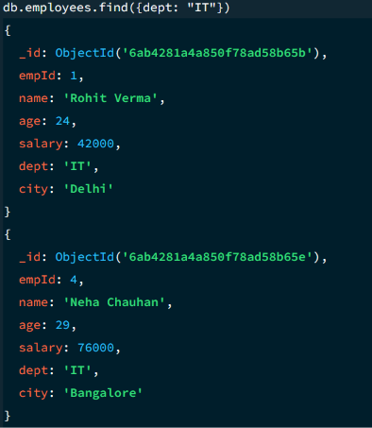
Output:
Emp ID | Name | Age | Salary | Department | City
1 | Rohit Verma | 24 | 42000 | IT | Delhi
4 | Neha Chauhan | 29 | 76000 | IT | Bangalore
7 | Suresh Nair | 34 | 95000 | IT | Hyderabad
12 | Ritu Saxena | 30 | 84000 | IT | Bangalore
16 | Preeti Sharma | 33 | 91000 | IT | Gurugram
19 | Harshad Pillai | 35 | 97000 | IT | Hyderabad
24 | Tanvi Solanki | 28 | 63000 | IT | Bangalore
28 | Divya Menon | 30 | 86000 | IT | Hyderabad
32 | Rahul Chatterjee | 29 | 78000 | IT | Bangalore
35 | Sonali Deshpande | 32 | 92000 | IT | Gurugram
39 | Shalini Reddy | 31 | 89000 | IT | Hyderabad
45 | Kirti Vashisht | 29 | 77000 | IT | Bangalore
46 | Devendra Pal | 33 | 93000 | IT | Gurugram

18. COUNT DOCUMENTS
MongoDB Query:
db.employees.countDocuments()
Explanation:
Counts the documents currently present in the collection (performed after the update and delete operations).
Output:
45
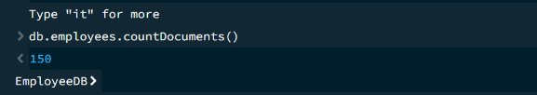

MONGODB OPERATORS USED
Operator | Meaning | Example
$eq | Equal to | salary: {$eq: 55000}
$gt | Greater than | salary: {$gt: 80000}
$lt | Less than | salary: {$lt: 30000}
$gte | Greater than or equal to | salary: {$gte: 90000}
$lte | Less than or equal to | salary: {$lte: 30000}
$and | All conditions true | $and: [...]
$or | At least one condition true | $or: [...]

CONCLUSION
This project provided practical knowledge of NoSQL databases using MongoDB. An Employee Management System containing employee information was created and different MongoDB operations were performed on the data.
Through this project, I learned how to insert, retrieve, update, and delete documents. I also learned how to sort data in ascending and descending order, how comparison operators such as $eq, $gt, $lt, $gte, and $lte work, along with logical operators such as $and and $or.
Overall, this project helped me understand how MongoDB can be used to manage and query employee data efficiently, and demonstrated the practical application of CRUD operations in a real-world NoSQL scenario.

