* Checking Docker installation, version and container on Ubuntu machine as shown.

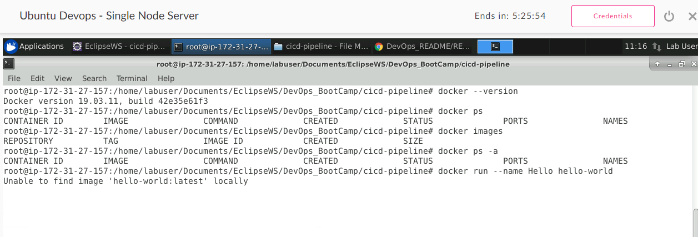

* Running hello-world docker container on Ubuntu machine.

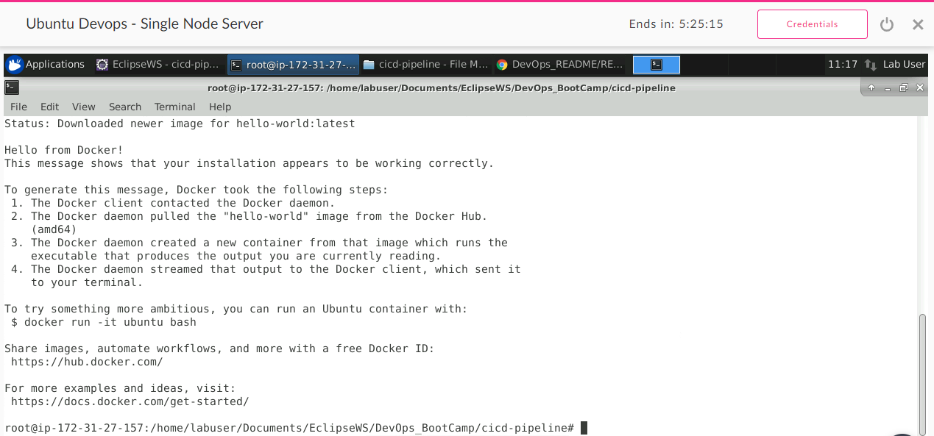

* Checking docker images and removing hello-world container and docker image.

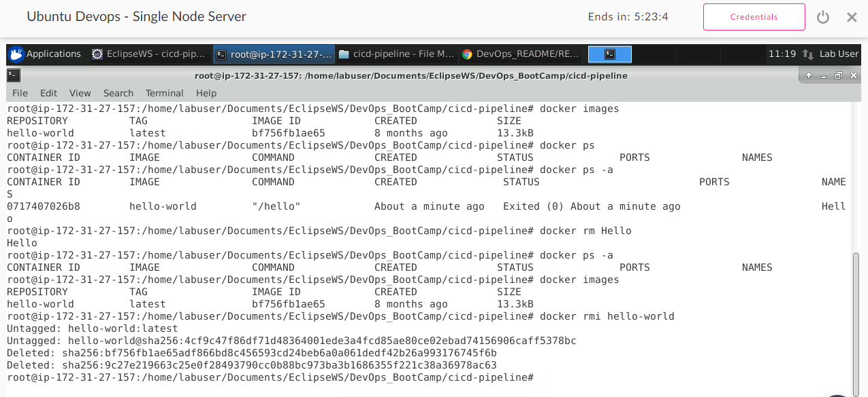

* Building a docker image from my spring boot project using dockerfile as shown.

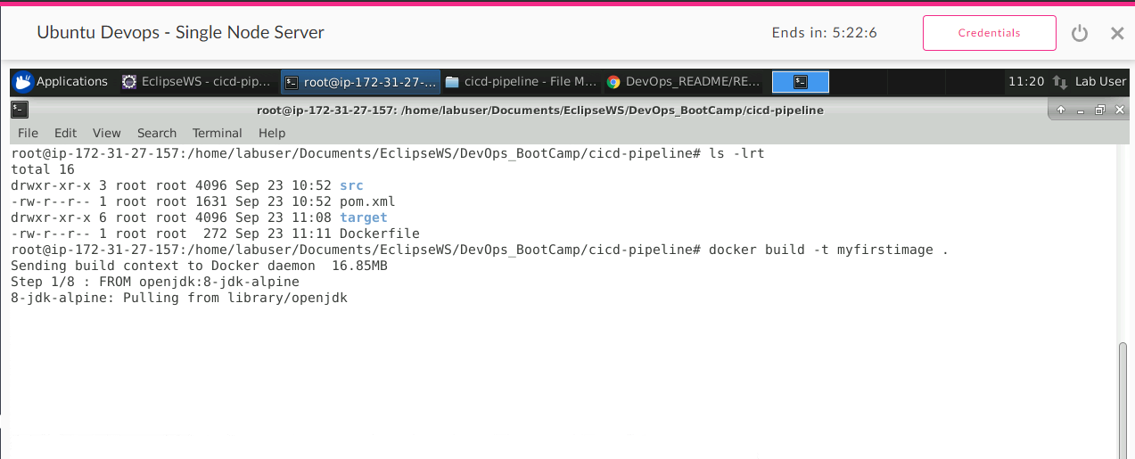

* Docker image is built for Spring boot project.

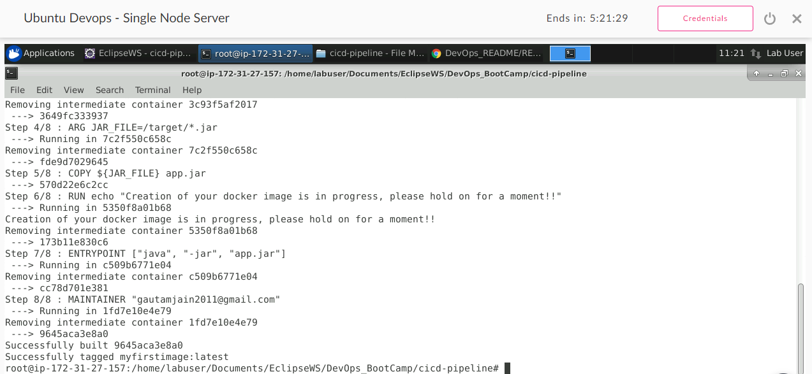

* Running newly built spring boot docker image and checking docker instance.

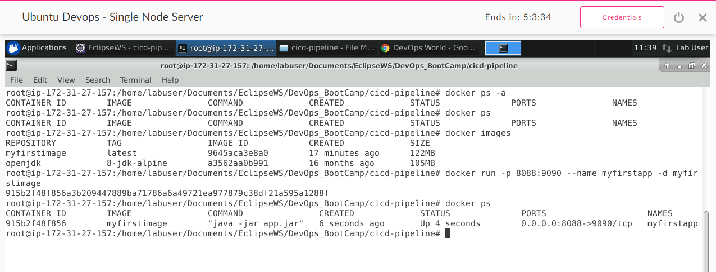

* Spring boot application is running as docker container successfully on Ubuntu machine.

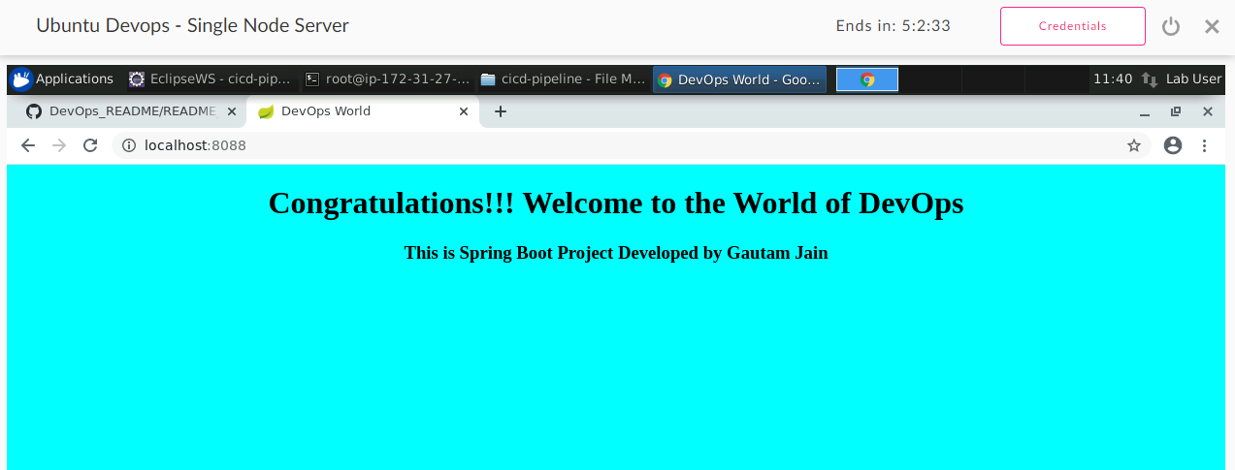

* Docker login to check-in docker image to Docker hub repo from Ubuntu machine.

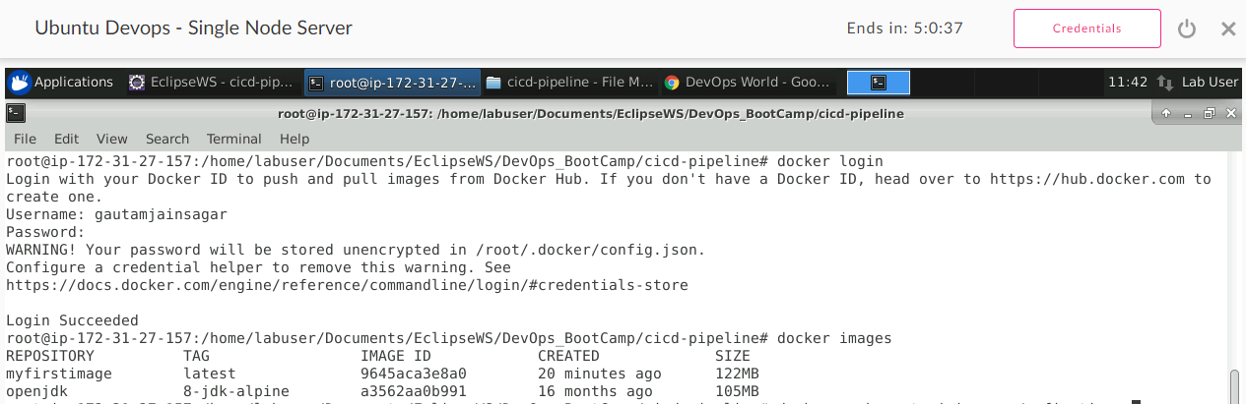

* Pushed newly built spring boot docker image to docker hub successfully.

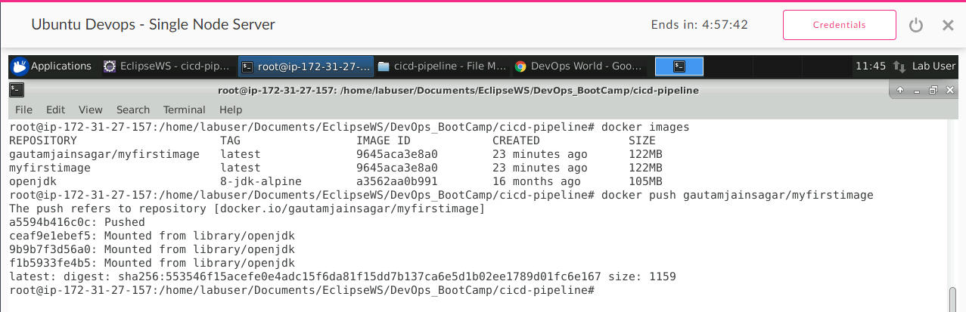

* Checking Docker installation on windows machine, version and pulling spring boot application from Docker Hub which we pushed earlier.

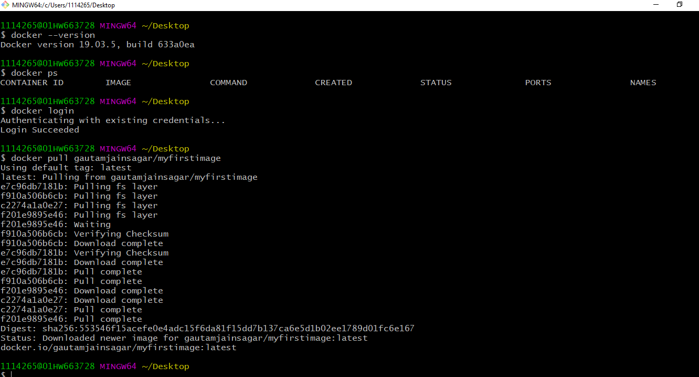

* Checking docker images and running docker container for spring boot app on windows machine.

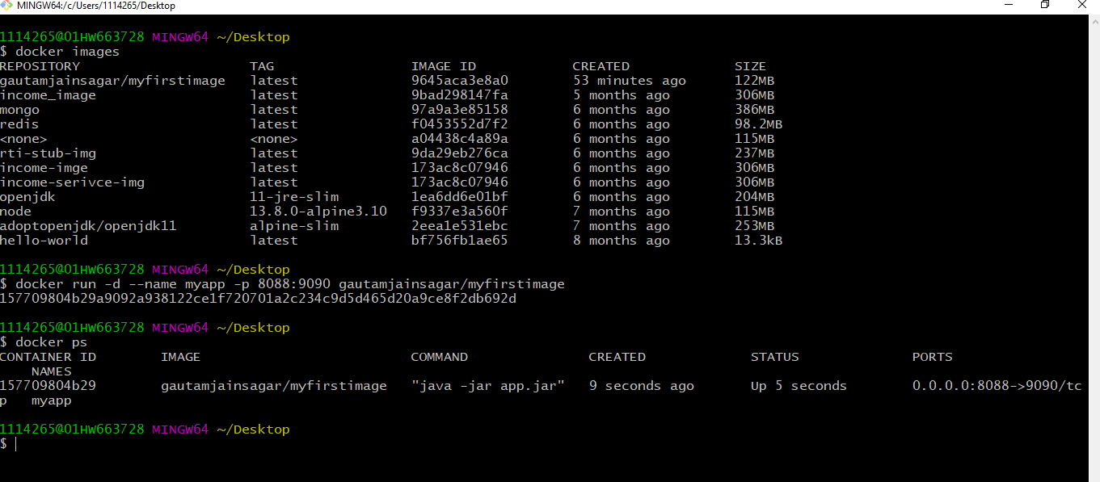

* Spring boot application is running as docker container successfully on windows machine.

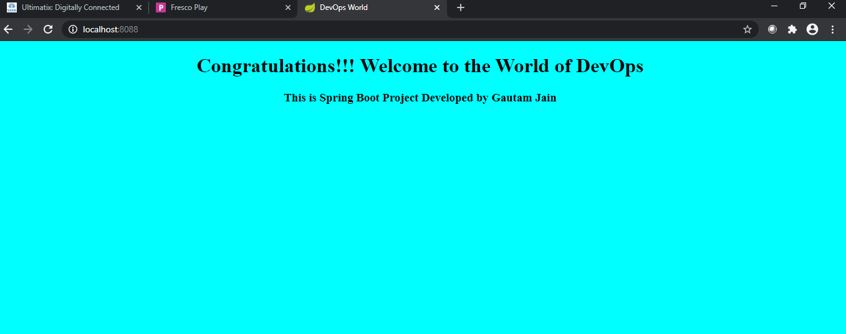

* Building a docker image from my java web application project using dockerfile as shown on Ubuntu machine.

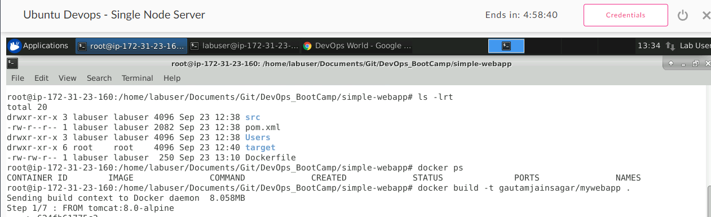

* Running newly built java webapp docker image and checking docker instance on Ubuntu machine.

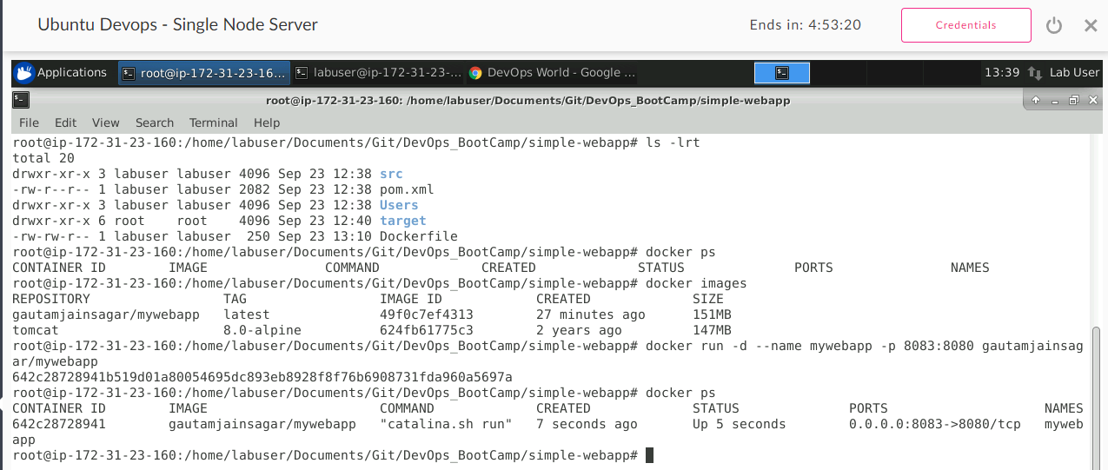

* Java web application is running as docker container successfully on Ubuntu machine.

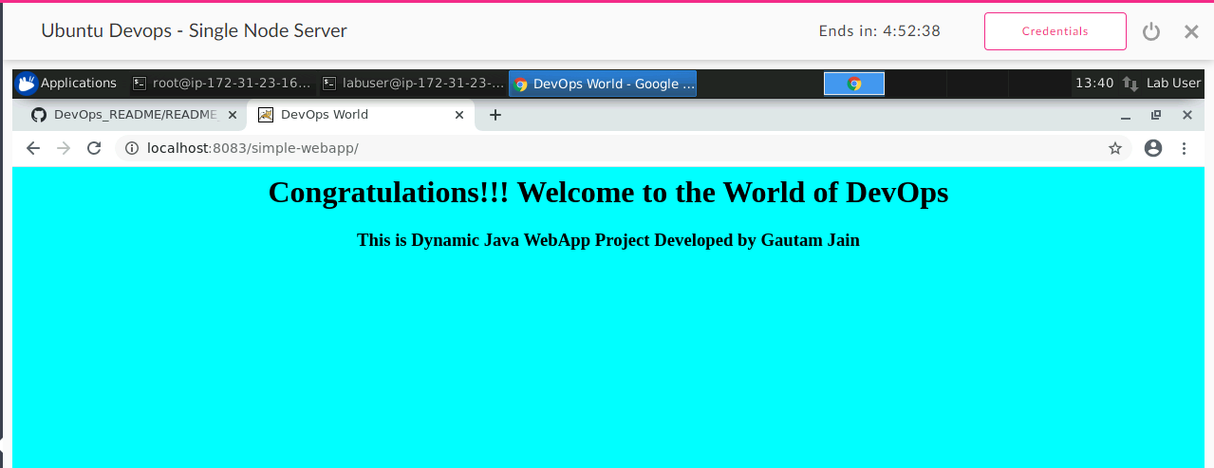

* Docker login to check-in docker java webapp image to Docker hub repo from Ubuntu machine.

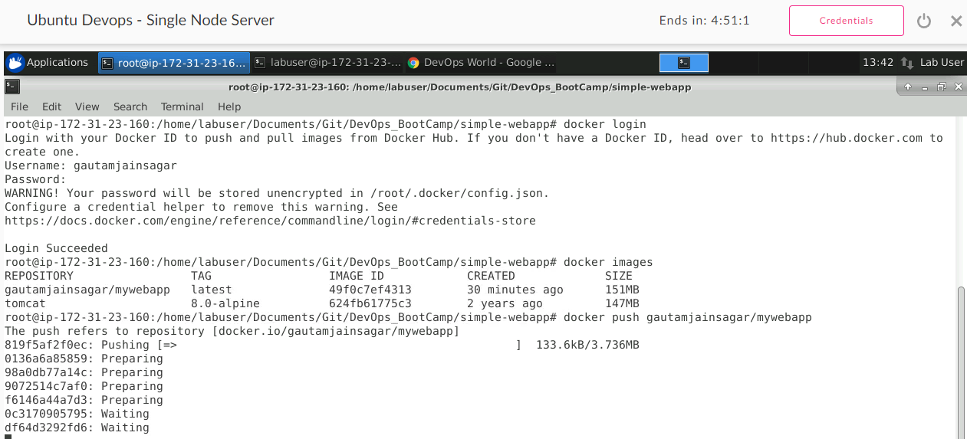

* Docker login on windows machine and pulling java web application from Docker Hub which we pushed earlier.

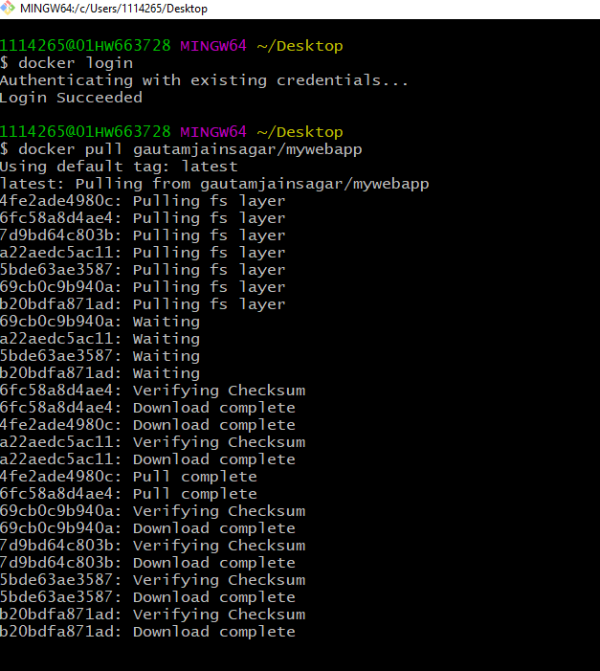

* Checking docker images and running docker container for java web app on windows machine.

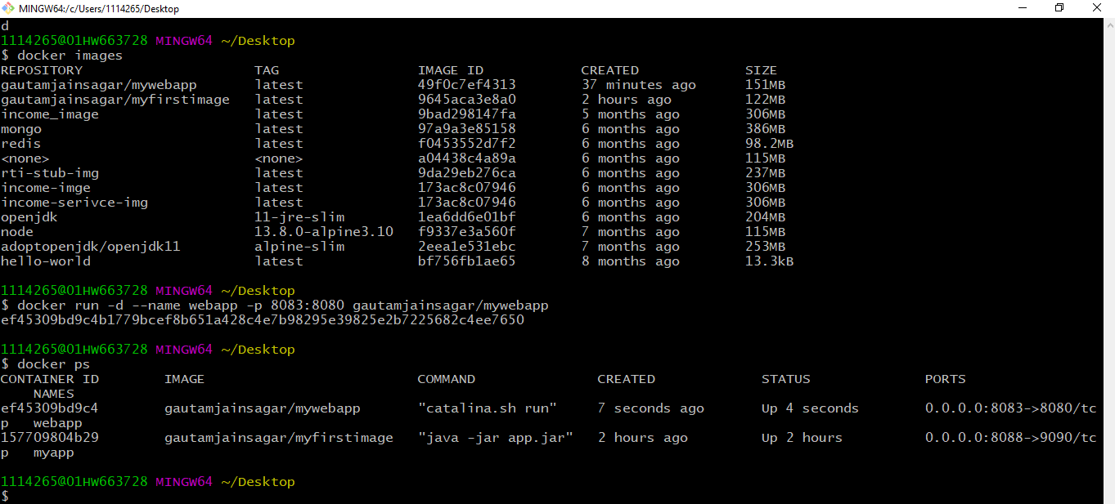

* Java web application is running as docker container successfully on windows machine.

