* Git installation and global git user configuration.

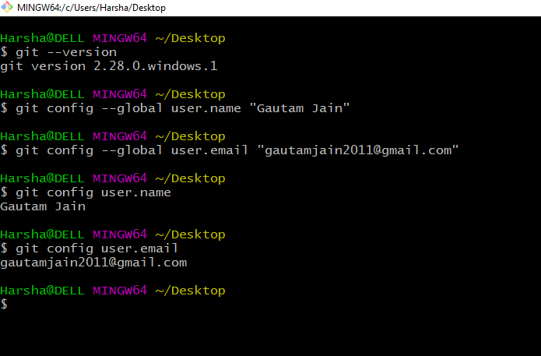

* Git repository initialization and to connect a local repository to a specific remote repository.

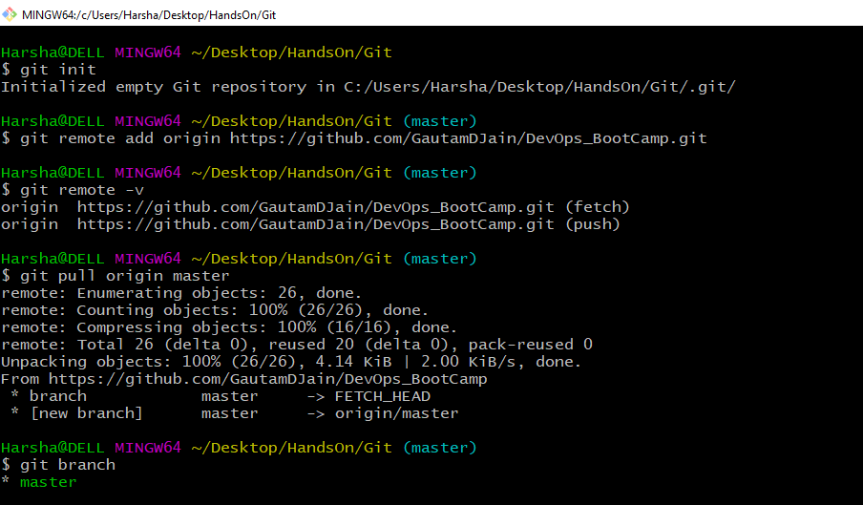

* Checking git status and creating new folder and new git file as shown.

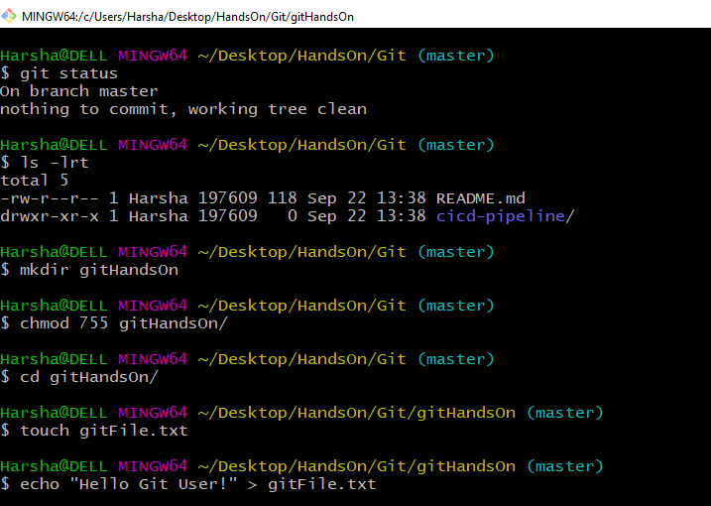

* Checking git status after creating new file as shown.

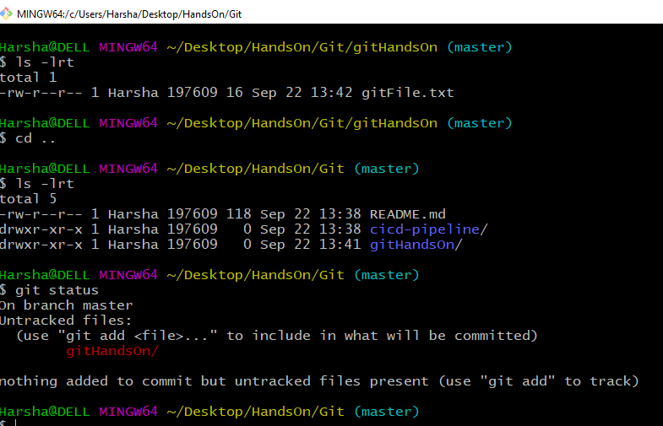

* Git add, Git commit and Git log commands.

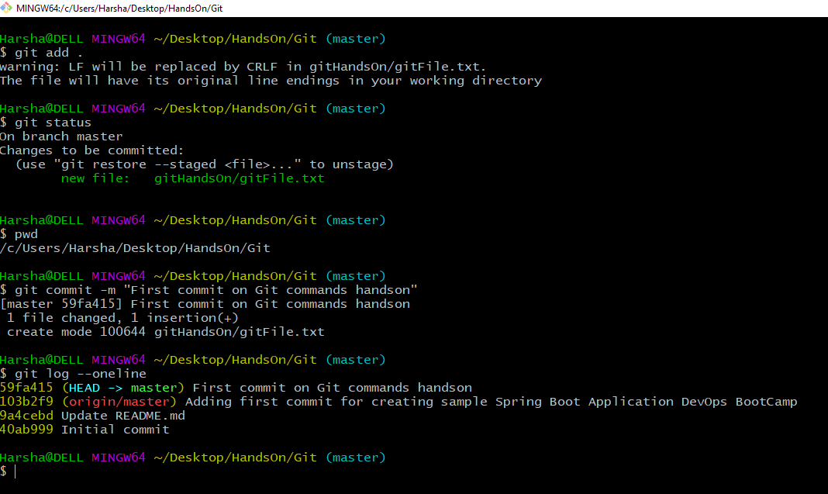

* Git push to push new changes to remote repo and git status.

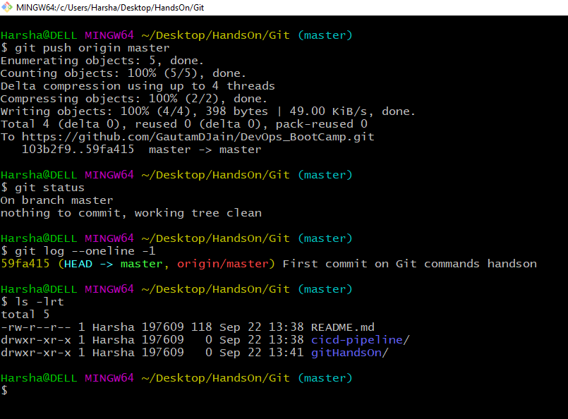

* Git clone in a new folder for running other git commands

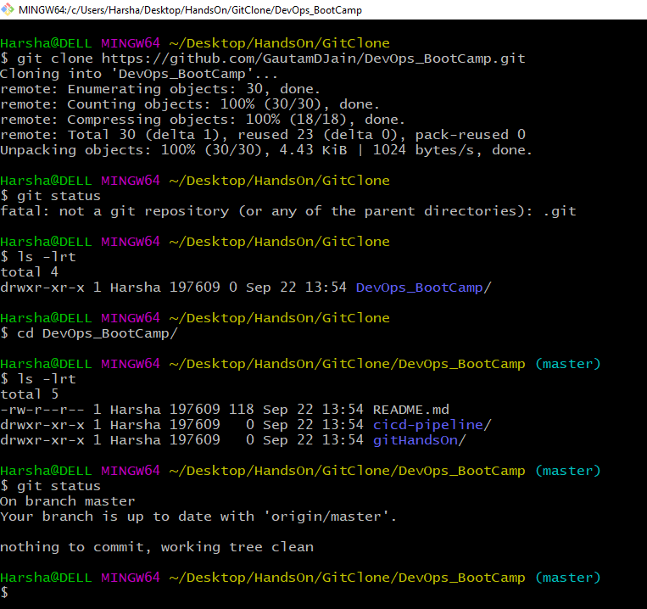

Creating new git branch **gitCMDBranch** and git checkout commands as shown.

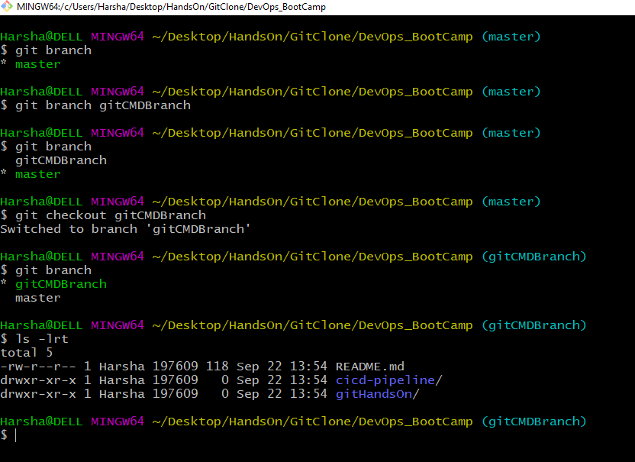

* Adding new file in new git branch and adding to staging Area.

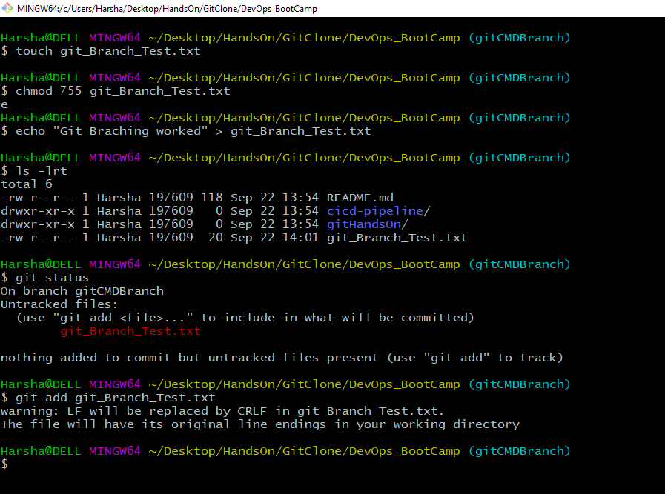

* Git commit into new branch and git status.

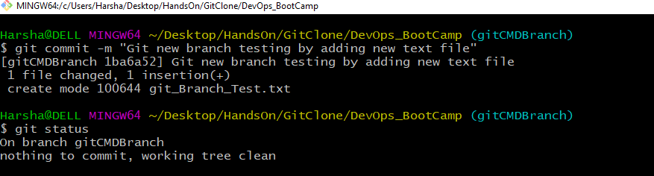

* Back to master branch to merge new **gitCMDBranch** into master branch as shown.

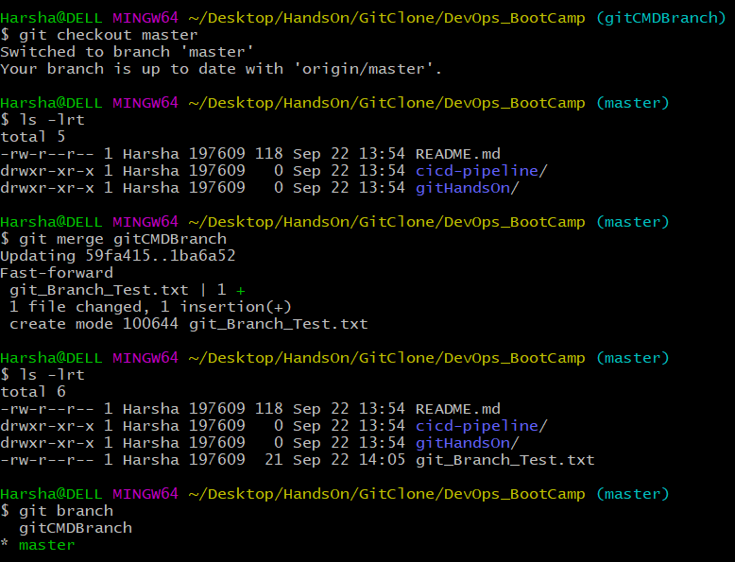

* Git branch, git delete branch and git push commands.

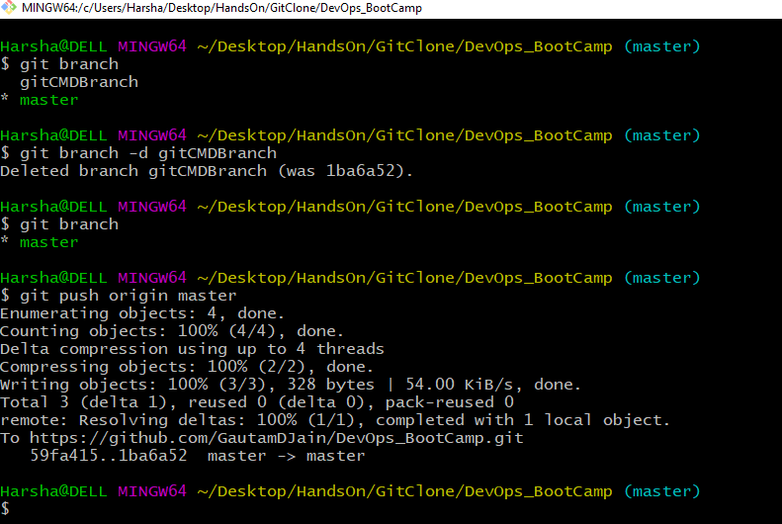

* Git log and Git Status

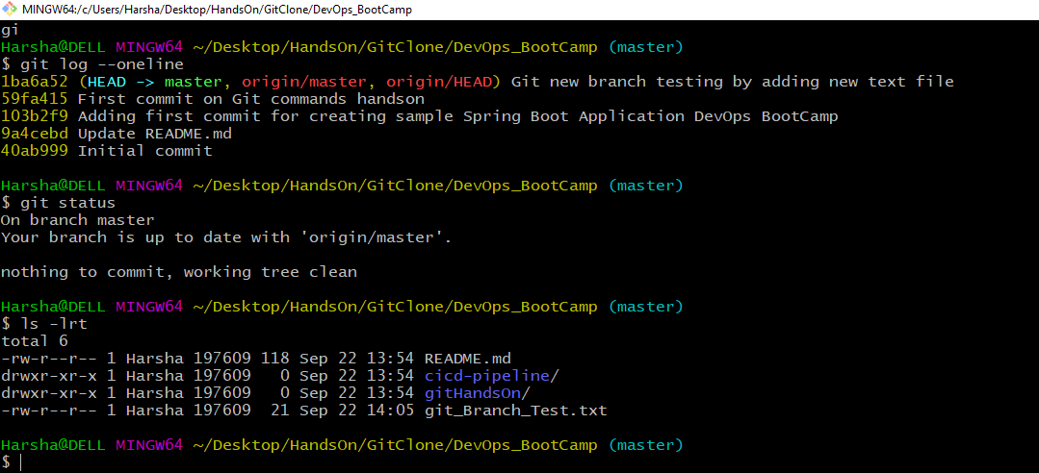

* Creating new file for stash change and remove as shown.

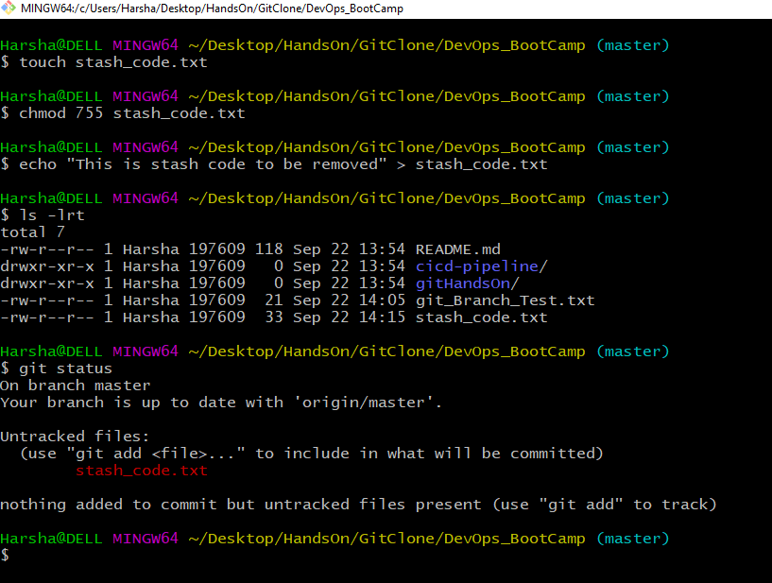

* Git stash after making temp changes which need to be saved for later use but not to commit.

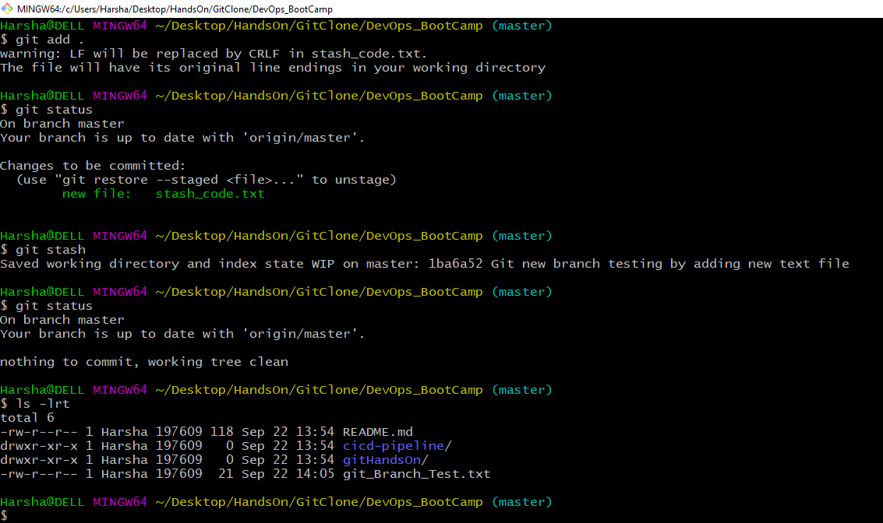

* Git stash list, git stash apply and git status.

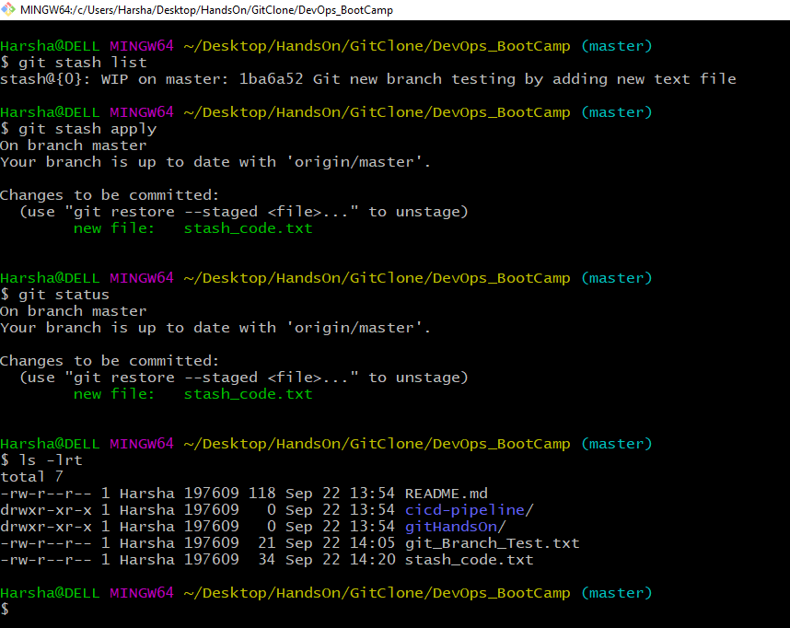

* Making new commit to show git revert command with git log list as ashown.

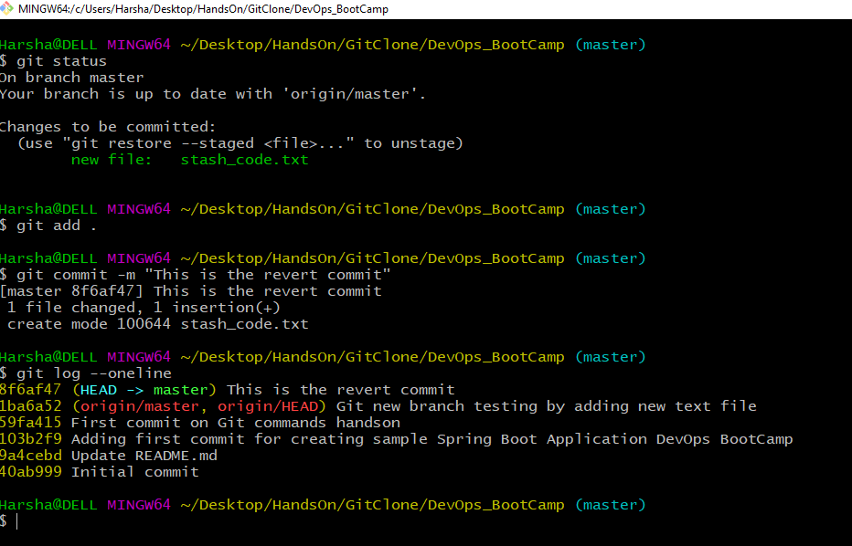

* Git revert command to revert changes to a particular commit with git log as shown.

