* Initial Jenkins setup on Ubuntu machine in GCP.

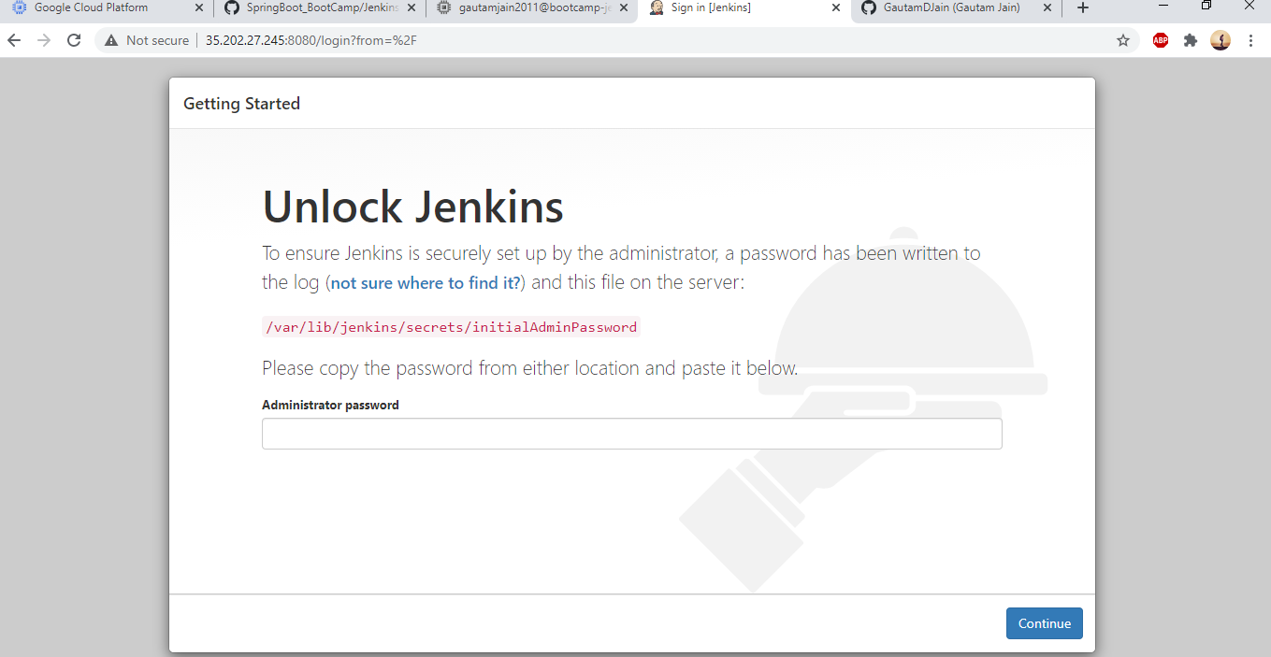

* Jenkins is ready to use with pre-defined plugins installed on GCP instance.

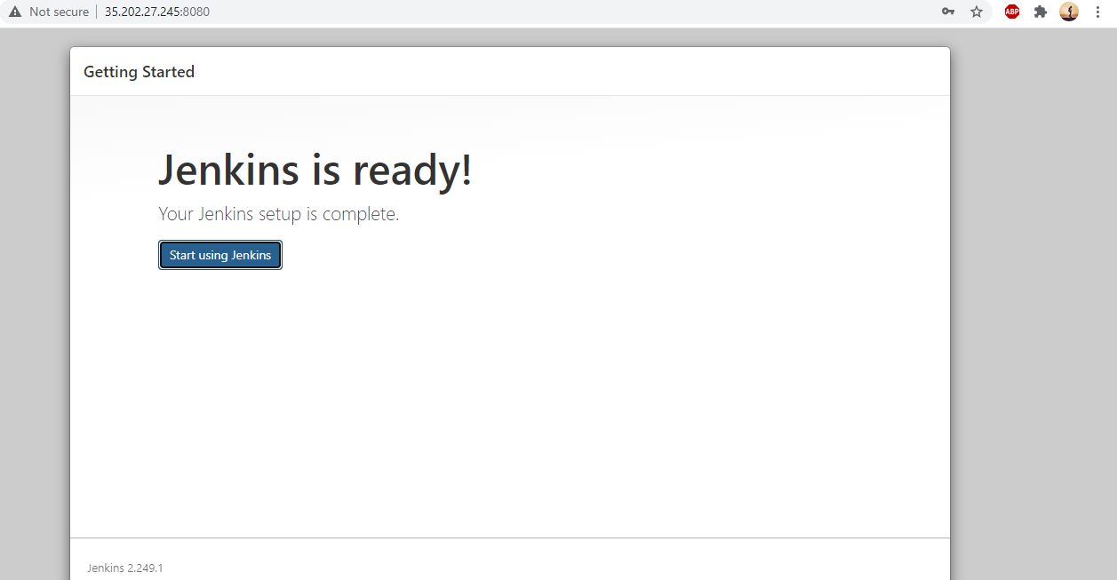

* Configuring Jenkins pipeline for both Spring boot and Java web app project on Jenkins server as shown.

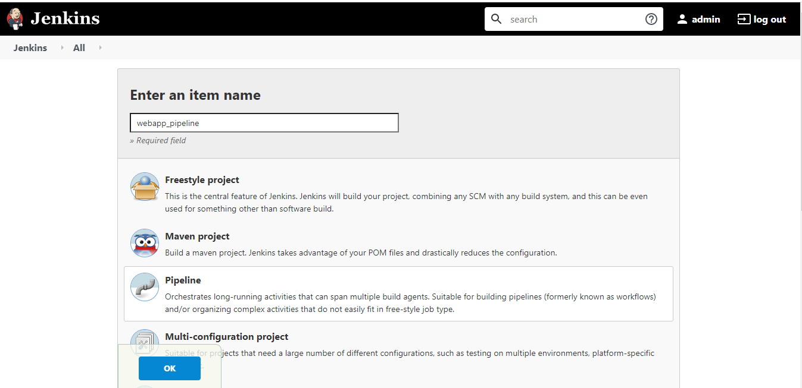

* Created two new jenkins pipelines as shown.

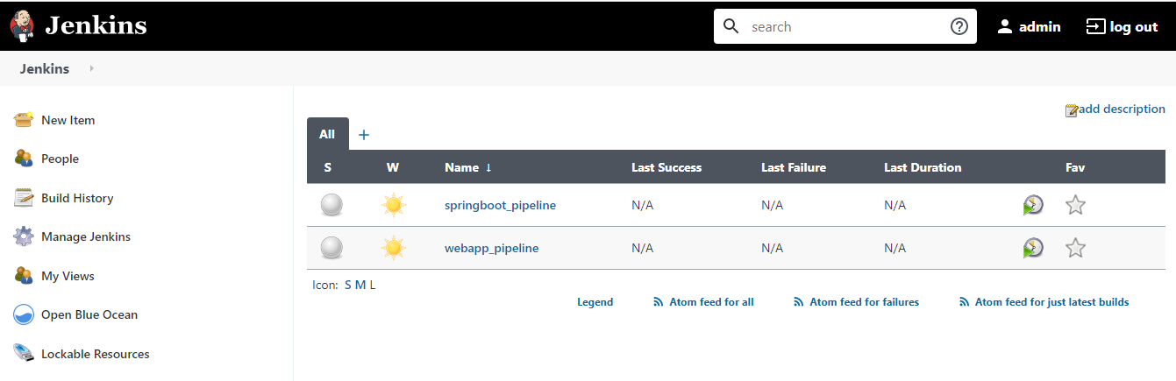

* Added global configuration for Maven and Docker as runtime plug-in as shown.

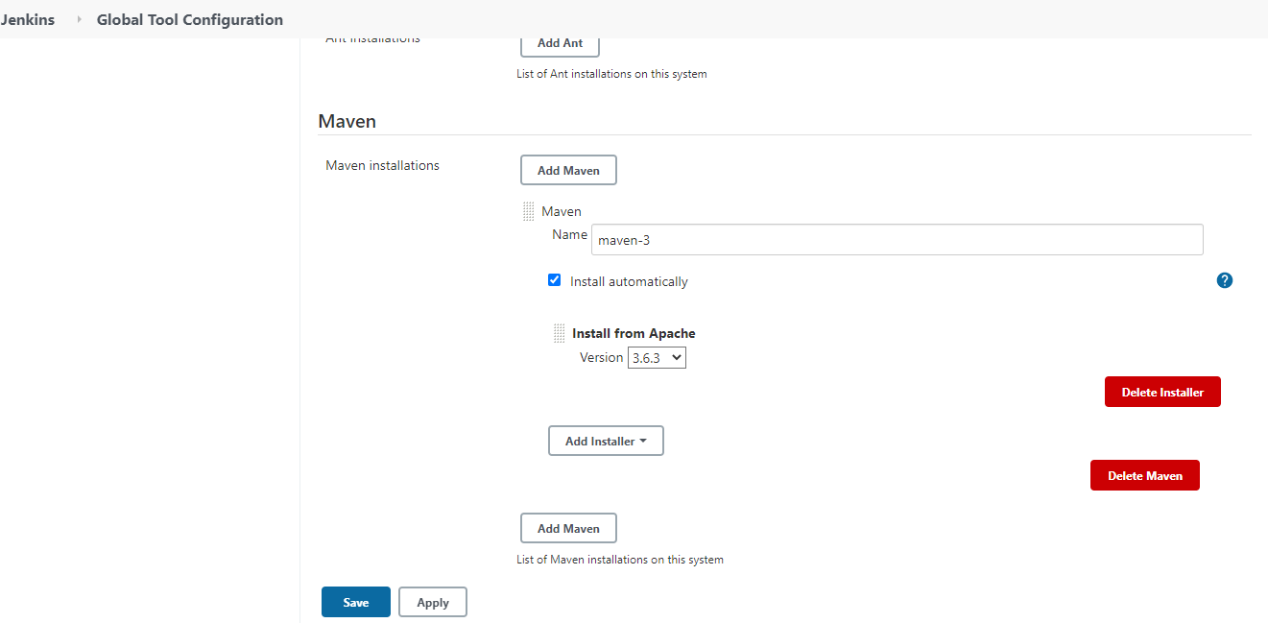

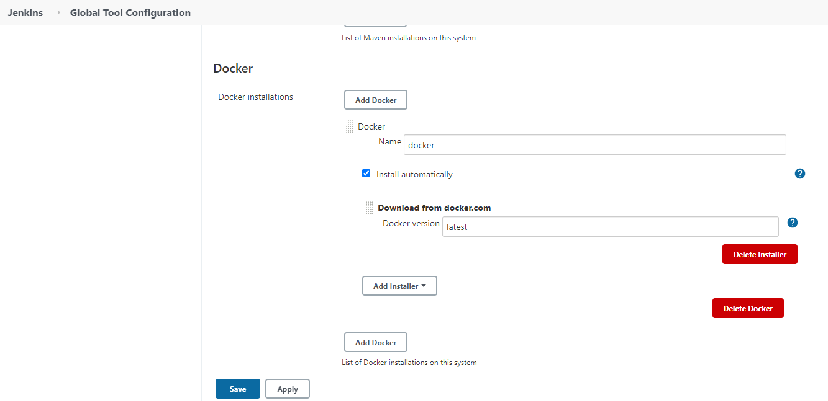

* Configuring Jenkins pipeline for both Spring & Web App as shown with pipeline script reading from GitHub as show.

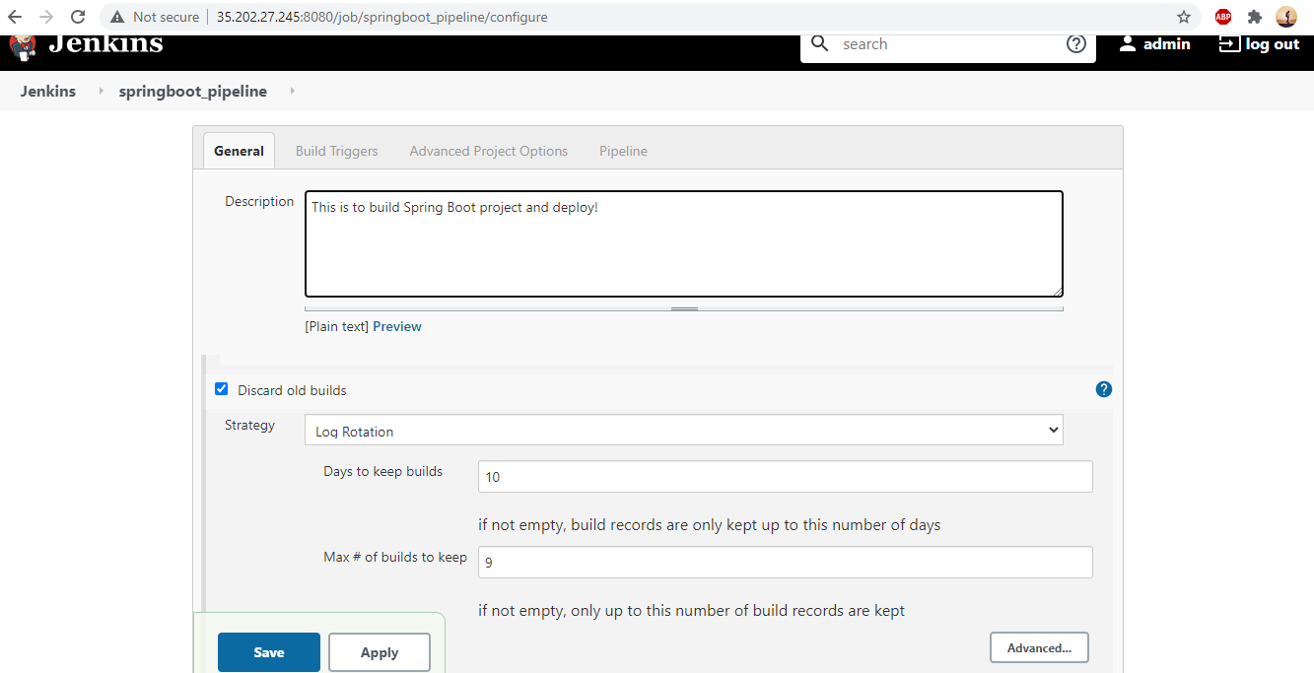

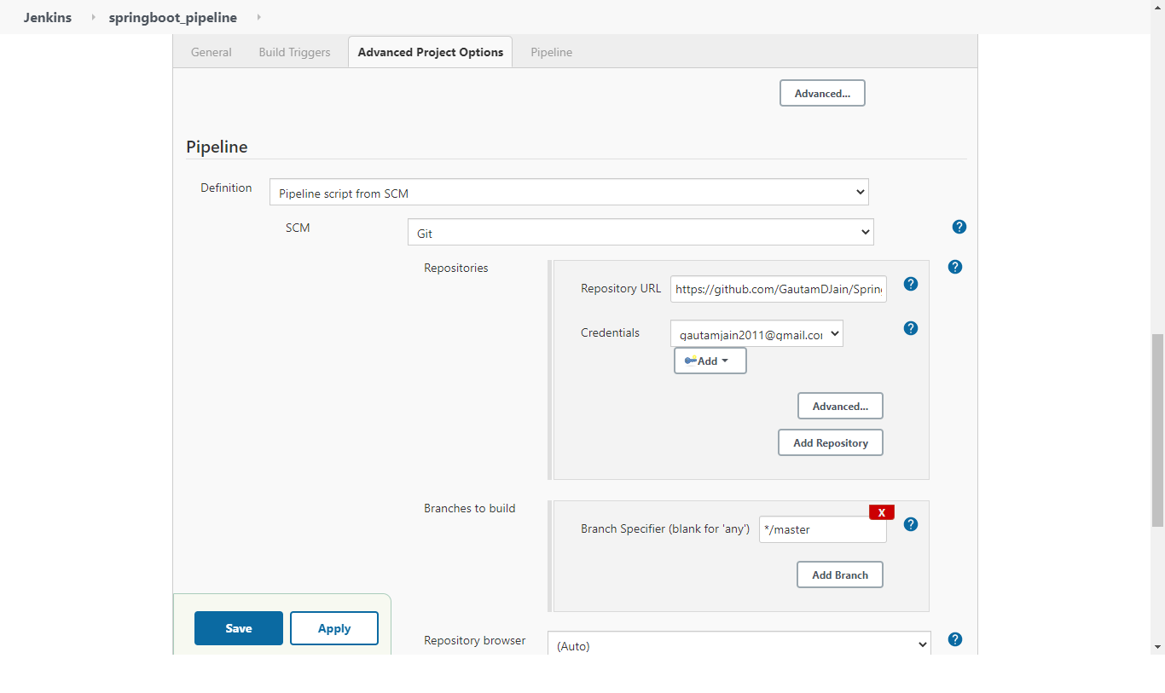

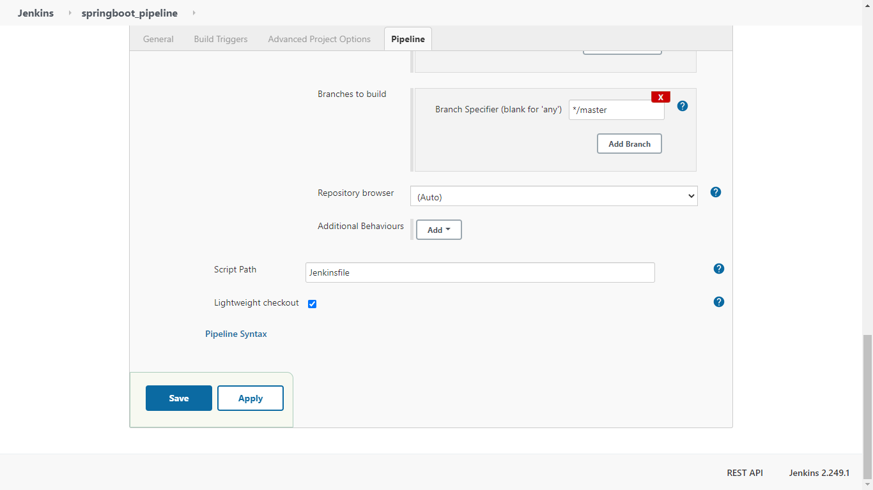

* Spring Boot Application is deployed in new Docker GCP instance and running as shown.

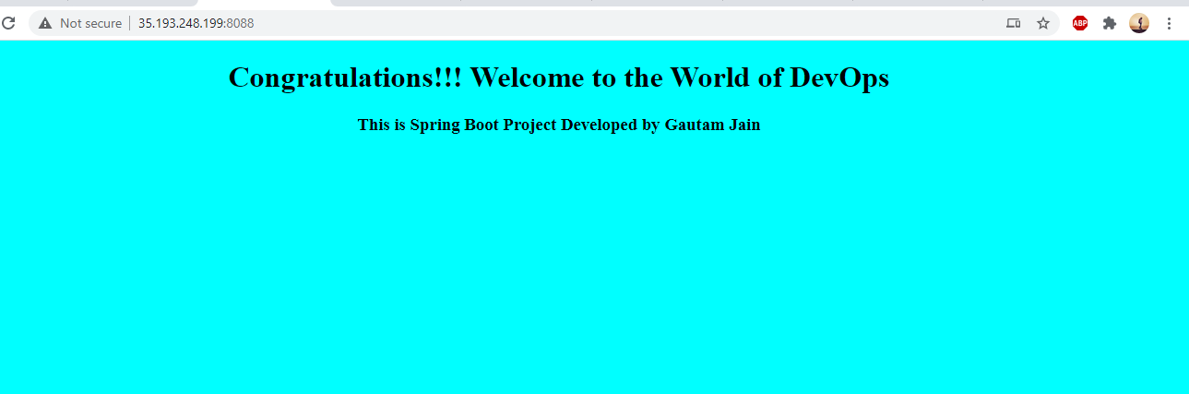

* Java web Application is deployed in new Docker GCP instance and running as shown.

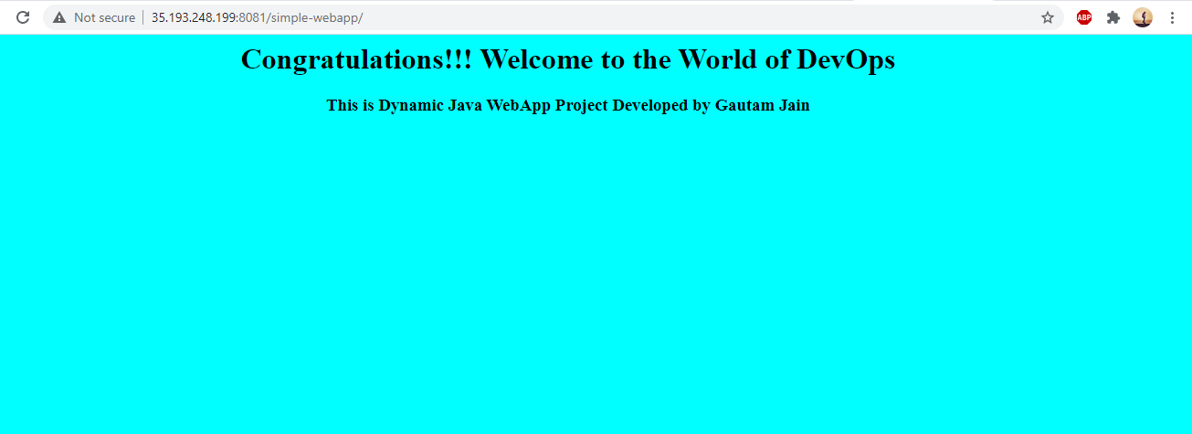

* Docker is installed in new GCP machine and two of the docker containers are running as shown.

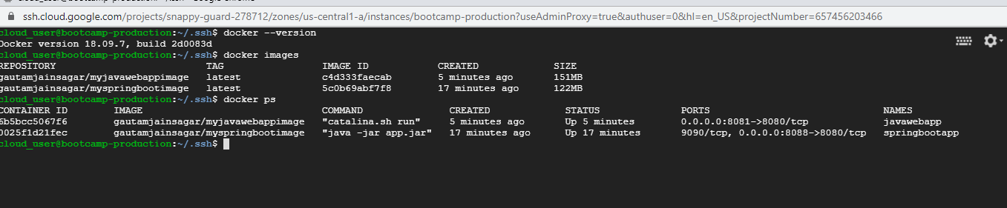

* Please have a look on Jenkins file and Jenkins pipeline console output shared for both projects.