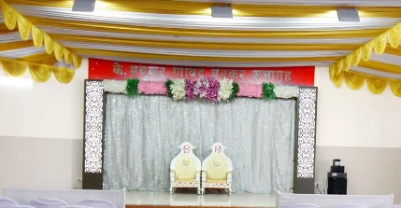
Daivadnya Sanskrutik Bhavan,
167, near Samarth mandir,
Anand Nagar, Chimanpura Peth,
Satara, Maharashtra 415002
PH : +91 94206 30490

To whomsoever it may concern
Marriage Hall Certificate

This is to certify that,
Husband : Mr. Gautam Ravindra Dange,
Son of : Mr. Ravindra Rajaram Dange
Passport Nr. : Z5650762,
residing at : 45, Bhavani Peth, Satara, Maharashtra, India
( Currently Residing in Bremen, Germany)
And
Wife : Ms. Nilambari Suresh Mahajan,
daughter of : Shri. Suresh Muralidhar Mahajan
Passport Nr. : V8620696
residing at: Flat no. 103, Rachana Park,
Sai city, Kopargaon, Maharashtra, India
got married on : 22nd May 2022
in our,
Daivadnya Sanskrutik Bhavan,
(Hall : Kai. Madhukar Govind Benkar Sabhagruh),
167, Anand Nagar, Chimanpura Peth, near Samarth mandir,
Satara, Maharashtra, India

Signature,

Marriage Hall Manager,
Mr. Prasad Narkar

