**System Flow Diagram**

**Admin**

1. **Admin**

Home

Display

Question

Tutorial

Edit

Profile

Language

Download

tutorial

1. **Client**

Test

(Quiz)

Download

Contact

Tutorial

Home

**Client**

**Data Flow Diagram**

**Client**

**Admin**

TutorialHub.sql

**Use case Diagram**

**(1)Admin**

**(2) Client**

**Activity Diagram**

1. **Admin**

**Logout**

**VIEW: error & Admin panel**

**VIEW: Home page, language, display question, download tutorial, tutorials, edit profile**

**Yes**

**No**

**Login**

**Admin**

1. **Client**

**Home page, Tutorial, Test (Quiz), Download,**

**Contact**

**Client**

**1st Level DFD for Admin**

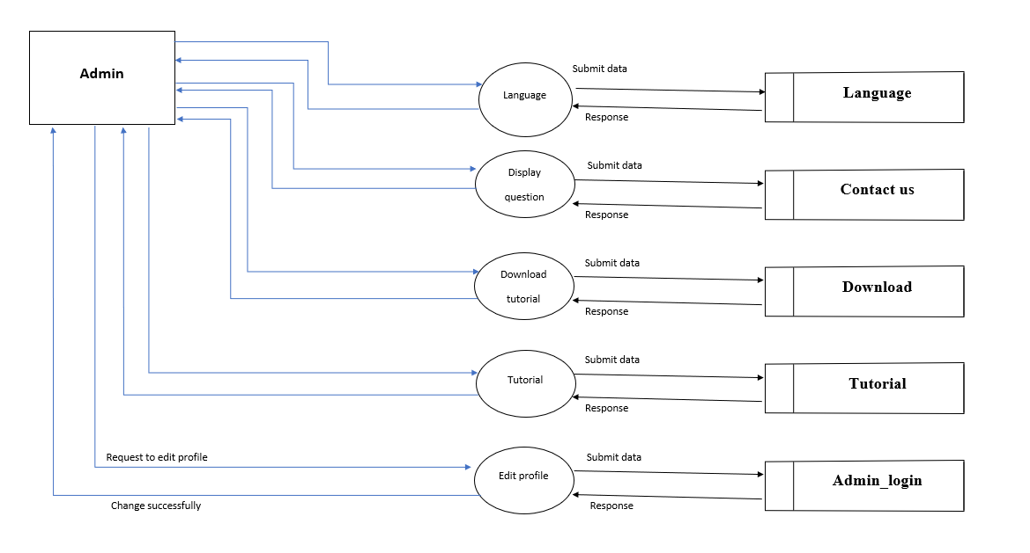

**1st Level DFD for Client**

