Project Aurora: Monthly Status Report
Reporting period: March 2026. Prepared by Dr. Priya Raman for the Helios Energy Lab steering committee.

Summary
Room-temperature cycling remains on track. The E-5 baseline failed at 45 °C (AUR-C103), so high-temperature testing moved to electrolyte E-7.
Milestone M2 (45 °C stability demonstrated, due 2026-05-30) is at risk.

Cycling Progress
All eight cells completed their latest checkpoint. Cells on E-7 at 45 °C are above 89% retention after 600 cycles.
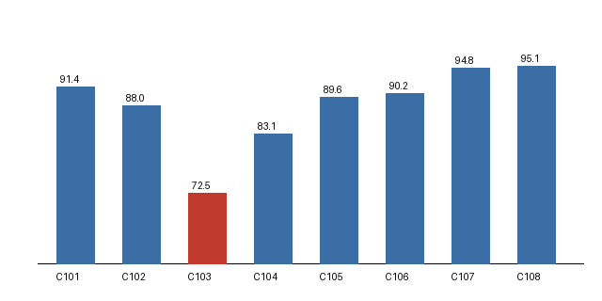
Figure 1: Capacity retention at the latest checkpoint, AUR-C101 to AUR-C108.

Budget
On 2026-03-19 the steering committee approved an additional EUR 85,000 for the E-7 qualification, raising the electrolyte workstream budget to EUR 240,000.

Risk Register
ID | Risk | Owner | Likelihood | Mitigation
R1 | E-7 swelling exceeds the 5% limit | Marco Lindqvist | Medium | Fall back to E-5 + FEC
R2 | Pilot-line pouch tooling arrives late | Samuel Okafor | Low | Order tooling by 2026-04-15
R3 | Single hard-carbon supplier | Dr. Priya Raman | Medium | Qualify Carbonix Materials as second supplier

Next Steps
- Run AUR-C105 to AUR-C108 to 1500 cycles
- Report swelling at every 100-cycle checkpoint
- Prepare pilot-line tooling for the E-7 fill volume
- Submit the E-7 qualification draft (2026-03-26)
- Freeze the pilot-line bill of materials (2026-04-30)

