**Hospital Management Project**

Spring Semester 2017

CSC 4350, 5:30-7:15

23 January 2017

Group 6

Gautam Ravichandran

Victoria Green

Ashwin Nair

Karankumar Parikh

Young Jun Son

**Hospital Management System (HMS)**

**HMS- 1.0 INTRODUCTION**

A Hospital Management System (HMS) is designed to automate and organize various day-to-day activities taking place in a hospital. It also stores patient and staff database for quick future access.

**HMS- 2.0 APPOINTMENTS**

The System shall help in setting up patient appointments by considering each individual case and the schedule of assigned doctor. The System shall also give doctors an option to set up or cancel an appointment.

**HMS- 2.1 APPOINTMENT DATA REQUIRED**

For each patient making an appointment, the system shall request the following information:

* Patient First and Last name
* Date of Birth
* Reason for Visit

This information shall be obtained over the phone or in person, and manually inputted into the system.

**HMS- 3.0 PATIENT RECORDS**

The System shall maintain patient records and diagnostic reports efficiently. This information will be manually recorded and inputted into the system after the patient’s visit to the doctor. Such records shall be accessed by assigned doctors in the future.

**HMS- 4.0 STAFF RECORDS**

The System shall maintain a record of doctor appointments, prescriptions given by the doctor and details of the doctor. The System shall also maintain relevant information about the nurses and other hospital staff.

**HMS- 4.1 STAFF STATIC DATA REQUIRED**

For each hospital employee, the system shall request the following information:

* First and Last Name
* Age
* Gender
* Place of education, degree level, and year graduated

This static data shall be obtained and documented when the staff member is hired.

**HMS- 4.2 STAFF ACTIVE DATA REQUIRED**

For each hospital employee, the system shall request the following information:

* List of appointments
* List of medicines prescribed

This active data shall be consistently updated when changes are made.

**HMS- 5.0 LAB RECORDS**

The System shall store lab reports and lab diagnostic information. The System shall forward the lab reports to assigned doctors.

**HMS- 6.0 PHARMACY**

The System shall efficiently maintain medicine inventory and notify when a new order needs to be placed.

**HMS- 6.1 REORDER SUPPLY**

For each item in 6.0, the system shall immediately react to the following situation:

* When the count of an item reaches <=3, the system shall send a notification to the user with the name of the item and the number on hand.

**HMS- 7.0 INVOICE MANAGEMENT**

The System shall manage patient invoices and transaction details.

**HMS- 7.1 INVOICE CREATION**

For each invoice created, the system shall immediately react to the following situation:

* When the doctor finishes recording procedures and medicine administered to the patient into the system, an invoice shall be generated.
* The generated invoice shall add up the cost of everything administered at the appointment.

|  |  |  |  |
| --- | --- | --- | --- |
| **Entry #** | **Paragraph #** | **System Specification Text** | **Type** |
| 1 | 2.0 | The System shall help in setting up patient appointments by considering each individual case and the schedule of assigned doctor. | SW |
| 2 | 2.0 | The System shall give doctors an option to set up or cancel an appointment. | SW |
| 3 | 2.1 | For each patient making an appointment, the system shall request the following information: patient first and last name, date of birth, reason for visit | SW |
| 4 | 2.1 | This information shall be obtained over the phone or in person, and manually inputted into the system. | SW |
| 5 | 3.0 | The System shall maintain patient records and diagnostic reports efficiently. | SW |
| 6 | 3.0 | Such records shall be accessed by assigned doctors in the future. | SW |
| 7 | 4.0 | The System shall maintain a record of doctor appointments, prescriptions given by the doctor and details of the doctor. | SW |
| 8 | 4.0 | The System shall maintain relevant information about the nurses and other hospital staff. | SW |
| 9 | 4.1 | For each hospital employee, the system shall request the following information: first and last name, age, gender, place of education, degree level, and year graduated | SW |
| 10 | 4.1 | This static data shall be obtained and documented when the staff member is hired. | SW |
| 11 | 4.2 | For each hospital employee, the system shall request the following information: list of appointments, list of medicines prescribed | SW |
| 12 | 4.2 | This active data shall be consistently updated when changes are made. | SW |
| 13 | 5.0 | The System shall store lab reports and lab diagnostic information. | SW |
| 14 | 5.0 | The System shall forward the lab reports to assigned doctors. | SW |
| 15 | 6.0 | The System shall efficiently maintain medicine inventory and notify when a new order needs to be placed | SW |
| 16 | 6.1 | When the count of an item reaches <=3, the system shall send a notification to the user with the name of the item and the number on hand. | SW |
| 17 | 7.0 | The System shall manage patient invoices and transaction details. | SW |
| 18 | 7.1 | When the doctor finishes recording procedures and medicine administered to the patient into the system, an invoice shall be generated. | SW |
| 19 | 7.1 | The generated invoice shall add up the cost of everything administered at the appointment. | SW |

**Work Structure Document: Group 6**

|  |  |
| --- | --- |
| Gautam Ravichandran | **Team Coordinator**  Documents Handler  Java Coder  Front-end Developer |
| Victoria Green | Database Manager  GUI Coder/tester |
| Ashwin Nair | Java Coder  Front-end Developer  GUI Coder |
| Karankumar Parikh | Database Manager  Finalize code documentation |
| Young Jun Son | Java Coder  User Guide  Application Tester |

**Gantt chart:**

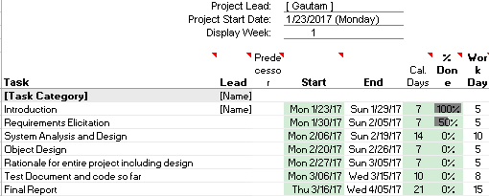

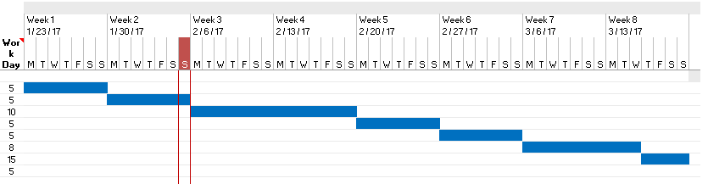

**Technical Terminology:**

* **Static:** This term defines fixed values. These are values that are set to equal a certain value throughout its iteration. This includes the relevant hospital employee information, such as: name, gender, etc. are static as they are fixed values depending on the individual employee information. This also pertains to the same relevant descriptive details of the patients.
* **Database:** This is a data storing system which will allow the software to access content of the system later by those including: doctors, nurses, front desk employees.
* **GUI:** (Graphic User Interface) This is the interface in which users will be able to access the content of the Hospital Management System. The GUI contains the UX/UI aspects of the program such as the window, buttons, search bars, tabs, etc.
* **Java:** The programming language which is used for the software’s implementation and design. This programming language will address the contents of the Hospital Management System and the layout of the system methodologies.
* **Active Data:** The data that is dynamic or interchangeable within the system. This is the system information pertaining to the employees and the general hospital supply/accommodation and the changes in their data (scheduling/inventory/room availability)
* **SQLite:** Database structuring/management tool which stores content related to the user. This user information includes but is not limited to: employee information, patient information, inventory/supply count, general hospital facilities.
* **UX/UI:** (User Experience/User Interface) This relates to the content on the front-end side of the software and its accessibility/use or general functionality of the content when used by people for testing purposes or public use.