**Hospital**

**Management Project**

Spring Semester 2017

CSC 4350, 5:30-7:15

8 March 2017

**Big Hero 5**

Gautam Ravichandran

Victoria Green

Ashwin Nair

Karankumar Parikh

Young Jun Son

Table of Contents:

Use Case Rational…………………………………………………………………………………3

Application Rational…………………………………………………………………………...4 - 5

Required Tractability Matrix…………………………………………………………………..6 - 9

Work Structure Document……………………………………………………………..……..... 10

Gantt Chart.………………………………………………………………………………………11

Dictionary………………………………………………………………………………….…… 12

Use Case Diagram:

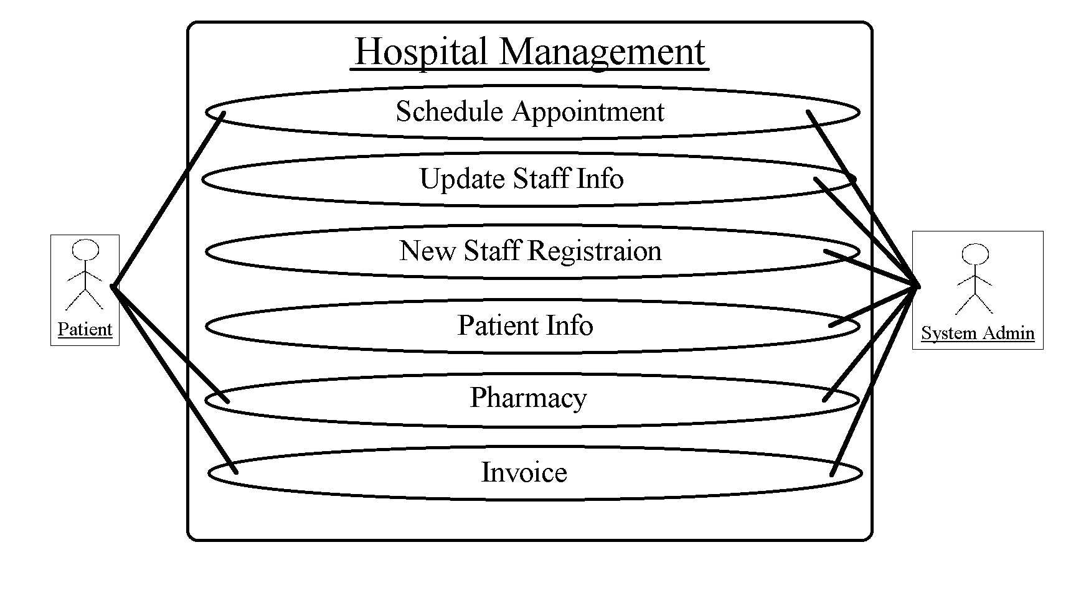

Use Case Diagram Rationale:

**Schedule Appointment** allows patients and admin to book an appointment during an available time slot.

**Update Staff Info** allows the system admin to change list of appointments and list of medications prescribed for all hospital employees as needed. This information should be readily available to patients.

**New Staff Registration** allows the system admin to input required information for hospital new hires, such as: first and last name, age, gender, place of education, degree level, and year graduated. This information should be readily available to patients.

**Patient Info** maintains each patient’s first and last name, date of birth, reason for visit, illnesses, and any prescribed medications.

**Pharmacy** maintains the medicine inventory, notifies the system admin when a quantity drops to 3 or under, and distributes prescribed medications to patients.

**Invoice** is generated after the doctor inputs details from the appointment, and is given to the patient through the system.

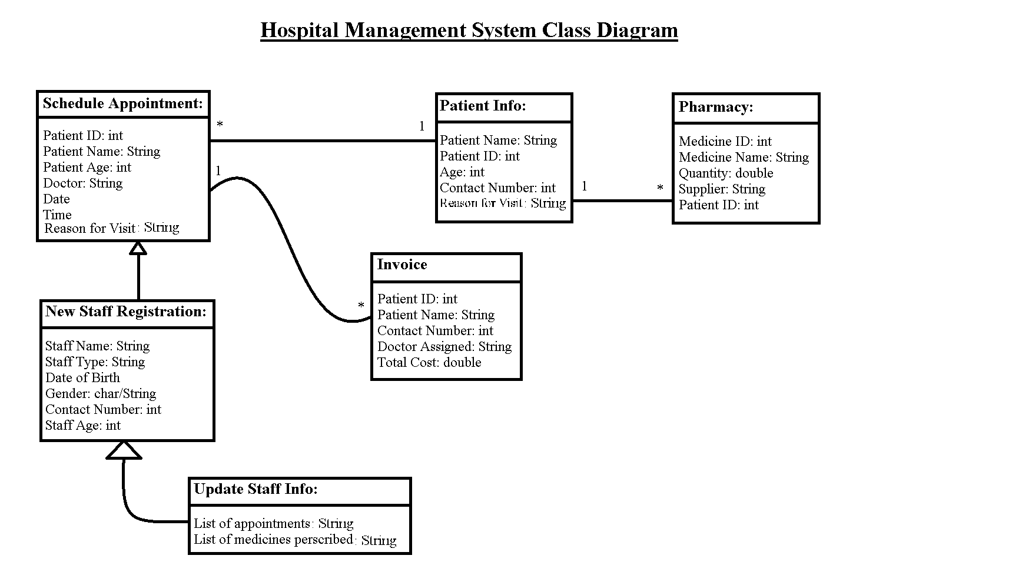

**Application Objects Rationale:**

**Schedule Appointment**

* *Patient ID:* Required for identification of each patient in the database
* *Patient Name:* Required information for scheduling and documentation purposes
* *Doctor:* Required information so patient gets the doctor they want
* *Date:* Required information for patient and doctor for scheduling purposes
* *Time:* Required information for patient and doctor for scheduling purposes
* *Reason for Visit:* Useful information for the doctor to know before appointment

**New Staff Info**

* *Staff ID:* Required for identification of staff member in the database
* *Staff Name:* Required information for documentation purposes
* *Staff Type:* Whether the staff is a doctor or other member, useful for update staff info
* *Date of Birth:* Useful information for patients to have when choosing a doctor
* *Age:* Useful information for patients to have when choosing a doctor
* *Gender:* Useful information for patients to have when choosing a doctor
* *Contact Number:* For other staff members to reach this staff member

**Update Staff Info**

* *List of Appointments:* Required so there is no overlap in scheduling appointments
* *List of Medicines Prescribed:* Useful information to have, some patients like to know

**Patient Info**

* *Patient Name:* Required information for scheduling and documentation purposes
* *Patient ID:* Required for identification of each patient in the database
* *Age:* Useful information for doctors to know when treating patients
* *Contact Number:* Required in case staff members need to reach the patient
* *Reason for Visit:* Useful information for the doctor to know before appointment

**Pharmacy**

* *Medicine ID:* Required information for identification of medicine in the database
* *Medicine Name:* Required information for documentation purposes
* *Quantity:* Required information in order to maintain supply
* *Supplier:* Required information for documentation purposes
* *Patient ID:* Required for identification of each patient taking medicine

**Invoice**

* *Patient ID:* Required for identification of each patient with an invoice
* *Patient Name:* Required information for invoice documentation purposes
* *Contact Number:* Required in case staff members need to reach the patient
* *Doctor:* Required for invoice documentation purposes
* *Total Cost:* Required value on the invoice for the patient

**Software Architecture Rationale**

The intent of the hospital management system is to obtain and update information for staff, as well as maintain several services for multiple patients at any given time. As a result, it has been determined that a client-server model is the best software architecture for this project.

**Hospital Management System (HMS)**

**HMS- 1.0 INTRODUCTION**

A Hospital Management System (HMS) is designed to automate and organize various day-to-day activities taking place in a hospital. It also stores patient and staff database for quick future access.

**HMS- 2.0 APPOINTMENTS**

**2.0.1** The System shall help in setting up patient appointments by considering each individual case and the schedule of assigned doctor.

**2.0.2** The System shall also give doctors an option to set up or cancel an appointment.

**HMS- 2.1 APPOINTMENT DATA REQUIRED**

**2.1.1** For each patient making an appointment, the system shall request the following information:

* Patient First and Last name
* Patient ID
* Patient Age
* Doctor
* Date
* Time
* Contact Number
* Reason for Visit

**HMS- 3.0 PATIENT RECORDS**

**3.0.1** The System shall maintain patient records and diagnostic reports efficiently. This information will be manually recorded and inputted into the system after the patient’s visit to the doctor.

**3.0.2** Such records shall be accessed by assigned doctors in the future.

**HMS- 4.0 STAFF RECORDS**

**4.0.1** The System shall maintain a record of doctor appointments, prescriptions given by the doctor and details of the doctor.

**4.0.2** The System shall also maintain relevant information about the nurses and other hospital staff.

**HMS- 4.1 STAFF STATIC DATA REQUIRED**

**4.1.1** For each hospital employee, the system shall request the following information:

* First and Last Name
* Staff Type
* Date of Birth
* Age
* Contact Number
* Gender

**4.1.2** This static data shall be obtained and documented when the staff member is hired.

**HMS- 4.2 STAFF ACTIVE DATA REQUIRED**

**4.2.1** For each hospital employee, the system shall request the following information:

* List of appointments
* List of medicines prescribed

**4.2.2** This active data shall be consistently updated when changes are made.

**HMS- 5.0 LAB RECORDS**

**5.0.1** The System shall store lab reports and lab diagnostic information.

**5.0.2** The System shall forward the lab reports to assigned doctors.

**HMS- 6.0 PHARMACY**

**6.0.1** The System shall efficiently maintain medicine inventory and notify when a new order needs to be placed. It keeps track of Medicine ID, medicine name, quantity, and supplier.

**HMS- 6.1 REORDER SUPPLY**

For each item in 6.0, the system immediately reacts to the following situation:

* **6.1.1** When the count of an item reaches <=3, the system shall send a notification to the user with the name of the item and the number on hand.

**HMS- 7.0 INVOICE MANAGEMENT**

**7.0.1** The System shall manage patient invoices and transaction details. It keeps track of patient ID, patient name, contact number, doctor assigned, and total cost.

**HMS- 7.1 INVOICE CREATION**

For each invoice created, the system immediately reacts to the following situation:

* **7.1.1** When the doctor finishes recording procedures and medicine administered to the patient into the system, an invoice shall be generated.
* **7.1.2** The generated invoice shall add up the cost of everything administered at the appointment.

|  |  |  |  |  |
| --- | --- | --- | --- | --- |
| **Entry #** | **Paragraph #** | **System Specification Text** | **Type** | **Build** |
| 2.0.1 | 2.0 | The System shall help in setting up patient appointments by considering each individual case and the schedule of assigned doctor. | SW | B1 |
| 2.0.2 | 2.0 | The System shall give doctors an option to set up or cancel an appointment. | SW | B1 |
| 2.1.1 | 2.1 | For each patient making an appointment, the system shall request the following information: Patient First and Last name, age, patient ID, doctor, date, time, contact number, reason for visit. | SW | B1 |
| 3.0.1 | 3.0 | The System shall maintain patient records and diagnostic reports efficiently. | SW | B2 |
| 3.0.2 | 3.0 | Such records shall be accessed by assigned doctors in the future. | SW | B2 |
| 4.0.1 | 4.0 | The System shall maintain a record of doctor appointments, prescriptions given by the doctor and details of the doctor. | SW | B2 |
| 4.0.2 | 4.0 | The System shall maintain relevant information about the nurses and other hospital staff. | SW | B2 |
| 4.1.1 | 4.1 | For each hospital employee, the system shall request the following information: first and last name, gender, date of birth, age, contact number, staff type. | SW | B2 |
| 4.1.2 | 4.1 | This static data shall be obtained and documented when the staff member is hired. | SW | B2 |
| 4.2.1 | 4.2 | For each hospital employee, the system shall request the following information: list of appointments, list of medicines prescribed. | SW | B2 |
| 4.2.2 | 4.2 | This active data shall be consistently updated when changes are made. | SW | B2 |
| 5.0.1 | 5.0 | The System shall store lab reports and lab diagnostic information. | SW | B2 |
| 5.0.2 | 5.0 | The System shall forward the lab reports to assigned doctors. | SW | B2 |
| 6.0.1 | 6.0 | The System shall efficiently maintain medicine inventory and notify when a new order needs to be placed. It keeps track of Medicine ID, medicine name, quantity, and supplier. | SW | B3 |
| 6.1.1 | 6.1 | When the count of an item reaches <=3, the system shall send a notification to the user with the name of the item and the number on hand. | SW | B3 |
| 7.0.1 | 7.0 | The System shall manage patient invoices and transaction details. It keeps track of patient ID, patient name, contact number, doctor assigned, and total cost. | SW | B4 |
| 7.1.1 | 7.1 | When the doctor finishes recording procedures and medicine administered to the patient into the system, an invoice shall be generated. | SW | B4 |
| 7.1.2 | 7.1 | The generated invoice shall add up the cost of everything administered at the appointment. | SW | B4 |

Work Structure Document:

|  |  |
| --- | --- |
| Gautam Ravichandran | **Team Coordinator**  Final Document Handler  Java Coder  Front-end Developer |
| Victoria Green | GUI Coder/tester  Front end tester  RTM Update Manager |
| Ashwin Nair | Java Coder  Front-end Developer  GUI Coder  Final Product Double Checker |
| Karankumar Parikh | Front-end Developer  Database Manager  Setting up Database Backend |
| Young Jun Son | Java Coder  User Guide  Application Tester |

Gantt Chart:

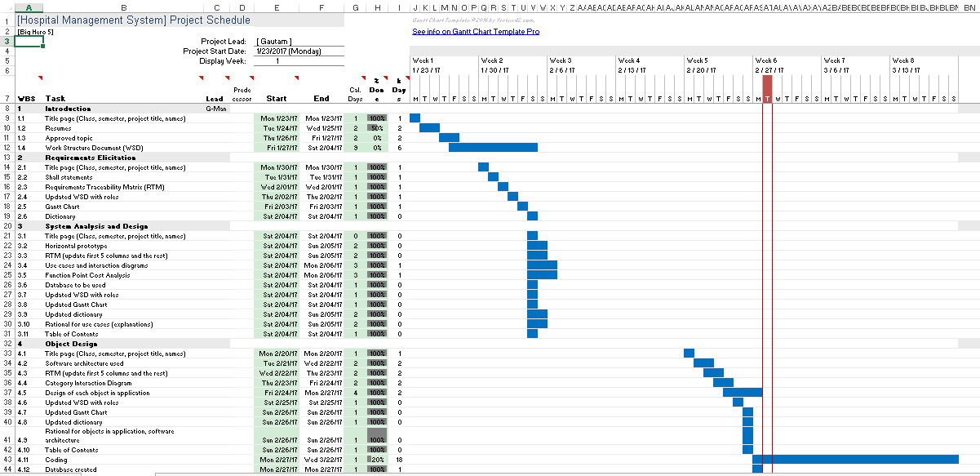

Dictionary:

Static:​ This term defines fixed values. These are values that are set to equal a certain value throughout its iteration. This includes the relevant hospital employee information, such as: name, gender, etc. are static as they are fixed values depending on the individual employee information. This also pertains to the same relevant descriptive details of the patients.

Database: ​This is a data storing system which will allow the software to access content of the system later by those including: doctors, nurses, and front desk employees.

GUI:​ (Graphic User Interface) This is the interface in which users will be able to access the content of the Hospital Management System. The GUI contains the UX/UI aspects of the program such as the window, buttons, search bars, tabs, etc.

Java:​ The programming language which is used for the software’s implementation and design. This programming language will address the contents of the Hospital

Management System and the layout of the system methodologies.

Active Data:​ The data that is dynamic or interchangeable within the system. This is the system information pertaining to the employees and the general hospital supply/accommodation and the changes in their data (scheduling/inventory/room availability)

SQLite:​ Database structuring/management tool which stores content related to the user. This user information includes but is not limited to: employee information, patient information, inventory/supply count, general hospital facilities.

UX/UI:​ (User Experience/User Interface) This relates to the content on the front-end side of the software and its accessibility/use or general functionality of the content when used by people for testing purposes or public use.

Use Case Diagram:​ Shows an overview of the system and functions.

Methods:​ These are functions which can be called throughout the program. Sometimes the code for how methods work is hidden from view in order to make code easier to read. These functions complete specific tasks, such as sorting, calculating, and adding/deleting.

Class:​ A class is a blueprint for objects created in a program. These classes will be made to contain organized code to control things like patient data, inventory, and patient accounts.

Object:​ An object is what a class controls. There can be a patient object, which will have states and behaviors such as name, date of birth, and wellness levels.

Horizontal Prototype:​ Shows the broad relationships between a system and maps out its range of abilities.