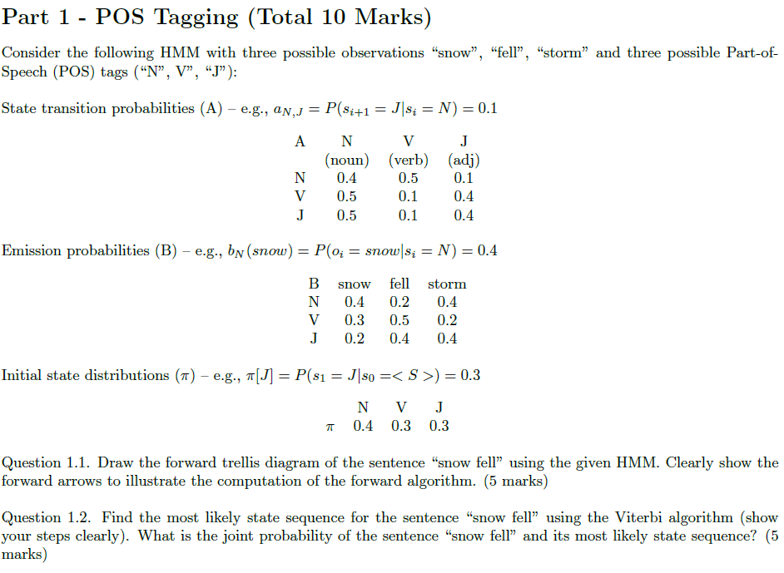

1.1) o1 = snow o2 = fell

(s1 = N) α1(1) = 0.16 α2(1) = 0.0278

(s2 = V) π α1(2) = 0.09 α2(2) = 0.0475

(s3 = J) α1(3) = 0.06 α2(3) = 0.0304

α1(1) = P(N|π)*P(o1|N) = 0.4*0.4 = 0.16,

α1(2) = P(V|π)*P(o1|V) = 0.3*0.3 = 0.09,

α1(3) = P(J|π)*P(o1|J) = 0.3*0.2 = 0.06,

α1(1)* P(N|N) = 0.16 * 0.4 = 0.064, α1(1)* P(V|N) = 0.16 * 0.5 = 0.08, α1(1)* P(J|N) = 0.16 * 0.1 = 0.016

α1(2)* P(N|V) = 0.09 * 0.5 = 0.045, α1(2)* P(V|V) = 0.09 * 0.1 = 0.009, α1(2)* P(J|V) = 0.09 * 0.4 = 0.036

α1(3)* P(N|J) = 0.06 * 0.5 = 0.03, α1(3)* P(V|J) = 0.06 * 0.1 = 0.006, α1(3)* P(J|J) = 0.06 * 0.4 = 0.024

P(o2|N) = 0.2, P(o2|V) = 0.5, P(o2|J) = 0.4

α2(1) = (α1(1) * P(N|N) + α1(2) * P(N|V) + α1(3) * P(N|J))*P(o2|N) = (0.064+0.045+0.03)*0.2 = 0.0278

α2(2) = (α1(1) * P(V|N) + α1(2) * P(V|V) + α1(3) * P(V|J))*P(o2|V) = (0.08+0.009+0.006)*0.5 = 0.0475

α2(3) = (α1(1) * P(J|N) + α1(2) * P(J|V) + α1(3) * P(J|J))*P(o2|J) = (0.016+0.036+0.024)*0.4 = 0.0304

1.2)

Given:

P(o2|N) = 0.2, P(o2|V) = 0.5, P(o2|J) = 0.4

Step 1:

v1(1) = P(N|π)*P(o1|N) = 0.4*0.4 = 0.16

v1(2) = P(V|π)*P(o1|V) = 0.3*0.3 = 0.09

v1(3) = P(J|π)*P(o1|J) = 0.3*0.2 = 0.06

Step 2:

v2(1) = max (v1(1) * p(N|N)* P(o2|N), v1(2) * p(N|V)* P(o2|N), v1(3) * p(N|J)* P(o2|N)) = max(0.16*0.4*0.2, 0.09*0.5*0.2, 0.06*0.5*0.2) = max(0.0128,0.009,0.006)

= **0.0128 (N->N)**

v2(2) = max (v1(1) * p(V|N)* P(o2|V), v1(2) * p(V|V)* P(o2|V), v1(3) * p(V|J)* P(o2|V)) =

max(0.16*0.5*0.5, 0.09*0.1*0.5, 0.06*0.1*0.5) = max(0.04,0.0045,0.003)

= **0.04 (N->V)**

v2(3) = max (v1(1) * p(J|N)* P(o2|J), v1(2) * p(J|V)* P(o2|J), v1(3) * p(J|J)* P(o2|J)) =

max(0.16*0.1*0.4, 0.09*0.4*0.4, 0.06*0.4*0.4) = max(0.0064,0.0144,0.0096)

= **0.0144 (V->J)**

Step 3:

P* = max(N->N,N->V,N->J) = max(0.0128,0.04,0.0144) = **0.04** **(N->V)**

As N->V has the highest joint probability of 0.04, (π,N,V) is the most likely state sequence using the Viterbi Scores for the phrase ‘snow fell’

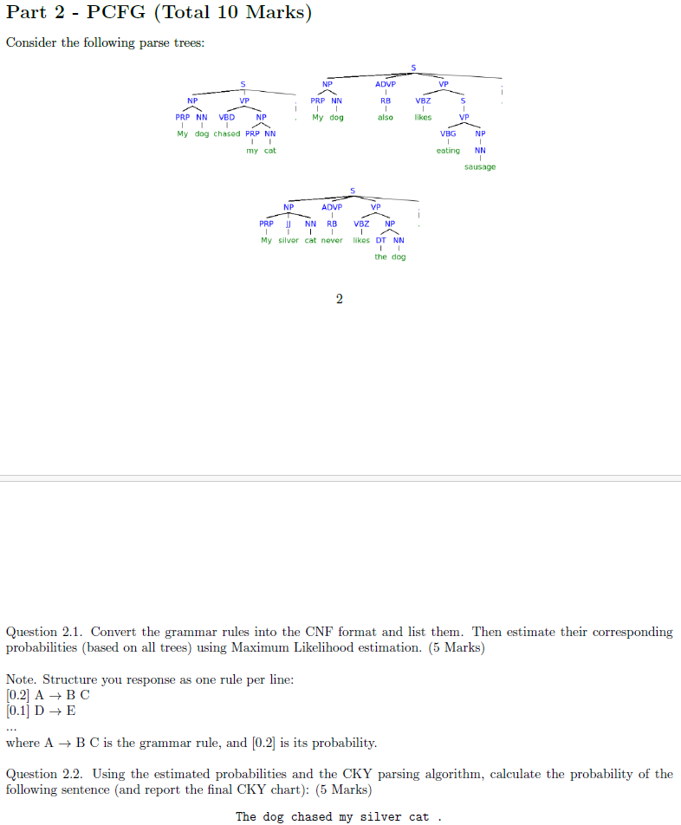

2.1)

[0.25] S -> NP X3

[1] X3 -> VP .

[1] . -> .

[0.5] S -> X1 VP

[1] X1 -> NP ADVP

[0.0625] S -> VBD NP

[0.0625] S -> VBZ S

[0.0625] S -> VBG NP

[0.0625] S -> VBZ NP

[0.5] NP -> PRP NN

[0.02822] NP -> sausage

[0.083] NP -> dog

[0.05478] NP -> cat

[0.166] NP -> DT NN

[0.166] NP -> X2 NN

[1] X2 -> PRP JJ

[0.25] VP -> VBD NP

[0.25] VP -> VBZ S

[0.25] VP -> VBG NP

[0.25] VP -> VBZ NP

[0.5] ADVP -> Also

[0.5] ADVP -> Never

[0.5] RB -> Also

[0.5] RB -> Never

[0.5] NN -> dog

[0.33] NN -> cat

[0.17] NN -> sausage

[1] PRP -> My

[1] VBD -> chased

[1] VBZ -> likes

[1] VBG -> eating

[1] DT -> the

[1] JJ -> silver

2.2)

The dog chased my silver cat .

|  |  |  |  |  |  |  |
| --- | --- | --- | --- | --- | --- | --- |
| **DT: 1** | **NP: 0.166 * 1* 0.5 = 0.083** | None | None | None | NP: 0.166 * 1 * 0.33 = 0.05478 | **S: 0.25 * 0.083 * 0.013675=** **0.00028375625** |
|  | **NN:0.5**,  NP: 0.083 | None | None | None | None | S: 0.25 * 0.083 * 0.013675= 0.00028375625 |
|  |  | VBD: 1 | None | none | **VP: 0.25 * 1 * 0.0547 = 0.013675**  S: 0.0625 *1 * 0.0547 = 0.00341875 | **X3: 1 * 1 * 0.013675 =** **0.013675** |
|  |  |  | PRP: 1 | X2 : 1*1*1 = 1 | NP: 0.166 * 1 * 0.33 = **0.0547**  NP: 0.5 * 1 * 0.33 = 0.165 |  |
|  |  |  |  | JJ: 1 |  |  |
|  |  |  |  |  | NN: **0.33**,  NP: 0.0547 |  |
|  |  |  |  |  |  | . : **1** |

The sentence “The dog chased my silver cat.” has a probability of **0.00028375625** with a parse tree of: S-> NP VP, where NP -> DT(The) NN(Dog), VP-> VBD(chased)NP, NP -> X2 NN(cat), X2 -> PRP(my) JJ(silver)**.**