**Analysis -2**

1. **No of Vehicles by Brand Available on ebay for sale with the help of visualization.**

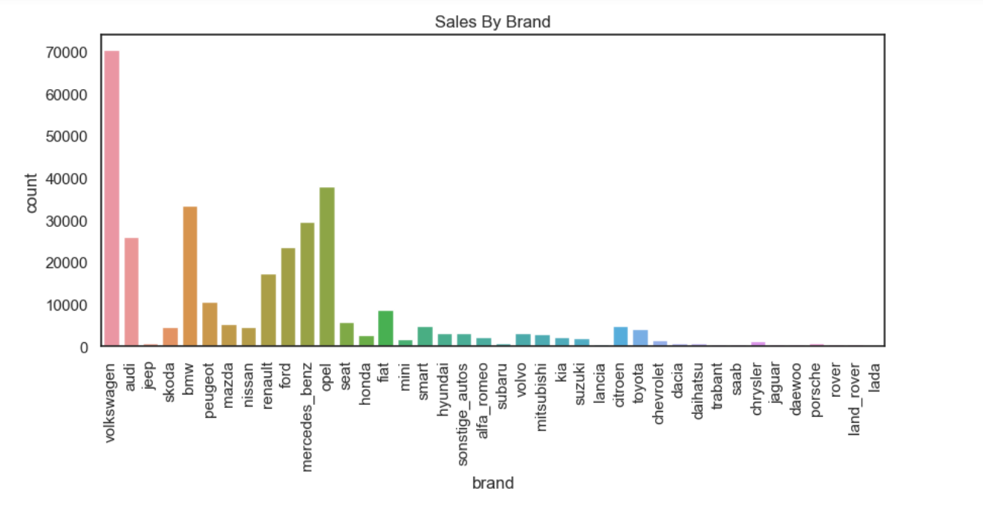

* From the above bar graph we can see the number of vehicles available on ebay based on the brand.
* As we can see the brand “volkswagen” has the highest count as compared to other brands.
* And we can also interpret that the brand “lada” has the lowest count among all the brands.

# What is the Average price for vehicles based on the type of vehicle as well as on the type of gearbox. Explain me with both numerical and visualization analysis.

# NUMERICAL ANALYSIS

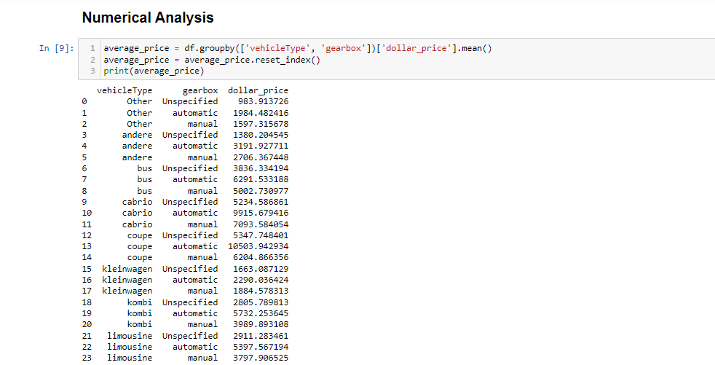

# Using groupby() function i have grouped the vehicle type and gearbox and calculated the mean price for each group using mean() function.

# The above numerical analysis shows the average price for each vehicle type based on the gear type.

**VISUALIZATION ANALYSIS**

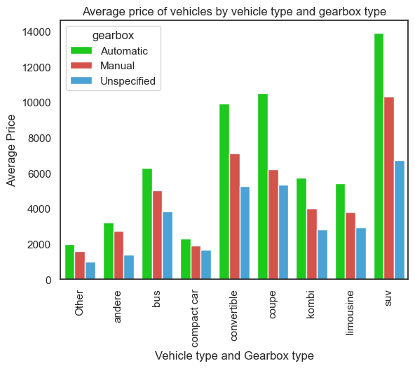

# From the above visualization we can see that the Average price of vehicles that has gearbox type Automatic, unspecified and Manual.

* We can see that the “SUV” type of vehicle shows the highest average price which has the gearbox type “automatic” compare to manual.

# What is the marginal probability of private seller?

# 11

# The marginal probability of a private seller being 0.9999908 which is almost 1, suggests that private sellers are the dominant players in the vehicle market. This has a number of implications for both buyers and sellers.