**Analysis – 3**

1. **The memory usage of the data is around 6.1 mb. How can we reduce the memory usage of the data set?**

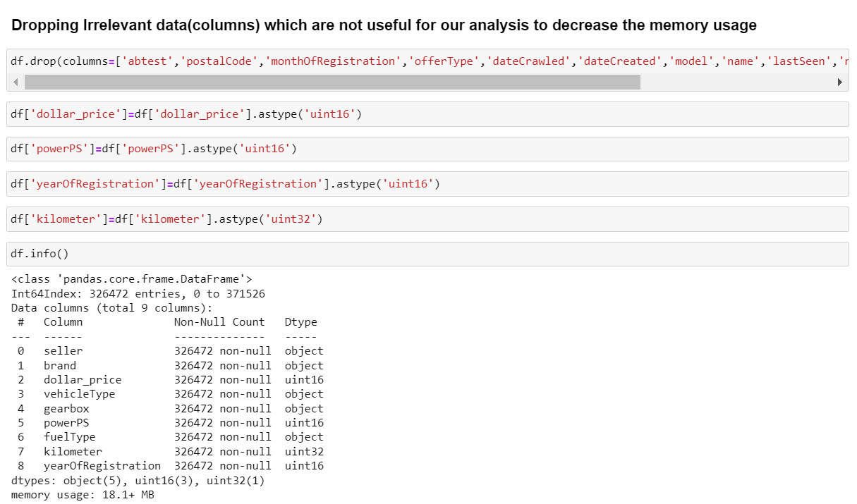

Here I have removed several columns from the “df” dataset using the ‘drop()’ function with the ‘inplace=True’ parameter. The columns being dropped are “monthOfRegistration”,”offerType”,”model”,”name” ,”abtest”,“date\_crawled”, “date\_created”, “postal\_code”,”notRepairedDamage”, and “last\_seen”.

Then i have changed the data type of the “dollar\_price”, “kilometre” column using ‘astype()’ from the NumPy library. And converted “dollar\_price” to ‘np.uint16’ and “kilometer” to ‘np.uint32’. This helps optimize memory usage and ensures the data is stored in the appropriate format.

Finally, check the dataset's information with `df.info()` to get an overview of its structure.

# What is the Average price of vehicle by fuel type and gearbox type.Give a plot.

# IMG_256

# The above plot shows the average price of vehicles by vehicle type and gearbox type.

* From the plot, we see that hybrids and automatic cars have the higher average price.
* The plot also shows that vehicles with automatic gearboxes have higher average power than vehicles with manual gearboxes.

1. **What is the Average power of a vehicle by vehicle type and gearbox type? Give a plot.**

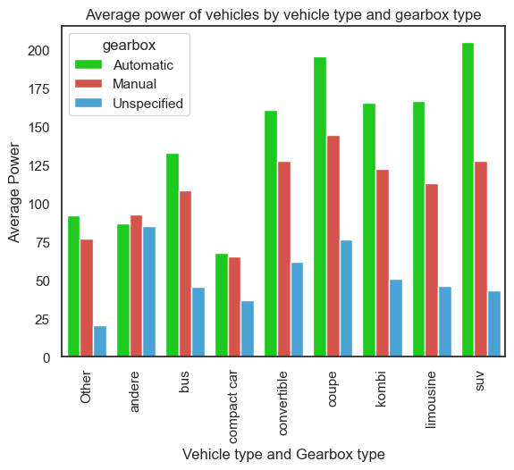

# The above plot shows the average power of vehicles by vehicle type and gearbox type.

* The plot shows that the average power of vehicles with automatic gearbox is higher than that of vehicles with manual gearbox for all vehicle types**.**
* From the plot, we see that automatic SUVs cars have the higher average power.
* And kleinwagen is the least among all the vehicle type.

# What is the Average price of a vehicle by brand as well as vehicle type? Use heatmap to explain this?

# IMG_256

**Heatmap for Average price of a vehicle by brand as well as vehicle type**

* From the heat map above we see that SUV by Audi has the higher average price.
* The heatmap shows the average price of a vehicle per brand and type of vehicle. The darker the colour of a cell in the heatmap, the higher the average price.
* The average price of a vehicle increases with the size and power of the vehicle.