v1.0 / 17 MAY 2019

Restaurants Finder

INTRODUCTION

A web application for finding and locating restaurants near them.
This web application helps in finding the best restaurants near by you with optimal searches,giving the user unlimited options for the comparison of restaurants.

TECHNOLOGY

Backend : Python,Django,Djangorestframework
Frontend: HTML,CSS,Javascript,Jquery,Bootstrap
Database: postgresql
Task Queue:Celery
Broker :Redis

The web app is build with Django. Styles are written in plain CSS and Bootstrap.Restaurants searches are powered with infinte scroll and AJAX to provide Good User Experience
The site is hosted on AWS and deployed with Gunicorn and Ngnix.

In order to get restaurant details Zomato and Google Maps APIs are used and to get the restraunts near a place Geospatial is used that gets stored in database in Background when user searches any city.The background task are accomplished by a Task Queue and Message Broker i.e CELERY and REDIS.

WORKING

Restaurants Finder helps you decide where to have your choice of meal by picking a restaurant in your area. Open the website and desired location to get a random restaurant nearby. Press on the walking distance information at the bottom to open the location in Google Maps, or tap the refresh button at the top right to get another suggestion.

LIBRARIES

For Local Installation
amqp==1.4.9
amqplib==1.0.2
anyjson==0.3.3
billiard==3.3.0.23
celery==3.1.18
certifi==2019.3.9
chardet==3.0.4
Django==2.2.1
django-map-widgets==0.2.2
djangorestframework==3.9.4
geographiclib==1.49
geopy==1.19.0
gunicorn==19.9.0
idna==2.8
kombu==3.0.37
psycopg2-binary==2.8.2
python-dateutil==2.8.0
pytz==2019.1
redis==2.10.3
requests==2.22.0
six==1.12.0
sqlparse==0.3.0
urllib3==1.25.2

Functionality

1.Searching Restaurants:

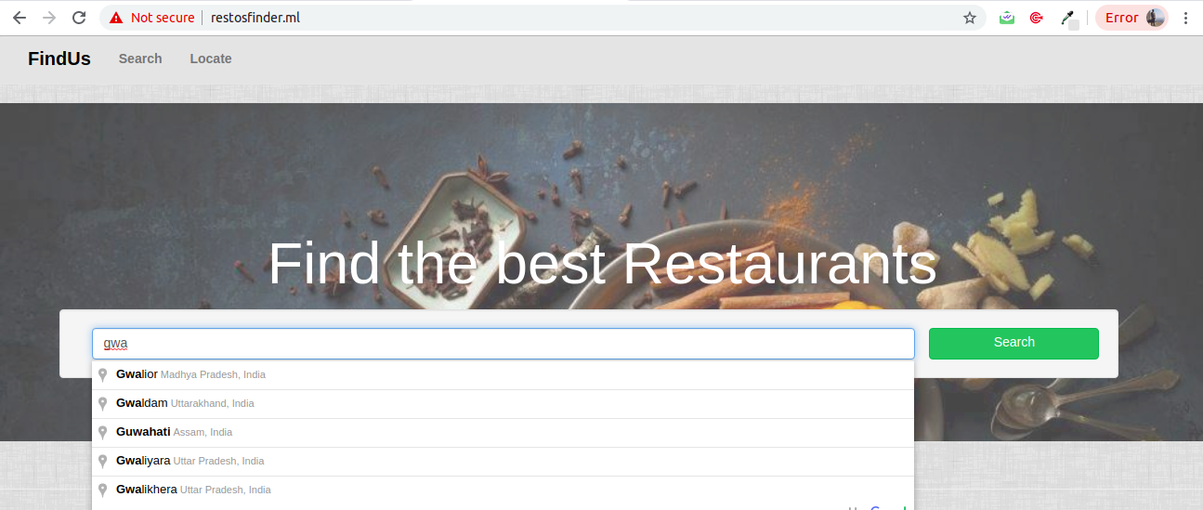

The idea behind searching is first checking in Database and if it not present, Zomato and Googlemaps API are used.As APIs are fullfulling the request at backend our response is also sent in the database simultaneously.This is done using Queue i.e Celery.

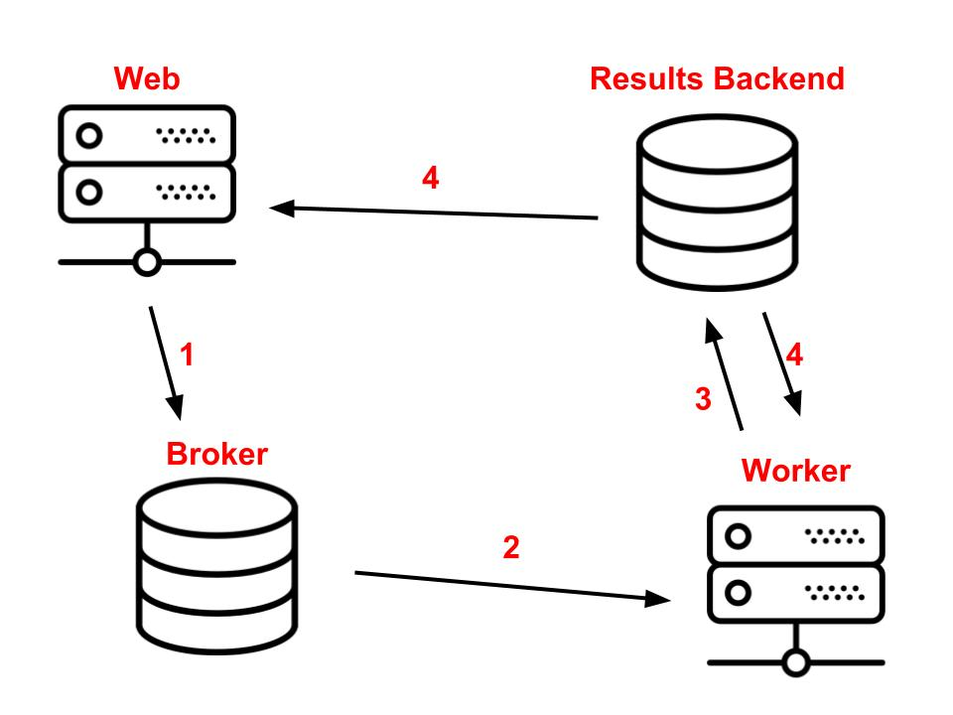

This helps in optimal and fast searches if they visit again

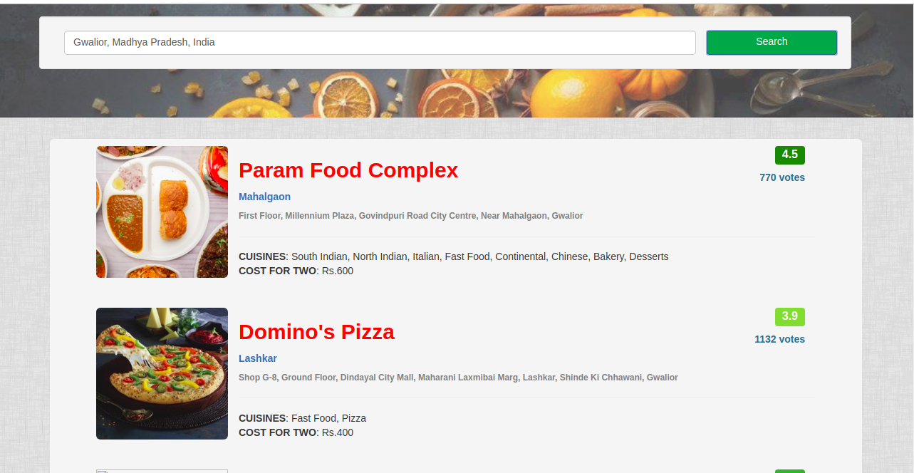
2. Finding Location:

The user is asked to enter the desired city after then the city is displayed on Google Map with latitude and longitude.The user has been provided with an aditional facility of choosing the radius for a particular location with the help of slider.The slider covers the range of 100 to 5000 meters

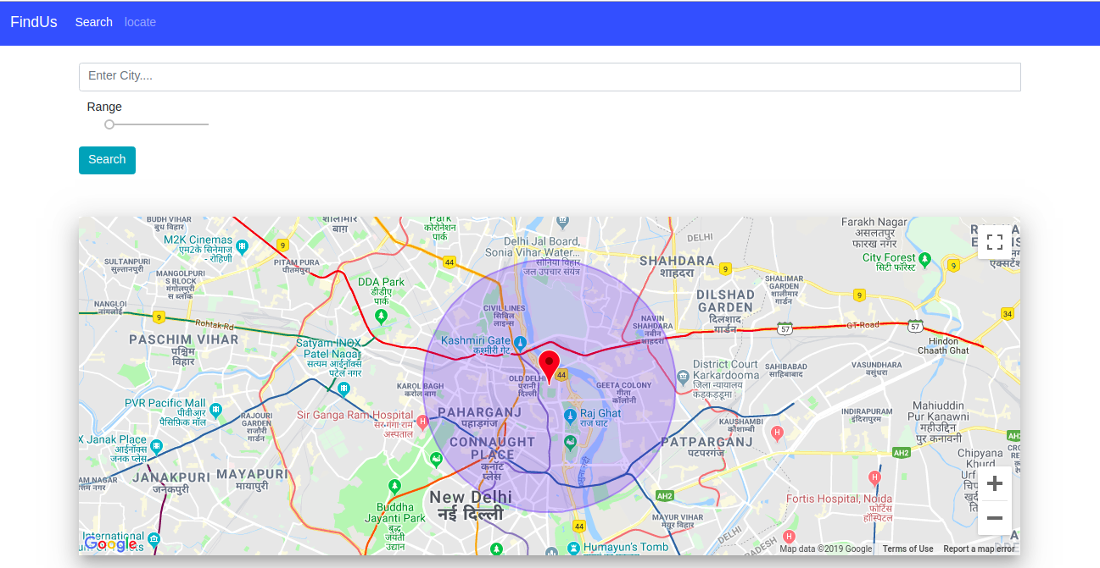

3.Showing Restaurants

For showing restaurants in the desired location within the radius the latitude and longitude is given in the request we query our database to search the Restaurants.
From the queryset we get all latitude and longitude and we give response to frontend using Jinga Templating.

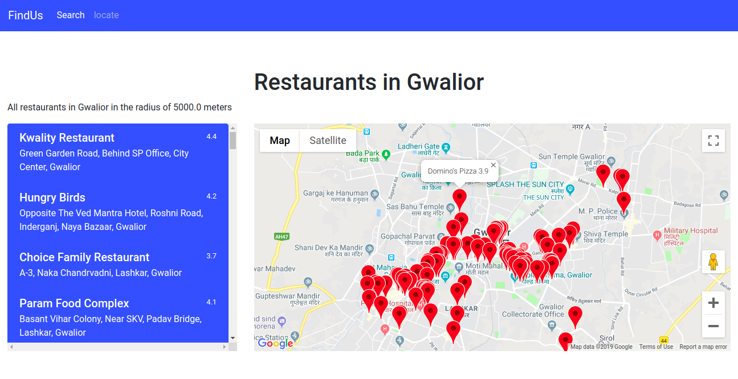

FUTURE DEVELOPMENT

- Get directions from desired Restaurant to another Restaurant
- Search by Cusine
- Dynamic Filters for food , Restaurants type

CONCLUSION

Solving the real world problem for finding Restaurants of their choice in their locality.
Getting the choices for Restaurants in their desired radius.

