**NATIONAL INSTITUTE OF TECHNOLOGY,**

**AGARTALA**

**SOFTWARE ENGINEERING LABORATORY**

**ASSIGNMENT**

**CAMPTREK**

**Submitted To:** Miss Mandira Bhowmik

**Date:**

**Submitted By:** GAUTAM DAGA

DUSHYANT PAREEK

**Enrollment No.:** 23MCA001 and 23MCA012

**Table of content**

**1** **PROBLEM STATEMENT** 1

**2** **INTRODUCTION** 2

**2.1** **BACKGROUND OF THE PROJECT** 2

**2.2** **OBJECTIVES** 2

**2.3** **PURPOSE, SCOPE AND APPLICABILITY** 3

**2.4** **OVERVIEW OF THE PROJECT** 3

**2.5** **USER CHARACTERISTICS** 4

**2.6** **SOFTWARE AND HARDWARE REQUIREMENTS** 4

**2.7** **CONSTRAINTS** 5

**2.8** **FUNCTIONAL REQUIREMENTS** 6

**2.9** **NON-FUNCTIONAL REQUIREMENTS** 6

3 ER DIAGRAM 7

4**. Data Flow Diagram** 8

# **PROBLEM STATEMENT**

CampTrek will play an essential role in making decisions like choosing a campground. This system heavily relies on individuals voluntarily submitted reviews to build the reputation for nearby businesses. Unfortunately, the reviews expose user(s) private information such as visited places to the public and adversaries. Even worse, such location information is usually public because it is that the basic information of companies, and adversaries might be anyone starting from advertisement spammer to physical stalker. This website formalizes the privacy preserving problem in campground review systems. The framework can preserve users’ location privacy in arbitrary local area and may maintain an honest utility for both the system and each user. We evaluate our framework towards real-world data traces. The results validate that the framework are able to do an honest performance.

Key Words: Advanced Web technology, JavaScript, NoSQL, Mongoose, ExpressJS.

**The system should contain the following features:**

1. View information about the required campground using the features listed by different user.
2. To create a website for reviewing campgrounds by using the data of users such as their geographic location to gather information about the campgrounds they have visited.
3. The user can post the review for campgrounds which can be public can be viewed by registered users.

# **INTRODUCTION**

This chapter contains the background of the project, objectives, scope and applicability.

## **BACKGROUND OF THE PROJECT**

CampTrek may be a website where users can create and review campgrounds. In order to review or create a campground, you want to have an account. This project was designed using Node.js, Express, MongoDB, and Bootstrap. Passport.js was used to handle authentication. The Login Feature gives the user right to login to the website after creation of the account successfully for the website. The login process is on high priority. During the login process the user needs to put the User id and Password in order to access the website contents. Whenever the user gets logged-in to the website he/she will be directed to the Homepage.

## **OBJECTIVES**

1. Primary Objective

Primary objective of this Project is to provide a website for reviewing campgrounds by using the data of users such as their geographic location to gather information about the campgrounds they have visited. This data is stored as per each user. The user can post the review for campgrounds which can be public can be viewed by registered users. One of the major aspects of the website is to keep the data of the user private. This website is packed with security features to meet the expectations of privacy and security.

1. Secondary Objectives

The consequent objective is to provide a platform for Campers to post their campsites and view other campsites, check reviews and rating, pictures of the campsite, before planning the trip.

## **PURPOSE, SCOPE AND APPLICABILITY**

The purpose of the *CampTrek* project is to help people interested in camping get to camping spots by difficulties an find it being over crowed or polluted by other campers. This site uses the feedback of the people already visited a specific camp to make easier decisions for other campers who can choose the camping spots based on this feedback from other people.

## **OVERVIEW OF THE PROJECT**

CampTrek is a full-stack website project where users can create and review campgrounds. In order to review or create a campground, you must have an account.

This project is being created using Node.js, Express, MongoDB, and Bootstrap. Passport.js is used to handle authentication.



### **USER CHARACTERISTICS**

The users for this project are property owners and Camptreks who are looking to sell their property. Investors and buyers for all types of properties.

### **SOFTWARE AND HARDWARE REQUIREMENTS**

Software requirements

|  |  |
| --- | --- |
| Operating System | Windows 7  Mac OS X 10.8  Ubuntu or Fedora |
| Software Selection | Sublime text / VS Studio Code  NodeJS  MongoDB  Python |
| Programming Languages | HTML CSS  JavaScript Python3 |
| Web Browser | Google Chrome  Mozilla Firefox  Internet Explorer  Safari  Microsoft Edge |

Hardware requirements

All the hardware requirements that are necessary in developing and deploying the proposed system is listed below.

|  |  |
| --- | --- |
| Processor | I3 |
| Hard Disk | 20GB |
| Ram | 4GB |
| Internet Connection | Internet Connection with a speed of minimum 2 mbps or more |
| Display Unit | Monitor with HD-Ready Resolution or more |

### **CONSTRAINTS**

The constraints of the project *Camptrek* are as follows:

* The constraints of this project are that this project is dependent on automatic data retrieval for properties that were sold in nearby areas which will be fetched from various sources like magic bricks.
* This project is also limited to connecting buyers to sellers and buyers to buyers for collaboration, this project does not host the transaction and takes no liability for any conflicts thereafter.
* The prices predicted by this project are not absolute, any fall or raise in price predicted by this project is applicable only on the seller’s discretion.

### **FUNCTIONAL REQUIREMENTS**

|  |  |  |
| --- | --- | --- |
| Requirement ID | Requirements | Description |
| FR1 | Creation | User Account and Profile creation, storage as well as updating for investor and seller |
| FR2 | Posting | Posting of Property by seller on publicly accessible platform with details stored in database |
| FR3 | Searching | search and display properties characterized by popularity |
| FR4 | Price Tracking | Tracking Price of different property from different websites. |
| FR5 | Purchasing Property | Collaboration Purchase posting |
| FR6 | Communication | Communication in the form of messages |
| FR7 | Machine Learning | Machine learning applied on the property prices to predict increase or decrease |

### **NON-FUNCTIONAL REQUIREMENTS**

Non-Functional requirements of the project CampTrek are as follows

|  |  |  |
| --- | --- | --- |
| Requirement ID | Requirements | Description |
| NFR1 | Usability | The interface should use terms and concepts, which are drawn from the experience of the people who will make most of the system. |
| NFR2 | Efficiency | The system must provide easy and fast access without consuming more cost. |
| NFR3 | Reliability | User should never be surprised by the behaviour of the system and it's easy to use to |

# ER DIAGRAM

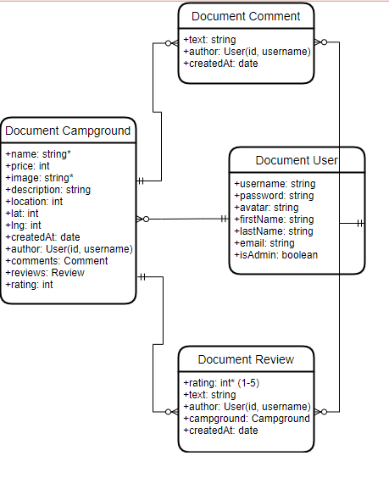

# 4**. Data Flow Diagram**

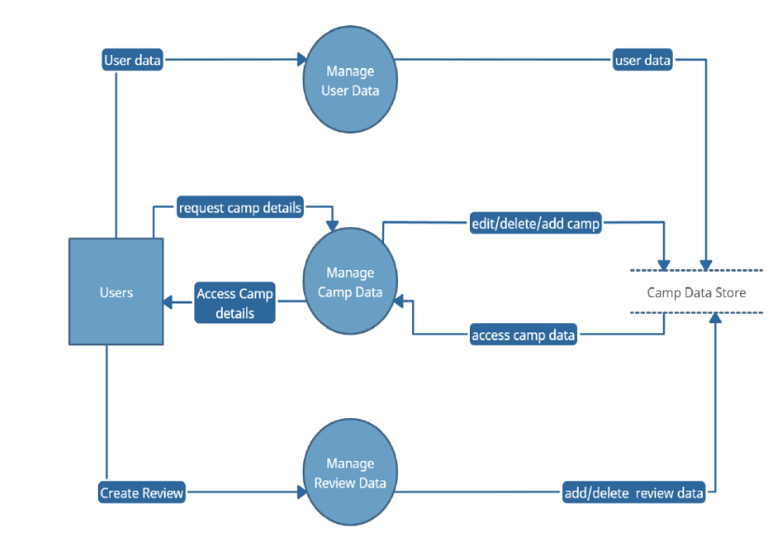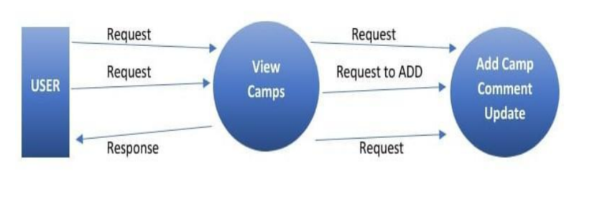

Data Flow Diagram level 1

Data Flow Diagram level 0